Part 1: TITLE, AUTHORS, APPROVALS, etc

Code assigned: | 2023.008F
Short title: Establishing 11 new genera and 19 species in the families Nenyaviridae, Naryaviridae and Vilyaviridae

Author(s) and email address(es)
Varsani A, Hopkins A, Lund MC, Krupovic | Arvind.varsani@asu.edu;  adhopki1@asu.edu  mclund2@asu.edu  mart.krupovic@pasteur.fr
Author(s) institutional address(es) (optional)

The Biodesign Center for Fundamental and Applied Microbiomics, Center for Evolution and Medicine, School of Life sciences, Arizona State University, Tempe, AZ 85287-5001, USA [AV, AH, MCL]
Institut Pasteur, Université Paris Cité, CNRS UMR6047, Archaeal Virology Unit, 25 rue du Dr Roux, 75015 Paris, France [MK]

Corresponding author
Arvind Varsani

List the ICTV Study Group(s) that have seen this proposal

ICTV Study Group comments and response of proposer

ICTV Study Group votes on proposal

Study Group | Number of members
 | Votes support | Votes against | No vote
Authority to use the name of a living person

Is any taxon name used here derived from that of a living person (Y/N) | N

Taxon name | Person from whom the name is derived | Permission attached (Y/N)

Submission dates
Date first submitted to SC Chair | 06-23-2023
Date of this revision (if different to above)
ICTV-EC comments and response of the proposer
Part 2: NON-TAXONOMIC PROPOSAL
Text of proposal

Part 3: TAXONOMIC PROPOSAL
Name of accompanying Excel module
2023.008F.v1.Arfiviricetes_11ng_19nsp.xlsx
Abstract

We aim to classify various new virus genomes in the families Naryaviridae, Nenyaviridae and Vilyaviridae whose members are likely associated with protozoan parasites Entamoeba and Giardia. We propose establishing 7 new genera and 9 new species in Naryaviridae, 1 new genus and 1 new species in Nenyaviridae, and 3 new genera and 9 new species in Vilyaviridae.

Text of proposal
Since the establishment of the families Naryaviridae, Nenyaviridae and Vilyaviridae, in the class Arfiviricetes (phylum Cressdnaviricota) in 2022 for classification of single-stranded DNA viruses associated with protozoan parasites Entamoeba and Giardia, a number of new virus genomes that can be assigned to these families have been identified. Namely, 11 new genomes can be classified into the family Naryaviridae, 1 into Nenyaviridae and 14 into Vilyaviridae. Four of the 14 in the family Vilyaviridae can be classified into the species Angristvirus fangorn (n=3) and Aranruthvirus numenor (n=1).

We follow the genus and species demarcation criteria outlined in Krupovic and Varsani [1], 65% pairwise nucleotide sequence identity for genus demarcation and 78% pairwise nucleotide sequence identity as a species demarcation criterion.

In this proposal we classify:

- 11 naryaviruses: we propose establishing 7 new genera and 9 new species
- 1 nenyavirus: we propose 1 new genus and 1 new species
- 10 vilyaviruses: we propose 3 new genera and 9 new species

Etymology of the taxa names

Naryaviridae
Genera:
Thengelvirus - Thengel: 16th King of Rohan
Sindarvirus - Sindar: Grey Elves
Beornivirus - Beorn: Chieftain of the Beorning
Arkenivirus - Arkenstone: gem discovered in the lonely mountain
Mirkivirus - Mirkwood: Woodland in Rhovanion
Tirithivirus - Minas Tirith: Capital of Gondor
Mallornivirus - Mallorn: large tree in Aman

Epithets:
poros - Poros: Small river in Gondor
dagmor - Dagmor: sword belonging to Beren
narsil - Narsil: sword belonging to Isildur
indis - Indis: Elvish for ‘Great or Valient Woman’
durin - Durin: Seven Fathers of the Dwarves
varda - Varda: Queen of Valar
athela - athelas: healing herb
golfim - Golfimbul: king of the Orcs
breg - Brego: horse of Rohan

Nenyaviridae
Genera:
Cirilivirus - Ciril: third of the Seven Rivers of Gondor

Epithet:
boffger -Concatenation of Boffin and Bolger (two prominent Hobbit families)

Vilyaviridae
Genera:

Ulaervirus - Ulaer: The Nazgûl are known also known as Ulaer in evlish
Ancalagonvirus - Ancalagon: A colossal dragon known as the mightiest of its kind
Berenvirus - Lúthien Tinúviel: A Half-elf maiden renowned for her beauty, grace, and courage

Epithets:
earendil - Eärendil: The mariner who carried the Silmaril and became the Morning and Evening Star.
glaurung - Glaurung: A powerful and deceitful dragon who played a significant role in The Silmarillion.
auledhrim - auledhrim: A blend of Aulë, the Vala who created the Dwarves, and Oropher, father of Thranduil and grandfather of Legolas.
mirksil - Mirksil: A concatenation of Mirkwood and Nirsil the sword of Elendil
morgothanc - Morgothanc: A mix of Morgoth, the first Dark Lord, and Fangorn, the forest home of the Ents.
tuor - Tuor: a mortal hero who played a significant role in The Silmarillion
maedhros - Maedhros: one of the Sons of Fëanor from The Silmarillion
eol - Eöl: The Dark Elf of Nan Elmoth
tinúviel - Lúthien Tinúviel: A Half-elf maiden renowned for her beauty, grace, and courage.

Supporting evidence

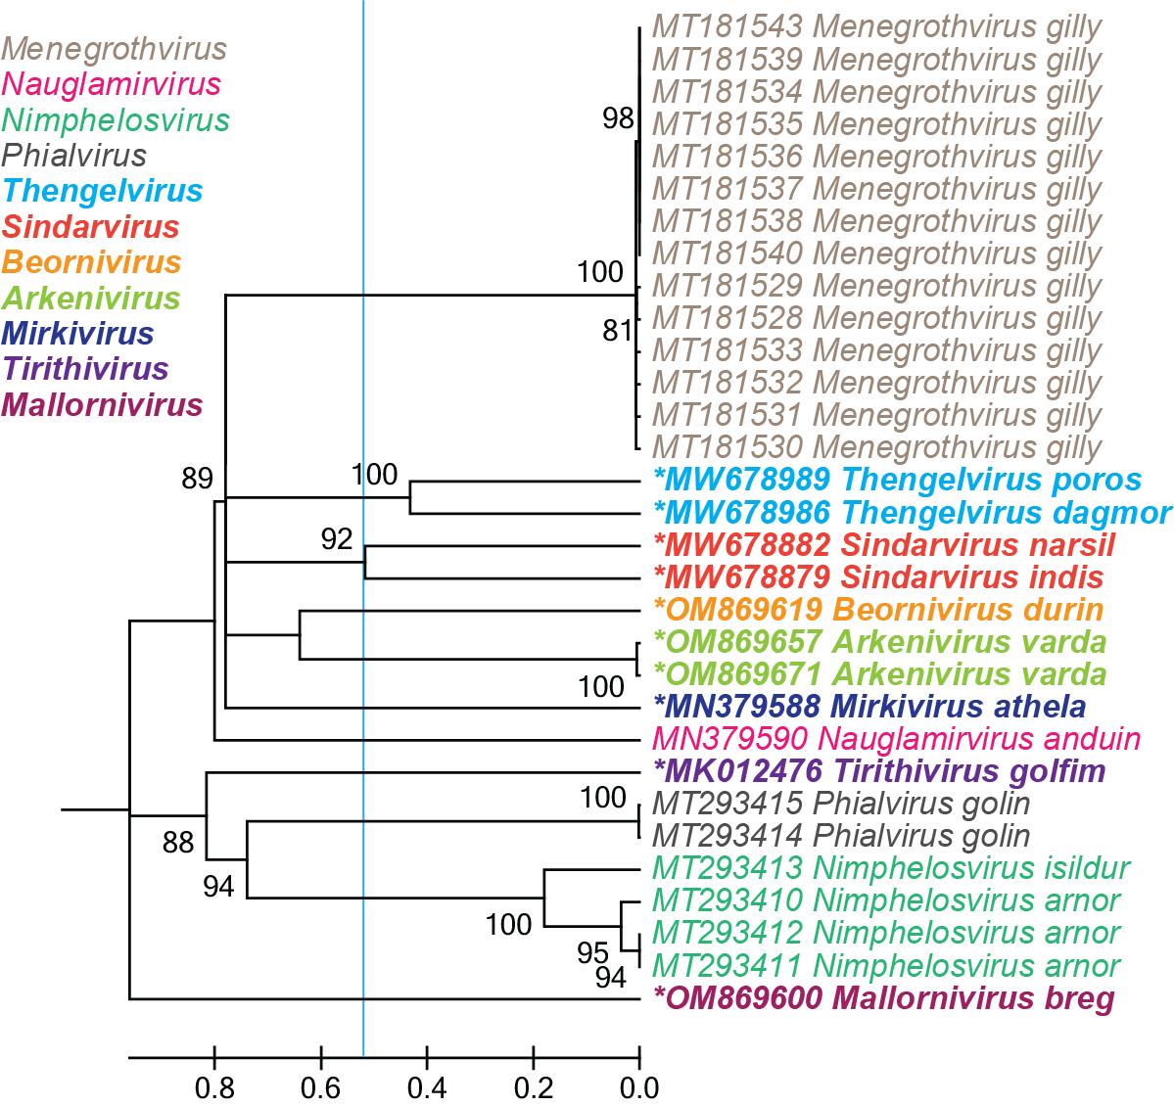
Figure 1: Maximum likelihood tree of the Rep sequences of members of the Naryaviridae family inferred from the aligned Rep amino-acid sequences using PhyML [2] with VT+F is the best substitution model. Numbers at the nodes represent aLRT branch supports. The cyan line shows a proposed demarcation of genera. The new genera are in bold font and * denotes the species assignment of the new viruses.

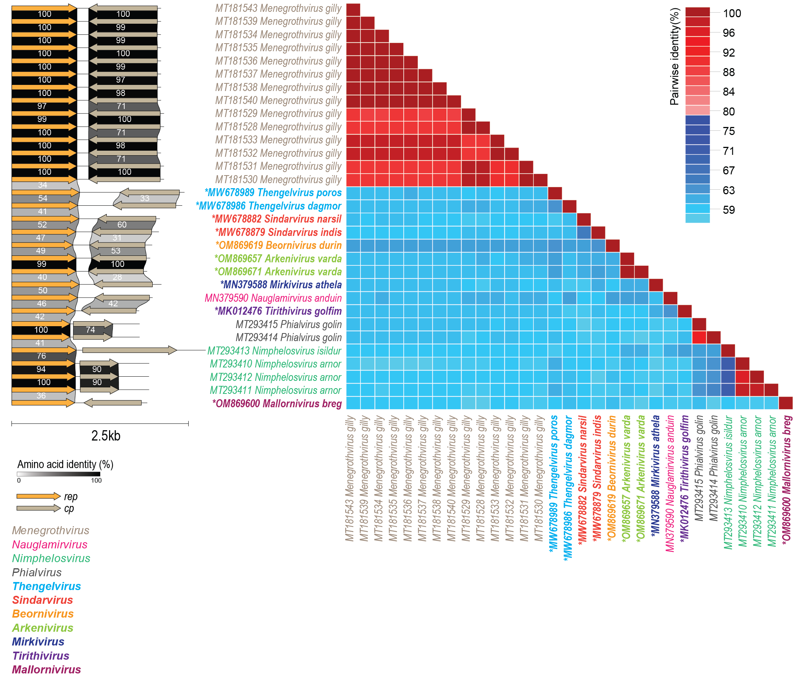

Figure 2: Genome-wide pairwise comparison of the naryavirid genomes. Genome maps are shown on the left and. The pairwise identities were calculated using SDT [3]. The new genus is in bold font and * denotes the species assignment of the new viruses.

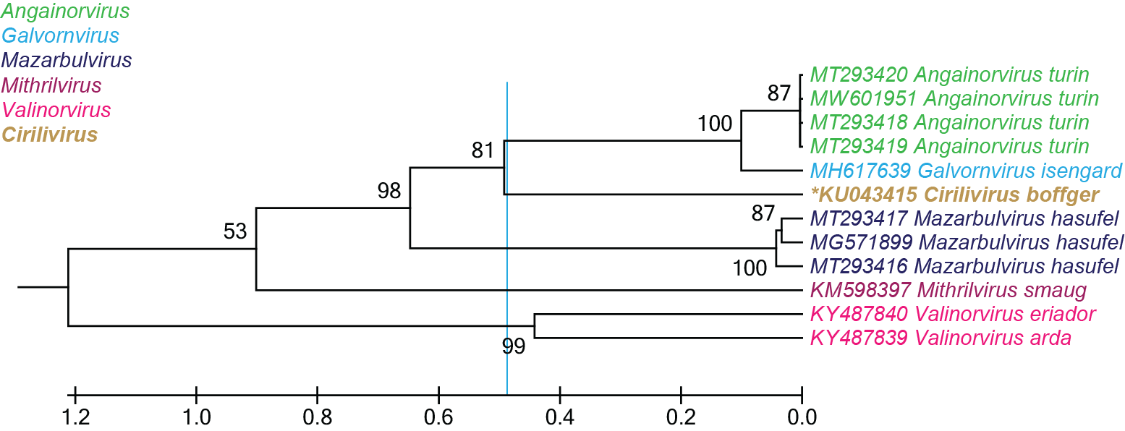

Figure 3: Maximum likelihood tree of the Rep sequences of members of the Nenyaviridae family inferred from the aligned Rep amino-acid sequences using PhyML [2] with VT+F is the best substitution model. Numbers at the nodes represent aLRT branch supports. The cyan line shows a proposed demarcation of genera. The new genus is in bold font and * denotes the species assignment of the new viruses.

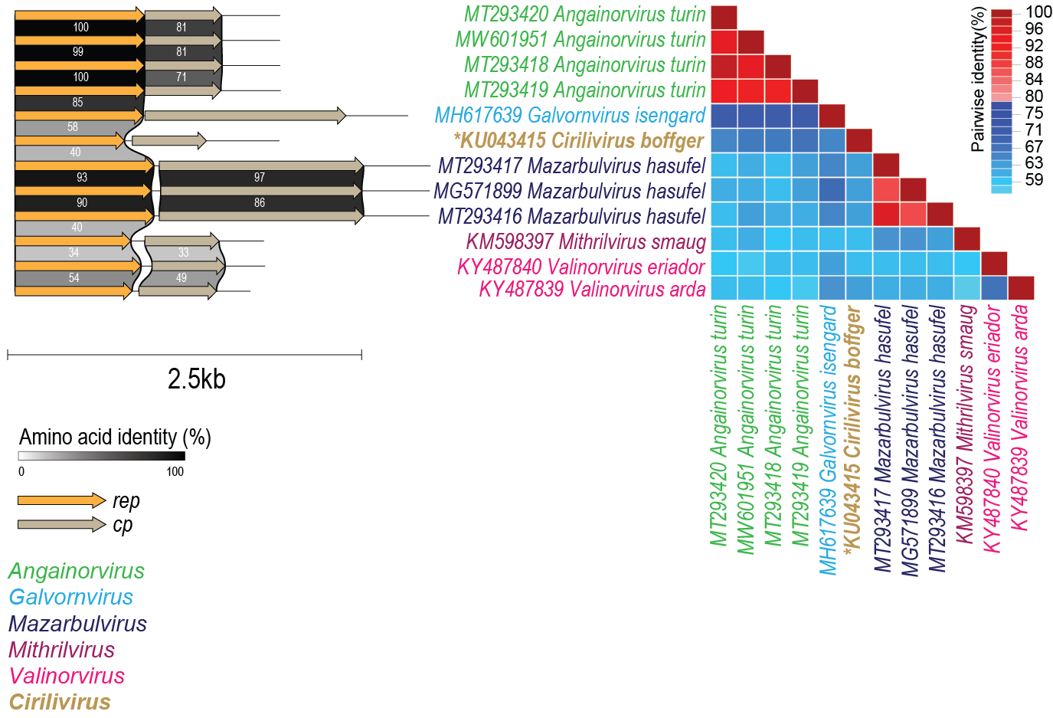

Figure 4: Genome-wide pairwise comparison of the nenyavirid genomes. Genome maps are shown on the left and. The pairwise identities were calculated using SDT [3]. The new genus is in bold font and * denotes the species assignment of the new viruses.

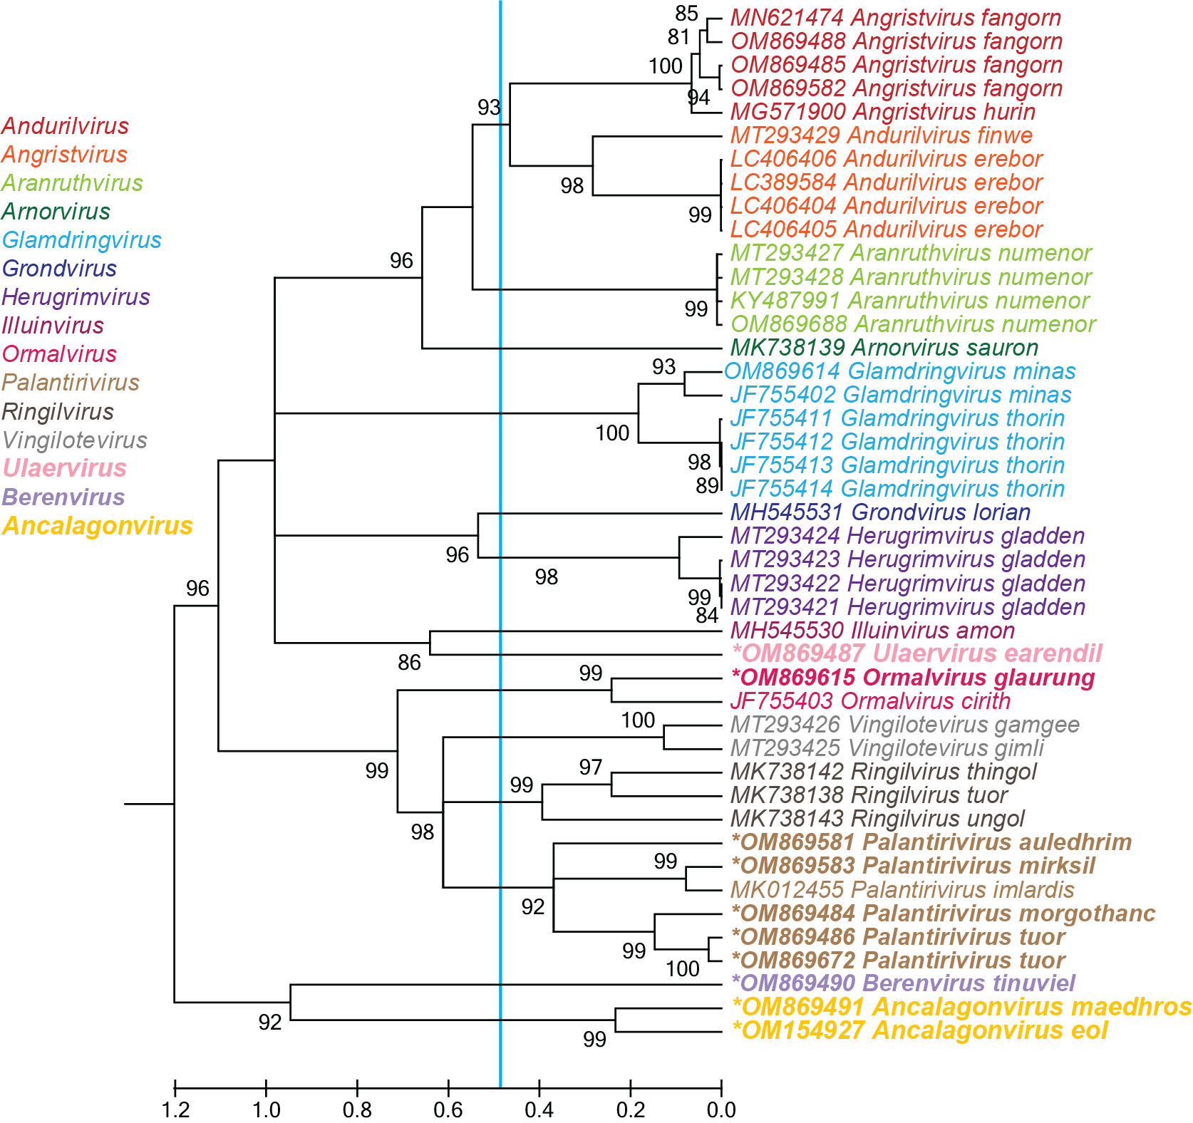

Figure 5: Maximum likelihood tree of the Rep sequences of members of the Vilyaviridae family inferred from the aligned Rep amino-acid sequences using PhyML [2] with rtREV+I+G+F is the best substitution model. Numbers at the nodes represent aLRT branch supports. The cyan line shows a proposed demarcation of genera. The new genera are in bold font and * denotes the species assignment of the new viruses.
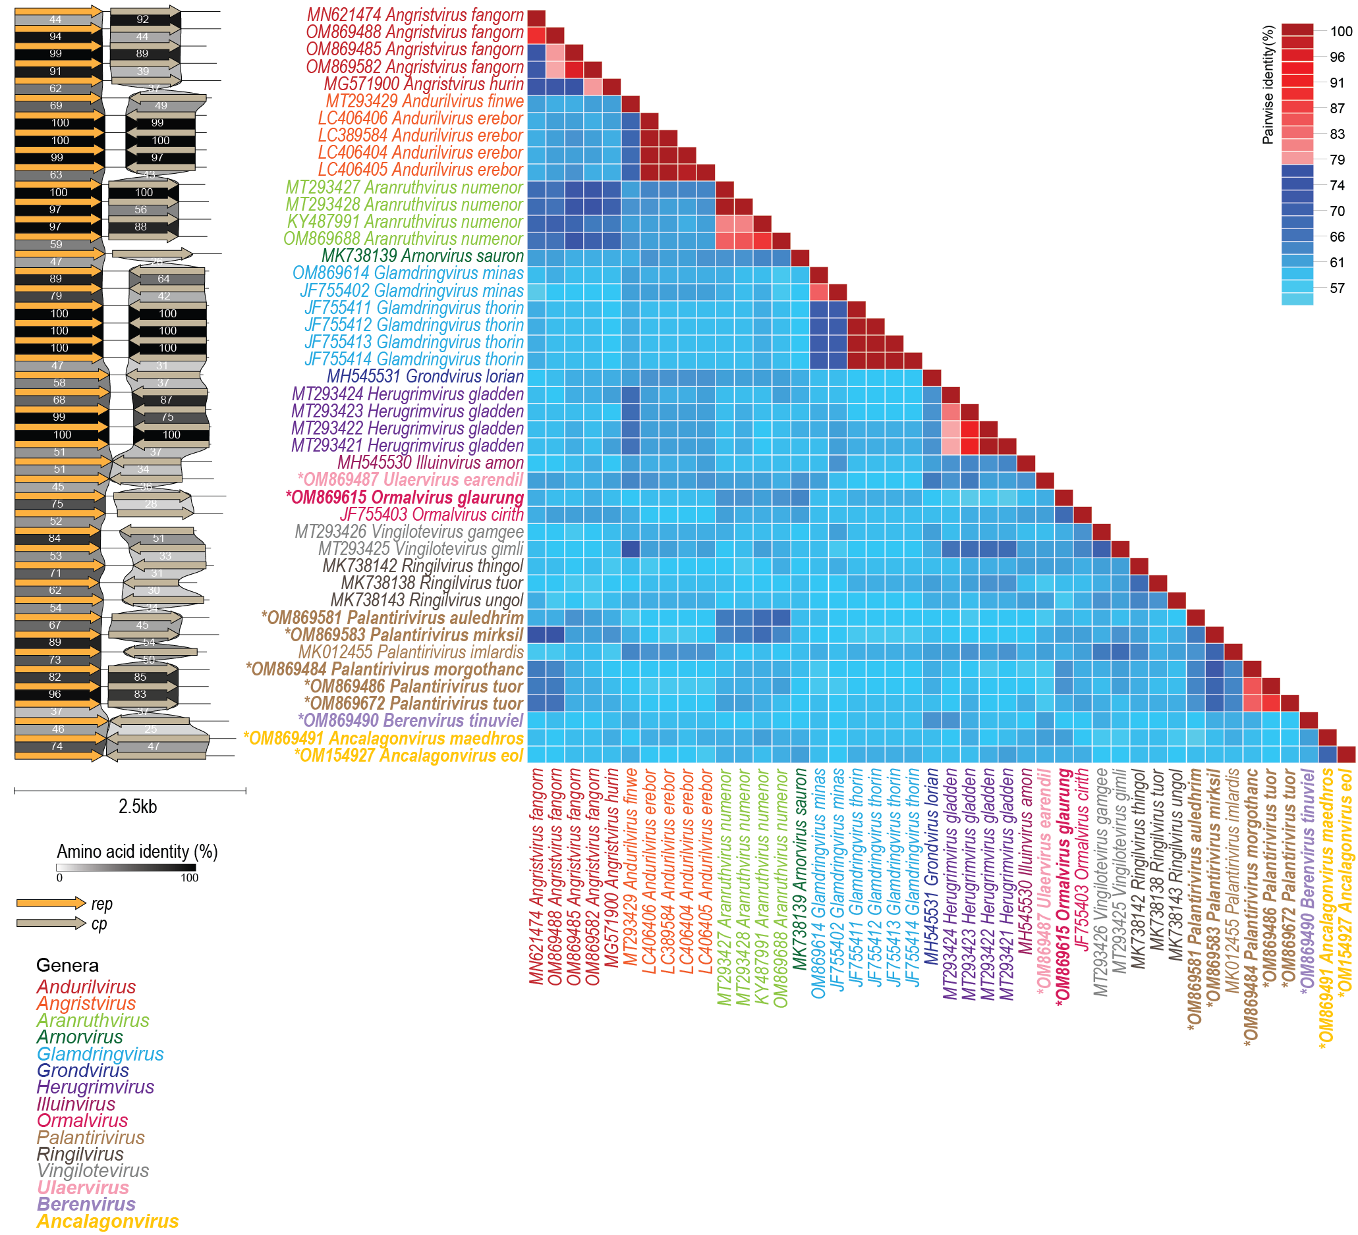

Figure 6: Genome-wide pairwise comparison of the vilyavirid genomes. Genome maps are shown on the left and. The pairwise identities were calculated using SDT [3]. The new genus is in bold font and * denotes the species assignment of the new viruses.

Table 1: Summary of new species in the families Naryaviridae, Nenyaviridae and Vilyaviridae. Those in black font are exemplar viruses for their respective species.

Family | Genus | Species | Accession # | Virus |  | Country of isolation | Host / source | Isolate | Sample type
Naryaviridae | Thengelvirus | Thengelvirus poros | MW678989 |  | Virus sp. D1_583 | USA | environmental | D1_583 | airborne particulate matter
Naryaviridae | Thengelvirus | Thengelvirus dagmor | MW678986 |  | Virus sp. D10_8234 | USA | environmental | D10_8234 | airborne particulate matter
Naryaviridae | Sindarvirus | Sindarvirus narsil | MW678882 |  | Virus sp. D10_11052 | USA | environmental | D10_11052 | airborne particulate matter
Naryaviridae | Sindarvirus | Sindarvirus indis | MW678879 |  | Virus sp. D3_1047 | USA | environmental | D3_1047 | airborne particulate matter
Naryaviridae | Beornivirus | Beornivirus durin | OM869619 |  | Peromfec virus RodF8_96 | USA | Peromyscus boylii | RodF8_96 | feces
Naryaviridae | Arkenivirus | Arkenivirus varda | OM869657 |  | Peromfec virus RodF7_30 | USA | Peromyscus boylii | RodF7_30 | feces
Naryaviridae | Arkenivirus | Arkenivirus varda | OM869671 |  | Peromfec virus RodF5_42 | USA | Peromyscus truei | RodF5_42 | feces
Naryaviridae | Mirkivirus | Mirkivirus athela | MN379588 |  | Chicken virus mg5_2197 | USA | Galus galus | mg5_2197 | tracheal swab
Naryaviridae | Tirithivirus | Tirithivirus golfim | MK012476 |  | CRESS virus sp. ctbi77 | USA | turkey | ctbi77 | tissue
Naryaviridae | Mallornivirus | Mallornivirus breg | OM869600 |  | Dipodfec virus UA23Rod_5718 | USA | Dipodomys spectabilis | UA23Rod_5718 | feces
Nenyaviridae | Cirilivirus | Cirilivirus boffger | KU043415 | Circular ssDNA virus sp. cg6319 |  | USA | Macaca mulatta | cg6319 | feces
Vilyaviridae | Ulaervirus | Ulaervirus earendil | OM869487 | Sigmofec virus UA08Rod_19468 |  | USA | Sigmodon arizonae | UA08Rod_19468 | feces
Vilyaviridae | Ormalvirus | Ormalvirus glaurung | OM869615 | Myodefec virus RodL3_773 |  | USA | Clethrionomys gapperi | RodL3_773 | liver
Vilyaviridae | Palantirivirus | Palantirivirus auledhrim | OM869581 | Dipodfec virus UA06Rod_119 |  | USA | Dipodomys ordii | UA06Rod_119 | feces
Vilyaviridae | Palantirivirus | Palantirivirus mirksil | OM869583 | Dipodfec virus UA06Rod_108 |  | USA | Dipodomys ordii | UA06Rod_108 | feces
Vilyaviridae | Palantirivirus | Palantirivirus morgothanc | OM869484 | Sigmofec virus UA08Rod_21233 |  | USA | Sigmodon arizonae | UA08Rod_21233 | feces
Vilyaviridae | Palantirivirus | Palantirivirus tuor | OM869486 | Sigmofec virus UA08Rod_20100 |  | USA | Sigmodon arizonae | UA08Rod_20100 | feces
Vilyaviridae | Palantirivirus | Palantirivirus tuor | OM869672 | Peromfec virus RodF5_41 |  | USA | Peromyscus truei | RodF5_41 | feces
Vilyaviridae | Berenvirus | Berenvirus tinuviel | OM869490 | Sigmofec virus UA08Rod_17746 |  | USA | Sigmodon arizonae | UA08Rod_17746 | feces
Vilyaviridae | Ancalagonvirus | Ancalagonvirus maedhros | OM869491 | Sigmofec virus UA08Rod_17037 |  | USA | Sigmodon arizonae | UA08Rod_17037 | feces
Vilyaviridae | Ancalagonvirus | Ancalagonvirus eol | OM154927 | Chaetfec virus UA24_7381 |  | USA | Chaetodipus sp. | UA24rod_7381 | feces

References

- Krupovic M, Varsani A, 2022. Naryaviridae, Nenyaviridae, and Vilyaviridae: three new families of single-stranded DNA viruses in the phylum Cressdnaviricota. Arch. Virol. 167, 2907–2921.PMID: 36098801 DOI: 10.1007/s00705-022-05557-w
- Guindon S, Dufayard JF, Lefort V, Anisimova M, Hordijk W, Gascuel O (2010) New algorithms and methods to estimate maximum-likelihood phylogenies: assessing the performance of PhyML 3.0. Syst Biol 59:307-321. PMID: 20525638; doi: 10.1093/sysbio/syq010
- Muhire BM, Varsani A, Martin DP (2014) SDT: A Virus Classification Tool Based on Pairwise Sequence Alignment and Identity Calculation. Plos One 9:e108277. doi:10.1371/journal.pone.0108277. PMID:WOS:000342685600059

