Part 1: TITLE, AUTHORS, APPROVALS, etc

Code assigned: | 2023.029P
Short title: Create the new genus Hubsclerovirus in the family Solemoviridae (Sobelivirales) and the new species Hubsclerovirus HUSRV in the proposed genus
Author(s) and email address(es)
Sõmera M, Sarmiento C, Fargette D | merike.somera@taltech.ee;  cecilia.sarmiento@taltech.ee;  denis.fargette@ird.fr
Corresponding author
Merike Sõmera merike.somera@taltech.ee
List the ICTV Study Group(s) that have seen this proposal
Solemoviridae SG

ICTV Study Group comments and response of proposer
ICTV Study Group votes on proposal
Study Group | Number of members
 | Votes support | Votes against | No vote
Solemoviridae SG | 4 |  | 0
Authority to use the name of a living person
Is any taxon name used here derived from that of a living person (Y/N) | N

Taxon name | Person from whom the name is derived | Permission attached (Y/N)

Submission dates
Date first submitted to SC Chair
Date of this revision (if different to above)
ICTV-EC comments and response of the proposer
Following the EC request to reconsider the use of acronyms as species epithets, the Study Group confirmed the decision of using the acronyms as species epithets.

Part 3: TAXONOMIC PROPOSAL
Name of accompanying Excel module
2023.029P.Uc.v1.Hubsclerovirus_1ng_1nsp
Abstract
We propose the creation of one new species Hubsclerovirus HUSRV and one novel genus Hubsclerovirus (from Hubei sclerotinia RNA virus) in the family Solemoviridae, to accommodate fungal viruses sharing close genetic relationships with sobemoviruses.
A founding member Hubei sclerotinia RNA virus 1 (HuSRV1) was isolated from the ascomyceteous fungus Sclerotinia sclerotiorum obtained from rapeseed. It has isometric virions 30 nm in diameter. The genome has four ORFs. ORF1a and ORF1b have phylogenetic relationships with ORF2a and ORF2b characteristic of viruses belonging to the genus Sobemovirus within the family Solemoviridae. HuSRV1 ORF2 encodes a viral capsid protein that is genetically related both to CPs of beta- and alphanecroviruses belonging to the family Tombusviridae (order Tolivirales) and to CPs of sobemoviruses belonging to the family Solemoviridae (order Sobelivirales). ORF3 has no homology.

Text of proposal
Sclerotinia sclerotiorum hypovirulent strain 277 containing a novel virus named Hubei sclerotinia RNA virus 1 (HuSRV1) was isolated from a sclerotium obtained from diseased rapeseed (Brassica napus) in the Hubei Province of China in 2013. Transmission electron microscopy results indicated virions with icosahedral symmetry approximately 30 nm in diameter. The virus was horizontally transmissible to S. sclerotiorum strain Ep-1PNA367R resulting in a new hypovirulent strain (Azhar et al 2019).

Sequencing of HuSRV1 genome (MK889164) revealed that:

- HuSRV1 is phylogenetically related to sobemoviruses (+ssRNA plant viruses belonging to the genus Sobemovirus family Solemoviridae);
- The complete genome of HuSRV1 is 4.5 kb long;
- The prediction shows four putative ORFs (Fig. 1);
- The 5ˊ-untranslated region (UTR) of HuSRV1 starts with the sequence “ACAAAA” (similar to many viruses belonging to different genera in the Solemoviridae);
- The 3ˊ-UTR lacks the poly(A) tail structure (also the members of Solemoviridae lack poly(A) tail);
- HuSRV1 genome lacks ORFs homologous to sobemoviral ORF1 and ORFx;
- HuSRV1 ORF1a and ORF1b contain conserved domains or motifs, including a protease, a virus genome-linked protein (VPg) and an RdRp most possibly translated via -1 ribosomal frameshifting. These sequence properties are also characteristic of ORF2a and ORF2b of +ssRNA plant viruses belonging to the genus Sobemovirus within Solemoviridae;
- A possible ribosomal frameshift signal (RFS) is composed of a slippery sequence GATTTTC followed by an RNA pseudoknot. Sobemoviral RFS is composed of a slippery sequence UUUAAAC followed by a stem-loop structure;
- HuSRV1 ORF2 encodes capsid protein (CP). In contrast to sobemoviruses, HuSRV1 CP contains only the virion core building block, called the S domain, and lacks the N-terminal R domain;
- Seven invariant CP amino acid residues of HuSRV1 are conserved based on multiple sequence alignment with CPs of sobemoviruses;
- Four of the invariant amino acid residues are involved in Ca²⁺ binding, and others are likely to be involved in backbone conformation. Ca²⁺ binding is also characteristic of sobemoviruses;
- A predicted 3D structure of HuSRV1 CP indicated three CP chains: A, B, and C similar to sobemovirus particles;
- HuSRV1 ORF3 encoded putative protein P3 has no homology with any known proteins. The sobemovirus genome lacks the respective ORF.

A BLASTN search at the NCBI site (nr/nt collection) revealed three sequences related to HuSRV1 (MK889164):
a near-complete genome sequence of HuSRV-1 isolate WX (MT646396), sequenced from an S. sclerotiorum metagenome (Jia et al 2021). The S. sclerotiorum sample was obtained from a diseased rapeseed in 2017 from China, showing 93% of identities to the Hubei isolate of HuSRV1 with 99% of coverage in pairwise BLASTN;
a 2941 nt sequence fragment (MN630192, called Erysiphe necator associated sobemo-like virus 4) sequenced from grape powdery mildew fungus Erysiphe necator in Spain in 2018 (Rodriguez-Romero et al 2021), showing 86% of identity to the Hubei isolate of HuSRV1 with 81% of coverage;
a 1351 nt sequence fragment (OM954022, called flumine sobemo-like virus 13) sequenced from a water sample of Manawatu River in New Zealand in 2019 (French et al 2022), showing 81% of identities to the Hubei isolate of HuSRV1 with 97% of coverage in pairwise BLASTN.

MUSCLE multiple sequence alignment of translated RdRP sequences of HuSRV1 isolates indicates 97% of identity whereas the other two sequences are also showing greater than 90% of identity to HuSRV1 and each other (Fig. 2).

The distance reconstruction of phylogeny of RdRP encoding genes calculated to analyze the relationships between these sequences and the sequences belonging to the members of the genera Sobemovirus, Enamovirus, and Polerovirus illustrate the close relationship of the hubsclerovirus(es) with the sobemoviruses (Fig. 3).

A network representation of the relationship of the member(s) of the tentative genus Hubsclerovirus with the members of other genera of the family Solemoviridae singles out the original position of the hubsclerovirus and relativizes its proximity with the sobemoviruses (Fig. 4). The results are consistent with those from the phylogenetic reconstruction.

Current phylogenetic calculations suggest that the identified HuSRV1-like sequences are probably not different species but different strains of HuSRV1. With that, it seems that HuSRV1 represents the first (and probably not the last) well-described fungal virus which shares close phylogenetic relationships with plant-infecting sobemoviruses.

Considering the presented data, we support the original idea of Azhar et al (2019) to establish a new genus Hubsclerovirus in the family Solemoviridae, including HuSRV1 as a member of Hubsclerovirus HUSRV.

We propose the following species demarcation criteria:

- Fungal viruses with isometric particles, in approx. 30 nm in diameter;
- Phylogenetic relationships of the virus-encoded genes of protease-VPg, RdRP and CP to the genes encoding respective sobemoviral proteins;
- Genome organization similar to HuSRV1;
- Differences in nucleotide sequence identity of genomes around or greater than 25%.

Supporting evidence
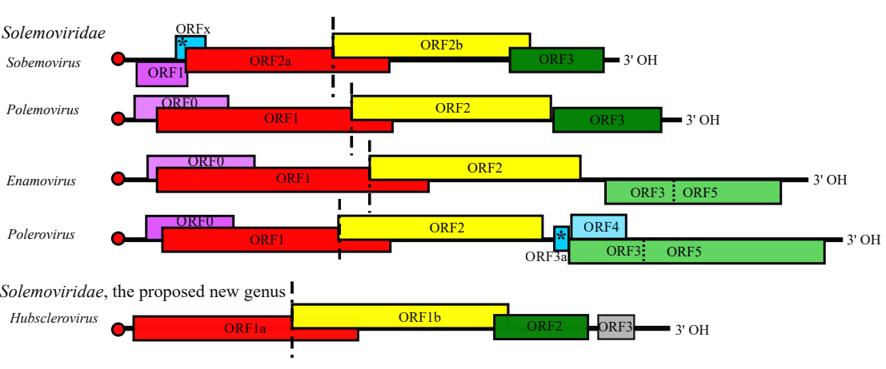

Fig. 1. Genome annotation of the typical members of phylogenetically related genera belonging to the family Solemoviridae: Sobemovirus, Polemovirus, Enamovirus, Polerovirus, and the proposed novel genus Hubsclerovirus. RdRP genes are shown in the upper frame (frame 0); middle frame represents +1 frame and lower frame represents +2 frame. Non-canonical AUG start codon is marked with asterisk (*). –1 ribosomal frameshifting site is marked by long vertical dashed line. Read-through codon is shown by short vertical dashed line. A genome-linked viral protein (VPg) is depicted as a red dot. Different protein functions are displayed with different colors. Color code: lilac—viral RNAi suppressor; red—serine protease-VPg; yellow—picornavirus-like RdRP; green—picornovirus-like CP (polero- and enamoviral CPs have additional readthrough domain translated via a stop codon suppression); blue—movement protein; grey—unknown function.
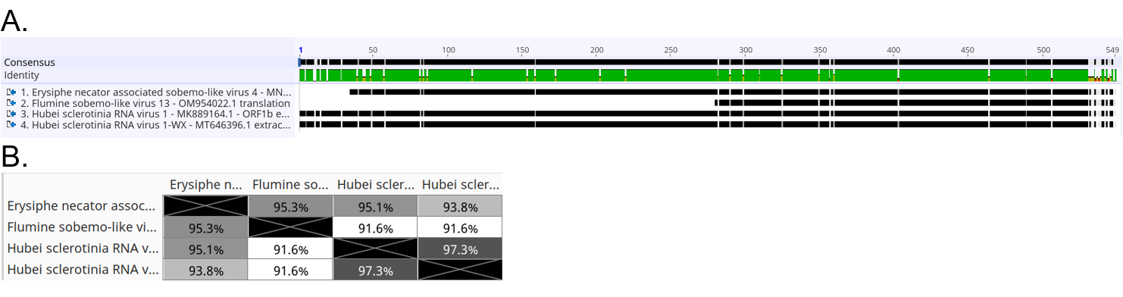

Fig. 2. Multiple sequence alignment of RdRPs (aa sequences) of HuSRV1 isolates and the other related sequences visualized as: (A) an alignment (conserved sequences are shown as black lines, the gaps indicate SNPs; 100% of identity is presented in green), (B) a heatmap of identity percentages.

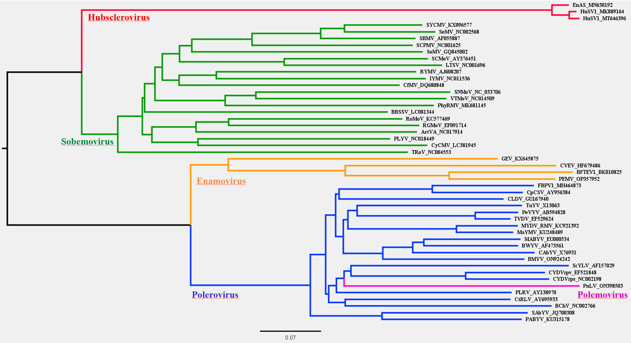

Fig. 3. Phylogenetic distance reconstruction based on the results of the Clustal Omega alignments of nucleotide sequences of RdRP genes. A scale bar indicates number of nucleotide substitutions per site.

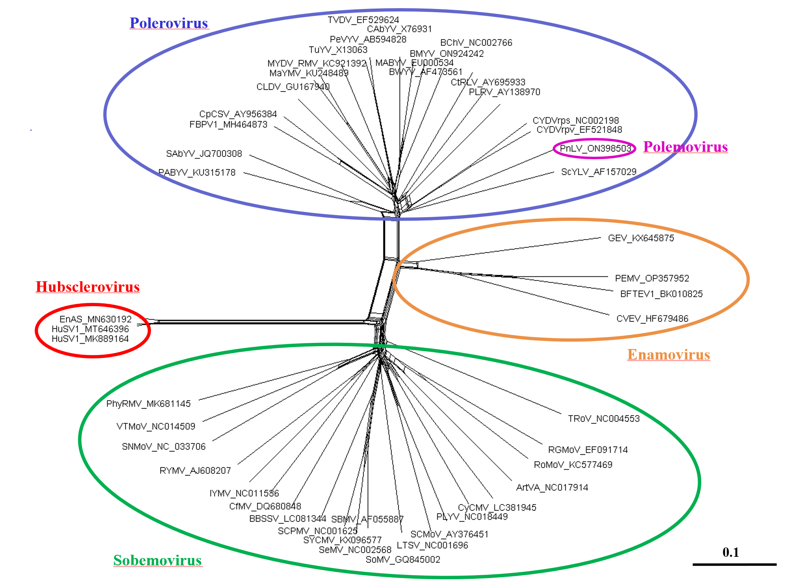

Fig. 4. Phylogenetic network reconstruction based on the results of the Clustal Omega alignments of nucleotide sequences of RdRP genes. A scale bar indicates number of nucleotide substitutions per site.

References
Azhar A, Mu F, Huang H, Cheng J, Fu Y, Hamid MR, Jiang D, Xie J (2019) A Novel RNA Virus Related to Sobemoviruses Confers Hypovirulence on the Phytopathogenic Fungus Sclerotinia sclerotiorum. Viruses11:759. doi: 10.3390/v11080759. PMID: 31426425

Jia J, Fu Y, Jiang D, Mu F, Cheng J, Lin Y, Li B, Marzano SL, Xie J (2021) Interannual dynamics, diversity and evolution of the virome in Sclerotinia sclerotiorum from a single crop field. Virus Evol 7:veab032. doi: 10.1093/ve/veab032. PMID: 33927888

Rodriguez-Romero J, Chiapello M, Cordoba L, Turina M, Ayllon MA (2021) GenBank Acc. No. MN630192.1: Erysiphe necator associated sobemo-like virus 4

French R, Charon J, Lay CL, Muller C, Holmes EC (2022) Human land use impacts viral diversity and abundance in a New Zealand river. Virus Evol 8:veac032. doi: 10.1093/ve/veac032. PMID: 35494173

