Part 1: TITLE, AUTHORS, APPROVALS, etc

Code assigned: | 2023.014P
Short title: Create a new genus Welwivirus in the family Geminiviridae, in the order Geplafuvirales, including two species, Welwivirus welwitschiae and Welwivirus mirabilis.
Author(s) and email address(es)
Bejerman N, Debat H | bejerman.nicolas@inta.gob.ar, debat.humberto@inta.gob.ar
Author(s) institutional address(es) (optional)

Corresponding author
N Bejerman (bejerman.nicolas@inta.gob.ar) and H Debat (debat.humberto@inta.gob.ar)

List the ICTV Study Group(s) that have seen this proposal

Geminiviridae and Tolecusatellitidae Study Group

ICTV Study Group comments and response of proposer

Approved by the Geminiviridae and Tolecusatellitidae Study Group

ICTV Study Group votes on proposal

Study Group | Number of members
 | Votes support | Votes against | No vote
Roumagnac, Philippe  Ascencio-Ibanez, Jose  Lett, Jean-Michel  López-Lambertini, Paola M.  Martin, Darren  Navas-Castillo, Jesús  Ribeiro, Simone  Urbino, Cica  Varsani, Arvind  Zerbini, F. Murilo | Y  Y  Y  Y  Y  Y  Y  Y  Y  Y
Authority to use the name of a living person
N
Is any taxon name used here derived from that of a living person (Y/N) | N

Taxon name | Person from whom the name is derived | Permission attached (Y/N)

Submission dates
Date first submitted to SC Chair | June 23th 2023
Date of this revision (if different to above)
ICTV-EC comments and response of the proposer
Part 2: NON-TAXONOMIC PROPOSAL
Text of proposal

Part 3: TAXONOMIC PROPOSAL
Name of accompanying Excel module
2023.014P.A.v1.Geminiviridae_1ng_2nsp
Abstract

The creation of a new genus of plant-infecting viruses is proposed. The new genus is named Welwivirus, and includes two new species: Welwivirus welwitschiae and Welwivirus mirabilis. Both viruses have circular, single-stranded DNA genomes that display a geminivirus-like genomic size and organization. The new genus should be classified in the family Geminiviridae, order Geplafuvirales, class Repensiviricetes, phylum Cressdnaviricota, kingdom Shotokuvirae, realm Monodnaviria.

Text of proposal
Cressdnaviricota is a phylum including viruses that have small, circular, single-stranded DNA (ssDNA) genomes encoding replication-associated proteins with an HUH endonuclease domain and a SH3 superfamily helicase domain [1]. Currently, Cressdnaviricota includes 11 families, three of which, Geminiviridae, Metaxyviridae and Nanoviridae, contain plant-infecting viruses [1]. The family Geminiviridae includes 14 genera [2].
Here we proposed the creation of a new genus within the family Geminiviridae named Welwivirus, including two new species, i.e. Welwivirus welwitschiae (formerly named Welwitschia mirabilis associated geminivirus A) and Welwitschia mirabilis (formerly named Welwitschia mirabilis associated geminivirus B). Welwitschia mirabilis associated geminivirus A (WMaGVA) and Welwitschia mirabilis associated geminivirus B (WMaGVB), respectively belonging to Welwivirus welwitschiae and Welwitschia mirabilis, have been characterized from mining Welwitschia mirabilis genomic data [3]. Their 2913 and 2912 nt long nucleotide genome sequences share less than 60.5% with all other known geminiviruses within currently established species (Figure 1). WMaGVA and WMaGVB genomes share 77.4% genome-wide pairwise identity with each other; while their capsid proteins aa sequences shared 84.32% identity between each other and their replicases aa sequences shared 87.16% identity between each other. Welwitschia mirabilis associated geminivirus A and Welwitschia mirabilis associated geminivirus B are clearly related to previously recognized geminiviruses, based on genome composition, similarities in the origin of replication (5'- TAATATTAC -3'), and the presence of homologous genes (Figure 2). Additionally, regardless of whether the full genome nucleotide sequence (Figure 3), the inferred replication associated protein (Rep) amino acid sequence (Figure 5), or the inferred CP amino acid sequence (Figure 4) are considered, WMaGVA and WMaGVB group separately from all other geminiviruses, with strong phylogenetic support and, consequently, we propose creating a new genus named Welwivirus to accommodate the highly divergent geminivirus species Welwivirus welwitschiae and Welwivirus mirabilis. While phylogenies based on the full genome nucleotide sequence and inferred replication associated protein (Rep) indicate that WMaGVA and WMaGVB cluster most closely with capulaviruses and topileviruses (Figures 3 and 5), the phylogeny based on inferred coat protein (CP) amino acid sequences shows that WMaGVA and WMaGVB CP´s cluster with the CPs of mastreviruses (Figure 4). The incongruence between the Rep and CP phylogenetic trees suggests that the evolutionary history of WMaGVA and WMaGVB includes a recombination event involving ancestrals of a mastre-like and a capula-like viruses. However, no recombination events were reported for these viruses [3]. This could be the result of long divergence times that erased the evidence of the event or due to the fact that the common ancestor is unknown, either because it has not yet been sampled or because it is extinct.
Recently, 78% identity over the whole genome was used as the species demarcation threshold for members belonging to five recently stablished genera within the family Geminiviridae [4]. Thus, using the same threshold for the proposed genus Welwivirus, WMaGVA and WMaGVB should be classified into two different species.

Derivation of names:
Welwivirus: from Welwitschia

Supporting evidence
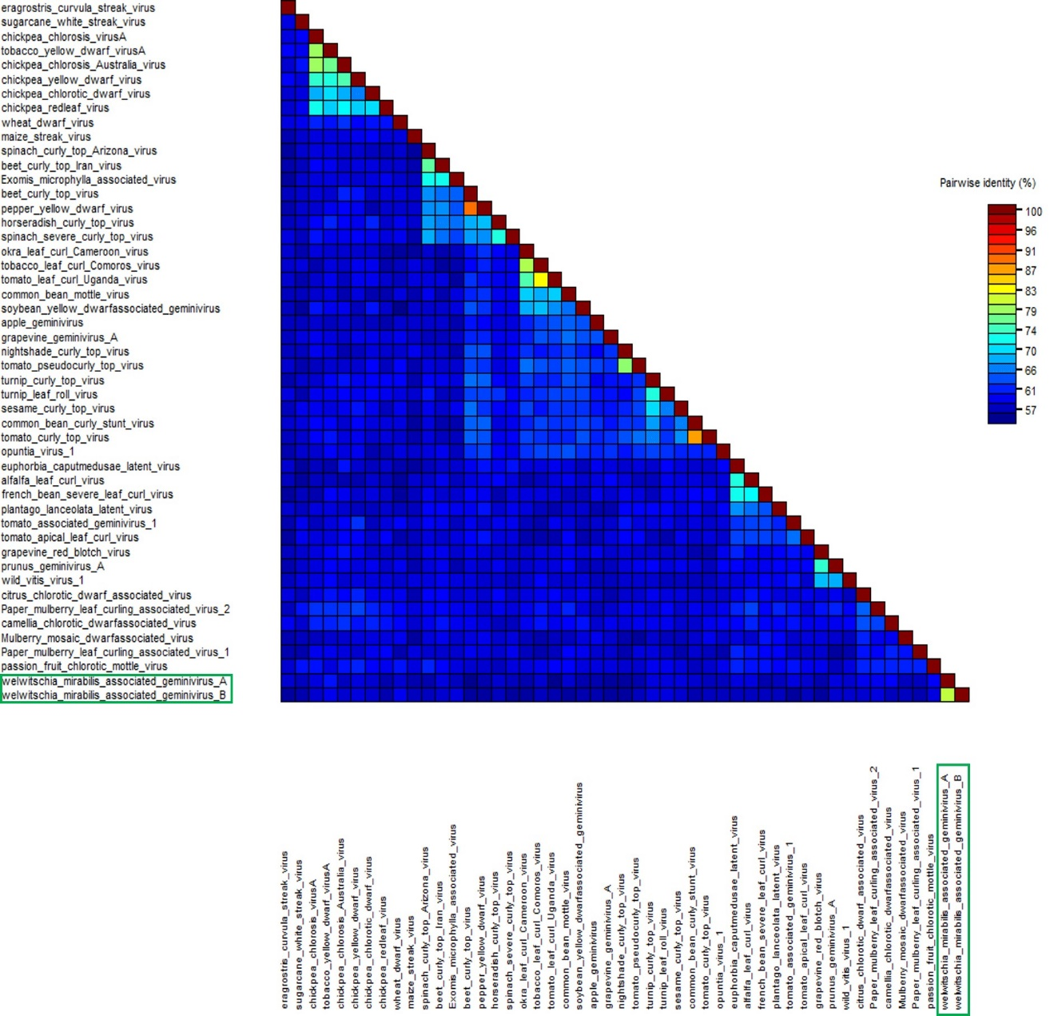

Figure 1. Pairwise identity matrix inferred using SDT v1.2 [4]

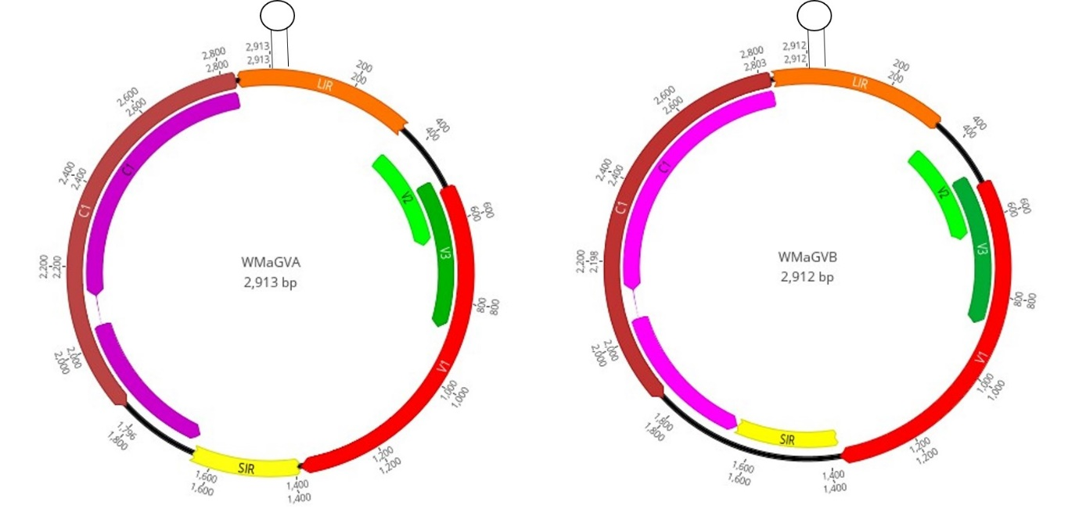
Figure 2. Genome organization of Welwitschia mirabilis associated geminivirus A (WMaGVA) and Welwitschia mirabilis associated geminivirus B (WMaGVB). The hairpin structure containing the putative viral origin of replication is indicated.

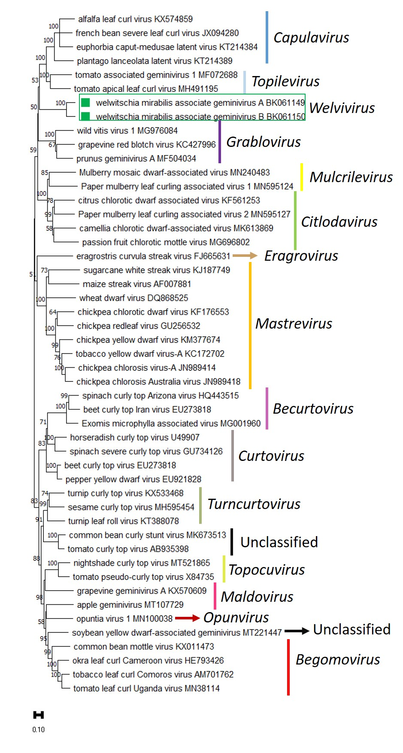
Figure 3. Unrooted neighbour-joining tree inferred from aligned full-genome nucleotide sequences of representative isolates from the various Geminiviridae genera. Numbers at the branches inform bootstrap values. The bar below each tree represents substitutions per site.

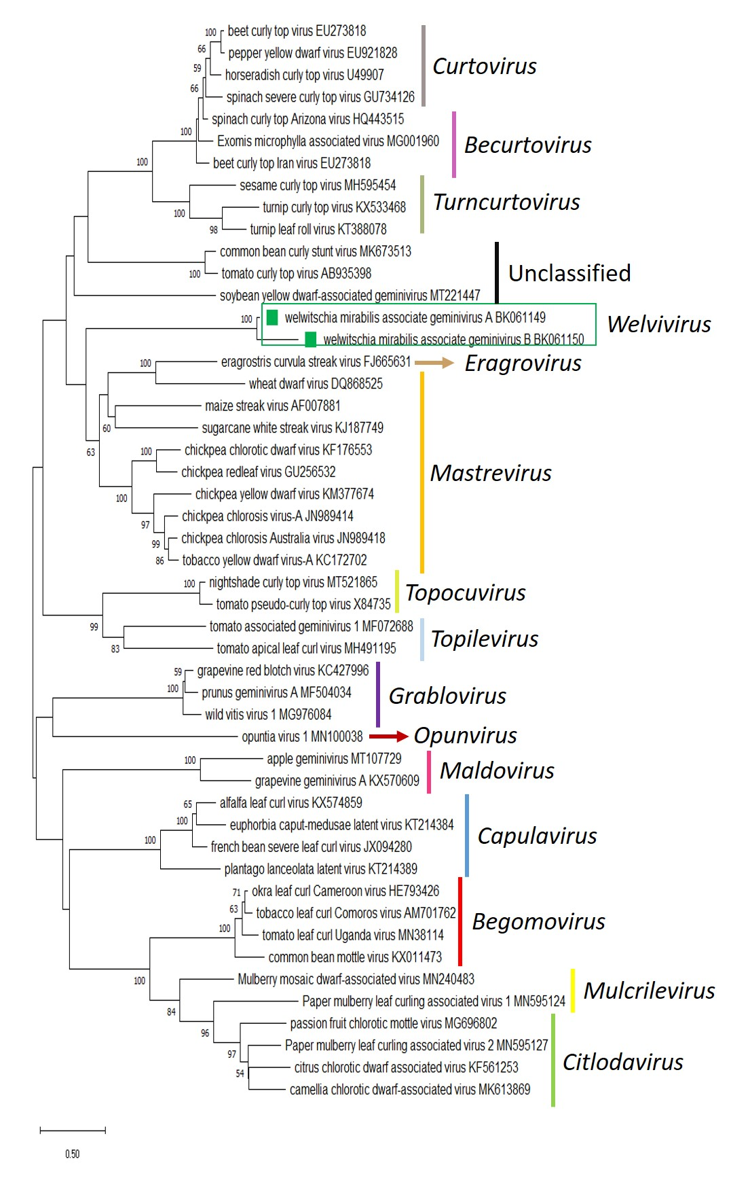
Figure 4. Unrooted Maximum- likelihood phylogenetic tree, applying the rtREV+G+F+I amino acid substitution models for CP of representative Geminiviridae genera. Numbers at the branches inform bootstrap values. The bar below each tree represents substitutions per site.

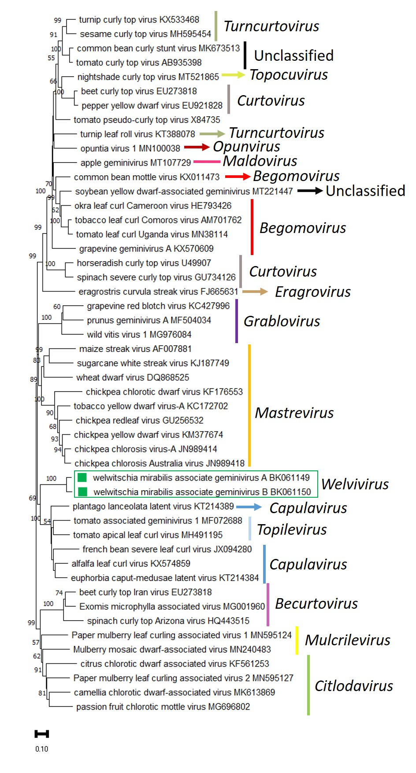
Figure 5. Unrooted Maximum- likelihood phylogenetic tree, applying the rtREV+G+I amino acid substitution models for Rep of representative Geminiviridae genera. Numbers at the branches inform bootstrap values. The bar below each tree represents substitutions per site.

References
- Krupovic M, Varsani A, Kazlauskas D, Breitbart M, Delwart E, Rosario K, Yutin N, Wolf YI, Harrach B, Zerbini FM, Dolja VV, Kuhn JH, Koonin EV (2020) Cressdnaviricota: a virus phylum unifying 7 families of Rep-encoding viruses with single-stranded, circular DNA genomes. J Virol 94:e00582-20
- Fiallo-Olive E, Lett J, Martin D, Roumagnac P, Varsani A, et al (2021) ICTV Virus Taxonomy Profile: Geminiviridae 2021. J Gen Virol 102:001696.
- Debat H, Bejerman N (2022). A glimpse into the DNA virome of the unique “living fossil” Welwitschia mirabilis. Gene 843:146806.
- Roumagnac P, Lett J, Fiallo-Olivé E, Nacas-Castillo J, Zerbini F, Martin D, Varsani A. (2022) Establishment of five new genera in the family Geminiviridae: Citlodavirus, Maldovirus, Mulcrilevirus, Opunvirus, and Topilevirus. Archives of Virology. 167:695-710.
- Muhire BM, Varsani A, Martin DP (2014) SDT: A virus classification tool based on pairwise sequence alignment and identity calculation. PLoS One 9:e108277

