

**Part 1:** **TITLE, AUTHORS, APPROVALS, etc**

|  |  |  |
| --- | --- | --- |
| **Code assigned:** | **2023.017P** |  |
| **Short title:** Create two new species in the genus *Badnavirus* (*Ortervirales*: *Caulimoviridae*), one new species in the genus *Caulimovirus* (*Ortervirales*: *Caulimoviridae*), one new species in the genus *Rosadnavirus* (*Ortervirales*: *Caulimoviridae*), two new species in the genus *Soymovirus* (*Ortervirales*: *Caulimoviridae*) and change exemplar isolate of species *Caulimovirus tesselodahliae*. | | |
|  | | |

**Author(s) and email address(es)**

|  |  |
| --- | --- |
|  |  |
| Pierre Yves Teycheney  Marie Umber | [teycheney@cirad.fr](mailto:teycheney@cirad.fr)  [marie.umber@inrae.fr](mailto:marie.umber@inrae.fr) |

**Author(s) institutional address(es) (optional)**

|  |
| --- |
| CIRAD [PYT]  INRAE [MU] |

**Corresponding author**

|  |
| --- |
| Pierre Yves Teycheney – [teycheney@cirad.fr](mailto:teycheney@cirad.fr) |

**List the ICTV Study Group(s) that have seen this proposal**

|  |
| --- |
| *Caulimoviridae* SG |

**ICTV Study Group comments and response of proposer**

|  |
| --- |
|  |

**ICTV Study Group votes on proposal**

|  |  |  |  |
| --- | --- | --- | --- |
| **Study Group** | **Number of members** | | |
| **Votes support** | **Votes against** | **No vote** |
| *Caulimoviridae* SG |  |  | X |

**Authority to use the name of a living person**

|  |  |
| --- | --- |
| **Is any taxon name used here derived from that of a living person (Y/N)** | N |

**Submission dates**

|  |  |
| --- | --- |
| Date first submitted to SC Chair |  |
| Date of this revision (if different to above) |  |

**ICTV-EC comments and response of the proposer**

|  |
| --- |
|  |

**Part 2:** **NON-TAXONOMIC PROPOSAL**

**Part 3:** **TAXONOMIC PROPOSAL**

**Name of accompanying Excel module**

|  |
| --- |
| 2023.017P.A.v1_Caulimoviridae_6ns |

**Abstract**

|  |
| --- |
| We propose the creation of two new species in the genus *Badnavirus*: *Badnavirus camelliae,* and *Badnavirus tessellopandani*; one new species in the genus *Caulimovirus*: *Caulimovirus puerariae*; one new species in the genus *Rosadnavirus*: *Rosadnavirus maculaviolae*; and two new species in the genus *Soymovirus*: *malvae* and *Soymovirus hibisci*. Complete genomes of the type members of all these proposed new species were sequenced and published recently. We also propose to change the exemplar virus isolate of species *Caulimovirus* *tesselodahliae* following a recent phylogenetic analysis. |

**Text of proposal**

|  |  |
| --- | --- |
| |  | | --- | | 1. **Creating species *Badnavirus camelliae* and *Badnavirus tessellopandani* in the genus *Badnavirus***   *Badnavirus camelliae* can be considered a new species in the genus *Badnavirus* for the following reasons:   1. Its exemplar isolate, Camellia sinensis badnavirus 1 (CSBV1), has a 8,195 bp bp circular double-stranded (ds) DNA genome with an organization typical of members of the genus *Badnavirus* with 3 putative open reading frames (ORF1 to ORF3). Its ORF3 encodes a putative polyprotein containing a conserved zinc knuckle finger and a reverse transcriptase (RT) and RNase H domains [1]. 2. The genome of CSBV1 harbors a putative tRNAMet primer binding site. 3. In phylogenetic analyses using the RT/RH1 domain nucleotide sequence, CSBV1 groups within the genus *Badnavirus* (Fig. 1). Its closest relative is Camellia lemon glow virus (CLGV) (Table 1). 4. CSBV1displays only 76.7% nucleotide (nt) sequence identity with CLGV in the RT/RH1 domain (Table 1), which is below the species demarcation criterion of 80% nt sequence identity, justifying the classification of *Badnavirus camelliae* as a separate species.   *Badnavirus tessellopandani* can be considered a new species in the genus *Badnavirus* for the following reasons:   1. Its exemplar isolate, Pandanus mosaic-associated virus (PMaV), has a 7,481 bp circular double-stranded (ds) DNA genome with an organization typical of members of the genus *Badnavirus* with 3 putative open reading frames (ORF1 to ORF3). Its ORF3 encodes a putative polyprotein with conserved domains including zinc finger, aspartic protease (AP), reverse transcriptase (RT), and RNase H [2]. 2. The genome of PMaV harbors a putative tRNAMet primer binding site. 3. In phylogenetic analyses using the RT/RH1 domain nucleotide sequence, PMaV groups within the genus *Badnavirus* (Fig. 1). Its closest relative is taro bacciliform virus (TaBV) *(*Table 1). 4. PMaV displays only 65.4% nucleotide (nt) sequence identity with TaBV in the RT/RH1 domain (Table 1), which is below the species demarcation criterion of 80% nt sequence identity, justifying the classification of *Badnavirus tessellopandani* as a separate species. 5. **Creating species *Caulimovirus puerariae* in the genus *Caulimovirus***   *Caulimovirus puerariae* can be considered a new species in the genus *Caulimovirus* for the following reasons:   1. Its exemplar isolate, Pueraria virus A (PVA), has a 7,572 bp circular double-stranded (ds) DNA genome with an organization typical of members of the genus *Caulimovirus* with 6 putative open reading frames (ORF1 to ORF6). ORF1 encodes a putative movement protein with two conserved motifs believed to be involved in cell to cell movement of caulimoviruses. ORF2 encodes a putative aphid transmission factor. ORF3 encodes a putative virion-associated protein. ORF4 encodes a putative coat protein with a conserved cysteine motif. ORF5 encodes a putative polyprotein with the conserve motifs of an aspartic protease, reverse transcriptase and RNase H. ORF6 encodes a putative viroplasmin with a conserved transactivator motif [3]. 2. The genome of PVA harbors a tRNAMet primer binding site. 3. In phylogenetic analyses using the RT/RH1 domain nucleotide sequence, PVA groups within the genus *Caulimovirus* (Fig. 1). Its closest relative is Metaplexis yellow mottle-associated virus (MeYMaV) (Table 1). 4. PVA displays only 74.1% nucleotide (nt) sequence identity with MeYMaV in the RT/RH1 domain (Table 1), which is below the species demarcation criterion of 80% nt sequence identity, justifying the classification of *Caulimovirus puerariae* as a separate species. 5. **Creating species *Rosadnavirus maculaviolae* in the genus *Rosadnavirus***   *Rosadnavirus maculaviolae* can be considered a new species in the genus *Rosadnavirus* for the following reasons:   1. Its exemplar isolate, Viola yellow mottle virus (VYMV), has a 9,872 bp circular double-stranded (ds) DNA genome with an organization typical of members of the genus *Rosadnavirus* with 8 putative open reading frames (ORF1 to ORF8). ORF1 encodes a putative movement protein. ORF2 encodes a putative capsid protein with a conserved zinc-finger domain. ORF3 encodes a large putative polyprotein with conserved domains of a peptidase, reverse transcriptase and RNase-H [4]. 2. In phylogenetic analyses using the RT/RH1 domain nucleotide sequence, VYMV groups within the genus *Rosadnavirus* (Fig. 1). Its closest relative is rose yellow vein virus (RYVV)(Table 1). 3. VYMV displays only 57.7% nucleotide (nt) sequence identity with RYVV in the RT/RH1 domain (Table 1), which is below the species demarcation criterion of 80% nt sequence identity, justifying the classification of *Rosadnavirus maculaviolae* as a separate species. 4. **Creating species *Soymovirus hibisci* and *Soymovirus malvae* in the genus *Soymovirus***   *Soymovirus hibisci* can be considered a new species in the genus *Soymovirus* for the following reasons:   1. Its exemplar isolate, Hibiscus soymovirus (HSV), has an 8,143 bp circular double-stranded (ds) DNA genome with an organization typical of members of the genus *Soymovirus* with 10 putative open reading frames (ORF1 to ORF10). HSV ORF6 encodes a putative viral replicase with the conserved domains of a reverse transcriptase (RT) and ribonuclease H (RNase H) [5]. 2. In phylogenetic analyses using the RT/RH1 domain nucleotide sequence, HSV groups within the genus *Soymovirus* (Fig. 1). Its closest relative is peanut chlorotic streak virus (PCSV;Table 1). 3. HSV displays only 66.2% nucleotide (nt) sequence identity with PCSV in the RT/RH1 domain, which is below the species demarcation criterion of 80% nt sequence identity, justifying the classification of *Soymovirus hibisci* as a separate species.   *Soymovirus malvae* can be considered a new species in the genus *Soymovirus* for the following reasons:   1. Its exemplar isolate, Malva-associated soymovirus 1 (MaSV1), has an 8,391 bp circular double-stranded (ds) DNA genome with an organization typical of members of the genus *Soymovirus* with 8 putative open reading frames (ORF1 to ORF8), although the genome of MaSV1 displays some features of members of genus *Caulimovirus*, such as a large intergenic region between ORFs 6 and 7 and no intergenic region between ORFs 5 and 6 [6]. ORF1 encodes a putative movement protein. ORF4 encodes a putative coat protein. ORF5 encodes a large putative polyprotein with conserved domains of a peptidase, a reverse transcriptase and a RNaseH. ORF6 encodes a putative transactivator protein [6]. 2. The genome of MaSV1 harbors a tRNAMet primer binding site. 3. In phylogenetic analyses using the RT/RH1 domain nucleotide sequence, MaSV1 groups within the genus *Soymovirus* (Fig. 1). Its closest relative is soybean chlorotic mottle virus (SbCMV;Table 1). 4. MaSV1 displays only 54.7% nucleotide (nt) sequence identity with SbCMV in the RT/RH1 domain (Table 1), which is far below the species demarcation criterion of 80% nt sequence identity, justifying the classification of *Soymovirus malvae* as a separate species. 5. **Changing the exemplar isolate of species *Caulimovirus dahliae***   A sequencing error was identified in the genome sequence of the exemplar isolate of species *Caulimovirus tesselodahliae* (Dahlia mosaic virus, isolate DMV-Portland, (GenBank accession number JX272320.1) [7]. Consequently, an alternative virus isolate should be nominated as the exemplar for this species. Dahlia common mosaic virus (DCMV) isolate JP (GenBank accession number LC625373) should be recognized as the exemplar isolate for species *Caulimovirus tesselodahliae* for the following reasons:   1. DCMV is a clonal lineage of Dahlia mosaic virus [7]. 2. The complete genome sequence of DCMV-JP takes precedence over that of other DCMV / DMV isolates. 3. DCMV-JP is the only isolate of species *Caulimovirus tesselodahliae* for which Koch’s postulates of pathogenicity have been satisfied through use of an infectious clone. | |

**Supporting evidence**

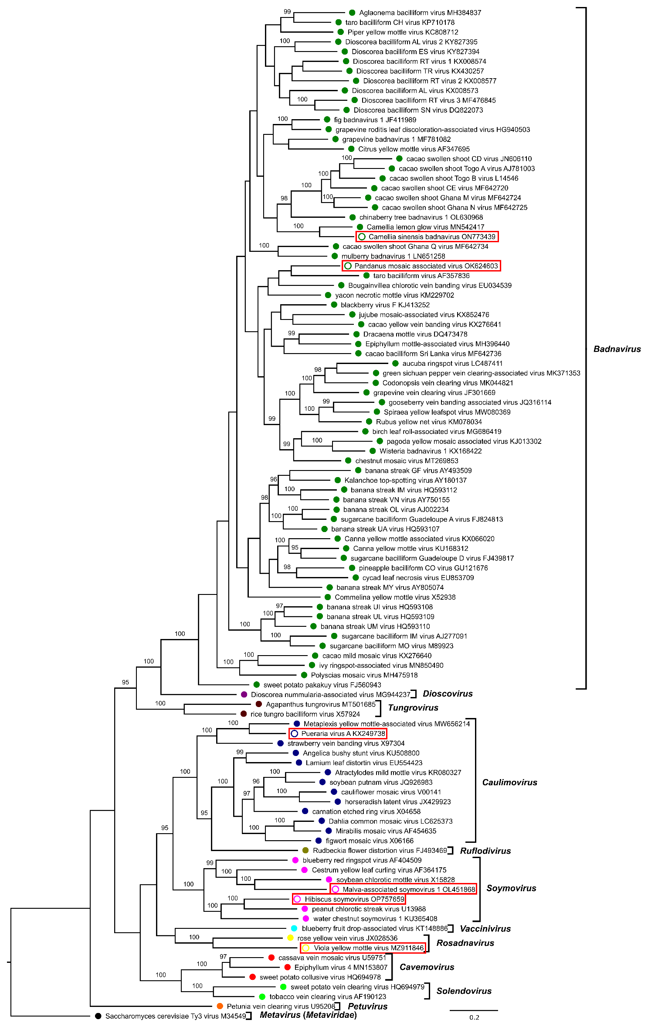

**Figure 1: Phylogenetic tree showing placement of Camellia sinensis badnavirus 1 (CSBV1; species *Badnavirus camelliae)*, Pandanus mosaic associated virus (PMaV, species** ***Badnavirus tessellopandani*), Pueraria virus A (PVA, species *Caulimovirus puerariae*), Viola yellow mottle virus (VYMV, species *Rosadnavirus maculaviolae*), Malva-associated soymovirus 1 (MaSV1, species *Soymovirus malvae*) and Hibiscus soymovirus (HSV, species *Soymovirus hibisci*).**

Maximum likelihood phylogenetic tree showing the relationships between sequences of viruses from the different genera in the family Caulimoviridae. Phylogenetic analyses were performed on the coding part of polymerase gene sequences of exemplar virus isolates of each viral species, corresponding to nucleotide positions 3741–5654 in the genome of cauliflower mosaic virus (V00141). Nucleotide sequence alignment was generated using MAFFT and phylogenetic analyses was done using IQTree v. 1.7 beta with HKY model. Support values above 95% from UltraFast bootstrap method with 10,000 replicates are shown above nodes. Saccharomyces cerevisiae Ty3 virus (genus Metavirus, family Metaviridae) was used as an outgroup. Colored dots indicate genera, with open circles indicating unclassified viruses in a genus. Type members of the proposed new species are shown with open circles and in red boxes.

**Table 1: Percent nucleotide identities for the *Caulimoviridae* in *pol* gene nucleotide sequences.**

Figures corresponding to type members of the proposed new species are highlighted in orange.



**References**

[1] Wang F, Zhu J, Zhu Y, Yan D, Dong Q, Jegede OJ, Wu Q. Complete genome sequence of a new badnavirus infecting a tea plant in China. *Arch Virol*. 2022 Dec;167(12):2811-2815. doi: 10.1007/s00705-022-05592-7. PMID: **36269416**

[2] Alvarez-Quinto RA, Grinstead S, Rott P, Mollov D. Genome characterization and complete sequence of a new badnavirus from *Pandanus amaryllifolius*. *Arch Virol.* 2022 Aug;167(8):1717-1720. doi: 10.1007/s00705-022-05480-0. PMID: **3561051**

[3] Gudeta WF, Igori D, Belete MT, Kim SE, Moon JS. Complete genome sequence of pueraria virus A, a new member of the genus *Caulimovirus*. *Arch Virol.* 2022 Jun;167(6):1481-1485. doi: 10.1007/s00705-022-05431-9. PMID: **35451686**

[4] Yang C, Zhang S, Sun J, Wang J, Zhang S, Cao M. Complete genome sequence of a distinct rosadnavirus isolated from *Viola* plants in China. *Arch Virol*. 2022 Feb;167(2):607-609. doi: 10.1007/s00705-021-05316-3. PMID: **34988695**

[5] Wang X, Larrea-Sarmiento AE, Olmedo-Velarde A, Kong A, Borth W, Suzuki JY, Wall MM, Melzer MJ, Hu J. First Detection and Genome Characterization of a New RNA Virus, Hibiscus Betacarmovirus, and a New DNA Virus, Hibiscus Soymovirus, Naturally Infecting *Hibiscus* spp. in Hawaii. *Viruses*. 2022 Dec 29;15(1):90. doi: 10.3390/v15010090. PMID: **36680129**

[6] Maachi A, Hernando Y, Aranda MA, Donaire L. Complete genome sequence of malva-associated soymovirus 1: a novel virus infecting common mallow. *Virus Genes*. 2022 Aug;58(4):372-375. doi: 10.1007/s11262-022-01900-0. PMID: **35471489**

[7] Geering ADW, McTaggart AR, Teycheney PY. Untangling the taxonomy of dahlia mosaic virus. *Arch Virol.* 2022 Nov;167(11):2325-2329. doi: 10.1007/s00705-022-05567-8. PMID: **35969294**