

**Part 1:** **TITLE, AUTHORS, APPROVALS, etc**

|  |  |  |
| --- | --- | --- |
| **Code assigned:** | **2023.031P** |  |
| **Short title:** Create a new species in the genus *Apscaviroid* (*Pospiviroidae*) | | |
|  | | |

**Author(s) and email address(es)**

|  |  |
| --- | --- |
| Chiumenti M, Navarro B, Di Serio F | michela.chiumenti@ipsp.cnr.it;  [beatriz.navarro@ipsp.cnr.it](mailto:beatriz.navarro@ipsp.cnr.it);  [francesco.diserio@ipsp.cnr.it](mailto:francesco.diserio@ipsp.cnr.it) |

**Author(s) institutional address(es) (optional)**

|  |
| --- |
| Istituto per la Protezione Sostenibile delle Piante, Consiglio Nazionale delle Ricerche, Via Amendola 122/D, 70122 - Bari, Italy |

**Corresponding author**

|  |
| --- |
| Francesco Di Serio ([francesco.diserio@ipsp.cnr.it](mailto:francesco.diserio@ipsp.cnr.it)) |

**List the ICTV Study Group(s) that have seen this proposal**

|  |
| --- |
| *Avsunviroidae* and *Pospiviroidae* Study Group |

**ICTV Study Group comments and response of proposer**

|  |
| --- |
|  |

**ICTV Study Group votes on proposal**

|  |  |  |  |
| --- | --- | --- | --- |
| **Study Group** | **Number of members** | | |
| **Votes support** | **Votes against** | **No vote** |
| *Avsunviroidae* and *Pospiviroidae* | 6 | 0 | 1 |
|  |  |  |  |

**Authority to use the name of a living person**

|  |  |
| --- | --- |
| **Is any taxon name used here derived from that of a living person (Y/N)** | N |

|  |  |  |
| --- | --- | --- |
| **Taxon name** | **Person from whom the name is derived** | **Permission attached (Y/N)** |
|  |  |  |
|  |  |  |
|  |  |  |

**Submission dates**

|  |  |
| --- | --- |
| Date first submitted to SC Chair | June 23, 2023 |
| Date of this revision (if different to above) |  |

**ICTV-EC comments and response of the proposer**

|  |
| --- |
|  |

**Part 2:** **NON-TAXONOMIC PROPOSAL**

**Text of proposal**

|  |
| --- |
|  |

**Part 3:** **TAXONOMIC PROPOSAL**

**Name of accompanying Excel module**

|  |
| --- |
| 2023.031P.A.v2.Pospiviroid_1nsp |

**Abstract**

|  |
| --- |
| A new viroid fulfils the criteria to be classified as a member of a new species in the genus *Apscaviroid.* Here we propose to create the species *Apscaviroid japanvitis* to classify Japanese grapevine viroid reported in grapevine in Japan. |

**Text of proposal**

|  |  |
| --- | --- |
| |  | | --- | | Japanese grapevine viroid (JGVd) was discovered in grapevine in Japan [1], where it has been identified through high-throughput sequencing technology. The JGVd genome sequence consists of 367 nt (GenBank accession No. LC500206) with a high G+C content (60.8%), a feature typical of most viroids. The RNA adopts a compact predicted rod-like secondary structure, with most (90%) paired nucleotides, that contains the typical central conserved region (CCR) reported for all members of the genus *Apscaviroid.* The CCR and the flanking imperfect inverted repeat sequences form the typical hairpin I likely involved in replication of apscaviroids. Moreover, the terminal conserved region, observed in members of the genera *Apscaviroid*, *Pospiviroid*, and *Coleviroid*, is also present in the JGVd rod-like secondary structure [1]. JGVd is clustered in the genus *Apscaviroid*, close to Persimmon viroid (PVd), in a Maximum likelihood phylogenetic tree based on an alignment including the sequences of representative members of all viroid species in the family *Pospiviroidae.* Altogether these data support that JGVd is to be considered as a new species in the genus *Apscaviroid*.  The current ICTV species demarcation criteria for the genus *Apscaviroid* (https://ictv.global/ictv/proposals/2021.015P.R.Viroid_demarcation_criteria.pdf) establish that “Viroids with rod-like or quasi rod-like conformation, with the TCR, with the CCR identical to that of members of the other species of the genus and with less than 78% pairwise sequence identity with respect to the members of the genus are classified in different species. For viroids with pairwise identity scores close to 78% evidence of distinct biological properties should be provided.”  According with the sequence identity matrix calculated considering all the members of the genus *Apscaviroid* [2], JGVd has the highest pairwise sequence identity of 60.8% with a variant of PVd, thus showing values below the threshold identity score of 78% established by ICTV (Fig. 2).  Since JGVd fulfils all the criteria established by ICTV to create a new species in the genus *Apscaviroid,* we propose to create the species *Apscaviroid japanvitis* to classify this viroid in this genus*.*  **Origin of the name of the species**: The species name *japanvitis* derives from the country (Japan) and the host (grapevine in the genus *Vitis*) in which the viroid has been identified. | |

**Supporting evidence**



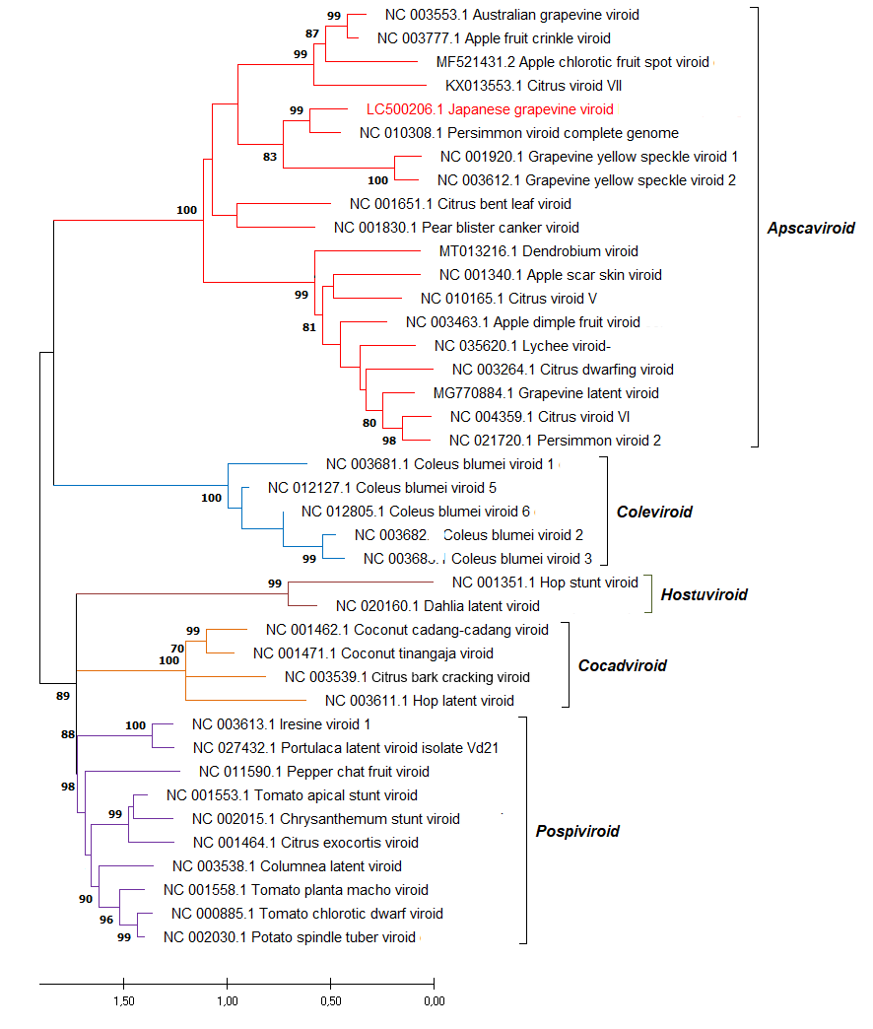

**Figure 1**

Maximum likelihood phylogenetic tree inferred with the reference variants of the species currently established by ICTV in the five genera of the family *Pospiviroidae* and Japanese grapevine viroid (in red). Bootstrap values >70 % (generated by 1,000 replicates) are shown at nodes. The tree is drawn to scale, with branch lengths measured in the number of substitutions per site.

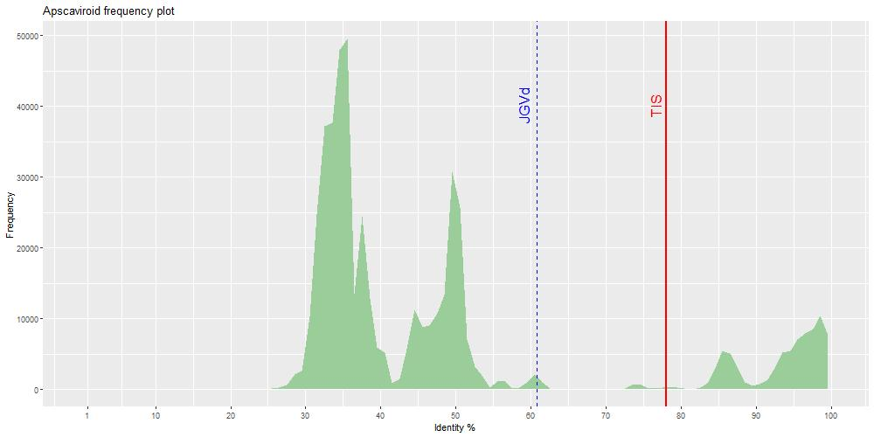

**Figure 2.**

Distribution of PWISs between full-length sequence variants of viroids classified in the genus *Apscaviroid* (family *Pospiviroidae*). The threshold identity score (TIS) proposed as a species demarcation criterion for the genus *Apscaviroid* (78%) is indicated by a red, vertical line. The maximum pairwise identity score (60,8%) calculated for Japanese grapevine viroid (JGVd) is marked by a blue, broken, vertical line.

**References**

1. Chiaki Y, Ito T (2020) Characterization of a distinct variant of hop stunt viroid and a new apscaviroid detected in grapevines. Virus Genes 56:260-265. doi: 10.1007/s11262-019-01728-1. PMID: 31916137.
2. Chiumenti M, Navarro B, Candresse T, Flores R, Di Serio F (2021) Reassessing species demarcation criteria in viroid taxonomy by pairwise identity matrices. Virus Evol. 7:veab001. doi: 10.1093/ve/veab001. PMID: 33623708; PMCID: PMC7887442.