Part 1: TITLE, AUTHORS, APPROVALS, etc

Code assigned: | 2023.023P
Short title: Establish a new species in the genus Nanovirus (family Nanoviridae)

Author(s) and email address(es)
Heydarnejad J, Gronenborn B, Varsani A, | heydarnejad@uk.ac.ir;  bgronenborn@gmail.com;  Arvind.varsani@asu,edu
Author(s) institutional address(es) (optional)

Department of Plant Protection, College of Agriculture, Shahid Bahonar University of Kerman, Kerman 7616914111, Iran [JH]
Im Broich 38, 50128 Bergheim-Fliesteden, Germany [BG]
The Biodesign Center of Fundamental and Applied Microbiomics, School of Life Sciences, Center for Evolution and Medicine, Arizona State University, 1001 S. McAllister Ave, Tempe, AZ 85287-5001, USA [AV]

Corresponding author
A. Varsani (Arvind.Varsani@asu.edu)

List the ICTV Study Group(s) that have seen this proposal

Nanoviridae SG

ICTV Study Group comments and response of proposer

ICTV Study Group votes on proposal

Study Group | Number of members
 | Votes support | Votes against | No vote
Nanoviridae | 10/12 | 0/12 | 2/12
Authority to use the name of a living person

Is any taxon name used here derived from that of a living person (Y/N) | N

Taxon name | Person from whom the name is derived | Permission attached (Y/N)

Submission dates
Date first submitted to SC Chair | 19th June 2023
Date of this revision (if different to above)
ICTV-EC comments and response of the proposer
Part 2: NON-TAXONOMIC PROPOSAL
Text of proposal

Part 3: TAXONOMIC PROPOSAL
Name of accompanying Excel module
2023.023P.A.v1_Nanovirus_1nsp.xlsx
Abstract

Milk vetch chlorotic dwarf virus was identified in Iran from two symptomatic milk vetch (Astragalus myriacanthus Boiss.) samples (sample ID G50 and G53; sampled in 2018) showing marginal leaf chlorosis, reduced leaf size and dwarfing symptoms. These two nanoviruses represent a new species in the family Nanoviridae.

Text of proposal
A new nanovirus, milk vetch chlorotic dwarf virus (MVCDV), was identified in Iran from two symptomatic milk vetch (Astragalus myriacanthus Boiss.) samples (sample ID G50 and G5). These were sampled in 2018 from Nafech in Chaharmahal and Bakhtiari province of central Iran, and showed marginal leaf chlorosis, small leaves and dwarfing symptoms [1].

Each genome component of the G50 and G53 share 84.4 - 99.7% pairwise identity, determined using SDT v1.2 [2] with the counterpart component sequences. The genomes (concatenated component sequences) of MVCDV share 62.2-74.7% pairwise identity with all other nanoviruses (Figure 1). The CPs encoded by DNA-S of MVCDV share 78.6-85.0% amino acid sequence identity with those of black medic leaf roll virus (BMLRV) and 44-62% with those of all others nanovirus CPs.

The species demarcation threshold for nanoviruses proposed by the ICTV Nanoviridae Study group [3-4] is >15% divergence in the CP amino acid sequence and/or nucleotide pairwise identity of overall genomes <75% when compared to other nanoviruses.

The genome of MVCDV and that of BMLRV is close to 75% and the CP amino acid identity is <85%, both of which are close to the new species demarcation limits. The phylogenetic analysis (Figure 2) of the individual components coupled with the pairwise identity analysis supports the establishment of a new species to accommodate MVCDV.

To conform with the binominal species names [5], we propose the name Nanovirus astragalirani (epithet is a contraction of host genus name Astragalus and Iran). The exemplar virus in this new species is milk vetch chlorotic dwarf virus isolate G53 with the following accession numbers:
DNA-U4: MN273339
DNA-U2: MN273338
DNA-U1: MN273337
DNA-R: MN273336
DNA-N: MN273335
DNA-M: MN273334
DNA-S: MN273333
DNA-C: MN273332

Supporting evidence

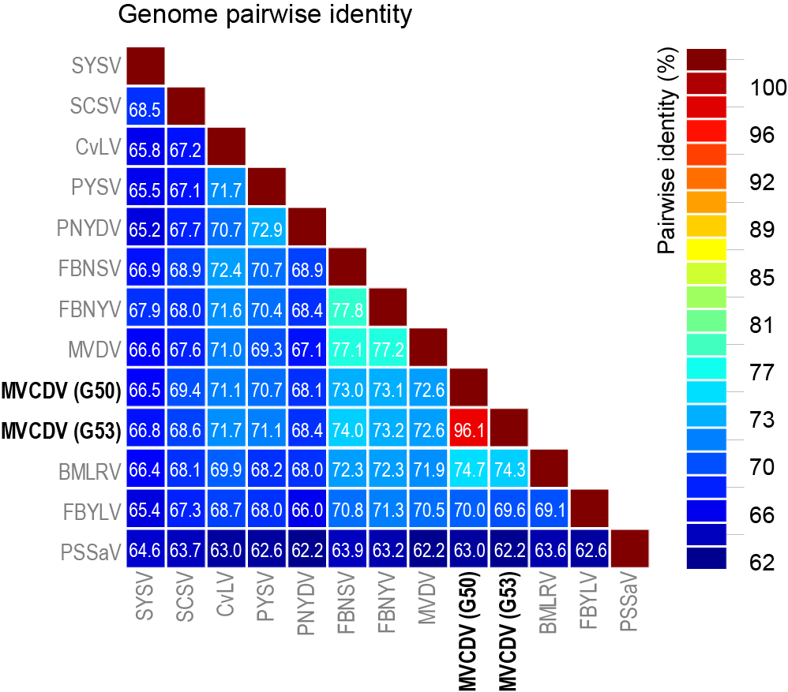
Black medic leaf roll virus – BMLRV
Cow vetch latent virus – CvLV
Faba bean necrotic stunt virus – FBNSV
Faba bean necrotic yellows virus – FBNY
Faba bean yellow leaf virus – FBYLV
Milk vetch chlorotic dwarf virus – MVCDV
Milk vetch dwarf virus – MVDV
Pea necrotic yellow dwarf virus, – PNYDV
Parsley severe stunt associated virus – PSSaV
Pea yellow stunt virus – PYSV
Subterranean clover stunt virus – SCSV
Sophora yellow stunt virus – SYSV

Figure 1: Pairwise identity matrix of the genome (concatenated component sequences) of representative nanoviruses determine using SDT v1.2 [2]. Figure adapted from Hassan-Sheikhi et al., [1].
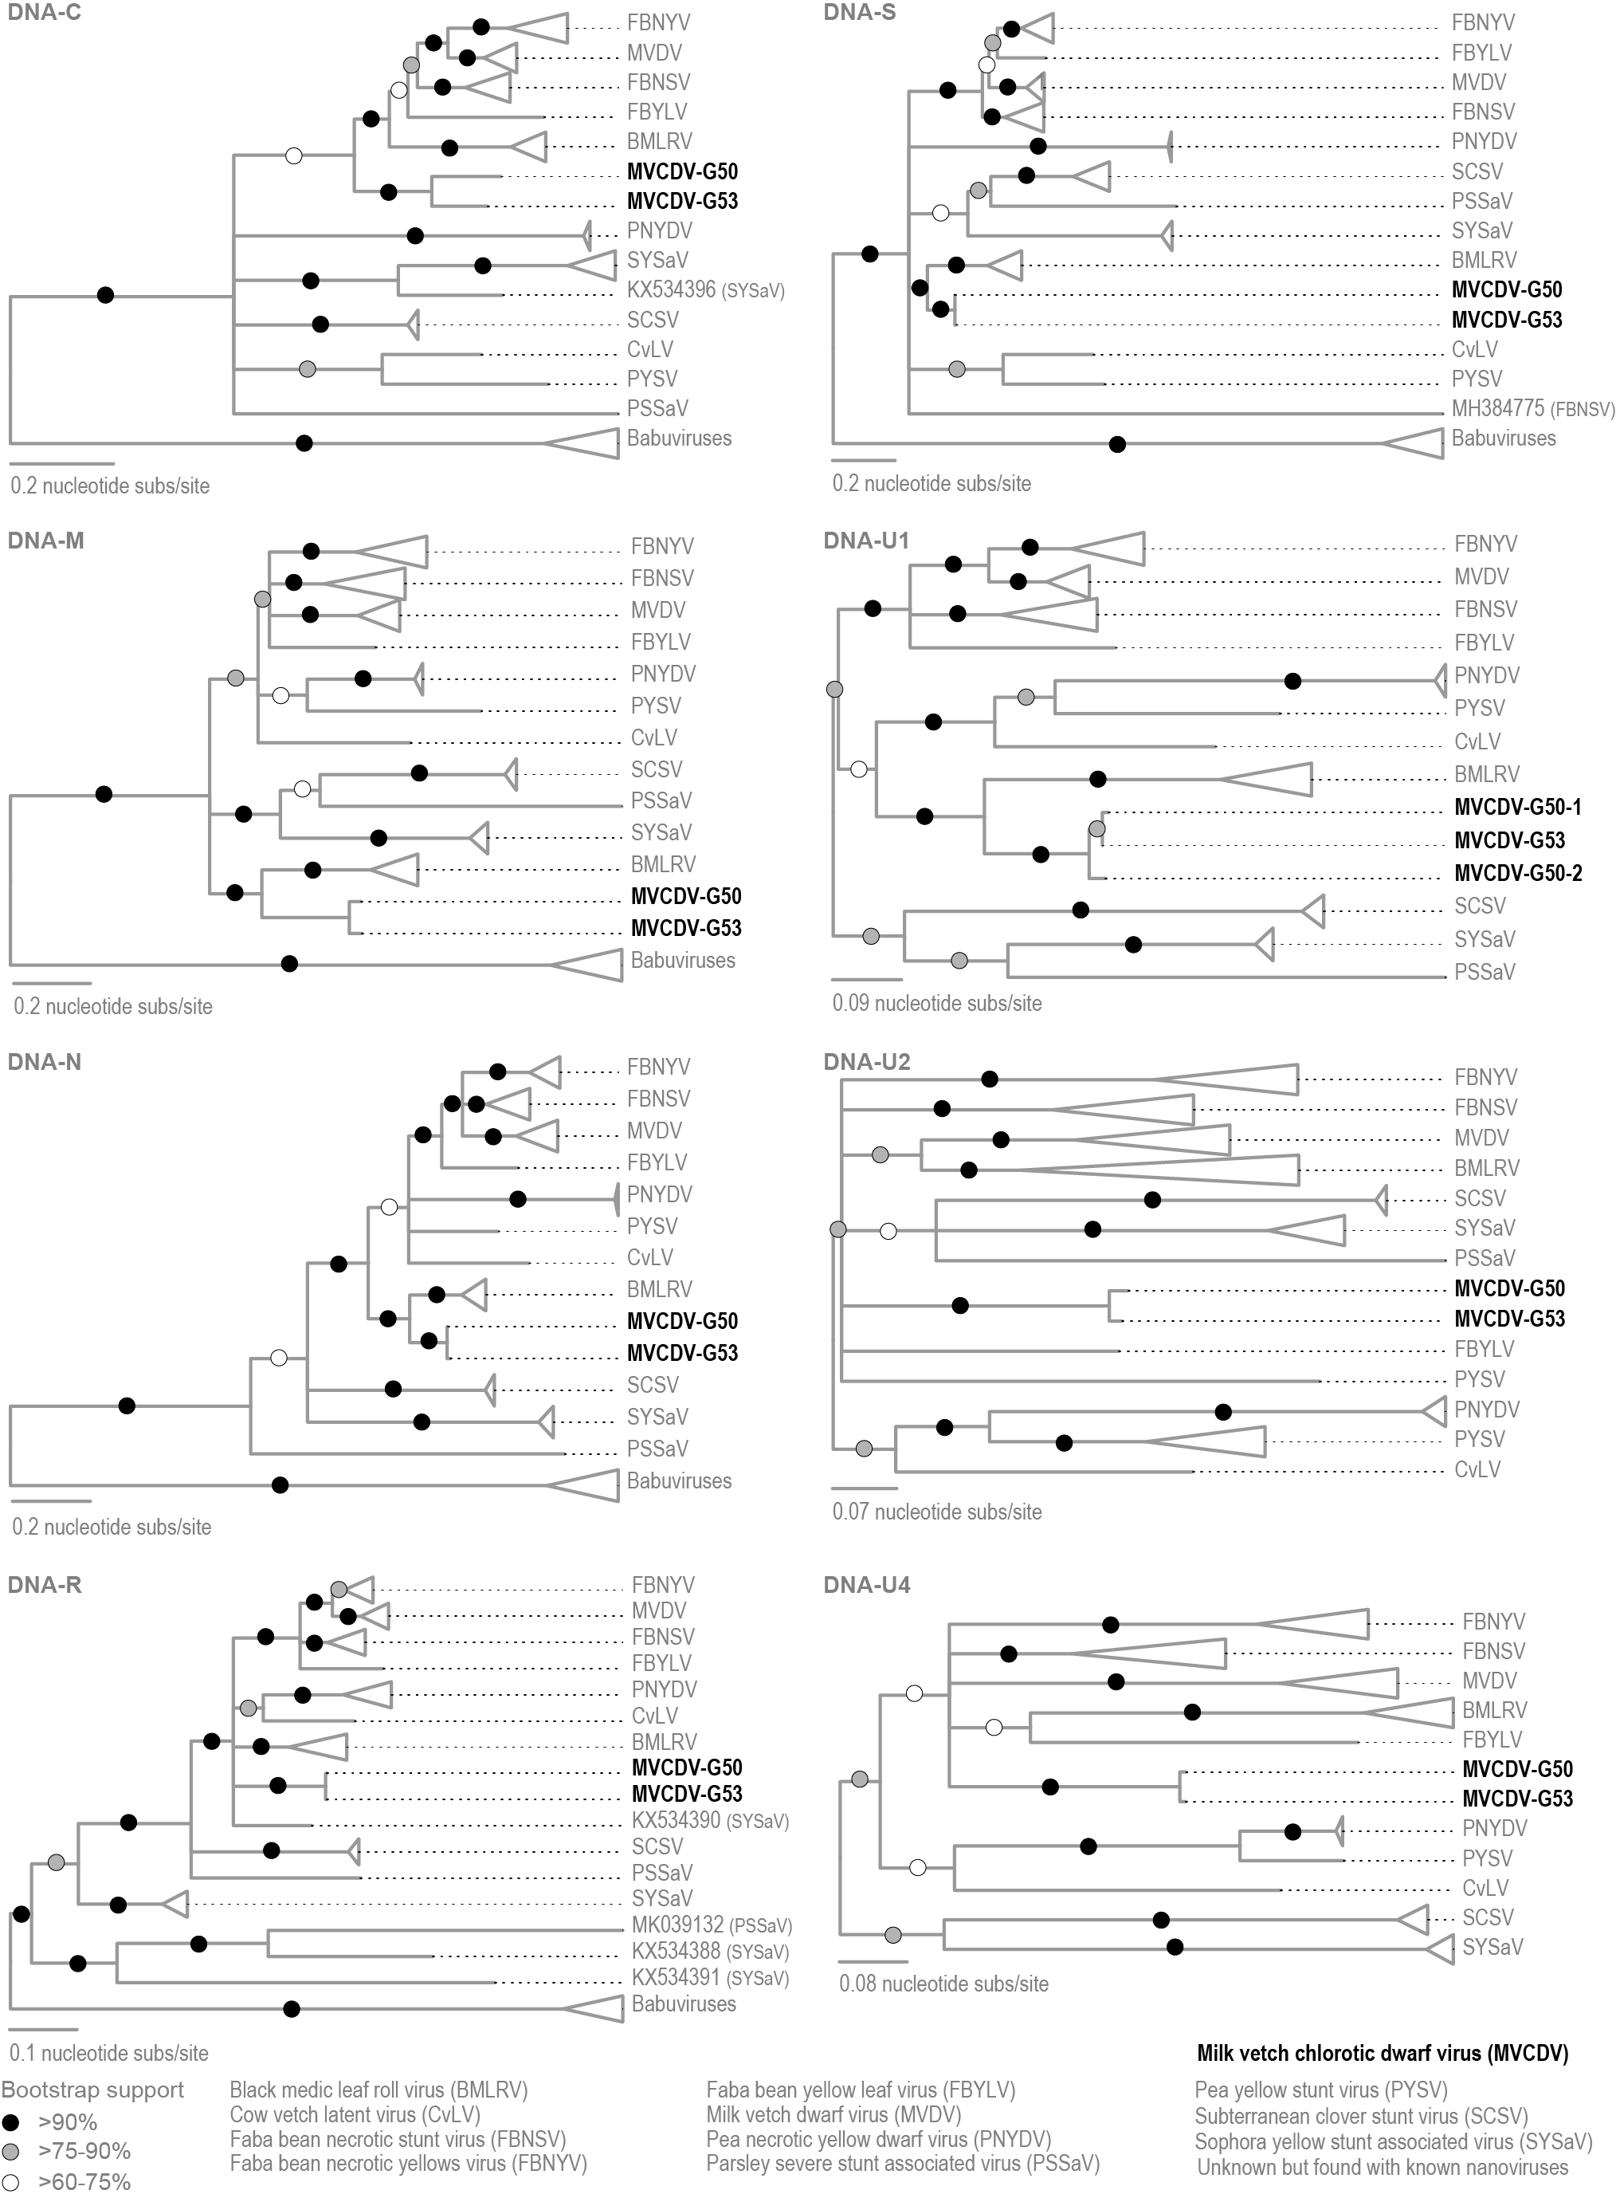

Figure 2: Maximum likelihood phylogenetic trees, inferred using PhyML [6] of MVCDV component nucleotide sequences and rooted with babuvirus sequences except for those of DNA-U1, DNA-U2 and DNA-U4 which are midpoint rooted. Figure adapted from Hassan-Sheikhi et al. [1].

References
- Hassan-Sheikhi P, Heydarnejad J, Massumi H, Kraberger S, Varsani A. 2020. Novel nanovirus and associated alphasatellites identified in milk vetch plants with chlorotic dwarf disease in Iran. Virus Res. 276: 197830. PMID: 31790775 DOI: 10.1016/j.virusres.2019.197830
- Muhire BM, Varsani A, Martin DP (2014) SDT: a virus classification tool based on pairwise sequence alignment and identity calculation. PLoS One 9:e108277. PMID: 25259891; DOI: 10.1371/journal.pone.0108277
- Thomas JE, Gronenborn B, Harding RM, Mandal B, Grigoras I, Randles JW, Sano Y, Timchenko T, Vetten HJ, Yeh H-H, Ziebell H, ICTV report consortium. (2021) ICTV virus taxonomy profile: Nanoviridae. Journal of General Virology, 102, 001544. PMID: 33433311 PMCID: PMC8515864 DOI: 10.1099/jgv.0.001544
- Vetten HJ, Dale JL, Grigoras I, Gronenborn B, Harding R, Randles JW, Sano Y, Thomas JE, Timchenko T, Yeh HH, 2012. Nanoviridae. In: King AMQ, Adams MJ, Carstens EB, Lefkowitz EJ (Eds.), Virus Taxonomy. Elsevier, San Diego, pp. 395-404.
- Siddell SG, Walker PJ, Lefkowitz EJ, Mushegian AR, Dutilh BE, Harrach B, Harrison RL, Junglen S, Knowles NJ, Kropinski AM, Krupovic M, Kuhn JH, Nibert ML, Rubino L, Sabanadzovic S, Simmonds P, Varsani A, Zerbini FM, Davison AJ (2020) Binomial nomenclature for virus species: a consultation. Arch Virol 165:519-525. PMID: 31797129; DOI: 10.1007/s00705-019-04477-6
- Guindon S, Dufayard JF, Lefort V, Anisimova M, Hordijk W, Gascuel O (2010) New algorithms and methods to estimate maximum-likelihood phylogenies: assessing the performance of PhyML 3.0. Syst Biol 59:307-321. PMID: 20525638; DOI: 10.1093/sysbio/syq010

