Part 1: TITLE, AUTHORS, APPROVALS, etc

Code assigned: | 2023.022P
Short title: Create forty-seven species in the genus Polerovirus (Sobelivirales:Solemoviridae)
Author(s) and email address(es)
Sõmera M | merike.somera@taltech.ee
Corresponding author
Merike Sõmera merike.somera@taltech.ee
List the ICTV Study Group(s) that have seen this proposal
Solemoviridae SG

ICTV Study Group comments and response of proposer
ICTV Study Group votes on proposal
Study Group | Number of members
 | Votes support | Votes against | No vote
Solemoviridae SG | 4 |  | 0
Authority to use the name of a living person
Is any taxon name used here derived from that of a living person (Y/N) | N

Taxon name | Person from whom the name is derived | Permission attached (Y/N)

Submission dates
Date first submitted to SC Chair | June 22, 2023
Date of this revision (if different to above)
ICTV-EC comments and response of the proposer
Following the EC request to reconsider the use of acronyms as species epithets, the Study Group confirmed the decision of using the acronyms as species epithets.

Part 3: TAXONOMIC PROPOSAL
Name of accompanying Excel module
2023.022P.Uc.v1.Polerovirus_47nsp
Abstract
A search in the NCBI GenBank revealed approx. 50 new viruses complete or near-complete sequences belonging to the viruses which tentatively belong to the genus Polerovirus. Analysis of their host range data and comparison of their most conserved RNA-directed RNA polymerases (RdRPs) aa sequences confirms that 47 viruses can be recognized as the novel species in the genus Polerovirus.

The growing number of sequenced genomes is providing a basis to set and specify the numeric values for the species demarcation criteria. We propose the following sequence-based changes to complement the existing rules:

- Differences in amino acid sequence identity of RdRPs of greater than 10%;
- Differences in nucleotide sequence identity of genomes around or greater than 25%

Text of proposal
Poleroviruses are a genetically diverse group of viruses that share several distinct characteristics:
- transmission by aphids in a persistent circulative and non-propagative manner, being highly dependent on interactions between the virus and the aphid vector;
- phloem-limited spread in the plant, lack of mechanical transmission;
- a high degree of vector specificity;
- close serological relationships between most members;
- virions are isometric, 25 to 30 nm in size;
- their genome is a single-stranded (ss) positive-sense RNA molecule of approximately 5.6 to 6.2 kb with a small genome-linked protein (VPg) covalently attached to the 5′ end of the genomic RNA (Fig. 1);
- ORF0 encodes a viral suppressor protein;
- ORF1 encodes a polyprotein that is proteolytically processed to several domains, including a serine protease and a VPg;
- ORF2 encodes a viral RdRP;
- ORF3a encodes a systemic movement protein and is translated via recognition of non-AUG initiation codon (because of that, it is annotated rather rarely);
- ORF3 encodes a viral capsid protein (CP);
- ORF4 is encoded within ORF3 in an alternate reading frame, and it encodes a viral movement protein;
- ORF5 encodes a read-through domain protein (RTD) via suppression of ORF3 stop codon, functioning as a viral phloem-limiting movement protein, and an aphid-transmission factor;
- additional ORFs can exist but not in all poleroviral genomes;
- polerovirus genomes are prone to recombination, therefore, many species are risen via modular evolution.

Fig.1. Typical genome organization of polerovirus genome.

The current list of poleroviruses includes twenty-nine species. The availability of high-throughput sequencing technologies has accelerated the discovery of new species during the last decade. Our search in the NCBI GenBank database has revealed additional tentative species that could be belonging to the genus Polerovirus but are not yet recognized by the ICTV. Most of these new viruses considered in this proposal have the complete or near-complete genomes sequenced, and these genomes show a genome organization characteristic of poleroviruses.

The species demarcation criteria for the genus Polerovirus are the following:

• Differences in breadth and specificity of host range;
• Failure of cross-protection in either one-way or two-way relationships;
• Differences in serological specificity with discriminatory polyclonal or monoclonal antibodies;
• Differences in amino acid sequence identity of any gene product of greater than 10%.

Given herein below, we have reviewed the descriptions of the tentative new species and aligned the nucleotide sequences of genomes and amino acid sequences of their RNA-directed RNA polymerases (RdRPs; encoded by the most conserved ORF) translated from ORF2 starting with a ribosomal frameshift site to evaluate their consistency to be accepted as the new species in the genus Polerovirus. The heatmaps on identity percentages generated from these alignments can be found in the section of Supporting Evidence (Table 1 and Table 2).

The descriptions of these new species candidates are given as follows:

African eggplant yellowing virus (AeYV) was identified from African eggplant (Solanum aethiopicum) samples from Bamako, Mali in 2009 using HTS. Assembled genome (KX856972) is composed of 5953 nt, and has a genome organization characteristic of poleroviruses. The genome ends were verified by RACE (Afouda et al 2017). MUSCLE multiple sequence alignment of poleroviral RdRPs reveals the highest identity percentage (81%) of AeYV to tentative new species, pepper whitefly borne vein yellow virus (PeWBVYV; MK333461). Thus, the recognition of AeYV as a member of Polerovirus AEYV is consistent with the species demarcation criteria in the genus Polerovirus.
Allium polerovirus (APVA) was identified from elephant garlic (Allium ampeloprasum) samples from an experimental area in the municipality of Rio do Sul, State of Santa Catarina, Brazil in 2021 using HTS. The sequence is missing a genome 3´-end, encoding the readthrough protein. Partially assembled genome (ON565072) is composed of 4367 nt, and in that part, it has a genome organization characteristic of poleroviruses (Santos et al 2022). MUSCLE multiple sequence alignment of poleroviral RdRPs reveals the highest identity percentage (67.8%) of APVA to turnip yellows virus. Thus, the recognition of APVE as a member of Polerovirus APVE is consistent with the species demarcation criteria in the genus Polerovirus.
Artemisia virus B (ArtVB) was identified from Japanese mugwort (Artemisia princeps) samples from Buyeo-gun county, Chungcheongnam-do (South Korea) in 2016 using HTS. Assembled genome (MT757161) is composed of 6141 nt and has a genome organization characteristic of poleroviruses. The genome ends were not verified (Igori et al 2021). MUSCLE multiple sequence alignment of poleroviral RdRPs reveals the highest identity percentage (57%) of ArtVB to a tentative new polerovirus, white clover mottle virus. Thus, the recognition of ArtVB as a member of Polerovirus ARTVB is consistent with the species demarcation criteria in the genus Polerovirus.
Barleria polerovirus 1 (BPV1) was identified from a native plant Barleria cristata (family Acanthaceae) samples from South Africa in 2019 using HTS. Assembled genome (MW251502) is composed of 6096 nt, and has a genome organization characteristic of poleroviruses. The genome ends were not verified (Read et al 2021). MUSCLE multiple sequence alignment of poleroviral RdRPs reveals the highest identity percentage (64%) of BPV1 to turnip yellows virus. Thus, the recognition of BPV1 as a member of Polerovirus BPV is consistent with the species demarcation criteria in the genus Polerovirus.
Barley virus G (BVG) was first identified from barley (Hordeum vulgare) samples from Gimje, South Korea in 2015 using HTS. Assembled genome (KT962089) is composed of 5620 nt, and has a genome organization characteristic of poleroviruses. The genome ends were verified by RACE (Zhao et al 2016). MUSCLE multiple sequence alignment of poleroviral RdRPs reveals the highest identity percentage (90%) of BVG to maize yellow mosaic virus, being on the borderline of species demarcation criteria. The recognition of BVG as a member of Polerovirus BVG is consistent with the species demarcation criteria in the genus Polerovirus.
Beet leaf yellowing virus (BLYV) was sequenced from sugar beet (Beta vulgaris) samples from Naganuma, Hokkaido (Japan) in 2015 using HTS. Assembled genome (LC428351) is composed of 5668 nt, and has a genome organization characteristic of poleroviruses. The genome ends were verified by RACE (Yoshida and Tamada 2019). MUSCLE multiple sequence alignment of poleroviral RdRPs reveals the highest identity percentage (92.1%) of BLYV to beet western yellows virus (BWYV), exceeding the borderline value (at least 10% of diversity) of species demarcation criteria.
However, the studies of the Japanese isolates of BWYV and the BLYV-type isolates found in Japan indicate the differences in their host range. Naturally, BWYV-JP was found in spinach and radish, and BLYV isolates were found in sugar beet. Laboratory tests showed that sugar beet and its relatives are highly susceptible to BLYV, whereas they are less susceptible to BWYV-JP (similar to BEYV-USA). Moreover, the overall host range of BLYV was much more limited than that of BWYV-JP: BLYV infected 28 species in seven families; in addition to those, an additional 30 species from 12 families were susceptible to BWYV (but not to BLYV) (Yoshida and Tamada 2019). Therefore, we find it justified to distinguish BWYV and BLYV, and recognize the BLYV as a member of Polerovirus BLYV in the genus Polerovirus.
Cardamom polerovirus (CdPV) was identified from public transcriptome of small cardamom (Elettaria cardamomum) samples from Kerala, India using HTS. Assembled genome (BK013145) is composed of 5869 nt, and has a genome organization characteristic of poleroviruses. The genome ends were not verified (Kavi Sidharthan et al 2021). MUSCLE multiple sequence alignment of poleroviral RdRPs reveals the highest identity percentage (62%) of CdPV to a tentative new polerovirus, tobacco polerovirus 1. Thus, the recognition of CdPV isolate as a member of Polerovirus CdPV is consistent with the species demarcation criteria in the genus Polerovirus.
Cassava polerovirus (CsPV) was identified from cassava (Manihot esculenta) samples from south/central and northern regions of Colombia collected between 1980 and 2012, and analyzed by using HTS. Partial genome (KC505249) was assembled for the isolate CM5460-10 from Valle de Cauca (collected in year 1989), composed of 2990 nt. Although the assembled sequence does not encompass the P0 or RTD region (at the 5´ and 3´end, respectively), the phylogenetic analysis of aa sequence of the P1–P2 confirmed that this cassava virus is evolutionarily closer to members of the genus Polerovirus than to any others (Carvajal-Yepes et al 2014). MUSCLE multiple sequence alignment of poleroviral RdRPs reveals the highest identity percentage (56.1%) of CsPV to a tentative new polerovirus, Barleria polerovirus 1. Thus, the recognition of CsPV isolate as a member of Polerovirus CSPV is consistent with the species demarcation criteria in Polerovirus.
Chickpea leafroll virus (CpLRV) was identified from chickpea (Cicer arietinum) cultivar Blanoro samples from Celaya, Guanajuato (Mexico) in 2015 using HTS. Assembled genome (ON555767) is composed of 5770 nt and has a genome organization characteristic of poleroviruses. The genome ends were verified by RACE (Chiquito-Almanza et al 2022). MUSCLE multiple sequence alignment of poleroviral RdRPs reveals the highest identity percentage (77.6%) of CpLRV to chickpea chlorotic stunt virus. Thus, the recognition of CpLRV as a member of Polerovirus CPLRV is consistent with the species demarcation criteria in the genus Polerovirus.
Cnidium polerovirus 1 (CnPV1) was identified from Cnidium officinale (family Apiaceae) samples from Yeongyang-gun, South Korea in 2021, using HTS. Assembled genome (OP067680) is composed of 6090 nt and has a genome organization characteristic of poleroviruses. The genome ends were verified by RACE (Park et al 2023). MUSCLE multiple sequence alignment of poleroviral RdRPs reveals the highest identity percentage (58.6%) of CnPV1 to a new tentative polerovirus, Trachyspermum ammi polerovirus. Thus, the recognition of CnPV1 as a member of Polerovirus CNPV is consistent with the species demarcation criteria in the genus Polerovirus.
Cotton bunchy top virus 1 (CBTV1) and cotton bunchy top virus 2 (CBTV2) were isolated and sequenced from cotton (Gossypium hirsutum) samples collected from Queensland, Australia in 2012 using HTS. Assembled genome of CBTV1 (MT966040) is composed of 5896 nt, and assembled genome of CBTV2 is composed of 5854 nt. The genome ends were not verified. Both viruses have a genome organization characteristic of poleroviruses. The genomes of the two CBTV species are more closely related to each other (77% of identity), than to other poleroviruses. Proteins encoded by CBTV1 and CBTV2 have greater than 10% diversity, being in accordance with the species demarcation criteria in the genus Polerovirus. CBTV1 and CBTV2 are spreading in Australia, vectored by the cotton aphid Aphis gossypii like another polerovirus, cotton leafroll dwarf virus, that is an economically significant problem in cotton in Brazil and Argentina (Sharman et al 2021). MUSCLE multiple sequence alignment of poleroviral RdRPs reveals the highest identity percentage (84.6%) between CBTV1 and CBTV2. The highest identity between the RdRPd of CBTV1 and CBTV2 with other polerovirus RdRPs is seen for a tentative new polerovirus, luffa aphid borne yellows virus (75.3% and 76.3%, respectively). Thus, the recognition of CBTV1 and CBTV2 as the members of Polerovirus CBTV1 and Polerovirus CBTV2, respectively, is consistent with the species demarcation criteria in the genus Polerovirus.
Cowpea polerovirus 1 (CPPV1) and cowpea polerovirus 2 (CPPV2) were identified and sequenced from cowpea (Vigna unguiculata) samples collected from Burkina Faso in 2013 using Sanger sequencing combined with RACE. Assembled genome of CPPV1 (KY364846) is composed of 5845 nt and the genome of CPPV2 (KY364847) is composed of 5945 nt. Both viruses have a genome organization characteristic of poleroviruses (Palanga et al 2019). Sequence alignment of their RdRPs reveals 55.7% of identity. MUSCLE multiple sequence alignment of poleroviral RdRPs reveals the highest identity percentage (60.4%) of CPPV1 to turnip yellows virus, and the highest identity percentage (85.4%) of CPPV1 to a tentative new polerovirus, soybean chlorotic leafroll virus. Thus, the recognition of CPPV1 and CPPV2 as the members of Polerovirus CPPV1 and Polerovirus CPPV2, respectively, is consistent with the species demarcation criteria in the genus Polerovirus.
Dregea volubilis polerovirus 1 (DVPV1) was identified from Dregea volubilis (family Apocynaceae) samples from China in 2019 using HTS. Assembled genome (MZ965076) is composed of 6149 nt and has a genome organization characteristic of poleroviruses (Li et al 2022). MUSCLE multiple sequence alignment of poleroviral RdRPs reveals the highest identity percentage (56.7%) of DVPV1 to a tentative new polerovirus, Plantago asiatica virus A. Thus, the recognition of DVPV1 as a member of Polerovirus DVPV is consistent with the species demarcation criteria in the genus Polerovirus.
Foeniculum vulgare polerovirus (FVPV) was identified from a transcriptome dataset of fennel (Foeniculum vulgare) samples originating from Italy, sequenced in 2016 (Palumbo 2018). Two contigs covering the genome with a small gap in the beginning of ORF5 were assembled. The longer contig (BK059375) is composed of 4288 nt, and the shorter contig (BK059376) is composed of 1352 nt. The genome ends were not verified. Despite of this, it seems that FvPV has a genome organization characteristic of poleroviruses (Kavi Sidharthan et al 2022). MUSCLE multiple sequence alignment of poleroviral RdRPs reveals the highest identity percentage (59%) of FVPV to turnip yellows virus. Thus, the recognition of FVPV as a member of Polerovirus FVPV is consistent with the species demarcation criteria in the genus Polerovirus.
Grapevine polerovirus 1 (GPoV1) was identified from grapevine (Vitis vinifera) cv. 'Kishmish Chjornyj' samples from Akitsu, Hiroshima (Japan) in 2018 using HTS. Originally, this grapevine cultivar was originally imported into NARO from Saint Petersburg, Russia in 1967. Assembled genome (LC507098) is composed of 5625 nt and has a genome organization characteristic of poleroviruses. The genome ends were verified by RACE (Chiaki and Ito 2020). MUSCLE multiple sequence alignment of poleroviral RdRPs reveals the highest identity percentage (58.8%) of GPoV1 to turnip yellows virus. Thus, the recognition of GPoV1 as a member of Polerovirus GPOV is consistent with the species demarcation criteria in the genus Polerovirus.
Hemisteptia virus A (HemVA) was identified from Hemisteptia lyrata (Asteraceae) samples from Daejeon, South Korea in 2016 using HTS. The genome ends were verified by RACE. Assembled genome (ON416859) is composed of 6122 nt and has a genome organization characteristic of poleroviruses (Igori et al 2022). MUSCLE multiple sequence alignment of poleroviral RdRPs reveals the highest identity percentage (57.6%) of HemVA to carrot red leaf virus. Thus, the recognition of HemVA as a member of Polerovirus HEMVA is consistent with the species demarcation criteria in the genus Polerovirus.
Kalanchoe marnieriana polerovirus (KMPV) was identified from a transcriptome dataset of a succulent Kalanchoe marnieriana samples originating from the greenhouse of the Research Institute of Subtropical Forestry at Fuyang, Zhejiang (China) sequenced in 2020 (Hu et al 2021). Assembled genome (BK059371) is composed of 5654 nt and has a genome organization characteristic of poleroviruses. The genome ends were not verified (Kavi Sidharthan et al 2022). MUSCLE multiple sequence alignment of poleroviral RdRPs reveals the highest identity percentage (73.1%) of KMPV to turnip yellows virus. Thus, the recognition of KMPV as a member of Polerovirus KMPV is consistent with the species demarcation criteria in the genus Polerovirus.
Luffa aphid-borne yellows virus (LABYV) was isolated and sequenced from Luffa acutangula samples from Kanchanaburi, Thailand collected in 2010, using primer walking. Assembled genome (KF427701) is composed of 5961 nt and has a genome organization characteristic of poleroviruses. The genome ends were not verified (Knierim et al 2014). MUSCLE multiple sequence alignment of poleroviral RdRPs reveals the highest identity percentage (76.3%) of LABYV to a tentative new polerovirus, cotton bunchy top virus 1. Thus, the recognition of LAYBV as a member of Polerovirus LAYBV is consistent with the species demarcation criteria in the genus Polerovirus.
Mallotus japonicus virus A (MjVA) was identified from Mallotus japonicus samples from Chiba, Japan in 2020 using HTS. Assembled genome (OP122168) is composed of 6217 nt and has a genome organization characteristic of poleroviruses. The genome ends were not verified (Choi et al 2023). MUSCLE multiple sequence alignment of poleroviral RdRPs reveals the highest identity percentage (59.1%) of MjVA to a tentative new polerovirus, Plantago asiatica virus A. Thus, the recognition of MjVA as a member of Polerovirus MJVA is consistent with the species demarcation criteria in the genus Polerovirus.
Miscanthus yellow fleck virus (MYFV) was identified from Chinese silvergrass (Miscanthus sinensis) from South Korea in 2017 using HTS. Assembled genome (MT520166) is composed of 5861 nt and has a genome organization characteristic of poleroviruses. The genome ends were not verified (Bolus et al 2020). MUSCLE multiple sequence alignment of poleroviral RdRPs reveals the highest identity percentage (77.9%) of MYFV to sugarcane yellow leaf virus. Thus, the recognition of MYFV as a member of Polerovirus MYFV is consistent with the species demarcation criteria in the genus Polerovirus.
Ornithogalum virus 5 (OrMV5) was identified from chincherinchee (Ornithogalum thyrsoides) samples from South Africa in 2017 using Sanger sequencing combined with RACE. Assembled genome (MN204612) is composed of 5855 nt and has a genome organization characteristic of poleroviruses (Mostert et al 2020). MUSCLE multiple sequence alignment of poleroviral RdRPs reveals the highest identity percentage (60.7%) of OrMV5 to turnip yellows virus. Thus, the recognition of OrMV5 as a member of Polerovirus ORMV is consistent with the species demarcation criteria in the genus Polerovirus.
Panicum distortion mosaic virus (PDMV) was identified from proso millet (Panicum miliaceum) samples from Uiseong, South Korea in 2015 using HTS. Assembled genome (LC424839) is composed of 5808 nt and has a genome organization characteristic of poleroviruses. The genome ends were not verified (Min et al 2017). MUSCLE multiple sequence alignment of poleroviral RdRPs reveals the highest identity percentage (68.9%) of PDMV to wheat yellow dwarf virus GPV. Thus, the recognition of PDMV as a member of Polerovirus PDMV is consistent with the species demarcation criteria in the genus Polerovirus.
Paspalum notatum polerovirus (PNPV) was identified from a transcriptome dataset of samples originating from Paspalum notatum, a laboratory model species for apomixis studies grown at the IICAR - CONICET Rosario in Argentina, sequenced in 2020 (Podio et al 2021). Assembled genome (BK059372) is composed of 5561 nt and has a genome organization characteristic of poleroviruses. The genome ends were not verified (Kavi Sidharthan et al 2022). MUSCLE multiple sequence alignment of poleroviral RdRPs reveals the highest identity percentage (91%) of PNPV to maize yellow dwarf virus RMV. Thus, the recognition of PNPV as a member of Polerovirus PNPV is consistent with the species demarcation criteria in the genus Polerovirus.
Pepper leafroll chlorosis virus (PeLRCV) was identified from bell pepper Capsicum annuum samples from Riyadh region, Saudi Arabia in 2014 using Sanger sequencing. Assembled genome (LT220496) is composed of 5496 nt and has a genome organization characteristic of poleroviruses. The genome ends were not verified (Kamran et al 2018). MUSCLE multiple sequence alignment of poleroviral RdRPs reveals the highest identity percentage (94.1%) of PeLRCV to a tentative new polerovirus, pepper whitefly borne yellows virus. Such identity percentage is higher than expected for the species demarcation in the the genus Polerovirus. However, there exist a group of six already recognized pepper vein yellows viruses which have recognized as the members of different species sharing about 95% of identity between their RdRP but showing recombinant origin and/or different areal. PeLRCV exhibit high sequence identity to other pepper-infecting poleroviruses in the 5′ part of the genome but it has a unique ORF5 sequence. PeLRCV has a broader host range than the other pepper poleroviruses, for example, it can infect Cucumis melo. Thus, we suggest the recognition of PeLRCV as a member of Polerovirus PELRCV in the genus Polerovirus.
Pepper whitefly borne vein yellow virus (PeWBVYV) was identified from bell pepper samples from Israel in 2017 using Sanger sequencing. Assembled genome (MK333461) is composed of 5925 nt and has a genome organization characteristic of poleroviruses. The genome ends were verified by RACE. Unusual for poleroviruses, the whitefly MEAM1 (Bemisia tabaci) was discovered as a vector of PeWBVYV (Ghosh et al 2019). MUSCLE multiple sequence alignment of poleroviral RdRPs reveals the highest identity percentage (94.1%) of PeWBVYV to a tentative new polerovirus, pepper leafroll chlorosis virus discovered from Saudi Arabia. Such identity percentage is higher than expected for the species demarcation in the genus Polerovirus. However, PeWBVYV is having a very unique vector for a polerovirus, therefore, it should be recognized as a separate species Polerovirus PEWBVYV in the genus Polerovirus.
Persimmon polerovirus (PPoV) was identified from Japanese persimmon (Diospyros kaki) cv. ‘Reigyoku’ samples from in 2013 using HTS. Assembled genome (LC488188) is composed of 5559 nt and has a genome organization characteristic of poleroviruses. The genome ends were not verified (Ito and Sato 2020). MUSCLE multiple sequence alignment of poleroviral RdRPs reveals the highest identity percentage (61.7%) of PPoV to a tentative new polerovirus, Plantago asiatica virus A. Thus, the recognition of PPoV as a member of Polerovirus PPOV is consistent with the species demarcation criteria in the genus Polerovirus.
Phasey bean mild yellows virus (PBMYV) was identified from chickpea (Cicer arietinum) samples from Liverpool Plains, New South Wales (Australia) collected in 2012 using HTS. Assembled genome (KT962999) is composed of 5851 nt and has a genome organization characteristic of poleroviruses. The genome ends were not verified. The additional isolates were also revealed from subterranean clover (Trifolium subterraneum) phasey bean (Macroptilium lathyroides) (Sharman et al 2016). MUSCLE multiple sequence alignment of poleroviral RdRPs reveals the highest identity percentage (83.9%) of PBMYV to a tentative new polerovirus, cowpea polerovirus 2. Thus, the recognition of PBMYV as a member of Polerovirus PBYMV is consistent with the species demarcation criteria in the genus Polerovirus.
Piper methysticum polerovirus (PMPV) was identified from a transcriptome dataset of samples originating from kava (Piper methysticum) root samples at Whitehead Institute of Biomedical Research, Massachusetts (USA), sequenced in 2013 (Pluskal et al 2019). Assembled genome (BK059373) is composed of 5744 nt and has a genome organization characteristic of poleroviruses. The genome ends were not verified (Kavi Sidharthan et al 2022). MUSCLE multiple sequence alignment of poleroviral RdRPs reveals the highest identity percentage (59.8%) of PMPV to a tentative new polerovirus, cotton bunchy top virus 1. Thus, the recognition of PMPV as a member of Polerovirus PMPV is consistent with the species demarcation criteria in the genus Polerovirus.
Plantago asiatica virus A (PlAVA) was identified from Plantago asiatica samples from South Korea in 2019 using HTS. The genome ends were verified by RACE. Assembled genome (MZ571143) is composed of 5819 nt and has a genome organization characteristic of poleroviruses (Igori et al 2022). MUSCLE multiple sequence alignment of poleroviral RdRPs reveals the highest identity percentage (68.5%) of PlAVA to cotton bunchy top virus 2. Thus, the recognition of PlAVA as a member of Polerovirus PLAVA is consistent with the species demarcation criteria in the genus Polerovirus.
Pod pepper vein yellows virus (PPeVYV) was identified from pod pepper (Capsicum frutescens) growing in Wenshan city, Yunnan province (China) in 2019 using HTS. Assembled genome (MT188667) is composed of 6015 nt and has a genome organization characteristic of poleroviruses. The genome ends were verified by RACE (Zhao et al 2021). MUSCLE multiple sequence alignment of poleroviral RdRPs reveals the highest identity percentage (95%) of PPeVYV to pepper vein yellows virus 5. Such identity percentage is higher than expected for the species demarcation in the the genus Polerovirus. However, there exist a group of six already recognized pepper vein yellows viruses which have recognized as the members of different species, sharing about 95% of identity between their RdRPs but showing recombinant origin and/or different areal. Indeed, the 5′ half of the PoPeVYV genome shares high identity with PeVYV-3 but the 3′ half is much more distant from PeVYV-3 but is more homologous with that of tobacco vein distorting virus. Thus, we suggest the recognition of PPeVYV as a member of Polerovirus PPeVYV in the genus Polerovirus.
Pterostylis polerovirus (PtPV) was identified from native Pterostylis nutans (family Orchidaceae) samples from Black Mountain Lookout, Australian Capital Territory (Australia) in 2020 using HTS. Assembled genome (OL471344) is composed of 5757 nt and has a genome organization characteristic of poleroviruses. The genome ends were verified by RACE (Chao et al 2022). MUSCLE multiple sequence alignment of poleroviral RdRPs reveals the highest identity percentage (60.7%) of PtPV to a new tentative polerovirus, tobacco polerovirus 1. Thus, the recognition of PtPV as a member of Polerovirus PTPV is consistent with the species demarcation criteria in the genus Polerovirus.
Sauropus yellowing virus (SaYV) was identified from Sauropus androgynus (Phyllanthaceae) samples from Nakhon Pathom province, Thailand in 2009 using HTS. Assembled genome (KJ885302) is composed of 5820 nt and has a genome organization characteristic of poleroviruses. The genome ends were verified by RACE (Knierim et al 2015). MUSCLE multiple sequence alignment of poleroviral RdRPs reveals the highest identity percentage (59.3%) of SaYV to turnip yellows virus. Thus, the recognition of SaYV as a member of Polerovirus SAYV is consistent with the species demarcation criteria in the genus Polerovirus.
Siratro latent polerovirus (SLPV) was identified from a tropical herbaceous legume siratro (Macroptilium atropurpureum) samples from Queensland, Australia in 2016 using HTS. The genome ends were not verified. Assembled genome (MK482114) is composed of 6090 nt. SLPV has a genome organization characteristic of poleroviruses, except it lacks a functional ORF0 start codon that is possibly replaced with near-cognate start codon (Filardo and Sharman 2019). MUSCLE multiple sequence alignment of poleroviral RdRPs reveals the highest identity percentage (83.2%) of SLPV to a tentative new polerovirus, cowpea polerovirus 2. Thus, the recognition of SLPV as a member of Polerovirus SLPV is consistent with the species demarcation criteria in the genus Polerovirus.
Soybean chlorotic leafroll virus (SbCLRV) was identified from soybean (Glycine max) samples from Guizhou, China in 2021 using HTS. Assembled genome (OM507197) is composed of 5822 nt and has a genome organization characteristic of poleroviruses. The genome ends were verified by RACE (Xu et al 2022). MUSCLE multiple sequence alignment of poleroviral RdRPs reveals the highest identity percentage (85.4%) of SbCLRV to a new tentative polerovirus, cowpea polerovirus 2. Thus, the recognition of SbCLRV as a member of Polerovirus SBCLRV is consistent with the species demarcation criteria in the genus Polerovirus.
Strawberry polerovirus 1 (SPV1) was identified from strawberry (Fragaria x ananassa) samples from Canada in 2013 using HTS. Assembled genome (KM233705) is composed of 5986 nt and has a genome organization characteristic of poleroviruses. The genome ends were verified by RACE (Xiang et al 2015). MUSCLE multiple sequence alignment of poleroviral RdRPs reveals the highest identity percentage (58%) of SPV1 to a tentative new polerovirus, cotton bunchy top virus 2. Thus, the recognition of SPV1 as a member of Polerovirus SPV is consistent with the species demarcation criteria in the genus Polerovirus.
Stellaria aquatica virus B (StAVB) was identified from Stellaria aquatica (syn. Myosoton aquaticum, family Caryophyllaceae) samples from South Korea in 2021 using HTS. Assembled genome (OP389993) is composed of 5900 nt and has a genome organization characteristic of poleroviruses. The genome ends were verified by RACE (Gudeta et al 2023). MUSCLE multiple sequence alignment of poleroviral RdRPs reveals the highest identity percentage (66.3%) of StAVB to a new tentative polerovirus, Kalanchoe marnieriana polerovirus. Thus, the recognition of StAVB as a member of Polerovirus STAVB is consistent with the species demarcation criteria in the genus Polerovirus.
Tobacco polerovirus 1 (TPV1) and tobacco polerovirus 2 (TPV2) were identified from the field samples of Nicotiana tabacum from Baoshan, Yunnan (China) in 2017 using HTS. Assembled genome of TPV1 (MW579552) is composed of 5722 nt, and the genome of TPV2 (MW579554) is composed of 5907 nt. The genome ends were verified by RACE. Both viruses have a genome organization characteristic of poleroviruses (Tan et al 2021). MUSCLE multiple sequence alignment of poleroviral RdRPs reveals the highest identity percentage (75.3%) of TPV1 to potato leafroll virus, and the highest identity percentage (82.4%) of TPV2 to a tentative new polerovirus, pod pepper vein yellows virus. Alignment of the RdRP sequences of TPV1 and TPV2 indicates 58.2% of identity with each other. Thus, the recognition of TPV1 and TPV2 as the members of Polerovirus TPV1 and Polerovirus TPV2, respectively, is consistent with the species demarcation criteria in the genus Polerovirus.
Tobacco yellow virus (TYV) was identified from Nicotiana tabacum samples from Shadong, China in 2017 using HTS. Assembled genome (MK751486) is composed of 5735 nt and has a genome organization characteristic of poleroviruses. The genome ends were verified by RACE. TYV can be transmitted by the aphid Myzus persicae (Liu et al 2020). MUSCLE multiple sequence alignment of poleroviral RdRPs reveals the highest identity percentage (97.7%) of TYV to a tentative new polerovirus, tobacco polerovirus 1, indicating that TYV should be considered as an isolate of TPV1.
Tobacco virus 2 (TV2) was identified from the field samples of Nicotiana tabacum cv. Yunyan 87 from Anhui, China in 2013 using HTS. Assembled genome (KY038943) is composed of 5979 nt and has a genome organization characteristic of poleroviruses. The genome ends were verified by RACE (Zhou et al 2017). MUSCLE multiple sequence alignment of poleroviral RdRPs reveals the highest identity percentage (97.4%) of TV2 to tobacco polerovirus 1, indicating that TV2 should be considered as an isolate of TPV1.
Torilis crimson leaf virus (TCLV) was identified from hedge parsley (Torilis arvensis subsp. arvensis) samples from Greece in 2008. Assembled genome (LT615235) is composed of 5756 nt and has a genome organization characteristic of poleroviruses (Lotos 2020). MUSCLE multiple sequence alignment of poleroviral RdRPs reveals the highest identity percentage (78.5%) of TCLV to carrot red leaf virus. Thus, the recognition of TCLV as a member of Polerovirus TCLV is consistent with the species demarcation criteria in the genus Polerovirus.
Trachyspermum ammi polerovirus (TAPV) was identified from a transcriptome dataset of samples originating from ajowan (Trachyspermum ammi) samples collected from Iran, sequenced in 2017 (Soltani Howyzeh et al 2018). Assembled genome (BK059374) is composed of 5704 nt and has a genome organization characteristic of poleroviruses. The genome ends were not verified (Kavi Sidharthan et al 2022). MUSCLE multiple sequence alignment of poleroviral RdRPs reveals the highest identity percentage (79.1%) of TAPV to carrot red leaf virus. Thus, the recognition of TAPV as a member of Polerovirus TAPV is consistent with the species demarcation criteria in the genus Polerovirus.
Triticum yellow stripe virus (TriYSV) was identified from wheat (Triticum aestivum) samples from Tai’an, Shandong province, (China) in 2021 using HTS. Assembled genome (OM829809) is composed of 5595 nt and has a genome organization characteristic of poleroviruses. The genome ends were verified by RACE (Yan et al 2023). MUSCLE multiple sequence alignment of poleroviral RdRPs reveals the highest identity percentage (78.9%) of TriYSV to cereal yellow dwarf virus RPV. Thus, the recognition of TriYSV as a member of Polerovirus TRIYSV is consistent with the species demarcation criteria in the genus Polerovirus.
Ullucus polerovirus 1 (UPoV1) was identified from Ullucus tuberosus samples from the UK in 2017 using HTS. Assembled genome (MH978189) is composed of 5686 nt and has a genome organization characteristic of poleroviruses. The genome ends were not verified (Fox et al 2019). MUSCLE multiple sequence alignment of poleroviral RdRPs reveals the highest identity percentage (62.4%) of UPoV1 to a tentative new polerovirus, Stellaria aquatica virus B. Thus, the recognition of UPoV1 as a member of Polerovirus UPOV is consistent with the species demarcation criteria in the genus Polerovirus.
Wheat leaf yellowing-associated virus (WLYaV) was identified from wheat samples from Jinan, Shandong (China) in 2016 using HTS. Assembled genome (KY605226) is composed of 5772 nt and has a genome organization characteristic of poleroviruses. The genome ends were verified by RACE (Zhang et al 2017). MUSCLE multiple sequence alignment of poleroviral RdRPs reveals the highest identity percentage (81.4%) of WLYaV to cereal yellow dwarf virus RPV. Thus, the recognition of WLYaV as a member of Polerovirus WLYAV is consistent with the species demarcation criteria in the genus Polerovirus.
White clover mottle virus (WCMV) was identified from white clover (Trifolium repens) samples from Cheongdo, North Gyeongsang (South Korea) in 2015 using HTS. Assembled genome (LC192169) is composed of 6205 nt and has a genome organization characteristic of poleroviruses (Park et al 2016). MUSCLE multiple sequence alignment of poleroviral RdRPs reveals the highest identity percentage (85.7%) of WCMV to chickpea chlorotic stunt virus. Thus, the recognition of WCMV as a member of Polerovirus WCMV is consistent with the species demarcation criteria in the genus Polerovirus.
Zucchini aphid-borne yellows virus (ZABYV) was identified from zucchini (Cucurbita pepo) samples from Wujiaqu, Fukang county in Xinjiang Uygur Autonomous Region (China) in 2016 using HTS. Assembled genome (MK050791) is composed of 5792 nt and has a genome organization characteristic of poleroviruses. The genome ends were verified by RACE (Peng et al 2019). MUSCLE multiple sequence alignment of poleroviral RdRPs reveals the highest identity percentage (79.6%) of ZABYV to turnip yellows virus. Thus, the recognition of ZABYV as a member of Polerovirus ZABYV is consistent with the species demarcation criteria in the genus Polerovirus.

As seen in Table 1, differences in amino acid sequence identity of RdRPs (the most conserved proteins) is usually greater than 10% between poleroviruses that can be recognized as different species, except for the close group of pepper-infecting poleroviruses (of which, many are with a recombinant origin), and in lesser extent, also for the group of beet poleroviruses or maize-infecting poleroviruses (which are on the borderline of demarcation). All these “rule-breaking” viruses are pathogens of important agricultural crops. Knowing the virus species and its properties (host range, vectors, recombination potential) is necessary for effective action against their spread, it is justified to discriminate these as the species.

As seen in Table 2, majority of recognized and tentative new species with completely sequenced genomes share a sequence identity of 75% or less.

The growing number of sequenced genomes is providing a basis to set and specify the numeric values for the species demarcation criteria. Regarding that, we propose to adapt and set additional criteria for the species demarcation in the genus Polerovirus:

• Differences in breadth and specificity of host range;
• Failure of cross-protection in either one-way or two-way relationships;
• Differences in serological specificity with discriminatory polyclonal or monoclonal antibodies;
• Differences in amino acid sequence identity of RdRPs on the borderline or greater than 10%;
• Differences in nucleotide sequence identity of genomes around or greater than 25%.

Supporting evidence
Table 1. Identity percentages between amino acid sequences of viral RdRPs translated from ORF2 extracted from the genomes of recognized and tentative new poleroviruses. Multiple sequence alignment was obtained using the MUSCLE algorithm.
Table 1 has been split into two pages.
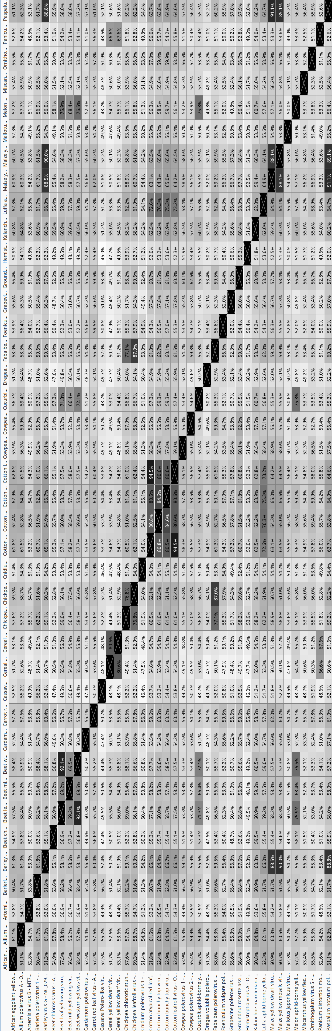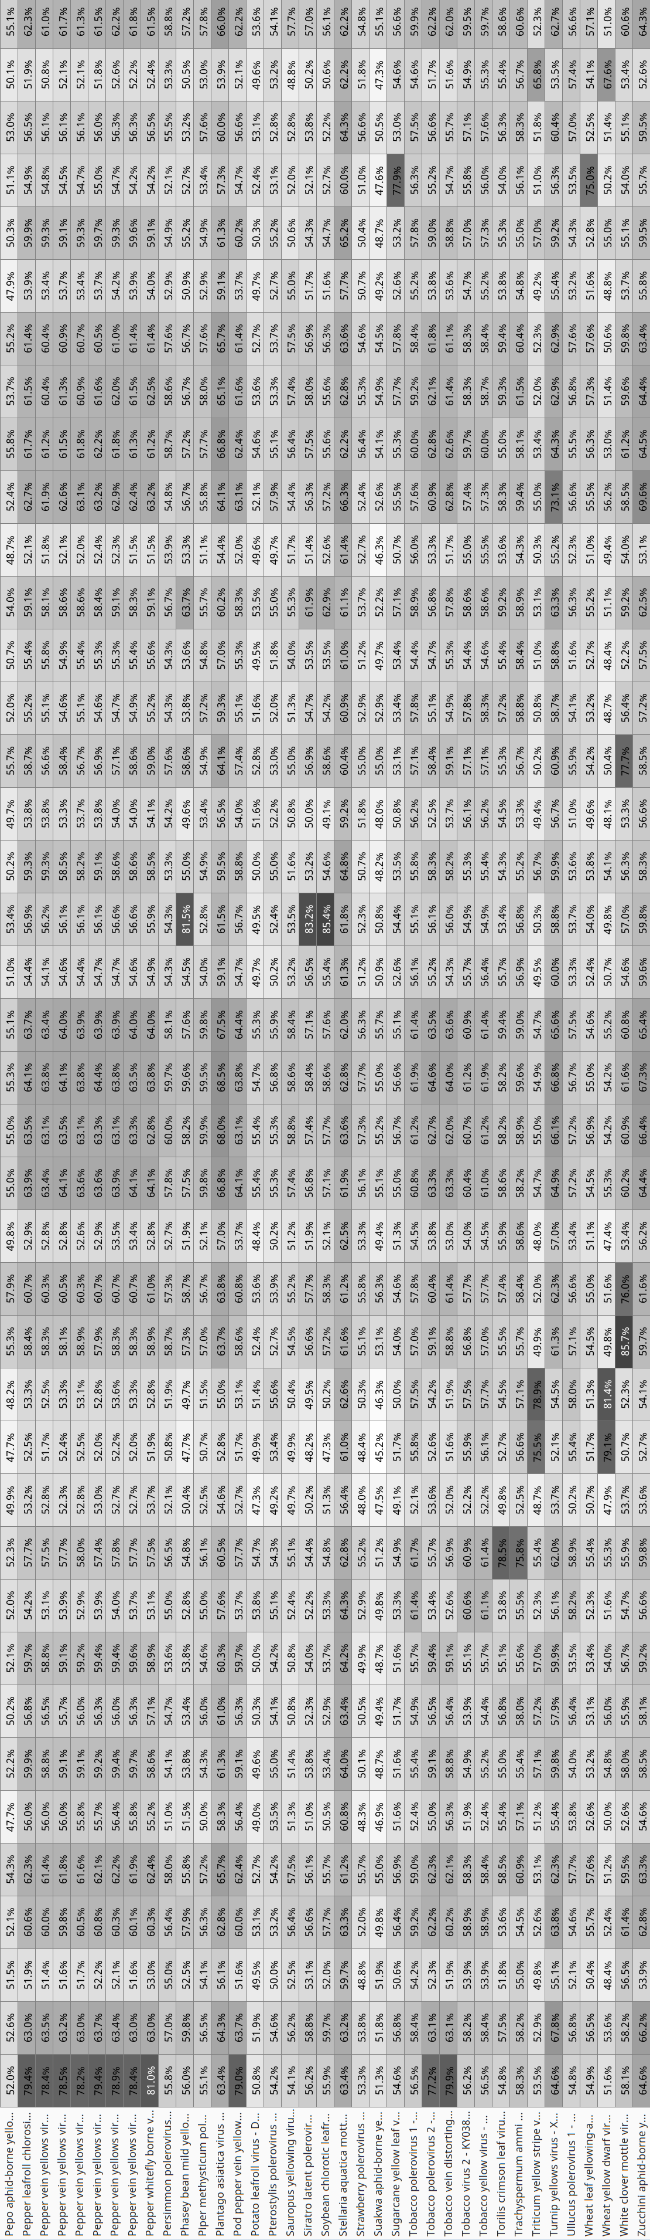
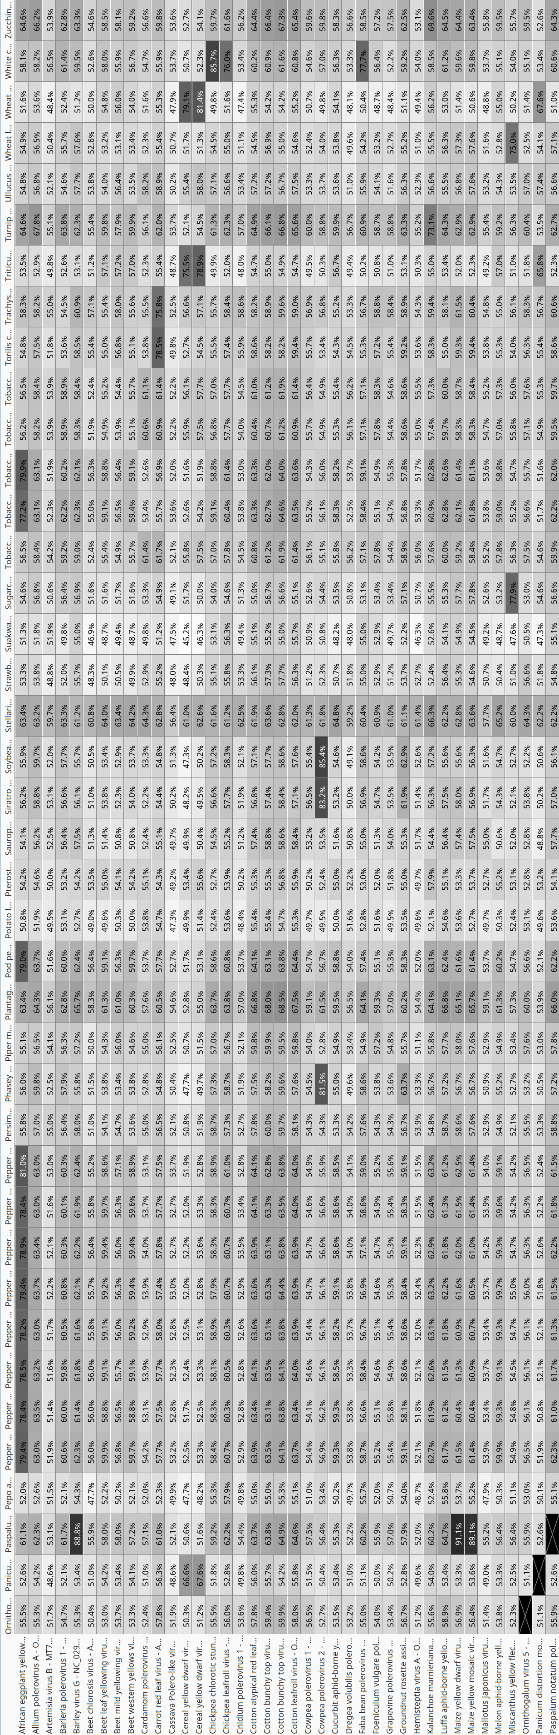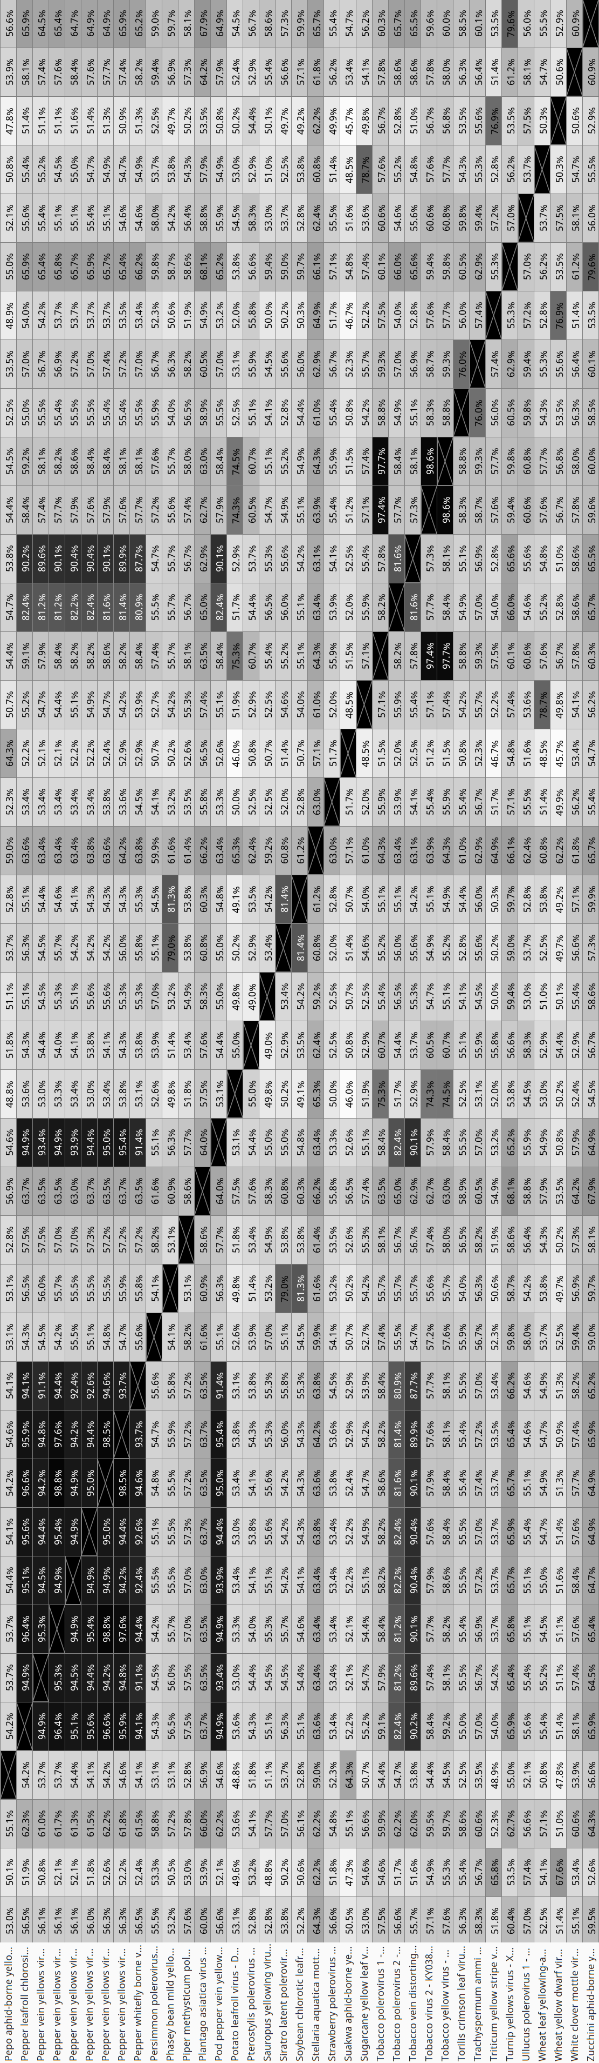

Table 2. Identity percentages between nucleotide sequences of viral genomes of recognized and tentative new poleroviruses retrieved from NCBI GenBank. Multiple sequence alignment was obtained using the MUSCLE algorithm. Table 2 has been split into two pages.
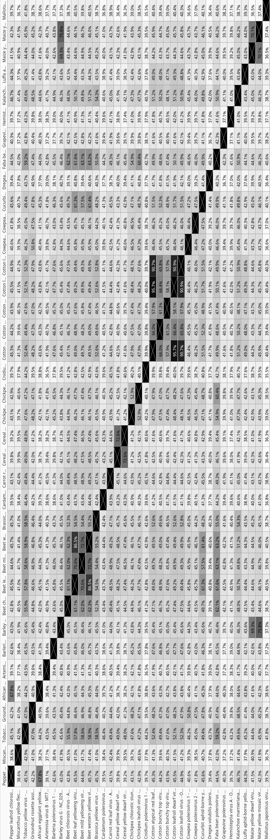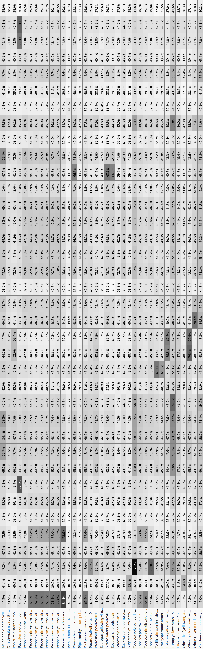
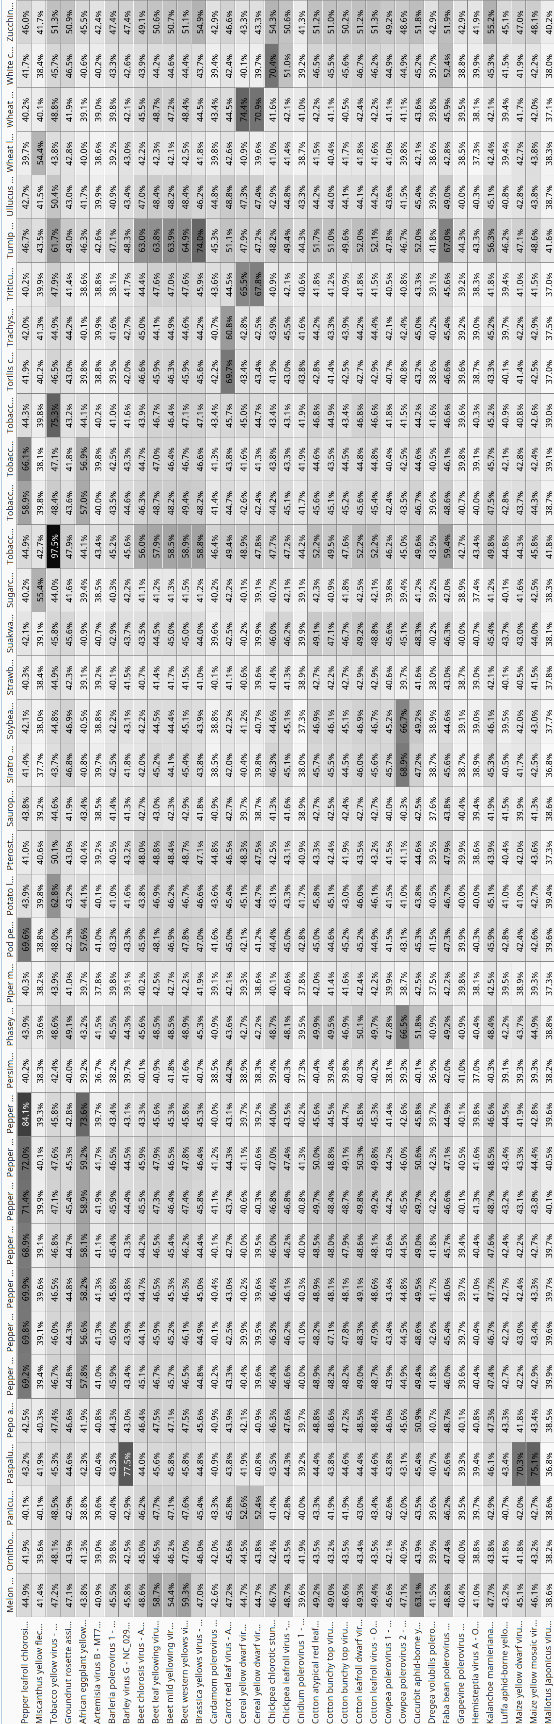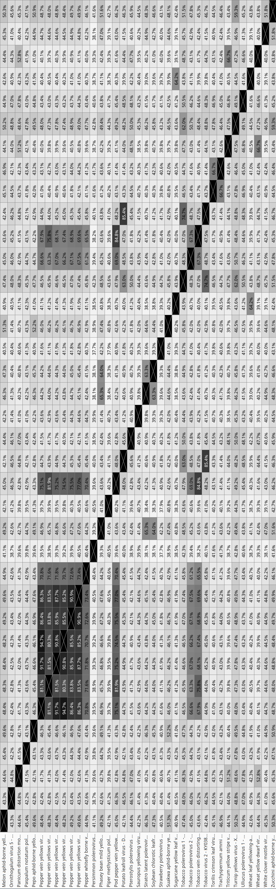
References
Afouda L, Kone D, Zinsou V, Dossou L, Kenyon L, Winter S, Knierim D (2017) Virus surveys of Capsicum spp. in the Republic of Benin reveal the prevalence of pepper vein yellows virus and the identification of a previously uncharacterised polerovirus species. Arch Virol 162:1599-1607. doi: 10.1007/s00705-017-3274-8. PMID: 28220324

Santos ANMR, Nascimento SCD, Albuquerque MRM, Gorayeb E, Pilatti MF, Marcuzzo LL, Bogo A, Nascimento da Silva F (2022) First report of Leek yellow stripe virus, Onion yellow dwarf virus, and the putative allium polerovirus A in elephant garlic (Allium ampeloprasum) in Brazil. Plant Dis 107:249. doi: 10.1094/PDIS-05-22-1219-PDN. PMID: 36089676

Igori D, Lim S, Cho HS, Kim HS, Park JM, Lee HJ, Hong KJ, Kwon SY, Moon JS (2021) Complete genome sequence of artemisia virus B, a new polerovirus infecting Artemisia princeps in South Korea. Arch Virol 166:1495-1499. doi: 10.1007/s00705-021-05004-2. PMID: 33646407

Read DA, Roberts R, Thompson G (2021) Genomic characterization of two novel viruses infecting Barleria cristata L. from the genera Orthotospovirus and Polerovirus. Arch Virol 166:2615-2618. doi: 10.1007/s00705-021-05150-7. PMID: 34196795

Zhao F, Lim S, Yoo RH, Igori D, Kim SM, Kwak do Y, Kim SL, Lee BC, Moon JS (2016) The complete genomic sequence of a tentative new polerovirus identified in barley in South Korea. Arch Virol 161:2047-50. doi: 10.1007/s00705-016-2881-0. PMID: 27146139

Yoshida N, Tamada T (2019). Host range and molecular analysis of Beet leaf yellowing virus, Beet western yellows virus-JP and Brassica yellows virus in Japan. Plant Pathol 68:1045-1058. doi: 10.1111/ppa.13023

Kavi Sidharthan V, Kalaivanan NS, Baranwal VK (2021) Identification of two putative novel RNA viruses in the transcriptome datasets of small cardamom. Plant gene 27: 100305. DOI: 10.1016/j.plgene.2021.100305

Carvajal-Yepes M, Olaya C, Lozano I, Cuervo M, Castaño M, Cuellar WJ (2014) Unraveling complex viral infections in cassava (Manihot esculenta Crantz) from Colombia. Virus Res 186:76-86. doi: 10.1016/j.virusres.2013.12.011. PMID: 24374265

Chiquito-Almanza E, Acosta-Gallegos JA, Anaya-López JL (2022) Complete genome sequence of a novel polerovirus infecting chickpea (Cicer arietinum L.). Arch Virol. 2022 167:2783-2788. doi: 10.1007/s00705-022-05581-w. PMID: 36269414

Park YC, Kim KK, Jun HJ, Kang EH, Lee SR, Ahn JK, Seo HK, Lee SH, Hoe KL (2023) Complete genome sequence of a novel member of the genus Polerovirus from Cnidium officinale in South Korea. Arch Virol. 2023 168:104. doi: 10.1007/s00705-023-05732-7. PMID: 36892625

Sharman M, Smith T, Webb M, Filardo F, Grundy P, Wilson L (2021) Host range and genetic diversity of two polerovirus species associated with cotton bunchy top disease. Australasian Plant Pathol 51:221–230. doi: 10.1007/s13313-021-00829-6

Palanga E, Martin DP, Galzi S, Zabré J, Bouda Z, Neya JB, Sawadogo M, Traore O, Peterschmitt M, Roumagnac P, Filloux D (2017) Complete genome sequences of cowpea polerovirus 1 and cowpea polerovirus 2 infecting cowpea plants in Burkina Faso. Arch Virol 162:2149-2152. doi: 10.1007/s00705-017-3327-z. PMID: 28337544

Li S, Chen Z, Wang Z, Gao L, Wen G, Zhao M (2022) Dregea volubilis polerovirus 1 isolate YN. Direct submission to GenBank. Acc. No. MZ965076

Kavi Sidharthan V, Nagendran K, Baranwal VK (2022) Exploration of plant transcriptomes reveals five putative novel poleroviruses and an enamovirus. Virus Genes 58:244-253. doi: 10.1007/s11262-022-01896-7. PMID: 35347589

Palumbo F, Vannozzi A, Vitulo N, Lucchin M, Barcaccia G (2018) The leaf transcriptome of fennel (Foeniculum vulgare Mill.) enables characterization of the t-anethole pathway and the discovery of microsatellites and single-nucleotide variants. Sci Rep 8:10459. doi: 10.1038/s41598-018-28775-2. PMID: 29993007

Hu Z, Nie Z, Yan C, Huang H, Ma X, Wang Y, Ye N, Tuskan GA, Yang X, Yin H (2021) Transcriptome and Degradome Profiling Reveals a Role of miR530 in the Circadian Regulation of Gene Expression in Kalanchoë marnieriana. Cells 10:1526. doi: 10.3390/cells10061526. PMID: 34204368

Chiaki Y, Ito T (2020) Complete genome sequence of a novel putative polerovirus detected in grapevine. Arch Virol 165:1007-1010. doi: 10.1007/s00705-020-04544-3. PMID: 32037489

Knierim D, Tsai WS, Maiss E, Kenyon L (2014) Molecular diversity of poleroviruses infecting cucurbit crops in four countries reveals the presence of members of six distinct species. Arch Virol 159:1459-65. doi: 10.1007/s00705-013-1939-5. PMID: 24337720

Choi D, Rai M, Rai A, Shin C, Yamazaki M, Hahn Y (2023) High-throughput RNA sequencing analysis of Mallotus japonicus revealed novel polerovirus and amalgavirus. Acta Virol 67:13-23. doi: 10.4149/av_2023_102. PMID: 36950882

Podio M, Colono C, Siena L, Ortiz JPA, Pessino SC (2021) A study of the heterochronic sense/antisense RNA representation in florets of sexual and apomictic Paspalum notatum. BMC Genomics 22:185. doi: 10.1186/s12864-021-07450-3. PMID: 33726667

Ito, T., Sato, A (2020) Three novel viruses detected from Japanese persimmon ‘Reigyoku’ associated with graft-transmissible stunt. Eur J Plant Pathol 158:163-175. doi: 10.1007/s10658-020-02063-0

Bolus S, Malapi-Wight M, Grinstead SC, Fuentes-Bueno I, Hendrickson L, Hammond RW, Mollov D (2020) Identification and characterization of Miscanthus yellow fleck virus, a new polerovirus infecting Miscanthus sinensis. PLoS One 15:e0239199. doi: 10.1371/journal.pone.0239199. PMID: 32941541

Mostert I, Visser M, Gazendam I, Cloete M, Burger JT, Maree HJ (2020) Complete genome sequence of a novel polerovirus in Ornithogalum thyrsoides from South Africa. Arch Virol 165:483-486. doi: 10.1007/s00705-019-04472-x. PMID: 31781858

Min H-G, Park CY, Lee H-K, Yeom Y-A, Oh J, Kim B-S, Lim S, Yoon Y, Lee S-H (2017) A Survey of Viral Diseases of Proso Millet (Panicum miliaceum L.) and Sorghum (Sorghum bicolor L.) in South Korea. Res Plant Dis 23:262-267. doi: 0.5423/RPD.2017.23.3.262

Pluskal T, Torrens-Spence MP, Fallon TR, De Abreu A, Shi CH, Weng J-K (2019) The biosynthetic origin of psychoactive kavalactones in kava. Nat Plants 5:867-878. doi: 10.1038/s41477-019-0474-0. PMID: 31332312

Kamran A, Lotos L, Amer MA, Al-Saleh MA, Alshahwan IM, Shakeel MT, Ahmad MH, Umar M, Katis NI (2018) Characterization of Pepper leafroll chlorosis virus, a New Polerovirus Causing Yellowing Disease of Bell Pepper in Saudi Arabia. Plant Dis 102:318-326. doi: 10.1094/PDIS-03-17-0418-RE. PMID: 30673532

Ghosh S, Kanakala S, Lebedev G, Kontsedalov S, Silverman D, Alon T, Mor N, Sela N, Luria N, Dombrovsky A, Mawassi M, Haviv S, Czosnek H, Ghanim M (2019) Transmission of a New Polerovirus Infecting Pepper by the Whitefly Bemisia tabaci. J Virol 93:e00488-19. doi: 10.1128/JVI.00488-19. PMID: 31092571

Sharman M, Kehoe M, Coutts B, van Leur J, Filardo F, Thomas J (2016) Two Complete Genome Sequences of Phasey Bean Mild Yellows Virus, a Novel Member of the Luteoviridae from Australia. Genome Announc 4:e01569-15. doi: 10.1128/genomeA.01569-15. PMID: 26847905

Igori D, Kim SE, Kwon S, Moon JS (2022) Complete genome sequence of Plantago asiatica virus A, a novel putative member of the genus Polerovirus. Arch Virol 167:219-222. https://doi.org/10.1007/s00705-021-05265-x

Zhao K, Yin Y, Hua M, Wang S, Mo X, Yuan E, Zheng H, Lin L, Chen H, Lu Y, Chen J, Peng J, Yan F (2021) Pod pepper vein yellows virus, a new recombinant polerovirus infecting Capsicum frutescens in Yunnan province, China. Virol J 18:42. doi: 10.1186/s12985-021-01511-5. PMID: 33622354

Chao HY, Clements MA, Mackenzie AM, Dietzgen RG, Thomas JE, Geering ADW (2022) Viruses Infecting Greenhood Orchids (Pterostylidinae) in Eastern Australia. Viruses 14:365. doi: 10.3390/v14020365. PMID: 35215958

Knierim D, Maiss E, Menzel W, Winter S, Kenyon L (2015) Characterization of the Complete Genome of a Novel Polerovirus Infecting Sauropus androgynus in Thailand. Journal of Phytopathology 163:695-702. DOI: 10.1111/jph.12365

Filardo FF, Sharman M (2019) Siratro latent polerovirus (SLPV): a new polerovirus from Australia with a non-functional open reading frame 0. Australasian Plant Pathol 48:491-501. doi: 10.1007/s13313-019-00650-2

Xu T, Lei L, Fu Y, Yang X, Luo H, Chen X, Wu X, Wang Y, Jia MA (2022) Molecular Characterization of a Novel Polerovirus Infecting Soybean in China. Viruses 14:1428. doi: 10.3390/v14071428. PMID: 35891408

Xiang Y, Bernardy M, Bhagwat B, Wiersma PA, DeYoung R, Bouthillier M (2015) The complete genome sequence of a new polerovirus in strawberry plants from eastern Canada showing strawberry decline symptoms. Arch Virol 160:553-556. doi: 10.1007/s00705-014-2267-0. PMID: 25362546

Gudeta WF, Shin AY, Kim SE, Jeong-A K, Seok-Yoon K, Moon JS (2023) Complete genome sequence of Stellaria aquatica virus B, a novel polerovirus that infects Stellaria aquatica. Arch Virol 168:22. doi: 10.1007/s00705-022-05687-1. PMID: 36593330

Zhou B, Wang F, Zhang X, Zhang L, Lin H (2017) Sequencing and phylogenetic analysis of tobacco virus 2, a polerovirus from Nicotiana tabacum. Arch Virol 162:2159-2162. doi: 10.1007/s00705-017-3339-8. PMID: 28342033

Tan ST, Liu F, Lv J, Liu QL, Luo HM, Xu Y, Ma Y, Chen XJ, Lan PX, Chen HR, Cao MJ, Li F (2021) Identification of two novel poleroviruses and the occurrence of Tobacco bushy top disease causal agents in natural plants. Sci Rep 11:21045. doi: 10.1038/s41598-021-99320-x. PMID: 34702954

Liu Y, Dong Y, Chen X, Zang Y, Liu J, Ren G, Xu P (2020) Sequencing and phylogenetic characterization of a novel Polerovirus from Nicotiana tabacum. Virus Genes 56:657-661. doi: 10.1007/s11262-020-01782-0. PMID: 32734508

Lotos L (2020) Torilis crimson leaf virus isolate RL5. Direct submission to GenBank. Acc. No. LT615235

Soltani Howyzeh M, Sadat Noori SA, Shariati J V, Amiripour M (2018) Comparative transcriptome analysis to identify putative genes involved in thymol biosynthesis pathway in medicinal plant Trachyspermum ammi L. Sci Rep 8:13405. doi: 10.1038/s41598-018-31618-9. PMID: 30194320

Yan D, Han K, Chen Y, Ma C, Hu S, Zhao W, Wang F (2023) Complete genome sequence of Triticum yellow stripe virus, a new polerovirus infecting wheat (Triticum aestivum) in China. Arch Virol 168:146. doi: 10.1007/s00705-023-05758-x. PMID: 37083847

Fox A, Fowkes R, Skelton A, Harju V, Buxton-Kirk A, Kelly M, Forde SMD, Pufal H, Conyers C, Ward R, Weekes R, Boonham N, Adams IP (2019) Using high-throughput sequencing in support of a plant health outbreak reveals novel viruses in Ullucus tuberosus (Basellaceae). Plant Pathol 68:576-587. doi: /10.1111/ppa.12962

Zhang P, Liu Y, Liu W, Cao M, Massart S, Wang X (2017) Identification, Characterization and Full-Length Sequence Analysis of a Novel Polerovirus Associated with Wheat Leaf Yellowing Disease. Front Microbiol 8:1689. doi: 10.3389/fmicb.2017.01689. PMID: 28932215

Park CY, Min HG, Oh JH, Kim MG, Lee SH (2016) White clover mottle virus genomic RNA, strain CD. Direct submission to GenBank. Acc. No. LC192169

Peng B, Kang B, Wu H, Liu L, Liu L, Fei Z, Hong N, Gu Q (2019) Detection and genome characterization of a novel member of the genus Polerovirus from zucchini (Cucurbita pepo) in China. Arch Virol 164:2187-2191. doi: 10.1007/s00705-019-04217-w. PMID: 31123960

