+

**Part 1:** **TITLE, AUTHORS, APPROVALS, etc**

|  |  |  |
| --- | --- | --- |
| **Code assigned:** | **2023.008P** |  |
| **Short title:** Create one new species in family *Aspiviridae* (*Serpentovirales*) | | |
|  | | |

**Author(s) and email address(es)**

|  |  |
| --- | --- |
| Sasaya T, Neriya Y, Shimomoto Y, Takemura C, Yanagisawa H | [tsasaya@affrc.go.jp](mailto:tsasaya@affrc.go.jp);  [neriya@a.utsunomiya-u.ac.jp](mailto:neriya@a.utsunomiya-u.ac.jp);  [yoshifumi_shimomoto@ken2.pref.kochi.lg.jp](mailto:yoshifumi_shimomoto@ken2.pref.kochi.lg.jp);  [chika_takemura@ken3.pref.kochi.lg.jp](mailto:chika_takemura@ken3.pref.kochi.lg.jp);  hironobu_yanagisa090@maff.go.jp |

**Author(s) institutional address(es) (optional)**

|  |
| --- |
| Institute for Plant Protection, NARO, Japan [TS]; Utsunomiya University, Japan [YN]; Kochi Agricultural Research Center, Japan [YS, CT]; Yokohama Plant Protection Station, Japan [HY] |

**Corresponding author**

|  |
| --- |
| Sasaya T |

**List the ICTV Study Group(s) that have seen this proposal**

|  |
| --- |
| ICTV *Aspiviridae* Study Group |

**ICTV Study Group comments and response of proposer**

|  |
| --- |
|  |

**ICTV Study Group votes on proposal**

|  |  |  |  |
| --- | --- | --- | --- |
| **Study Group** | **Number of members** | | |
| **Votes support** | **Votes against** | **No vote** |
| ICTV *Aspiviridae* Study Group | 13/13 |  |  |

**Authority to use the name of a living person**

|  |  |
| --- | --- |
| **Is any taxon name used here derived from that of a living person (Y/N)** | N |

|  |  |  |
| --- | --- | --- |
| **Taxon name** | **Person from whom the name is derived** | **Permission attached (Y/N)** |
| N/A | N/A | N/A |

**Submission dates**

|  |  |
| --- | --- |
| Date first submitted to SC Chair | June 20, 2023 |
| Date of this revision (if different to above) |  |

**ICTV-EC comments and response of the proposer**

|  |
| --- |
| N/A |

**Part 2:** **NON-TAXONOMIC PROPOSAL**

**Text of proposal**

|  |
| --- |
| N/A |

**Part 3:** **TAXONOMIC PROPOSAL**

**Name of accompanying Excel module**

|  |
| --- |
| 2023.008P.A.v1.Aspiviridae_1nsp |

**Abstract**

|  |
| --- |
| Pepper chlorosis associated virus (PepCaV) fulfils the criteria established by the International Committee on Taxonomy of Viruses *Aspiviridae* Study Group to be classified as representative member of a new species in the aspivirid genus *Ophiovirus*. The name *Ophiovirus capsici* is proposed for such a species. |

**Text of proposal**

|  |  |
| --- | --- |
| |  | | --- | | **Biology**  The chlorotic disease of pepper (*Capsicum annuum* Linnaean (1753)) was observed in Kochi, Japan. The streaking symptoms appear as white-to-yellow elongated stripes along the leaf veins, with necrotic streaking or color banding on petals. PepCaV is transmitted by grafting. Mechanical transmission using diseased-pepper sap extracts to other plants was not successful [1].  **Genome:**  The genome of PepCaV comprise three segments of negative-sense RNA (Fig. 1). RNA 1 (7,678 nt) encodes a protein with a predicted molecular mass of 262 kDa that shares the mononegavirales RNA-dependent RNA polymerase (RdRp) domain and a protein of 18 kDa of unknown function. RNA2 (1,783 nt) encodes a protein of 55 kDa that shares the core domain of 30K viral movement proteins, and RNA3 (1,541 nt) that shares the plant viral coat protein (CP) nucleocapsid domain. The CP of PepCaV has amino acid identity ranging from 31.7 % to 61.9 % with the CP of classified ophioviruses, and the highest identity value was obtained with the CP encoded by ranunculus white mottle virus, which is below the species demarcation criterion (<85% identity) (Fig. 2) [1, 2].  **Phylogenetic relationships**:  The phylogenetic analysis and identity matrix based on an RdRp alignment with representatives of current aspiviral species, show PepCaV clusters with ophioviruses, and the high bootstrap values in the phylogenetic tree strongly support the classification of PepCaV in the genus *Ophiovirus* (Fig. 3).  For these reasons, we propose to classify PepCaV as a member of a novel species, named *Ophiovirus capsici*.  **Origin of the name of the species**: *capsici* is named after plant host genus _ *Capsicum* _, in which PepCaV was first discovered. | |

**Supporting evidence**

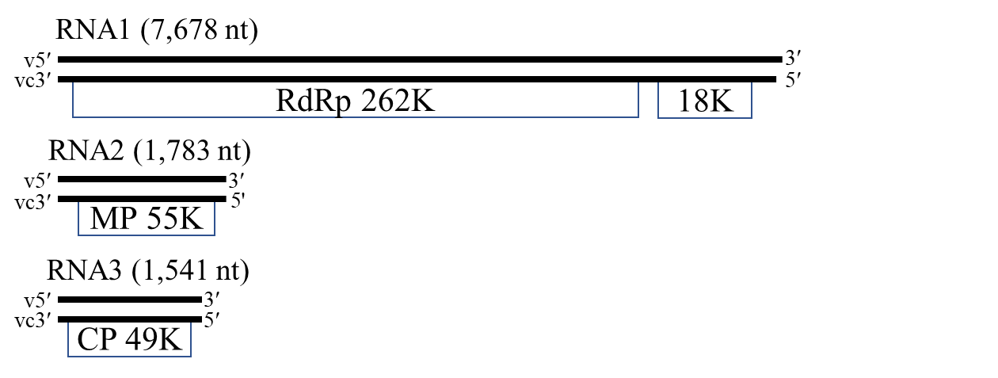

**Figure 1**. Genome organization of pepper chlorosis associated virus (PepCaV). Boxes represent ORFs and the length of the RNA segments and the predicted sizes of the ORF products are indicated. v, viral RNA; vc, viral complementary RNA. RNA4 is not reported for all ophioviruses. RdRP, RNA polymerase; MP, movement protein; CP, coat protein.



**Figure 2**. Amino acid identity (%) matrix of the four proteins of the proposed pepper chlorosis associated virus and the current members of the genus *Ophiovirus*.

AF335429 ranunculus white mottle virus

99

88

38

100

0.20

LC719619 pepper chlorosis associated virus

AF525933 Mirafiori lettuce big-vein virus

AY535016 lettuce ring necrosis virus

AY654892 citrus psorosis virus

KJ704366 blueberry mosaic associated virus

L32603 sonchus yellow net virus

**Figure 3.** Neighbor joining phylogenetic tree constructed from the amino acid sequences of RdRP of pepper chlorosis associated virus (PepCaV) and the current members of the genus *Ophiovirus* that are available for the complete coding sequence of RdRP at the GenBank nucleotide sequence database. Bars represent the number of amino acid replacements per site. Tree was assessed by bootstrapping using 1,000 pseudo-replicates. The numbers at each node represent a percentage of bootstrap values. Sonchus yellow net virus in the genus *Betanucleorhabdovirus*, family *Rhabdoviridae* was used as an outgroup. MEGA-X was used to build the tree. The GenBank accession numbers are shown next to the respective virus taxon.

**References**

1. Shimomoto Y, Takemura C, Yanagisawa H, Neriya Y, Sasaya T (2023) Complete genome sequence of a novel ophiovirus associated with chlorotic disease of pepper (*Capsicum annuum* L.) in Japan. Arch Virol 168:48. PMID: 36609794. doi: 10.1007/s00705-022-05691-5.
2. García ML, Bó ED, da Graça JV, Gago-Zachert S, Hammond J, Moreno P, Natsuaki T, Pallás V, Navarro JA, Reyes CA, Luna GR, Sasaya T, Tzanetakis IE, Vaira AM, Verbeek M, ICTV Report Consortium (2017) ICTV virus taxonomy profle: Ophioviridae. J Gen Virol 98:1161–1162. PMID: 28635587. Doi: 10.1099/jgv.0.000836.