Part 1: TITLE, AUTHORS, APPROVALS, etc

Code assigned: | 2023.009P
Short title: Create Emaravirus kudzu as a new species in the genus Emaravirus, family Fimoviridae
Author(s) and email address(es)
Digiaro M, Elbeaino T, Kubota K,  Ochoa Corona FM, von Bargen S | digiaro@iamb.it; elbeaino@iamb.it;  kubotak@affrc.go.jp; ochoaco@okstate.edu;  susanne.von.bargen@agrar.hu-berlin.de

Author(s) institutional address(es) (optional)
CIHEAM, Istituto Agronomico Mediterraneo of Bari, Via Ceglie 9, 70010 Valenzano (BA), Italy [DM, ET]
Institute for Plant Protection, NARO 2-1-18, Kannondai, Tsukuba, Ibaraki 305-8666, Japan [KK]
Oklahoma State University, Institute for Biosecurity & Microbial Forensics, 127 NRC Stillwater, OK 74078 [OCFM]
Humboldt-Universität zu Berlin, Unter den Linden 6, 10099 Berlin, Germany [vBS]

Corresponding author
Digiaro Michele, digiaro@iamb.it

List the ICTV Study Group(s) that have seen this proposal
Fimoviridae study group

ICTV study group comments and response of proposer

ICTV Study Group votes on proposal
Study Group | Number of members
 | Votes support | Votes against | No vote
Fimoviridae | 5 | / | /

Authority to use the name of a living person
Is any taxon name used here derived from that of a living person (Y/N) | N

Taxon name | Person from whom the name is derived | Permission attached (Y/N)

Submission dates
Date first submitted to SC Chair | June 19, 2023
Date of this revision (if different to above)

ICTV-EC comments and response of the proposer

Part 3: TAXONOMIC PROPOSAL

Name of accompanying Excel module
2023.009P.A.v1.Emaravirus_1nsp

Abstract

The creation of the new species Emaravirus kudzu in the genus Emaravirus, family Fimoviridae, is proposed to accommodate Pueraria lobata-associated emaravirus (PloaEV), identified in China on Pueraria lobata (Pueraria lobata (Willd) Ohwi), as its exemplar virus isolate. The exemplar isolate consists of five segmented, linear, single-stranded (ss), negative sense RNA genomes, fully sequenced. The genomic segments show features common to homologous RNAs of other known emaraviruses, while they differ significantly in nucleotide and amino acid sequences.

Text of proposal
Pueraria lobata-associated emaravirus (PloaEV) has been recently identified in Pueraria lobata (Pueraria lobata (Willd) Ohwi), in China and its genome has been sequenced (Liang et al., 2022). PloaEV possesses all molecular and biological features to be considered as a new member of the genus Emaravirus, which currently comprises 28 species (Elbeaino et al. 2018; Mielke and Muehlbach 2007; https://talk.ictvonline.org/ictv-reports/ictv_online_report/negative-sense-rna-viruses/w/fimoviridae/981/genus-emaravirus). The RNA-dependent RNA polymerase (RdRp), glycoprotein precursor (GP), nucleocapsid (NP) and movement protein (MP) show different levels of sequence identity with ortholog proteins of other emaraviruses.

Virus properties
- Genome: resembles that of members of the genus Emaravirus. It is composed of five segments of negative sense ssRNA RNA-1: 7,068 nt, RNA-2: 2,252 nt, RNA3: 1,521 nt, RNA-4: 1,275 nt and RNA-5: 1,710 (Figure 1) (in order from RNA-1 to RNA-5, accession numbers are: ON181430 – ON181434) (Liang et al., 2022). Each segment is monocistronic, encoding a single protein translated from the complementary strand (Figure 1). Untranslated regions (UTRs) at the 3’ and 5’ termini of all RNA segments extended from 45 to 101 nt and from 130 to 482 nt, respectively.
- Virus-encoded proteins: RNA-dependent RNA-polymerase (p1): 266.5 kDa; putative glycoprotein precursor (p2): 74.8 kDa; putative nucleocapsid protein (p3): 35.3 kDa; putative movement protein (p4): 40.5 kDa; p5: 54.0 kDa (Figure 1).
- Phylogenetic relationships: RdRp, GP, NP and MP proteins of PloaEV consistently segregated with those of pigeonpea sterility mosaic virus 2 (PPSMV-2) and formed a cluster with the emaraviruses PPSMV-2, FMV and ASaV (Figure 2). PloaEV shared the highest amino acid sequence identity with PPSMV-2: 77.2% for RdRp, 67.0% for GP, 82.1% for NP, 80.4% for MP, and 45.5% for p5, and lower sequence identity with other emaraviruses.
- Experimental transmission: PloaEV is mechanically transmissible onto Nicotiana benthamiana. No observations and specific trials were carried out for insect vectors.
- Natural host range: Pueraria lobata or kudzu (Pueraria lobata (Willd) Ohwi)

Although the sequence identities found only partially meet the current criteria for demarcation of species in the genus, i.e. amino acid sequence of relevant gene products of RNA1 (RdRP), RNA2 (GP) and RNA3 (NP) differing by more than 25%, PlobaV is considered belonging to a new species rather than a strain of Emaravirus toordali (exemplar isolate: pigeonpea sterility mosaic virus 2). In fact, of the relevant gene products of RNA1 (RdRp), RNA2 (GP) and RNA3 (NP), only GP exceeds the threshold of a 25% difference in amino acid sequence, the other two differing by less than 25% (23.8% RdRp and 19.6% NP).

Supporting evidence

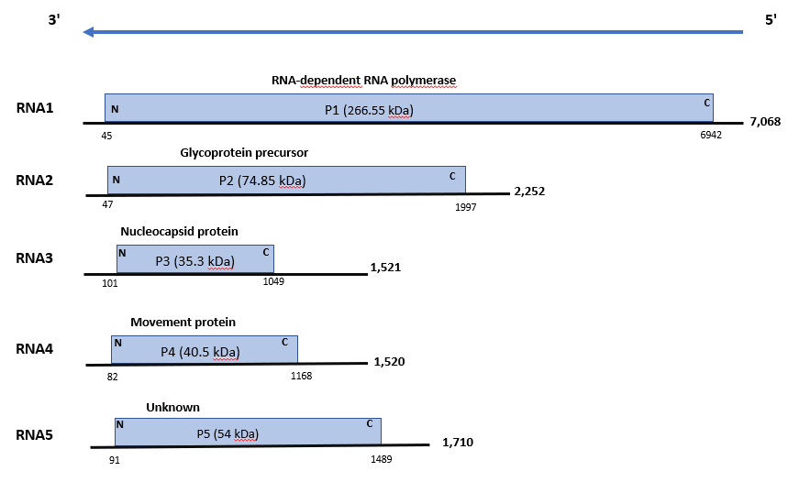

Figure 1. Genome organization of Pueraria lobata-associated emaravirus (PloaEV). Colored boxes represent the protein encoding region (ORF) for each RNA. The length of RNAs, the putative protein product for each ORF, function (if known), and estimated molecular weight are provided. The genomic RNAs are not drawn to scale.

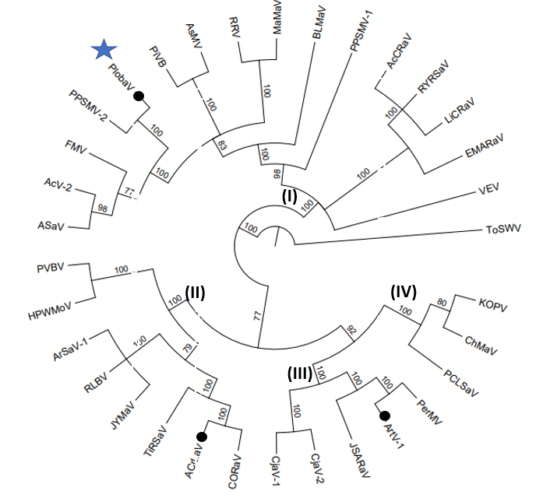

Figure 2. Phylogenetic tree constructed with amino acid sequences encoded by RNA1 (RdRp), of recognized emaraviruses and corresponding tentative species (indicated by a black circle). Alignment was obtained using ClustalW, and analyzed by the Neighbor-Joining method, with 1000 bootstrap replicates. The percentage of replicate trees in which the associated taxa clustered together in the bootstrap is shown next to the branches (when >60%). TSWV (tomato spotted wilt virus), an orthotospovirus of the family Tospoviridae, was used as an outgroup species. Actinidia chlorotic ringspot-associated virus (AcCRaV), Actinidia virus 2 (AcV-2), Ailanthus crinkle leaf-associated virus (ACrLaV), Arceuthobium sichuanense-associated virus 1 (ArSaV-1), Artemisia fimovirus 1 (ArtV1), ash shoestring-associated virus (ASaV), aspen mosaic-associated virus (AsMaV), blackberry leaf mottle associated virus (BLMaV), Camellia japonica-associated virus 1 (CjaV-1), Camellia japonica-associated virus 2 (CjaV-2), chrysanthemum mosaic-associated virus (ChMaV), common oak ringspot-associated virus (CORaV), European mountain ash ringspot-associated virus (EMARaV), fig mosaic virus (FMV), High Plains wheat mosaic virus (HPWMoV), Japanese star anise ringspot-associated virus (JSARaV), jujube yellow mottle-associated virus (JYMaV), karaka Okahu purepure emaravirus (KOPV), lilac chlorotic ringspot-associated virus (LiCRaV), maple mottle-associated virus (MaMaV), palo verde broom virus (PVBV), pear chlorotic leaf spot-associated virus (PCLSaV), perilla mosaic virus (PerMV), pigeonpea sterility mosaic virus 1 (PPSMV-1), pigeonpea sterility mosaic virus 2 (PPSMV-2), Pistacia virus B (PiVB), Pueraria lobata-associated virus (PloAEV), raspberry leaf blotch virus (RLBV), redbud yellow ringspot-associated virus (RYRSaV), rose rosette virus (RRV), ti ringspot-associated virus (TiRSaV), and Vitis emaravirus (VEV).

References

Elbeaino T, Digiaro M, Mielke-Ehret N, Muehlbach HP, Martelli GP and ICTV Report Consortium (2018) ICTV Virus Taxonomy Profile: Fimoviridae. J Gen Virol 99(11):1478-1479. PMID: 30204080, DOI: 10.1099/jgv.0.001143
Liang X, Mei S, Yu H, Zhang S, Wu J, Cao M (2022) Mixed infection of an emaravirus, a crinivirus, and a begomovirus in Pueraria lobata (Willd) Ohwi. Front Microbiol 13:926724. doi: 10.3389/fmicb.2022.926724

Mielke N, Muehlbach HP (2007) A novel, multipartite, negative-strand RNA virus is associated with the ringspot disease of European mountain ash (Sorbus aucuparia L.). J Gen Virol 88:1337–1346. PMID: 17374780. DOI 10.1099/vir.0.82715-0

https://talk.ictvonline.org/ictv-reports/ictv_online_report/negative-sense-rna-viruses/w/fimoviridae/981/genus-emaravirus

