Part 1: TITLE, AUTHORS, APPROVALS, etc

Code assigned: | 2023.011P
Short title: Create Emaravirus ailanthi as a new species in the genus Emaravirus, family Fimoviridae
Author(s) and email address(es)
Wenxia A, Chengyu L, Song Z,  MeiChun Y, Mengji C, Caixia Y,  Digiaro M, Elbeaino T, Kubota K,  Ochoa Corona FM, von Bargen S | xueyang27@126.com; caomengji@cric.cn; digiaro@iamb.it; elbeaino@iamb.it;  kubotak@affrc.go.jp; ochoaco@okstate.edu;  susanne.von.bargen@agrar.hu-berlin.de

Author(s) institutional address(es) (optional)
Liaoning Key Laboratory of Urban Integrated Pest Management and Ecological Security, College of Life Science and Engineering, Shenyang University, Dadong, Shenyang 110044, Liaoning, China [WA, CL, MY, CY]
National Citrus Engineering and Technology Research Center, Citrus Research Institute, Southwest University, Beibei, Chongqing 400712, China [SZ, MC]
CIHEAM, Istituto Agronomico Mediterraneo of Bari, Via Ceglie 9, 70010 Valenzano (BA), Italy [DM, ET]
Institute for Plant Protection, NARO 2-1-18, Kannondai, Tsukuba, Ibaraki 305-8666, Japan [KK]
Oklahoma State University, Institute for Biosecurity & Microbial Forensics, 127 NRC Stillwater, OK 74078 [OCF]
Humboldt-Universität zu Berlin, Unter den Linden 6, 10099 Berlin, Germany [vBS]

Corresponding author
Caixia Yang, xueyang27@126.com
Digiaro Michele, digiaro@iamb.it

List the ICTV Study Group(s) that have seen this proposal
Fimoviridae study group

ICTV study group comments and response of proposer

ICTV Study Group votes on proposal
Study Group | Number of members
 | Votes support | Votes against | No vote
Fimoviridae | 5 | / | /

Authority to use the name of a living person
Is any taxon name used here derived from that of a living person (Y/N) | N

Taxon name | Person from whom the name is derived | Permission attached (Y/N)

Submission dates
Date first submitted to SC Chair | June 19, 2023
Date of this revision (if different to above)

ICTV-EC comments and response of the proposer

Part 3: TAXONOMIC PROPOSAL

Name of accompanying Excel module
2023.011P.A.v1.Emaravirus_1nsp

Abstract
The creation of the new species Emaravirus ailanthi in the genus Emaravirus, family Fimoviridae, is proposed to accommodate Ailanthus crinkle leaf-associated virus (ACrLaV), identified in China on Ailanthus, commonly known as tree of heaven (Ailanthus altissima (Mill.) Swingle), as its exemplar virus isolate. The exemplar isolate consists of four segmented, linear, single-stranded (ss), negative sense RNA genomes, fully sequenced, except for a few nucleotides at the genomic termini. The genomic segments show features common to homologous RNAs of other known emaraviruses, while they differs significantly in nucleotide and amino acid sequences.

Text of proposal
Ailanthus crinkle leaf-associated virus (ACrLaV) has been recently identified in Ailanthus, (Ailanthus altissima (Mill.) Swingle) in China and its genome has been sequenced (An et al. 2022). ACrLaV possesses all molecular and biological features to be considered as a member of a new species of the genus Emaravirus, which currently comprises 28 species (Elbeaino et al. 2018; Mielke and Muehlbach 2007; https://talk.ictvonline.org/ictv-reports/ictv_online_report/negative-sense-rna-viruses/w/fimoviridae/981/genus-emaravirus). The RNA-dependent RNA polymerase (RdRp), glycoprotein precursor (GP), nucleocapsid (NP) and movement protein (MP) show different levels of sequence identity with orthologous proteins of other emaraviruses.

Virus properties
- Genome: it resembles that of members of the genus Emaravirus. It is composed of four segments of negative sense ssRNA RNA-1: 7,094 nt, RNA-2: 2,222 nt, RNA3: 1,309 nt, and RNA-4: 1,631 nt (Figure 1) (in order from RNA-1 to RNA-4, accession numbers are: OM687517 – OM687520) (An et al., 2022). Each segment is monocistronic, encoding a single protein translated from the complementary strand (Figure 1). Untranslated regions (UTRs) at the 3’ and 5’ termini of all RNA segments consist of 53 to 82 nt and from 100 to 471 nt, respectively.
- Virus-encoded proteins: RNA-dependent RNA-polymerase (p1): 269.15 kDa; putative glycoprotein precursor (p2): 77.8 kDa; putative nucleocapsid protein (p3): 33.2 kDa; putative movement protein (p4): 41.4 kDa (Figure 1).
- Phylogenetic relationships: RdRp, GP, NP and MP proteins of ACrLaV consistently segregated with those of common oak ringspot-associated virus (CORaV) and formed a cluster with the emaraviruses CorAV, TiRSaV and HPWMoV (Figure 2). ACrLaV shared the highest amino acid sequence identity with CORaV: 57.0% for RdRp, 49.9% for GP, 40.4% for NP, and 65.9% for MP, and much lower sequence identity with other emaraviruses.
- Experimental transmission: No observations and specific trials were carried out.
- Natural host range: Ailanthus or tree of heaven (Ailanthus altissima.(Mill.) Swingle).

The detected identities fulfilling the demarcation criteria for species in the genus [aa sequence of relevant gene products of RNA1 (RdRp), RNA2 (GP) and RNA3 (NP) differing by more than 25%], and the genome organization typical of emaraviruses clearly indicate that ACrLaV represents a new species in the genus Emaravirus. Therefore, the creation of the new viral species Emaravirus ailanthi within the genus Emaravirus, which contains ACrLaV isolate LNGZ-CH1 as the exemplar isolate, is proposed.

Supporting evidence

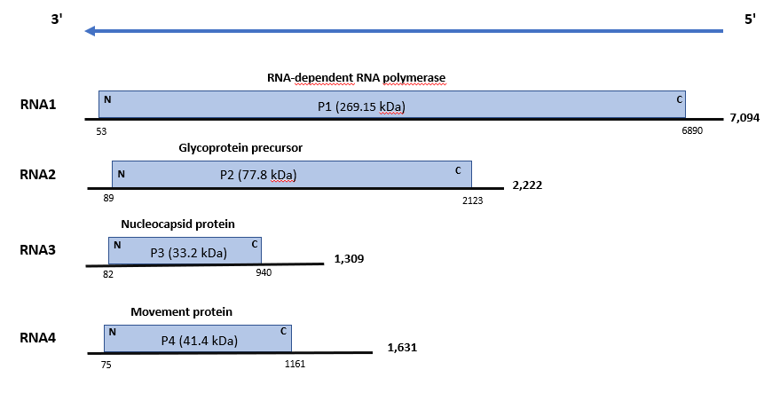

Figure 1. Genome organization of Ailanthus crinkle leaf-associated virus (ACrLaV). Colored boxes represent the protein encoding region (ORF) for each RNA. The length of RNAs, the putative protein product for each ORF, function (if known), and estimated molecular weight are provided. The genomic RNAs are not drawn to scale.

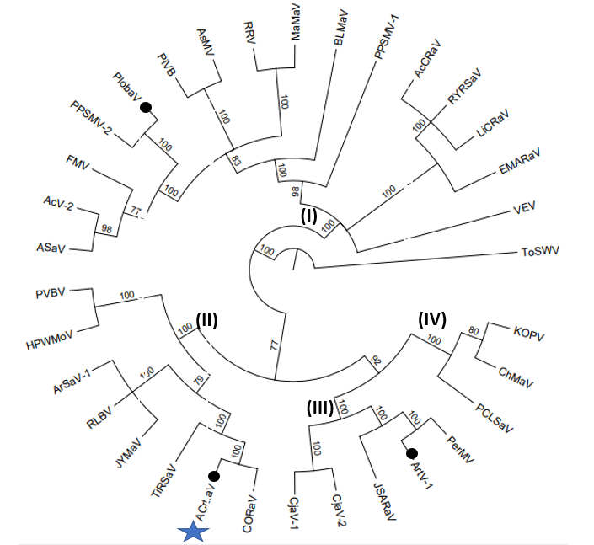

Figure 2. Phylogenetic tree constructed with amino acid sequences encoded by RNA1 (RdRp), of recognized emaraviruses and corresponding tentative species (indicated by a black circle). Alignment was obtained using ClustalW, and analyzed by the Neighbor-Joining method, with 1000 bootstrap replicates. The percentage of replicate trees in which the associated taxa clustered together in the bootstrap is shown next to the branches (when >60%). TSWV (tomato spotted wilt virus), an orthotospovirus of the family Tospoviridae, was used as an outgroup species. Actinidia chlorotic ringspot-associated virus (AcCRaV), Actinidia virus 2 (AcV-2), Ailanthus crinkle leaf-associated virus (ACrLaV). Arceuthobium sichuanense-associated virus 1 (ArSaV-1), Artemisia fimovirus 1 (ArtV1), ash shoestring-associated virus (ASaV), aspen mosaic-associated virus (AsMaV), blackberry leaf mottle associated virus (BLMaV), Camellia japonica-associated virus 1 (CjaV-1), Camellia japonica-associated virus 2 (CjaV-2), chrysanthemum mosaic-associated virus (ChMaV), common oak ringspot-associated virus (CORaV), European mountain ash ringspot-associated virus (EMARaV), fig mosaic virus (FMV), High Plains wheat mosaic virus (HPWMoV), Japanese star anise ringspot-associated virus (JSARaV), jujube yellow mottle-associated virus (JYMaV), karaka Okahu purepure emaravirus (KOPV), lilac chlorotic ringspot-associated virus (LiCRaV), maple mottle-associated virus (MaMaV), palo verde broom virus (PVBV), pear chlorotic leaf spot-associated virus (PCLSaV), perilla mosaic virus (PerMV), pigeonpea sterility mosaic virus 1 (PPSMV-1), pigeonpea sterility mosaic virus 2 (PPSMV-2), Pistacia virus B (PiVB), Pueraria lobata-associated virus (PloAEV), raspberry leaf blotch virus (RLBV), redbud yellow ringspot-associated virus (RYRSaV), rose rosette virus (RRV), ti ringspot-associated virus (TiRSaV), and Vitis emaravirus (VEV).

References

An W, Li C. Zhang S Yu MC, Cao M, Yang C (2022). A putative new emaravirus isolated from Ailanthus altissima (Mill.) Swingle with severe crinkle symptoms in China. Arch Virol
https://doi.org/10.1007/s00705-022-05569-6

Elbeaino T, Digiaro M, Mielke-Ehret N, Muehlbach HP, Martelli GP and ICTV Report Consortium (2018) ICTV Virus Taxonomy Profile: Fimoviridae. J Gen Virol 99(11):1478-1479. PMID: 30204080, DOI: 10.1099/jgv.0.001143
Mielke N, Muehlbach HP (2007) A novel, multipartite, negative-strand RNA virus is associated with the ringspot disease of European mountain ash (Sorbus aucuparia L.). J Gen Virol 88:1337–1346. PMID: 17374780. DOI 10.1099/vir.0.82715-0

https://talk.ictvonline.org/ictv-reports/ictv_online_report/negative-sense-rna-viruses/w/fimoviridae/981/genus-emaravirus

