Part 1: TITLE, AUTHORS, APPROVALS, etc

Code assigned: | 2023.028P
Short title: Create 13 new species (Tymovirales: Betaflexiviridae)
Author(s) and email address(es)
Candresse T, Blouin A, Cao M, Cho WK, Constable F, Mollov D, Nagata T, Sabanadzovic S, Saldarelli P, Tzanetakis I, Villamor DE | thierry.candresse@inrae.fr; arnaud.blouin@agroscope.admin.ch; mengjicao@gmail.com; wonkyong@gmail.com; Fiona.Constable@ecodev.vic.gov.au; dimitre.mollov@usda.gov; tatsuya@unb.br; SSabanadzovic@entomology.msstate.edu; pasquale.saldarelli@ipsp.cnr.it; itzaneta@uark.edu; dvvillam@uark.edu
Author(s) institutional address(es) (optional)
Corresponding author
Candresse T
List the ICTV Study Group(s) that have seen this proposal
ICTV Beta-, Delta- and Gammaflexiviridae Study Group

ICTV Study Group comments and response of proposer
ICTV Study Group votes on proposal
Study Group | Number of members 11
 | Votes support | Votes against | No vote
Beta-, Delta-, Gammaflexiviridae | 11

Authority to use the name of a living person
Is any taxon name used here derived from that of a living person (Y/N) | NO

Taxon name | Person from whom the name is derived | Permission attached (Y/N)

Submission dates
Date first submitted to SC Chair | June 26, 2023
Date of this revision (if different to above)
ICTV-EC comments and response of the proposer

Part 3: TAXONOMIC PROPOSAL
Name of accompanying Excel module
2023.028P.A.v1.Betaflexiviridae_13nsp
Abstract
We propose the creation of 13 novel species in extant genera in the family Betaflexiviridae (7 new species in genus Carlavirus, 1 in genus Foveavirus, 2 in genus Capillovirus, 1 in genus Citrivirus, and 2 in genus Vitivirus).

Text of proposal
The family Betaflexiviridae currently includes two subfamilies, Trivirinae and Quinvirinae. The Trivirinae contains 10 genera, while the Quinvirinae contains 5 genera. With the exception of Citrivirus, Ravavirus, Sustrivirus and Wamavirus which are currently monospecific, all other Betaflexiviridae genera already contain multiple species which are differentiated on the basis of multiple criteria, including sequence-based ones. The currently approved species demarcation criteria based on sequence identity for the family are <72% nucleotide identity or <80% amino acid identity in the replication-associated (REP) or capsid (CP) proteins, of the member viruses.

Here, we propose to expand the family Betaflexiviridae by creation of new species for recently discovered novel viruses [1-8]. In performing its analyses the SG considered only novel recently described viruses for which publications provided solid evidence that the sequence corresponding to the full coding capacity of the genome was at least available.

Application of the current sequence-based criteria results in the expansion of the currently accepted species by a total of 13 species allocated to the following genera: Carlavirus (7), Foveavirus (1), Capillovirus (2), Citrivirus (1), and Vitivirus (2).

Etymology
- After extensive debate about possible options for the new binomial nomenclature, the SG voted and decided to change it previous decision and adopt “Genus + latinized binomial” format for species names in the family Betaflexiviridae.

Supporting evidence

Figure 1. The maximum-likelihood phylogenetic tree was inferred using FastTree and a multiple alignment of replication-associated proteins (REP) prepared using Muscle. Bootstrap values >70% are shown. Tree branches are proportional to genetic distances between sequences, and the scale bar at the bottom indicates substitutions per amino acid. Accession numbers are shown next to the respective virus taxon. Novel species proposed in extant genera are indicated by a black diamond.
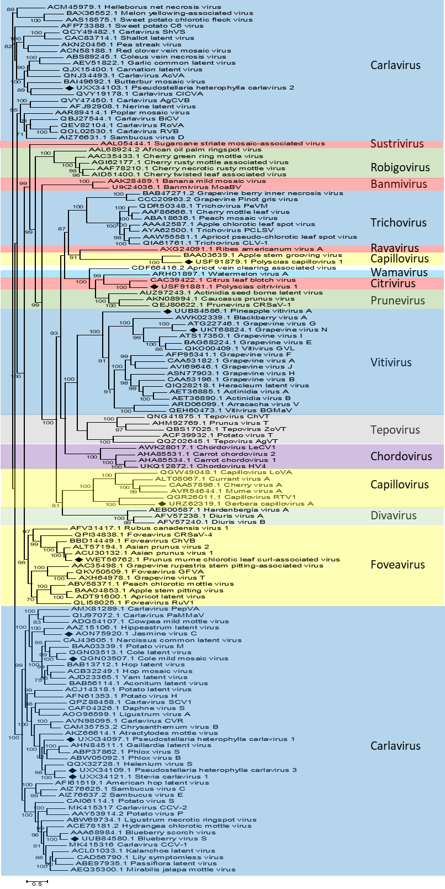
References
- Villamor DEV, Mejia AS, Martin RR et al (2023) Genomic Analysis and Development of Infectious Clone of a Novel Carlavirus Infecting Blueberry. Phytopathology 113:98-103. https://doi.org/10.1094/PHYTO-05-22-0186-R
- Oliveira AM, Rodrigues LK, Chabi-Jesus C et al (2022) Biological and molecular characterization of two closely related carlaviruses affecting brassica plants. Plant Pathology, 71:479-493. https://doi.org/10.1111/ppa.13472
- Li Y, Liu S, Guo K, Ding W, Wang R. Virome of Pseudostellaria heterophylla: Identification and characterization of three novel carlaviruses and one novel amalgavirus associated with viral diseases of Pseudostellaria heterophylla. Front Microbiol 13:955089. https://doi.org/10.3389/fmicb.2022.955089
- Zheng L, Han Y, Gong P et al (2023) Molecular characterization of a novel chlorotic leaf curl-associated foveavirus infecting prune trees. Research Square (Preprint). https://doi.org/10.21203/rs.3.rs-1937671/v1
- Bak S, Jeong W, Kim M et al (2023) Complete genome sequence of a tentative novel capillovirus isolated from Gerbera jamesonii. Arch Virol 168:117. https://doi.org/10.1007/s00705-023-05730-9
- Ma Y, Che H, Gao S et al (2022) Diverse Novel Viruses Coinfecting the Tropical Ornamental Plant Polyscias balfouriana in China. Viruses 14:1120. https://doi.org/10.3390/v14061120
- Read DA, Thompson GD, Cordeur NL et al (2022) Genomic characterization of grapevine viruses N and O: novel vitiviruses from South Africa. Arch Virol 167:611-614. https://doi.org/10.1007/s00705-021-05333-2
- Massé D, Filloux D, Candresse T et al (2022) Identification of a novel vitivirus from pineapple in Reunion Island. Arch Virol 167:2355-2357. https://doi.org/10.1007/s00705-022-05512-9

