Part 1: TITLE, AUTHORS, APPROVALS, etc

Code assigned: | 2023.010P
Short title: Create Emaravirus artemisiae as a new species in the genus Emaravirus, family Fimoviridae
Author(s) and email address(es)
Selda Rivarez MP, Pecman A,  Bačnik K, Maksimović O,  Vučurović A, Seljak G, Mehle N, Gutiérrez‑Aguirre I, Ravnikar M, Kutnjak D, Digiaro M, Elbeaino T,  Kubota K, Ochoa Corona FM,  von Bargen S | mpsrivarez@gmail.com; denis.kutnjak@nib.si; digiaro@iamb.it; elbeaino@iamb.it; kubotak@affrc.go.jp; ochoaco@okstate.edu; susanne.von.bargen@agrar.hu-berlin.de

Author(s) institutional address(es) (optional)
Department of Biotechnology and Systems Biology, National Institute of Biology, Večna pot 111, Ljubljana 1000, Slovenia [SRMP, PA, BK, MO, VA, SG, MN, G-A I, RM, KD].
Jožef Stefan International Post‑graduate School, Jamova cesta 39, Ljubljana 1000, Slovenia [SRMP, PA, MO].
Present Affiliations: Department of Entomology and Plant Pathology, North Carolina State University, Partners II, 840 Main Campus Dr., Raleigh, NC 27606, USA. Bioinformatics Research Center, North Carolina State University, Ricks Hall, 1 Lampe Dr., Raleigh, NC 27607, USA. College of Agriculture and Agri-Industries, Caraga State University, Ampayon, Butuan City, Agusan del Norte, 8600, Philippines [SRMP],
School for Viticulture and Enology, University of Nova Gorica, Dvorec Lanthieri Glavni trg 8, Vipava 5271, Slovenia [MN].

CIHEAM, Istituto Agronomico Mediterraneo of Bari, Via Ceglie 9, 70010 Valenzano (BA), Italy [DM, ET].
Institute for Plant Protection, NARO 2-1-18, Kannondai, Tsukuba, Ibaraki 305-8666, Japan [KK].
Oklahoma State University, Institute for Biosecurity & Microbial Forensics, 127 NRC Stillwater, OK 74078 [OCFM]
Humboldt-Universität zu Berlin, Thaer-Institute of Agricultural and Horticultural Sciences, Lentzeallee 55/57, 14195 Berlin, Germany [vBS].

Corresponding author
Digiaro Michele, digiaro@iamb.it

List the ICTV Study Group(s) that have seen this proposal
Fimoviridae study group

ICTV study group comments and response of proposer

ICTV Study Group votes on proposal
Study Group | Number of members
 | Votes support | Votes against | No vote
Fimoviridae | 5 | / | /

Authority to use the name of a living person
Is any taxon name used here derived from that of a living person (Y/N) | N

Taxon name | Person from whom the name is derived | Permission attached (Y/N)

Submission dates
Date first submitted to SC Chair | June 19, 2023
Date of this revision (if different to above)

ICTV-EC comments and response of the proposer

Part 3: TAXONOMIC PROPOSAL

Name of accompanying Excel module
2023.010P.A.v1.Emaravirus_1nsp

Abstract
The creation of the new species Emaravirus artemisiae in the genus Emaravirus, family Fimoviridae, is proposed to accommodate Artemisia fimovirus 1 (ArtV1), identified in Slovenia on Artemisia verlotiorum Lamotte as its exemplar virus isolate. The exemplar isolate consists of six segmented, linear, single-stranded (ss), negative sense RNA genomes, fully sequenced. The genomic segments show features common to homologous RNAs of other known emaraviruses, while they differ significantly in nucleotide and amino acid sequences.

Text of proposal
Artemisia fimovirus 1 (ArtV1) has been recently identified in Artemisia verlotiorum Lamotte, in Slovenia and its genome has been sequenced (Rivarez et al. 2023). ArtV1 possesses all molecular features to be considered as a member of a new species in the genus Emaravirus, which currently comprises 28 species (Elbeaino et al. 2018; Mielke and Muehlbach 2007; https://talk.ictvonline.org/ictv-reports/ictv_online_report/negative-sense-rna-viruses/w/fimoviridae/981/genus-emaravirus). The RNA-dependent RNA polymerase (RdRp), glycoprotein precursor (GP), nucleocapsid (NP) and movement protein (MP) show different levels of sequence identity with orthologous proteins of other emaraviruses.

Virus properties
- Genome: resembles that of members of the genus Emaravirus. It is composed of six segments of negative sense ssRNA RNA-1: 7,249 nt, RNA-2: 2,057 nt, RNA3: 1,088 nt, RNA-4: 1,325 nt, RNA-5: 902 nt and RNA-7: 999 nt (Figure 1) (in order from RNA-1 to RNA-5, accession numbers are: OL471978 – OL471982; RNA-7: OP441764) (Rivarez et al. 2023). Each segment is monocistronic, encoding a single protein translated from the complementary strand (Figure 1). Untranslated regions (UTRs) at the 3’ and 5’ termini of the first four RNA segments extended from 59 to 81 nt and from 84 to 180 nt, respectively.
- Virus-encoded proteins: RNA-dependent RNA-polymerase (p1): 278.0 kDa; putative glycoprotein precursor (p2): 73.4 kDa; putative nucleocapsid protein (p3): 31.4 kDa; putative movement protein (p4): 42.8 kDa; p5: 26.0 kDa; p7: 29.4 kDa (Figure 1).
- Phylogenetic relationships: RdRp, GP, NP and MP proteins of ArtV1 consistently segregated with those of perilla mosaic virus (PerMV) and formed a cluster with the emaraviruses PerMV, JSARaV, CjaV-1 and CjaV-2 (Figure 2). ArtV1 shared the highest amino acid sequence identity with PerMV, 45.2% for RdRp, 32.5% for GP, 39.6% for NP, 45.4% for MP, and 36.3% for p5, and much lower sequence identity with other emaraviruses. The hypothetical p7 of ArtV1 also shows some weak amino acid sequence identity in Blastp to the protein of PerMV encoded by RNA7.
- Experimental transmission: No observations and specific trials were carried out for arthropod vectors.
Natural host range: Artemisia verlotiorum Lamotte

The detected identities fulfilling the demarcation criteria for species in the genus [aa sequence of relevant gene products of RNA1 (RdRp), RNA2 (GP) and RNA3 (NP) differing by more than 25%], and the genome organization typical of emaraviruses clearly indicate ArtV-1 represents a new species in the genus Emaravirus. Therefore, the creation of the new viral species Emaravirus artemisiae within the genus Emaravirus, which contains ArtV1 isolate MIR20SW as the exemplar isolate, is proposed.

Supporting evidence
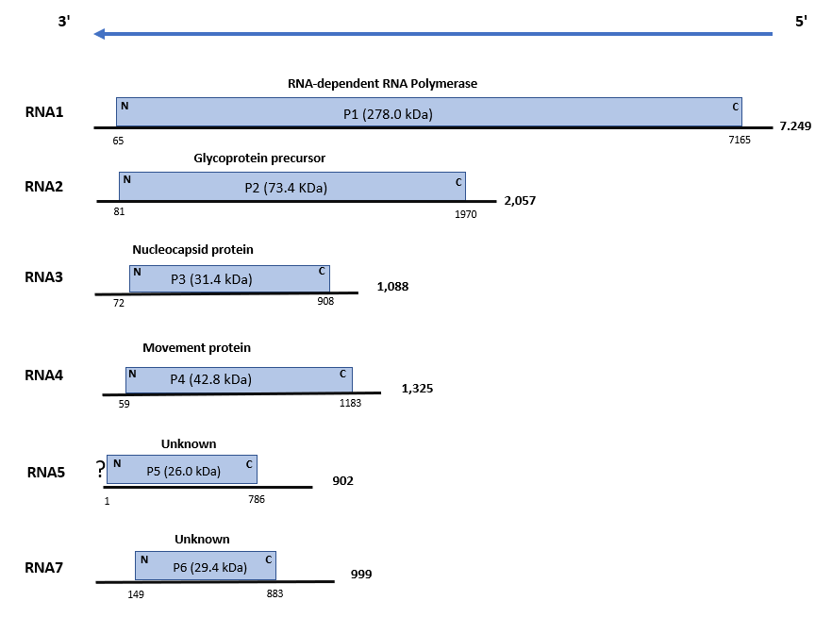

Figure 1. Genome organization of Artemisia fimovirus 1 (ArtV1). Colored boxes represent the protein encoding region (ORF) for each RNA. The length of RNAs, the putative protein product for each ORF, function (if known), and estimated molecular weight are provided. The genomic RNAs are not drawn to scale. (? = incomplete 3’-UTR sequence)

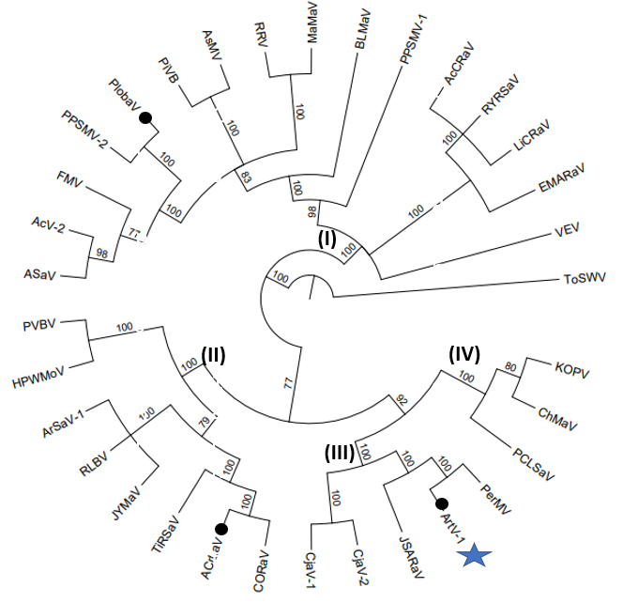

Figure 2. Phylogenetic tree constructed with amino acid sequences encoded by RNA1 (RdRp), of recognized emaraviruses and corresponding tentative species (indicated by a blue star). Alignment was obtained using ClustalW, and analyzed by the Neighbor-Joining method, with 1000 bootstrap replicates. The percentage of replicate trees in which the associated taxa clustered together in the bootstrap is shown next to the branches (when >60%). TSWV (tomato spotted wilt virus), an orthotospovirus of the family Tospoviridae, was used as an outgroup species. Actinidia chlorotic ringspot-associated virus (AcCRaV), Actinidia virus 2 (AcV-2), Ailanthus crinkle leaf-associated virus (ACrLaV), Arceuthobium sichuanense-associated virus 1 (ArSaV-1), Artemisia fimovirus 1 (ArtV1), ash shoestring-associated virus (ASaV), aspen mosaic-associated virus (AsMaV), blackberry leaf mottle associated virus (BLMaV), Camellia japonica-associated virus 1 (CjaV-1), Camellia japonica-associated virus 2 (CjaV-2), chrysanthemum mosaic-associated virus (ChMaV), common oak ringspot-associated virus (CORaV), European mountain ash ringspot-associated virus (EMARaV), fig mosaic virus (FMV), High Plains wheat mosaic virus (HPWMoV), Japanese star anise ringspot-associated virus (JSARaV), jujube yellow mottle-associated virus (JYMaV), karaka Okahu purepure emaravirus (KOPV), lilac chlorotic ringspot-associated virus (LiCRaV), maple mottle-associated virus (MaMaV), palo verde broom virus (PVBV), pear chlorotic leaf spot-associated virus (PCLSaV), perilla mosaic virus (PerMV), pigeonpea sterility mosaic virus 1 (PPSMV-1), pigeonpea sterility mosaic virus 2 (PPSMV-2), Pistacia virus B (PiVB), Pueraria lobata-associated virus (PloAEV), raspberry leaf blotch virus (RLBV), redbud yellow ringspot-associated virus (RYRSaV), rose rosette virus (RRV), ti ringspot-associated virus (TiRSaV), and Vitis emaravirus (VEV).

References

Elbeaino T, Digiaro M, Mielke-Ehret N, Muehlbach HP, Martelli GP and ICTV Report Consortium (2018) ICTV Virus Taxonomy Profile: Fimoviridae. J Gen Virol 99(11):1478-1479. PMID: 30204080, DOI: 10.1099/jgv.0.001143
Mielke N, Muehlbach HP (2007) A novel, multipartite, negative-strand RNA virus is associated with the ringspot disease of European mountain ash (Sorbus aucuparia L.). J Gen Virol 88:1337–1346. PMID: 17374780. DOI 10.1099/vir.0.82715-0
Rivarez MPS, Pecman A, Bačnik K, Maksimović O, Vučurović A, Seljak G, Mehle N, Gutiérrez‑Aguirre I, Ravnikar M, Kutnjak D (2023) In-depth study of tomato and weed viromes reveals undiscovered plant virus diversity in an agroecosystem. Microbiome 11:60, https://doi.org/10.1186/s40168-023-01500-6
https://talk.ictvonline.org/ictv-reports/ictv_online_report/negative-sense-rna-viruses/w/fimoviridae/981/genus-emaravirus

