Part 1: TITLE, AUTHORS, APPROVALS, etc

Code assigned: | 2023.004D
Short title: A new species in the genus Gyrovirus (Anelloviridae)

Author(s) and email address(es)
Fehér E, Kaszab E, Bányai K | feher.eniko@vmri.hu; kaszab.eszter@vmri.hu; bkrota@hotmail.com
Author(s) institutional address(es) (optional)
Veterinary Medical Research Institute (FE, KE, BK)
Corresponding author
Enikő Fehér
List the ICTV Study Group(s) that have seen this proposal

ICTV Study Group comments and response of proposer
ICTV Study Group votes on proposal
Study Group | Number of members
 | Votes support | Votes against | No vote
Anelloviridae SG | 7
Authority to use the name of a living person
Is any taxon name used here derived from that of a living person (Y/N)

Taxon name | Person from whom the name is derived | Permission attached (Y/N)

Submission dates
Date first submitted to SC Chair | 3 May 2023
Date of this revision (if different to above) | 19 June 2023

ICTV-EC comments and response of the proposer
Part 2: NON-TAXONOMIC PROPOSAL
Text of proposal

Part 3: TAXONOMIC PROPOSAL
Name of accompanying Excel module
2023.004D.N.v2.Anelloviride_1nsp.xlsx
Abstract
A novel gyrovirus has been detected in mixed organ sample (liver, spleen brain, heart, intestine) of a common pheasant (Phasianus colchicus) in Hungary. The genome length of the pheasant-associated gyrovirus (PAGyV) is 2353 nt (Fehér et al., 2022). The genomic structure of the PAGyV corresponds to that of other gyroviruses (GenBank accession number OK665854) (Figure 1A). Phylogenetic analysis and pairwise identity comparison suggest that the novel virus belongs to a distinct species of the Gyrovirus genus, Anelloviridae family, and was tentatively named Gyrovirus phaco1 (Fehér et al., 2022).
Text of proposal
The 2353 nt circular ssDNA genome of the PAGyV contains putative ORFs coding for viral proteins VP1, VP2 and VP3 (Figure 1A) (Fehér et al., 2022). Phylogenetic analysis and pairwise nt identity comparison of gyrovirus VP1 nt sequences (≤67.6% nt identity of PAGyV VP1 with that of other gyroviruses) suggest that PAGyV represents a novel species within the Gyrovirus genus, Anelloviridae family (Figure 1B and 1C) (Fehér et al., 2022). Pairwise identity <69% for the VP1 nt sequences meets the criteria set by the ICTV for species demarcation, thus the PAGyV is proposed as member of a novel species named Gyrovirus phaco1.

Supporting evidence

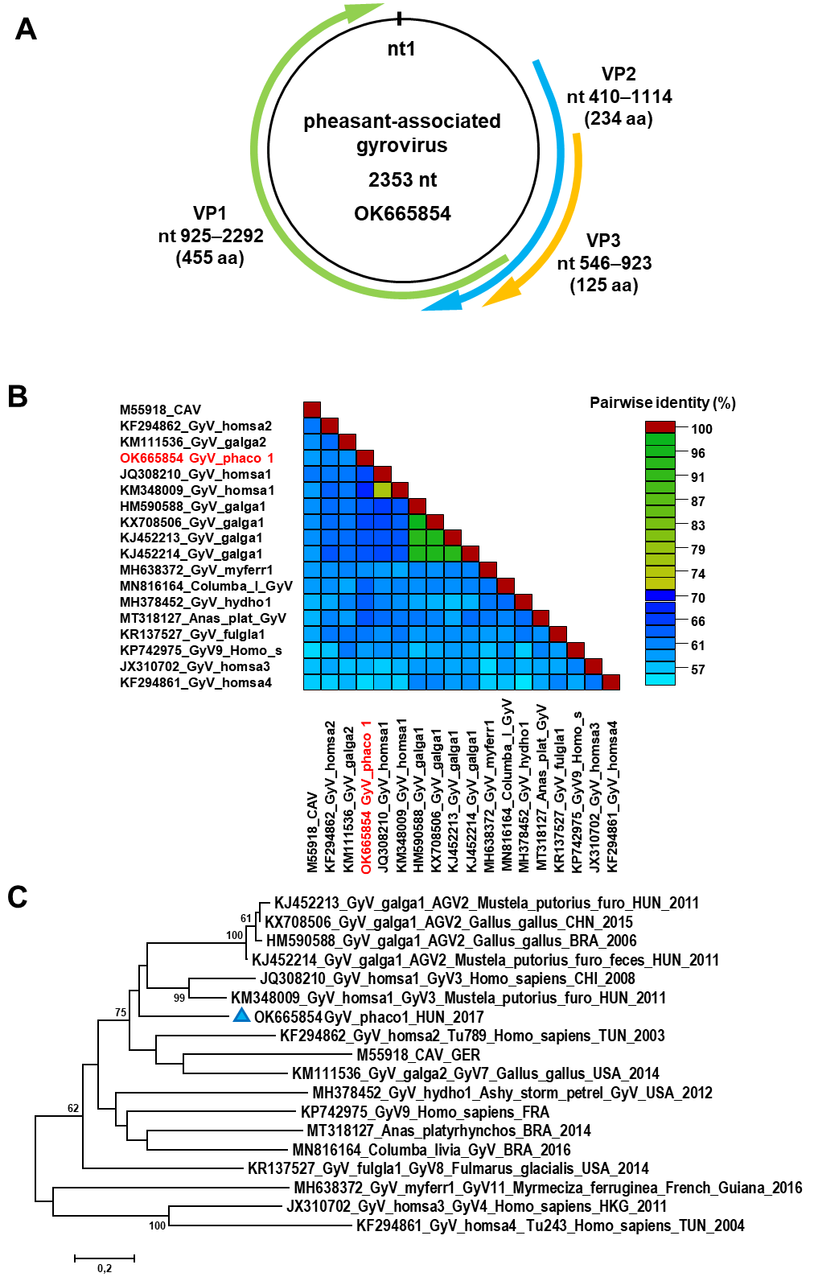

Figure 1. (A) Schematic representation of the pheasant-associated gyrovirus (PAGyV) genome. (B) VP1 nucleotide sequence based pairwise identity matrix of representative gyrovirus sequences prepared using SDT v1.2 software. (C) Unrooted maximum likelihood phylogenetic tree of representative gyrovirus VP1 sequences. The analysis was performed with the MEGA6 software, utilizing maximum likelihood method, GTR+G model, 1000 bootstrap replicates. Support values <60 are hidden. The scale bar shows substitutions per site. PAGyV is highlighted with blue triangle (Fehér et al., 2022).

References
Fehér E, Bali K, Kaszab E, Ihász K, Jakab S, Nagy B, Ursu K, Farkas SL, Bányai K (2022) A novel gyrovirus in a common pheasant (Phasianus colchicus) with poult enteritis and mortality syndrome. Arch Virol 167(5):1349-1353. https://doi.org/10.1007/s00705-022-05417-7

Guindon S, Dufayard JF, Lefort V, Anisimova M, Hordijk W, Gascuel O (2010) New Algorithms and Methods to Estimate Maximum-Likelihood Phylogenies: Assessing the Performance of PhyML 3.0. Syst Biol 59(3):307–321. https://doi.org/10.1093/sysbio/syq010

Kraberger S, Opriessnig T, Celer V, Maggi F, Okamoto H, Blomström AL, Cadar D, Harrach B, Biagini P, Varsani A (2021) Taxonomic updates for the genus Gyrovirus (family Anelloviridae): recognition of several new members and establishment of species demarcation criteria. Arch Virol 166(10):2937–2942. https://doi.org/10.1007/s00705-021-05194-9

Muhire BM, Varsani A, Martin DP (2014) SDT: A Virus Classification Tool Based on Pairwise Sequence Alignment and Identity Calculation. PLoS ONE 9(9): e108277. https://doi.org/10.1371/journal.pone.0108277

Tamura K, Stecher G, Peterson D, Filipski A, Kumar S (2013) MEGA6: Molecular Evolutionary Genetics Analysis Version 6.0. Mol Biol Evol 30:2725–2729. https://doi.org/10.1093/molbev/mst197

