Part 1: TITLE, AUTHORS, APPROVALS, etc

Code assigned: | 2023.020D
Short title: Establishing one new family, associated genera and species in the order Geplafuvirales

Author(s) and email address(es)
Varsani A, Kraberger S, Hopkins A, Lund MC, Krupovic M | Arvind.varsani@asu.edu;  Simona.kraberger@asu.edu; adhopki1@asu.edu; mclund2@asu.edu; mart.krupovic@pasteur.fr
Author(s) institutional address(es) (optional)
The Biodesign Center for Fundamental and Applied Microbiomics, Center for Evolution and Medicine, School of Life sciences, Arizona State University, Tempe, AZ 85287-5001, USA [AV, SK, AH, MCL]
Institut Pasteur, Université Paris Cité, Archaeal Virology Unit, 25 rue du Dr Roux, 75015 Paris, France [MK]
Corresponding author
Arvind Varsani
List the ICTV Study Group(s) that have seen this proposal

ICTV Study Group comments and response of proposer

ICTV Study Group votes on proposal

Study Group | Number of members
 | Votes support | Votes against | No vote
Authority to use the name of a living person

Is any taxon name used here derived from that of a living person (Y/N) | N

Taxon name | Person from whom the name is derived | Permission attached (Y/N)

Submission dates
Date first submitted to SC Chair | 14 July 2023
Date of this revision (if different to above) | 5 Oct 2023
ICTV-EC comments and response of the proposer
The proposal was deemed acceptable in the form presented at the EC meeting.

Part 2: NON-TAXONOMIC PROPOSAL
Text of proposal

Part 3: TAXONOMIC PROPOSAL
Name of accompanying Excel module
2023.020D.N.v2. Geplafuvirales_1nf_18ng_30nsp.xlsx
Abstract

We aim to establish a new family, Geplanaviridae, in the order Geplafuvirales to classify new virus genomes that have been identified from various sources. The new family will include 18 genera and 30 species.
Text of proposal
Geplafuvirales currently is comprised of two virus families, Geminiviridae and Genomoviridae. An informal group called CRESSV6 of cressdnaviruses has been previously described [1-4]. Here we analyze the 37 virus genomes that are part of this group (based on the Rep protein sequences) that have been identified from various sources (Table 1) (Figure 1). The Reps of these 37 viruses all have the geminivirus Rep sequence (GRS) motif [5] characteristic and specific of Reps encoded by viruses in the families Geminiviridae and Genomoviridae.

We have named the family Geplanaviridae which is derived from gemini-like Rep plant and animal associated viruses.

Genus and species demarcation

To analyze the relationships between viruses within the proposed family, we performed comparative genomics and phylogenetic analyses of the Rep proteins. Genera were delineated based on phylogenetic analyses coupled with pairwise identities and also the genome organization relative to the rep open reading frame (Figures 2 - 3).

For species demarcation we used a 78% pairwise nucleotide genome-wide sequence identity which is similar to that used for other cressdnaviricots [6-8].

Genera
Etymology of genus names - the genera names are all based on spells from Harry Potter literature.

- Acciovirus
- Aguamentivirus
- Alohovirus
- Aparevirus
- Avadavirus
- Densaugvirus
- Diffindovirus
- Engorgivirus
- Episkevirus
- Expellivirus
- Impedivirus
- Lumovirus
- Oblivivirus
- Patrovirus
- Protegovirus
- Riddikuvirus
- Stupevirus
- Wingardivirus

Etymology of species epithets
- tongis: Pteropus tonganus
- mintis: minnow tissue
- ailuris: Ailurus fulgens
- austrosis: Austrosimulium australense
- phoenis: Phoenicopteridae
- bromis: Bromus hordeaceus
- ailgensis: Ailurus fulgens
- bromhordis: Bromus hordeaceus
- trifolis: Trifolium resupinatum
- kummerois: Kummerowia striata
- airobis: airborne particulate matter
- arcechis: Arctopus echinatus
- copteris: Phoenicopteridae
- libequis: Libellula quadrimaculata
- racskinis: raccoon skin
- avheatis: Avon-Heathcote Estuary
- arilais: Arizlama virus AZLM_683
- capibaris: Capybara virus 11_cap1_98
- mincris: minnow cressvirus - tissue
- musculis: Musculium novaezelandiae
- maspris: Manatee spring
- trichosis: Trichosanthes kirilowii
- kirilis: Trichosanthes kirilowii
- yangtsis: water samples from river ports along the Yangtze River in China
- manatis: Manatee Spring
- forpesis: Forsythia suspensa
- dianchis: Dianchi freshwater lake
- arizlamas: Arizlama virus
- quadrimis: Libellula quadrimaculata
- minnis: minnow tissue

Supporting evidence

Table 1: Summary of the viruses classified into various genera and species in the family Geplanaviridae in the order Geplafuvirales

Genus | Species | Accession # | Virus | Year | Country | Host /source | Isolate
Protegovirus | Protegovirus tongis | KT732831 | Pacific flying fox faeces associated circular DNA virus-2 | 2015 | Tonga | Pteropus tonganus | Tbat_H_103763
Protegovirus | Protegovirus tongis | KT732829 | Pacific flying fox faeces associated circular DNA virus-2 | 2015 | Tonga | Pteropus tonganus | Tbat_A_103763
Protegovirus | Protegovirus mintis | MH617562 | CRESS virus sp. ctbg173 | 2017 | USA | Minnow tissue | ctbg173
Protegovirus | Protegovirus ailuris | MZ556147 | Red panda feces-associated circular DNA virus 11 | 2015 | China: Sichuan Province | Ailurus fulgens | AliP02cress04-2015
Diffindovirus | Diffindovirus austrosis | MK433230 | Blackfly DNA Virus 16 | 2015 | New Zealand: Canterbury | Austrosimulium australense | SF02_377
Avadavirus | Avadavirus phoenis | MN928944 | CRESS virus sp. fmg067cre2 | 2018 | China | Phoenicopteridae | fmg067cre2
Alohovirus | Alohovirus bromis | KM510190 | Bromus-associated circular DNA virus 1 | 2012 | New Zealand | Bromus hordeaceus | BasCV-1_NZ-NZG03_Wel-2012
Alohovirus | Alohovirus bromis | KM510189 | Bromus-associated circular DNA virus 1 | 2012 | New Zealand | Bromus sp. | BasCV-1_NZ-NZG01_Sef-2012
Alohovirus | Alohovirus ailgensis | MZ556204 | Red panda feces-associated circular DNA virus 12 | 2020 | China: Sichuan Province | Ailurus fulgens | Rpf011unssDNA01-5
Alohovirus | Alohovirus bromhordis | KP005454 | Bromus-associated circular DNA virus 4 | 2013 | France | Bromus hordeaceus | BasCV-4_FR38-38-Cam
Alohovirus | Alohovirus trifolis | KP005453 | Trifolium-associated circular DNA virus 1 | 2013 | France | Trifolium resupinatum | TasCV-1_FR34-34-Cam
Stupevirus | Stupevirus kummerois | MN891814 | Kummerowia striata CRESS virus pt119-nep-9 | - | China | Kummerowia striata | pt119-nep-9
Aparevirus | Aparevirus airobis | MW678915 | Virus sp. D1_753 | 2009 | USA: Pinal County, Arizona | airborne particulate matter | D1_753
Lumovirus | Lumovirus arcechis | MH425569 | Arctopus echinatus-associated virus 2-76-E | 2012 | South Africa | Arctopus echinatus | 2-76-E
Impedivirus | Impedivirus copteris | MN928943 | CRESS virus sp. fmg067cir3 | 2018 | China | Phoenicopteridae | fmg067cir3
Impedivirus | Impedivirus libequis | KM598398 | Odonata-associated circular virus-15 | 2012 | USA | Libellula quadrimaculata | OdasCV-15-US-1640LM1-12
Aguamentivirus | Aguamentivirus racskinis | MK012475 | Circoviridae sp. ctcc28 | 2017 | USA | Procyon lotor | ctcc28
Aguamentivirus | Aguamentivirus avheatis | MW588038 | Avon-Heathcote Estuary associated circular virus 25 | 2016 | United Kingdom | Cygnus olor | Abbotsbury/A/2016
Aguamentivirus | Aguamentivirus avheatis | KM874355 | Avon-Heathcote Estuary associated circular virus 25 | 2012 | New Zealand | Austrovenus stutchburyi | AHEaCV-25-NZ-2942CO-2012
Aguamentivirus | Aguamentivirus avheatis | KM874356 | Avon-Heathcote Estuary associated circular virus 25 | 2012 | New Zealand | Paphies subtriangulata | AHEaCV-25-NZ-2250TU-2012
Aguamentivirus | Aguamentivirus avheatis | KM874358 | Avon-Heathcote Estuary associated circular virus 25 | 2012 | New Zealand | Amphibola crenata | AHEaCV-25-NZ-3789GA-2012
Aguamentivirus | Aguamentivirus avheatis | KM874357 | Avon-Heathcote Estuary associated circular virus 25 | 2012 | New Zealand | Benthic sediment | AHEaCV-25-NZ-1935SG-2012
Wingardivirus | Wingardivirus arilais | MW697535 | Arizlama virus AZLM_683 | 12-Jul | USA | Lake water sample | AZLM_683
Wingardivirus | Wingardivirus capibaris | MK570173 | Capybara virus 11_cap1_98 | 2016 | Brazil | Hydrochoerus hydrochaeris | cap1_98
Engorgivirus | Engorgivirus mincris | MH616705 | CRESS virus sp. ctce103 | 2017 | USA | Minnow tissue | ctce103
Engorgivirus | Engorgivirus musculis | KP153501 | Lake Sarah-associated circular virus-45 | 2013 | New Zealand | Musculium novaezelandiae | LSaCV-45-LSCO-2013
Densaugvirus | Densaugvirus maspris | MW202708 | CRESS virus sp. ctrLR020 | 2019 | USA | Manatee Spring | ctrLR020
Episkevirus | Episkevirus trichosis | MW202452 | CRESS virus sp. ctrD6136 | 2019 | USA | Manatee Spring | ctrD6136
Episkevirus | Episkevirus kirilis | MN891804 | Trichosanthes kirilowii CRESS virus t111-nep-5 | - | China | Trichosanthes kirilowii | pt111-nep-5
Oblivivirus | Oblivivirus yangtsis | MW346688 | CRESS virus sp. 1aq-CRESS-1 | 2017 | China: Yangtze River | Water samples from river ports along the Yangtze River in China | 1aq-CRESS-1
Riddikuvirus | Riddikuvirus manatis | MW202840 | CRESS virus sp. ctKR5164 | 2019 | USA | Manatee Spring | ctKR5164
Riddikuvirus | Riddikuvirus forpesis | MN891803 | Trichosanthes kirilowii CRESS virus pt111-nep-4 | - | China | Trichosanthes kirilowii | pt111-nep-4
Riddikuvirus | Riddikuvirus forpesis | MN891795 | Forsythia suspensa CRESS virus pt110-nep-1 | - | China | Forsythia suspensa | pt110-nep-1
Patrovirus | Patrovirus dianchis | KT149395 | Circovirus-like genome DCCV-2 | 2010 | China | Freshwater lake (Dianchi) sample (< 0.5m) | DCCV-2
Acciovirus | Acciovirus arizlamas | MW697536 | Arizlama virus AZLM_678 | 2012 | USA | Lake water sample | AZLM_678
Acciovirus | Acciovirus quadrimis | KM598390 | Odonata-associated circular virus-7 | 2012 | USA | Libellula quadrimaculata | OdasCV-7-US-1706LM1-12
Expellivirus | Expellivirus minnis | MH616944 | CRESS virus sp. ctdg299 | 2017 | USA | Minnow tissue | ctdg299

Figure 1: Maximum likelihood phylogenetic tree inferred from Rep proteins of members of the phylum Cressdnaviricota. Related sequence groups are collapsed into triangles, the side lengths of which are proportional to the distances between the closest and farthest leaf nodes. The alignment was trimmed with TrimAL [9] with gap threshold of 0.2. The maximum likelihood phylogenetic tree was constructed using IQtree [10] with automatic selection of the best-fit substitution model for a given alignment, which was Q.pfam+F+R10. Numbers at the nodes represent aLRT branch supports. The scale bar represents the number of substitutions per site.

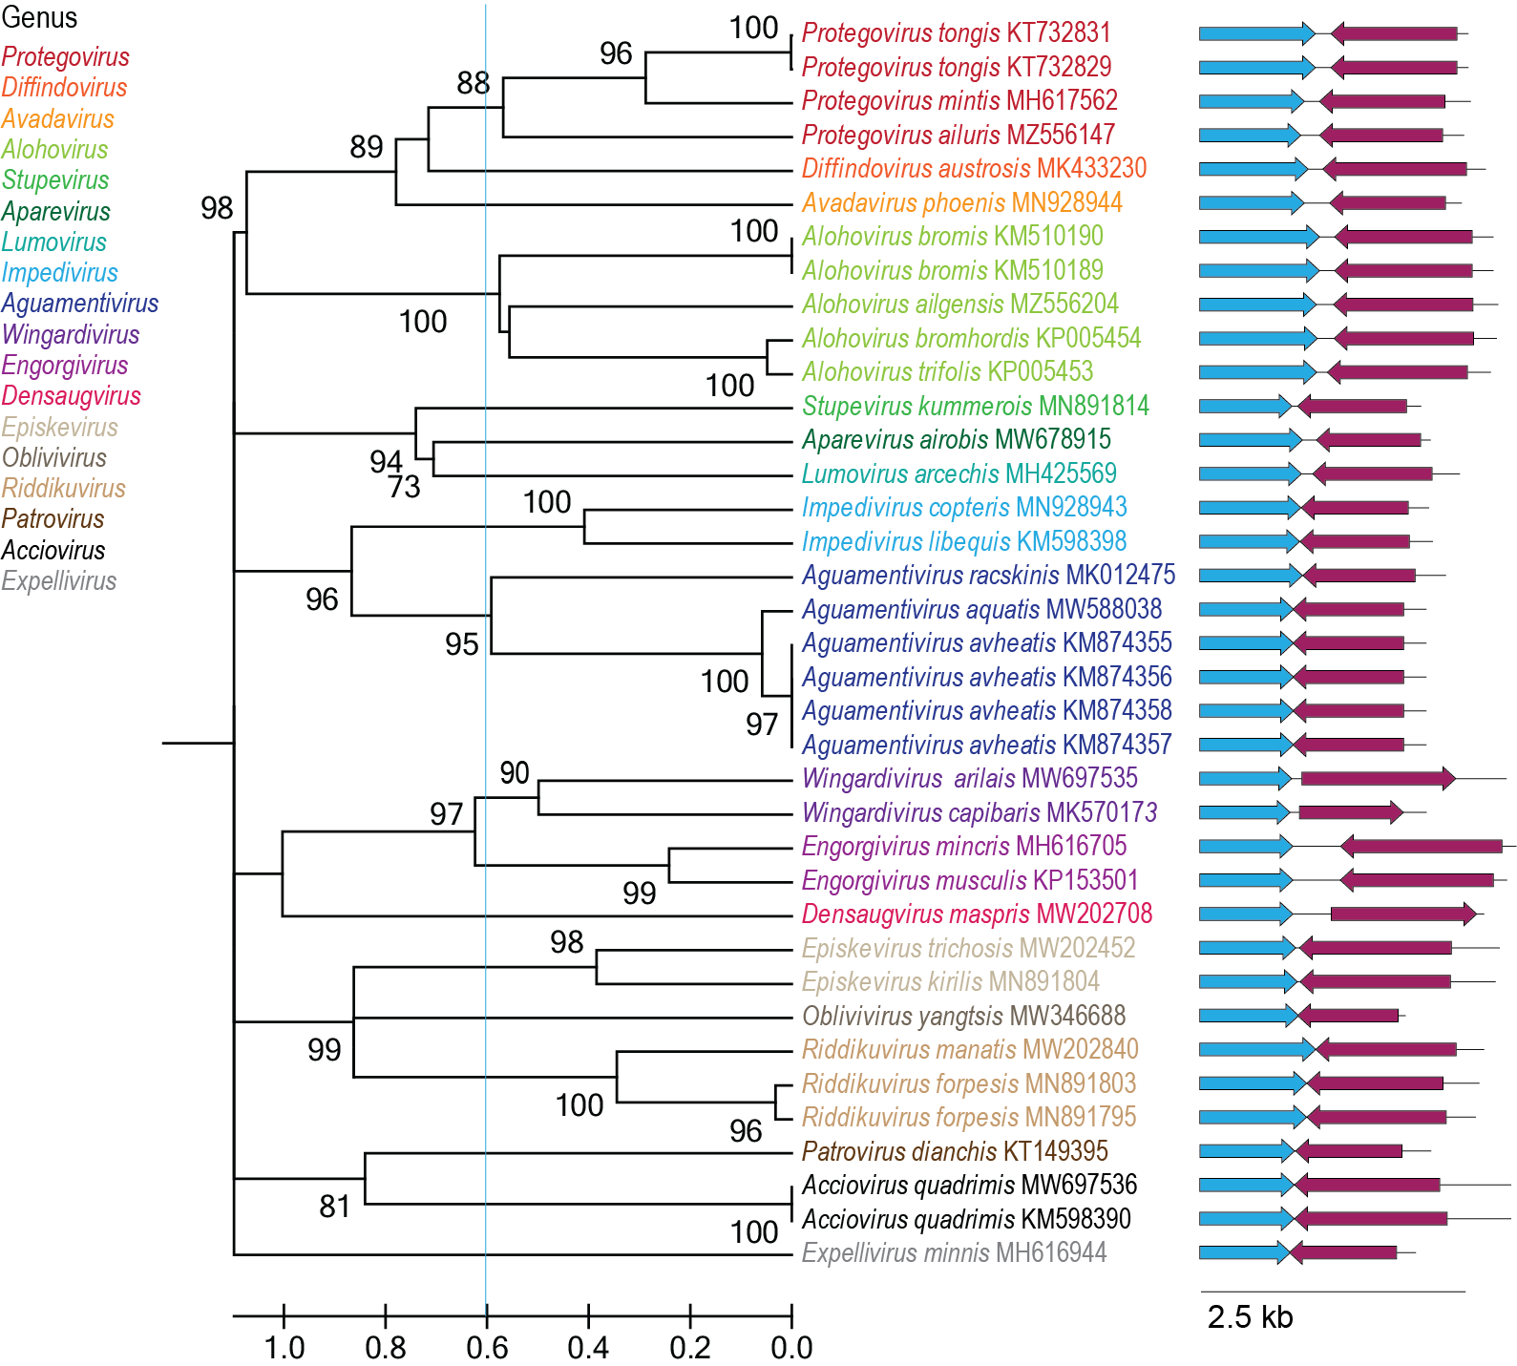

Figure 2: Maximum likelihood phylogenetic tree of the Rep sequences of the members of the Geplanaviridae family inferred with PhyML 3.0 [11] with LG+I+G model determined as the best substitution model using ProtTest 3 [12] and rooted with representative sequences of members of the family Geminiviridae. The species belonging to the same genus are indicated with the same color. Numbers at the nodes represent aLRT branch supports. The cyan line shows a proposed demarcation of genera. The genome organization relative to the rep ORF is shown to the right of the phylogeny.

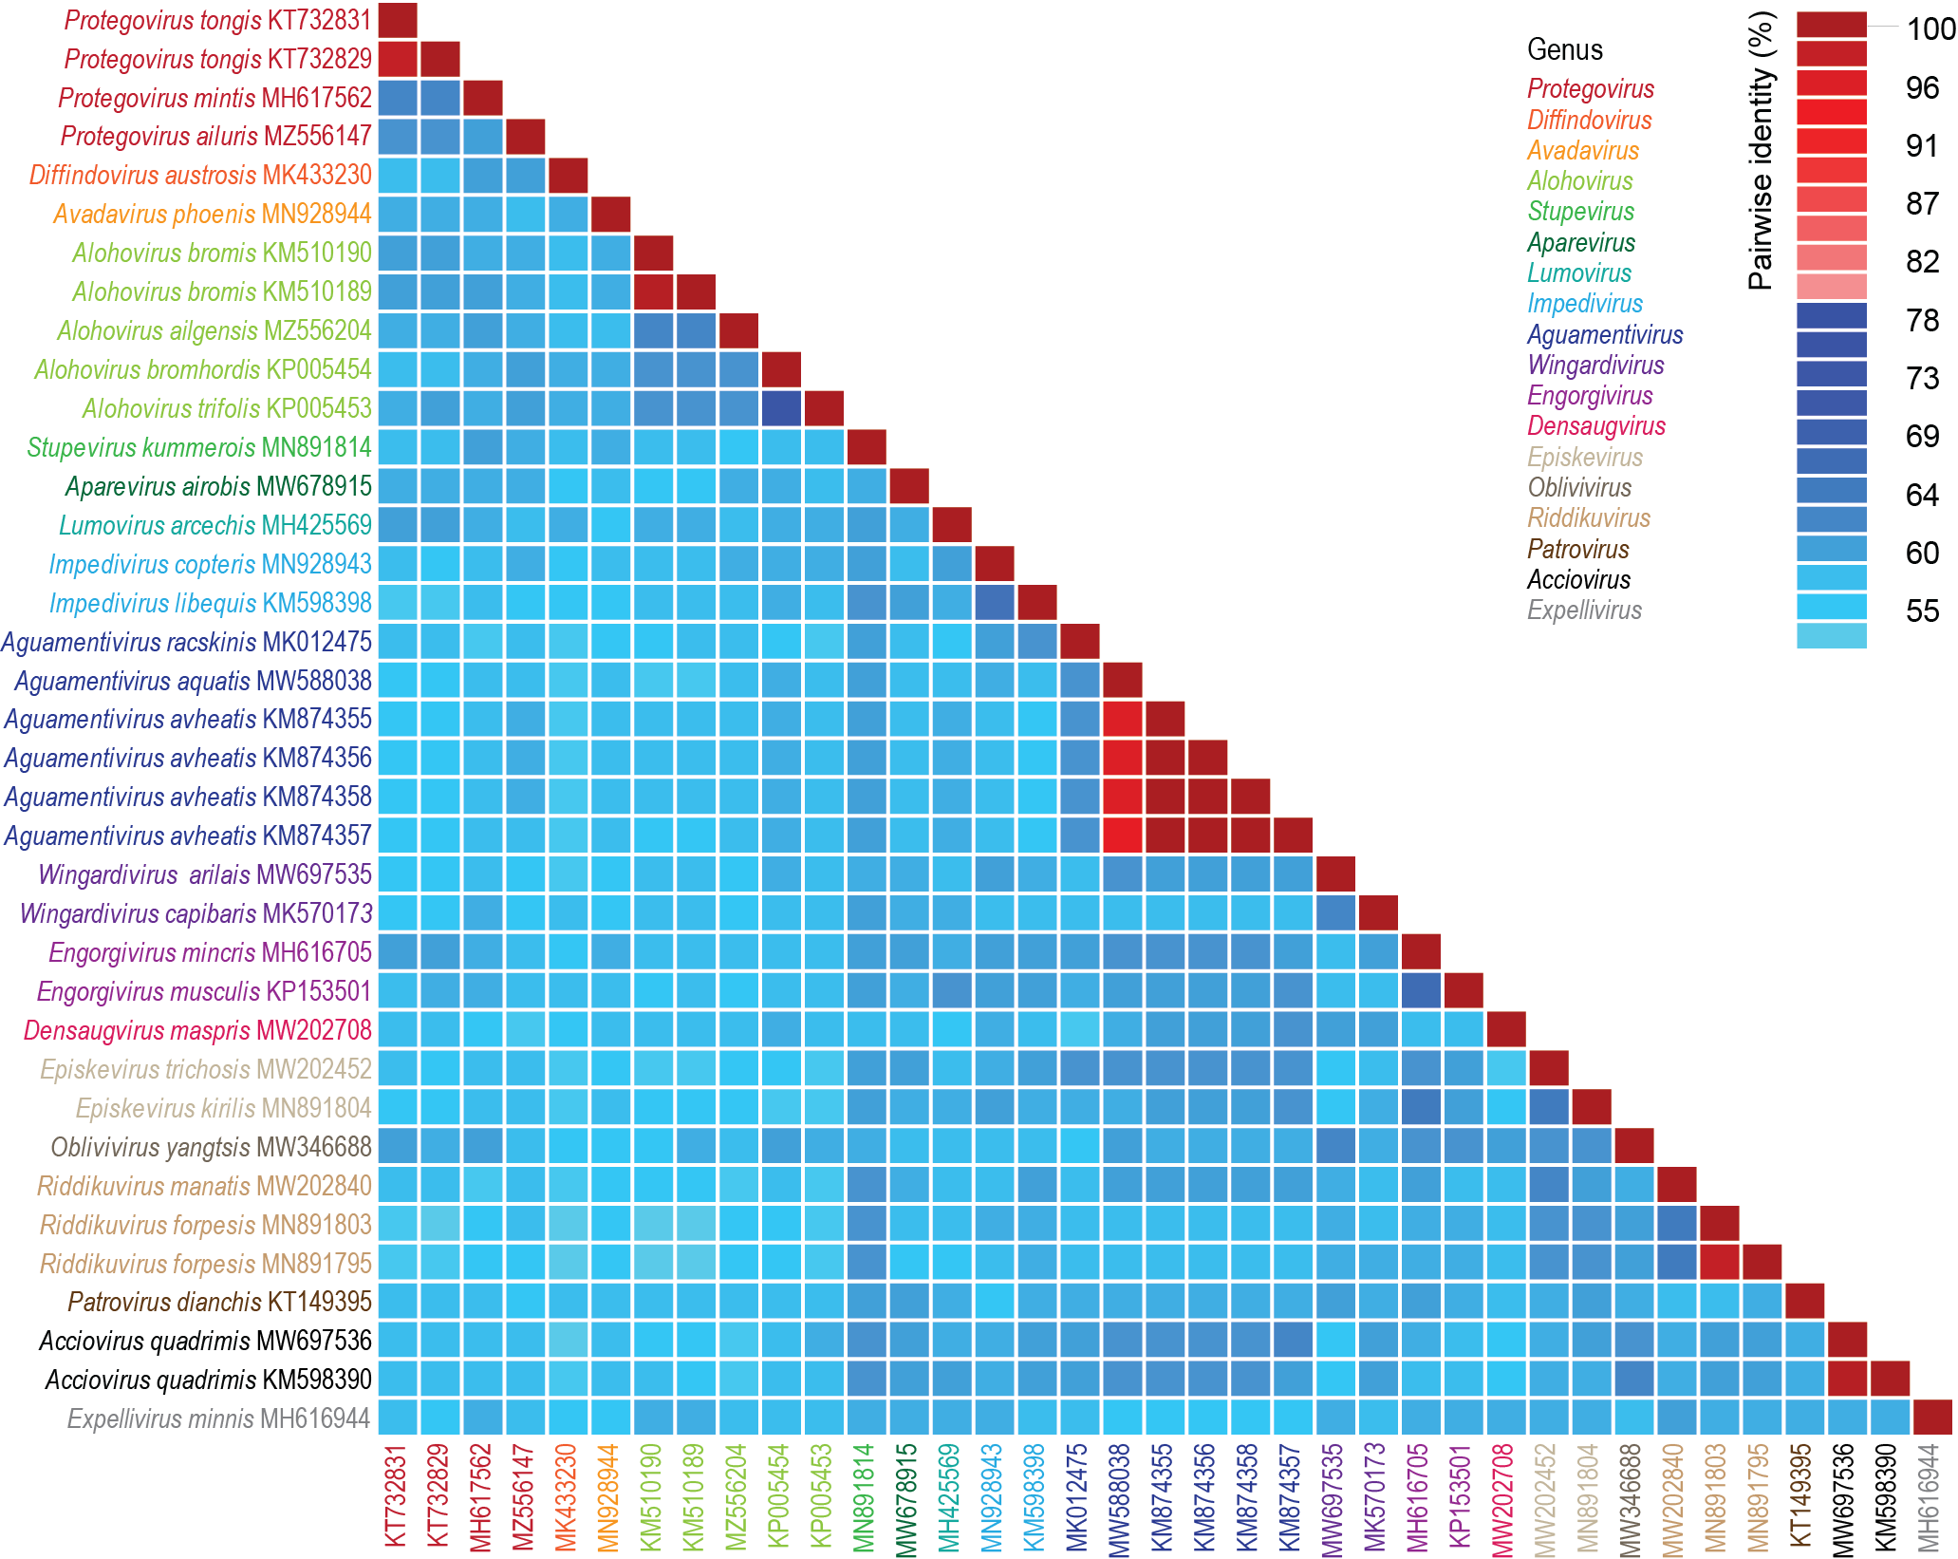

Figure 3: A ‘two color’ pairwise identity matrix of members of the family Geplanaviridae with 78% species threshold, using full genome comparison, inferred using SDT v1.2 [13].

References

- Kazlauskas D, Varsani A, Krupovic M (2018) Pervasive Chimerism in the Replication-Associated Proteins of Uncultured Single-Stranded DNA Viruses. Viruses 10:187. doi:10.3390/v10040187. PMID:29642587
- Kazlauskas D, Varsani A, Koonin EV, Krupovic M (2019) Multiple origins of prokaryotic and eukaryotic single-stranded DNA viruses from bacterial and archaeal plasmids. Nat Commun 10:3425. doi:10.1038/s41467-019-11433-0. PMID:31366885
- Kinsella CM, Deijs M, Becker C, Broekhuizen P, van Gool T, Bart A, Schaefer AS, van der Hoek L. (2022). Host prediction for disease-associated gastrointestinal cressdnaviruses. Virus Evol. 8(2):veac087. doi: 10.1093/ve/veac087. PMID: 36325032; PMCID: PMC9615429.
- Krupovic M, Varsani A, Kazlauskas D, Breitbart M, Delwart E, Rosario K, Yutin N, Wolf YI, Harrach B, Zerbini FM, Dolja VV, Kuhn JH, Koonin EV (2020) Cressdnaviricota: A virus phylum unifying seven families of Rep-encoding viruses with single-stranded, circular DNA genomes. J Virol 94:e00582-20. doi:10.1128/JVI.00582-20. PMID:32269128
- Nash TE, Dallas MB, Reyes MI, Buhrman GK, Ascencio-Ibañez JT, Hanley-Bowdoin L. (2011). Functional analysis of a novel motif conserved across geminivirus Rep proteins. J Virol. 85(3):1182-92. doi: 10.1128/JVI.02143-10.. PMID: 21084480; PMCID: PMC3020519.
- Krupovic M, Varsani A. (2022). Naryaviridae, Nenyaviridae, and Vilyaviridae: three new families of single-stranded DNA viruses in the phylum Cressdnaviricota. Arch. Virol. 167, 2907–2921.PMID: 36098801 DOI: 10.1007/s00705-022-05557-w
- Varsani A, Krupovic M (2017) Sequence-based taxonomic framework for the classification of uncultured single-stranded DNA viruses of the family Genomoviridae. Virus Evol 3:vew037. doi:10.1093/ve/vew037. PMID:28458911
- Varsani A, Krupovic M (2018) Smacoviridae: a new family of animal-associated single-stranded DNA viruses. Arch Virol 163:2005-2015. doi:10.1007/s00705-018-3820-z. PMID:29572596
- Capella-Gutierrez S, Silla-Martinez JM, Gabaldon T (2009) trimAl: a tool for automated alignment trimming in large-scale phylogenetic analyses. Bioinformatics 25:1972-3. doi:10.1093/bioinformatics/btp348. PMID:19505945
- Minh BQ, Schmidt HA, Chernomor O, Schrempf D, Woodhams MD, von Haeseler A, Lanfear R (2020) IQ-TREE 2: New Models and Efficient Methods for Phylogenetic Inference in the Genomic Era. Mol Biol Evol 37:1530-1534. doi:10.1093/molbev/msaa015. PMID:32011700
- Guindon S, Dufayard JF, Lefort V, Anisimova M, Hordijk W, Gascuel O (2010) New algorithms and methods to estimate maximum-likelihood phylogenies: assessing the performance of PhyML 3.0. Syst Biol 59:307-321. PMID: 20525638; doi: 10.1093/sysbio/syq010
- Darriba D, Taboada GL, Doallo R, Posada D. (2011). ProtTest 3: fast selection of best-fit models of protein evolution. Bioinformatics. 27(8):1164-5. doi: 10.1093/bioinformatics/btr088. Epub 2011 Feb 17. PMID: 21335321; PMCID: PMC5215816.
- Muhire BM, Varsani A, Martin DP (2014) SDT: A Virus Classification Tool Based on Pairwise Sequence Alignment and Identity Calculation. Plos One 9:e108277. PMID: 25259891; PMCID: PMC4178126.

