Part 1: TITLE, AUTHORS, APPROVALS, etc

Code assigned: | 2023.003D
Short title: Two new species in the genus Circovirus (Cirlivirales: Circoviridae)
Author(s) and email address(es)
Fehér E, Kaszab E, Bányai K | feher.eniko@vmri.hu; kaszab.eszter@vmri.hu;  bkrota@hotmail.com
Author(s) institutional address(es) (optional)
Veterinary Medical Research Institute (FE, KE, BK)
Corresponding author
Enikő Fehér
List the ICTV Study Group(s) that have seen this proposal

Circoviridae Study Group
ICTV Study Group comments and response of proposer
ICTV Study Group votes on proposal
Study Group | Number of members
 | Votes support | Votes against | No vote
Circoviridae SG | 8 |  | 2
Authority to use the name of a living person
Is any taxon name used here derived from that of a living person (Y/N) | N

Taxon name | Person from whom the name is derived | Permission attached (Y/N)

Submission dates
Date first submitted to SC Chair | 21 May 2023
Date of this revision (if different to above)
ICTV-EC comments and response of the proposer
Part 2: NON-TAXONOMIC PROPOSAL
Text of proposal

Part 3: TAXONOMIC PROPOSAL
Name of accompanying Excel module
2023.003D.A.v2.Circoviridae_2nsp.xlsx
Abstract
Two novel circoviruses have been detected in organ samples (kidney, liver, bursa of Fabricius) of a little bittern (Ixobrychus minutus) and a European bee-eater (Merops apiaster) in Hungary. The genome length is 1935 nt and 1960 nt for the little bittern circovirus (TorCV) and European bee-eater circovirus (GyurCV), respectively (Fehér et al., 2022). The genomic structure of both viruses (GenBank accession numbers MZ710934 and MZ710935) corresponds to that of other circoviruses (Figure 1). Phylogenetic analysis and pairwise identity comparisons suggest that the two novel viruses belong to two distinct species of the Circovirus genus, Circoviridae family (Fehér et al., 2022), that were tentatively named Circovirus torpegem and Circovirus gyurgyalag.
Text of proposal
The genome of the TorCV and GyurCV contain putative ORFs of the replication-associated protein (Rep) in the viral DNA strand and the capsid protein in the replicative complementary DNA strand. The nonanucleotide motif (TAGTATTAC) locates upstream of the rep in the 5’ intergenic region (Figure 1) (Fehér et al., 2022). Phylogenetic analysis of complete circovirus genome sequences (Figure 2) suggests that the TorCV and GyurCV represent two novel species within the Circovirus genus, Circoviridae family. The genome of the novel viruses show <41.5% genome-wide nt identitiy with that of other circoviruses (Figure 3) (Fehér et al., 2022). Genome-wide sequence pairwise identity <80% meets the criterion set by the ICTV for species demarcation of circoviruses, thus the TorCV and GyurCV are proposed as members of two novel species named Circovirus torpegem and Circovirus gyurgyalag, respectively.

Supporting evidence

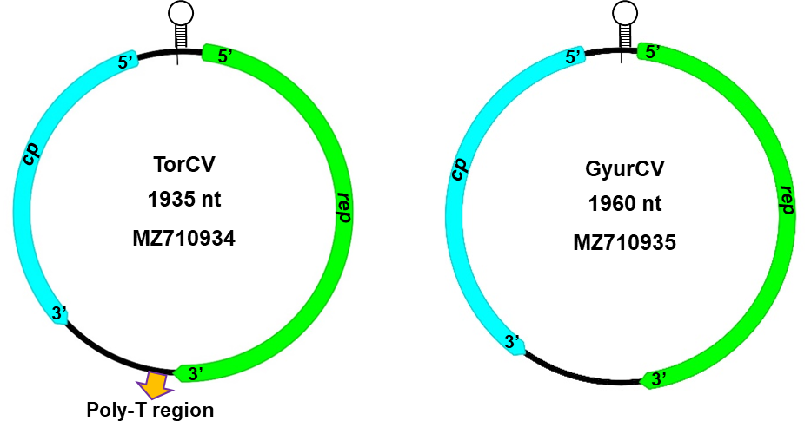

Figure 1. Schematic representation of the genomic structure of the little bittern circovirus (TorCV) and European bee-eater (GyurCV) circovirus. The TAGTATTAC nonanucleotide motif and the flanking inverted repeats are labelled as stem-loops (Fehér et al., 2022).

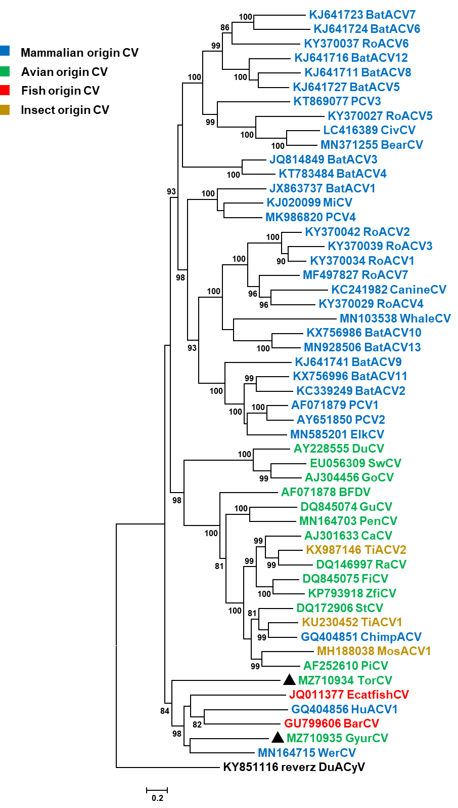

Figure 2. Maximum likelihood phylogenetic tree of complete circovirus genome sequences. The tree was generated with the PhyML software, GTR+G+I model and aLRT SH-like branch support (values lower than 80 are hidden). Reverse complement sequence of the duck associated cyclovirus 1 (GenBank accession no. KY851116) was used as root of the tree. The scale bar shows substitutions per site. The little bittern circovirus (TorCV) and European bee-eater circovirus (GyurCV) are highlighted with black triangles (Fehér et al., 2022).

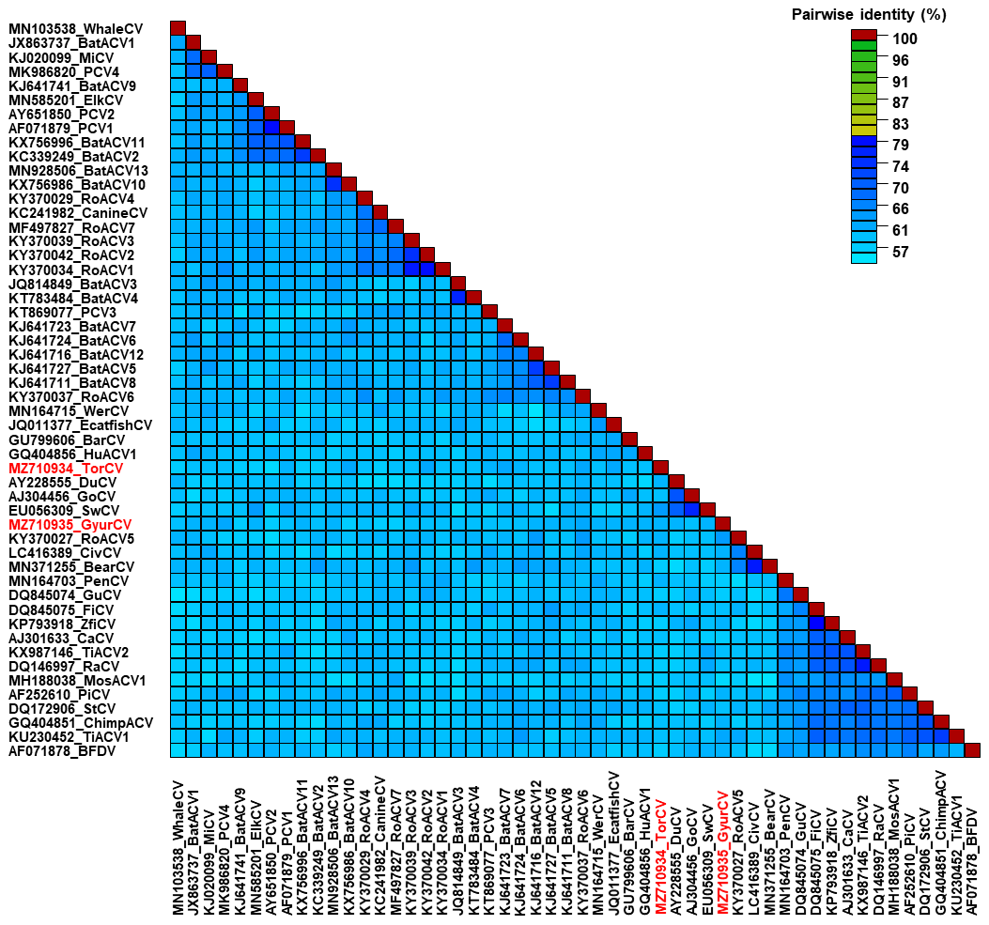

Figure 3. Pairwise identity matrix of complete circovirus genome sequences using SDT v1.2 software. The little bittern circovirus (TorCV) and European bee-eater circovirus (GyurCV) are highlighted with red font (Fehér et al., 2022).

References

Fehér E, Kaszab E, Bali K, Hoitsy M, Sós E, Bányai K (2022) Novel Circoviruses from Birds Share Common Evolutionary Roots with Fish Origin Circoviruses. Life (Basel) 12(3):368. https://doi.org/10.3390/life12030368

Guindon S, Dufayard JF, Lefort V, Anisimova M, Hordijk W, Gascuel O (2010) New Algorithms and Methods to Estimate Maximum-Likelihood Phylogenies: Assessing the Performance of PhyML 3.0. Syst Biol 59(3):307–321. https://doi.org/10.1093/sysbio/syq010

Krupovic M, Varsani A, Kazlauskas D, Breitbart M, Delwart E, Rosario K, Yutin N, Wolf YI, Harrach B, Zerbini FM, Dolja VV, Kuhn JH, Koonin EV (2020) Cressdnaviricota: a virus phylum unifying seven families of Rep-encoding viruses with single-stranded, circular DNA genomes. J Virol 94(12):e00582-20. https://doi.org/10.1128/JVI.00582-20

Rosario K, Breitbart M, Harrach B, Segalés J, Delwart E, Biagini P, Varsani A (2017) Revisiting the taxonomy of the family Circoviridae: establishment of the genus Cyclovirus and removal of the genus Gyrovirus. Arch Virol 162:1447–1463. https://doi.org/10.1007/s00705-017-3247-y

Muhire BM, Varsani A, Martin DP (2014) SDT: A virus classification tool based on pairwise sequence alignment and identity calculation. PLoS ONE 9(9): e108277. https://doi.org/10.1371/journal. pone.0108277

