Part 1: TITLE, AUTHORS, APPROVALS, etc

Code assigned: | 2023.018D
Short title: Establishing one new family, associated genera and species in the order Mulpavirales

Author(s) and email address(es)
Varsani A, Hopkins A, Lund MC, Kraberger S, Krupovic M | Arvind.varsani@asu.edu;  adhopki1@asu.edu; mclund2@asu.edu;  Simona.kraberger@asu.edu; mart.krupovic@pasteur.fr
Author(s) institutional address(es) (optional)
The Biodesign Center for Fundamental and Applied Microbiomics, Center for Evolution and Medicine, School of Life sciences, Arizona State University, Tempe, AZ 85287-5001, USA [AV, AH, MCL, SK]
Institut Pasteur, Université Paris Cité, Archaeal Virology Unit, 25 rue du Dr Roux, 75015 Paris, France [MK]

Corresponding author
Arvind Varsani

List the ICTV Study Group(s) that have seen this proposal

ICTV Study Group comments and response of proposer

ICTV Study Group votes on proposal

Study Group | Number of members
 | Votes support | Votes against | No vote

Authority to use the name of a living person

Is any taxon name used here derived from that of a living person (Y/N) | N

Taxon name | Person from whom the name is derived | Permission attached (Y/N)

Submission dates
Date first submitted to SC Chair | 14 July 2023
Date of this revision (if different to above) | 5 Oct 2023
ICTV-EC comments and response of the proposer
The proposal was deemed acceptable in the form presented at the EC meeting.

Part 2: NON-TAXONOMIC PROPOSAL
Text of proposal

Part 3: TAXONOMIC PROPOSAL
Name of accompanying Excel module
2023.018D.N.v2. Mulpavirales_1nf_9ng_9nsp.xlsx
Abstract

We aim to establish a new family, Anicreviridae, in the order Mulpavirales to classify various new virus genomes (n=16) that have been identified from various sources. The new family will include 9 genera and 9 species.
Text of proposal
There are currently three viral families (Amesuviridae, Metaxyviridae and Nanoviridae) in the order Mulpavirales. The Reps of Alphasatellitidae phylogenetically cluster with those of the members of Mulpavirales (Figure 1). Here we analyze the 16 virus genomes (Table 1) whose Reps are most closely related to those of the members of Amesuviridae, Metaxyviridae, Nanoviridae and Alphasatellitidae (Figure 1). This group of viruses has been informally referred to in the literature as CRESSV4 [1-4]. Whereas the monophyly of the Amesuviridae clade is well supported in the phylogenetic analyses, its position relative to other members of the Mulpavirales and Gredzevirales is less stable. We opted to include Amesuviridae into the order Mulpavirales, but its membership in this order might need revision once more members become available.

We propose the name Anicreviridae, for animal associated CRESS viruses.

Genus and species demarcation

To analyze the relationships between viruses in the proposed family Anicreviridae, we performed comparative genomics and phylogenetic analyses of the Rep proteins. Genera were delineated based on phylogenetic analyses coupled with pairwise identities and also the genome organization relative to the rep open reading frame (Figures 2 - 3).

For species demarcation we used a 78% pairwise nucleotide genome-wide sequence identity which is similar to that used other cressdnaviruses [5-7].

Genera
Etymology of genus names

- Manawavirus: oasis in Maori - kōmanawa
- Rakkovirus: ocean in Muscogee - Uehvtkvrakko
- Otevirus: beach in Muscogee - ote
- Baranavirus: ocean in Garifuna - barana
- Pekavirus: Flying fox in Tongan - peka
- Kopavirus: fly in Maori - kopa
- Ketkevirus: spider in Sencoteen (Saanich Dialect) - ḴETḴEĆOLE
- Patavirus: drop of water in Maori - Pata
- Uewvirus: water in Muscogee - Uewv

Etymology of species epithets

- kapowais: dragonfly in Maori - kapowai
- canuewis: fly in Muscogee - cana; water in Muscogee - uewv
- soksuewis: bug in Muscogee – soksv; water in Muscogee - uewv
- uduis: whale in Garifuna - udu
- fuais: –fruit in Tongan - fua
- kakawais: Cyanoramphus auriceps in Maori - Ḵākāwaiariki
- silauonis: tent in Sencoteen (Saanich Dialect) - SILÁU¸TW̱; KELEJTEN
- kakahis: Freshwater mussel; Hyridella menziesi in Maori - Kākahi
- yahnais: fish in Muscogee - Yah-nah-sah

Supporting evidence
Table 1: Summary of the viruses classified in the new family Anicreviridae.

Genus | Species | Accession # | Virus | Year | Country | Host /source | Isolate
Manawavirus | Manawavirus kapowais | KP153517 | Dragonfly larvae associated circular virus-10 | 2013 | New Zealand | water | DflaCV-10-LSWA-2013
Manawavirus | Manawavirus kapowais | KP153516 | Dragonfly larvae associated circular virus-10 | 2013 | New Zealand | Musculium novaezelandiae | DflaCV-10-LSCO-2013
Manawavirus | Manawavirus kapowais | KP153518 | Dragonfly larvae associated circular virus-10 | 2013 | New Zealand | sediment | DflaCV-10-LSSO-2013
Manawavirus | Manawavirus kapowais | KP153519 | Dragonfly larvae associated circular virus-10 | 2013 | New Zealand | Echyridella menziesii | DflaCV-10-LSMU-2013
Manawavirus | Manawavirus kapowais | KF738884 | Dragonfly larvae associated circular virus-10 | 2012 | New Zealand | Xanthocnemis zealandica | DflaCV-10_NZ-XZ2-LS
Manawavirus | Manawavirus kapowais | KP153521 | Dragonfly larvae associated circular virus-10 | 2013 | New Zealand | Potamopyrgus antipodarum | DflaCV-10-LSGA-2013
Manawavirus | Manawavirus kapowais | KP153520 | Dragonfly larvae associated circular virus-10 | 2013 | New Zealand | Procordulia grayi | DflaCV-10-LSLA-2013
Manawavirus | Manawavirus kapowais | KF738885 | Dragonfly larvae associated circular virus-10 | 2012 | New Zealand | Xanthocnemis zealandica | DflaCV-10_NZ-XZ1-LH
Rakkovirus | Rakkovirus canuewis | KR528548 | Littorina sp. associated circular virus I0041 | - | USA | Littorina sp. | I0041
Otevirus | Otevirus soksuewis | KR528568 | Palaemonetes sp. common grass shrimp associated circular virus I0006H | - | USA | Palaemonetes sp. | I0006H
Baranavirus | Baranavirus uduis | MW562321 | Delphin virus 1 | 2016 | Saint Vincent and the Grenadines | Orcinus orca | 3_2016_1939
Pekavirus | Pekavirus fuais | KT732818 | Pacific flying fox faeces associated circular DNA virus-3 | 2014 | Tonga | Pteropus tonganus | Tbat_38855
Kopavirus | Kopavirus kakawais | JX908739 | Cyanoramphus nest associated circular X DNA virus | 2012 | New Zealand | Cyanoramphus auriceps | CynNCXV
Ketkevirus | Ketkevirus silauonis | MH545533 | Tentweb spider associated circular virus 1 | 2017 | Canada: Victoria, British Columbia | Cyrtophora sp. | BC_I1608_E1
Patavirus | Patavirus kakahis | KP153409 | Lake Sarah-associated circular virus-11 | 2013 | New Zealand | Echyridella menziesii | LSaCV-11-LSMU-2013
Uewvirus | Uewvirus yahnais | MH617188 | CRESS virus sp. ctcc62 | 2017 | USA | rainbow trout tissue | ctcc62

Figure 1: Maximum likelihood phylogenetic tree inferred from Rep proteins of members of the phylum Cressdnaviricota. Related sequence groups are collapsed into triangles, the side lengths of which are proportional to the distances between the closest and farthest leaf nodes. The alignment was trimmed with TrimAL [8] with gap threshold of 0.2. The maximum likelihood phylogenetic tree was constructed using IQtree [9] with automatic selection of the best-fit substitution model for a given alignment, which was Q.pfam+F+R10. Numbers at the nodes represent aLRT branch supports. The scale bar represents the number of substitutions per site.

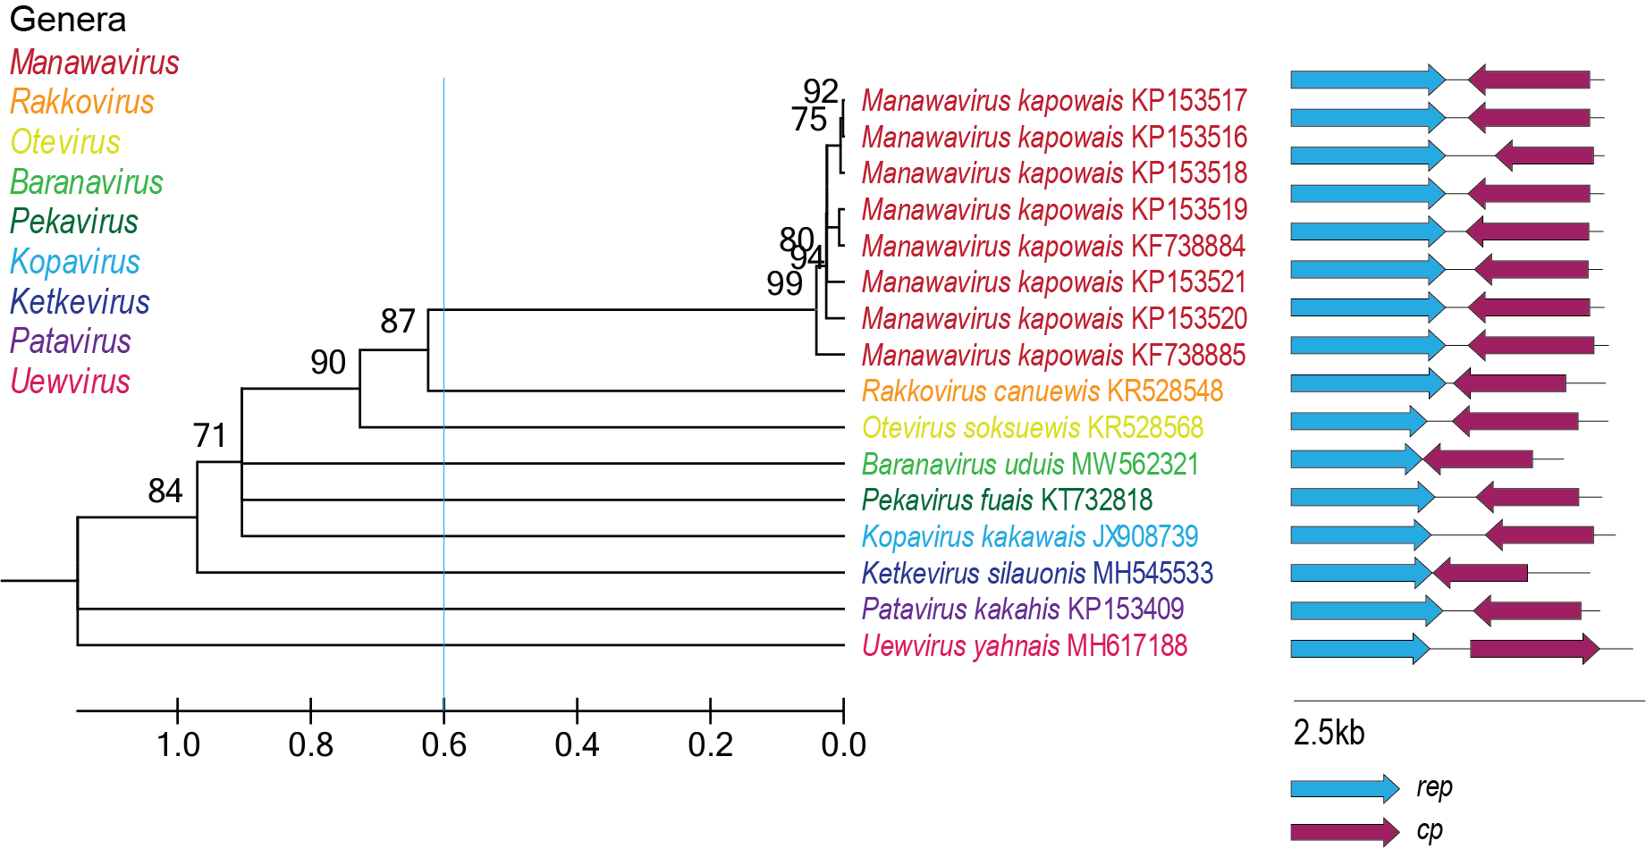
Figure 2: Maximum likelihood phylogenetic tree of the Rep sequences of the members of the Anicreviridae family inferred with PhyML 3.0 [10] with rtREV+I+G+F model determined as the best substitution model using ProtTest 3 [11] and rooted with representative sequences of members of the family Smacoviridae. The species belonging to the same genus are indicated with the same color. Numbers at the nodes represent aLRT branch supports. The cyan line shows a proposed demarcation of genera. The genome organization relative to the rep ORF is shown to the right of the phylogeny.

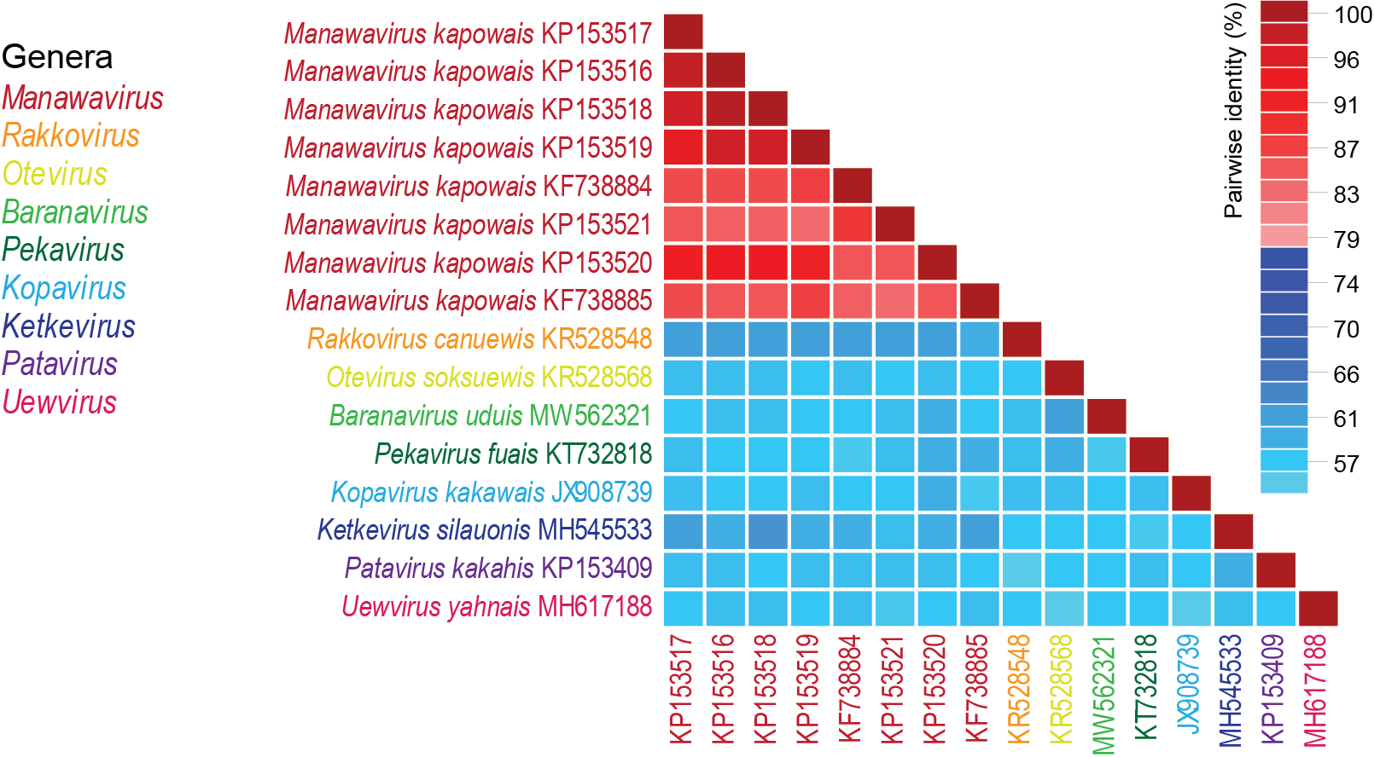
Figure 3: A ‘two color’ pairwise identity matrix of members of the family Anicreviridae with 78% species threshold, using full genome comparison, inferred using SDT v1.2 [12].

References

- Kazlauskas D, Varsani A, Krupovic M (2018) Pervasive Chimerism in the Replication-Associated Proteins of Uncultured Single-Stranded DNA Viruses. Viruses 10:187. doi:10.3390/v10040187. PMID:29642587
- Kazlauskas D, Varsani A, Koonin EV, Krupovic M (2019) Multiple origins of prokaryotic and eukaryotic single-stranded DNA viruses from bacterial and archaeal plasmids. Nat Commun 10:3425. doi:10.1038/s41467-019-11433-0. PMID:31366885
- Kinsella CM, Deijs M, Becker C, Broekhuizen P, van Gool T, Bart A, Schaefer AS, van der Hoek L. (2022) Host prediction for disease-associated gastrointestinal cressdnaviruses. Virus Evol. 8(2):veac087. doi: 10.1093/ve/veac087. PMID: 36325032; PMCID: PMC9615429.
- Krupovic M, Varsani A, Kazlauskas D, Breitbart M, Delwart E, Rosario K, Yutin N, Wolf YI, Harrach B, Zerbini FM, Dolja VV, Kuhn JH, Koonin EV (2020) Cressdnaviricota: a Virus Phylum Unifying Seven Families of Rep-Encoding Viruses with Single-Stranded, Circular DNA Genomes. J Virol 94:e00582-20. doi:10.1128/JVI.00582-20. PMID:32269128
- Krupovic M, Varsani A, 2022. Naryaviridae, Nenyaviridae, and Vilyaviridae: three new families of single-stranded DNA viruses in the phylum Cressdnaviricota. Arch. Virol. 167, 2907–2921.PMID: 36098801 DOI: 10.1007/s00705-022-05557-w
- Varsani A, Krupovic M (2017) Sequence-based taxonomic framework for the classification of uncultured single-stranded DNA viruses of the family Genomoviridae. Virus Evol 3:vew037. doi:10.1093/ve/vew037. PMID:28458911
- Varsani A, Krupovic M (2018) Smacoviridae: a new family of animal-associated single-stranded DNA viruses. Arch Virol 163:2005-2015. doi:10.1007/s00705-018-3820-z. PMID:29572596
- Capella-Gutierrez S, Silla-Martinez JM, Gabaldon T (2009) trimAl: a tool for automated alignment trimming in large-scale phylogenetic analyses. Bioinformatics 25:1972-3. doi:10.1093/bioinformatics/btp348. PMID:19505945
- Minh BQ, Schmidt HA, Chernomor O, Schrempf D, Woodhams MD, von Haeseler A, Lanfear R (2020) IQ-TREE 2: New Models and Efficient Methods for Phylogenetic Inference in the Genomic Era. Mol Biol Evol 37:1530-1534. doi:10.1093/molbev/msaa015. PMID:32011700
- Guindon S, Dufayard JF, Lefort V, Anisimova M, Hordijk W, Gascuel O (2010) New algorithms and methods to estimate maximum-likelihood phylogenies: assessing the performance of PhyML 3.0. Syst Biol 59:307-321. PMID: 20525638; doi: 10.1093/sysbio/syq010
- Darriba D, Taboada GL, Doallo R, Posada D. (2011).ProtTest 3: fast selection of best-fit models of protein evolution. Bioinformatics. 27(8):1164-5. doi: 10.1093/bioinformatics/btr088. Epub 2011 Feb 17. PMID: 21335321; PMCID: PMC5215816.
- Muhire BM, Varsani A, Martin DP (2014) SDT: A Virus Classification Tool Based on Pairwise Sequence Alignment and Identity Calculation. Plos One 9:e108277. PMID: 25259891; PMCID: PMC4178126.
- Muhire BM, Varsani A, Martin DP (2014) SDT: A Virus Classification Tool Based on Pairwise Sequence Alignment and Identity Calculation. Plos One 9:e108277. PMID: 25259891; PMCID: PMC4178126.

