Part 1: TITLE, AUTHORS, APPROVALS, etc

Code assigned: | 2023.022D
Short title: Establishing one new order (Ringavirales), one new family and associated genera and species in the class Arfiviricetes (phylum Cressdnaviricota)
Author(s) and email address(es)
Varsani A, Lund MC, Hopkins A, Kraberger S, Krupovic M | Arvind.varsani@asu.edu; mclund2@asu.edu; adhopki1@asu.edu; Simona.kraberger@asu.edu; mart.krupovic@pasteur.fr
Author(s) institutional address(es) (optional)
The Biodesign Center for Fundamental and Applied Microbiomics, Center for Evolution and Medicine, School of Life sciences, Arizona State University, Tempe, AZ 85287-5001, USA [AV, MCL, AH, SK]
Institut Pasteur, Université Paris Cité, Archaeal Virology Unit, 25 rue du Dr Roux, 75015 Paris, France [MK]

Corresponding author
Arvind Varsani

List the ICTV Study Group(s) that have seen this proposal

ICTV Study Group comments and response of proposer

ICTV Study Group votes on proposal

Study Group | Number of members
 | Votes support | Votes against | No vote
Authority to use the name of a living person

Is any taxon name used here derived from that of a living person (Y/N) | N

Taxon name | Person from whom the name is derived | Permission attached (Y/N)

Submission dates
Date first submitted to SC Chair | 14 July 2023
Date of this revision (if different to above) | 5 Oct 2023
ICTV-EC comments and response of the proposer
The proposal was deemed acceptable in the form presented at the EC meeting.

Part 2: NON-TAXONOMIC PROPOSAL
Text of proposal

Part 3: TAXONOMIC PROPOSAL
Name of accompanying Excel module
2023.022D.N.v2.Ringavirales_1no_1nf_8ng_15nsp.xlsx
Abstract

We propose a new order, Ringavirales, in the class Arfiviricetes (phylum Cressdnaviricota), including a new family Pecoviridae with 8 genera and 15 species.

Text of proposal
CRESSV1 is an informal group of viruses in the phylum Cressdnaviricota [1-4]. Within this group various viruses have been identified from animal samples, including primates.

In the global phylogeny of Rep proteins, CRESSV1 forms a clade outside of existing orders (Figure 1) and we propose considering it as a separate new order within the class Arfiviricetes. The order name, Ringavirales, is derived from Latin ringa for “ring”, referring to circularity of the virus genomes. Phan et al. [5] named the human derived viruses in this group as pecoviruses - Peruvian stool-associated circo-like viruses. Thus, we propose to name the family Pecoviridae.

Genus and species demarcation

We undertook comparative genomics and phylogenetic analyses of the Rep proteins of members of this group to determine their relationships. Genera were delineated based on phylogenetic analyses coupled with pairwise identities and also the genome organization relative to the rep open reading frame (Figures 2 - 3).

For species demarcation, we used a 78% pairwise nucleotide genome-wide sequence identity which is similar to that used for other cressdnaviruses [6-8].

Genera
Etymology of genus names

- Intivirus: inti - sun (Quechua - Cuzco dialect)
- Cinchivirus: Cinchi Roca - The second Inca, son of Manco Capac
- Quillavirus: Quilla - Moon (Quechua)
- Tambotovirus: Tambotoco - The cave from which the first mythical Incas emerged
- Amaruvirus: Tupac Amaru - Youngest son of Manco Inca
- Yaviravirus: Yavira - Shrine on the slope of Picchu mountain
- Macochavirus: Mamacocha - Mother Lake
- Capamivirus: Capac Raymi - Ritual month including the December solstice (Quechua)

Etymology of species epithets

- Runais: runa - adult person (Quechua - Cuzco dialect)
- quris: quri - gold (Quechua - Cuzco dialect)
- surtixais: surtixa - ring (Quechua - Cuzco dialect)
- asulis: asul - blue (Quechua - Cuzco dialect)
- quwis: quwi - guinea pig (Quechua - Cuzco dialect)
- pakuis: paku - alpaca (Quechua - Ayacucho dialect)
- akarais: k'akara - crest of a bird (Quechua - Cuzco dialect)
- tarukais: taruka - deer (Quechua - Cuzco dialect)
- akais: aka - feces (Quechua - Cuzco dialect)
- masis: masi - fellow man (Quechua - Cuzco dialect)
- kapatais: kapatas - foreman (Quechua - Cuzco dialect)
- kucis: k''ući - pig (Quechua - Cuzco dialect)
- uywais: uywa - domestic animal (Quechua - Cuzco dialect)
- cipis: ćipi - monkey (Quechua - Ayacucho dialect)
- muyuis: muyu - round, spherical (Quechua - Cuzco dialect)

Supporting evidence

Table 1: Summary of the viruses classified in the new order Ringavirales and family Pecoviridae.

Genus | Species | Accession # | Virus | Year | Country | Host /source | Isolate
Intivirus | Intivirus runa | KT600066 | human feces pecovirus PeCV-NI | 2005 | Nicaragua | Homo sapiens | PeCV-NI
Intivirus | Intivirus runa | KT600067 | human feces pecovirus PeCV-CH | 2006 | Chile | Homo sapiens | PeCV-CH
Intivirus | Intivirus runa | KT600065 | human feces pecovirus PeCV-PE | 2013 | Peru | Homo sapiens | PeCV-PE
Intivirus | Intivirus runa | LC708000 | pecovirus sp. CRESSV1-84-AMS-02 DNA | 1984 | Netherlands | Homo sapiens | CRESSV1-84-AMS-02
Intivirus | Intivirus quri | KU043425 | unidentified circular ssDNA virus cg8094 | 2014 | USA | Macaca mulatta | cg8094
Intivirus | Intivirus surtixa | MG571897 | unidentified circular ssDNA virus V11B | 2015 | Venezuela | Homo sapiens | V11B
Intivirus | Intivirus surtixa | MG571895 | unidentified circular ssDNA virus clone V9C2 | 2015 | Venezuela | Homo sapiens | V9C2
Cinchivirus | Cinchivirus asul | OQ599927 | nanfec virus 3 V16_S08a | - | USA: Arizona | Canis latrans | V16_S08a
Cinchivirus | Cinchivirus quwi | KY370035 | rodent circovirus RtBi-CV-1/FJ2015 | 2015 | China | Bandicota indica | RtBi-CV-1/FJ2015
Quillavirus | Quillavirus paku | KM573766 | dromedary stool-associated circular ssDNA virus DcSCV_c1054 | 2013 | United Arab Emirates | Camelus dromedarius | DcSCV_c1054
Tambotovirus | Tambotovirus akara | MN379592 | chicken virus mg8_273 | 2017 | USA | Gallus gallus | mg8_273
Tambotovirus | Tambotovirus akara | MN379585 | chicken virus mg4_657 | 2017 | USA | Gallus gallus | mg4_657
Tambotovirus | Tambotovirus akara | MK012530 | circoviridae sp. ctbf43 | 2017 | USA | turkey tissue | ctbf43
Tambotovirus | Tambotovirus akara | MT138080 | CRESS virus sp. w3chi091cir4 | 2016 | China | Avian | w3chi091cir4
Tambotovirus | Tambotovirus akara | MN928925 | CRESS virus sp. gps222cir1 | 2018 | China | Chrysolophuspictus | gps222cir1
Amaruvirus | Amaruvirus taruka | MN621476 | CRESS virus sp. UJSL017 | 2016 | China | Moschus erezovskii | UJSL017
Amaruvirus | Amaruvirus aka | KJ206566 | human circovirus VS6600022 | - | Netherlands | Homo sapiens | VS6600022
Amaruvirus | Amaruvirus masi | LC708001 | pecovirus sp. CRESSV1-84-AMS-03 DNA | 1984 | Netherlands | Homo sapiens | CRESSV1-84-AMS-03
Amaruvirus | Amaruvirus masi | KU043411 | unidentified circular ssDNA virus cg1855 | 2014 | USA | Macaca mulatta | cg1855
Yaviravirus | Yaviravirus kapata | KU043424 | unidentified circular ssDNA virus cg5269 | 2014 | USA | Macaca mulatta | cg5269
Yaviravirus | Yaviravirus kapata | LC708002 | pecovirus sp. CRESSV1-84-AMS-04 DNA | 1984 | Netherlands | Homo sapiens | CRESSV1-84-AMS-04
Yaviravirus | Yaviravirus kapata | KJ417134 | porcine stool-associated circular virus 4 CP2 | 2011 | USA | Sus scrofa domesticus | CP2
Macochavirus | Macochavirus kuci | MW601954 | porcine associated circular DNA virus-3 P20_37_BR | 2014 | Brazil | Sus scrofa domesticus | P20_37_BR
Macochavirus | Macochavirus uywa | MW601953 | porcine associated circular DNA virus-2 P20_36_BR | 2014 | Brazil | Sus scrofa domesticus | P20_36_BR
unclassified | unclassified | KT862256 | bovine faeces associated circular DNA molecule 1 5_Fec60361_cow | 2011 | New Zealand | Sus scrofa domesticus | 5_Fec60361_cow
Macochavirus | Macochavirus uywa | MK462122 | fur seal faeces associated circular DNA virus CHN | 2017 | China | Sus scrofa domesticus | CHN
Macochavirus | Macochavirus uywa | LC133373 | fur seal faeces associated circular DNA virus DNA, isolate: JPN1 | 2014 | Japan | Sus scrofa domesticus | JPN1
Macochavirus | Macochavirus uywa | KF246569 | fur seal faeces associated circular DNA virus as50 | 2012 | New Zealand | Arctocephalus forsteri | as50
Macochavirus | Macochavirus uywa | MW847284 | fur seal faeces associated circular DNA virus 451_2 | 2012 | Hungary | Sus scrofa | 451_2
Macochavirus | Macochavirus uywa | MW847283 | fur seal faeces associated circular DNA virus 306_2 | 2012 | Hungary | Sus scrofa | 306_2
Capamivirus | Capamivirus cipi | MH616647 | Circoviridae sp. ctia25 | 2017 | USA | Macaca mulatta | ctia25
Capamivirus | Capamivirus muyu | LC708004 | pecovirus sp. CRESSV1-94-AMS-01 | 1994 | Netherlands | Homo sapiens | CRESSV1-94-AMS-01
Capamivirus | Capamivirus muyu | LC708003 | pecovirus sp. CRESSV1-84-AMS-05 DNA | 1984 | Netherlands | Homo sapiens | CRESSV1-84-AMS-05
Capamivirus | Capamivirus muyu | LC707999 | pecovirus sp. CRESSV1-84-AMS-01 DNA | 1984 | Netherlands | Homo sapiens | CRESSV1-84-AMS-01

Figure 1: Maximum likelihood phylogenetic tree inferred from Rep proteins of members of the phylum Cressdnaviricota. Related sequence groups are collapsed into triangles, the side lengths of which are proportional to the distances between the closest and farthest leaf nodes. The alignment was trimmed with TrimAL [9] with gap threshold of 0.2. The maximum likelihood phylogenetic tree was constructed using IQtree [10] with automatic selection of the best-fit substitution model for a given alignment, which was Q.pfam+F+R10. Numbers at the nodes represent aLRT branch supports. The scale bar represents the number of substitutions per site.

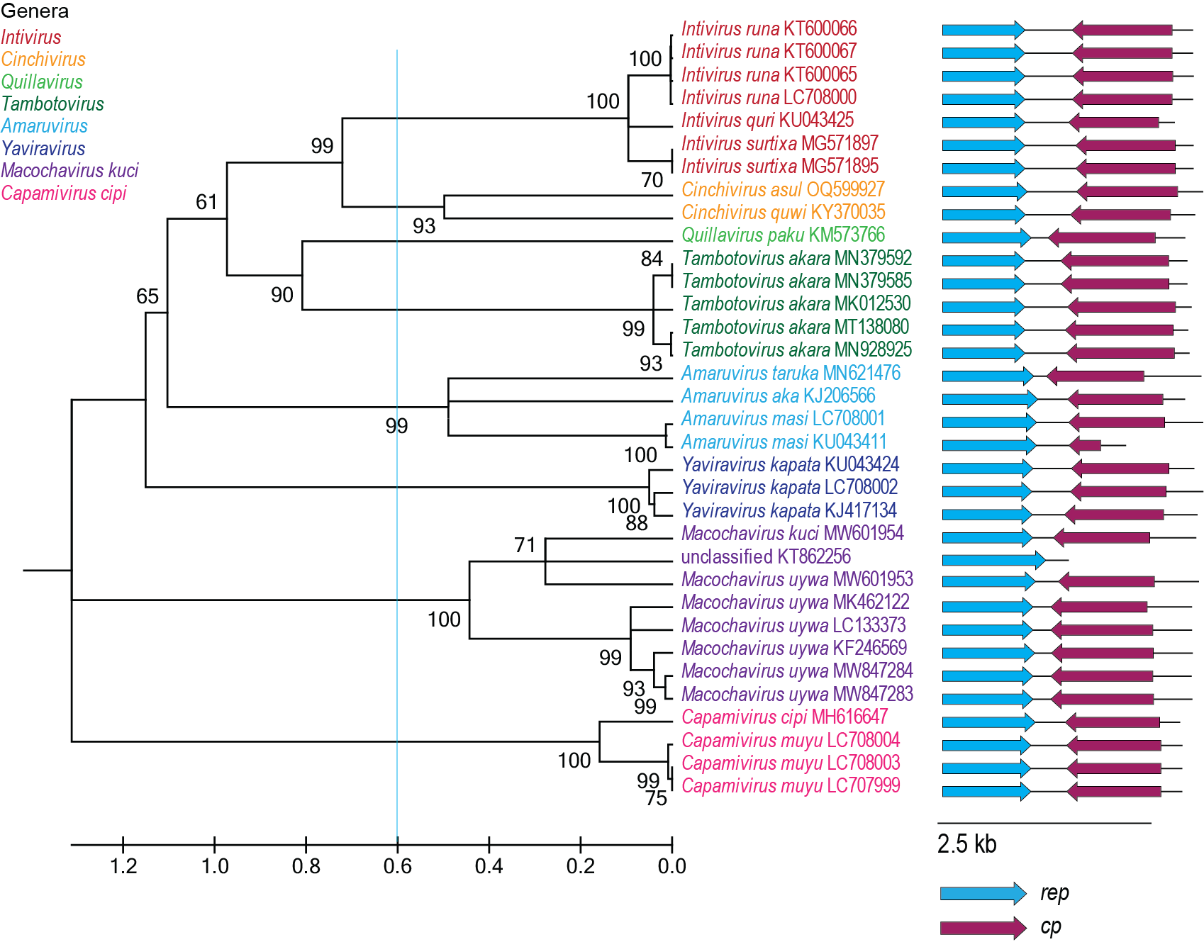
Figure 2: Maximum likelihood phylogenetic tree of the Rep sequences of the members of the Pecoviridae family inferred with PhyML 3.0 [11] with LG+I+G model determined as the best substitution model using ProtTest 3 [12] and rooted with representative sequences of members of the family Bacilladnaviridae. The species belonging to the same genus are indicated with the same color. Numbers at the nodes represent aLRT branch supports. The cyan line shows a proposed demarcation of genera. The genome organization relative to the rep ORF is shown to the right of the phylogeny.

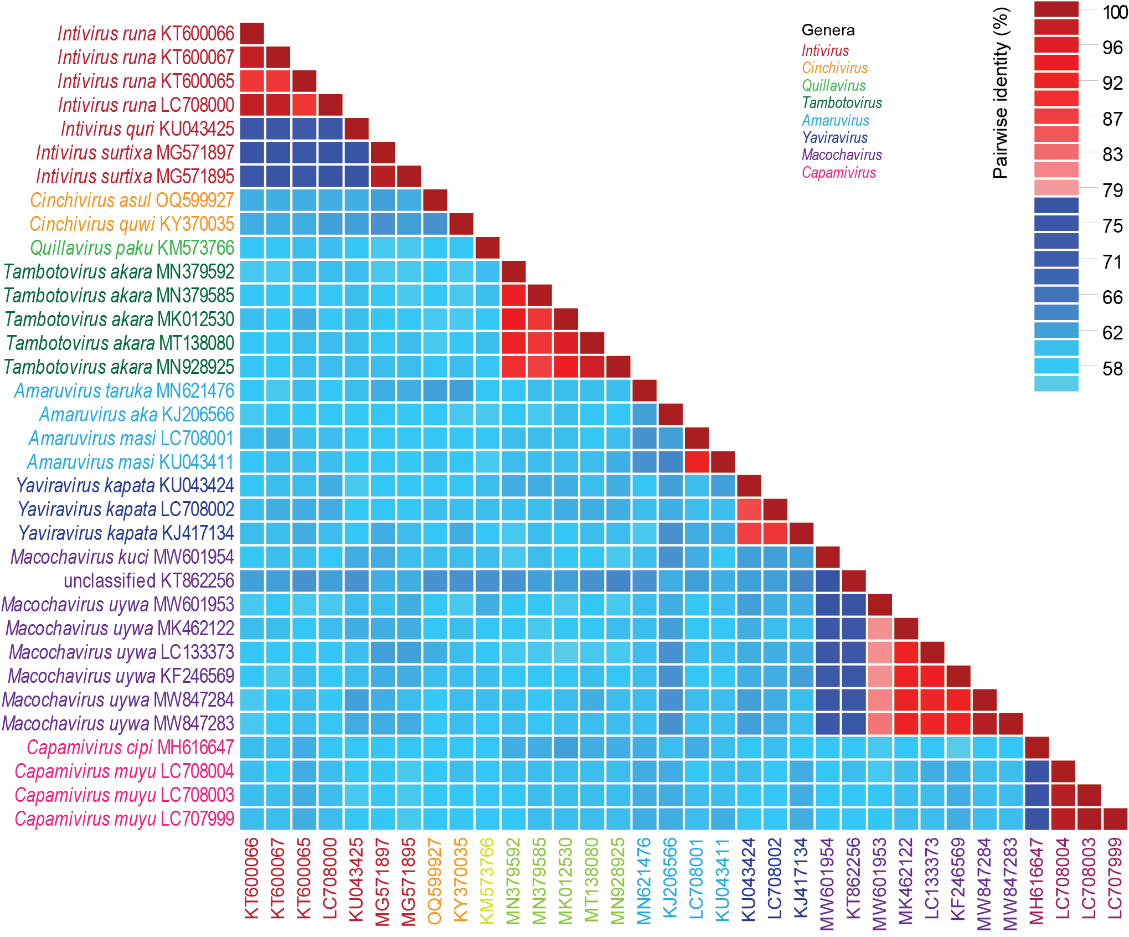
Figure 3: A ‘two color’ pairwise identity matrix of members of the family Pecoviridae with 78% species threshold s inferred using SDT v1.2 [13].

References

- Kazlauskas D, Varsani A, Krupovic M (2018) Pervasive Chimerism in the Replication-Associated Proteins of Uncultured Single-Stranded DNA Viruses. Viruses 10:187. doi:10.3390/v10040187. PMID:29642587
- Kazlauskas D, Varsani A, Koonin EV, Krupovic M (2019) Multiple origins of prokaryotic and eukaryotic single-stranded DNA viruses from bacterial and archaeal plasmids. Nat Commun 10:3425. doi:10.1038/s41467-019-11433-0. PMID:31366885
- Kinsella CM, Deijs M, Becker C, Broekhuizen P, van Gool T, Bart A, Schaefer AS, van der Hoek L. (2022). Host prediction for disease-associated gastrointestinal cressdnaviruses. Virus Evol. 8(2):veac087. doi: 10.1093/ve/veac087. PMID: 36325032; PMCID: PMC9615429.
- Krupovic M, Varsani A, Kazlauskas D, Breitbart M, Delwart E, Rosario K, Yutin N, Wolf YI, Harrach B, Zerbini FM, Dolja VV, Kuhn JH, Koonin EV (2020) Cressdnaviricota: a Virus Phylum Unifying Seven Families of Rep-Encoding Viruses with Single-Stranded, Circular DNA Genomes. J Virol 94:e00582-20. doi:10.1128/JVI.00582-20. PMID:32269128
- Phan TG, da Costa AC, Del Valle Mendoza J, Bucardo-Rivera F, Nordgren J, O'Ryan M, Deng X, Delwart E. (2016). The fecal virome of South and Central American children with diarrhea includes small circular DNA viral genomes of unknown origin. Arch Virol. 161(4):959-66. doi: 10.1007/s00705-016-2756-4. Epub 2016 Jan 19. PMID: 26780893; PMCID: PMC4814309.
- Krupovic M, Varsani A, 2022. Naryaviridae, Nenyaviridae, and Vilyaviridae: three new families of single-stranded DNA viruses in the phylum Cressdnaviricota. Arch. Virol. 167, 2907–2921.PMID: 36098801 DOI: 10.1007/s00705-022-05557-w
- Varsani A, Krupovic M (2017) Sequence-based taxonomic framework for the classification of uncultured single-stranded DNA viruses of the family Genomoviridae. Virus Evol 3:vew037. doi:10.1093/ve/vew037. PMID:28458911
- Varsani A, Krupovic M (2018) Smacoviridae: a new family of animal-associated single-stranded DNA viruses. Arch Virol 163:2005-2015. doi:10.1007/s00705-018-3820-z. PMID:29572596
- Capella-Gutierrez S, Silla-Martinez JM, Gabaldon T (2009) trimAl: a tool for automated alignment trimming in large-scale phylogenetic analyses. Bioinformatics 25:1972-3. doi:10.1093/bioinformatics/btp348. PMID:19505945
- Minh BQ, Schmidt HA, Chernomor O, Schrempf D, Woodhams MD, von Haeseler A, Lanfear R (2020) IQ-TREE 2: New Models and Efficient Methods for Phylogenetic Inference in the Genomic Era. Mol Biol Evol 37:1530-1534. doi:10.1093/molbev/msaa015. PMID:32011700
- Guindon S, Dufayard JF, Lefort V, Anisimova M, Hordijk W, Gascuel O (2010) New algorithms and methods to estimate maximum-likelihood phylogenies: assessing the performance of PhyML 3.0. Syst Biol 59:307-321. PMID: 20525638; doi: 10.1093/sysbio/syq010
- Darriba D, Taboada GL, Doallo R, Posada D. (2011).ProtTest 3: fast selection of best-fit models of protein evolution. Bioinformatics. 27(8):1164-5. doi: 10.1093/bioinformatics/btr088. Epub 2011 Feb 17. PMID: 21335321; PMCID: PMC5215816.
- Muhire BM, Varsani A, Martin DP (2014) SDT: A Virus Classification Tool Based on Pairwise Sequence Alignment and Identity Calculation. Plos One 9:e108277. PMID: 25259891; PMCID: PMC4178126.

