Part 1: TITLE, AUTHORS, APPROVALS, etc

Code assigned: | 2023.019D
Short title: Establishing one new family, associated genera and species in the order Cirlivirales
Author(s) and email address(es)
Varsani A, Hopkins A, Lund MC, Kraberger S, Krupovic M | Arvind.varsani@asu.edu;  adhopki1@asu.edu; mclund2@asu.edu;  Simona.kraberger@asu.edu; mart.krupovic@pasteur.fr
Author(s) institutional address(es) (optional)

The Biodesign Center for Fundamental and Applied Microbiomics, Center for Evolution and Medicine, School of Life sciences, Arizona State University, Tempe, AZ 85287-5001, USA [AV, AH, MCL, SK]
Institut Pasteur, Université Paris Cité, Archaeal Virology Unit, 25 rue du Dr Roux, 75015 Paris, France [MK]

Corresponding author
Arvind Varsani

List the ICTV Study Group(s) that have seen this proposal

ICTV Study Group comments and response of proposer

ICTV Study Group votes on proposal

Study Group | Number of members
 | Votes support | Votes against | No vote

Authority to use the name of a living person

Is any taxon name used here derived from that of a living person (Y/N) | N

Taxon name | Person from whom the name is derived | Permission attached (Y/N)

Submission dates
Date first submitted to SC Chair | 14 July 2023
Date of this revision (if different to above) | 5 Oct 2023
ICTV-EC comments and response of the proposer
The proposal was deemed acceptable in the form presented at the EC meeting.

Part 2: NON-TAXONOMIC PROPOSAL
Text of proposal

Part 3: TAXONOMIC PROPOSAL
Name of accompanying Excel module
2023.019D.N.v2.Cirlivirales_1nf_4ng_10nsp.xlsx
Abstract
We aim to establish a new family, Endolinaviridae, in the order Cirlivirales to classify 39 new virus genomes that have been identified from mammals. The new family will include 4 genera and 10 species.

Text of proposal
Circoviridae and Vilyaviridae are the two families in the order Cirlivirales. The Reps of 39 viruses that are informally referred to as hudisaviruses [1-3] cluster with those of members of the families Circoviridae and Vilyaviridae.
Analyses by Kinsella et al. [1] predicted that hudiaviruses infect the protist Endolimax nana. Thus, we propose the name Endolinaviridae, derived from the host name Endolimax nana.

Genus and species demarcation
We performed comparative genomics and phylogenetic analyses of the Rep proteins to determine the relationships between viruses in the proposed family Endolinaviridae. Genera were delineated based on phylogenetic analyses coupled with pairwise identities and also the genome organization relative to the rep open reading frame (Figures 2 - 3).
For species demarcation, we used a 78% pairwise nucleotide genome-wide sequence identity which is similar to that used other cressdnaviruses [4-6].
Thus, all viral genomes showing identities higher than 78% should be considered as variants of the existing species. There may be situations where it is difficult to assign species because a particular new sequence is
1. >78% similar to sequences from a particular species but is <78% similar to other variants of that same species;
2. >78% similar to sequences from two or more different species.
To resolve the above conflicts, we suggest adopting a similar approach proposed for geminiviruses [5] and genomoviruses [5]. To resolve conflict 1, we suggest that the new sequence be classified within any species in which it shares >78% identity to any one variant formerly classified as belonging to that species, even if it is <78% identical to other viruses within that species. To resolve conflict 2, we suggest that the new sequence be considered as belonging to the species with sequences with which it shares the highest degree of similarity.

Genera
Etymology of genus names

We used the name ‘disa’ from the name hudisavirus that was given by Altan et al. [1-2] and add a prefix to it from the most common host / source for the viruses in the genus.

- Bovdisavirus: Bovine
- Camdisavirus: Camel
- Chidisavirus: Chiken
- Hudisavirus: Human

Etymology of species epithets
- runais: human in Quechwa - runa
- sewis: human in amharic - sewi
- jaqis: human in Aymata - jaqi
- niois: bird in Chiinese - niao
- ryguais: chicken in Guarani - ryguasu
- miluis: elk in chinese - milu
- kauis: cow in Māori - kau
- jamalis: camal inb arabic - jamal
- lingis: monken in Thai - ling
- nainis: cow in Chinese - nainiu

Supporting evidence

Table 1: Summary of the viruses classified in the new family Endolinaviridae in the order Cirlivirales.
Genus | Species | Accession # | Virus | Year | Country | Source | Isolate
Bovdisavirus | Bovdisavirus nainis | MH782429 | Circoviridae sp. C042793 | 2016 | China | Bos taurus | C042793
Camdisavirus | Camdisavirus jamalis | KM573765 | Dromedary stool-associated circular ssDNA virus DcSCV_c941 | 2013 | United Arab Emirates | Camelus dromedarius | DcSCV_c941
Camdisavirus | Camdisavirus kauis | KT862230 | Bovine faeces associated circular DNA virus 1 GP3-46075_cow2 | 2013 | New Zealand | Bos taurus | GP3-46075_cow2
Camdisavirus | Camdisavirus lingis | MN165385 | Macaca fascicularis stool-associated virus PPT018/MFS01 | 2017 | Thailand | Macaca fascicularis | PPT018/MFS01
Camdisavirus | Camdisavirus miluis | MT367282 | CRESS virus sp. Elk10cre2 | 2015 | China | Cervus canadensis | Elk10cre2
Chidisavirus | Chidisavirus niois | MT138064 | CRESS virus sp. zftwig07cir1 genomic sequence | 2016 | China | avian | zftwig07cir1
Chidisavirus | Chidisavirus ryguais | MG846355 | Chicken stool associated circular virus 2 RS/BR/2015/1R | 2015 | Brazil | Gallus gallus | RS/BR/2015/1R
Chidisavirus | Chidisavirus ryguais | MG846356 | Chicken stool associated circular virus 1 RS/BR/2015/1R | 2015 | Brazil | Gallus gallus | RS/BR/2015/1R
Hudisavirus | Hudisavirus jaqis | MF351519 | Hudisavirus sp. P13_1 | - | Peru | Homo sapiens | P13_1
Hudisavirus | Hudisavirus runais | MF351514 | Hudisavirus sp. P19 | - | Peru | Homo sapiens | P19
Hudisavirus | Hudisavirus runais | MF351517 | Hudisavirus sp. P29 | - | Peru | Homo sapiens | P29
Hudisavirus | Hudisavirus runais | LC708005 | Hudisavirus sp. CRESSV19-84-AMS-01 DNA | 1984 | Netherlands | Homo sapiens | CRESSV19-84-AMS-01
Hudisavirus | Hudisavirus runais | LC708013 | Hudisavirus sp. CRESSV19-84-AMS-09 DNA | 1984 | Netherlands | Homo sapiens | CRESSV19-84-AMS-09
Hudisavirus | Hudisavirus runais | LC708017 | Hudisavirus sp. CRESSV19-84-AMS-13 DNA | 1984 | Netherlands | Homo sapiens | CRESSV19-84-AMS-13
Hudisavirus | Hudisavirus runais | LC708018 | Hudisavirus sp. CRESSV19-84-AMS-14 DNA | 1984 | Netherlands | Homo sapiens | CRESSV19-84-AMS-14
Hudisavirus | Hudisavirus runais | LC708016 | Hudisavirus sp. CRESSV19-84-AMS-12 DNA | 1984 | Netherlands | Homo sapiens | CRESSV19-84-AMS-12
Hudisavirus | Hudisavirus runais | LC708019 | Hudisavirus sp. CRESSV19-84-AMS-15 DNA | 1984 | Netherlands | Homo sapiens | CRESSV19-84-AMS-15
Hudisavirus | Hudisavirus runais | LC708008 | Hudisavirus sp. CRESSV19-84-AMS-04 DNA | 1984 | Netherlands | Homo sapiens | CRESSV19-84-AMS-04
Hudisavirus | Hudisavirus runais | LC708007 | Hudisavirus sp. CRESSV19-84-AMS-03 DNA | 1984 | Netherlands | Homo sapiens | CRESSV19-84-AMS-03
Hudisavirus | Hudisavirus runais | LC708010 | Hudisavirus sp. CRESSV19-84-AMS-06 DNA | 1984 | Netherlands | Homo sapiens | CRESSV19-84-AMS-06
Hudisavirus | Hudisavirus runais | LC708009 | Hudisavirus sp. CRESSV19-84-AMS-05 DNA | 1984 | Netherlands | Homo sapiens | CRESSV19-84-AMS-05
Hudisavirus | Hudisavirus runais | MG522853 | Hudisavirus sp. ETH_P4_2016 | 2016 | Ethiopia | Homo sapiens | ETH_P4_2016
Hudisavirus | Hudisavirus runais | LC708014 | Hudisavirus sp. CRESSV19-84-AMS-10 DNA | 1984 | Netherlands | Homo sapiens | CRESSV19-84-AMS-10
Hudisavirus | Hudisavirus runais | LC708012 | Hudisavirus sp. CRESSV19-84-AMS-08 DNA | 1984 | Netherlands | Homo sapiens | CRESSV19-84-AMS-08
Hudisavirus | Hudisavirus runais | LC708015 | Hudisavirus sp. CRESSV19-84-AMS-11 DNA | 1984 | Netherlands | Homo sapiens | CRESSV19-84-AMS-11
Hudisavirus | Hudisavirus runais | MG522858 | Hudisavirus sp. ETH_P25_2016 | 2016 | Ethiopia | Homo sapiens | ETH_P25_2016
Hudisavirus | Hudisavirus runais | MH170059 | Porcine serum-associated circular virus PoSCV 7B RS/BR | 2016 | Brazil | Sus scrofa domesticus | PoSCV 7B RS/BR
Hudisavirus | Hudisavirus runais | MG522855 | Hudisavirus sp. ETH_P8_2016 | 2016 | Ethiopia | Homo sapiens | ETH_P8_2016
Hudisavirus | Hudisavirus runais | MF351520 | Hudisavirus sp. P13_2 | - | Peru | Homo sapiens | P13_2
Hudisavirus | Hudisavirus runais | MG522857 | Hudisavirus sp. ETH_P22_2016 | 2016 | Ethiopia | Homo sapiens | ETH_P22_2016
Hudisavirus | Hudisavirus runais | MF351518 | Hudisavirus sp. P3_2 | - | Peru | Homo sapiens | P3_2
Hudisavirus | Hudisavirus runais | MF351516 | Hudisavirus sp. P23 | - | Peru | Homo sapiens | P23
Hudisavirus | Hudisavirus runais | MF351515 | Hudisavirus sp. P22 | - | Peru | Homo sapiens | P22
Hudisavirus | Hudisavirus runais | MF351513 | Hudisavirus sp. P18 | - | Peru | Homo sapiens | P18
Hudisavirus | Hudisavirus sewis | MG522854 | Hudisavirus sp. ETH_P7_2016 | 2016 | Ethiopia | Homo sapiens | ETH_P7_2016
Hudisavirus | Hudisavirus sewis | MG522856 | Hudisavirus sp. ETH_P20_2016 | 2016 | Ethiopia | Homo sapiens | ETH_P20_2016
Hudisavirus | Hudisavirus sewis | KU043400 | Unidentified circular ssDNA virus cg_8815 | 2014 | USA | Macaca | cg_8815
Hudisavirus | Hudisavirus sewis | LC708011 | Hudisavirus sp. CRESSV19-84-AMS-07 DNA | 1984 | Netherlands | Homo sapiens | CRESSV19-84-AMS-07
Hudisavirus | Hudisavirus sewis | MW620877 | Porcine associated circular DNA virus 5 | 2014 | Brazil | Sus scrofa domesticus | P20_41_BR

Figure 1: Maximum likelihood phylogenetic tree inferred from Rep proteins of members of the phylum Cressdnaviricota. Related sequence groups are collapsed into triangles, the side lengths of which are proportional to the distances between the closest and farthest leaf nodes. The alignment was trimmed with TrimAL [8] with gap threshold of 0.2. The maximum likelihood phylogenetic tree was constructed using IQtree [9] with automatic selection of the best-fit substitution model for a given alignment, which was Q.pfam+F+R10. Numbers at the nodes represent aLRT branch supports. The scale bar represents the number of substitutions per site.

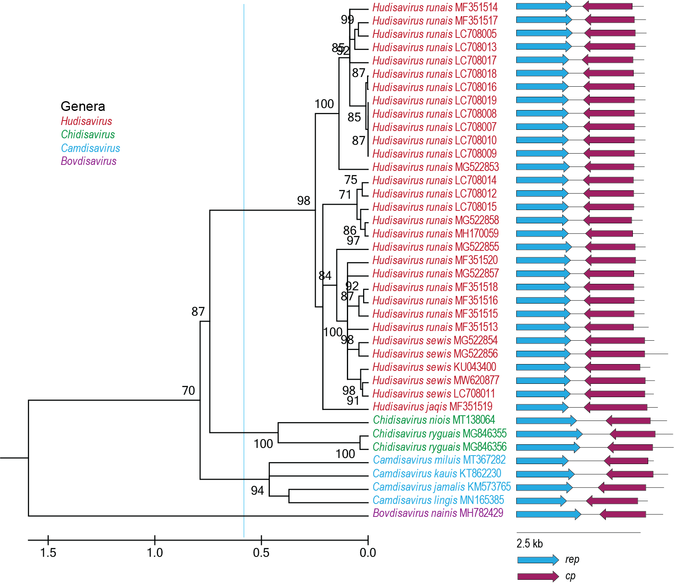

Figure 2: Maximum likelihood phylogenetic tree of the Rep sequences of the members of the Endolinaviridae family inferred with PhyML 3.0 [10] with LG+I+G model determined as the best substitution model using ProtTest 3 [11] and rooted with representative sequences of members of the family Circoviridae. The species belonging to the same genus are indicated with the same color. Numbers at the nodes represent aLRT branch supports. The cyan line shows a proposed demarcation of genera. The genome organization relative to the rep ORF is shown to the right of the phylogeny.

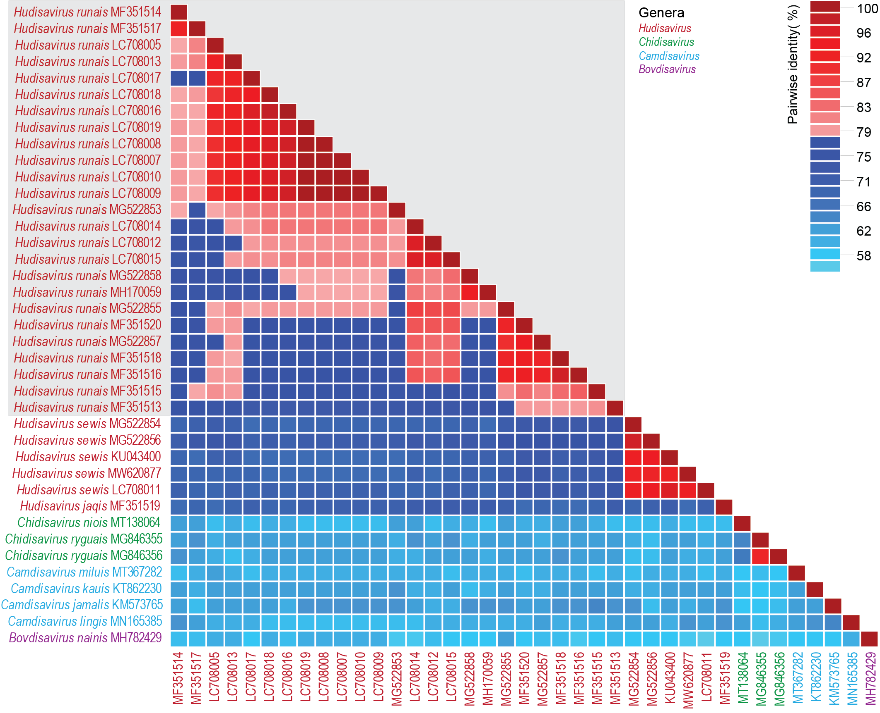

Figure 3: A ‘two color’ pairwise identity matrix of members of the family Endolinaviridae with 78% species threshold s inferred using SDT v1.2 [12]. The grey box shows members of the species Hudisavirus runais with conflictsof 78% species demarcation which we resolved using the criteria outlined in the proposal coupled with phylogenetic support of the genome sequence-based maximum likelihood phylogeny (Figure 4).

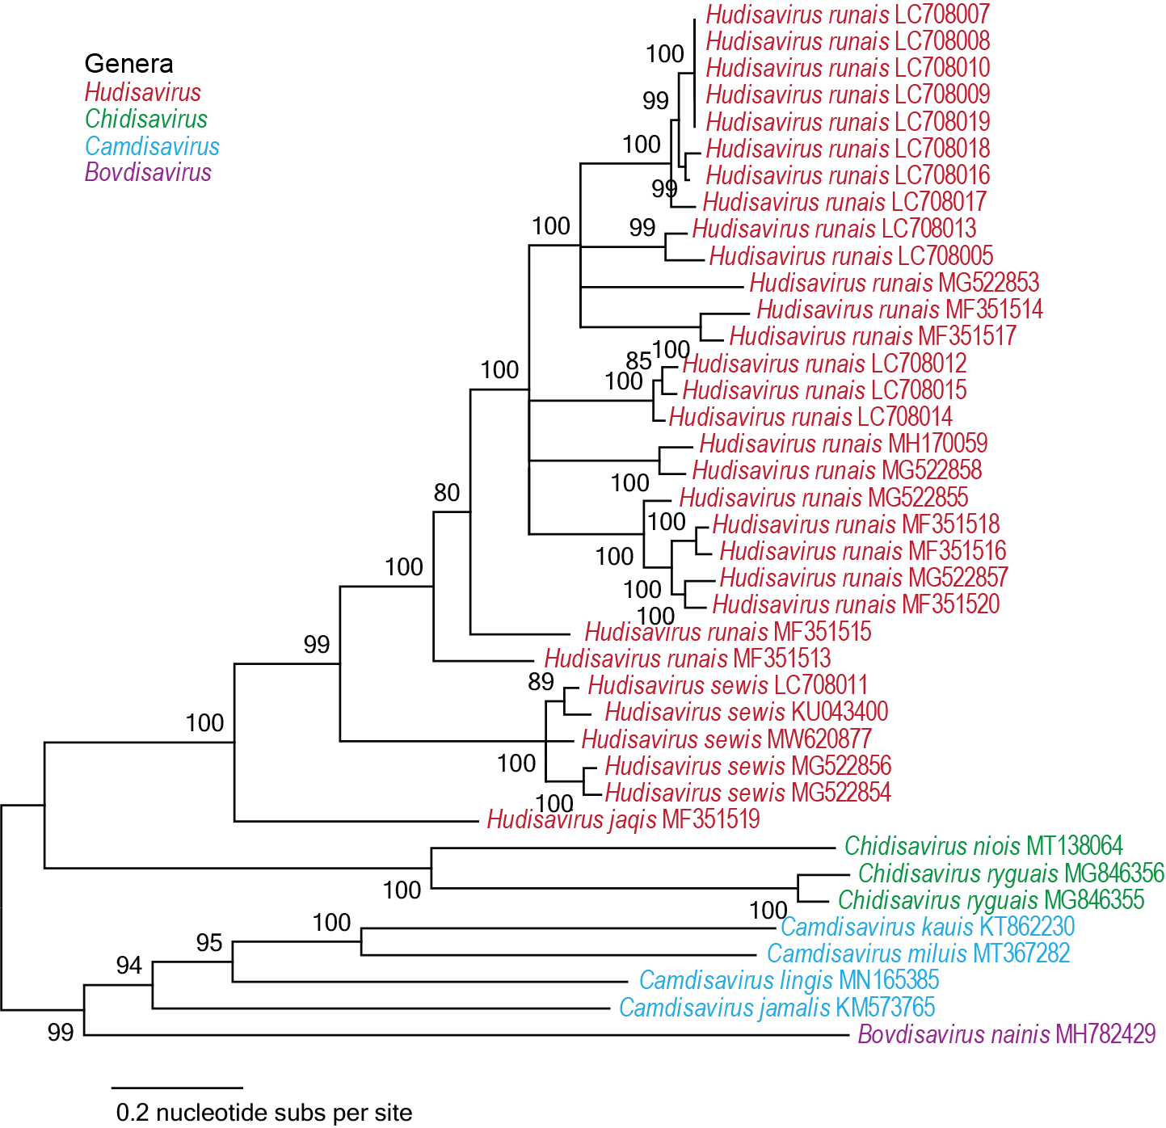

Figure 4: Maximum likelihood phylogenetic tree of the genome sequences of the members of the Endolinaviridae family inferred with PhyML 3.0 [10] with GTR model determined as the best substitution model using jModelTest 3 [13]. The tree is midpoint rooted.

References

- Kinsella CM, Deijs M, Becker C, Broekhuizen P, van Gool T, Bart A, Schaefer AS, van der Hoek L. (2022) Host prediction for disease-associated gastrointestinal cressdnaviruses. Virus Evol. 8(2):veac087. doi: 10.1093/ve/veac087. PMID: 36325032; PMCID: PMC9615429.
- Altan E, Del Valle Mendoza J, Deng X, Phan TG, Sadeghi M, Delwart EL. (2017). Small circular Rep-encoding single-stranded DNA genomes in Peruvian diarrhea virome. Genome Announc. 5(38):e00822-17. doi: 10.1128/genomeA.00822-17. PMID: 28935725; PMCID: PMC5609404.
- Altan E, Aiemjoy K, Phan TG, Deng X, Aragie S, Tadesse Z, Callahan KE, Keenan J, Delwart E. (2018) Enteric virome of Ethiopian children participating in a clean water intervention trial. PLoS One. 13(8):e0202054. doi: 10.1371/journal.pone.0202054. PMID: 30114205; PMCID: PMC6095524.
- Krupovic M, Varsani A, 2022. Naryaviridae, Nenyaviridae, and Vilyaviridae: three new families of single-stranded DNA viruses in the phylum Cressdnaviricota. Arch. Virol. 167, 2907–2921.PMID: 36098801 DOI: 10.1007/s00705-022-05557-w
- Varsani A, Krupovic M (2017) Sequence-based taxonomic framework for the classification of uncultured single-stranded DNA viruses of the family Genomoviridae. Virus Evol 3:vew037. doi:10.1093/ve/vew037. PMID:28458911
- Varsani A, Krupovic M (2018) Smacoviridae: a new family of animal-associated single-stranded DNA viruses. Arch Virol 163:2005-2015. doi:10.1007/s00705-018-3820-z. PMID:29572596
- Muhire B, Martin DP, Brown JK, Navas-Castillo J, Moriones E, Zerbini FM, Rivera-Bustamante R, Malathi VG, Briddon RW, Varsani A. (2013). A genome-wide pairwise-identity-based proposal for the classification of viruses in the genus Mastrevirus (family Geminiviridae). Arch Virol. 158(6):1411-24. doi: 10.1007/s00705-012-1601-7. Epub 2013 Jan 23. PMID: 23340592.
- Capella-Gutierrez S, Silla-Martinez JM, Gabaldon T (2009) trimAl: a tool for automated alignment trimming in large-scale phylogenetic analyses. Bioinformatics 25:1972-3. doi:10.1093/bioinformatics/btp348. PMID:19505945
- Minh BQ, Schmidt HA, Chernomor O, Schrempf D, Woodhams MD, von Haeseler A, Lanfear R (2020) IQ-TREE 2: New Models and Efficient Methods for Phylogenetic Inference in the Genomic Era. Mol Biol Evol 37:1530-1534. doi:10.1093/molbev/msaa015. PMID:32011700
- Guindon S, Dufayard JF, Lefort V, Anisimova M, Hordijk W, Gascuel O (2010) New algorithms and methods to estimate maximum-likelihood phylogenies: assessing the performance of PhyML 3.0. Syst Biol 59:307-321. PMID: 20525638; doi: 10.1093/sysbio/syq010
- Darriba D, Taboada GL, Doallo R, Posada D. (2011).ProtTest 3: fast selection of best-fit models of protein evolution. Bioinformatics. 27(8):1164-5. doi: 10.1093/bioinformatics/btr088. Epub 2011 Feb 17. PMID: 21335321; PMCID: PMC5215816.
- Muhire BM, Varsani A, Martin DP (2014) SDT: A Virus Classification Tool Based on Pairwise Sequence Alignment and Identity Calculation. Plos One 9:e108277. PMID: 25259891; PMCID: PMC4178126.
- Darriba D, Taboada GL, Doallo R, Posada D. (2012). jModelTest 2: more models, new heuristics and parallel computing. Nat Methods. 9(8):772. doi: 10.1038/nmeth.2109. PMID: 22847109; PMCID: PMC4594756.

