Part 1: TITLE, AUTHORS, APPROVALS, etc

Code assigned: | to be assigned by ICTV officers
Short title:
(1) Rename all currently listed viral species of the family Orthohepadnaviridae to the binominal nomenclature
(2) Introduce 7 new virus species in the genus Orthohepadnavirus and 2 new species in the genus Avihepadnavirus.
Author(s) and email address(es)
Glebe D, Drexler JF, Kramvis A, Lehmann F, Lauber C, Littlejohn M, Kann M, Sureau C | dieter.glebe@viro.med.uni-giessen.de; felix.drexler@charite.de; anna.kramvis@wits.ac.za; felix.lehmann@charite.de; chris.lauber@twincore.de; margaret.littlejohn@mh.org.au; csureau@inserm.fr
Author(s) institutional address(es) (optional)
Corresponding author
Glebe D
List the ICTV Study Group(s) that have seen this proposal
ICTV study group Hepadnaviridae

ICTV Study Group comments and response of proposer
The ICTV study group Hepadnaviridae core group (Glebe D, Drexler JF, Kramvis A together with external scientist Lehmann F) made the initial proposal that was discussed and voted within the whole ICTV study group (11 members, all 7 active members named in the authors list above agreed upon the proposal, while 4 members did not respond to the proposal and the voting at all).

ICTV Study Group votes on proposal
Study Group | Number of members (11)
 | Votes support | Votes against | No vote
Hepadnaviridae | 7 | 0 | 4
Authority to use the name of a living person

Is any taxon name used here derived from that of a living person (Y/N) | N

Taxon name | Person from whom the name is derived | Permission attached (Y/N)

Submission dates
Date first submitted to SC Chair | 06/14/2023
Date of this revision (if different to above)
ICTV-EC comments and response of the proposer
Part 2: NON-TAXONOMIC PROPOSAL
Text of proposal

Part 3: TAXONOMIC PROPOSAL
Name of accompanying Excel module
2023.014N.v1.1_Hepadnaviridae_19renam_9nsp.xlsx
Abstract
Here we propose: (1) Binominal naming of all currently ICTV-assigned viral species of the family Hepadnaviridae to; (2) Introduction of 7 new species in the genus Orthohepadnavirus and 2 new species in the genus Avihepadnavirus. The transformation of known viral species to binominal names was done for the known genera: Orthohepadnavirus (12 species), Avihepadnavirus (3), Herpetohepadnvirus (1), Metahepadnavirus (1), Parahepadnavirus (1). The introduction of the 7 new species in the genus Orthohepadnavirus and 2 new species in the genus Avihepadnavirus was done according to the species demarcation criteria in the family Hepadnaviridae of more than 20% nucleotide sequence divergence of complete genomes (including information on cross-infectivity, if available). More than 20% nucleotide sequence divergence of complete genomes (and Genbank listed) was fulfilled for all new virus species. Genus Orthohepadnavirus contains now 19 recognized virus species and the genus Avihepadnavirus 5 recognized virus species. There was no change within the other genera.

Text of proposal
1. Renaming of all currently ICTV-assigned viral species of Hepadnaviridae
The transformation of known species to binominal names was done for the known Genera: Orthohepadnavirus (12 species), Avihepadnavirus (3), Herpetohepadnvirus (1), Metahepadnavirus (1), Parahepadnavirus (1). The description of the chosen binominal names is indicated in the accompanying Excel-Sheet.

2. Introduction of 7 new species in the genus Orthohepadnavirus and 2 new species in the order Avihepadnavirus (all complete virus genomes and GenBank listed).
The species demarcation criteria in the genera Orthohepadnavirus and Avihepadnavirus is more than 20% nucleotide sequence divergence of complete genomes and was fulfilled for all new virus species. The description of the chosen binominal names is indicated in the accompanying Excel-Sheet.

2.1. New species in the genus Orthohepadnavirus
2.1.1. Orthohepadnavirus magniferrequini from “Bat Hepatitis B virus isolate Jiyuan-Rf-11”, GenBank: KY962687 from the bat species Rhinolophus ferrumequinum, trivial name “Greater Horseshoe Bat”. (Nie et al., Virology 514, 88-97 (2018). The virus was named “Greater Horseshoe Bat Hepatitis B Virus”, abbreviation: GHBHBV.
The virus has 57-79% nucleotide sequence identity to all other Orthohepadnavirus species.

2.1.2. Orthohepadnavirus myominrhinus from “Bat Hepatitis B virus isolate Guizhou-Md-295”, GenBank: KY9662683 from the bat species Myotis davidii, trivial name “David's Myotis” (Nie et al., Virology 514, 88-97 (2018). The virus was named “Myodav bat hepatitis B virus”. Virus abbreviation: MDBHBV.
The virus has 57-77% nucleotide sequence identity to all other Orthohepadnavirus species.

2.1.3. Orthohepadnavirus magnimyotis from “Longquan Myotis chinensis orthohepadnavirus 1 isolate LQB_ZhongShu” GenBank: OM030297 from the bat species Myotis chinensis, trivial name. “Large Myotis” via direct submission to GenBank. The virus was named: “Large myotis bat hepatitis B virus”, Virus abbreviation: LMBHBV.
The virus has 57-68% nucleotide sequence identity to all other Orthohepadnavirus species.

2.1.4. Orthohepadnavirus soricicoronati from “Crowned shrew hepatitis B virus isolate GF2139” GenBank: MK345465 from the shrew species Sorex coronatus, trivial name: “Crowned shrew” (Rasche et al., 2019). The virus was named: “Crowned shrew hepatitis B virus”, Virus abbreviation: CRSHBV.
The virus has 55-72% nucleotide sequence identity to all other Orthohepadnavirus species.

2.1.6. Orthohepadnavirus soriciodoris from “Musk shrew hepatitis B virus isolate CIV-304” GenBank: MK345463 from the shrew species Crocidura olivieri, trivial name: “Musk shrew” (Rasche et al., 2019). The virus was named: “Musk shrew hepatitis B virus”, Virus abbreviation: MSHBV.
The virus has 55-77% nucleotide sequence identity to all other Orthohepadnavirus species.

2.1.6. Orthohepadnavirus bassarisci from “Ringtail hepadnavirus isolate CO-09/924” GenBank: MZ393519 from the ringtail species Bassariscus astutus, trivial name: “Ringtail” (Jo et al., 2021). The virus was named: “Ringtail hepatitis B virus”, Virus abbreviation: RtHBV.
The virus has 57-70% nucleotide sequence identity to all other Orthohepadnavirus species.

2.1.7. Orthohepadnavirus equidae from “Equine hepatitis B virus isolate doneky86” GenBank: MT134309 from the donkey species Equus asinus, trivial name: “domestic donkey” (Rasche et al., 2021). The virus was named: “Equine hepatitis B virus”, Virus abbreviation: EqHBV, because the virus species was also found in zebras (Equus quagga).
The virus has 57-70% nucleotide sequence identity to all other Orthohepadnavirus species.

Genus Orthohepadnavirus
Now 19 recognized virus species in 7 animal orders
Primates: 3; Chiroptera: 7; Artiodactyla: 1, Perissodactyla: 1, Carnivora: 2, Rodentia: 2, Eulipotyphla:3

Overview of the genus Orthohepadnavirus
No | Species name | Virus | New | Host order
1 | Orthohepadnavirus hominoidei | HBV chHBV giHBV goHBV orHBV | - | Primates
2 | Orthohepadnavirus sapaji | CMHBV | - | Primates
3 | Orthohepadnavirus lagothricis | WMHBV | - | Primates
4 | Orthohepadnavirus longidigiti | LFBHBV | - | Chiroptera
5 | Orthohepadnavirus tabernarii | TMBHBV | - | Chiroptera
6 | Orthohepadnavirus rotundifolii | RLBHBV, HSBHBV | - | Chiroptera
7 | Orthohepadnavirus pomi | PBHBV | - | Chiroptera
8 | Orthohepadnavirus magniferrequini | GHBHBV | new | Chiroptera
9 | Orthohepadnavirus myominrhinus | MDBHBV | new | Chiroptera
10 | Orthohepadnavirus magnimyotis | LMBHBV | new | Chiroptera
11 | Orthohepadnavirus philantombae | TFoHBV | - | Artiodactyla
12 | Orthohepadnavirus equidae | EqHBV | new | Perissodactyla
13 | Orthohepadnavirus felisdomestici | DCHBV | - | Carnivora
14 | Orthohepadnavirus bassarisci | RtHBV | new | Carnivora
15 | Orthohepadnavirus marmotae | WHV | - | Rodentia
16 | Orthohepadnavirus sciuri | GSHV (ASHV) | - | Rodentia
16 | Orthohepadnavirus soricisinensis | CSHBV | - | Eulipotyphla
18 | Orthohepadnavirus soricicoronati | CRSHBV | new | Eulipotyphla
19 | Orthohepadnavirus soriciodoris | MSHBV | new | Eulipotyphla
Still unclassified: ASHV, Arctic Squirrel hepatitis B Virus. It is not yet clear, if this virus belongs to WHV or GSHV species.

2.2. New species in the genus Avihepadnavirus
2.2.1. Avihepadnavirus psittaduorum from “Parrot hepatitis B virus isolate P902”, GenBank: JX274018 from the parrot species Platycercus elegans, trivial name “Crimson rosella”. (Piasecki et al., Virology 438 (2), 98-105 (2013)). The virus was named “Parrot hepatitis B virus 2”, abbreviation: PHBV2.
The virus has 73-78% nucleotide sequence identity to all other Avihepadnavirus species.

2.2.1. Avihepadnavirus bonicursoris from “Tinamou hepatitis B virus isolate 160050”, GenBank: KY977507 from the bird species Eudromia elegans, trivial name “elegant-crested tinamou”. (Jo et al., EID, 2013). The virus was named “Elegant-crested tinamou hepatitis B virus”, abbreviation: ETHBV.
The virus has 73-76% nucleotide sequence identity to all other Avihepadnavirus species.

Genus Avihepadnavirus
Now 5 recognized virus species in 4 animal orders
Anseriformes: 1; Pelecaniformes: 1; Psittaciformes: 2; Tinamiformes: 1

Overview of the genus Avihepadnavirus
No | Species name | Virus | New | Host order
1 | Avihepadnavirus anatigruidae | DHBV SHGHBV SGHBV CHBV RGHBV | - | Anseriformes
2 | Avihepadnavirus ciconiardeae | HHBV STHBV | - | Pelecaniformes
3 | Avihepadnavirus psittaunius | PHBV1 | - | Psittaciformes
4 | Avihepadnavirus psittaduorum | PHBV2 | new | Psittaciformes
5 | Avihepadnavirus bonicursoris | ETHBV | new | Tinamiformes

Genus Herpetohepadnavirus (no changes)
1 recognized virus species in 1 animal order:
Anura: 1
No | Species name | Virus | New | Host order
1 | Herpetohepadnavirus nanoranae | TFHBV | - | Anura

Genus Metahepadnavirus (no changes)
1 recognized virus species in 1 animal order
Perciformes: 1
No | Species name | Virus | New | Host order
1 | Metahepadnavirus lepomi | BGHBV | - | Perciformes

Genus Parahepadnavirus (no changes)
1 recognized virus species in 1 animal order
Cypriniformes: 1
No | Species name | Virus | New | Host order
1 | Parahepadnavirus osdeorsi | WSHBV | - | Cypriniformes

The following species will not be included at this time, but will be when the full GenBank accession number and documentation is available in the near future (this was discussed in a phone call with Chris Lauber on 05/31/2023).

Notes from the current ICTV website Hepadnaviridae:
See: https://ictv.global/report/chapter/hepadnaviridae/hepadnaviridae

Genus Herpetohepadnavirus
Metagenomic sequencing has identified two exogenous hepadnaviruses genetically similar to herpetohepadnavirus (Lauber et al., 2017). One was isolated from a skink (Saproscinus basilikus) and designated skink hepatitis B virus (SkHBV), and another from liver from a spiny lizard (Sceloporus adleri) and designated spiny lizard hepatitis B virus (SLHBV-1).
Virus name | Accession number | Virus abbreviation
skink hepatitis B virus | # | SkHBV
spiny lizard hepatitis B virus | # | SLHBV-1

Genus Metahepadnavirus
Apart from BGHBV, there are additional virus isolates that may represent three tentative species in the genus. These viruses were identified from teleost fish samples by metagenomic sequencing. These three viruses are: icefish metahepadnavirus (IMDV) from the muscle of crocodile icefish (Chionodraco hamatus), Astatotilapia metahepadnavirus (AMDV) from Astatotilapia (Astatotilapia sp.) and tetra metahepadnavirus (TMDV) from the eye-surface of Mexican tetra (Astyanax mexicanus) (Lauber et al., 2017).
Virus name | Accession number | Virus abbreviation
Astatotilapia metahepadnavirus | # | AMDV
icefish metahepadnavirus | # | IMDV
tetra metahepadnavirus | # | TMDV
Virus names and virus abbreviations are not official ICTV designations.
#GenBank accession number not available, but the sequence can be obtained from the alignment file associated with Figure 4. Hepadnaviridae and provided in the Resources section of this Report.
Genus Parahepadnavirus
A virus, CSKV, infecting the Coho salmon (Oncorhynchus kisutch) was identified by metagenomic sequencing of the complete genome of the Coho salmon (NC_034179). However this genome is incomplete, and the regions corresponding to the C-terminal part of the polymerase and the core region are missing. The genome was identified from kidney tissue (Lauber et al., 2017).

Supporting evidence
A
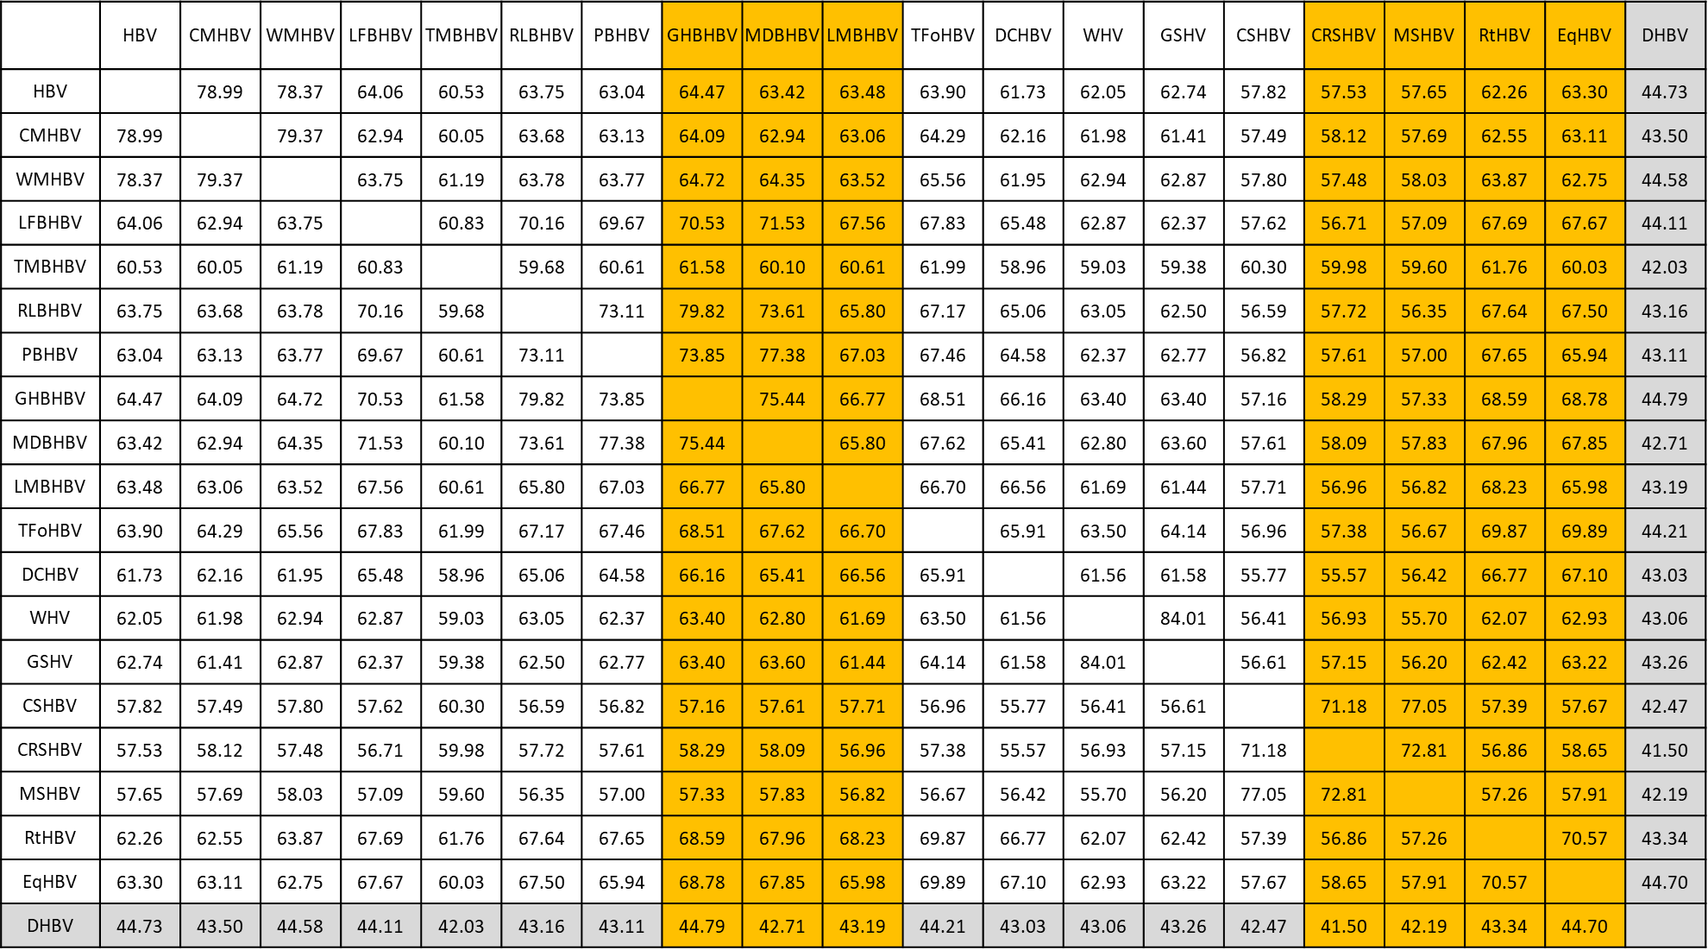
B
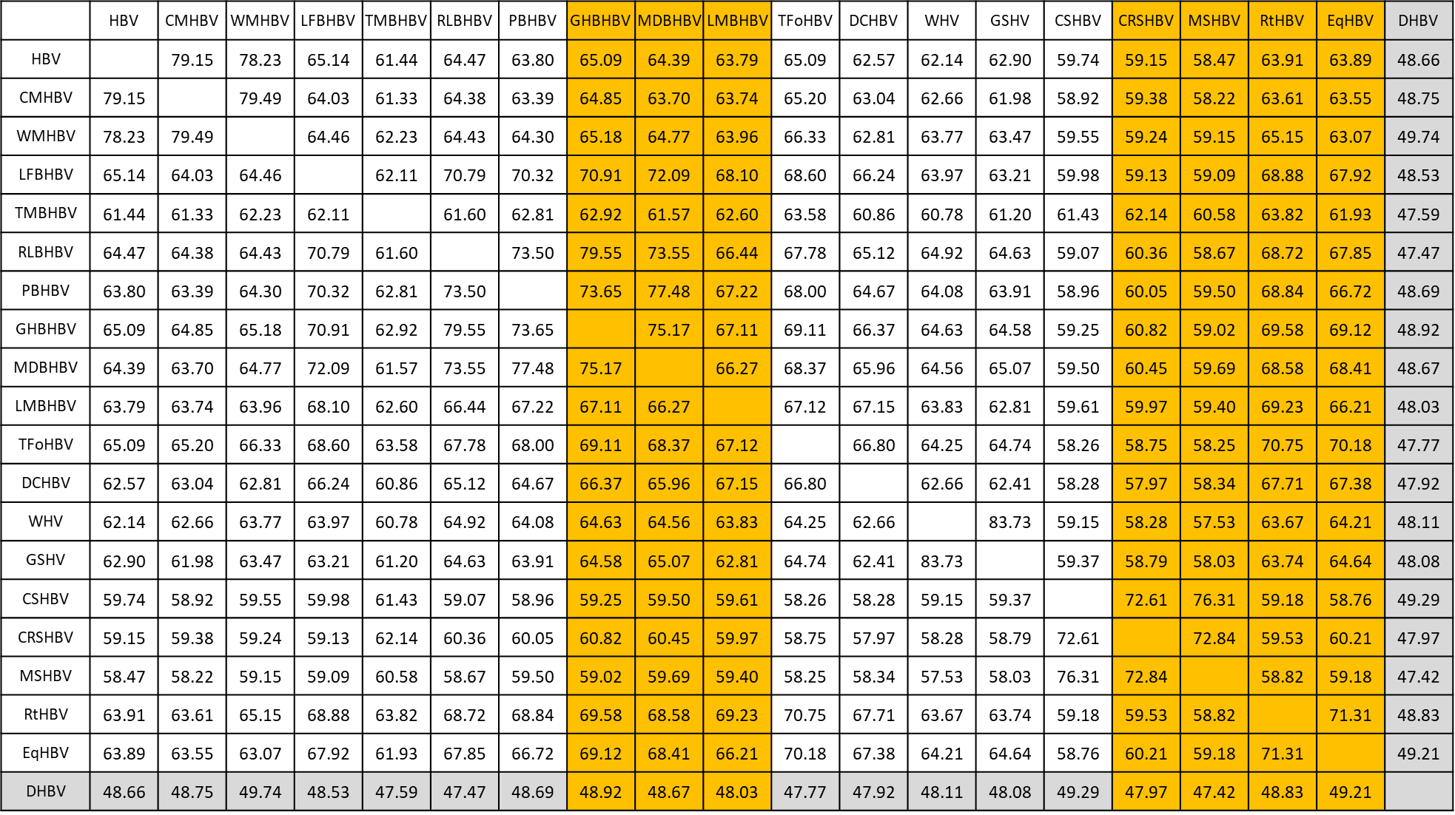
Figure 1: Nucleotide identity between the complete genomes of the viral species belonging to the genus Orthohepadnavirus. Known (white) and new (orange) species of the genus Orthohepadnavirus are listed. The identity matrix (% identity on full genomes) was done with (A) MEGA11 and following parameters: boostrap method (1000 bootstraps) p-distance model incl. transitions and transversions, uniform rates of transitions/transversions, pairwise deletion for gaps using MAFFT-(L-INS-i)-Algorithm for alignment, Geneious. (B) MEGA11 using the MUSCLE-Algorithm for alignment using MEGA11 with same parameters as (A). All new species meet the criteria of more than 20% nucleotide sequence divergence of complete genomes (GenBank listed) with both algorithm. As shown in the previous ICTV report, WHV and GSHV share 84 % identity, but are regarded as different species, since WHV could not infect the host of GSHV (ground squirrels). ASHV still remains unassigned. The isolate HSBHBV (Horseshoe bat hepatitis B virus) clusters with the master species Roundleaf bat hepatitis B virus (RLBHBV) with a difference of about 20% and is not considered a separate species, as agreed upon in the last ICTV report. The DHBV (grey) of the genus Avihepadnavirus is listed as an outgroup.

A
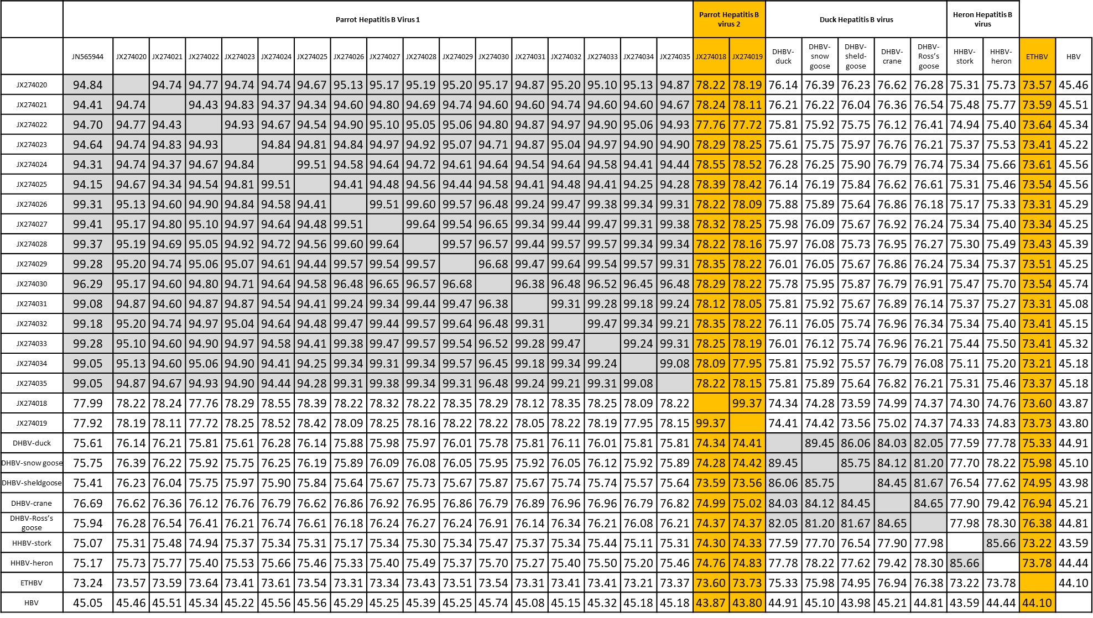
B
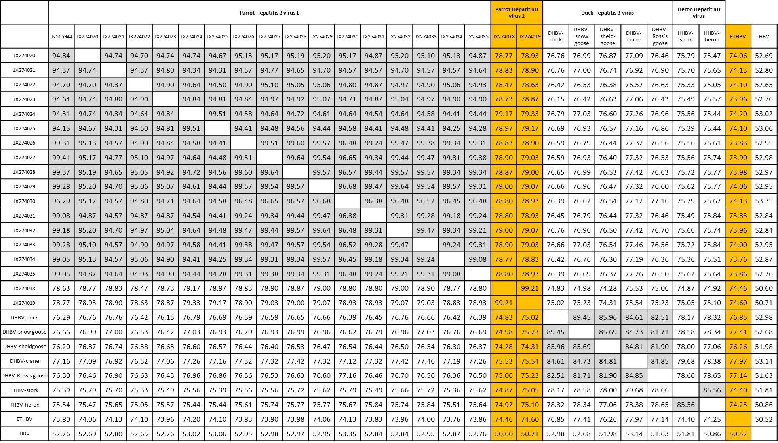
Figure 2: Nucleotide identity between the complete genomes of the viral species belonging to the genus Avihepadnavirus. Known (white) and new (orange) species of the genus Avihepadnavirus are listed. The identity matrix (% identity on full genomes) was done with (A) MEGA11 and following parameters: boostrap method (1000 bootstraps) p-distance model incl. transitions and transversions, uniform rates of transitions/transversions, pairwise deletion for gaps using MAFFT-(L-INS-i)-Algorithm for alignment, Geneious. (B) MEGA11 using the MUSCLE-Algorithm for alignment using MEGA11 with same parameters as (A). All new species meet the criteria of more than 20% nucleotide sequence divergence of complete genomes (GenBank listed) with both algorithm. New Parrot virus isolates (Piasecki et al., 2013) cluster either together with previously classified PHBV1 (Piasecki et al., 2012; grey), or form a new species designated “Parrot Hepatitis B virus 2” (PHBV2) The “Elegant-crested tinamou hepatitis B virus” (ETHBV) showed >20 % difference to other species of the genus Avihepadnavirus. ETHBV was not able to infect Peking duck embryos via allantoic cavity or by intravenous infection (Jo et al., 2017). The HBV of the genus Orthohepadnavirus is listed as an outgroup.

References
Jo WK, Alfonso-Toledo JA, Salas-Rojas M, Almazan-Marin C, Galvez-Romero G, García-Baltazar A, Obregón-Morales C, Rendón-Franco E, Kühne A, Carvalho-Urbieta V, Rasche A, Brünink S, Glebe D, Aguilar-Setién Á, Drexler JF. Natural co-infection of divergent hepatitis B and C virus homologues in carnivores. Transbound Emerg Dis. 2022 Mar;69(2):195-203. doi: 10.1111/tbed.14340. Epub 2021 Oct 19. PMID: 34606685

Jo WK, Pfankuche VM, Petersen H, Frei S, Kummrow M, Lorenzen S, Ludlow M, Metzger J, Baumgärtner W, Osterhaus A, van der Vries E. New Avian Hepadnavirus in Palaeognathous Bird, Germany. Emerg Infect Dis. 2017 Dec;23(12):2089-2091. doi: 10.3201/eid2312.161634. PMID: 29148393

Lauber C, Seitz S, Mattei S, Suh A, Beck J, Herstein J, Börold J, Salzburger W, Kaderali L, Briggs JAG, Bartenschlager R. Deciphering the Origin and Evolution of Hepatitis B Viruses by Means of a Family of Non-enveloped Fish Viruses. Cell Host Microbe. 2017 Sep 13;22(3):387-399.e6. doi: 10.1016/j.chom.2017.07.019. Epub 2017 Aug 31. PMID: 28867387

Nie FY, Lin XD, Hao ZY, Chen XN, Wang ZX, Wang MR, Wu J, Wang HW, Zhao G, Ma RZ, Holmes EC, Zhang YZ. Virology. Extensive diversity and evolution of hepadnaviruses in bats in China 2018 Jan 15;514:88-97. doi: 10.1016/j.virol.2017.11.005. Epub 2017 Nov 16. PMID: 29153861

Piasecki T, Kurenbach B, Chrząstek K, Bednarek K, Kraberger S, Martin DP, Varsani A. Molecular characterisation of an avihepadnavirus isolated from Psittacula krameri (ring-necked parrot). Arch Virol. 2012 Mar;157(3):585-90. doi: 10.1007/s00705-011-1197-3. Epub 2011 Dec 20. PMID: 22183110.

Piasecki T, Harkins GW, Chrząstek K, Julian L, Martin DP, Varsani A. Avihepadnavirus diversity in parrots is comparable to that found amongst all other avian species. Virology. 2013 Apr 10;438(2):98-105. doi: 10.1016/j.virol.2013.01.009. Epub 2013 Feb 12. PMID: 23411008

Rasche A, Lehmann F, Goldmann N, Nagel M, Moreira-Soto A, Nobach D, de Oliveira Carneiro I, Osterrieder N, Greenwood AD, Steinmann E, Lukashev AN, Schuler G, Glebe D, Drexler JF; Equid HBV Consortium. A hepatitis B virus causes chronic infections in equids worldwide. Proc Natl Acad Sci U S A. 2021 Mar 30;118(13):e2013982118. doi: 10.1073/pnas.2013982118. PMID: 33723007

Rasche A, Lehmann F, König A, Goldmann N, Corman VM, Moreira-Soto A, Geipel A, van Riel D, Vakulenko YA, Sander AL, Niekamp H, Kepper R, Schlegel M, Akoua-Koffi C, Souza BFCD, Sahr F, Olayemi A, Schulze V, Petraityte-Burneikiene R, Kazaks A, Lowjaga KAAT, Geyer J, Kuiken T, Drosten C, Lukashev AN, Fichet-Calvet E, Ulrich RG, Glebe D, Drexler JF. Highly diversified shrew hepatitis B viruses corroborate ancient origins and divergent infection patterns of mammalian hepadnaviruses. Proc Natl Acad Sci U S A. 2019 Aug 20;116(34):17007-17012. doi: 10.1073/pnas.1908072116. Epub 2019 Aug 1. PMID: 31371507

