Part 1: TITLE, AUTHORS, APPROVALS, etc

Code assigned: | 2023.005D
Short title: Create 16 new species and 4 new genera in the family Anelloviridae

Author(s) and email address(es)
Laubscher F, Cordey S | Florian.laubscher@hcuge.ch;Samuel.cordey@hcuge.ch

Author(s) institutional address(es) (optional)
University Hospitals of Geneva [LF, CS]

Corresponding author
Laubscher F

List the ICTV Study Group(s) that have seen this proposal

ICTV Study Group comments and response of proposer

ICTV Study Group votes on proposal

Study Group | Number of members
 | Votes support | Votes against | No vote
Anelloviridae SG | 7

Authority to use the name of a living person

Is any taxon name used here derived from that of a living person (Y/N) | N

Taxon name | Person from whom the name is derived | Permission attached (Y/N)

Submission dates
Date first submitted to SC Chair | 2 Dec 2022
Date of this revision (if different to above)
ICTV-EC comments and response of the proposer
Part 2: NON-TAXONOMIC PROPOSAL
Text of proposal

Part 3: TAXONOMIC PROPOSAL

Name of accompanying Excel module
2023.005D.N.v2.Anelloviride_4ngen_16nsp.xlsx
Abstract

In order to classify human anellovirid sequences that don’t belong to the three classical human infecting genera (Alpha-, Beta-, Gammatorquevirus), we propose the establishment of 16 new species together with 4 new genera in the Anelloviridae family.
This includes:
- 6 new species in the exiting Hetorquevirus genus:
- Hetorquevirus hominid3
- Hetorquevirus hominid4
- Hetorquevirus hominid5
- Hetorquevirus hominid6
- Hetorquevirus hominid7
- Hetorquevirus hominid8

- 2 new species in the new proposed genus Yodtorquevirus:
- Yodtorquevirus hominid9
- Yodtorquevirus hominid10

- 1 new species in new proposed genus Lamedtorquevirus:
- Lamedtorquevirus hominid11

- 3 new species in new proposed genus Memtorquevirus:
- Memtorquevirus hominid12
- Memtorquevirus hominid13
- Memtorquevirus hominid14

- 4 new species in the new proposed genus Samektorquevirus:
- Samektorquevirus hominid15
- Samektorquevirus hominid16
- Samektorquevirus hominid17
- Samektorquevirus hominid18

Text of proposal
Currently, ORF1-codding sequences are used to classify Anelloviridae, with a species demarcation threshold at >69% pairwise nucleotide identity, whereas genera demarcation is based on phylogeny [1]. Human infecting anelloviruses have been assigned to genera Alphatorquevirus, Betatorquevirus, Gammatorquevirus and more recently to Hetorquevirus.
For this proposal, all anellovirus sequences with complete ORF1-coding sequence available in GenBank from genera known to infect primates were considered for analysis. Representative amino acid sequences were selected for Alphatorquevirus, Betatorquevirus and Gammatorquevirus using CD-HIT (50% amino acid identity) [2, 3].The 502 remaining sequences were aligned and trimmed using MAFFT [4]. Then, evolutionary analysis was done using Maximum Likelihood method LG+G+I+F model [5] (best fitting model; 100 bootstrap) and phylogenetic tree was generated by MEGA X [6]. In addition, pairwise nucleotide identity were used to determine species assignation.
Novel genera and species were named using the Phoenician alphabet and binomial names, respectively, according to the International Committee on Taxonomy of Viruses (ICTV) recommendations [7, 8].
Our analysis reveal 6 new species (total number of sequences = 102) in the exiting Hetorquevirus genus (Hetorquevirus hominid3, Hetorquevirus hominid4, Hetorquevirus hominid5, Hetorquevirus hominid6, Hetorquevirus hominid7 and Hetorquevirus hominid8), 2 new species (total number of sequences = 17) in the new proposed genus Yodtorquevirus (Yodtorquevirus hominid9 and Yodtorquevirus hominid10), 1 new species (total number of sequences = 33) in the new proposed genus Lamedtorquevirus (Lamedtorquevirus hominid11), 3 new species (total number of sequences = 55) in the new proposed genus Memtorquevirus (Memtorquevirus hominid12, Memtorquevirus hominid13 and Memtorquevirus hominid14) and 4 new species (total number of sequences = 123) in the new proposed genus Samektorquevirus (Samektorquevirus hominid15, Samektorquevirus hominid16, Samektorquevirus hominid17 and Samektorquevirus hominid18).
Bootstrap values reported in the phylogenetic tree further support the genera demarcations and the analysis of the pairwise identity matrix of the ORF1 nucleotide sequences confirms the species demarcations.

Supporting evidence
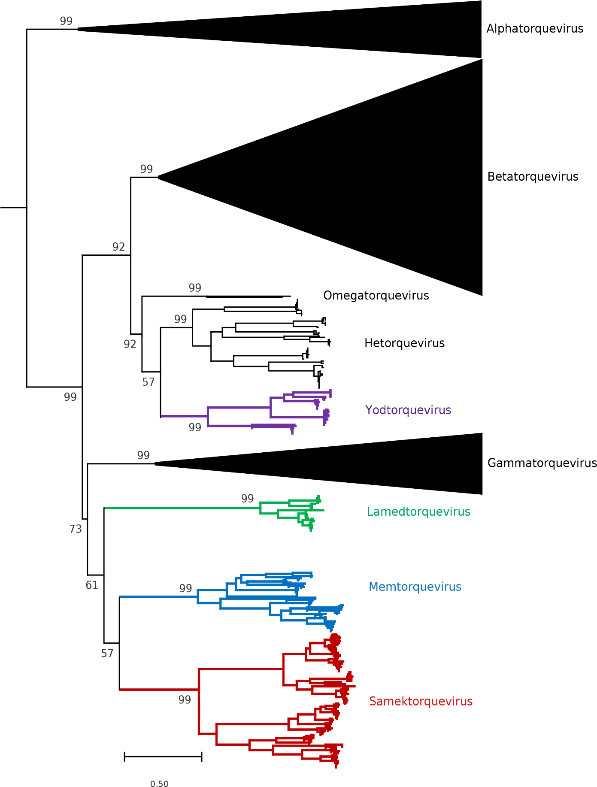
Figure 1: Phylogenetic analysis of the ORF1 product of the Anelloviridae family members. The tree shows Alpha-, Beta-, Gamma-, Omega- and Hetorqueviruses, rooted with Epsilon- and Zetatorqueviruses [AB041960 and AB041961, respectively]. Novel genera are displayed in colours. Bootstrap values (100 replicates) and evolutionary distances are reported.
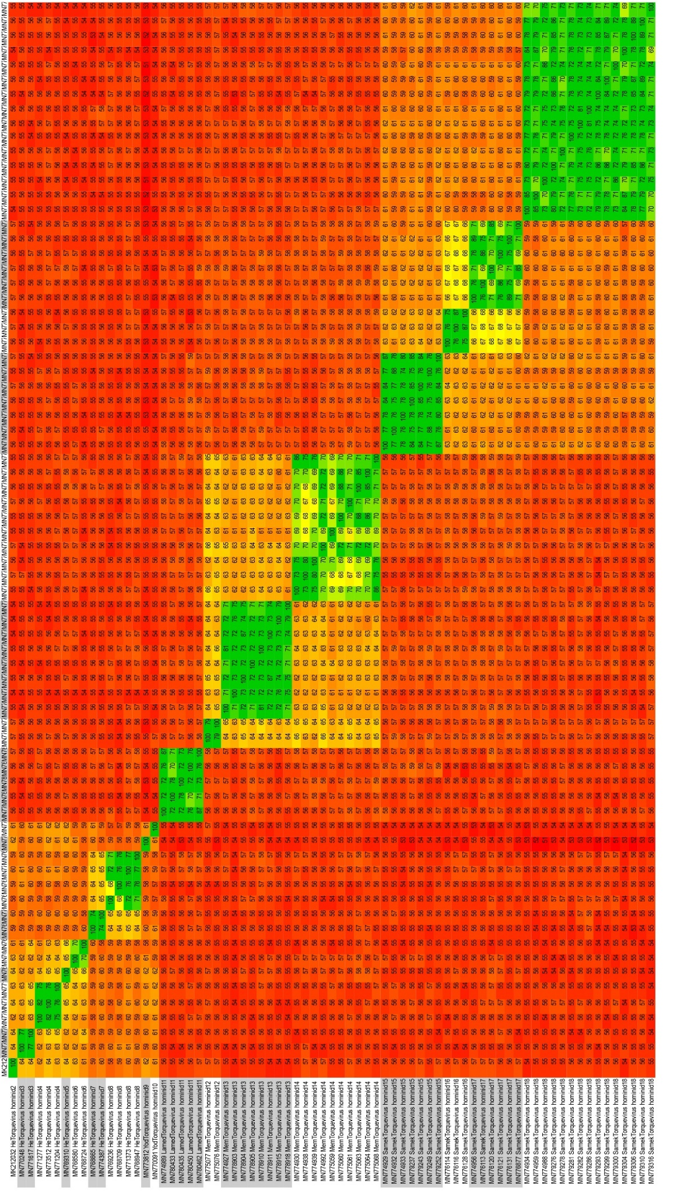
Figure 2: Pairwise identity matrix of the ORF1 nucleotide sequences of representative members from He-, Yod-, Lamed-, Mem- and Samektorquevirus.
References

- Varsani A, Opriessnig T, Celer V, Maggi F, Okamoto H, Blomström AL, Cadar D, Harrach B, Biagini P, Kraberger S (2021) Taxonomic update for mammalian anelloviruses (family Anelloviridae). Arch Virol 166:2943-2953. PMID: 34383165
- Fu L, Niu B, Zhu Z, Wu S, Li W (2012) CD-HIT: accelerated for clustering the next-generation sequencing data. Bioinformatics (Oxford, England) 28:3150-3152. PMID: 23060610
- Li W, Godzik A (2006) Cd-hit: a fast program for clustering and comparing large sets of protein or nucleotide sequences. Bioinformatics (Oxford, England) 22:1658-1659. PMID: 16731699
- Katoh K, Misawa K, Kuma K, Miyata T (2002) MAFFT: a novel method for rapid multiple sequence alignment based on fast Fourier transform. Nucleic Acids Res 30:3059-3066. PMID: 12136088
- Le S Q and Gascuel O (2008). An Improved General Amino Acid Replacement Matrix. Mol Biol Evol 25:1307-1320. PMID: 18367465
- Kumar S, Stecher G, Li M, Knyaz C, Tamura K (2018) MEGA X: Molecular Evolutionary Genetics Analysis across Computing Platforms. Mol Biol Evol 35:1547-1549. PMID: 29722887
- Varsani A, Kraberger S (2020) Create 17 genera and new 80 species (Anelloviridae) https://ictv.global/ictv/proposals/2020.015D.R.Anelloviridae_17ngen_80nsp.zip
- Zerbini FM, Siddell SG, Mushegian AR, Walker PJ, Lefkowitz EJ, Adriaenssens EM, Alfenas-Zerbini P, Dutilh BE, García ML, Junglen S, Krupovic M, Kuhn JH, Lambert AJ, Lobocka M, Oksanen HM, Robertson DL, Rubino L, Sabanadzovic S, Simmonds P, Suzuki N, Van Doorslaer K, Vandamme AM, Varsani A (2022) Differentiating between viruses and virus species by writing their names correctly. Arch Virol 167:1231-1234. PMID: 35043230

