Part 1: TITLE, AUTHORS, APPROVALS, etc

Code assigned: | 2023.002D
Short title: Establishing 3 new species in the family Circoviridae
Author(s) and email address(es)
Varsani A, Harrach B, Benkő M, Breitbart M, Delwart E, Franzo G, Kazlauskas D, Rosaio, K., Segalés J, Krupovic M | Arvind.varsani@asu.edu; balazs.harrach@gmail.com; maribenko@gmail.com; mya@usf.edu; delwarte@medicine.ucsf.edu; giovanni.franzo@unipd.it; dariausk@gmail.com; krosariocora@gmail.com; joaquim.segales@uab.cat; mart.krupovic@pasteur.fr
Author(s) institutional address(es) (optional)

The Biodesign Center for Fundamental and Applied Microbiomics, Center for Evolution and Medicine, School of Life sciences, Arizona State University, Tempe, AZ 85287-5001, USA [AV]
Veterinary Medical Research Institute, Budapest 1143, Hungary [BH, MB]
College of Marine Science, University of South Florida, Saint Petersburg, FL 33701, USA [MB]
Department of Laboratory Medicine, University of California San Francisco, San Francisco, CA 94118, USA [ED]
Dipartimento di Medicina Animale, Produzione e Salute, Università di Padova, Viale dell’Università 16, 35020 Legnaro, Italy [GF]
Institute of Biotechnology, Life Sciences Center, Vilnius University, Saulėtekio av. 7, Vilnius 10257, Lithuania [DK]
UAB, Centre de Recerca en Sanitat Animal (CReSA, IRTAUAB), Campus de la Universitat Autònoma de Barcelona, Bellaterra, 08193 Barcelona, Spain [JS]
Institut Pasteur, Université Paris Cité, CNRS UMR6047, Archaeal Virology Unit, 25 rue du Dr Roux, 75015 Paris, France [MK]

Corresponding author
Arvind Varsani

List the ICTV Study Group(s) that have seen this proposal

Circoviridae Study Group

ICTV Study Group comments and response of proposer

All who responded in agreement is an author on this TP

ICTV Study Group votes on proposal

Study Group | Number of members
 | Votes support | Votes against | No vote
Authority to use the name of a living person

Is any taxon name used here derived from that of a living person (Y/N) | N

Taxon name | Person from whom the name is derived | Permission attached (Y/N)

Submission dates
Date first submitted to SC Chair | 16 June 2023
Date of this revision (if different to above) | 28 July 2023
ICTV-EC comments and response of the proposer
Part 2: NON-TAXONOMIC PROPOSAL
Text of proposal

Part 3: TAXONOMIC PROPOSAL
Name of accompanying Excel module
2023.002D.N.v2.Circoviridae_3nsp.xlsx
Abstract

Circoviruses have small circular single-stranded DNA genomes. They are classified within two genera, Circovirus and Cyclovirus, in the family Circoviridae (phylum Cressdnaviricota, class Arfiviricetes, order Circlivirales). The classification of species is based on the guidelines set forward, i.e., 80% genome-wide pairwise identity species threshold and based on this we propose 3 new species to classify 3 new viruses in the genus Circovirus.

Text of proposal
Circovirus and Cyclovirus are the two genera in the family Circoviridae (phylum Cressdnaviricota, class Arfiviricetes order Circlivirales). Viruses within these two genera are classified into species based on genome-wide pairwise identities, with a species demarcation threshold of 80% identity [1].

Over the last the last year various new circovirus genomes have been identified from various organisms and represent 5 new species. Two of these are described in a separate TP and here we address the classification of 3 circoviruses identified in human (n=1) and coyote (n=2) samples.

The proposed classification of the three viruses that represent new species is supported by phylogenetic analysis of the genome nucleotide sequences and pairwise nucleotide sequence identity analysis of the (Figure 1-2).

Supporting evidence

Accession | Virus name | Host /source | Country | New species name | Epithet notes
OQ599922 | banfec circovirus 1 | Canis latrans | USA | Circovirus kukwuria | Coyote, Scavenger in comanche
OQ599924 | banfec circovirus 2 | Canis latrans | USA | Circovirus ban | Coyote in Tohono O’odham
ON677309 | human circovirus 1 | Homo sapiens | France | Circovirus human | Virus identified in human tissue

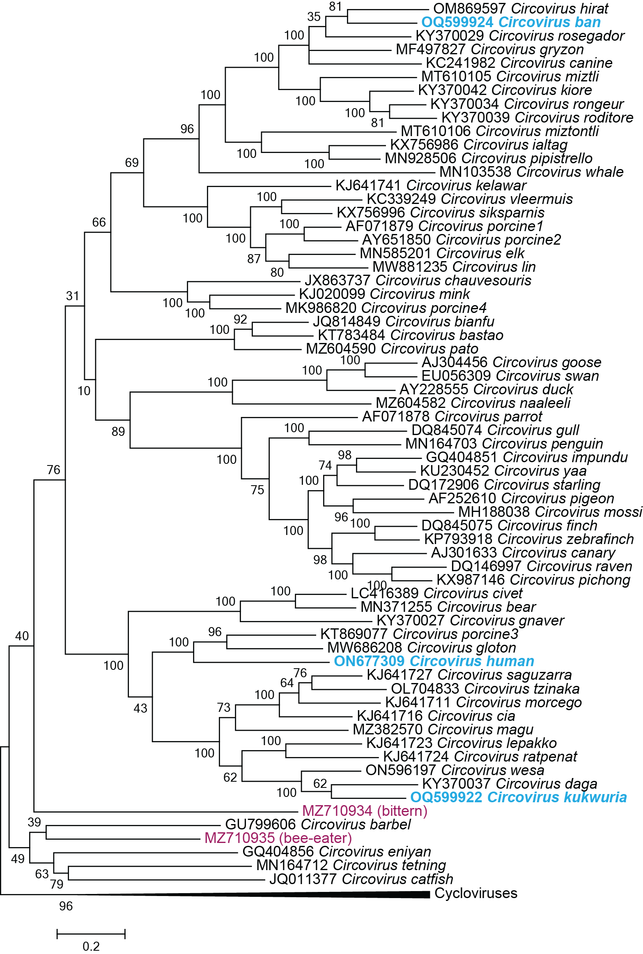
Figure 1: Maximum likelihood phylogenetic tree (rooted with reverse complement sequences of cycloviruses) of representative genomes from each circovirus species (aligned with MAFFT v7 [3]) inferred using PHYML [4] with GTR+I+G4 chosen as the best fit model.

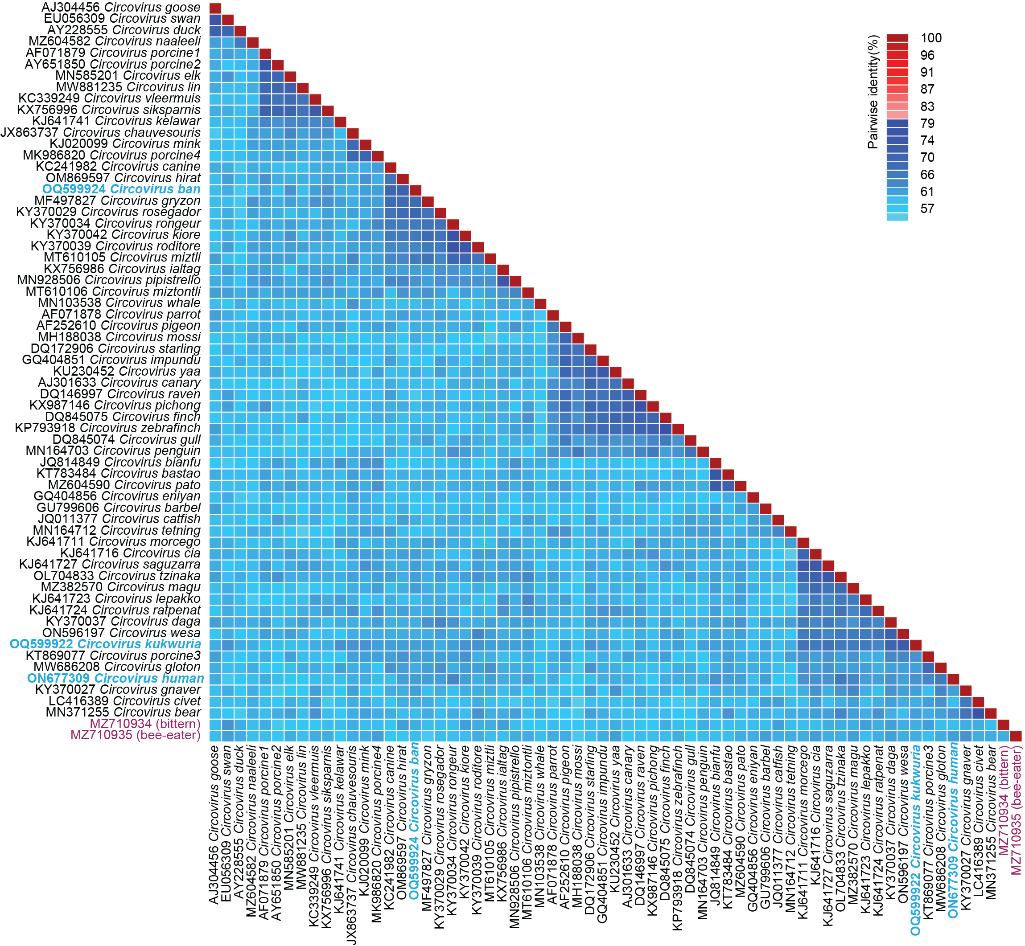
Figure 2: A ‘two color’ pairwise identity matrix of representative genome-wide comparisons among sequences in the genus Circovirus inferred using SDT v1.2 [2]. Representative sequences from the proposed new species (n=3) are highlighted in blue font and the two in purple font represent two additional species and are addressed in a separate proposal.

References
- Rosario K, Breitbart M, Harrach B, Segales J, Delwart E, Biagini P, Varsani A (2017) Revisiting the taxonomy of the family Circoviridae: establishment of the genus Cyclovirus and removal of the genus Gyrovirus. Arch Virol 162:1447-1463. PMID: 28155197; DOI: 10.1007/s00705-017-3247-y
- Muhire BM, Varsani A, Martin DP (2014) SDT: a virus classification tool based on pairwise sequence alignment and identity calculation. PLoS One 9:e108277. PMID: 25259891; DOI: 10.1371/journal.pone.0108277
- Katoh K, Rozewicki J, Yamada KD (2019) MAFFT online service: multiple sequence alignment, interactive sequence choice and visualization. Brief Bioinform 20:1160-1166. PMID: 28968734; DOI: 10.1093/bib/bbx108
- Guindon S, Dufayard JF, Lefort V, Anisimova M, Hordijk W, Gascuel O (2010) New algorithms and methods to estimate maximum-likelihood phylogenies: assessing the performance of PhyML 3.0. Syst Biol 59:307-321. PMID: 20525638; DOI: 10.1093/sysbio/syq010

