Part 1: TITLE, AUTHORS, APPROVALS, etc

Code assigned: | 2023.21D
Short title: Establishing two families, associated genera and species in the order Rohanvirales
Author(s) and email address(es)
Varsani A, Hopkins A, Lund MC, Kraberger S, Krupovic M | Arvind.varsani@asu.edu;  adhopki1@asu.edu; mclund2@asu.edu;  Simona.kraberger@asu.edu; mart.krupovic@pasteur.fr
Author(s) institutional address(es) (optional)
The Biodesign Center for Fundamental and Applied Microbiomics, Center for Evolution and Medicine, School of Life sciences, Arizona State University, Tempe, AZ 85287-5001, USA [AV, AH, MCL, SK]
Institut Pasteur, Université Paris Cité, Archaeal Virology Unit, 25 rue du Dr Roux, 75015 Paris, France [MK]
Corresponding author
Arvind Varsani
List the ICTV Study Group(s) that have seen this proposal

ICTV Study Group comments and response of proposer

ICTV Study Group votes on proposal

Study Group | Number of members
 | Votes support | Votes against | No vote
Authority to use the name of a living person

Is any taxon name used here derived from that of a living person (Y/N) | N

Taxon name | Person from whom the name is derived | Permission attached (Y/N)

Submission dates
Date first submitted to SC Chair | 14 July 2023
Date of this revision (if different to above) | 5 Oct 2023
ICTV-EC comments and response of the proposer
The proposal was deemed acceptable in the form presented at the EC meeting.

Part 2: NON-TAXONOMIC PROPOSAL
Text of proposal

Part 3: TAXONOMIC PROPOSAL
Name of accompanying Excel module
2023.021D.N.v2. Rohanvirales_2nf_28ng_34nsp.xlsx
Abstract

We aim to establish two new families, Adamaviridae and Kirkoviridae, in the order Rohanvirales to classify new virus genomes that have been identified from various sources. Within these two families, we propose a total of 28 genera and 34 species.

Text of proposal
During the past 5 years, two informal groups of cressdnaviruses, informally referred to in the literature as kirkoviruses and CRESSV2 [1-7], have been described. Based on the analysis of the replication associated proteins (Rep) of representative viruses in currently established families in the phylum Cressdnaviricota [8], the groups CRESSV1-6, and four additional viral family level groups (Figure 1), we determined that the Rep of viruses in the CRESSV2 and those of kirkoviruses cluster together with those of nenyaviruses [9] in the order Rohanvirales.

Thus, we propose establishing two families, Adamaviridae and Kirkoviridae, in the order Rohanvirales.

Adamaviridae: Derived from the Ring of Nenya that is also called the Ring of Adamant; adamant was a mythical stone with impenetrable hardness.

Kirkoviridae: Based on the name given to a group of viruses by various authors in their publications [3-7]. This virus group was first described in 2018 from a dead thoroughbred mare (horse) in northern Xinjiang, China [7].

The members of the family Nenyaviridae in the order Rohanvirales are named after various characters or objects from Tolkien’s Middle-earth books and we upheld this theme when devising names of other taxa for the two new proposed families.

Genus and species demarcation

To analyze the relationships between viruses within each of the two proposed families, we performed comparative genomics and phylogenetic analyses of the Rep protein. Genera were delineated based on phylogenetic analyses coupled with pairwise identities and the genome organization relative to the rep open reading frame (Figures 2 - 5).

For species demarcation we used a 78% pairwise nucleotide genome-wide sequence identity, which is similar to that used for other cressdnaviricots [9-11].

Adamaviridae:
Etymology of the genus names

- Caradhivirus - Caradhras: peak in the misty mountains
- Enedivirus - Enedwaith: region of Middle-earth between Arnor and Gondor
- Tharbavirus - Tharbad: town near the southern edge of Eriaodr in Middle-earth
- Ulwavirus - Ulwarth: Son of Ulfang the Black
- Harfovirus - Harfoot: lineage of Hobbits
- Stoorivirus - Stoor: lineage of Hobbits
- Nurnevirus - Sea of Nurnen: large inland body of water in Mordor
- Pelorivirus - Pelóri: mountain range in Aman
- Dolmedivirus - Mount Dolmed: mountain at the far west of Eriador
- Moriavirus - Moria: dwarvish city
- Celebovirus - Celebrimbor: craftsman who forged the rings of power
- Valarivirus - Valar: Powers of Arda
- Telperivirus - Telperion: elder of the Two Trees of Valinor
- Nilmovirus - Nimloth: White Tree in the King's Court in Armenelos
- Andorivirus - Andor: "The Land of Gift" (Silmarillion)
- Taravirus - Taras: Mountain in Nevrast
- Vanyarvirus - Vanyar: The first host of the Eldar
- Zirakzivirus - Zirakzigil: One of the Mountains of Moria

Etymology of species epithets
- amobel - Amon Obel: a hill in the Forest of Brethil
- anar - anar: Elvish name for the Sun
- serni - serni: Inland sea in Rhun fed by the River Running
- aelin - aelin: Elvish work for lake
- helevor - Helevorn: a lake in the north of Thargelion
- londae - Lond Daer: Harbour in Eriador
- tarnae - Tar Aeluin: lake to the east of Dorthonion
- wethil - Thuringwethil: vampire servant of Sauron
- melia - Melian: Queen of Doriath
- noldo - Noldo: the Deep Elves
- nahar - Nahar: the horse of Vala Orome
- rohirri - Rohirrim: the Horse-lords of Rohan
- lorelli - Lórellin: The lake in Lórien in Valinor
- sithago - sithagong: Gnomish word for dragonfly
- sithali - sithaling: Gnomish word for 'fly snake''
- annon - annon: Elvish word for 'great door'
- nenuia - Nenuial: 'Lake of Twilight' in Eriador
- almar - Almaren: isle in a great lake in Middle-earth
- forochel - Forochel: one of the regions of the Northern Waste
- cuivi - Cuiviénen: the lake in Middle-earth where the Elves awoke
- aros - Aros: the southern river of Doriath
- ulmo - Ulmo: a Vala known as King of the Sea

Kirkoviridae:
Etymology of the genus names

- Aglavirus - Aglarond: 'The Glittering Cavern' of Helm's Deep
- Denevirus - Denethor: leader of the Nanorin Elves in Ossiriland
- Halavirus - Haladin: The People of Haleth
- Edravirus - Edrahil: Chief of the Elves of Nargothrond
- Nessavirus - Nessa: One of the Valier, the sister of Oromë
- Melianvirus - Melian: A Maia, who left Valinor and came to Middle-earth
- Luinilvirus - Luinil Name of a star (one shining with a blue light)
- Irmovirus - Irmo: The Vala usually named Lórien, the place of his dwelling.Irmo means ‘Desirer’ or ‘Master of Desire’
- Yavannavirus - Yavama: Giver of fruits’; one of the Valier.
- Ossirvirus - Ossir: Queen of King Thingol in Doriath.

Etymology of species epithets
- caranthi - Caranthir: The fourth son of Fëanor
- geli - Gelion: The great river of East Beleriand
- bele - beleg: Elvish word for mighty
- khele - khelek: Elvish word for ice
- lothluin - loth: Elvish word for flower, luin: Elvish word for blue
- uinen - Unien: A Maia, the Lady of the Seas, spouse of Ossë.
- wilwarin - Wilwarin: The name of a constellation. The word means ‘butterfly’
- umbar - Umbar: Great natural haven and fortress of the Númenóreans
- valimar - Valimar: is made equivalent to Valinor In Galadriel’s lament in Lórien
- amras - Amaras: Twin-brother of Amrod, youngest of the sons of Fëanor
- dimbar - Dimbar: he land between the rivers Sirion and Mindeb.
- eru - Eru: ‘The One’, ‘He that is Alone’: Ilúvatar. Also in Children of Eru

Supporting evidence

Table 1: Summary of the viruses classified into various genera and species in the family Adamaviridae in the order Rohanvirales

Genus | Species | Accession # | Virus | Year | Country | Source | Isolate
Andorivirus | Andorivirus nenuia | KP153485 | Lake Sarah-associated circular virus-39 | 2013 | New Zealand | Potamopyrgus antipodarum | LSaCV-39-LSGA-2013
Andorivirus | Andorivirus almar | KT149412 | Circovirus-like genome DHCV-6 | 2010 | China | Freshwater lake (Donghu) sample (< 0.5 m) | DHCV-6
Andorivirus | Andorivirus forochel | KJ547648 | McMurdo Ice Shelf pond-associated circular DNA virus-3 | 1988 | Antarctica | McMurdo Ice Shelf pond | alg49-39
Caradhivirus | Caradhivirus amobel | KM821764 | Sewage-associated circular DNA virus-29 | 2012 | New Zealand | sewage oxidation pond | SaCV-29_NZ-BS4325-2012
Celebovirus | Celebovirus lorelli | KP153447 | Dragonfly larvae associated circular virus-3 | 2013 | New Zealand | Procordulia grayi | DflaCV-3-LSLA-2013
Dolmedivirus | Dolmedivirus noldo | KU043397 | unidentified circular ssDNA virus 2035 | 2014 | USA | Macaca mulatta | 2035
Enedivirus | Enedivirus anar | KM821755 | Sewage-associated circular DNA virus-20 | 2012 | New Zealand | sewage oxidation pond | SaCV-20_NZ-BS3900-2012
Harfovirus | Harfovirus londae | FJ959082 | Circovirus-like genome CB-A |  | USA | Sea water from Chesapeake Bay | CB-A
Moriavirus | Moriavirus nahar | KM573776 | Dromedary stool-associated circular ssDNA virus DcSCV_c1566 | 2013 | United Arab Emirates | Camelus dromedarius | DcSCV_c1566
Moriavirus | Moriavirus rohirri | KM573767 | Dromedary stool-associated circular ssDNA virus DcSCV_c1422 | 2013 | United Arab Emirates | Camelus dromedarius | DcSCV_c1422
Nurnevirus | Nurnevirus wethil | KT732819 | Pacific flying fox faeces associated circular DNA virus-4 | 2014 | Tonga | Pteropus tonganus | Tbat_29894
Pelorivirus | Pelorivirus melia | KU043406 | unidentified circular ssDNA virus cg_1467 | 2014 | USA | Macaca mulatta | cg_1467
Stoorivirus | Stoorivirus tarnae | KF738877 | Dragonfly larvae associated circular virus-4 | 2012 | New Zealand | Procordulia grayi | DflaCV-4_NZ-PG3-LG
Taravirus | Taravirus cuivi | KT149398 | Circovirus-like genome DCCV-5 | 2010 | China | Freshwater lake (Dianchi) sample (< 0.5m) | DCCV-5
Telperivirus | Telperivirus sithali | KM598396 | Odonata-associated circular virus-13 | 2012 | USA | Libellula quadrimaculata | OdasCV-13-US-1591LM1-12
Nimlovirus | Nimlovirus annon | KT732823 | Pacific flying fox faeces associated circular DNA virus-6 | 2015 | Tonga | Pteropus tonganus | Tbat_H_77994
Tharbaviru | Tharbavirus aelin | KP153483 | Lake Sarah-associated circular virus-38 | 2013 | New Zealand | Potamopyrgus antipodarum | LSaCV-38-LSGA-2013
Ulwavirus | Ulwavirus helevor | KP153468 | Lake Sarah-associated circular virus-32 | 2013 | New Zealand | Chironomus zealandicus | LSaCV-32-LSWO-2013
Valarivirus | Valarivirus sithago | JX185415 | Dragonfly circularisvirus |  | Tonga: Tongatapu | Pantala flavescens | TO-DF3E-2010
Vanyavirus | Vanyavirus aros | KP153404 | Lake Sarah-associated circular virus-7 | 2013 | New Zealand | Sediment | LSaCV-7-LSSO-2013
Vanyavirus | Vanyavirus ulmo | KC248416 | Diporeia sp. associated circular virus | 2008 | USA | Diporeia sp. | LM3487
Zirakzivirus | Zirakzivirus serni | KT732816  KT732815  KT732817 | Pacific flying fox associated multicomponent virus | 2015 | Tonga | Pteropus tonganus | Tbat_K_12099
unclassified | unclassified | KP153364 | Lake Sarah-associated circular molecule 5 | 2013 | New Zealand | Chironomus zealandicus | LSaCM-5-LSWO-2013
unclassified | unclassified | JX904185 | uncultured marine virus SOG05268 |  |  | Strait of Georgia, British Columbia, Canada | SOG05268
unclassified | unclassified | JX904344 | uncultured marine virus GOM03041 |  |  | Gulf of Mexico | GOM03041
unclassified | unclassified | JF755415 | Rodent stool-associated circular genome virus | 2008 | USA | Mus musculus | RodSCV_M-53
unclassified | unclassified | JX904420 | uncultured marine virus SI00197 |  |  | Saanich Inlet, British Columbia, Canada | SI00197
unclassified | unclassified | KT149394 | Circovirus-like genome DCCV-1 | 10-Jan | China | Freshwater lake (Dianchi) (< 0.5 m) | DCCV-1
unclassified | unclassified | KP153360 | Lake Sarah-associated circular molecule 2 | 2013 | New Zealand | Echyridella menziesii | LSaCM-2-LSMU-2013
unclassified | unclassified | KP153369 | Lake Sarah-associated circular molecule 6 | 2013 | New Zealand | Potamopyrgus antipodarum | LSaCM-6-LSGA-2013
unclassified | unclassified | JX904562 | uncultured marine virus SI03717 |  |  | Saanich Inlet, British Columbia, Canada | SI03717
unclassified | unclassified | JX904107 | uncultured marine virus SOG00781 |  |  | Strait of Georgia, British Columbia, Canada | SOG00781
unclassified | unclassified | KP153377 | Lake Sarah-associated circular molecule 9 | 2013 | New Zealand | Procordulia grayi | LSaCM-9-LSLA-2013
The “unclassified” molecules encode only the Rep protein and might represent either satellite or subgenomic nucleic acids, or represent multipartite genomes. Regardless, these molecules are not classified in this proposal.

Table 2: Summary of the viruses classified into various genera and species in the family Kirkoviridae in the order Rohanvirales

Genus | Species | Accession # | Virus | Year | Country | Source | Isolate
Aglavirus | Aglavirus caranthi | JF713716 | Po-Circo-like virus 21 | 2010 | USA | Sus scrofa | 21
Aglavirus | Aglavirus caranthi | JF713717 | Po-Circo-like virus 22 | 2010 | USA | Sus scrofa | 22
Aglavirus | Aglavirus caranthi | MH316857 | Bo-Circo-like virus CH | 2016 | China | Bos taurus | CH
Aglavirus | Aglavirus caranthi | MN263296 | Po-Circo-like virus GX14 | 2018 | China | Sus scrofa | GX14
Aglavirus | Aglavirus caranthi | MN263297 | Po-Circo-like virus GX19 | 2018 | China | Sus scrofa | GX19
Aglavirus | Aglavirus caranthi | MN263298 | Po-Circo-like virus GX15 | 2018 | China | Sus scrofa | GX15
Aglavirus | Aglavirus caranthi | MW166350 | Po-Circo-like virus GD06 | 2020 | China | Sus scrofa | GD06
Aglavirus | Aglavirus caranthi | MW166351 | Po-Circo-like virus GD09 | 2020 | China | Sus scrofa | GD09
Aglavirus | Aglavirus caranthi | MW847276 | Po-Circo-like virus 21 | 2012 | Hungary | Sus scrofa | 288_4
Aglavirus | Aglavirus caranthi | MW847277 | Po-Circo-like virus 21 | 2012 | Hungary | Sus scrofa | 302_4
Aglavirus | Aglavirus caranthi | MW881205 | Circoviridae sp. CMM06 | 2020 | China | Sus scrofa | CMM06
Aglavirus | Aglavirus caranthi | MW881206 | Circoviridae sp. CQY09 | 2020 | China | Sus scrofa | CQY09
Aglavirus | Aglavirus caranthi | MW881207 | Circoviridae sp. CHZ09 | 2020 | China | Sus scrofa | CHZ09
Aglavirus | Aglavirus caranthi | MW881208 | Po-Circo-like virus | 2020 | China | Sus scrofa | CSW10
Aglavirus | Aglavirus caranthi | MW881209 | Po-Circo-like virus | 2020 | China | Sus scrofa | CZQ11
Aglavirus | Aglavirus caranthi | MW881210 | Po-Circo-like virus | 2020 | China | Sus scrofa | CZH12
Aglavirus | Aglavirus caranthi | MZ048020 | Po-Circo-like virus | 2020 | China | Sus scrofa | FJ4-2020
Aglavirus | Aglavirus caranthi | MZ048021 | Po-Circo-like virus | 2020 | China | Sus scrofa | FJ5-2020
Aglavirus | Aglavirus caranthi | MZ048022 | Po-Circo-like virus | 2020 | China | Sus scrofa | JX8-2020
Aglavirus | Aglavirus caranthi | MZ048023 | Po-Circo-like virus | 2020 | China | Sus scrofa | JX9-2020
Aglavirus | Aglavirus caranthi | MZ048024 | Po-Circo-like virus | 2020 | China | Sus scrofa | JX10-2020
Aglavirus | Aglavirus caranthi | MZ048025 | Po-Circo-like virus | 2020 | China | Sus scrofa | JX11-2020
Aglavirus | Aglavirus caranthi | MZ048026 | Po-Circo-like virus | 2020 | China | Sus scrofa | JX12-2020
Aglavirus | Aglavirus caranthi | MZ048027 | Po-Circo-like virus | 2020 | China | Sus scrofa | FJ7-2020
Aglavirus | Aglavirus caranthi | MZ048028 | Po-Circo-like virus | 2020 | China | Sus scrofa | FJ8-2020
Aglavirus | Aglavirus caranthi | MZ056893 | Po-Circo-like virus | 2020 | China | Sus scrofa | JX1-2020
Aglavirus | Aglavirus caranthi | MZ056894 | Po-Circo-like virus | 2020 | China | Sus scrofa | JX2-2020
Aglavirus | Aglavirus caranthi | MZ056895 | Po-Circo-like virus | 2020 | China | Sus scrofa | JX3-2020
Aglavirus | Aglavirus caranthi | MZ056897 | Po-Circo-like virus | 2020 | China | Sus scrofa | FJ2-2020
Aglavirus | Aglavirus caranthi | MZ056898 | Po-Circo-like virus | 2020 | China | Sus scrofa | FJ3-2020
Aglavirus | Aglavirus caranthi | MZ066791 | Po-Circo-like virus | 2020 | China | Sus scrofa | FJ6-2020
Aglavirus | Aglavirus caranthi | MZ066792 | Po-Circo-like virus | 2020 | China | Sus scrofa | JX4-2020
Aglavirus | Aglavirus caranthi | MZ066793 | Po-Circo-like virus | 2020 | China | Sus scrofa | JX5-2020
Aglavirus | Aglavirus caranthi | MZ066794 | Po-Circo-like virus | 2020 | China | Sus scrofa | JX6-2020
Aglavirus | Aglavirus caranthi | MZ066795 | Po-Circo-like virus | 2020 | China | Sus scrofa | JX7-2020
Aglavirus | Aglavirus caranthi | MZ153220 | Po-Circo-like virus | 2020 | China | Sus scrofa | FJ10-2020
Aglavirus | Aglavirus caranthi | MZ153221 | Po-Circo-like virus | 2020 | China | Sus scrofa | JX26-2020
Aglavirus | Aglavirus caranthi | MZ153222 | Po-Circo-like virus | 2020 | China | Sus scrofa | JX27-2020
Aglavirus | Aglavirus caranthi | MZ153223 | Po-Circo-like virus | 2020 | China | Sus scrofa | JX28-2020
Aglavirus | Aglavirus caranthi | MZ153224 | Po-Circo-like virus | 2020 | China | Sus scrofa | JX29-2020
Aglavirus | Aglavirus caranthi | MZ153225 | Po-Circo-like virus | 2020 | China | Sus scrofa | JX30-2020
Aglavirus | Aglavirus caranthi | MZ153226 | Po-Circo-like virus | 2020 | China | Sus scrofa | JX18-2020
Aglavirus | Aglavirus caranthi | MZ153227 | Po-Circo-like virus | 2020 | China | Sus scrofa | JX19-2020
Aglavirus | Aglavirus caranthi | MZ153228 | Po-Circo-like virus | 2020 | China | Sus scrofa | JX20-2020
Aglavirus | Aglavirus caranthi | MZ153229 | Po-Circo-like virus | 2020 | China | Sus scrofa | JX21-2020
Aglavirus | Aglavirus caranthi | MZ153230 | Po-Circo-like virus | 2020 | China | Sus scrofa | JX22-2020
Aglavirus | Aglavirus caranthi | MZ153231 | Po-Circo-like virus | 2020 | China | Sus scrofa | JX23-2020
Aglavirus | Aglavirus caranthi | MZ153232 | Po-Circo-like virus | 2020 | China | Sus scrofa | JX24-2020
Aglavirus | Aglavirus caranthi | MZ153233 | Po-Circo-like virus | 2020 | China | Sus scrofa | JX25-2020
Aglavirus | Aglavirus caranthi | MZ191157 | Po-Circo-like virus | 2020 | China | Sus scrofa | FJ9-2020
Aglavirus | Aglavirus caranthi | MZ191158 | Po-Circo-like virus | 2020 | China | Sus scrofa | FJ10-2020
Aglavirus | Aglavirus caranthi | MZ191159 | Po-Circo-like virus | 2020 | China | Sus scrofa | FJ11-2020
Aglavirus | Aglavirus caranthi | MZ191160 | Po-Circo-like virus | 2020 | China | Sus scrofa | FJ12-2020
Aglavirus | Aglavirus caranthi | MZ191161 | Po-Circo-like virus | 2020 | China | Sus scrofa | FJ13-2020
Aglavirus | Aglavirus caranthi | MZ191162 | Po-Circo-like virus | 2020 | China | Sus scrofa | JX13-2020
Aglavirus | Aglavirus caranthi | MZ191163 | Po-Circo-like virus | 2020 | China | Sus scrofa | JX14-2020
Aglavirus | Aglavirus caranthi | MZ191164 | Po-Circo-like virus | 2020 | China | Sus scrofa | JX15-2020
Aglavirus | Aglavirus caranthi | MZ191165 | Po-Circo-like virus | 2020 | China | Sus scrofa | JX16-2020
Aglavirus | Aglavirus caranthi | MZ191166 | Po-Circo-like virus | 2020 | China | Sus scrofa | JX17-2020
Aglavirus | Aglavirus caranthi | MZ773067 | Porcine circovirus-like virus | 2018 | China | Sus scrofa | PCL-AH-23
Aglavirus | Aglavirus caranthi | MZ773068 | Porcine circovirus-like virus | 2019 | China | Sus scrofa | PCL-AH-25
Aglavirus | Aglavirus caranthi | MZ960935 | Porcine circovirus-like virus | 2021 | China | Sus scrofa | PCLV-HB-2021
Denevirus | Denevirus geli | KY370025 | Rodent circovirus RtRf-CV-1/YN2013 | 2013 | China | Rattus flavipectus | RtRf-CV-1/YN2013
Edravirus | Edravirus khele | MT457884 | Raccoon dog stool-Circo-like_virus | 2015 | China | Nyctereutes procyonoides | CJY10
Halavirus | Halavirus bele | KR902498 | Kirkovirus Equ1 | 2010 | USA | Sus scrofa | horse 1
Halavirus | Halavirus bele | MK520880 | Kirkovirus sp. | 2012 | Hungary | Sus scrofa | Cj-7-7
Halavirus | Halavirus bele | MW147101 | Donkey kirkovirus Hetian-46 | 2012 | Hungary | Sus scrofa | Hetian-46
Halavirus | Halavirus bele | MW147102 | Donkey kirkovirus Hetian-48 | 2012 | Hungary | Sus scrofa | Hetian-48
Halavirus | Halavirus bele | MW147103 | Donkey kirkovirus Hetian-58 | 2020 | China | Sus scrofa | Hetian-58
Halavirus | Halavirus bele | MW504209 | Porcine kirkovirus Cj-D5 | 2012 | USA | Equus caballus | Kirkovirus Cj-D5
Halavirus | Halavirus bele | MW504210 | Porcine kirkovirus Cj-D32 | 2018 | China | Equus caballus | Kirkovirus Cj-D32
Halavirus | Halavirus bele | MW504211 | Porcine kirkovirus Cj-D43 | 2019 | China | Equus asinus | Kirkovirus Cj-D43
Irmovirus | Irmovirus amras | MH617154 | Circoviridae sp. ctcd13 | 2019 | China | Equus asinus | ctcd13
Luinilvirus | Luinilvirus valimar | KY370030 | Rodent circovirus RtCb-CV-1/HeB2014 | 2019 | China | Equus asinus | RtCb-CV-1/HeB2014
Luinilvirus | Luinilvirus valimar | KY370031 | Rodent circovirus RtCb-CV-2/HeB2014 | 2020 | China | Sus scrofa | RtCb-CV-2/HeB2014
Melianvirus | Melianvirus umbar | JF713718 | Po-Circo-like virus 41 | 2020 | China | Sus scrofa | 41
Melianvirus | Melianvirus umbar | MW847278 | Po-Circo-like virus 41 | 2020 | China | Sus scrofa | 302_5
Melianvirus | Melianvirus umbar | MW847279 | Po-Circo-like virus 41 | 2017 | USA | Mus musculus | 303_5
Melianvirus | Melianvirus umbar | MW847280 | Po-Circo-like virus 41 | 2014 | China | Cricetulus barabensis | 453_5
Melianvirus | Melianvirus wilwarin | OM095377 | Porcine kirkovirus HNU-XX-2020 | 2014 | China | Cricetulus barabensis | HNU-XX-2020
Melianvirus | Melianvirus uinen | JF713719 | Po-Circo-like virus 51 | 2010 | USA | Sus scrofa | 51
Melianvirus | Melianvirus uinen | MW847281 | Po-Circo-like virus 51 | 2012 | Hungary | Sus scrofa | 303_7
Melianvirus | Melianvirus uinen | MW847282 | Po-Circo-like virus 51 | 2012 | Hungary | Sus scrofa | 453_7
Nessavirus | Nessavirus lothluin | KM573773 | Dromedary stool-associated circular ssDNA virus | 2013 | United Arab Emirates | Camelus dromedarius | DcSCV_c1009
Nessavirus | Nessavirus lothluin | KU043416 | unidentified circular ssDNA virus | 2014 | USA | Macaca mulatta | cg10456
Ossirvirus | Ossirvirus eru | LC708032 | Kirkovirus sp. Kirkovirus-84-AMS-01 | 1984 | Netherlands | Homo sapiens | Kirkovirus-84-AMS-01
Ossirvirus | Ossirvirus eru | LC708033 | Kirkovirus sp. Kirkovirus-84-AMS-02 | 1984 | Netherlands | Homo sapiens | Kirkovirus-84-AMS-02
Ossirvirus | Ossirvirus eru | MF118166 | Human fecal virus Tarto |  | Estonia | Homo sapiens | Tarto
Ossirvirus | Ossirvirus eru | MF118167 | Human fecal virus Jorvi2 |  | Finland | Homo sapiens | Jorvi2
Yavannavirus | Yavannavirus dimbar | KY370041 | Rodent circovirus RtAc-CV-1/GZ2015 | 2015 | China | Apodemus chevrieri | RtAc-CV-1/GZ2015

Figure 1: Maximum likelihood phylogenetic tree inferred from Rep proteins of members of the phylum Cressdnaviricota. Related sequence groups are collapsed into triangles, the side lengths of which are proportional to the distances between the closest and farthest leaf nodes. The alignment was trimmed with TrimAL [12] with gap threshold of 0.2. The maximum likelihood phylogenetic tree was constructed using IQtree [13] with automatic selection of the best-fit substitution model for a given alignment, which was Q.pfam+F+R10. Numbers at the nodes represent aLRT branch supports. The scale bar represents the number of substitutions per site.

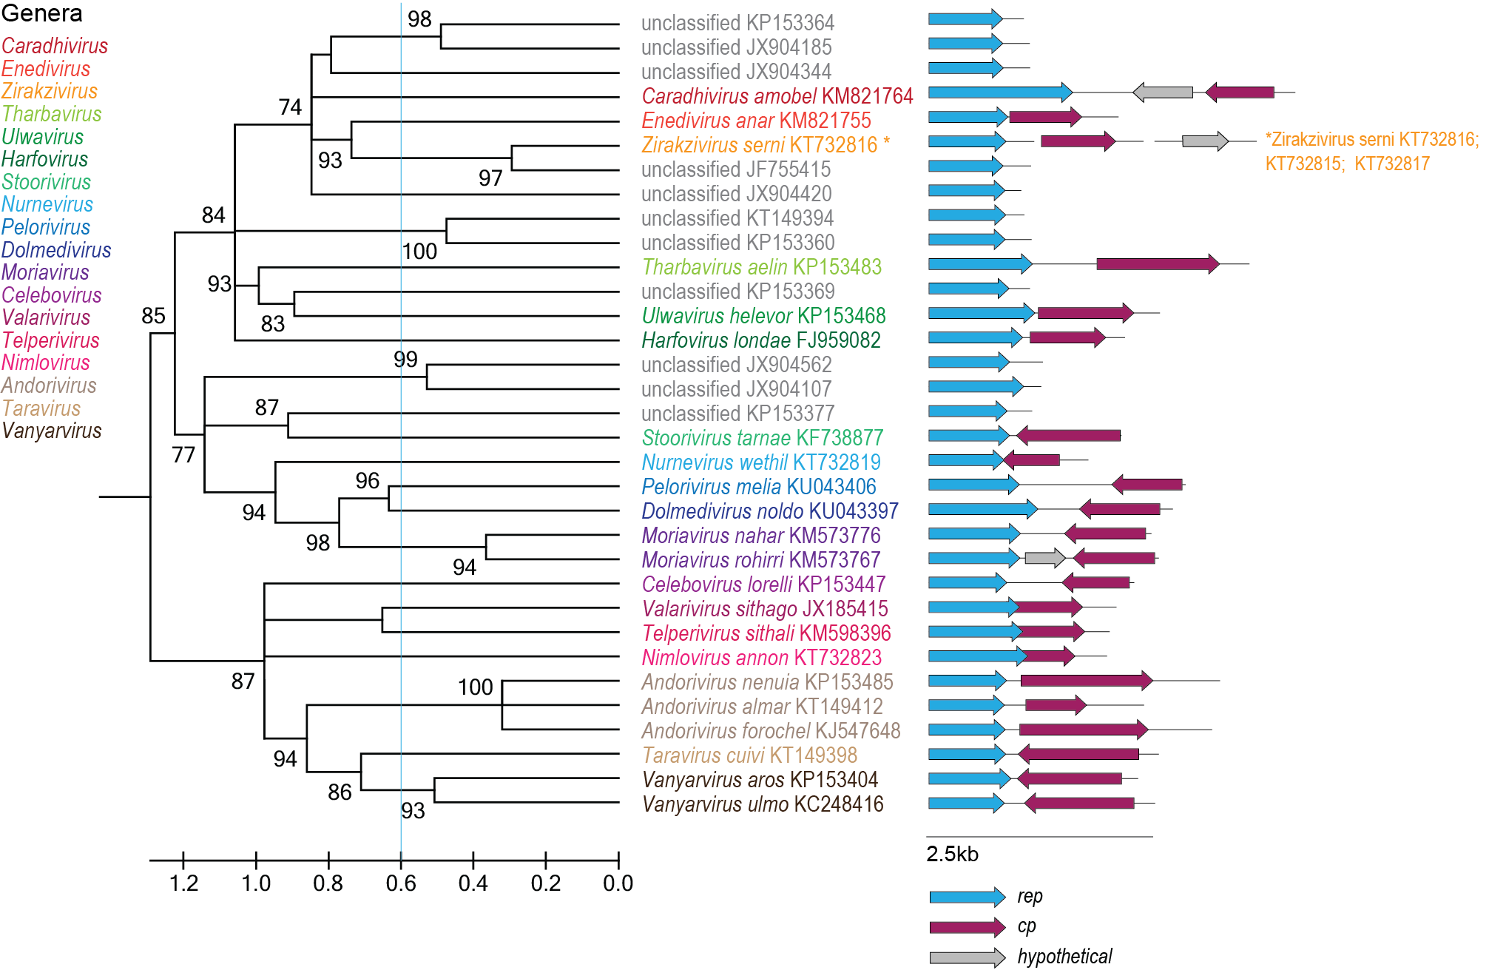

Figure 2: Maximum likelihood phylogenetic tree of the Rep sequences of the members of the Adamaviridae family inferred with PhyML 3.0 [14] with rtREV+I+G+F model determined as the best substitution model using ProtTest 3 [15] and rooted with representative sequences of members of the family Circoviridae. The species belonging to the same genus are indicated with the same color. Numbers at the nodes represent aLRT branch supports. The cyan line shows a proposed demarcation of genera. The genome organization relative to the rep ORF is shown to the right of the phylogeny. * Please note that Zirakzivirus serni has a multipartite genome with accessions KT732816 (Rep coding), KT732815 (Cp coding), KT732817 (hypothetical protein coding).

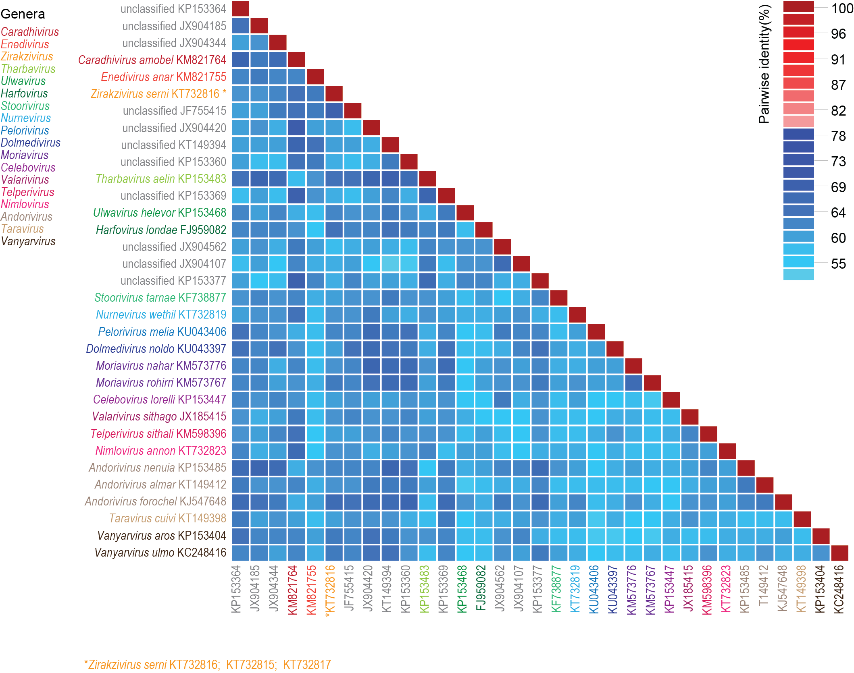

Figure 3: A ‘two color’ pairwise identity matrix of members of the family Adamaviridae with 78% species threshold s inferred using SDT v1.2 [16]. * Please note that Zirakzivirus serni has a multipartite genome with accessions KT732816 (Rep coding), KT732815 (Cp coding), KT732817 (hypothetical protein coding).

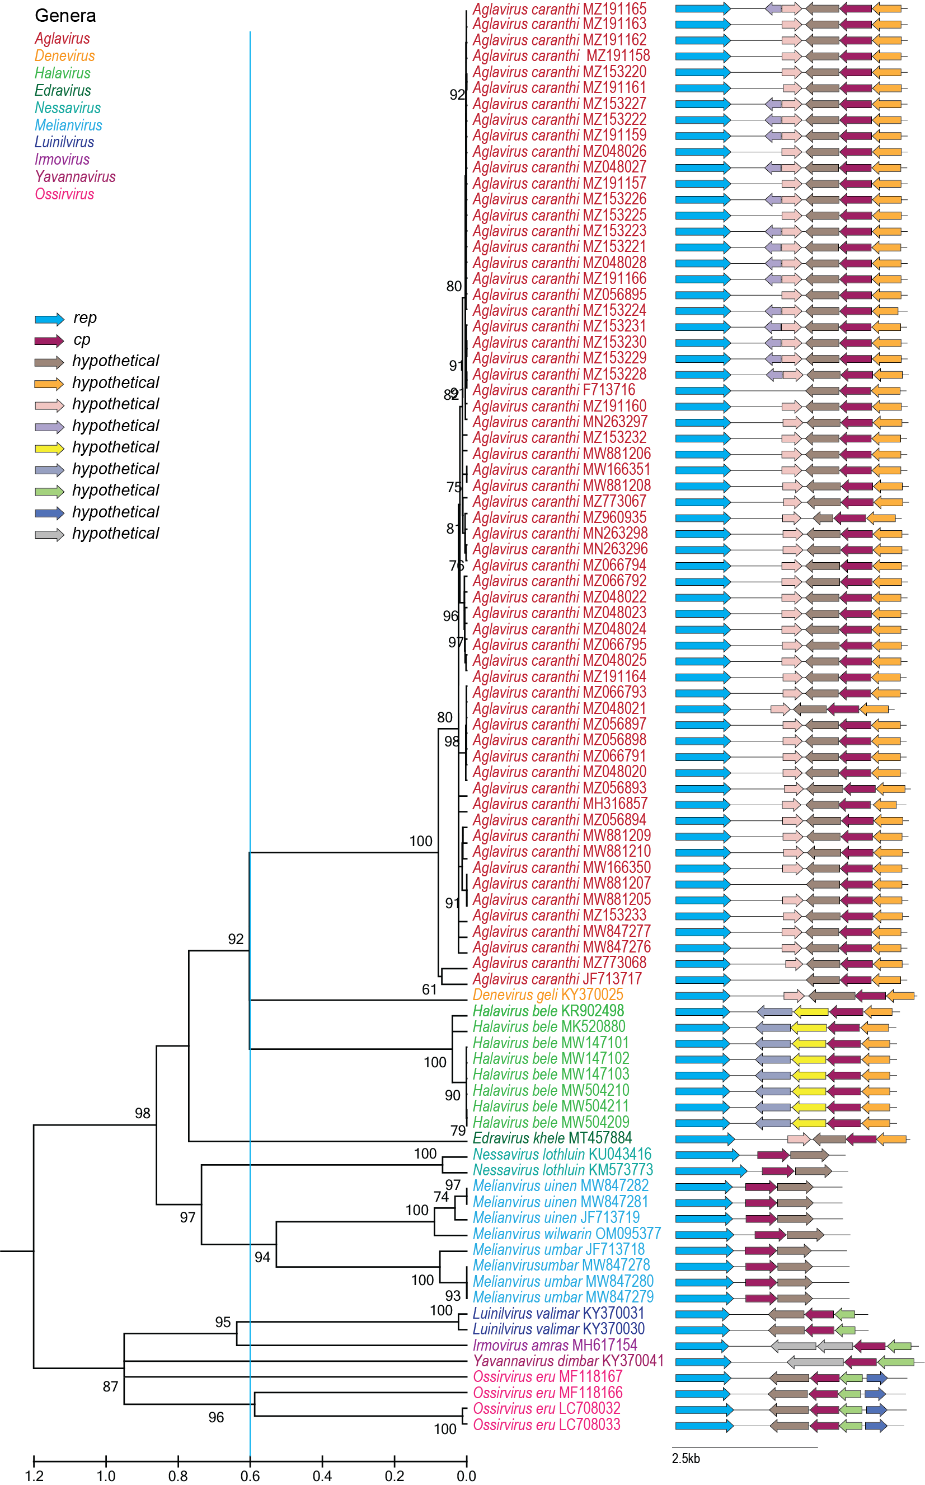
Figure 4: Maximum likelihood phylogenetic tree of the Rep sequences of the members of the Kirkoviridae family inferred with PhyML 3.0 [14] with LG+I+G model determined as the best substitution model using ProtTest 3 [15] and rooted with representative sequences of members of the family Nenyaviridae. The species belonging to the same genus are indicated with the same color. Numbers at the nodes represent aLRT branch supports. The cyan line shows a proposed demarcation of genera. The genome organization relative to the rep ORF is shown to the right of the phylogeny.

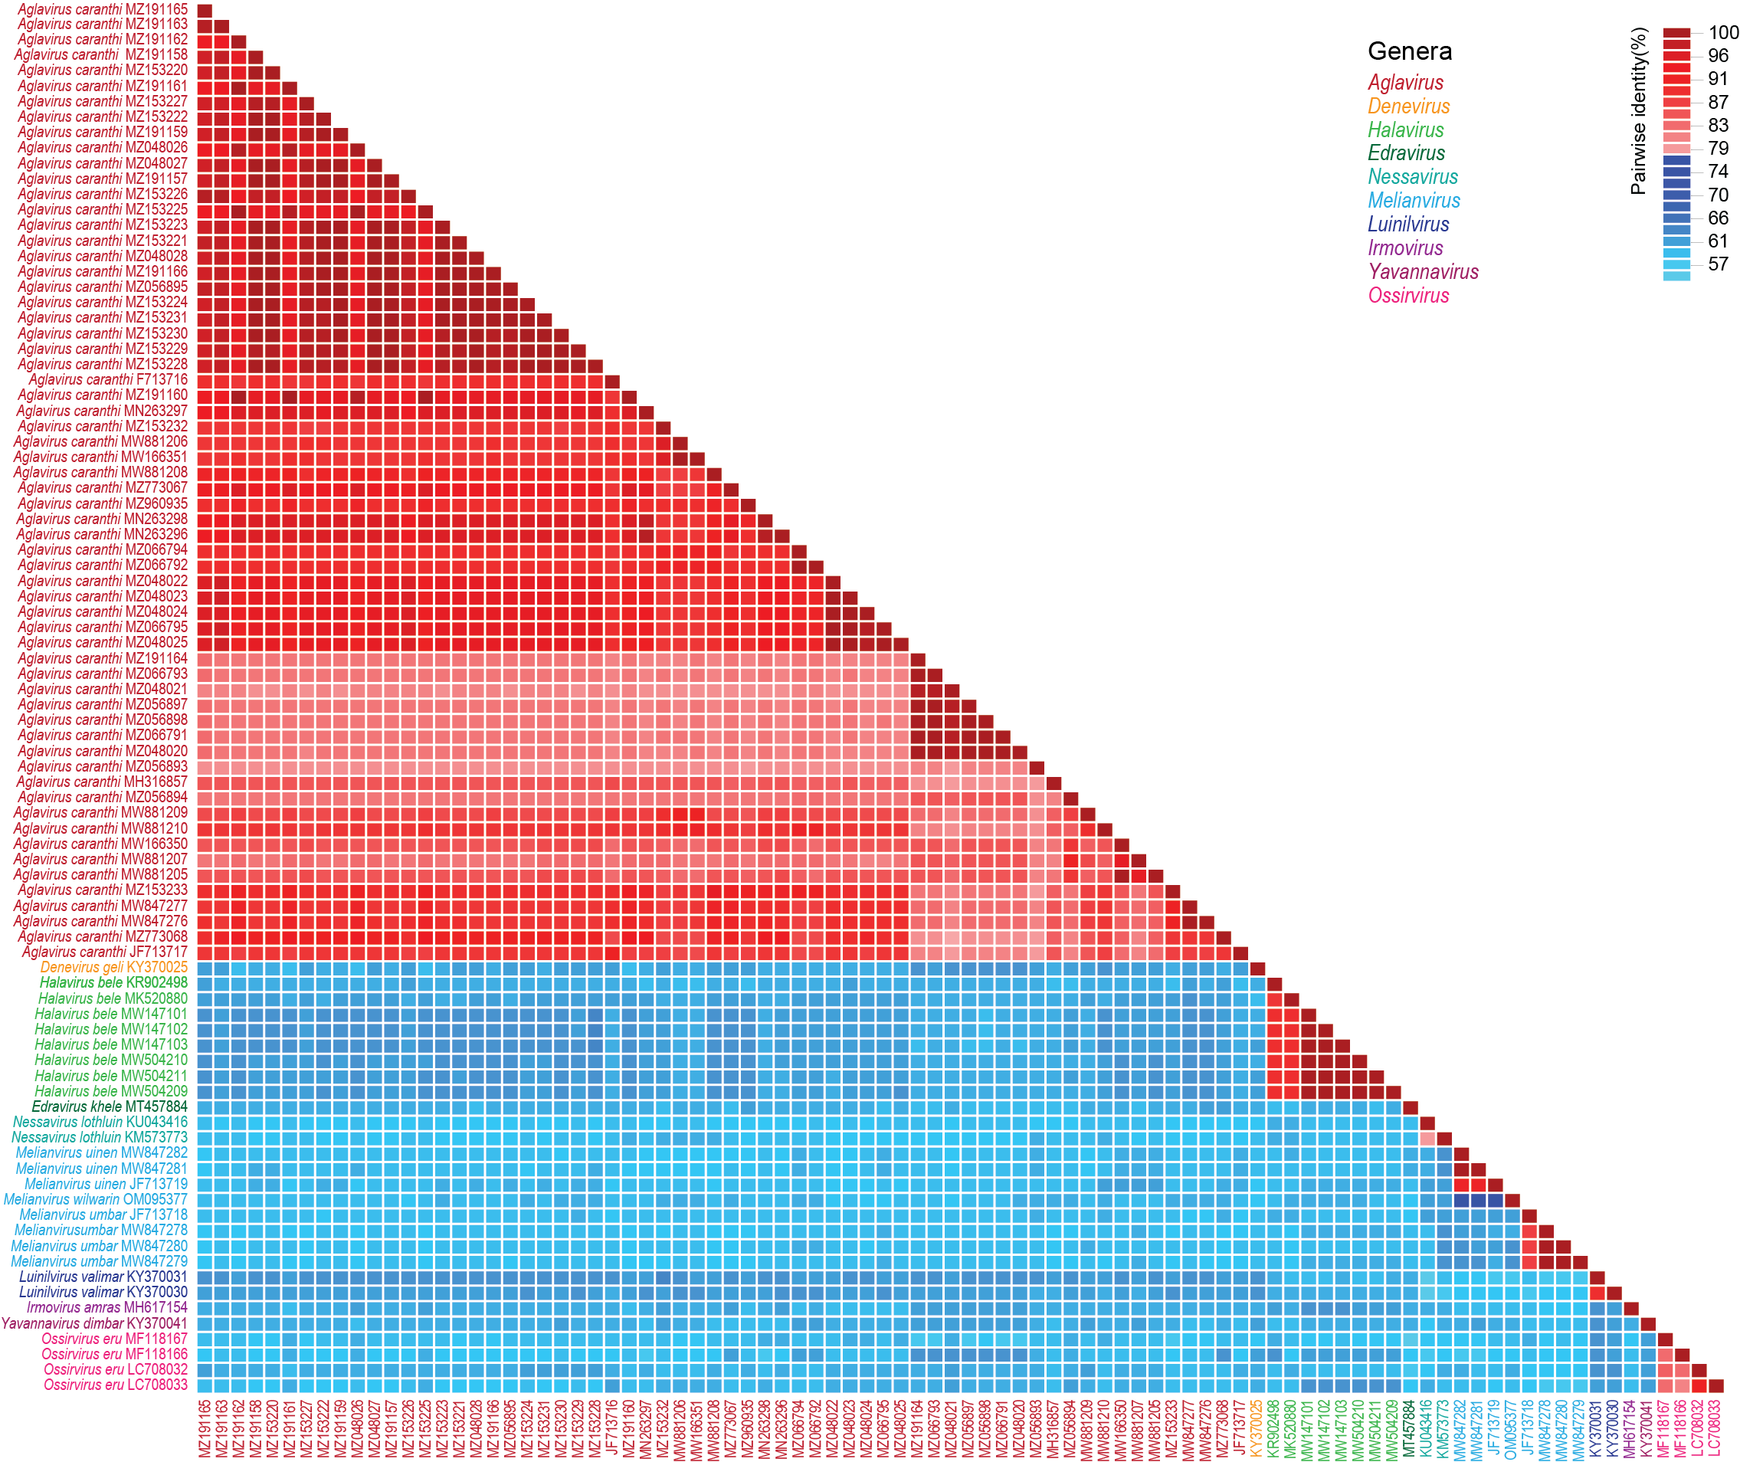

Figure 5: A ‘two color’ pairwise identity matrix of members of the family Kirkoviridae with 78% species threshold, full genome comparison, inferred using SDT v1.2 [16].

References

- Kazlauskas D, Varsani A, Krupovic M (2018) Pervasive Chimerism in the Replication-Associated Proteins of Uncultured Single-Stranded DNA Viruses. Viruses 10:187. doi:10.3390/v10040187. PMID:29642587
- Kazlauskas D, Varsani A, Koonin EV, Krupovic M (2019) Multiple origins of prokaryotic and eukaryotic single-stranded DNA viruses from bacterial and archaeal plasmids. Nat Commun 10:3425. doi:10.1038/s41467-019-11433-0. PMID:31366885
- Kinsella CM, Deijs M, Becker C, Broekhuizen P, van Gool T, Bart A, Schaefer AS, van der Hoek L. (2022). Host prediction for disease-associated gastrointestinal cressdnaviruses. Virus Evol. 8(2):veac087. doi: 10.1093/ve/veac087. PMID: 36325032; PMCID: PMC9615429.
- Liu TN, Liu CX, Liao JY, Xiong WJ, Xia JY, Xiao CT. (2022) Identification and genomic characterization of a novel porcine CRESS DNA virus from a pig suffering from diarrhea in China. Arch Virol. 167(5):1355-1359. doi: 10.1007/s00705-022-05423-9. Epub 2022 Mar 21. PMID: 35312844.
- Tong P, Deng H, Duan L, Ren M, Song X, Wang H, Gulimire D, Kuang L, Xie J. (2022). First detection of the occurrence and study of the genetic diversity of novel putative kirkoviruses in donkey in China. Virus Genes. 58(2):146-149. doi: 10.1007/s11262-022-01891-y. Epub 2022 Mar 7. PMID: 35254587.
- Sun W, Wang W, Cao L, Zheng M, Zhuang X, Zhang H, Yu N, Tian M, Lu H, Jin N. (2021). Genetic characterization of three porcine circovirus-like viruses in pigs with diarrhoea in China. Transbound Emerg Dis. 68(2):289-295. doi: 10.1111/tbed.13731. Epub 2020 Jul 30. PMID: 32657534.
- Xie J, Tong P, Zhang A, Yan Y, Zhang L, Song X, Chen J, Zhai S, Shaya N, Wang D, Su Z, Kuang L. (2018) First detection and genetic characterization of a novel kirkovirus from a dead thoroughbred mare in northern Xinjiang, China, in 2018. Arch Virol. 165(2):403-406. doi: 10.1007/s00705-019-04487-4. PMID: 31797130.
- Krupovic M, Varsani A, Kazlauskas D, Breitbart M, Delwart E, Rosario K, Yutin N, Wolf YI, Harrach B, Zerbini FM, Dolja VV, Kuhn JH, Koonin EV (2020) Cressdnaviricota: a Virus Phylum Unifying Seven Families of Rep-Encoding Viruses with Single-Stranded, Circular DNA Genomes. J Virol 94:e00582-20. doi:10.1128/JVI.00582-20. PMID:32269128
- Krupovic M, Varsani A. (2022). Naryaviridae, Nenyaviridae, and Vilyaviridae: three new families of single-stranded DNA viruses in the phylum Cressdnaviricota. Arch. Virol. 167, 2907–2921.PMID: 36098801 DOI: 10.1007/s00705-022-05557-w
- Varsani A, Krupovic M (2017) Sequence-based taxonomic framework for the classification of uncultured single-stranded DNA viruses of the family Genomoviridae. Virus Evol 3:vew037. doi:10.1093/ve/vew037. PMID:28458911
- Varsani A, Krupovic M (2018) Smacoviridae: a new family of animal-associated single-stranded DNA viruses. Arch Virol 163:2005-2015. doi:10.1007/s00705-018-3820-z. PMID:29572596
- Capella-Gutierrez S, Silla-Martinez JM, Gabaldon T (2009) trimAl: a tool for automated alignment trimming in large-scale phylogenetic analyses. Bioinformatics 25:1972-3. doi:10.1093/bioinformatics/btp348. PMID:19505945
- Minh BQ, Schmidt HA, Chernomor O, Schrempf D, Woodhams MD, von Haeseler A, Lanfear R (2020) IQ-TREE 2: New Models and Efficient Methods for Phylogenetic Inference in the Genomic Era. Mol Biol Evol 37:1530-1534. doi:10.1093/molbev/msaa015. PMID:32011700
- Guindon S, Dufayard JF, Lefort V, Anisimova M, Hordijk W, Gascuel O (2010) New algorithms and methods to estimate maximum-likelihood phylogenies: assessing the performance of PhyML 3.0. Syst Biol 59:307-321. PMID: 20525638; doi: 10.1093/sysbio/syq010
- Darriba D, Taboada GL, Doallo R, Posada D. (2011). ProtTest 3: fast selection of best-fit models of protein evolution. Bioinformatics. 27(8):1164-5. doi: 10.1093/bioinformatics/btr088. Epub 2011 Feb 17. PMID: 21335321; PMCID: PMC5215816.
- Muhire BM, Varsani A, Martin DP (2014) SDT: A Virus Classification Tool Based on Pairwise Sequence Alignment and Identity Calculation. Plos One 9:e108277. doi:10.1

