Part 1: TITLE, AUTHORS, APPROVALS, etc

Code assigned: | 2023.023D
Short title: Establishing the order Jormunvirales, one new family (Draupnirviridae) and associated genera and species in the class Arfiviricetes (phylum Cressdnaviricota)
Author(s) and email address(es)
Varsani A, Lund MC, Hopkins A, Kraberger S, Krupovic M | Arvind.varsani@asu.edu; mclund2@asu.edu; adhopki1@asu.edu; Simona.kraberger@asu.edu; mart.krupovic@pasteur.fr
Author(s) institutional address(es) (optional)
The Biodesign Center for Fundamental and Applied Microbiomics, Center for Evolution and Medicine, School of Life sciences, Arizona State University, Tempe, AZ 85287-5001, USA [AV, MCL, AH, SK]
Institut Pasteur, Université Paris Cité, Archaeal Virology Unit, 25 rue du Dr Roux, 75015 Paris, France [MK]

Corresponding author
Arvind Varsani

List the ICTV Study Group(s) that have seen this proposal

ICTV Study Group comments and response of proposer

ICTV Study Group votes on proposal

Study Group | Number of members
 | Votes support | Votes against | No vote
Authority to use the name of a living person

Is any taxon name used here derived from that of a living person (Y/N) | N

Taxon name | Person from whom the name is derived | Permission attached (Y/N)

Submission dates
Date first submitted to SC Chair | 14 July 2023
Date of this revision (if different to above) | 5 Oct 2023
ICTV-EC comments and response of the proposer
The proposal was deemed acceptable in the form presented at the EC meeting. However, in the meantime, an article has been published [13] where a group of viruses considered in the current TaxoProp was suggested to be classified into a new family, Draupnirviridae. To avoid confusion in the literature, we renamed the originally proposed family Jormunviridae to Draupnirviridae. To maintain the link to Norse mythology in both family and order names, we also replaced the order name Squillovirales with Jormunvirales. No changes to the classification scheme itself were made.
Part 2: NON-TAXONOMIC PROPOSAL
Text of proposal

Part 3: TAXONOMIC PROPOSAL
Name of accompanying Excel module
2023.023D.N.v2. Squillovirales_1no_1nf_42ng_67nsp.xlsx
Abstract

We propose to establish the order Jormunvirales in the class Arfiviricetes (phylum Cressdnaviricota), including one new family, Draupnirviridae, with 42 genera and 67 species.
Text of proposal
We propose to establish the order Jormunvirales, including one new family, Draupnirviridae, comprising 42 genera and 67 species to classify 102 viral sequences that are part of a group of viruses informally referred to as CRESSV3 in the phylum Cressdnaviricota [1-4].

The order name Jormunvirales is derived from Jourmundgander (Norse mytology) - the enemy of the thunder god Thor was also called World Serpent, because its body coiled around the whole Earth (Midgard).

The family name Draupnirviridae was proposed by Dr. Cormac M Kinsella and Dr. Lia van der Hoek (University of Amsterdam) in a recent publication [13] and is derived from the ring Draupnir of Norse mythology, said to have multiplied itself every ninth night. It alludes to both the circular viral genome and genome replication.

Genus and species demarcation

We undertook comparative genomics and phylogenetic analyses of the Rep proteins of members of this group to determine their relationships. Genera were delineated based on phylogenetic analyses coupled with pairwise identities and also the genome organization relative to the rep open reading frame (Figures 2 - 3).

For species demarcation, we used a 78% pairwise nucleotide genome-wide sequence identity which is similar to that used for other cressdnaviruses [5-7].

Genera
Etymology of genus names (derived from gladiator names)

- Atroxivirus: Atrox meaning savage and bloody or cruel
- Audacivirus: Audacia meaning boldness or courage
- Audaxivirus: Audaxi meaning daring
- Bellicinaivirus: Bellicina meaning female warrior
- Citataivirus: Citata meaning an agile warrior
- Ferullusivirus: Ferullus meaning as strong as iron
- Incitativirus: Incitata meaning fast-moving, aroused or passionate
- Malificivirus: Malificia meaning evil
- Potensivirus: Potens meaning powerful, to confer potency
- Rapidusivirus: Rapidus meaning swift and fierce
- Citiorivirus: Citior meaning with a lot of speed
- Asperivirus: Asper meaning hope answered
- Fervidivirus: Fervida meaning boiling hot
- Durusivirus: Durus meaning hard or fast
- Nocentianivirus: Nocentianus meaning determined killer or fierce warrior
- Nervillivirus: Nervilla meaning tough and small
- Mordaxivirus: Mordax meaning biting or snappish
- Periculosovirus: Periculosa meaning dangerous
- Properatisvirus: Properatus meaning to hasten
- Strenuaivirus: Strenua means Goddess of the new year, well-being and purification
- Tetricillivirus: Tetricilla meaning a harsh and cruel woman
- Robaratusivirus: Robaratus meaning one with strength
- Torentivirus: Torentius meaning a treacherous river
- Valentivirus: Valentia meaning a powerful female
- Funestivirus: Funestus meaning calamitous , deadly or, fatal
- Citaivirus: Cita meaning a woman with agility
- Armipotenivirus: Armipotens (English origin) meaning powerful
- Validivirus: Validus meaning strong and powerful
- Roburiusivirus: Roburius meaning one with strength and fury
- Vegetinivirus: Vegetinus meaning powerful one
- Pollentivirus: Pollentius meaning one who has power
- Vegetivirus: Vegetus meaning power or strength
- Vehemenivirus: Vehemens (origin) meaning emphatic, vigorous or lively
- Velocianivirus: Velocianus meaning rapid or fast
- Veloxivirus: Velox meaning swift
- Incitatusivirus: Incitatus meaning swift
- Violenivirus: Violens meaning destructive action
- Belligerivirus: Belliger meaning bringer of war
- Viratusivirus: Viratus meaning strong or virility
- Virilianivirus: Virilianus meaning manly or energetic
- Volantivirus: Volantius meaning flying
- Strenuusivirus: Strenuus meaning vigorous

Etymology of species epithets – derived from host names, source and institutions names that generated the sequence data.

- Aedvexis: Aedes vexans - latinized by 'is'
- Anlentse: Saanich Inlet - latinized by 'ense'
- Antaflavis: Pantala flavescens - latinized by 'is'
- Arilasis: Arizona virus Lake water sample - latinized by 'is'
- Aristcris: Arizona State University crucivirus - latinized by 'is'
- Austris: Austrovenus - latinized by 'is'
- Bacesis: bat feces- latinized by 'is'
- Baguanis: bat guano - latinized by 'is'
- Cotis: cow tissue
- Crordgris: Procordulia grayi - latinized by 'is'
- Crutis: crucian tissue
- Curcianense: crucivirus France - latinized by 'ense'
- Cylocis: Cygnus olor fecal material -latinized by 'is'
- Diadonense: Dianchi and Donghu Lake - latinized by 'ense'
- Erthyycolis: Erythemis simplicicollis
- Flovetense: Florida State University wastewater - latinized by 'ense'
- Flowis: Florida wastewater - latinized by 'is'
- Frelianis: Freshwater lake (Dianchi) sample- latinized by 'is'
- Grunawis: Gruidae anal swab - latinized by 'is'
- Lancristus: Lanius cristatus - latinized by 'is'
- Lanversius: Portland State University crucivirus
- Lasamoense: Lake Sarah mollusc latinized by 'ense'
- Lasarense: Lake Sarah latinized by 'ense'
- Lastavis: Portland State University crucivirus - latinized by 'is'
- Loriverwastis: Florida State University wastewater - latinized by 'is'
- Mimentis: Mollusca sediment - latinized by 'is'
- Minfulis: Miniopterus fuliginosus - latinized by 'is'
- Minifulis: Miniopterus fuliginosus - latinized by 'is'
- Molmolis: Molossus molossus - latinized by 'is
- Motavenis: Marmota flaviventris - latinized by 'is'
- Myomainis: Myotis myotis brain - latinized by 'is'
- Nemenis: New Zealand sediment- latinized by 'is'
- Nobatis: bat guano - latinized by 'is'
- Orancis: Oregon France crucivirus - latinized by 'is'
- Orstucis: Portland State University cruci - latinized by 'is'
- Pachylongis: Pachydiplax longipennis - latinized by 'is'
- Phonalis: Phoenicopteridae anal swab - latinized by 'is'
- Pinazonis: Pinal County, Arizona airborne particulate matter - latinized by 'is'
- Pleritis: Plecotus auritus -latinized by 'is'
- Porcris: Portland State University crucivirus - latinized by 'is'
- Portlucense: Portland State University crucivirus - latinized by 'ense'
- Potacris: Portland State University crucivirus - latinized by 'is'
- Raptis: red snapper tissue
- Recresis: red-crowned crane feces - latinized by 'is'
- Reperis: red snapper tissue
- Reperis: red snapper tissue
- Resnapis: red snapper tissue
- Rhisidis: Rhinolophus hipposideros - latinized by 'is'
- Ridensis: Tadarida brasiliensis
- Sabatis: USA seabass tissue
- Saidatense: USA: Florida wastewater - latinized by 'ense'
- Sanlemaris: Saanich Inlet uncultured marine virus -latinized by 'is'
- Saquitis: USA mosquito - latinized by 'is'
- Satuanis: USA bat guano - latinized by 'is'
- Seabatis: sea bass tissue
- Semberis: sea cucumber tissue
- Sitoranense: University of South Florida Manatee Spring - latinized by 'ense'
- Stregense: Strait of Georgia - latinized by 'ense'
- Tanscopis: Tangara episcopus -latinized by 'is'
- Ubatis: USA seabass tissue
- Uhadis: USA haddock tissue
- Umantense: USA Manatee springs -latinized by 'ense'
- Umaspis: USA Manatee Spring- latinized by 'is'
- Westrobis: New Zealand Austrovenus stutchburyi -latinized by 'is'
- Yotargis: Myotis emarginatus - latinized by 'is'
- Zocris: Arizona State University crucivirus - latinized by 'is'
- Zuncris: Arizona State University crucivirus - latinized by 'is'

Supporting evidence

Table 1: Summary of the viruses classified in the new order Jormunvirales and family Draupnirviridae.

Genus | Species | Accession # | Virus | Year | Country | Host /source | Isolate
Robaratusivirus | Robaratusivirus reperis | MH616644 | Circoviridae sp. ctbc359 | 2017 | USA | red snapper tissue | tbc359
Robaratusivirus | Robaratusivirus semberis | KX246262 | Uncultured virus PcaCV4 | 2015 | USA | Parastichopus californicus | PcaCV4
Funestivirus | Funestivirus seabatis | MH649188 | CRESS virus sp. ctbb692 | 2017 | USA | seabass tissue | ctbb692
Funestivirus | Funestivirus anlentse | JX904581 | Uncultured marine virus SI03931 |  | Canada | Saanich Inlet, British Columbia, Canada | SI03931
Violenivirus | Violenivirus cotis | MH617295 | Circoviridae sp. ctbe120 | 2017 | USA | Bos taurus | ctbe120
Violenivirus | Violenivirus raptis | MH617708 | Circoviridae sp. ctcb567 | 2017 | USA | red snapper tissue | ctcb567
Atroxivirus | Atroxivirus austris | KM874300 | Avon-Heathcote Estuary associated circular virus 4 | 2012 | New Zealand | Austrovenus stutchburyi | AHEaCV-4-NZ-3049C3-2012
Atroxivirus | Atroxivirus austris | KM874299 | Avon-Heathcote Estuary associated circular virus 4 | 2012 | New Zealand | Austrovenus stutchburyi | AHEaCV-4-NZ-3049C2-2012
Atroxivirus | Atroxivirus austris | KM874298 | Avon-Heathcote Estuary associated circular virus 4 | 2012 | New Zealand | Austrovenus stutchburyi | AHEaCV-4-NZ-3049C1-2012
Strenuusivirus | Strenuusivirus lasamoense | MH648972 | CRESS virus sp. ctee590 | 2017 | USA | seabass tissue | ctee590
Strenuusivirus | Strenuusivirus lasamoense | KM874308 | Avon-Heathcote Estuary associated circular virus 6 | 2012 | New Zealand | i | AHEaCV-6-NZ-4645GA-2012
Strenuusivirus | Strenuusivirus lasamoense | KM874306 | Avon-Heathcote Estuary associated circular virus 6 | 2012 | New Zealand | benthic sediment | AHEaCV-6-NZ-2974SG-2012
Strenuusivirus | Strenuusivirus lasamoense | KM874305 | Avon-Heathcote Estuary associated circular virus 6 | 2012 | New Zealand | Austrovenus stutchburyi | AHEaCV-6-NZ-3103C3-2012
Strenuusivirus | Strenuusivirus lasamoense | KM874304 | Avon-Heathcote Estuary associated circular virus 6 | 2012 | New Zealand | Austrovenus stutchburyi | AHEaCV-6-NZ-3103C1-2012
Strenuusivirus | Strenuusivirus lasamoense | KM874307 | Avon-Heathcote Estuary associated circular virus 6 | 2012 | New Zealand | Paphies subtriangulata | AHEaCV-6-NZ-2194TU-2012
Strenuusivirus | Strenuusivirus resnapis | MH617406 | Circoviridae sp. ctce509 | 2017 | USA | red snapper tissue | ctce509
Asperivirus | Asperivirus lasarense | KP153423 | Lake Sarah-associated circular virus-16 | 2013 | New Zealand | Potamopyrgus antipodarum | LSaCV-16-LSGA-2013
Asperivirus | Asperivirus lasarense | KP153421 | Lake Sarah-associated circular virus-16 | 2013 | New Zealand | water | LSaCV-16-LSWA-2013
Asperivirus | Asperivirus lasarense | KP153420 | Lake Sarah-associated circular virus-16 | 2013 | New Zealand | Echyridella menziesii | LSaCV-16-LSMU-122865-13
Asperivirus | Asperivirus lasarense | KP153422 | Lake Sarah-associated circular virus-16 | 2013 | New Zealand | Chironomus zealandicus | LSaCV-16-LSWO-2013
Asperivirus | Asperivirus nemenis | KP153408 | Lake Sarah-associated circular virus-10 | 2013 | New Zealand | sediment | LSaCV-10-LSSO-2013
Citaivirus | Citaivirus phonalis | MT138056 | CRESS virus sp. zftfla02cir6 | 2016 | China | Avian | zftfla02cir6
Citaivirus | Citaivirus phonalis | MN928937 | CRESS virus sp. fla06cir2 | 2018 | China | Phoenicopteridae | fla06cir2
Citaivirus | Citaivirus phonalis | MN928936 | CRESS virus sp. fla05cir2 | 2018 | China | Phoenicopteridae | fla05cir2
Citaivirus | Citaivirus phonalis | MN928935 | CRESS virus sp. fla04cir1 | 2018 | China | Phoenicopteridae | fla04cir1
Rapidusivirus | Rapidusivirus mimentis | KM874318 | Avon-Heathcote Estuary associated circular virus 9 | 2012 | New Zealand | benthic sediment | AHEaCV-9-NZ-3131SG-2012
Rapidusivirus | Rapidusivirus mimentis | KM874317 | Avon-Heathcote Estuary associated circular virus 9 | 2012 | New Zealand | Amphibola crenata | AHEaCV-9-NZ-4424GA-2012
Rapidusivirus | Rapidusivirus mimentis | KM874316 | Avon-Heathcote Estuary associated circular virus 9 | 2012 | New Zealand | Austrovenus stutchburyi | AHEaCV-9-NZ-3171C3-2012
Rapidusivirus | Rapidusivirus mimentis | KM874315 | Avon-Heathcote Estuary associated circular virus 9 | 2012 | New Zealand | Austrovenus stutchburyi | AHEaCV-9-NZ-3171C1-2012
Veloxivirus | Veloxivirus ubatis | MH649090 | CRESS virus sp. ctfb748 | 2017 | USA | seabass tissue | ctfb748
Citataivirus | Citataivirus uhadis | MH617523 | CRESS virus sp. ctbj245 | 2017 | USA | haddock tissue | ctbj245
Citataivirus | Citataivirus sanlemaris | JX904407 | Uncultured marine virus SI00078 |  | Canada | Saanich Inlet, British Columbia, Canada | SI00078
Roburiusivirus | Roburiusivirus westrobis | KM874294 | Avon-Heathcote Estuary associated circular virus 2 | 2012 | New Zealand | Austrovenus stutchburyi | AHEaCV-2-NZ-3024C3-2012
Roburiusivirus | Roburiusivirus westrobis | KM874293 | Avon-Heathcote Estuary associated circular virus 2 | 2012 | New Zealand | Austrovenus stutchburyi | AHEaCV-2-NZ-3024C2-2012
Roburiusivirus | Roburiusivirus westrobis | KM874292 | Avon-Heathcote Estuary associated circular virus 2 | 2012 | New Zealand | Austrovenus stutchburyi | AHEaCV-2-NZ-3024C1-2012
Properatisvirus | Properatisvirus sabatis | MH617385 | Circoviridae sp. ctcb18 | 2017 | USA | seabass tissue | ctcb18
Properatisvirus | Properatisvirus sabatis | JX904076 | Uncultured marine virus SOG00164 |  | Canada | Strait of Georgia, British Columbia, Canada | SOG00164
Properatisvirus | Properatisvirus stregense | JX904075 | Uncultured marine virus SOG00160 |  | Canada | Strait of Georgia, British Columbia, Canada | SOG00160
Properatisvirus | Properatisvirus stregense | JX904139 | Uncultured marine virus SOG03994 |  | Canada | Strait of Georgia, British Columbia, Canada | SOG03994
Fervidivirus | Fervidivirus umantense | MW202677 | CRESS virus sp. ctaE5783 | 2019 | USA | Manatee Spring | ctaE5783
Velocianivirus | Velocianivirus diadonense | KT149410 | Circovirus-like genome DHCV-4 | 2010 | China | Freshwater lake (Donghu) sample (< 0.5 m) | DHCV-4
Velocianivirus | Velocianivirus diadonense | KT149409 | Circovirus-like genome DHCV-3 | 2010 | China | Freshwater lake (Donghu) sample (< 0.5 m) | DHCV-3
Torentivirus | Torentivirus curcianense | MT478552 | Crucivirus sp. Crucivirus-136 001794_virusbaton | 2013 | France | water | Crucivirus-136 001794_virusbaton
Torentivirus | Torentivirus orstucis | MT478527 | Crucivirus sp. Crucivirus-217 001577_virusbaton | 2013 | France | water | Crucivirus-217 001577_virusbaton
Torentivirus | Torentivirus crutis | MK012508 | CRESS virus sp. ctef39 | 2017 | USA | crucian tissue | ctef39
Torentivirus | Torentivirus potacris | MT478520 | Crucivirus sp. Crucivirus-231 001539_virusbaton | 2013 | France | water | Crucivirus-231 001539_virusbaton
Torentivirus | Torentivirus aristcris | MT263594 | Crucivirus-295 BS_189 | 2012 | New Zealand | water | BS_189
Torentivirus | Torentivirus lanversius | MT478518 | Crucivirus sp. Crucivirus-235 001534_virusbaton | 2013 | France | water | Crucivirus-235 001534_virusbaton
Torentivirus | Torentivirus zocris | MT263533 | Crucivirus-184 CHIVOP3_758 | 2015 | Brazil | plant | CHIVOP3_758
Torentivirus | Torentivirus | MT181527 | Marmot associated feces circular DNA molecule 4 | 2018 | USA | Marmota flaviventris | MAR3_3_1358
Malificivirus | Malificivirus porcris | MT478521 | Crucivirus sp. Crucivirus-230 001540_virusbaton | 2013 | France | water | Crucivirus-230 001540_virusbaton
Incitatusivirus | Incitatusivirus orancis | MT478515 | Crucivirus sp. Crucivirus-256 001509_virusbaton | 2013 | France | water | Crucivirus-256 001509_virusbaton
Volantivirus | Volantivirus lastavis | MT478550 | Crucivirus sp. Crucivirus-138 001787_virusbaton | 2013 | France | water | Crucivirus-138 001787_virusbaton
Volantivirus | Volantivirus zuncris | MT263655 | Crucivirus-523 GP1_93596 | 2014 | New Zealand | water | GP1_93596
Armipotenivirus | Armipotenivirus tanscopis | MF804498 | Circoviridae TaCV2 | 2012 | Ecuador | Tangara episcopus | TaCV2
Pollentivirus | Pollentivirus pleritis | KJ641729 | bat circovirus BtPa-CV-3/NX2013 | 2013 | China | Plecotus auritus | BtPa-CV-3/NX2013
Ferullusivirus | Ferullusivirus cylocis | MW588080 | mute swan feces associated circular virus 6 | 2016 | United Kingdom | Cygnus olor | Abbotsbury/A/2016
Ferullusivirus | Ferullusivirus minfulis | KJ641722 | bat circovirus BtMf-CV/HeN2013 | 2013 | China | Miniopterus fuliginosus | BtMf-CV/HeN2013
Ferullusivirus | Ferullusivirus baguanis | HM228875 | Circoviridae TM-6c | 2008 | USA | bat | TM-6c
Valentivirus | Valentivirus ridensis | OL704835 | Tadarida brasiliensis associated circovirus 1 MAVG-10 | 2017 | Argentina | Tadarida brasiliensis | MAVG-10
Valentivirus | Valentivirus ridensis | OL704834 | Tadarida brasiliensis associated circovirus 1 MAVG-09 | 2017 | Argentina | Tadarida brasiliensis | MAVG-09
Valentivirus | Valentivirus ridensis | MH188040 | Culex circovirus-like virus CCirVL/Butte | 2016 | USA | Culex sp. | CCirVL/Butte
Valentivirus | Valentivirus saquitis | MH188041 | Culex circovirus-like virus CCirVL/Shasta | 2016 | USA | Culex sp. | CCirVL/Shasta
Valentivirus | Valentivirus aedvexis | KM972726 | mosquito circovirus B51 | 2013 | Germany | Aedes vexans | B51
Valentivirus | Valentivirus aedvexis | KM972725 | mosquito circovirus B19 | 2013 | Germany | Aedes vexans | B19
Valentivirus | Valentivirus rhisidis | MT815981 | bat associated circovirus BatACV/Rh1/Switzerland/2019 | 2019 | Switzerland: Grisons | Rhinolophus hipposideros | BatACV/Rh1/Switzerland/2019
Valentivirus | Valentivirus rhisidis | KY302864 | Circovirus sp. EP38/Hun/2013 | 2013 | Hungary | Myotis alcathoe | EP38/Hun/2013
Valentivirus | Valentivirus rhisidis | HQ335042 | Uncultured circovirus SDWAP I |  | USA: San Diego | mosquito | SDWAP I
Vegetinivirus | Vegetinivirus nobatis | MT734816 | bat associated circovirus BatCV/BB | 2020 | USA | bat | BatCV/BB
Vegetinivirus | Vegetinivirus nobatis | MT734815 | bat associated circovirus BatCV/RM | 2020 | USA | bat | BatCV/RM
Vegetinivirus | Vegetinivirus nobatis | MT734814 | bat associated circovirus BatCV/YB | 2020 | USA | bat | BatCV/YB
Vegetinivirus | Vegetinivirus molmolis | KM382272 | bat circovirus POA/2012/V | 2012 | Brazil | bat colony of Molossus molossus and Tadarida brasiliensis | POA/2012/V,
Vegetinivirus | Vegetinivirus molmolis | KM382271 | bat circovirus POA/2012/I | 2012 | Brazil | bat colony of Molossus molossus and Tadarida brasiliensis | POA/2012/I,
Citiorivirus | Citiorivirus crordgris | KF738883 | dragonfly larvae associated circular virus-9 | 2012 | New Zealand | Procordulia grayi | DflaCV-9_NZ-PG10-LD
Audaxivirus | Audaxivirus myomainis | MT815980 | bat associated circovirus BatACV/Mm1/Switzerland/2019 | 2019 | Switzerland: Aargau | Myotis myotis | BatACV/Mm1/Switzerland/2019
Audaxivirus | Audaxivirus yotargis | KY302869 | Circovirus sp. Bb1/Hun/2013 | 2013 | Hungary | Myotis emarginatus | Bb1/Hun/2013
Audaxivirus | Audaxivirus minifulis | KJ641718 | bat circovirus BtMf-CV-1/GD2012 | 2012 | China | Miniopterus fuliginosus | BtMf-CV-1/GD2012
Audaxivirus | Audaxivirus bacesis | JN857329 | Circoviridae batCV-SC703 | 2007 | China | bat feces | batCV-SC703
Periculosovirus | Periculosovirus satuanis | MT734813 | bat associated circovirus BatCV/WD | 2020 | USA | bat | BatCV/WD
Periculosovirus | Periculosovirus lancristus | MT138071 | CRESS virus sp. thr095cir1nc | 2018 | China | avian | thr095cir1nc
Periculosovirus | Periculosovirus lancristus | MT138069 | CRESS virus sp. rtr167cir1 | 2018 | China | avian | rtr167cir1
Periculosovirus | Periculosovirus lancristus | MN928934 | CRESS virus sp. brs113cir1 | 2018 | China | Lanius cristatus | brs113cir1
Periculosovirus | Periculosovirus lancristus | MT138040 | CRESS virus sp. wpk049cir01 | 2018 | China | avian | wpk049cir01
Strenuaivirus | Strenuaivirus antaflavis | JX185418 | dragonfly cyclicusvirus FL1-NZ37-2010 | 2010 | USA: St. Petersburg, Florida | Pantala flavescens | FL1-NZ37-2010
Vegetivirus | Vegetivirus portlucense | MT478555 | Crucivirus sp. Crucivirus-130 001815_virusbaton | 2013 | France | water | Crucivirus-130 001815_virusbaton
Vegetivirus | Vegetivirus loriverwastis | KY487866 | Uncultured virus CG197 | 2016 | USA: Florida | wastewater | CG197
Vehemenivirus | Vehemenivirus recresis | KY312555 | Circovirus sp. yc-16 | 2014 | China | Grus japonensis | yc-16
Nervillivirus | Nervillivirus flovetense | KY487847 | Uncultured virus CG178 | 2016 | USA: Florida | wastewater | CG178
Nervillivirus | Nervillivirus flovetense | KY487838 | Uncultured virus CG169 | 2016 | USA: Florida | wastewater | CG169
Virilianivirus | Virilianivirus pachylongis | KM598405 | Odonata-associated circular virus-19 | 2012 | USA | Pachydiplax longipennis | OdasCV-19-US-1604SC1-12
Virilianivirus | Virilianivirus pachylongis | KM598404 | Odonata-associated circular virus-19 | 2012 | USA | Libellula quadrimaculata | OdasCV-19-US-1594LM1-12
Nocentianivirus | Nocentianivirus saidatense | KY487945 | Uncultured virus CG276 | 2016 | USA: Florida | wastewater | G276
Mordaxivirus | Mordaxivirus sitoranense | MW202764 | CRESS virus sp. ctSa3636 | 2019 | USA | Manatee Spring | ctSa3636
Incitativirus | Incitativirus reperis | MH616869 | CRESS virus sp. ctbd540 | 2017 | USA | red snapper tissue | ctbd540
Durusivirus | Durusivirus erthyycolis | KM598406 | Odonata-associated circular virus-20 | 2012 | USA | Erythemis simplicicollis | OdasCV-20-US-718DFS-12
Audacivirus | Audacivirus pinazonis | MW678988 | virus sp. D3_88 | 2009 | USA: Pinal County, Arizona | airborne particulate matter | D3_88
Bellicusivirus | Bellicusivirus grunawis | MN928938 | CRESS virus sp. hftoti49cir2 | 2016 | China | Gruidae | hftoti49cir2
Belligerivirus | Belligerivirus frelianis | KT149403 | circovirus-like genome DCCV-10 | 2010 | China | Freshwater lake (Dianchi) | DCCV-10
Tetricillivirus | Tetricillivirus motavenis | MT181546 | marmot associated feces virus 6 | 2018 | USA | Marmota flaviventris | MAR1_1_1900
Validivirus | Validivirus umaspis | MW202896 | CRESS virus sp. ctIfk793 | 2019 | USA | Manatee Spring | ctIfk793
Validivirus | Validivirus umaspis | MW202735 | CRESS virus sp. ctVLj790 | 2019 | USA | Manatee Spring | ctVLj790
Viratusivirus | Viratusivirus arilasis | MW697472 | MAG: Arizlama virus AZLM_985 | 2012 | USA | Lake water sample | AZLM_985
Potensivirus | Potensivirus flowis | KY487854 | Uncultured virus CG185 | 2016 | USA: Florida | wastewater

Figure 1: Maximum likelihood phylogenetic tree inferred from Rep proteins of members of the phylum Cressdnaviricota. Related sequence groups are collapsed into triangles, the side lengths of which are proportional to the distances between the closest and farthest leaf nodes. The alignment was trimmed with TrimAL [8] with gap threshold of 0.2. The maximum likelihood phylogenetic tree was constructed using IQtree [9] with automatic selection of the best-fit substitution model for a given alignment, which was Q.pfam+F+R10. Numbers at the nodes represent aLRT branch supports. The scale bar represents the number of substitutions per site.

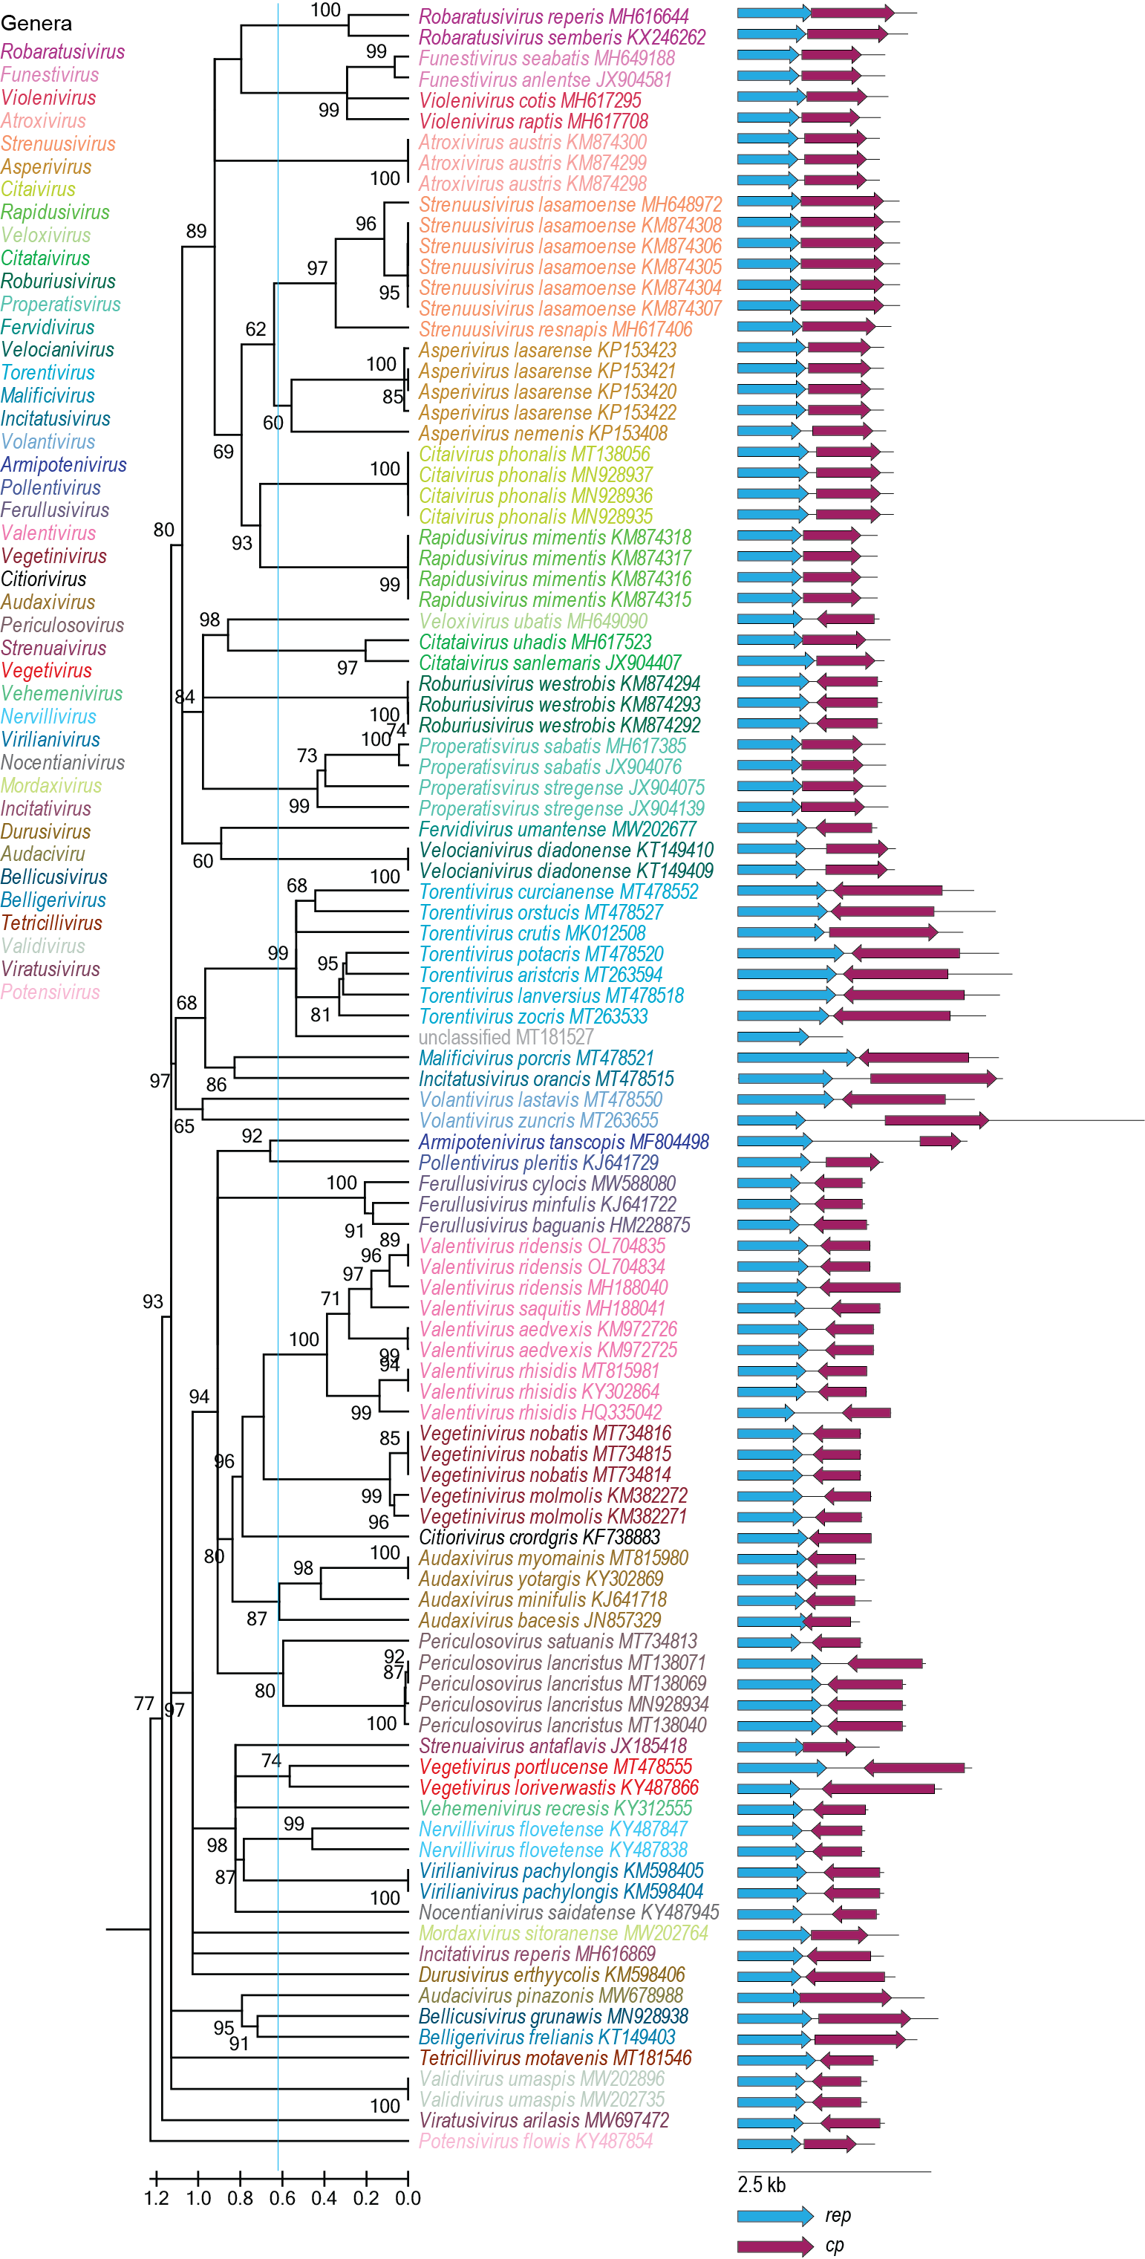
Figure 2: Maximum likelihood phylogenetic tree of the Rep sequences of the members of the Draupnirviridae family inferred with PhyML 3.0 [11] with rtREV+I+G+F model determined as the best substitution model using ProtTest 3 [12] and rooted with representative sequences of members of the family Bacilladnaviridae. The species belonging to the same genus are indicated with the same color. Numbers at the nodes represent aLRT branch supports. The cyan line shows a proposed demarcation of genera. The genome organization relative to the rep ORF is shown to the right of the phylogeny.

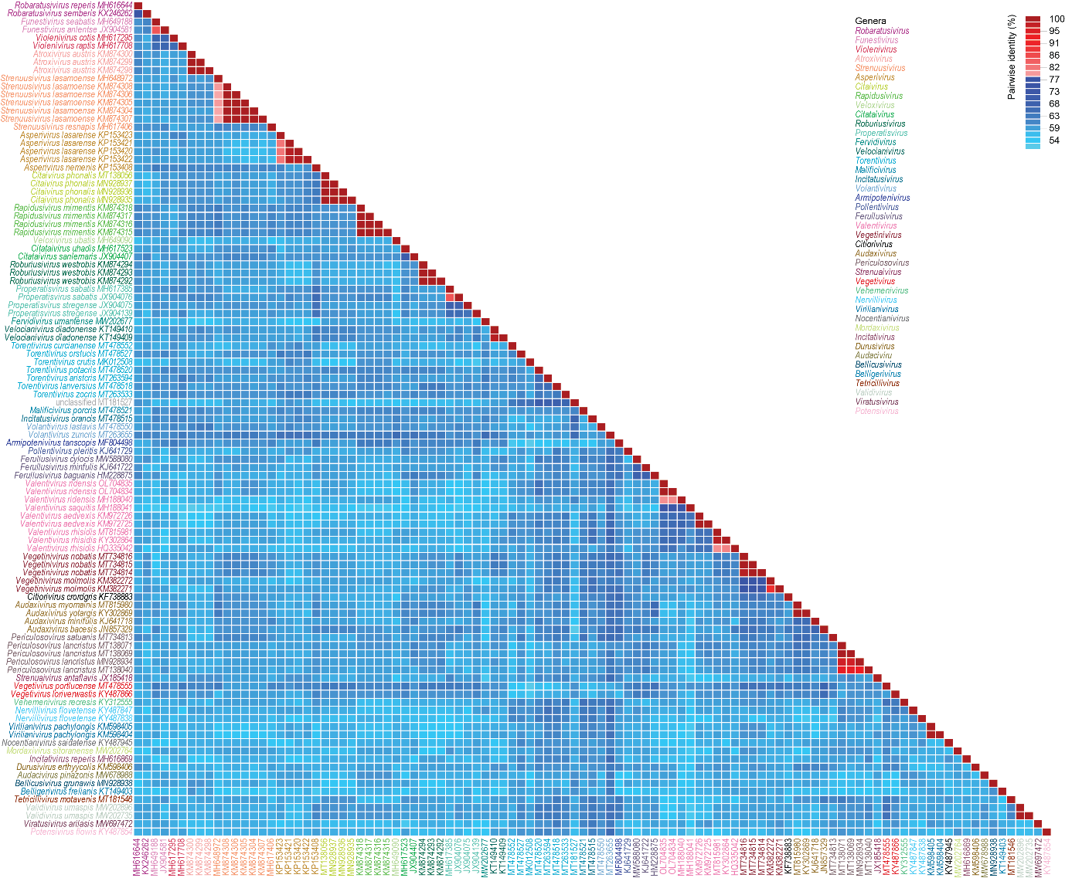

Figure 3: A ‘two color’ pairwise identity matrix of members of the family Draupnirviridae with 78% species threshold s inferred using SDT v1.2 [12].

References

- Kazlauskas D, Varsani A, Krupovic M (2018) Pervasive chimerism in the Replication-associated proteins of uncultured single-stranded DNA viruses. Viruses 10:187. doi:10.3390/v10040187. PMID:29642587
- Kazlauskas D, Varsani A, Koonin EV, Krupovic M (2019) Multiple origins of prokaryotic and eukaryotic single-stranded DNA viruses from bacterial and archaeal plasmids. Nat Commun 10:3425. doi:10.1038/s41467-019-11433-0. PMID:31366885
- Kinsella CM, Deijs M, Becker C, Broekhuizen P, van Gool T, Bart A, Schaefer AS, van der Hoek L. (2022). Host prediction for disease-associated gastrointestinal cressdnaviruses. Virus Evol. 8(2):veac087. doi: 10.1093/ve/veac087. PMID: 36325032; PMCID: PMC9615429.
- Krupovic M, Varsani A, Kazlauskas D, Breitbart M, Delwart E, Rosario K, Yutin N, Wolf YI, Harrach B, Zerbini FM, Dolja VV, Kuhn JH, Koonin EV (2020) Cressdnaviricota: A virus phylum unifying seven families of Rep-encoding viruses with single-stranded, circular DNA genomes. J Virol 94:e00582-20. doi:10.1128/JVI.00582-20. PMID:32269128
- Krupovic M, Varsani A, 2022. Naryaviridae, Nenyaviridae, and Vilyaviridae: three new families of single-stranded DNA viruses in the phylum Cressdnaviricota. Arch. Virol. 167, 2907–2921.PMID: 36098801 DOI: 10.1007/s00705-022-05557-w
- Varsani A, Krupovic M (2017) Sequence-based taxonomic framework for the classification of uncultured single-stranded DNA viruses of the family Genomoviridae. Virus Evol 3:vew037. doi:10.1093/ve/vew037. PMID:28458911
- Varsani A, Krupovic M (2018) Smacoviridae: a new family of animal-associated single-stranded DNA viruses. Arch Virol 163:2005-2015. doi:10.1007/s00705-018-3820-z. PMID:29572596
- Capella-Gutierrez S, Silla-Martinez JM, Gabaldon T (2009) trimAl: a tool for automated alignment trimming in large-scale phylogenetic analyses. Bioinformatics 25:1972-3. doi:10.1093/bioinformatics/btp348. PMID:19505945
- Minh BQ, Schmidt HA, Chernomor O, Schrempf D, Woodhams MD, von Haeseler A, Lanfear R (2020) IQ-TREE 2: New models and efficient methods for phylogenetic inference in the genomic era. Mol Biol Evol 37:1530-1534. doi:10.1093/molbev/msaa015. PMID:32011700
- Guindon S, Dufayard JF, Lefort V, Anisimova M, Hordijk W, Gascuel O (2010) New algorithms and methods to estimate maximum-likelihood phylogenies: assessing the performance of PhyML 3.0. Syst Biol 59:307-321. PMID: 20525638; doi: 10.1093/sysbio/syq010
- Darriba D, Taboada GL, Doallo R, Posada D. (2011) ProtTest 3: fast selection of best-fit models of protein evolution. Bioinformatics. 27(8):1164-5. doi: 10.1093/bioinformatics/btr088. Epub 2011 Feb 17. PMID: 21335321; PMCID: PMC5215816.
- Muhire BM, Varsani A, Martin DP (2014) SDT: A virus classification tool based on pairwise sequence alignment and identity calculation. Plos One 9:e108277. PMID: 25259891; PMCID: PMC4178126.
- Kinsella CM, van der Hoek L. (2023) Vertebrate-tropism of a cressdnavirus lineage implicated by poxvirus gene capture. Proc Natl Acad Sci U S A. 120(20):e2303844120. PMID: 37155884

