Part 1: TITLE, AUTHORS, APPROVALS, etc

Code assigned: | 2023.013D
Short title: A new species in the genus Gammapolyomavirus (Polyomaviridae)
Author(s) and email address(es)
Fehér E, Kaszab E, Bányai K | feher.eniko@vmri.hu; kaszab.eszter@vmri.hu; bkrota@hotmail.com
Author(s) institutional address(es) (optional)
Veterinary Medical Research Institute (FE, KE, BK)
Corresponding author
Enikő Fehér
List the ICTV Study Group(s) that have seen this proposal

ICTV Study Group comments and response of proposer
ICTV Study Group votes on proposal
Study Group | Number of members
 | Votes support | Votes against | No vote
ICTV Polyomaviridae Study Group | 7 |  | 3 (did not reply)
Authority to use the name of a living person
Is any taxon name used here derived from that of a living person (Y/N) | N

Taxon name | Person from whom the name is derived | Permission attached (Y/N)
N/A | N/A | N/A

Submission dates
Date first submitted to SC Chair | 3 May 2023
Date of this revision (if different to above)
ICTV-EC comments and response of the proposer
Part 2: NON-TAXONOMIC PROPOSAL
Text of proposal

Part 3: TAXONOMIC PROPOSAL
Name of accompanying Excel module
2023.013D.N.v2.Polyomaviridae_1nsp.xlsx
Abstract
A novel gammapolyomavirus (named cormorant polyomavirus [CoPyV]) has been detected in mixed organ samples (kidney, liver) of a great cormorant (Phalacrocorax carbo). The genome of the CoPyV is 5,133 bp long and has a genomic structure typical for other gammapolyomaviruses (GenBank accession number MZ666388). The genome contains putative ORFs encoding the large and small T antigens (LTA and STA, respectively), the viral proteins VP1, VP2 and VP3, and the ORF-X (Figure 1A). Each of the coding sequences shared a maximum of 66.6% aa pairwise identity with that of other gammapolyomaviruses. CoPyV is proposed as the first member of a novel species within the Gammapolyomavirus genus (Fehér et al., 2022) that has been tentatively named Gammapolyomavirus phacarbo.
Text of proposal
The genomic structure of the CoPyV (Fehér et al., 2022; GenBank accession number MZ666388) (Figure 1A), as well as the phylogenetic analysis (Figure 1B) suggested that the CoPyV represents a novel species within the Gammapolyomavirus genus. The LTA aa sequence of the CoPyV showed 45.6–50.4% pairwise identity with that of other gammapolyomaviruses. The genetic distance >15% of the LTA nuceotide sequence meets the criterion set by the ICTV for species demarcation, thus CoPyV is proposed as member of a novel species tentatively named Gammapolyomavirus phacarbo.

Supporting evidence

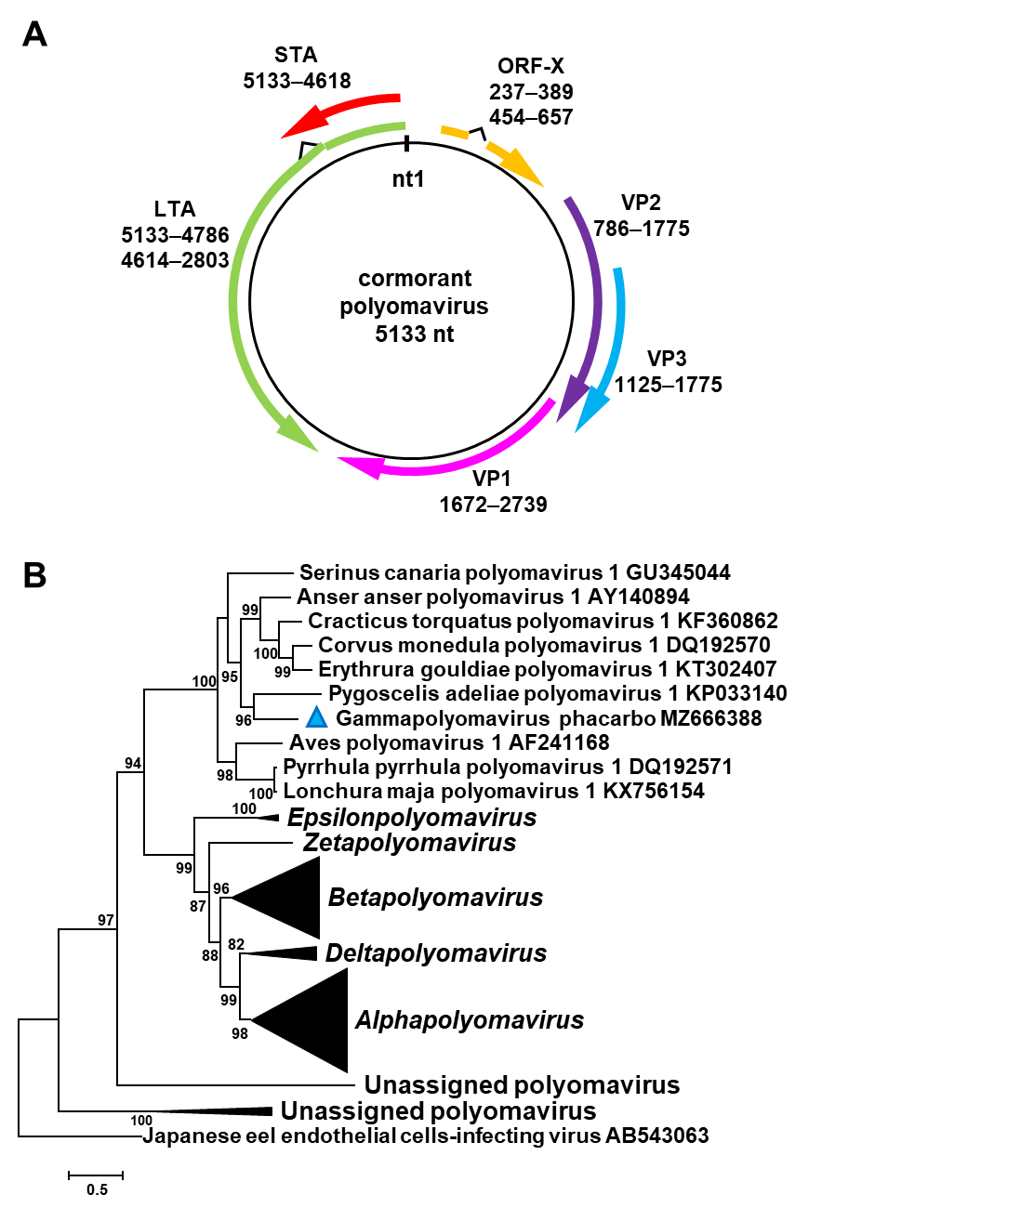

Figure 1. (A) Structure of the cormorant polyomavirus genome. (B) Maximum likelihood phylogenetic tree prepared using large T antigen aa sequences of representative polyomaviruses. The tree was generated by the PhyML software, GTR+G+I model and aLRT SH-like branch support (<80% support are hidden). The scale bar shows substitutions per site. The sequence of the Japanese eel endothelial cells-infecting virus was applied as the root. The proposed cormorant polyomavirus is labelled with blue triangle.

References
Ehlers B, Anoh AE, Ben Salem N, Broll S, Couacy-Hymann E, Fischer D, Gedvilaite A, Ingenhütt N, Liebmann S, Martin M, Mossoun A, Mugisha L, Muyembe-Tamfum JJ, Pauly M, Pérez de Val B, Preugschas H, Richter D, Schubert G, Szentiks CA, Teichmann T, Walter C, Ulrich RG, Wiersma L, Leendertz FH, Calvignac-Spencer S (2019) Novel Polyomaviruses in Mammals from Multiple Orders and Reassessment of Polyomavirus Evolution and Taxonomy. Viruses 11(10):930. https://doi.org/10.3390/v11100930

Calvignac-Spencer S, Feltkamp MCW, Daugherty MD, Moens U, Ramqvist T, Johne R, Ehlers B (2016) A taxonomy update for the family Polyomaviridae. Arch Virol 161(6):1739–1750. https://doi.org/10.1007/s00705-016-2794-y

Varsani A, Porzig EL, Jennings S, Kraberger S, Farkas K, Julian L, Massaro M, Ballard G, Ainley DG (2015) Identification of an avian polyomavirus associated with Adélie penguins (Pygoscelis adeliae). J Gen Virol 96(4):851–857. https://doi.org/10.1099/vir.0.000038

Guindon S, Dufayard JF, Lefort V, Anisimova M, Hordijk W, Gascuel O (2010) New Algorithms and Methods to Estimate Maximum-Likelihood Phylogenies: Assessing the Performance of PhyML 3.0. Syst Biol 59(3):307–321. https://doi.org/10.1093/sysbio/syq010

Fehér E, Kaszab E, Bali K, Hoitsy M, Sós E, Bányai K (2022). A novel gammapolyomavirus in a great cormorant (Phalacrocorax carbo). Arch Virol 167(8):1721-1724. https://doi.org/10.1007/s00705-022-05478-8

