Part 1: TITLE, AUTHORS, APPROVALS, etc

Code assigned: | 2023.025D
Short title: Establishing a new order Saturnivirales, two new families (Kanorauviridae and Mahapunaviridae) and associated genera and species in the class Arfiviricetes (phylum Cressdnaviricota)
Author(s) and email address(es)
Krupovic M, Hopkins A, Lund MC, Kraberger S, Varsani A | mart.krupovic@pasteur.fr; adhopki1@asu.edu; mclund2@asu.edu; Simona.kraberger@asu.edu; Arvind.varsani@asu.edu
Author(s) institutional address(es) (optional)
Institut Pasteur, Université Paris Cité, Archaeal Virology Unit, 25 rue du Dr Roux, 75015 Paris, France [MK]
The Biodesign Center for Fundamental and Applied Microbiomics, Center for Evolution and Medicine, School of Life sciences, Arizona State University, Tempe, AZ 85287-5001, USA [AH, MCL, SK, AV]

Corresponding author
Arvind Varsani

List the ICTV Study Group(s) that have seen this proposal

ICTV Study Group comments and response of proposer

ICTV Study Group votes on proposal

Study Group | Number of members
 | Votes support | Votes against | No vote
Authority to use the name of a living person

Is any taxon name used here derived from that of a living person (Y/N) | N

Taxon name | Person from whom the name is derived | Permission attached (Y/N)

Submission dates
Date first submitted to SC Chair | 14 July 2023
Date of this revision (if different to above) | 5 Oct 2023
ICTV-EC comments and response of the proposer
The proposal was deemed acceptable in the form presented at the EC meeting.

Part 2: NON-TAXONOMIC PROPOSAL
Text of proposal

Part 3: TAXONOMIC PROPOSAL
Name of accompanying Excel module
2023.025D.N.v2.Saturnivirales_1no_2nf_35ng_120nsp.xlsx
Abstract

We propose to establish the order Saturnivirales in the class Arfiviricetes (phylum Cressdnaviricota), which includes the families Kanorauviridae and Mahapunavirida. In the family Kanorauviridae we propose 24 genera and 89 species, whereas in Mahapunaviridae, we propose 11 genera and 31 species.

Text of proposal
We propose establishing a new order, Saturnivirales, in the class Arfiviricetes (phylum Cressdnaviricota).

The order Saturnivirales is named after planet Saturn, which is also known as the Ringed Planet due to its pronounced and complex ring system.

The family name Kanorauviridae is derived from Kanorau meaning to be diverse in Māori.
In this family, we establish 24 genera and 80 species.

The family name Mahapunaviridae is derived from maha puna meaning many sources in Māori. In this family, we establish 11 genera and 31 species.

Genus and species demarcation

We undertook comparative genomics and phylogenetic analyses of the Rep proteins of members of this group to determine their relationships. Genera were delineated based on phylogenetic analyses coupled with pairwise identities and also the genome organization relative to the rep open reading frame (Figures 2 - 5).

For species demarcation, we used a 78% pairwise nucleotide genome-wide sequence identity which is similar to that used for other cressdnaviruses [1-3].

Genera for Kanorauviridae
Etymology of genus names
- Sakkuthvirus: named after Sak′kuth, a synonym of the star-god Saturn
- Kaiwanvirus: named after Kai′wan, a synonym of the star-god Saturn
- Kajamanuvirus: named after Kajamānu, the ancient Mesopotamian name for the planet Saturn
- Sagusvirus: named after Lubat-saguš, the ancient Mesopotamian name for the planet Saturn
- Shabtayvirus: named after Shabtay, the current Hebrew name of Saturn
- Chiunvirus: named after Chiun, a name used in the Bible (Amos 5:26) to refer to Saturn
- Doseivirus: named after 土星 (Dosei), meaning Saturn in Japanese
- Shanivirus: named after Shani (Sanskrit: शनि, Śani), the divine personification of the planet Saturn in Hinduism
- Phainonvirus: named after Phainon (Φαίνων) for Saturn in ancient Greek
- Sickelvirus: named after sickel, a symbol of Saturn, as Saturn was the god of seed-sowing and also of time.
- Scythevirus: named after scythe, a symbol of Saturn, as Saturn was the god of seed-sowing and also of time.
- Ninurtavirus: named after Ninurta, Sumerian and Babylonian name for the planet Saturn
- Sanivirus: named after Sani, Sanskrit name for the planet Saturn
- Saothovirus: named after Sao Tho, Vietnamese name for Saturn
- Chinseivirus: named after Chinsei, an older Japanese name for Saturn
- Sanchirviurs: named after sanchir garig, Mongolian name for saturn
- Kronovirus: named after Kronos, equivalent of Saturn in Greek mythology
- Zohali: named after Zohali for Saturn in Swahili
- Raagevirus: named after Raage for Saturn in Somali
- Seetinvirus: named after Séetin for Saturn in Navajo
- Savurvirus: named after savur for Saturn in Kashmiri (Arabic script)
- Tuxingvirus: named after 土星 (Tǔxīng) for Saturn in Chinese (Traditional and Simplified)
- Sadornvirus: named after Sadorn for Saturn in Breton
- Zuhalvirus: named after zuḥal for Saturn in Arabic

Etymology of species epithets

- acrenis: Amphibola crenata
- airbis: airborne particulate matter
- auroris: Phoenicurus auroreus
- batchis: bat china
- bortici: airborne particulate matter
- bowris: Rainbow Spring
- brolerae: Brassica oleracea var. gongylodes
- chesapis: Chesapeake Bay
- crassaminis: after crassaminis, Latin for sediment, source of origin
- crownis: red-crowned crane
- cruti: crucian tissue
- cryonitae: Cryoconite holes
- culiziae: Musculium novaezelandiae
- dianchis: Freshwater lake (Dianchi) sample
- duliaris: Procordulia grayi
- floridaense: reclaimed water; USA: Southwest Florida
- gruidis: Gruidae
- grujae: Grus japonensis
- hydris: Hydrochoerus hydrochaeris
- jaringis: Jackson Spring
- lawatis: Lake water sample
- libraris: library preparation reagents
- lophus: Rhinolophus hipposideros
- manatis: Manatee Spring
- maramis: Mareca americana
- maringis: Manatee Spring
- melani: Ailuropoda melanoleuca
- mintis: minnow tissue
- monetis: Palaemonetes kadiakensis
- moutis: mouse tissue
- muliumi: Austrosimulium australense
- musmis: Mus musculus
- napperis: red snapper
- natringis: Manatee Spring
- neozealandicus: water sample from New Zealand
- oceanis: ocean water
- particulae: airborne particulate matter
- partimae: airborne particulate matter
- pintis: minnow (known as pinkeens in Ireland) tissue
- pintis: sediment:
- pondae: sewage oxidation pond
- procoris: Procordulia grayi
- raringis: Rainbow Spring
- rhiphus: Rhinolophus hipposideros
- sainlis: Saanich Inlet, British Columbia, Canada
- sewoxi: sewage oxidation pond
- suspensae: Forsythia suspensa
- tersae: Lake water sample
- wagopi: sewage oxidation pond
- waseris: wastewater

Genera for Mahapunaviridae
Etymology of genus names

- Acamarivirus: Acamar - star in the Eridanus constellation
- Cursavirus: Cursa - second-brightest star in the Eridanus constellation
- Fuluvirus: Fulu - variable star in the Cassiopeia constellation
- Elnathivirus: Elnath - second-brightest star in the Taurus constellation
- Enifivirus: Enif - brightest star in the Pegasus constellation
- Garivirus: Gar - red dwarf star in the Virgo constellation
- Amalthevirus: Amalthea gossamer ring - one of the outer rings of Jupiter
- Thebevirus: Thebe gossamer ring - one of the outer rings of Jupiter
- Himalivirus: Himalia ring - recently formed ring of Jupiter
- Janusivirus: Janus ring - one of the outer rings of Saturn
- Anthevirus: Anthe Ring Arc - a faint ring arc detected around Saturn

Etymology of species epithets

- apogeeis: apogee - the furthest point of orbit from Earth
- cometis: comet - small, icy body with visible coma
- faculaes: facula - bright spot on the photosphere of a star
- solis: sol - Spanish word for Sun
- lunaes: lunar - relating to Earth's moon
- nebulais: nebula - interstellar cloud of dust
- parsecis: parsec - unit of length equal to 3.3 light years
- perigeeis: perigee - the closest point of orbit from Earth
- rocheis: Roche limit - distance at which tidal force matches self-attraction
- nadis: nadir - point of the celestial sphere directly below the observer
- zenis: zenith - point of the celestial sphere directly above the observer
- siderealis: sidereal - of or relating to the stars
- stellaris: stellar - of or relating to star systems
- orbitis: orbit - path of a celestial body - orbitis
- asteris: Asterism - Any prominent star pattern that isn’t a whole constellation, such as the Northern Cross or the Big Dipper
- zodis: Zodiac - Greek for “circle of animals.” It’s the set of constellations situated along the ecliptic in the sky, through which the Sun, Moon, and planets move
- altais: Altair - The eleventh brightest star in the sky has a celestial feel, but also could be the name of a commercial airline
- arielis: Ariel - a moon of Uranus
- celestis: Celeste - French, Italian, means “of the sky, heavenly”
- cordelis: Cordelia - a moon of Uranus
- chandais: Chanda - Hindu Mythology, goddess of the moon
- halles: Halley - a comet
- ophels: Ophelia - a moon of Uranus
- portis: Portia - a moon of Uranus
- cielois: Cielo - Italian, means “sky”
- archis: Arche - a moon of Jupiter
- kuiperis: Kuiper - a belt of asteroids in our solar system
- beronis: beron - a moon of Uranus
- rigelis: Rigel - the star that forms the left foot of the constellation Orion
- eris: Eris - a dwarf planet; Greek Mythology, goddess of discord
- perseuis: Perseus - a constellation

Supporting evidence

Table 1: Summary of the viruses classified in the new order Saturnivirales and family Kanorauviridae

Genus | Species | Accession # | Virus | Year | Country | Host /source | Isolate
Sakkuthvirus | Sakkuthvirus raringis | MN582092 | CRESS virus sp. ctjUS5 | 2017 | USA | Rainbow Spring | ctjUS5
Sakkuthvirus | Sakkuthvirus napperis | MH616921 | CRESS virus sp. ctbc431 | 2017 | USA | red snapper | ctbc431
Sakkuthvirus | Sakkuthvirus batchis | JF938078 | Bat circovirus ZS/China/2011 YN-BtCV-1 | 2009 | China | bat | YN-BtCV-1
Sakkuthvirus | Sakkuthvirus donghis | KT149408 | Circovirus-like genome DHCV-2 | 2010 | China | Freshwater lake (Donghu) sample (< 0.5 m) | DHCV-2
Sakkuthvirus | Sakkuthvirus culiziae | KP153500 | Lake Sarah-associated circular virus-44 | 2013 | New Zealand | Musculium novaezelandiae | LSaCV-44-LSCO-2013
Kaiwanvirus | Kaiwanvirus raringis | MN582056 | CRESS virus sp. cte1G3 | 2017 | USA | Rainbow Spring | cte1G3
Kaiwanvirus | Kaiwanvirus sewoxi | KM821751 | sewage-associated circular DNA virus-16 | 2012 | New Zealand | sewage oxidation pond | SaCV-16_NZ-BS3759-2012
Kajamanuvirus | Kajamanuvirus cryonitae | MN328279 | Antarctic virus COCH21_47 | 2016 | Antarctica | Cryoconite holes | COCH21_V_47
Kajamanuvirus | Kajamanuvirus cruti | MK012494 | CRESS virus sp. ctdb55 | 2017 | USA | crucian tissue | ctdb55
Kajamanuvirus | Kajamanuvirus moutis | MH617369 | CRESS virus sp. ctbb55 | 2017 | USA | mouse tissue | ctbb55
Kajamanuvirus | Kajamanuvirus lawatis | MW697525 | Arizlama virus AZLM_719 | 2012 | USA | Lake water sample | AZLM_719
Kajamanuvirus | Kajamanuvirus musmis | JF755408 | Rodent stool-associated circular genome virus RodSCV_M-44 | 2008 | USA | Mus musculus | RodSCV_M-44
Sagusvirus | Sagusvirus jaringis | MN582110 | CRESS virus sp. ct0Vt4 | 2017 | USA | Jackson Spring | ct0Vt4
Sagusvirus | Sagusvirus crownis | KY312554 | Circovirus sp. yc-15 | 2014 | China | red-crowned crane | yc-15
Shabtayvirus | Shabtayvirus lawatis | MW697555 | arizlama virus AZLM_610 | 2012 | USA | Lake water sample | AZLM_610
Shabtayvirus | Shabtayvirus brolerae | MN891788 | Brassica caulorapa CRESS virus pt079-cirl-1 | - | China | Brassica oleracea var. gongylodes | pt079-cirl-1
Shabtayvirus | Shabtayvirus brolerae | MN891825 | Euonymus alatus CRESS virus pt168-cirl-4 | - | China | Euonymus alatus (Thunb.) Sieb. | pt168-cirl-4
Shabtayvirus | Shabtayvirus brolerae | MN891789 | Toona sinensis CRESS virus pt109-cirl-2 | - | China | Toona sinensis (A. Juss.) Roem. | pt109-cirl-2
Chiunvirus | Chiunvirus sainlis | JX904478 | uncultured marine virus clone SI00898 | - | Canada | Saanich Inlet, British Columbia, Canada | SI00898
Chiunvirus | Chiunvirus muliumi | MK433226 | blackfly DNA Virus 12 SF02_422 | 2015 | New Zealand: Canterbury | Austrosimulium australense | SF02_422
Chiunvirus | Chiunvirus auroris | MN928931 | CRESS virus sp. hbl169cir1 | 2018 | China | Phoenicurus auroreus | hbl169cir1
Chiunvirus | Chiunvirus grujae | MN928928 | CRESS virus sp. cra070cir1 | 2018 | China | Grus japonensis | cra070cir1
Chiunvirus | Chiunvirus melani | MF327573 | Giant panda circovirus 1 gpci001 | 2015 | China | Ailuropoda melanoleuca | gpci001
Doseivirus | Doseivirus sewoxi | KJ547632 | Sewage-associated circular DNA virus-8 | 2012 | New Zealand | sewage oxidation pond | SaCV-8_NZ-BS4075-2012
Shanivirus | Shanivirus maringis | MW202578 | CRESS virus sp. ctghP836 | 2019 | USA | Manatee Spring | ctghP836
Shanivirus | Shanivirus maringis | MW202521 | CRESS virus sp. ctBLi026 | 2019 | USA | Manatee Spring | ctBLi026
Shanivirus | Shanivirus cryonitae | MN328268 | Antarctic circular DNA molecule CAA_003_V_40 | 2016 | Antarctica | Cryoconite holes | CAA_003_V_40
Shanivirus | Shanivirus neozealandicus | KP153393 | Lake Sarah-associated circular virus-1 | 2013 | New Zealand | water | LSaCV-1_LSWA-2013
Shanivirus | Shanivirus neozealandicus | KP153392 | Lake Sarah-associated circular virus-1 | 2013 | New Zealand | Chironomus zealandicus | LSaCV-1-LSWO-2013
Shanivirus | Shanivirus neozealandicus | KP153391 | Lake Sarah-associated circular virus-1 | 2013 | New Zealand | Potamopyrgus antipodarum | LSaCV-1-LSGA-2013
Shanivirus | Shanivirus neozealandicus | KP153390 | Lake Sarah-associated circular virus-1 | 2013 | New Zealand | Musculium novaezelandiae | LSaCV-1-LSCO-2013
Shanivirus | Shanivirus culiziae | KP153458 | Lake Sarah-associated circular virus-30 | 2013 | New Zealand | Musculium novaezelandiae | LSaCV-30-LSCO-2013
Shanivirus | Shanivirus culiziae | KP153457 | Lake Sarah-associated circular virus-30 | 2013 | New Zealand | Potamopyrgus antipodarum | LSaCV-30-LSGA-2013
Shanivirus | Shanivirus culiziae | KP153456 | Lake Sarah-associated circular virus-30 | 2013 | New Zealand | sediment | LSaCV-30-LSSO-2013
Shanivirus | Shanivirus sewoxi | KM821767 | sewage-associated circular DNA virus-32 | 2012 | New Zealand | sewage oxidation pond | SaCV-32_NZ-BS4194-2012
Shanivirus | Shanivirus yangris | MW347479 | Circoviridae sp. 4zj-CRESS-1 | 2017 | China: Yangtze River | water samples from river ports along the Yangtze River in China | 4zj-CRESS-1
Shanivirus | Shanivirus lawatis | MW697497 | arizlama virus AZLM_839 | 2012 | USA | Lake water sample | AZLM_839
Shanivirus | Shanivirus waseris | KY487785 | uncultured virus clone CG114 | 2015 | USA | wastewater | CG114
Shanivirus | Shanivirus particulae | MW678994 | Virus sp. D10_6684 | 2009 | USA: Pinal County, Arizona | airborne particulate matter | D10_6684
Shanivirus | Shanivirus airbis | MW678995 | Virus sp. D3_581 | 2009 | USA: Pinal County, Arizona | airborne particulate matter | D3_581
Shanivirus | Shanivirus pondae | KM821754 | Sewage-associated circular DNA virus-19 SaCV-19_NZ-BS4128-2012 | 2012 | New Zealand | sewage oxidation pond | SaCV-19_NZ-BS4128-2012
Shanivirus | Shanivirus partimae | MW678991 | virus sp. D3_648 | 2009 | USA: Pinal County, Arizona | airborne particulate matter | D3_648
Shanivirus | Shanivirus bortici | MW678999 | virus sp. D3_523 | 2009 | USA: Pinal County, Arizona | airborne particulate matter | D3_523
Shanivirus | Shanivirus acrenis | KM874297 | Avon-Heathcote Estuary associated circular virus 3 | 2012 | New Zealand | Amphibola crenata | AHEaCV-3-NZ-3887G-2012
Shanivirus | Shanivirus acrenis | KM874296 | Avon-Heathcote Estuary associated circular virus 3 | 2012 | New Zealand | Austrovenus stutchburyi | AHEaCV-3-NZ-3030C3-2012
Shanivirus | Shanivirus acrenis | KM874295 | Avon-Heathcote Estuary associated circular virus 3 | 2012 | New Zealand | Austrovenus stutchburyi | AHEaCV-3-NZ-3030C2-2012
Phainonvirus | Phainonvirus cryonitae | MN328267 | antarctic circular DNA molecule CAA_003_V_32 | 2016 | Antarctica | Cryoconite holes | CAA_003_V_32
Phainonvirus | Phainonvirus hydris | MK570195 | capybara virus 33_cap3_6684 | 2016 | Brazil | Hydrochoerus hydrochaeris | cap3_6684
Phainonvirus | Phainonvirus libraris | LC671626 | Cressdnaviricota sp. 2020-AMS-TS DNA | 2020 | Netherlands | library preparation reagents | 2020-AMS-TS
Sickelvirus | Sickelvirus maringis | MW202831 | Circoviridae sp. ctRbk103 | 2019 | USA | Manatee Spring | ctRbk103
Sickelvirus | Sickelvirus hydris | MK570187 | capybara virus 25_cap1_1914 | 2016 | Brazil | Hydrochoerus hydrochaeris | cap1_1914
Scythevirus | Scythevirus maringis | MW202805 | CRESS virus sp. ct3IM547 | 2019 | USA | Manatee Spring | ct3IM547
Scythevirus | Scythevirus maringis | MW202715 | CRESS virus sp. ctxwf270 | 2019 | USA | Manatee Spring | ctxwf270
Scythevirus | Scythevirus maringis | MW202538 | CRESS virus sp. ctUHN991 | 2019 | USA | Manatee Spring | ctUHN991
Scythevirus | Scythevirus maringis | MW202488 | CRESS virus sp. ctSRL579 | 2019 | USA | Manatee Spring | ctSRL579
Scythevirus | Scythevirus maringis | MW202438 | CRESS virus sp. ct18Y395 | 2019 | USA | Manatee Spring | ct18Y395
Scythevirus | Scythevirus dianchis | KT149406 | Circovirus-like genome DCCV-13 | 2010 | China | Freshwater lake (Dianchi) sample (< 0.5m) | DCCV-13
Scythevirus | Scythevirus lawatis | MW697550 | arizlama virus AZLM_25947 | 2012 | USA | Lake water sample | AZLM_25947
Scythevirus | Scythevirus manatis | MW202443 | CRESS virus sp. ctFVx272 | 2019 | USA | Manatee Spring | ctFVx272
Scythevirus | Scythevirus natringis | MW202436 | CRESS virus sp. ctKNF714 | 2019 | USA | Manatee Spring | ctKNF714
Scythevirus | Scythevirus monetis | KR528560 | Palaemonetes kadiakensis Mississippi grass shrimp associated circular virus I0099 | - | USA | Palaemonetes kadiakensis | I0099
Ninurtavirus | Ninurtavirus muliumi | MK433229 | blackfly DNA Virus 15 SF02_403 | 2015 | New Zealand: Canterbury | Austrosimulium australense | SF02_403
Ninurtavirus | Ninurtavirus floridaense | FJ959081 | Circovirus-like genome RW-E | - | USA: Southwest Florida | reclaimed water | RW-E
Ninurtavirus | Ninurtavirus lawatis | MW697516 | arizlama virus AZLM_757 | 2012 | USA | Lake water sample | AZLM_757
Ninurtavirus | Ninurtavirus jaringis | MN582084 | CRESS virus sp. ctf7a5 | 2017 | USA | Jackson Spring | ctf7a5
Ninurtavirus | Ninurtavirus cruti | MK012442 | CRESS virus sp. ctbi59 | 2017 | USA | crucian tissue | ctbi59
Ninurtavirus | Ninurtavirus mintis | MK032730 | CRESS virus sp. ctci503 | 2017 | USA | minnow tissue | ctci503
Ninurtavirus | Ninurtavirus procoris | KF738873 | dragonfly larvae associated circular virus-1 | 2012 | New Zealand | Procordulia grayi | DflaCV-1_NZ-PG11-LD
Ninurtavirus | Ninurtavirus momolo | OL704855 | Molossus molossus associated CRESSDNA virus MAVG-30 | - | Argentina | Molossus molossus | MAVG-30
Ninurtavirus | Ninurtavirus sewoxi | KM821762 | sewage-associated circular DNA virus-27 | 2012 | New Zealand | sewage oxidation pond | SaCV-27_NZ-BS4103-2012
Ninurtavirus | Ninurtavirus waseris | KY487776 | uncultured virus clone CG105 | - | USA | wastewater | CG10
Ninurtavirus | Ninurtavirus pondae | KJ547630 | Sewage-associated circular DNA virus-6 | 2012 | New Zealand | sewage oxidation pond | SaCV-6_NZ-BS4017-2012
Ninurtavirus | Ninurtavirus wagopi | KJ547631 | Sewage-associated circular DNA virus-7 | 2012 | New Zealand | sewage oxidation pond | SaCV-7_NZ-BS3976-2012
Ninurtavirus | Ninurtavirus oceanis | KF133825 | Circoviridae 18 LDMD-2013 | 2009 | USA | ocean water | 18 LDMD-2013
Ninurtavirus | Ninurtavirus oceanis | KF133819 | Circoviridae 12 LDMD-2013 | 2009 | USA | ocean water | 12 LDMD-2013
unclassified | unclassified | KP153376 | Lake Sarah-associated circular molecule 8 | 2013 | New Zealand | Echyridella menziesii | LSaCM-8-LSMU-2013
unclassified | unclassified | KP153371 | Lake Sarah-associated circular molecule 8 | 2013 | New Zealand | Potamopyrgus antipodarum | LSaCM-8-LSGA-2013
unclassified | unclassified | KP153373 | Lake Sarah-associated circular molecule 8 | 2013 | New Zealand | Chironomus zealandicus | LSaCM-8-LSWO-2013
unclassified | unclassified | KP153372 | Lake Sarah-associated circular molecule 8 | 2013 | New Zealand | Musculium novaezelandiae | LSaCM-8-LSCO-2013
unclassified | unclassified | KP153374 | Lake Sarah-associated circular molecule 8 | 2013 | New Zealand | sediment | LSaCM-8-LSSO-2013
unclassified | unclassified | KP153375 | Lake Sarah-associated circular molecule 8 | 2013 | New Zealand | water | LSaCM-8-LSWA-2013
Ninurtavirus | Ninurtavirus nowtis | MH616738 | CRESS virus sp. ctcf175 | 2017 | USA | minnow tissue | ctcf175
Ninurtavirus | Ninurtavirus particulae | MW678993 | Virus sp. D3_606 | 2009 | USA: Pinal County, Arizona | airborne particulate matter | D3_606
Ninurtavirus | Ninurtavirus maringis | MW202638 | CRESS virus sp. ctg8o776 | 2019 | USA | Manatee Spring | ctg8o776
Ninurtavirus | Ninurtavirus rhiphus | KJ641736 | Bat circovirus BtRh-CV-5/Tibet2013 | 2013 | China | Rhinolophus hipposideros | BtRh-CV-5/Tibet2013
Ninurtavirus | Ninurtavirus lophus | KJ641735 | Bat circovirus BtRh-CV-1/Tibet2013 | 2013 | China | Rhinolophus hipposideros | BtRh-CV-1/Tibet2013
Ninurtavirus | Ninurtavirus duliaris | KF738874 | dragonfly larvae associated circular virus-2 | 2012 | New Zealand | Procordulia grayi | DflaCV-2_NZ-PG8-LS
Ninurtavirus | Ninurtavirus raringis | MN582072 | CRESS virus sp. ctczB4 | - | USA | Rainbow Spring | ctczB4
Ninurtavirus | Ninurtavirus tersae | MW697552 | Arizlama virus AZLM_25953 | 2012 | USA | Lake water sample | AZLM_25953
Ninurtavirus | Ninurtavirus bowris | MN582083 | CRESS virus sp. cta0f7 | - | USA | Rainbow Spring | cta0f7
Ninurtavirus | Ninurtavirus pintis | MH616769 | CRESS virus sp. ctcg234 | 2017 | USA | minnow tissue | ctcg234
Ninurtavirus | Ninurtavirus pintis | KP153495 | Lake Sarah-associated circular virus-41 | 2013 | New Zealand | sediment | LSaCV-41-LSSO-2013
Ninurtavirus | Ninurtavirus culiziae | KP153494 | Lake Sarah-associated circular virus-41 | 2013 | New Zealand | Musculium novaezelandiae | LSaCV-41-LSCO-2013
Sanivirus | Sanivirus maringis | MW202411 | CRESS virus sp. ct3I9170 | 2019 | USA | Manatee Spring | ct3I9170
Sanivirus | Sanivirus suspensae | MN891791 | Forsythia suspensa CRESS virus pt110-cirl-3 | - | China | Forsythia suspensa | pt110-cirl-3
Saothovirus | Saothovirus lawatis | MW697518 | Arizlama virus AZLM_746 | 2012 | USA | Lake water sample | AZLM_746
Saothovirus | Saothovirus lawatis | KM598395 | odonata-associated circular virus-12 | 2012 | USA | Libellula quadrimaculata | OdasCV-12-US-1518LM1-12
Saothovirus | Saothovirus maringis | MW202707 | CRESS virus sp. ctsVI820 | 2019 | USA | Manatee Spring | ctsVI820
Saothovirus | Saothovirus cruti | MK012512 | CRESS virus sp. ctba54 | 2017 | USA | crucian tissue | ctba54
Saothovirus | Saothovirus dianchis | KT149401 | Circovirus-like genome DCCV-8 | 2010 | China | Freshwater lake (Dianchi) sample (< 0.5m) | DCCV-8
Saothovirus | Saothovirus mintis | MK032700 | CRESS virus sp. ctbd169 | 2017 | USA | minnow tissue | ctbd169
Saothovirus | Saothovirus manatis | MW202813 | CRESS virus sp. ctmKE188 | 2019 | USA | Manatee Spring | ctmKE188
Saothovirus | Saothovirus manatis | MW202652 | CRESS virus sp. cttdt362 | 2019 | USA | Manatee Spring | cttdt362
Chinseivirus | Chinseivirus sewoxi | KM821759 | Sewage-associated circular DNA virus-24 | 2012 | New Zealand | sewage oxidation pond | SaCV-24_NZ-BS4091-2012
Sanchirviurs | Sanchirviurs lawatis | MW697509 | Arizlama virus AZLM_785 | 2012 | USA | Lake water sample | AZLM_785
Kronovirus | Kronovirus crassaminis | KP153508 | Lake Sarah-associated circular virus-49 | 2013 | New Zealand | sediment | LSaCV-49-LSSO-2013
Kronovirus | Kronovirus crassaminis | KP153509 | Lake Sarah-associated circular virus-49 | 2013 | New Zealand | Musculium novaezelandiae | LSaCV-49-LSCO-2013
Kronovirus | Kronovirus crassaminis | KP153510 | Lake Sarah-associated circular virus-49 | 2013 | New Zealand | water | LSaCV-49-LSWA-2013
Kronovirus | Kronovirus crassaminis | KP153507 | Lake Sarah-associated circular virus-49 | 2013 | New Zealand | Potamopyrgus antipodarum | LSaCV-49-LSGA-2013
Zohali | Zohali maramis | OP549819 | wigfec virus K19_432 | 2021 | USA | Mareca americana | K19_MH_432
Raagevirus | Raagevirus napperis | MH617563 | Circoviridae sp. ctda199 | 2017 | USA | red snapper | ctda199
Raagevirus | Raagevirus napperis | KM874359 | Avon-Heathcote Estuary associated circular virus 26 | 2012 | New Zealand | Paphies subtriangulata | AHEaCV-26-NZ-2311TU-2012
Seetinvirus | Seetinvirus maringis | MW202873 | CRESS virus sp. ctP9b653 | 2019 | USA | Manatee Spring | ctP9b653
Savurvirus | Savurvirus yangris | MW347481 | CRESS virus sp. 4zj-CRESS-3 | 2017 | China: Yangtze River | water samples from river ports along the Yangtze River in China | 4zj-CRESS-3
Tuxingvirus | Tuxingvirus gruidis | MN928956 | CRESS virus sp. hftoti49cir1 | 2016 | China | Gruidae | hftoti49cir1
Sadornvirus | Sadornvirus chesapis | FJ959083 | Circovirus-like genome CB-B | - | USA | Chesapeake Bay | CB-B
Zuhalvirus | Zuhalvirus cruti | MK012507 | CRESS virus sp. ctdb57 | 2017 | USA | crucian tissue | ctdb57

Table 2: Summary of the viruses classified in the new order Saturnivirales and family Mahapunaviridae

Genus | Species | Accession # | Virus | Year | Country | Host /source | Isolate
Acamarivirus | Acamarivirus apogeeis | MT181545 | marmot associated feces virus 5 | 2018 | USA | Marmota flaviventris | MAR1_1_2070
Acamarivirus | Acamarivirus cometis | KJ641730 | Bat circovirus BtMl-CV/QH2013 | 2013 | China | Murina leucogaster | BtMl-CV/QH2013
Acamarivirus | Acamarivirus faculaes | MH617345 | CRESS virus sp. ctda86 | 2017 | USA | mouse tissue | ctda86
Acamarivirus | Acamarivirus faculaes | MH552490 | CRESS virus sp. ctce55 | 2017 | USA | mouse tissue | ctce55
Acamarivirus | Acamarivirus solis | KT862235 | llama faeces associated circular DNA virus-1 | 2012 | New Zealand | Lama glama | 29_llama
Acamarivirus | Acamarivirus lunaes | MK433218 | blackfly DNA Virus 4 | 2015 | New Zealand: Canterbury | Austrosimulium australense | SF02_664
Acamarivirus | Acamarivirus nebulais | MH617097 | CRESS virus sp. ctbg966 | 2017 | USA | minnow tissue | ctbg966
Acamarivirus | Acamarivirus parsecis | KP153407 | Lake Sarah-associated circular virus-9 | 2013 | New Zealand | sediment | LSaCV-9-LSSO-2013
Acamarivirus | Acamarivirus perigeeis | MK433219 | blackfly DNA Virus 5 | 2015 | New Zealand: Canterbury | Austrosimulium australense | SF02_839
Cursavirus | Cursavirus rocheis | KP153471 | Lake Sarah-associated circular virus-34 | 2013 | New Zealand | sediment | LSaCV-34-LSSO-2013
Cursavirus | Cursavirus rocheis | KP153470 | Lake Sarah-associated circular virus-34 | 2013 | New Zealand | Potamopyrgus antipodarum | LSaCV-34-LSGA-2013
Cursavirus | Cursavirus nadis | MH616917 | CRESS virus sp. ctbb930 | 2017 | USA | minnow tissue | ctbb930
Cursavirus | Cursavirus zenis | MK570199 | capybara virus 37_cap1_578 | 2016 | Brazil | Hydrochoerus hydrochaeris | cap1_578
Cursavirus | Cursavirus zenis | MK570198 | capybara virus 36_cap1_42 | 2016 | Brazil | Hydrochoerus hydrochaeris | cap1_42
Fuluvirus | Fuluvirus siderealis | MK570172 | capybara virus 10_cap1_55 | 2016 | Brazil | Hydrochoerus hydrochaeris | cap1_55
Fuluvirus | Fuluvirus stellaris | MK433217 | blackfly DNA Virus 3 | 2016 | New Zealand: Canterbury | Austrosimulium australense | SF02_402
Elnathivirus | Elnathivirus orbitis | MW697488 | arizlama virus AZLM_890 | 2012 | USA | Lake water sample | AZLM_890
Enifivirus | Enifivirus asteris | MH617376 | CRESS virus sp. ctcf955 | 2017 | USA | minnow tissue | ctcf955
Garivirus | Garivirus zodis | MZ556194 | Red panda feces-associated circular DNA virus 21 | 2019 | China: Sichuan Province | Ailurus fulgens | Rpf284cress20-12
Amalthevirus | Amalthevirus altais | MT671987 | Cressdnaviricota sp. 169P | 2018 | Brazil | Sus scrofa domesticus | 169P
Thebevirus | Thebevirus arielis | OM523006 | Chifec virus UA13_119 | 2018 | USA: Arizona | Tadarida brasiliensis feces | UA13_119
Himalivirus | Himalivirus celestis | MZ556184 | Red panda feces-associated circular DNA virus 14 | 2019 | China: Sichuan Province | Ailurus fulgens | Rpf279cress02-12
Himalivirus | Himalivirus cordelis | MN928932 | CRESS virus sp. hbl169cre1 | 2018 | China | Phoenicurus auroreus | hbl169cre1
Himalivirus | Himalivirus chandais | MH617692 | CRESS virus sp. ctbf75 | 2017 | USA | mouse tissue | ctbf75
Himalivirus | Himalivirus halles | MH617488 | CRESS virus sp. ctbe77 | 2017 | USA | mouse tissue | ctbe77
Janusivirus | Janusivirus ophels | MZ556154 | giant panda feces-associated circular DNA virus Gpf270cir01-12 | 2018 | China: Sichuan Province | Ailuropoda melanoleuca | Gpf270cir01-12
Janusivirus | Janusivirus portis | MN954870 | Caesalpinia pluviosa associated gemycircularvirus DF 226 | 2014 | Brazil | Cenostigma pluviosum | DF 226
Anthevirus | Anthevirus cielois | OP549838 | wigfec virus K19_558 | 2021 | USA: Arizona | Mareca americana | K19_558
Anthevirus | Anthevirus archis | KM821752 | Sewage-associated circular DNA virus-17 | 2012 | New Zealand | sewage oxidation pond | SaCV-17_NZ-BS4236-2012
Anthevirus | Anthevirus kuiperis | MW202776 | CRESS virus sp. ctr5b272 | 2019 | USA | Manatee Spring | ctr5b272
Anthevirus | Anthevirus beronis | MH545536 | giant house spider associated circular virus 2 | 2017 | Canada: Victoria, British Columbia | Eratigena atrica | BC_I1657E_H4
Anthevirus | Anthevirus rigelis | KP153475 | Lake Sarah-associated circular virus-36 | 2013 | New Zealand | Musculium novaezelandiae | LSaCV-36-LSCO-2013
Anthevirus | Anthevirus eris | KP153474 | Lake Sarah-associated circular virus-36 | 2013 | New Zealand | Potamopyrgus antipodarum | LSaCV-36-LSGA-2013
Anthevirus | Anthevirus perseuis | MH552505 | CRESS virus sp. ctbf541 | 2017 | USA | mouse tissue | ctbf541

Figure 1: Maximum likelihood phylogenetic tree inferred from Rep proteins of members of the phylum Cressdnaviricota. Related sequence groups are collapsed into triangles, the side lengths of which are proportional to the distances between the closest and farthest leaf nodes. The alignment was trimmed with TrimAL [4] with gap threshold of 0.2. The maximum likelihood phylogenetic tree was constructed using IQtree [5] with automatic selection of the best-fit substitution model for a given alignment, which was Q.pfam+F+R10. Numbers at the nodes represent aLRT branch supports. The scale bar represents the number of substitutions per site.
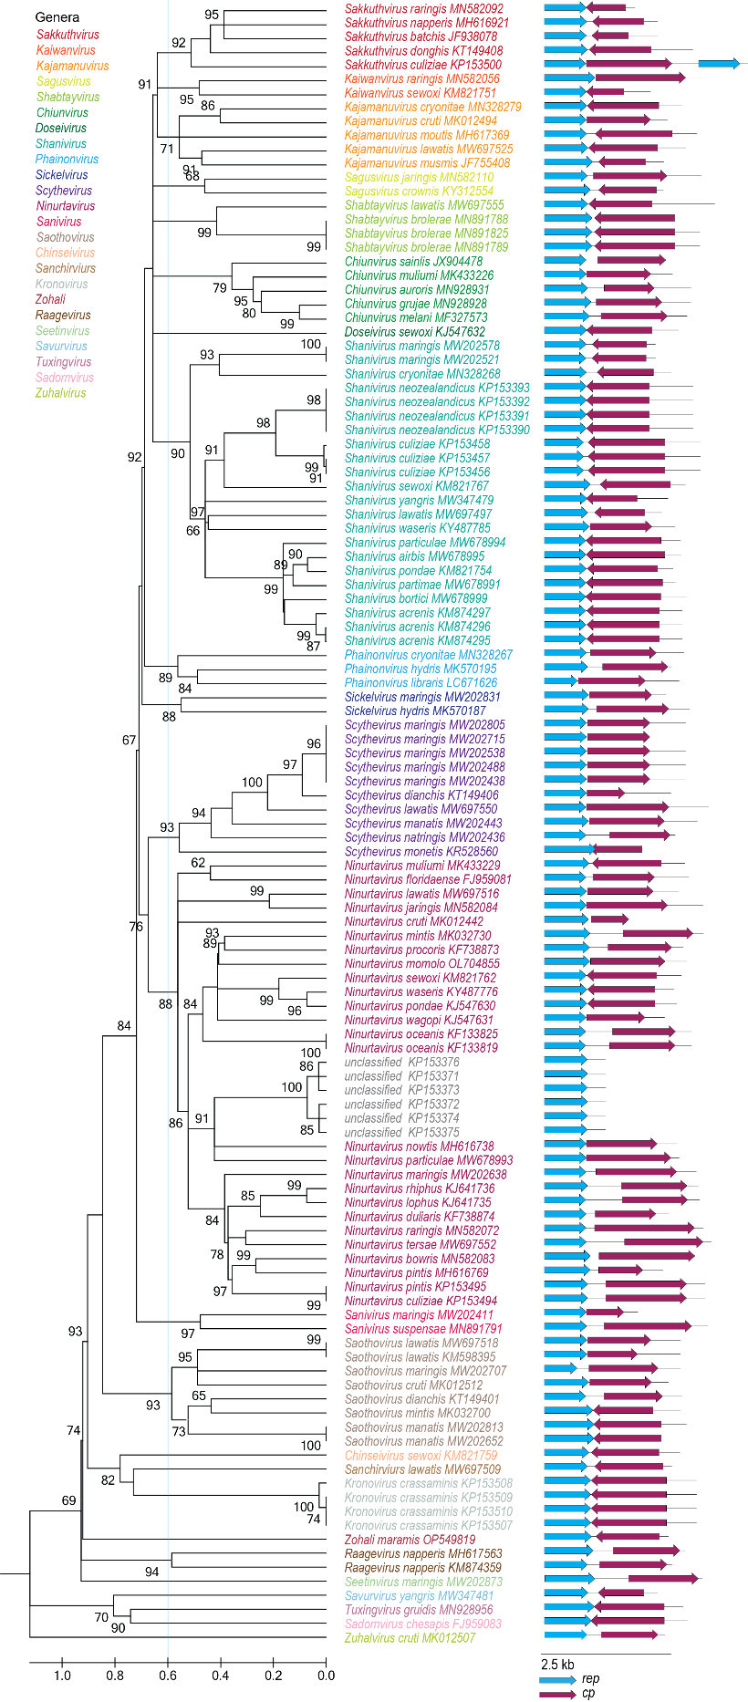

Figure 2: Maximum likelihood phylogenetic tree of the Rep sequences of the members of the family Kanorauviridae inferred with PhyML 3.0 [6] with rtREV+I+G+F model determined as the best substitution model using ProtTest 3 [7] and rooted with representative sequences of members of the family Nanyaviridae. The species belonging to the same genus are indicated with the same color. Numbers at the nodes represent aLRT branch supports. The cyan line shows a proposed demarcation of genera. The genome organization relative to the rep ORF is shown to the right of the phylogeny.

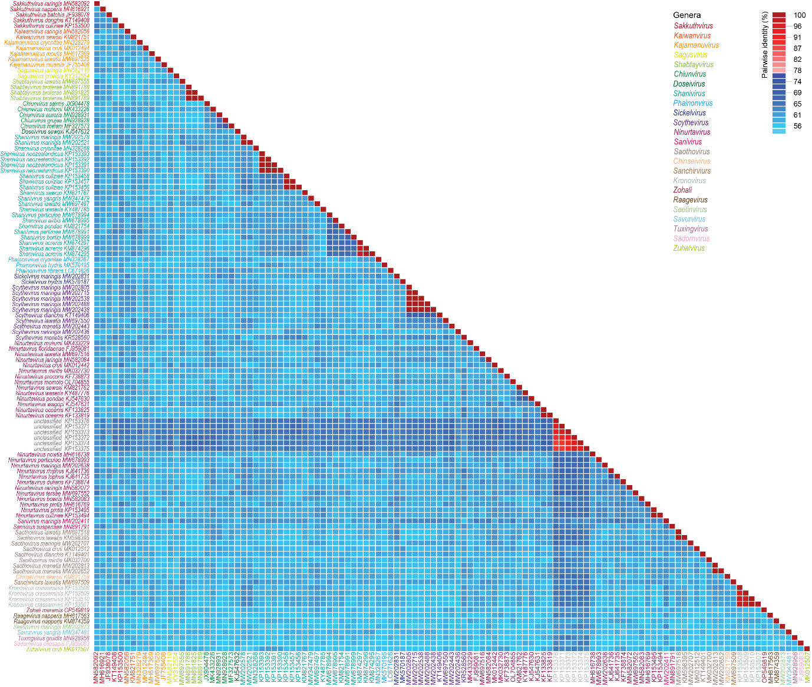

Figure 3: A ‘two color’ pairwise identity matrix of members of the families Kanorauviridae with 78% species threshold s inferred using SDT v1.2 [8].

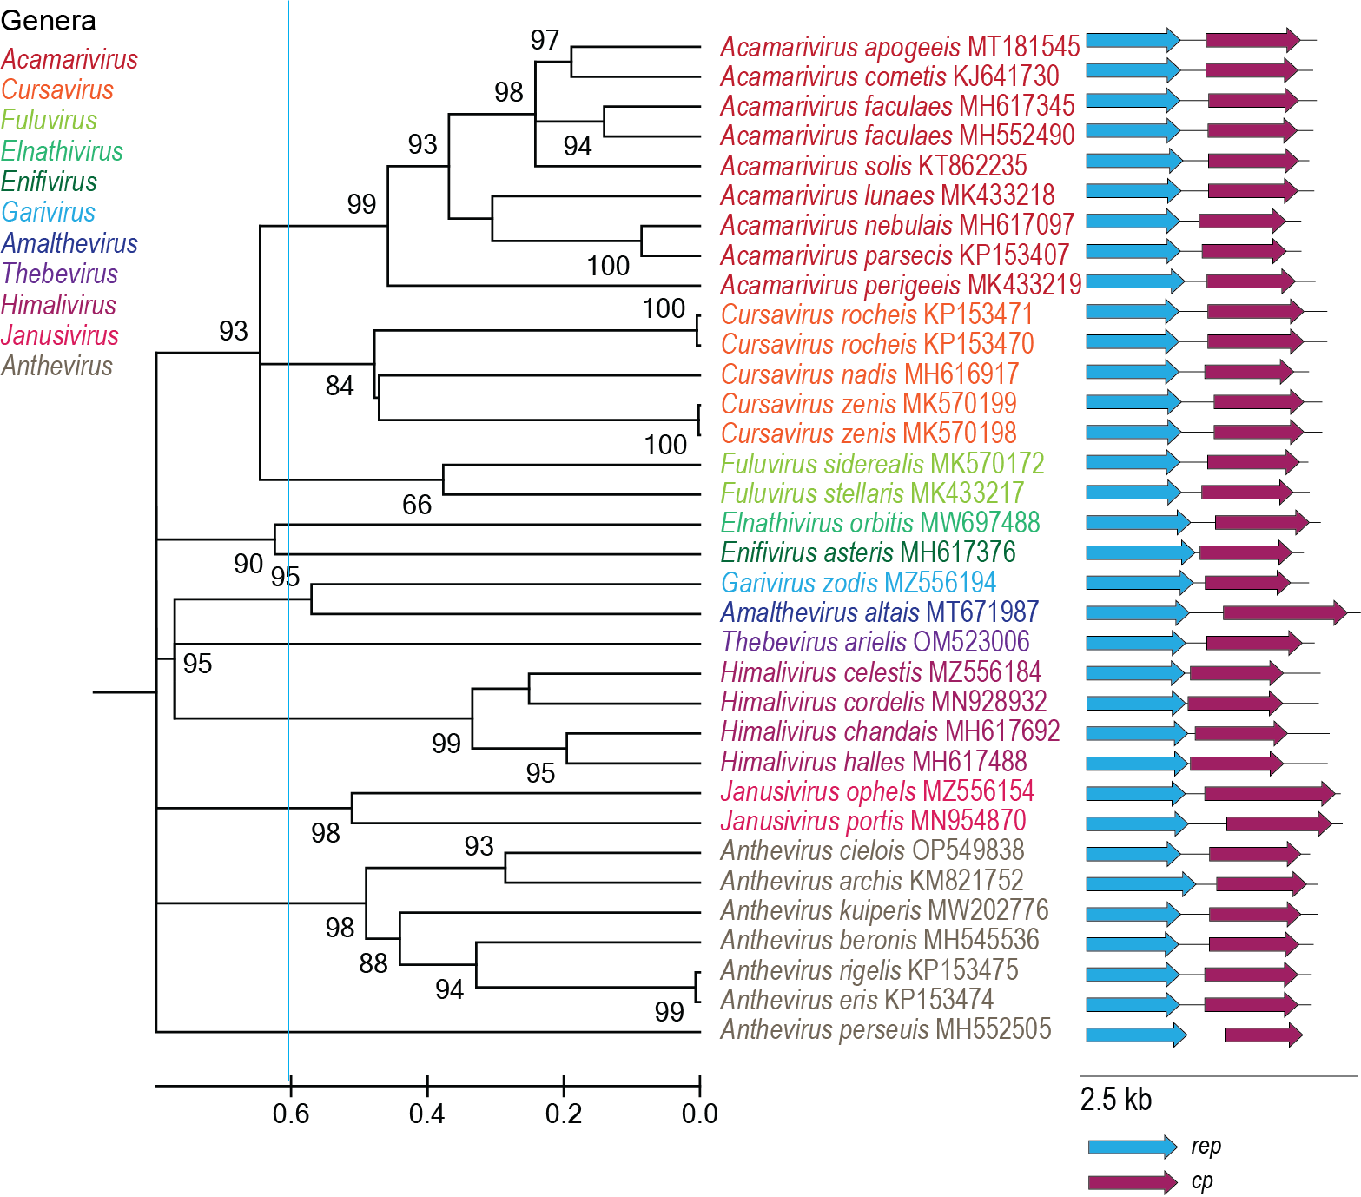

Figure 4: Maximum likelihood phylogenetic tree of the Rep sequences of the members of the family Mahapunaviridae inferred with PhyML 3.0 [6] with rtREV+I+G+F model determined as the best substitution model using ProtTest 3 [7] and rooted with representative sequences of members of the family Nanyaviridae. The species belonging to the same genus are indicated with the same color. Numbers at the nodes represent aLRT branch supports. The cyan line shows a proposed demarcation of genera. The genome organization relative to the rep ORF is shown to the right of the phylogeny.

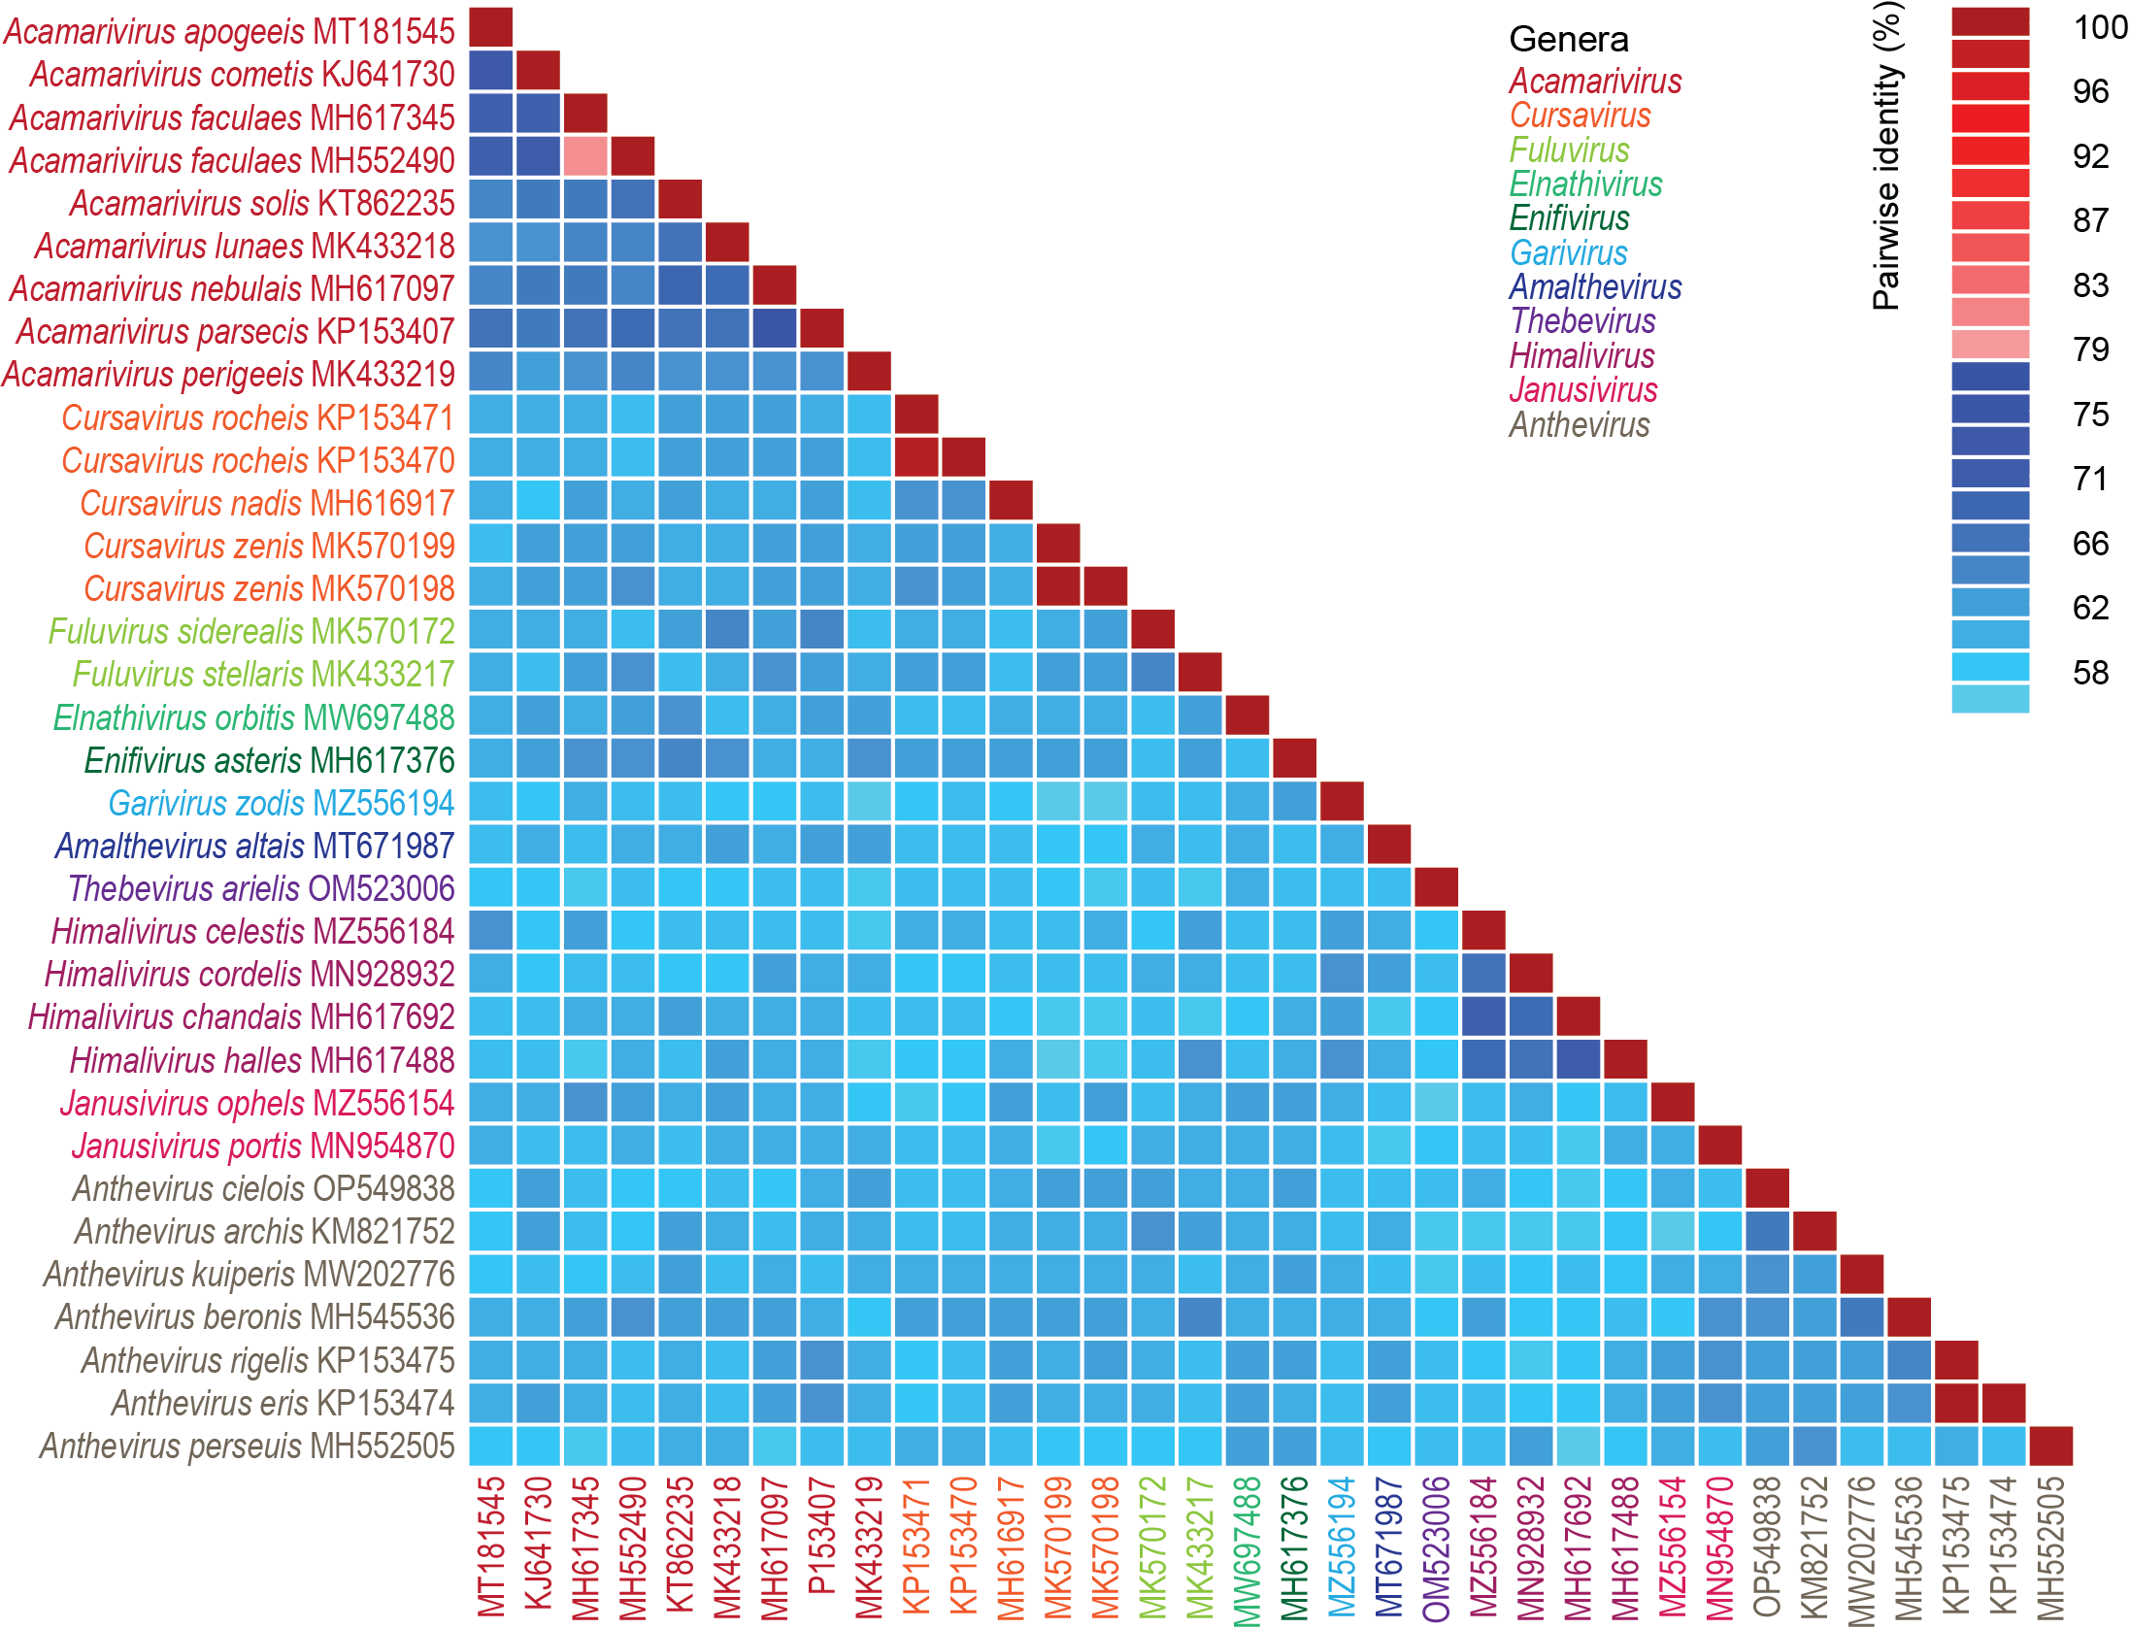

Figure 5: A ‘two color’ pairwise identity matrix of members of the families Mahapunaviridae with 78% species threshold s inferred using SDT v1.2 [8].

References

- Krupovic M, Varsani A, 2022. Naryaviridae, Nenyaviridae, and Vilyaviridae: three new families of single-stranded DNA viruses in the phylum Cressdnaviricota. Arch. Virol. 167, 2907–2921.PMID: 36098801 DOI: 10.1007/s00705-022-05557-w
- Varsani A, Krupovic M (2017) Sequence-based taxonomic framework for the classification of uncultured single-stranded DNA viruses of the family Genomoviridae. Virus Evol 3:vew037. doi:10.1093/ve/vew037. PMID:28458911
- Varsani A, Krupovic M (2018) Smacoviridae: a new family of animal-associated single-stranded DNA viruses. Arch Virol 163:2005-2015. doi:10.1007/s00705-018-3820-z. PMID:29572596
- Capella-Gutierrez S, Silla-Martinez JM, Gabaldon T (2009) trimAl: a tool for automated alignment trimming in large-scale phylogenetic analyses. Bioinformatics 25:1972-3. doi:10.1093/bioinformatics/btp348. PMID:19505945
- Minh BQ, Schmidt HA, Chernomor O, Schrempf D, Woodhams MD, von Haeseler A, Lanfear R (2020) IQ-TREE 2: New Models and Efficient Methods for Phylogenetic Inference in the Genomic Era. Mol Biol Evol 37:1530-1534. doi:10.1093/molbev/msaa015. PMID:32011700
- Guindon S, Dufayard JF, Lefort V, Anisimova M, Hordijk W, Gascuel O (2010) New algorithms and methods to estimate maximum-likelihood phylogenies: assessing the performance of PhyML 3.0. Syst Biol 59:307-321. PMID: 20525638; doi: 10.1093/sysbio/syq010
- Darriba D, Taboada GL, Doallo R, Posada D. (2011).ProtTest 3: fast selection of best-fit models of protein evolution. Bioinformatics. 27(8):1164-5. doi: 10.1093/bioinformatics/btr088. Epub 2011 Feb 17. PMID: 21335321; PMCID: PMC5215816.
- Muhire BM, Varsani A, Martin DP (2014) SDT: A Virus Classification Tool Based on Pairwise Sequence Alignment and Identity Calculation. Plos One 9:e108277. PMID: 25259891; PMCID: PMC4178126.

