Part 1: TITLE, AUTHORS, APPROVALS, etc

Code assigned: | 2023.016D
Short title: Creation of a new genus within the Entomopoxvirinae subfamily
Author(s) and email address(es)
McInnes CJ, Damon IK, Smith GL, McFadden G, Isaacs SN, Roper RL, Evans DH, Damaso CR, Carulei O, Wise LM, Takatsuka J, Traktman P and Lefkowitz E | colin.mcinnes@moredun.ac.uk; iad7@cdc.gov; geoffrey.smith@path.ox.ac.uk; grantmcf@asu.edu; isaacs@pennmedicine.upenn.edu; roperr@ecu.edu; devans@ualberta.ca; damasoc@biof.ufrj.br; ocarulei@gmail.com; lyn.wise@otago.ac.nz; junsan@affrc.go.jp; traktman@musc.edu; elliotl@uab.edu
Author(s) institutional address(es) (optional)
Corresponding author
McInnes CJ
List the ICTV Study Group(s) that have seen this proposal

ICTV Poxviridae Study Group
ICTV Study Group comments and response of proposer

The Study Group was in agreement with the proposal to create a new genus within the Entomopoxvirinae subfamily to accommodate the species Diachasmimorpha longicaudata entomopoxvirus. If accepted the species would also need to be renamed to the standardised binomial format and would become Epsilonentomopoxvirus dlongicaudata.

ICTV Study Group votes on proposal

Study Group | Number of members
 | Votes support | Votes against | No vote
ICTV Poxviridae Study Group | 12 | 0 | 1
Authority to use the name of a living person

Is any taxon name used here derived from that of a living person (Y/N) | N

Taxon name | Person from whom the name is derived | Permission attached (Y/N)
N/A | N/A | N/A

Submission dates
Date first submitted to SC Chair | June 2023
Date of this revision (if different to above) | 1 Aug 2023
ICTV-EC comments and response of the proposer
Part 2: NON-TAXONOMIC PROPOSAL
Text of proposal

Part 3: TAXONOMIC PROPOSAL
Name of accompanying Excel module
2023.016D.N.v3.Poxviridae_1ng.xlsx
Abstract
Here we propose to create a new genus within the Entomopoxvirinae subfamily of the Poxviridae family to accommodate the species Diachasmimorpha longicaudata entomopoxvirus. Following past convention within the subfamily the new genus name would be based on the Greek alphabet and would be Epsilonentomopoxirus. If accepted, the further proposal would be to rename the Diachasmimorpha longicaudata entomopoxvirus species to Epsilonentomopoxvirus dlongicaudata.
Text of proposal
Poxvirus-induced disease and the presence of poxvirions has been reported in host of many different species world-wide, including mammalian, avian, reptilian, piscine and insect species. Traditional poxvirus species demarcation relied on the host spectrum and virus properties such as particle morphology, in vitro and in vivo growth characteristics, cross-neutralisation studies and cross-hybridisation, Restriction fragment length polymorphism (RFLP), and PCR analyses of the DNA genomes. The availability of full genome sequences has added a further dimension to virus species demarcation allowing robust phylogenetic analyses to be used to study the relationship between newly isolated/identified viruses and those of established virus species.

A poxvirus, known as Diachasmimorpha longicaudata entomopoxvirus (DLEV), has been found within the venom glands of a parasitoid wasp (braconid Diachasmimorpha longicaudata (Ashmead)) which parasitizes tephritid fruit flies. Uniquely within the Poxviridae, it has been reported that this poxvirus exists as a heritable mutualistic symbiont of its wasp host, able to cause pathology in the fruit flies, but also able to complete non-pathogenic replication within the parasitoid wasp.

Complete coding sequence has been obtained (1) from the virus and has revealed a number of characteristics that separate it from all other classified entomopoxviruses sequenced to date. The G+C content is markedly different being 30% in comparison to the 20% normally found among entomopoxviruses; and the coding density of the genome, at 65%, is extremely low in comparison to all other poxviruses in which it is normally around 90%. Annotation of the genome also revealed that 4 of the 49 genes considered to represent the core set present in all poxvirus genomes, are likely missing. Phylogenetic analysis, using the amino acid sequences of 25 genes conserved across all genera of poxviruses (see below), was used to infer the relationship of DLEV with representative viruses from all other established poxvirus species. Bootstrap analysis clearly supported the creation of a new genus within the Entomopoxvirinae subfamily to accommodate DLEV.

As a result of the comparative analyses we propose that a new genus is created within the Entomopoxvirinae. This would be designated Epsilonentomopoxvirus following the previously used convention within the Entompoxvirinae of naming genera based on the Greek alphabet. Also following convention, we propose to create a new species, Epsilonentomopoxvirus dlongicaudata (following the new standardised binomial format) with DLEV as its exemplar virus.

Supporting evidence
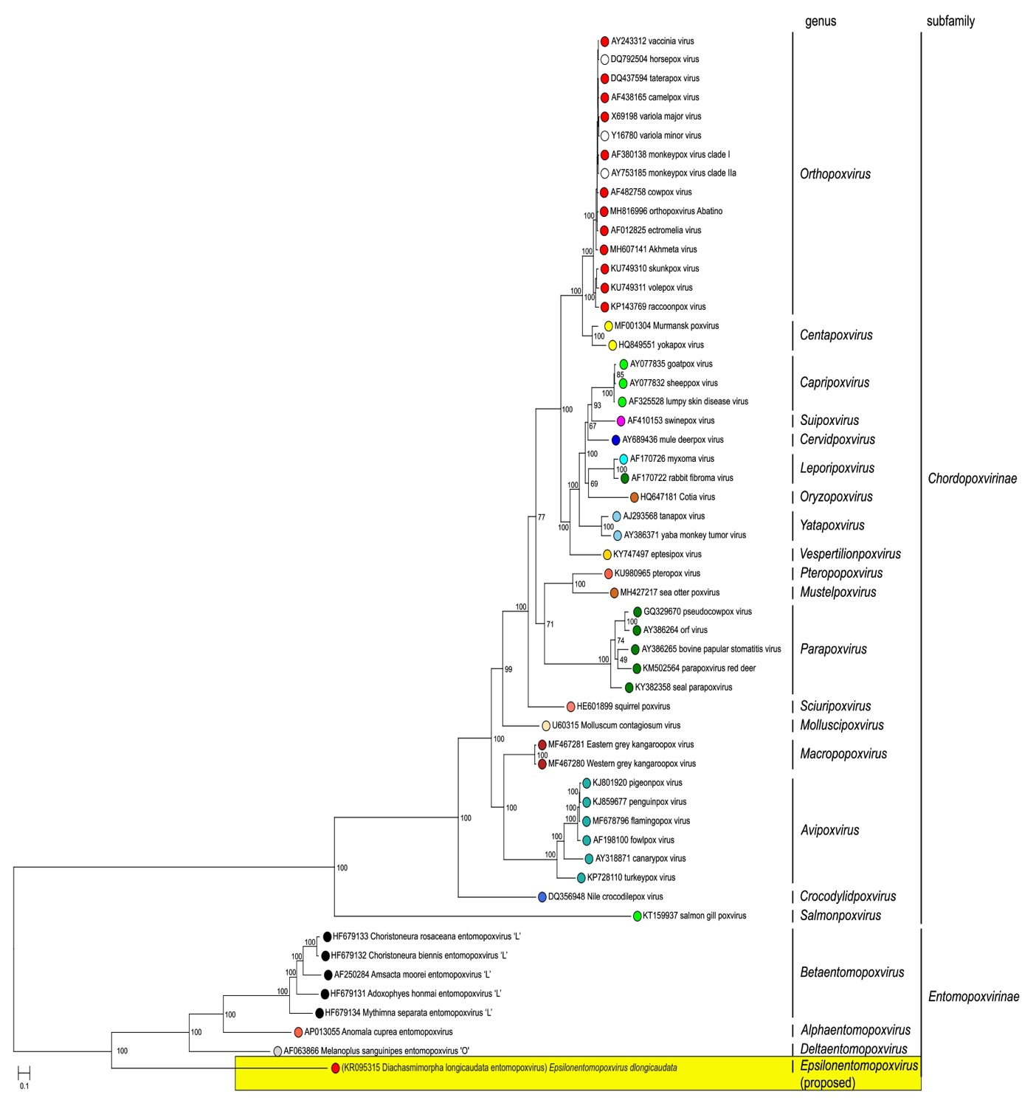

Phylogenetic relationships in the family Poxviridae. Representative viruses belonging to species in the family Poxviridae are shown based on their inferred phylogenetic placement. Individual genera in the subfamilies Chordopoxvirinae (vertebrate-infecting viruses) and Entomopoxvirinae (invertebrate-infecting viruses) are shown. Each species is represented by an exemplar isolate labeled with the name of the virus isolate and GenBank accession number for the complete genomic nucleotide sequence. Phylogeny was inferred using Maximum Likelihood (ML) phylogenetic inference using an amino acid multiple sequence alignment of 25 genes conserved between poxviruses. The amino acid sequences for each gene were aligned using MUSCLE, and then the aligned sequences were concatenated into a single sequence for each isolate prior to phylogenetic inference. The program modeltest-ng (https://github.com/ddarriba/modeltest) was used to determine the optimum evolutionary model for phylogenetic reconstruction. Maximum Likelihood (ML) trees were inferred with the program raxml-ng (https://github.com/amkozlov/raxml-ng) using the model LG+I+G4+F, and 1,000 bootstrap replicates.

References
- Coffman KA and Burke GR (2020) Genomic analysis reveals an exogenous viral symbiont with dual functionality in parasitoid wasps and their hosts. PLoS Pathog. 16(11):e1009069. doi: 10.1371/journal.ppat.1009069. eCollection 2020 Nov.

