Part 1: TITLE, AUTHORS, APPROVALS, etc

Code assigned: | 2023.007D
Short title: Creating 13 new species in family Parvoviridae
Author(s) and email address(es)
Penzes JJ, Canuti M, Francois S, Söderlund-Venermo M, Tijssen P, Tattersall P | judycash08@gmail.com; marta.canuti@gmail.com;  sarah.francois@biology.ox.ac.uk;  Maria.Soderlund-Venermo@helsinki.fi;  tijssenpc@gmail.com  peter.tattersall@yale.edu
Author(s) institutional address(es) (optional)
Corresponding author
Judit J Penzes (judycash08@gmail.com)
List the ICTV Study Group(s) that have seen this proposal

ICTV Parvoviridae Study Group
ICTV Study Group comments and response of proposer

ICTV Study Group votes on proposal

Study Group | Number of members
 | Votes support | Votes against | No vote
ICTV Parvoviridae Study Group | 6

Authority to use the name of a living person

Is any taxon name used here derived from that of a living person (Y/N) | N

Taxon name | Person from whom the name is derived | Permission attached (Y/N)
N/A | N/A | N/A

Submission dates
Date first submitted to SC Chair | 15 June 2023
Date of this revision (if different to above) | 5 Aug 2023
ICTV-EC comments and response of the proposer
Part 2: NON-TAXONOMIC PROPOSAL
Text of proposal

Part 3: TAXONOMIC PROPOSAL
Name of accompanying Excel module
2023.007D.N.v2.Parvoviridae_12nsp.xlsx
Abstract

The Parvoviridae Study Group (SG) proposes the introduction of 13 new species, all of which can be established in already established genera. For the introduction of three of these, the splitting the species, i.e., Amdoparvovirus carnivoran1 is necessary, in the light of new evidence on the divergent nature and heterogeneity of the viruses of this species. This is the first time that a previously established taxon is required to be split in the family Parvoviridae. For the first time ever, the SG classifies a parvovirus with a bipartite genome, which makes the revision of the previous virus definition necessary, by omitting the requirement of a monopartite genome.

Text of proposal
1. Demarcation criteria, definition of a parvovirus suitable for classification

I, Virus definition:
In order for an agent to be classified in the family Parvoviridae, it must be judged to be an authentic parvovirus on the basis of having been sequenced from tissues, secretions, or excretions of its possible host or, failing this, from an additional biological source when the true viral host identity remains unknown. All such sequences must be reported in a credible peer-reviewed publication, in which insights into their host and biology, such as genome annotation, transcription strategy, epidemiology, serology, structure, trafficking, replication and evolution, are strongly encouraged. The sequence must contain the complete coding region of the large nonstructural protein (NS1), which must possess an SF3 helicase domain in its protein sequence, as well as the virus particle (VP) coding regions. If the genome is multipartite, evidence must be presented to confirm that these are indeed multiple genome segments of the same viral genome (e.g., corresponding termini, experimental evidence of concurrent replication). The sequence must also meet the length constraints and motif patterns typical of the family. In case a presumed host cannot be assigned, the ambiguous host assignment must be indicated in species rank nomenclature. This definition is designed to allow the inclusion of viruses identified by virus discovery approaches, including those with an unknown host, which typically lack reliable sequences from the telomeric hairpins, while avoiding viral sequence fragments integrated into host genomes as well as sequences derived from cDNA-based metatranscriptomes.

II, Demarcation criteria and nomenclature:
Species: two parvoviruses can be potentially classified in one species if their NS1 proteins share at least 85% protein sequence identity. A species must be designated under a binomial name, consisting of the genus name, within which the given virus is classified, and a specific epithet. The epithet must mirror the order rank affiliation of the virus host, or in case of multiple host involvement, the lowest taxonomy unit encompassing the affected host species. Failing this, if the exact host spectrum is unknown, the epithet will be indicated as “incertum”. A number in simple Arabic numeric may be added if more species are to share the same epithet within a given genus, e.g., Copiparvovirus ungulate2.
Genus: two parvoviruses can be potentially classified in one genus if they cluster as a robust monophyletic lineage based on their complete NS1 protein sequence in case of subfamily-level phylogeny and also based on their SF3 helicase domains in case of family-wide phylogenetic inference. Additionally, their NS1 proteins should share 35-40% protein sequence identity and display a coverage of at least 80% between two members of the genus in question. Flexibility in these numbers may apply. Failing the sequence-identity-based criteria, common genus affiliation can also be justified by similar genome organization, i.e., presence or absence of certain auxiliary protein encoding genes, genome length and/or transcription strategy, provided the criterion of the well-supported monophyly is still satisfied.

2. Objectives and aims of the current proposal

- One new virus classified within subfamily Densovirinae (Figure 1)
Create a new species in genus Hemiambidensovirus
- Sitobion miscanthi densovirus to Hemiambidensovirus hemipteran3
- Shares 61% identity on 95% coverage with Myzus persicae densovirus 2 and similarly harbors an ambisense genome. Chronically infects Indian grain aphids (Sitobion miscanthi) .

- Five new viruses classified within subfamily Hamaparvovirinae (Figure 2)
Create four new species in genus Chaphamaparvovirus
- Phasianus chapparvovirus 1 to Chaphamaparvovirus galliform6
- Shares 65% identity on 100% overlap with chestnut teal chapparvovirus 1 NS1 protein. Detected as the causative agent of hepatitis in wild pheasants .
- Galliform chaphamaparvovirus 4 to Chaphamaparvovirus galliform7
- Detected in the bile virome of free-roaming chickens , its NS1 aa sequence displays 78.22% identity on 100% coverage with that of chicken chapparvovirus HK of genus Chaphamaparvovirus.
- Pangolin chaphamaparvovirus 1 to Chaphamaparvovirus pholidota1
- Shares 46% identity with the NS1 protein aa sequence of mouse kidney parvovirus on a 99% overlap, detected in trafficked Malaysian pangolins .
- Molossus molossus chapparvovirus to Chaphamaparvovirus chiropteran2
- There were five different genotypic variants detected for this virus in Brazil in the velvety free-tailed bat (Molossus molossus) , which harbor 90% to 100% identity at the aa of level of the NS1. Within genus Chaphamaparvovirus, the most complete entry, under accession number OQ420634, displays 76% identity and 100% coverage with the NS1 of Desmodus rotondus parvovirus.
Create a new species in genus Brevihamaparvovirus
- Acheta domesticus segmented densovirus (AdSDV) to Brevihamaparvovirus orthopteran1
- AdSDV is the first known parvovirus to possess a bipartite genome, yet it displays a Brevihamaparvovirus-like NS1, NS2 and VP1 ORF homolog, within a genome that – similarly to all members of the genus to date - lacks ITRs while being flanked by the typical T-shaped hairpins of brevihamaparvoviruses. The derived NS1 aa sequence is 38% identical to that of Aedes albopictus densovirus of the Brevihamaparvovirus genus, with 97% coverage .

- Seven new viruses classified within subfamily Parvovirinae (Figure 3)
Create a new species in genus Dependoparvovirus
- Psittacidae dependoparvovirus (PsDPV) to Dependoparvovirus psittacine1
- PsDPV was discovered in cloacal samples collected from monk parakeets (Myiopsitta monachus) in Europe. The closest relative to this virus is another virus found in Psittacine birds in China (77% identity based on NS1 protein), a partially sequenced potential member of the Dependoparvovirus. The NS1 of PsDPV is less than 60% identical to any other members of the genus and its genome has been completely sequenced and fully characterized.
Create a new species in the genus Copiparvovirus
- Sika deer copiparvovirus (SDCopiPV) to Copiparvovirus ungulate9
- SDCopiPV was discovered in blood samples collected from wild sika deer (Cervus nippon) from Japan. The closest relatives of this virus are members of the species Copiparvovirus ungulate5, with which they share about 62% aa identity at the level of the NS1 protein. The full genomes of 9 strains have been completely sequenced and fully characterized. SDCopiPV was detected in multiple areas of Japan with a prevalence of approximately 15% (31/206) that varied across investigated regions. SDCopiPV strains are over 90% identical to each other but three different viral types with different regional distribution exist .
Create a new species in the genus Protoparvovirus
- Porcine parvovirus 8 (PPV8) to Protoparvovirus ungulate4
- PPV8 was discovered in lung tissue samples collected from Chinese pigs that were porcine reproductive and respiratory syndrome virus-positive . Its genome has been completely sequenced and fully characterized. The closest relatives of this virus are members of the Protoparvovirus, with which it shares about 39% aa identity at the level of the NS1 protein. However, PPV8 occupies a basal position in the phylogeny.

Splitting one species to three species and creating four new species in the genus Amdoparvovirus
- British Columbia amdoparvovirus (BCAV) to Amdoparvovirus carnivoran8
- BCAV was discovered in a spleen sample of a mink in British Columbia, Canada. This virus could be the same as a partially sequenced viral strain that was previously thought to be an Aleutian mink disease virus strain (Amdoparvovirus carnivoran1) with reduced pathogenicity in non-Aleutian mink. The complete coding region of the virus has been obtained and fully characterized. The closest relatives to BCAV are members of the genus Amdoparvovirus and its NS1 shares 83% or lower identity with other viruses in this genus .
- Sabeidhel virus 1 (SBEHV1) to Amdoparvovirus chiropteran1
- SBEHV1 was discovered in spleen samples collected from straw-colored fruit bats (Eidolon helvum) from Nigeria. The virus was identified in 10 bats (prevalence of 50%) and in 3/20 (15%) bat flies (Cyclopodia greefi) sampled from the same bats. Given the higher positivity rate in bats, the fact that two of the ticks were sampled from SBEHV1-negative bats, and that similar partially sequenced viruses have been found in bats, it is hypothesized that SBEHV1 is a virus of bats that might be transmitted by ticks. Its genome has been completely sequenced and fully characterized. The closest relatives of this virus are members of the Amdoparvovirus, with which it shares about 65-69% aa identity at the level of the NS1 protein .
- Splitting Amdoparvovirus carnivoran1 to three new species, i.e., Amdoparvovirus carnivoran1, Amdoparvovirus carnivoran9, and Amdoparvovirus carnivoran10
- A recent study has determined that viruses currently included in the species Amdoparvovirus carnivoran1 (AMDV) are divergent and should be considered separate viral species that have been co-circulating in mink farms and historically considered as one virus . Specifically, NS1 pairwise aa identities between members of this species are as low as 77%, way below the cut-off for species demarcation (85%). Despite some overlap in pairwise identities between and within groups, three distinct phylogenetic clades of AMDV that have the characteristics to be classified as separate species have been identified. Therefore, we propose to split the current species Amdoparvovirus carnivoran1 into three separate species and create two new species to accommodate the new classification. Amdoparvovirus carnivoran1 will still be represented by the same exemplar virus AMDV-G, while we propose to create the two species Amdoparvovirus carnivoran9 and Amdoparvovirus carnivoran10 to include viruses that have been recently defined as AMDV2 and AMDV3, respectively.

Supporting evidence

Figure 1 Maximum likelihood phylogenetic inference of the Densovirinae family, based on the complete NS1 derived amino acid sequences, and rooted by two members of the Parvovirinae family. The reliability of the topology is indicated by bootstrap values, shown as node labels. The calculations were carried out by RAxML. Each species is indicated after the GenBank accession number of the representative strain of given species. The new virus awaiting classification is highlighted in red.

Figure 2 Bayesian phylogenetic inference of the Hamaparvovirinae subfamily, based on homologous regions of the complete NS1 protein derived amino acid sequences (453 aa). The reliability of the topology is indicated as posterior probability values, shown as node labels. The calculations were carried out by BEAST. Viruses to be classified in this proposal are indicated in red.

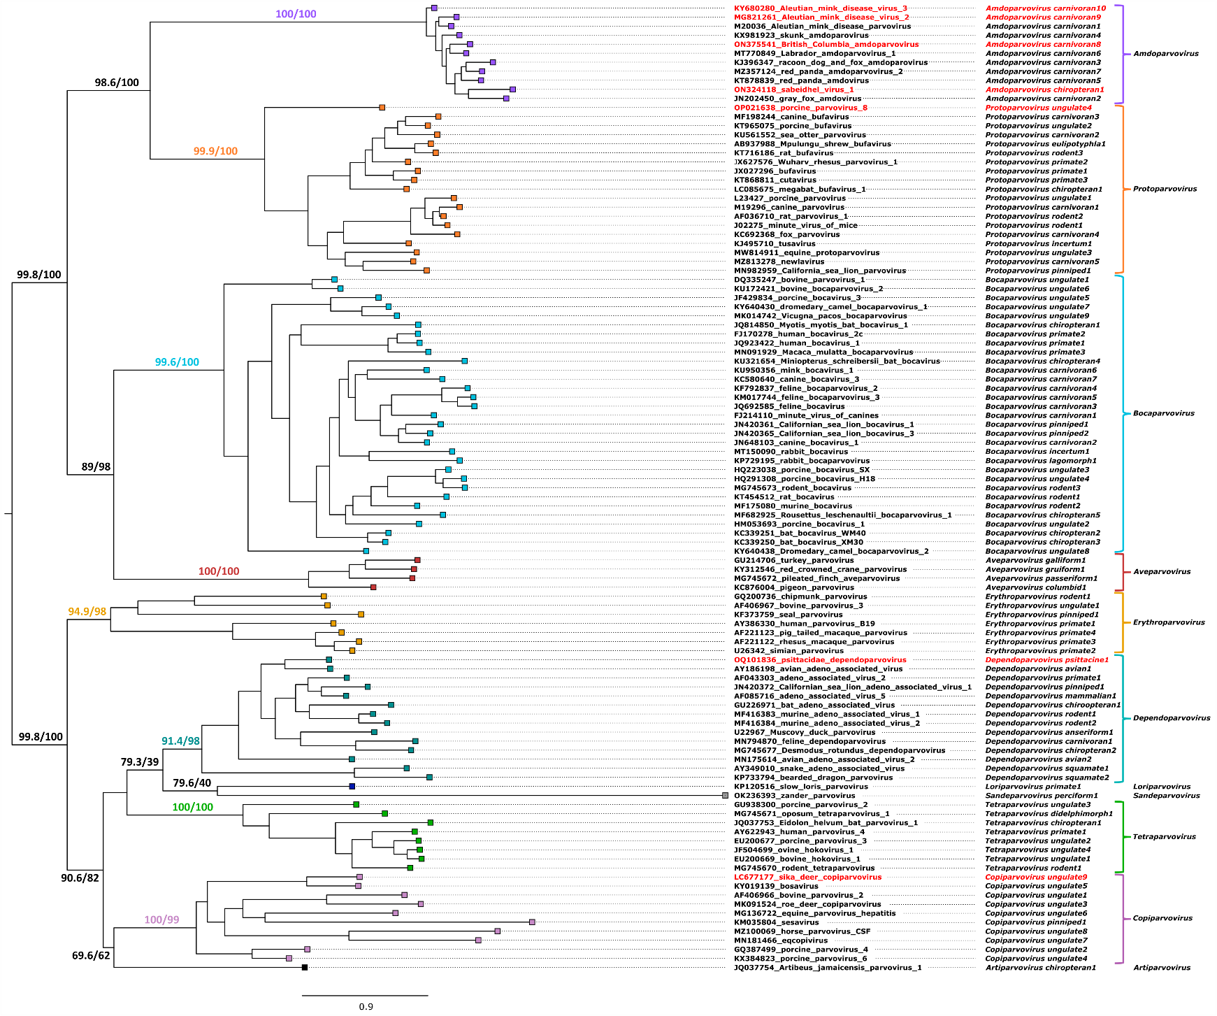

Figure 3. Maximum likelihood inference of subfamily Parvovirinae, based on a 576-aa-long alignment encompassing the homologous regions of the NS1 protein (by IQ-TREE 2 using the LG+F+R6 substitution model). The reliability of the topology was tested by SH-aLRT test and bootstrapping of 1,000 replicates and results are shown for all main nodes. Sequences in each genus are labelled with a colored square that is unique for each genus. New species to be classified are indicated in red.

References
1. Canuti M, Pénzes JJ, Lang AS (2022) A new perspective on the evolution and diversity of the genus Amdoparvovirus (family Parvoviridae) through genetic characterization, structural homology modeling, and phylogenetics. Virus Evol 8:veac056. PMID: 35783582, PMCID: PMC9242002, DOI: 10.1093/ve/veac056
2. Guo Y, Yan G, Chen S, Han H, Li J, Zhang H, Luo S, Liu M, Wu Q, Li Q, Tu C, Huang L, Gong W (2022) Identification and genomic characterization of a novel porcine parvovirus in China. Front Vet Sci 9:1009103. PMID: 36204286, PMCID: PMC9530791, DOI: 10.3389/fvets.2022.1009103
3. Kamani J, González-Miguel J, Msheliza EG, Goldberg TL (2022) Straw-Colored Fruit Bats (Eidolon helvum) and Their Bat Flies (Cyclopodia greefi) in Nigeria Host Viruses with Multifarious Modes of Transmission. Vector Borne Zoonotic Dis 22:545-552. PMID: 36315188, DOI: 10.1089/vbz.2022.0025
4. Li T, Li H, Wu Y, Li S, Yuan G, Xu P (2022) Identification of a Novel Densovirus in Aphid, and Uncovering the Possible Antiviral Process During Its Infection. Front Immunol 13:905628. PMID: 35757766, PMCID: PMC9218065, DOI: 10.3389/fimmu.2022.905628
5. Matos M, Bilic I, Viloux N, Palmieri N, Albaric O, Chatenet X, Tvarogová J, Dinhopl N, Heidl S, Liebhart D, Hess M (2022) A novel Chaphamaparvovirus is the etiological agent of hepatitis outbreaks in pheasants (Phasianus colchicus) characterized by high mortality. Transbound Emerg Dis 69:e2093-e2104. PMID: 35363935, PMCID: PMC9790297, DOI: 10.1111/tbed.14545
6. Nishizawa T, Takahashi M, Matsuoka H, Nishizono A, Yamamoto S, Fukui E, Mizuo H, Kawakami M, Murata K, Okamoto H (2022) Genomic characterization and the prevalence of a novel copiparvovirus in wild sika deer (Cervus nippon) in Japan. Virus Res 314:198749. PMID: 35344744, DOI: 10.1016/j.virusres.2022.198749
7. Pénzes JJ, Pham HT, Chipman P, Smith EW, McKenna R, Tijssen P (2023) Bipartite genome and structural organization of the parvovirus Acheta domesticus segmented densovirus. Nature Communications 14:3515. PMID: 37316488, PMCID: PMC10267136, DOI: 10.1038/s41467-023-38875-x
8. Ramos E, Abreu WU, Rodrigues LRR, Marinho LF, Morais VDS, Villanova F, Pandey RP, Araújo ELL, Deng X, Delwart E, da Costa AC, Leal E (2023) Novel Chaphamaparvovirus in Insectivorous Molossus molossus Bats, from the Brazilian Amazon Region. Viruses 15. PMID: 36992315, PMCID: PMC10054343, DOI: 10.3390/v15030606
9. Sánchez C, Doménech A, Gomez-Lucia E, Méndez JL, Ortiz JC, Benítez L (2023) A Novel Dependoparvovirus Identified in Cloacal Swabs of Monk Parakeet (Myiopsitta monachus) from Urban Areas of Spain. Viruses 15:850. PMID: 37112831, PMCID: PMC10145644, DOI: 10.3390/v1504085
10. Sarker S, Talukder S, Anwar A, Van TTH, Petrovski S (2022) Unravelling Bile Viromes of Free-Range Laying Chickens Clinically Diagnosed with Spotty Liver Disease: Emergence of Many Novel Chaphamaparvoviruses into Multiple Lineages. Viruses 14. PMID: 36423151, PMCID: PMC9695665, DOI: 10.3390/v14112543
11. Shi W, Shi M, Que T-C, Cui X-M, Ye R-Z, Xia L-Y, Hou X, Zheng J-J, Jia N, Xie X, Wu W-C, He M-H, Wang H-F, Wei Y-J, Wu A-Q, Zhang S-F, Pan Y-S, Chen P-Y, Wang Q, Li S-S, Zhong Y-L, Li Y-J, Tan L-H, Zhao L, Jiang J-F, Hu Y-L, Cao W-C (2022) Trafficked Malayan pangolins contain viral pathogens of humans. Nature Microbiology 7:1259-1269. PMID: 35918420, PMCID: PMC9352580, DOI: 10.1038/s41564-022-01181-1

