Part 1: TITLE, AUTHORS, APPROVALS, etc

Code assigned: | 2023.011D
Short title: Establishing 59 new species in the family Smacoviridae

Author(s) and email address(es)
Varsani M, Krupovic M | Arvind.varsani@asu.edu; mart.krupovic@pasteur.fr
Author(s) institutional address(es) (optional)

The Biodesign Center for Fundamental and Applied Microbiomics, Center for Evolution and Medicine, School of Life sciences, Arizona State University, Tempe, AZ 85287-5001, USA [AV]
Institut Pasteur, Université Paris Cité, CNRS UMR6047, Archaeal Virology Unit, 25 rue du Dr Roux, 75015 Paris, France [MK]

Corresponding author
Arvind Varsani

List the ICTV Study Group(s) that have seen this proposal

ICTV Study Group comments and response of proposer

ICTV Study Group votes on proposal

Study Group | Number of members
 | Votes support | Votes against | No vote
Authority to use the name of a living person

Is any taxon name used here derived from that of a living person (Y/N) | N

Taxon name | Person from whom the name is derived | Permission attached (Y/N)

Submission dates
Date first submitted to SC Chair | 23 June 2023
Date of this revision (if different to above) | 14 Aug 2023
ICTV-EC comments and response of the proposer
Part 2: NON-TAXONOMIC PROPOSAL
Text of proposal

Part 3: TAXONOMIC PROPOSAL
Name of accompanying Excel module
2023.011D.N.v2.Smacoviridae_59nsp.xlsx
Abstract

There are 12 genera in the family Smacoviridae. Here we propose to establish 59 new species in the genera Porprismacovirus (n=25), Inpeasmacovirus (n=1), Felismacovirus (n=22), Drosmacovirus (n=4), Dragsmacovirus (n=2), Bovismacovirus (n=4) and Bonzesmacovirus (n=1).

Text of proposal
Smacoviruses have small circular single stranded DNA genomes that encode for a rolling-circle replication initiation protein (Rep) and unique capsid protein (Cp). There are 12 established genera in the family Smacoviridae [1]. The single member of the genus Felismacovirus which is classified in the species Felismacovirus lynas1 encodes the Rep and Cp in a unidirectional orientation, whereas members of the other 11 genera in an ambience orientation.

In the last couple of years, a large number of smacoviruses (n=176) have been identified and many display considerable sequence divergence to be considered as representatives of new species. We assembled a dataset of the complete genomes (with annotations available in GenBank) of smacoviruses that have not yet been classified since the last report by Krupovic and Varsani [1]. These were analysed with previously classified viruses to first determine their genus and species level classification. We identified 144 smacoviruses that could not be classified into existing species and for these we propose 59 new species based on the species demarcation criteria (77% pairwise identity threshold) outlined in Varsani and Krupovic [2]. These 59 new species are distributed across the genera Porprismacovirus (n=25), Inpeasmacovirus (n=1), Felismacovirus (n=22), Drosmacovirus (n=4), Dragsmacovirus (n=2), Bovismacovirus (n=4) and Bonzesmacovirus (n=1).

Similar to the sole member of Felismacovirus (Felismacovirus lynas1; MK796234) all the members of the 22 new proposed species of Felismacovirus also have genomes with Rep and Cp organized in a unidirectional orientation.

The species epithets are derived from the first 5 letters of the host or source family name or generic name followed by a number in sequence.

Supporting evidence

Table 1: Summary of the 59 new species and the exemplar sequences.

Species | Accession # | Description | host | isolate
Bonzesmacovirus camas1 | OQ198240 | MAG: Smacoviridae CM13_Smaco | camel | CM13_Smaco
Bovismacovirus bovas3 | MH782430 | Genomoviridae sp. C021765 | dairy cow | C021765
Bovismacovirus cervi1 | MN621481 | CRESS virus sp. UJSL004 | forest musk deer | UJSL004
Bovismacovirus equid1 | OM892365 | MAG: Smacoviridae sp. 215Smaco-1 | wild horse | 215Smaco-1
Bovismacovirus equid2 | OQ198251 | MAG: Smacoviridae D33_Smaco_3 | donkey | D33_Smaco_3
Dragsmacovirus budor1 | OM892344 | MAG: Smacoviridae sp. 132Smaco-3 | takin | 132Smaco-3
Dragsmacovirus cervi1 | OM892357 | MAG: Smacoviridae sp. 195Smaco | deer | 195Smaco
Drosmacovirus camas3 | OM892356 | MAG: Smacoviridae sp. 190Smaco | camel | 190Smaco
Drosmacovirus cervi1 | MN621468 | CRESS virus sp. UJSL002 | forest musk deer | UJSL002
Drosmacovirus kobus1 | OM892355 | MAG: Smacoviridae sp. 180Smaco | waterbuck | 180Smaco
Drosmacovirus macro1 | OM892353 | MAG: Smacoviridae sp. 172Smaco | white kangaroo | 172Smaco
Felismacovirus avias2 | MT138076 | Smacoviridae sp. w3chi090cir1 | Avian | w3chi090cir1
Felismacovirus avias1 | MT138081 | Smacoviridae sp. w3chi091cir5 | Avian | w3chi091cir5
Felismacovirus babas1 | LC386203 | Papio kindae associated smacovirus 1/ZM09-64 | Papio kindae | 1/ZM09-64
Felismacovirus canid1 | MT457880 | Raccoon dog stool-associated smacovirus 3 CJY6 | raccoon dog | 3 CJY6
Felismacovirus cervi1 | OM892358 | MAG: Smacoviridae sp. 198Smaco | white-lipped deer | 198Smaco
Felismacovirus chicas1 | OM849239 | Cressdnaviricota sp. Y02-smal-02 | Gallus gallus | Y02-smal-02
Felismacovirus chicas2 | MN379594 | Chicken virus mg5_1345 | Gallus gallus | mg5_1345
Felismacovirus chicas3 | MN379595 | Chicken virus mg6_1197 | Gallus gallus | mg6_1197
Felismacovirus macas1 | KU043448 | Unidentified circular ssDNA virus cg5862 | Macaca mulatta | cg5862
Felismacovirus macro1 | OM892351 | MAG: Smacoviridae sp. 167Smaco-2 | macropusrufus | 167Smaco-2
Felismacovirus porci1 | MH111079 | CRESS virus sp. 17489x95_4644 | Sus scrofa domesticus | 17489x95_4644
Felismacovirus porci10 | MH111107 | CRESS virus sp. 17668x34_1256 | Sus scrofa domesticus | 17668x34_1256
Felismacovirus porci2 | MH111084 | CRESS virus sp. 17668x41_1812 | Sus scrofa domesticus | 17668x41_1812
Felismacovirus porci3 | MH111082 | CRESS virus sp. 17499x9_1430 | Sus scrofa domesticus | 17499x9_1430
Felismacovirus porci4 | JQ023166 | Pig stool associated circular ssDNA virus GER2011 | Sus scrofa domesticus | GER2011
Felismacovirus porci5 | MH111074 | CRESS virus sp. 17489x12_563 | Sus scrofa domesticus | 17489x12_563
Felismacovirus porci6 | MH111114 | CRESS virus sp. 17489x27_1313 | Sus scrofa domesticus | 17489x27_1313
Felismacovirus porci7 | MH111086 | CRESS virus sp. 17668x7_933 | Sus scrofa domesticus | 17668x7_933
Felismacovirus porci8 | MH111090 | CRESS virus sp. 17489x57_911 | Sus scrofa domesticus | 17489x57_911
Felismacovirus porci9 | MH111116 | CRESS virus sp. 17489x90_2227 | Sus scrofa domesticus | 17489x90_2227
Felismacovirus ratas1 | MH500349 | Rat associated smacovirus 22084x8_1043 | Rattus argentiventer | 22084x8_1043
Felismacovirus vulpe1 | ON872782 | MAG: Vulpes vulpes-associated smacovirus SMCO22 | Vulpes vulpes | SMCO22
Inpeasmacovirus avias1 | MT138084 | MAG: Smacoviridae sp. wbp226sma1 | Avian | wbp226sma1
Porprismacovirus anati1 | MW183072 | MAG: Cygnus columbianus Smacoviridae sp. swn66sma1 | Cygnus columbianus | swn66sma1
Porprismacovirus avias2 | MT138077 | MAG: Smacoviridae sp. w3chi091cir1 | Avian | w3chi091cir1
Porprismacovirus bovas3 | MH782431 | Genomoviridae sp. C025899 | dairy cow | C025899
Porprismacovirus camas5 | OM892354 | MAG: Smacoviridae sp. 173Smaco | alpaca | 173Smaco
Porprismacovirus canid1 | OQ198181 | MAG: Canine associated porprismacovirus SmacoviridaeDogfe369C1 | canine | SmacoviridaeDogfe369C1
Porprismacovirus canid2 | OQ198185 | MAG: Canine associated porprismacovirus SmacoviridaeDogfe322C1 | canine | SmacoviridaeDogfe322C1
Porprismacovirus canid3 | MT457881 | Raccoon dog stool-associated smacovirus 4 CJY7 | raccoon dog | 4 CJY7
Porprismacovirus canid4 | OQ198178 | MAG: Canine associated porprismacovirus SmacoviridaeDogfe433C1 | canine | SmacoviridaeDogfe433C1
Porprismacovirus canid5 | OQ198179 | MAG: Canine associated porprismacovirus SmacoviridaeDogfe401C1 | canine | SmacoviridaeDogfe401C1
Porprismacovirus canid6 | OQ198180 | MAG: Canine associated porprismacovirus SmacoviridaeDogfe373C1 | canine | SmacoviridaeDogfe373C1
Porprismacovirus canid7 | OQ198183 | MAG: Canine associated porprismacovirus SmacoviridaeDogfe342C1 | canine | SmacoviridaeDogfe342C1
Porprismacovirus canid8 | MT457878 | Raccoon dog stool-associated smacovirus 1 CJY4 | raccoon dog | CJY4
Porprismacovirus canid9 | MT457879 | Raccoon dog stool-associated smacovirus 2 CJY5 | raccoon dog | CJY5
Porprismacovirus envor1 | MW679000 | Virus sp. D3_464 | Dust | D3_464
Porprismacovirus envor2 | MW678996 | Virus sp. D3_567 | Dust | D3_567
Porprismacovirus equid1 | OQ198247 | MAG: Smacoviridae D23_Smaco | donkey | D23_Smaco
Porprismacovirus equid2 | OQ198250 | MAG: Smacoviridae D33_Smaco_2 | donkey | D33_Smaco_2
Porprismacovirus macas7 | KU043449 | Macaca mulatta feces associated virus 1 cg6982 | Macaca mulatta (Rhesus macaque) | cg6982
Porprismacovirus macro1 | OM892350 | MAG: Smacoviridae sp. 167Smaco-1 | macropusrufus | 167Smaco-1
Porprismacovirus macro2 | OM892352 | MAG: Smacoviridae sp. 171Smaco | red-necked wallaby | 171Smaco
Porprismacovirus molos1 | OM892349 | MAG: Smacoviridae sp. 164Smaco-1 | monkey | 164Smaco-1
Porprismacovirus phasi1 | MW183070 | MAG: Chrysolophus pictus Smacoviridae sp. gps222sma2 | Chrysolophus pictus | gps222sma2
Porprismacovirus phasi2 | MW183073 | MAG: Pavo cristatus Smacoviridae sp. blp211sma3 | Pavo cristatus | blp211sma3
Porprismacovirus phasi3 | MW183071 | MAG: Chrysolophus pictus Smacoviridae sp. gps222sma6 | Chrysolophus pictus | gps222sma6
Porprismacovirus strut1 | OM892362 | MAG: Smacoviridae sp. 207Smaco | ostrich | 207Smaco

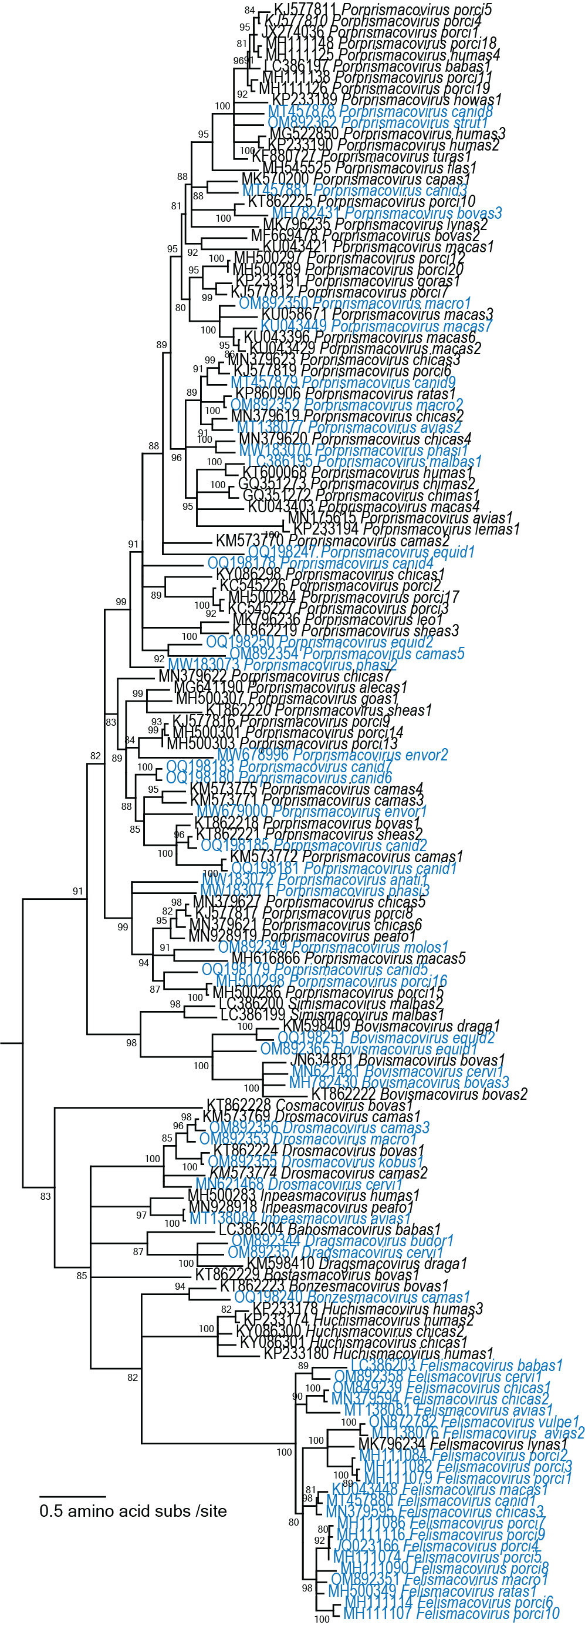
Figure 1: Maximum likelihood phylogenetic tree of the Rep amino acid sequences of reprehensive member of each species and rooted with a subset of Reps of nanoviruses. The Rep sequence alignment was constructed with MAFFT [3] and trimmed with TrimAL [4] using the gappyout option. The final alignment contained 199 amino-acid sites and was used to infer a maximum likelihood phylogenetic with PhyML [5] with LG+F+I+G4 substitution model. New species are highlighted in blue font.

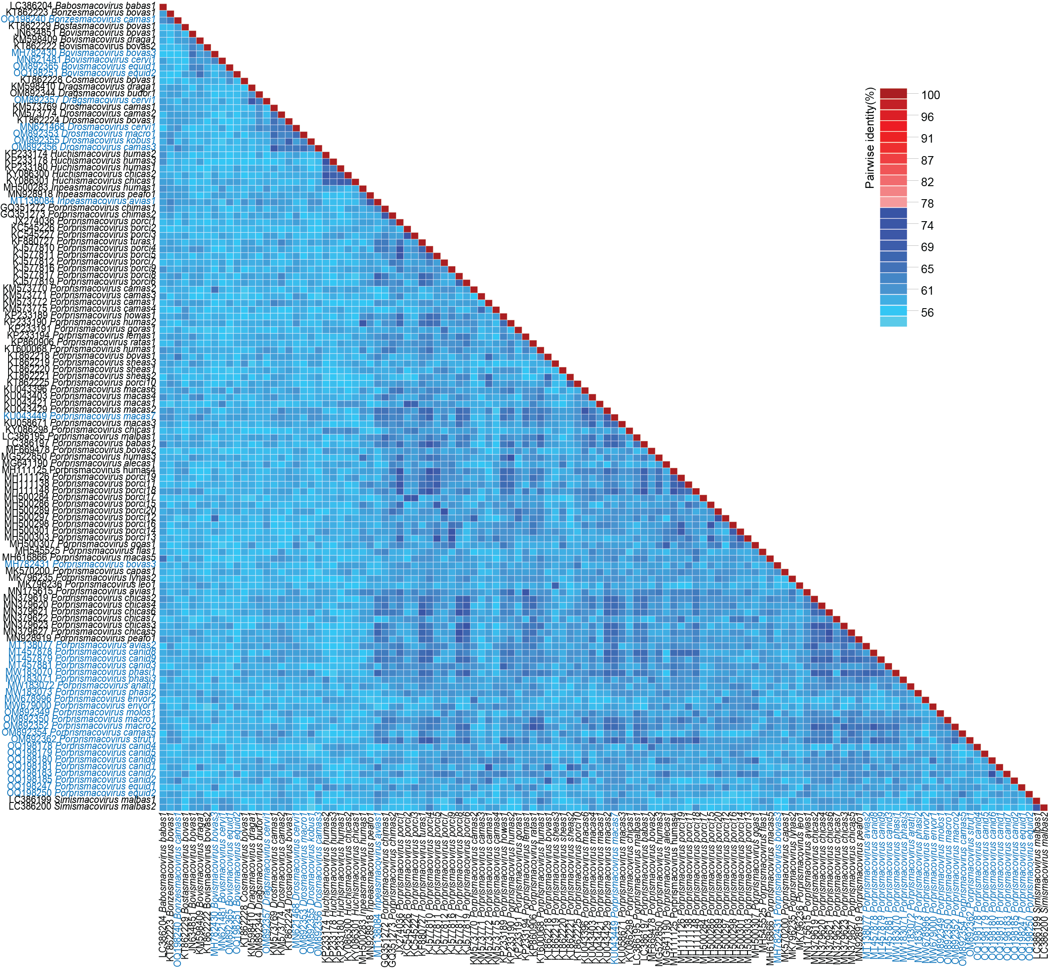
Figure 2: Pairwise identity matrix of the genome sequences of a representative member from each species in the genera Babosmacovirus, Bonzesmacovirus, Bostasmacovirus, Bovismacovirus, Cosmacovirus, Dragsmacovirus, Drosmacovirus, Huchismacovirus, Inpeasmacovirus, Porprismacovirus and Simismacovirus determined using SDT v1.2 [6]. New species are highlighted in blue font.

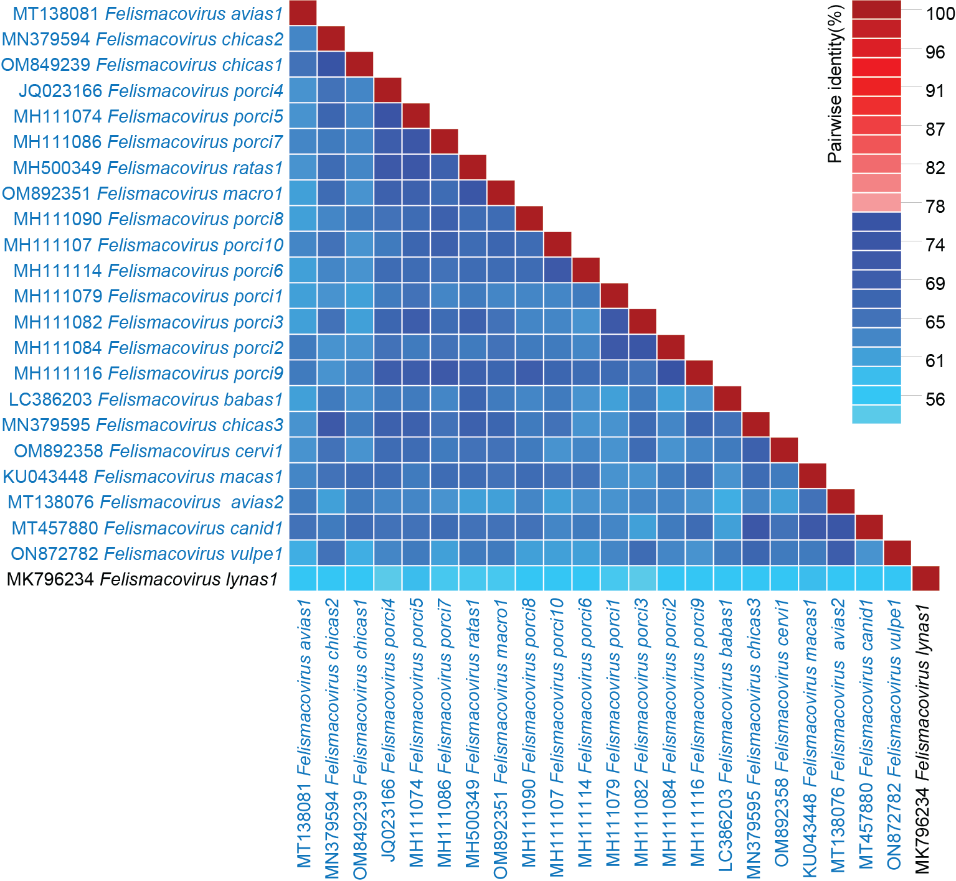
Figure 3: Pairwise identity matrix of the genome sequences of a representative member from each species in the genus Felismacovirus determined using SDT v1.2 [6]. New species are highlighted in blue font. Felismacovirus genomes have the Rep and CP organized in a unidirectional orientation.

References
- Krupovic M, Varsani A. 2021. A 2021 taxonomy update for the family Smacoviridae. Arch Virol. 166:3245–3253. PMID: 34546431 DOI: 10.1007/s00705-021-05224-6
- Varsani A, Krupovic M (2018) Smacoviridae: a new family of animal-associated single-stranded DNA viruses. Arch Virol 163:2005-2015. PMID: 29572596; DOI: 10.1007/s00705-018-3820-z
- Katoh K, Rozewicki J, Yamada KD (2019) MAFFT online service: multiple sequence alignment, interactive sequence choice and visualization. PMID: 28968734; Brief Bioinform 20:1160-1166. DOI: 10.1093/bib/bbx108
- Capella-Gutierrez S, Silla-Martinez JM, Gabaldon T (2009) trimAl: a tool for automated alignment trimming in large-scale phylogenetic analyses. Bioinformatics 25:1972-1973. PMID: 19505945; DOI: 10.1093/bioinformatics/btp348
- Guindon S, Dufayard JF, Lefort V, Anisimova M, Hordijk W, Gascuel O (2010) New algorithms and methods to estimate maximum-likelihood phylogenies: assessing the performance of PhyML 3.0. Syst Biol 59:307-321. PMID: 20525638; doi: 10.1093/sysbio/syq010
- Muhire BM, Varsani A, Martin DP (2014) SDT: a virus classification tool based on pairwise sequence alignment and identity calculation. PMID: 2525989; PLoS One 9:e108277. DOI: 10.1371/journal.pone.0108277

