Part 1: TITLE, AUTHORS, APPROVALS, etc

Code assigned: | 2023.001D
Short title: Create one new species in the genus Cyclovirus (Cirlivirales: Circoviridae)
Author(s) and email address(es)
Dunay E, Rukundo J, Goldberg TL | dunay@wisc.edu; director@ngambaisland.org; tony.goldberg@wisc.edu
Author(s) institutional address(es) (optional)
Department of Pathobiological Sciences, University of Wisconsin-Madison School of Veterinary Medicine, Madison, WI, USA [ED, TLG]
Ngamba Island Chimpanzee Sanctuary/Chimpanzee Trust, Entebbe, Uganda [JR]

Corresponding author
Dunay E

List the ICTV Study Group(s) that have seen this proposal
Circoviridae Study Group

ICTV Study Group comments and response of proposer
ICTV Study Group votes on proposal
Study Group | Number of members
 | Votes support | Votes against | No vote
Circoviridae SG | 8 |  | 2
Authority to use the name of a living person
Is any taxon name used here derived from that of a living person (Y/N) | N

Taxon name | Person from whom the name is derived | Permission attached (Y/N)
Submission dates
Date first submitted to SC Chair | 21 May 2023
Date of this revision (if different to above) | 1 Aug 2023
ICTV-EC comments and response of the proposer
Part 2: NON-TAXONOMIC PROPOSAL
Text of proposal

Part 3: TAXONOMIC PROPOSAL
Name of accompanying Excel module
2023.001D.N.v2.Circoviridae_1nsp.xlsx
Abstract
Here we suggest the creation of one new species in the genus Cyclovirus based on the species demarcation threshold of 80% genome-wide nucleotide sequence identity based on pairwise identity comparisons.

Text of proposal
The family Circoviridae (phylum Cressdnaviricota; order Cirlivirales) has two established genera (Circovirus and Cyclovirus). Viruses within these two genera are classified into species based on genome-wide pairwise identities with 80% species demarcation threshold [1].

Based on the species demarcation threshold coupled with phylogenetic support, one new species for the genus Cyclovirus (Table 1, Figures 1-2) is proposed.

Details of the virus belonging to this species are summarized in Table 1. The species name was selected to comply with the mandated binomial species naming format [2]. ‘Ezzike’ is the word for chimpanzee in Luganda.

Supporting evidence

Table 1: Summary of new species in the genus Cyclovirus
Species | Accession | Virus Name | Acronym | Country | Host/isolation source | Isolate
Cyclovirus ezzike | OP934204 | Chimpanzee associated cyclovirus 2 | ChimpACyV2 | Uganda | Pan troglodytes | UGA33-1

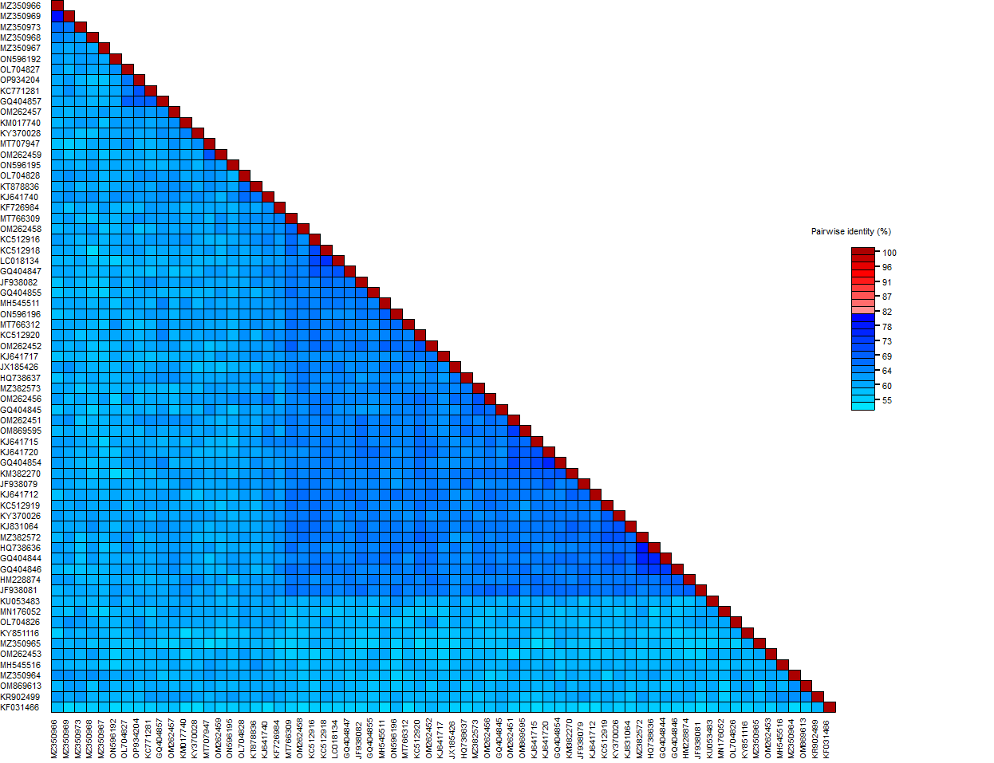

Figure 1: A ‘two colour’ pairwise identity matrix of representative genome-wide comparisons among sequences in the genus Cyclovirus inferred using SDT v1.2 [3] and MUSCLE alignment. The virus representing proposed new species is indicated by a red arrow.

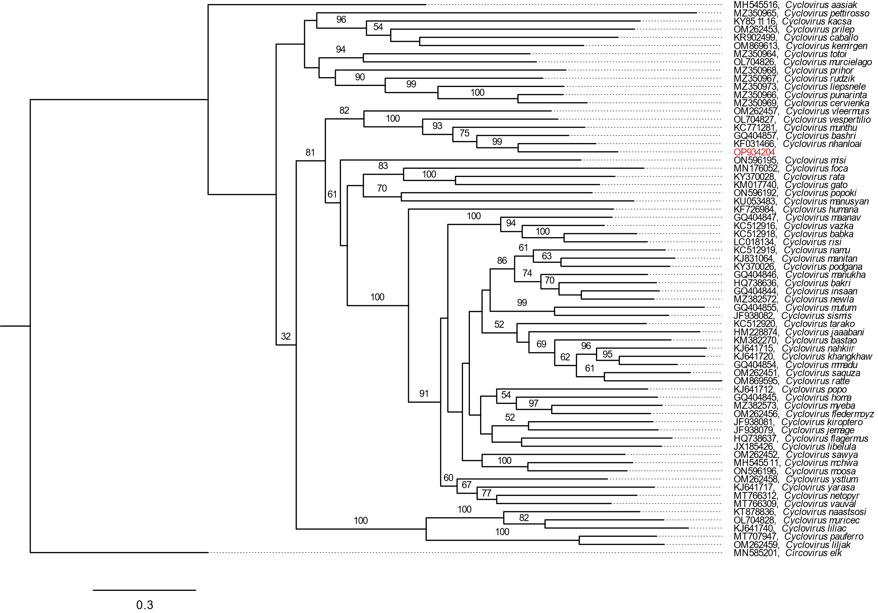

Figure 2: Maximum likelihood phylogenetic tree (rooted with reverse complement sequences of a circovirus) of representative genomes for each cyclovirus species (aligned with MAFFT [4]) inferred using PHYML [5] with Smart Model Selection [6]. Statistical confidence in clades based on 100 bootstrap replicates is represented by numbers beside branches (values ≥ 50 are shown). Scale bar is equal to nucleotide substitutions per site. The tree was visualized in FigTree v. 1.4.4 [7].

References
1. Rosario K, Breitbart M, Harrach B, Segalés J, Delwart E, Biagini P, Varsani A (2017) Revisiting the taxonomy of the family Circoviridae: establishment of the genus Cyclovirus and removal of the genus Gyrovirus. Arch Virol 162(5):1447–63. https://doi.org/10.1007/s00705-017-3247-y
2. Siddell SG, Walker PJ, Lefkowitz EJ, Mushegian AR, Dutilh BE, Harrach B, et al (2020) Binomial nomenclature for virus species: a consultation. Arch Virol 165(2):519–25. https://doi.org/10.1007/s00705-019-04477-6
3. Muhire BM, Varsani A, Martin DP (2014) SDT: a virus classification tool based on pairwise sequence alignment and identity calculation. PloS One 9(9):e108277. https://doi.org/10.1371/journal.pone.0108277
4. Katoh K, Rozewicki J, Yamada KD (2019) MAFFT online service: multiple sequence alignment, interactive sequence choice and visualization. Brief Bioinform 20(4):1160–6. https://doi.org/10.1093/bib/bbx108

5. Guindon S, Dufayard JF, Lefort V, Anisimova M, Hordijk W, Gascuel O (2010) New Algorithms and Methods to Estimate Maximum-Likelihood Phylogenies: Assessing the Performance of PhyML 3.0. Syst Biol 59(3):307–21. https://doi.org/10.1093/sysbio/syq010

6. Lefort V, Longueville JE, Gascuel O (2017) SMS: Smart Model Selection in PhyML. Mol Biol Evol 34(9):2422–4. https://doi.org/10.1093/molbev/msx149

7. Rambaut A. FigTree, version 1.4.4. (2018) Available from: http://tree.bio.ed.ac.uk/software/figtree/

