Part 1: TITLE, AUTHORS, APPROVALS, etc

Code assigned: | 2023.024D
Short title: Establishing the order Gredzevirales, two new families (Ouroboviridae and Gandrviridae) and associated genera and species in the class Arfiviricetes (phylum Cressdnaviricota)

Author(s) and email address(es)
Varsani A, Hopkins A, Lund MC, Kraberger S, Krupovic M | Arvind.varsani@asu.edu; adhopki1@asu.edu; mclund2@asu.edu; Simona.kraberger@asu.edu; mart.krupovic@pasteur.fr
Author(s) institutional address(es) (optional)

The Biodesign Center for Fundamental and Applied Microbiomics, Center for Evolution and Medicine, School of Life sciences, Arizona State University, Tempe, AZ 85287-5001, USA [AV, AH, MCL, SK]
Institut Pasteur, Université Paris Cité, Archaeal Virology Unit, 25 rue du Dr Roux, 75015 Paris, France [MK]

Corresponding author
Arvind Varsani

List the ICTV Study Group(s) that have seen this proposal

ICTV Study Group comments and response of proposer

ICTV Study Group votes on proposal

Study Group | Number of members
 | Votes support | Votes against | No vote
Authority to use the name of a living person

Is any taxon name used here derived from that of a living person (Y/N) | N

Taxon name | Person from whom the name is derived | Permission attached (Y/N)

Submission dates
Date first submitted to SC Chair | 14 July 2023
Date of this revision (if different to above) | 5 Oct 2023
ICTV-EC comments and response of the proposer
The proposal was deemed acceptable in the form presented at the EC meeting.

Part 2: NON-TAXONOMIC PROPOSAL
Text of proposal

Part 3: TAXONOMIC PROPOSAL
Name of accompanying Excel module
2023.024D.N.v2. Gredzevirales_1no_2nf_38ng_58nsp.xlsx
Abstract

We propose to establish the order Gredzevirales in the class Arfiviricetes (phylum Cressdnaviricota), including two new families, Ouroboviridae and Gandrviridae, with 38 genera and 58 species.

Text of proposal
We propose to establish the order Gredzevirales, including two new families, Ouroboviridae and Gandrviridae, comprising 38 genera and 58 species to classify 79 viral sequences that are part of a group of viruses informally referred to as CRESSV5 in the phylum Cressdnaviricota [1-4].

The order name Gredzevirales is derived from Latvian gredzens for “ring”, referring to the circularity of the viral genomes.

The family name Ouroboviridae is derived from ouroboros, a symbol depicting a serpent eating its own tail.

The family name Gandrviridae is derived from Jörmungandr, a serpent in Norse mythology equivalent of ouroboros. The prefix "Jörmun-" denotes something huge, vast superhuman, whereas the word "gandr" refers to elongated entities, including snake, and or supernatural beings.

Genus and species demarcation

We undertook comparative genomics and phylogenetic analyses of the Rep proteins of members of this group to determine their relationships. Genera were delineated based on phylogenetic analyses coupled with pairwise identities and also the genome organization relative to the rep open reading frame (Figures 2-3).

For species demarcation, we used a 78% pairwise nucleotide genome-wide sequence identity which is similar to that used for other cressdnaviruses [5-7].

Genera for Ouroboviridae
Etymology of genus names

- Boebeisivirus: Boebeïs - lake in ancient Magnesia
- Kreonivirus: Kreon - king of Thebes
- Proteusivirus: Proteus - old man of the sea
- Tantalovirus: Tantalos - early king of Lydia
- Ioniavirus: Ionia - west coast of Asia Minor (Homer's Odyssey)
- Tethyvirus: Tethys - a Titan, wife of Ocean
- Dorisivirus: Doris - a Nereid, daugther of Tethys
- Eurynomevirus: Eurynome - an Oceanid, daughter of Tethys
- Otosivirus: Otos - brother of Ephialtes
- Demetevirus: Demeter - goddess of the grain harvest
- Naiadivirus: Naiad - spirit who guards freshwater
- Persevirus: Persê - daughter of Ocean
- Perimedevirus: Perimedes - one of Odysseus' companions
- Telemovirus: Telemos - the seer of the Cyclops
- Pylenevirus: Pylene - town in ancient Aetolia
- Rhipevirus: Rhipe - city in ancient Arcadia
- Taphiavirus: Taphians - pirates of the western seas
- Styxivirus: Styx - a river in the underworld
- Lamposivirus: Lampos - one of Dawn's horses
- Kadmovirus: Kadmos - founder of Thebes
- Doliovirus: Dolios - an aged servant of Penelope
- Stentovirus: Stentor - Herald of the Argives
- Aretevirus: Aretê - queen of the Phaeacians
- Gorgovirus: Gorgon - head of Medusa
- Heravirus: Hera - daughter of Kronos and Rhea
- Mantiovirus: Mantios - son of Melampous
- Peronelivirus: Pero - daughter of Neleus
- Patroklovirus: Patroklos - Achilles' best friend
- Horusivirus: Horus - child of Isis and Osiris
- Pythorivirus: Pytho - Homer's name for Delphi

Etymology of species epithets – derived from host names and source

- manatense: Manatee Spring
- mintis: minnow tissue
- cygolis: Cygnus olor
- seabatis: seabass tissue
- raitis: rainbow trout tissue
- resnatis: red snapper tissue
- farduois: Farfantepenaeus duorarum
- callioris: Callinectes ornatus
- abatis: abalone tissue
- nemileis: Mnemiopsis leidyi
- orcatis: Orcinus orca tissue
- aiptaes: Aiptasia
- troutis: rainbow trout tissue
- volusiense: Volusia Spring
- plantaes: planta is the Spanish word for plant
- haddotis: haddock tissue
- wakense: Wakvhokte - cow in Muscogee (Manatee springs)
- vacaense: vaca - cow in Spanish (Manatee springs)
- befense: bèf - cow in Haitian Creole (Manatee springs)
- forpensaes: Forsythia suspensa
- pectis: minnow tissue; pececillo is the Spanish word for minnow
- pargotis: red snapper tissue; pargo is the Spanish word for snapper
- truchatis: rainbow trout tissue, trucha is the Spanish word for trout
- niaois: bird metagenome; niao is the Mandarin pinyin word for bird
- mingois: flamingo
- blatis: black fly tissue
- vaitis: minnow tissue; vairon is the French word for minnow
- paphis: Paphies subtriangulata
- didemis: Didemnum sp.
- pestrotis: rainbow trout tissue; pestrófa is the Greek word for trout
- ecklonis: Ecklonia radiata
- ageladense: Manatee Spring; ageláda is the Greek word for cow
- gammaris: Gammarus sp.
- poulis: bird metagenome; poulí is the Greek word for bird
- lythtis: red snapper tissue, lythríni is the Greek word for snapper
- reppertis: red snapper tissue
- swances: mute swan; cygnus olor feces
- marisnaco: marine snail associated circovirus
- hermico: Hermit crab associated circovirus
- cisneis: cisne is the Spanish word for swan
- camaronis: camarón is the Spanish word for shrimp
- ealaes: eala is the Irish word for swan
- clamco: clam associated circovirus
- doingaes: doingaen is the Irish word for seabass
- palaeminteris: Palaemonetes intermedius
- gulmense: Gulf of Mexico
- pandaco: Giant panda circovirus
- mencois: flamenco is the Spanish word for flamingo
- apimellis: Apis mellifera
- pauaes: pāua is the Māori name given to abalone

Genera for Gandrviridae
Etymology of genus names

- Satyrivirus: Satyrs - rustic fertility spirits of the countryside and wilds.
- Oreadivirus: Oreads - the nymphs of trees, groves, woodlands and mountain forests
- Meliavirus: Meliae - nymphs of the ash-tree
- Oreiadivirus: Oreiades - Nymphs of the mountains
- Atripovirus: Atropos - One of the three Fates.
- Thyiavirua: Thyia - Naiad-nymph of Mount Parnassus loved by the god Apollo
- Thisbivirus: Thisbe - The eponymous nymph of the Boeotian town of Thebes
- Sthenivirus: Stheno - One of the two immortal Gorgons

Etymology of species epithets – derived from host names and source

- cordulis: Procordulia grayi
- manflis: Manatee Spring – Florida
- jackflis: Jackson Spring - Florida
- spriflis: Manatee Spring - Florida
- timinis: minnow tissue
- flanatis: Manatee Spring - Florida
- naringis: Manatee Spring - Florida
- nowtis: minnow tissue

Supporting evidence

Table 1: Summary of the viruses classified in the new order Gredzevirales and family Ouroboviridae.

Genus | Species | Accession # | Virus | Year | Country | Host /source | Isolate
Boebeisivirus | Boebeisivirus manatense | MW202799 | Circoviridae sp. ctMfu914 | 2019 | USA | Manatee Spring | ctMfu914
Boebeisivirus | Boebeisivirus manatense | MW202791 | Circoviridae sp. cthqR948 | 2019 | USA | Manatee Spring | cthqR948
Boebeisivirus | Boebeisivirus mintis | MH617165 | Circoviridae sp. ctbg280 | 2017 | USA | minnow tissue | ctbg280
Kreonivirus | Kreonivirus cygolis | MW588082 | mute swan feces associated circular virus 8 | 2016 | United Kingdom | Cygnus olor | Abbotsbury/A/2016
Kreonivirus | Kreonivirus seabatis | MH648934 | Circoviridae sp. ctch688 | 2017 | USA | seabass tissue | ctch688
Proteusivirus | Proteusivirus raitis | MH617435 | Circoviridae sp. ctda94 | 2017 | USA | rainbow trout tissue | ctda94
Proteusivirus | Proteusivirus raitis | MH617183 | Circoviridae sp. ctic98 | 2017 | USA | rainbow trout tissue | ctic98
Tantalovirus | Tantalovirus resnatis | MH649205 | Circoviridae sp. ctch025 | 2017 | USA | red snapper tissue | ctch025
Ioniavirus | Ioniavirus farduois | KR528553 | Farfantepenaeus duorarum pink shrimp associated circular virus I0069 |  | USA | Farfantepenaeus duorarum | I0069
Ioniavirus | Ioniavirus callioris | KR528549 | Callinectes ornatus blue crab associated circular virus I0054 |  | USA | Callinectes ornatus | I0054
Tethyvirus | Tethyvirus abatis | MH617703 | CRESS virus sp. ctce130 | 2017 | USA | abalone tissue | ctce130
Tethyvirus | Tethyvirus nemileis | KT945163 | Ctenophore-associated circular virus 2 | 2013 | USA: Skidaway River, Georgia | Mnemiopsis leidyi | I1098
Dorisivirus | Dorisivirus orcatis | MW562325 | delphin virus 2 M3_2163_2086 | 2018 | Saint Vincent and the Grenadines | Orcinus orca | M3_2163_2086
Dorisivirus | Dorisivirus orcatis | MW562319 | delphin virus 2 K3_2163_2086 | 2018 | Saint Vincent and the Grenadines | Orcinus orca | K3_2163_2086
Dorisivirus | Dorisivirus aiptaes | KR528545 | Aiptasia sp. sea anemone associated circular virus I0007C3 |  | USA | Aiptasia sp. | I0007C3
Dorisivirus | Dorisivirus aiptaes | KR528544 | Aiptasia sp. sea anemone associated circular virus I0007C2 |  | USA | Aiptasia sp. | I0007C2
Eurynomevirus | Eurynomevirus troutis | MH617336 | CRESS virus sp. ctii88 | 2017 | USA | rainbow trout tissue | ctii88
Otosivirus | Otosivirus volusiense | MN582106 | CRESS virus sp. ct6pe1 | 2017 | USA | Volusia Spring | ct6pe1
Demetevirus | Demetevirus plantaes | MN891801 | Trichosanthes kirilowii CRESS virus strain pt111-nan-3 |  | China | Trichosanthes kirilowii | pt111-nan-3
Demetevirus | Demetevirus plantaes | MN891790 | Toona sinensis CRESS virus strain pt109-nan-1 |  | China | Toona sinensis (A. Juss.) Roem. | pt109-nan-1
Demetevirus | Demetevirus haddotis | MH616684 | CRESS virus sp. ctcg236 | 2017 | USA | haddock tissue | ctcg236
Naiadivirus | Naiadivirus wakense | MW202695 | Circoviridae sp. ct2da291 | 2019 | USA | Manatee Spring | ct2da291
Naiadivirus | Naiadivirus vacaense | MW202688 | Circoviridae sp. ctVGY598 | 2019 | USA | Manatee Spring | ctVGY598
Naiadivirus | Naiadivirus befense | MW202635 | Circoviridae sp. ctk92474 | 2019 | USA | Manatee Spring | ctk92474
Naiadivirus | Naiadivirus befense | MW202468 | Circoviridae sp. cttJj217 | 2019 | USA | Manatee Spring | cttJj217
Persevirus | Persevirus forpensaes | MN891794 | Forsythia suspensa CRESS virus strain pt110-nan-2 |  | China | Forsythia suspensa
Persevirus | Persevirus pectis | MH617169 | CRESS virus sp. ctba375 | 2017 | USA | minnow tissue | ctba375
Persevirus | Persevirus pargotis | MH649214 | CRESS virus sp. cthh024 | 2017 | USA | red snapper tissue | cthh024
Persevirus | Persevirus truchatis | MH617752 | Circoviridae sp. ctbj92 | 2017 | USA | rainbow trout tissue | ctbj92
Persevirus | Persevirus niaois | MT138055 | CRESS virus sp. zftfla02cir5 genomic sequence | 2016 |  | Avian anal swab | zftfla02cir5
Persevirus | Persevirus mingois | MN928940 | CRESS virus sp. fla04cir2 | 2018 | China | Phoenicopteridae | fla04cir2
Persevirus | Persevirus mingois | MT138057 | CRESS virus sp. zftfla02cir7 genomic sequence | 2016 |  | Avian anal swab | zftfla02cir7
Persevirus | Persevirus mingois | MN928941 | CRESS virus sp. fla06cir3 | 2018 | China | Phoenicopteridae | fla06cir3
unclassified | unclassified | MT341480 | clinch circular virus 1 | 2018 | USA: Clinch River, Kyle's Ford, Tennessee | Actinonaias pectorosa | CCcrV1/C64/2018
Perimedevirus | Perimedevirus blatis | MK433220 | blackfly DNA Virus 6 | 2014 | New Zealand: Canterbury | Austrosimulium australense | SF01_308
Telemovirus | Telemovirus vaitis | MH616801 | CRESS virus sp. ctch860 | 2017 | USA | minnow tissue | ctch860
Pylenevirus | Pylenevirus paphis | KM874354 | Avon-Heathcote Estuary associated circular virus 24 | 2012 | New Zealand | Paphies subtriangulata | AHEaCV-24-NZ-2183TU-2913
Rhipevirus | Rhipevirus didemis | KR528547 | Didemnum sp. Sea Squirt associated virus I0026A7 |  | USA | Didemnum sp. | I0026A7
Taphiavirus | Taphiavirus pestrotis | MH617453 | Circoviridae sp. ctdb89 | 2017 | USA | rainbow trout tissue | ctdb89
Styxivirus | Styxivirus ecklonis | MG740721 | Ecklonia radiata-associated virus 10 | 2014 | Australia | Ecklonia radiata
Styxivirus | Styxivirus ecklonis | MG740722 | Ecklonia radiata-associated virus 11 | 2014 | Australia | Ecklonia radiata
Styxivirus | Styxivirus ecklonis | MG740716 | Ecklonia radiata-associated virus 5 | 2014 | Australia | Ecklonia radiata
Styxivirus | Styxivirus ecklonis | MG740713 | Ecklonia radiata-associated virus 2 | 2014 | Australia | Ecklonia radiata
Styxivirus | Styxivirus ecklonis | MG740715 | Ecklonia radiata-associated virus 4 | 2014 | Australia | Ecklonia radiata
Styxivirus | Styxivirus ecklonis | MG740717 | Ecklonia radiata-associated virus 6 | 2014 | Australia | Ecklonia radiata
Lamposivirus | Lamposivirus ageladense | MW202684 | Circoviridae sp. ct7MN831 | 2019 | USA | Manatee Spring | ct7MN831
Lamposivirus | Lamposivirus gammaris | KR528561 | Gammarus sp. amphipod associated circular virus I0153 |  | USA | Gammarus sp. | I0153
Kadmovirus | Kadmovirus poulis | MT138059 | CRESS virus sp. zftfla02cir9 genomic sequence | 2016 |  | Avian anal swab | zftfla02cir9
Doliovirus | Doliovirus lythtis | MH616757 | Circoviridae sp. ctda242 | 2017 | USA | red snapper tissue | ctda242
Stentovirus | Stentovirus reppertis | KJ641738 | bat circovirus BtRh-CV-7/Tibet2013 | 2013 | China | Rhinolophus hipposideros | BtRh-CV-7/Tibet2013
unclassified | unclassified | MT341482 | clinch circular virus 2 | 2018 | USA: Clinch River, Sycamore Island, Virginia | Actinonaias pectorosa | CCcrV2/B28/2018
Stentovirus | Stentovirus reppertis | MH617575 | Circoviridae sp. ctbf290 | 2017 | USA | red snapper tissue | ctbf290
Aretevirus | Aretevirus swances | MW588088 | mute swan feces associated circular virus 14 | 2016 | United Kingdom | Cygnus olor | Abbotsbury/A/2016
Aretevirus | Aretevirus marisnaco | KR528554 | marine snail associated circular virus I0084 |  | USA | marine snail | I0084
Aretevirus | Aretevirus hermico | KR528556 | hermit crab associated circular virus I0085A5 |  | USA | hermit crab | I0085A5
Aretevirus | Aretevirus hermico | KR528555 | hermit crab associated circular virus I0085A4 |  | USA | hermit crab | I0085A4
Gorgovirus | Gorgovirus cisneis | MW588087 | mute swan feces associated circular virus 13 | 2016 | United Kingdom | Cygnus olor | Abbotsbury/A/2016
Heravirus | Heravirus camaronis | KR528552 | Farfantepenaeus duorarum pink shrimp associated circular virus I0066 |  | USA | Farfantepenaeus duorarum | I0066
Mantiovirus | Mantiovirus ealaes | MW588078 | mute swan feces associated circular virus 4 | 2016 | United Kingdom | Cygnus olor | Abbotsbury/A/2016
Mantiovirus | Mantiovirus clamco | KR528562 | Mytilus sp. clam associated circular virus I0169 |  | USA | Mytilus sp. | I0169
Peronelivirus | Peronelivirus doingaes | MH649155 | Circoviridae sp. ctcg564 | 2017 | USA | seabass tissue | ctcg564
Peronelivirus | Peronelivirus palaeminteris | KR528551 | Palaemonetes intermedius brackish grass shrimp associated circular virus I0059 |  | USA | Palaemonetes intermedius | I0059
Patroklovirus | Patroklovirus gulmense | JX904231 | uncultured marine virus GOM00443 |  |  | Gulf of Mexico | GOM00443
Horusivirus | Horusivirus pandaco | MF327574 | giant panda circovirus 2 gpci002 | 2015 | China | feces | gpci002
Horusivirus | Horusivirus mencois | MN928942 | CRESS virus sp. fmg067cir4 | 2018 | China | Phoenicopteridae | fmg067cir4
Horusivirus | Horusivirus apimellis | MW697481 | arizlama virus AZLM_927 | 2012 | USA | Lake water sample | AZLM_927
Horusivirus | Horusivirus apimellis | MH973773 | Apis mellifera virus-16 | 2018 | USA | Apis mellifera carnica | BNH4370NG
Horusivirus | Horusivirus apimellis | MH973772 | Apis mellifera virus-16 | 2018 | USA | Apis mellifera carnica | BFB18385
Pythorivirus | Pythorivirus pauaes | MH617051 | Circoviridae sp. ctih115 | 2017 | USA | abalone tissue | ctih115

Table 2: Summary of the viruses classified in the new order Gredzevirales and family Gandrviridae.

Genus | Species | Accession # | Virus | Year | Country | Host /source | Isolate
unclassified | unclassified | MH648979 | CRESS virus sp. ctda051 | 2017 | USA | red snapper tissue | ctda051
unclassified | unclassified | MH648980 | CRESS virus sp. ctch048 | 2017 | USA | red snapper tissue | ctch048
unclassified | unclassified | MH649149 | CRESS virus sp. ctcf047 | 2017 | USA | red snapper tissue | ctcf047
unclassified | unclassified | MH648975 | CRESS virus sp. ctjb043 | 2017 | USA | red snapper tissue | ctjb043
unclassified | unclassified | MH616905 | CRESS virus sp. ctcc758 | 2017 | USA | red snapper tissue | ctcc758
unclassified | unclassified | MH649027 | CRESS virus sp. cthd049 | 2017 | USA | red snapper tissue | cthd049
unclassified | unclassified | MH649126 | CRESS virus sp. ctcf052 | 2017 | USA | red snapper tissue | ctcf052
unclassified | unclassified | MH617558 | CRESS virus sp. ctga771 | 2017 | USA | red snapper tissue | ctga771
unclassified | unclassified | MH648963 | CRESS virus sp. ctbg040 | 2017 | USA | red snapper tissue | ctbg040
unclassified | unclassified | MH649154 | CRESS virus sp. ctie003 | 2017 | USA | crab tissue | ctie003
unclassified | unclassified | MH648895 | CRESS virus sp. ctbb003 | 2017 | USA | rainbow trout tissue | ctbb003
unclassified | unclassified | MH617007 | CRESS virus sp. ctjh137 | 2017 | USA | rainbow trout tissue | ctjh137
Satyrivirus | Satyrivirus cordulis | KP153453 | Lake Sarah-associated circular virus-28 | 2013 | New Zealand | Procordulia grayi | LSaCV-28-LSLA-2013
Trintonivirus | Satyrivirus cordulis | KP153452 | Lake Sarah-associated circular virus-28 | 2013 | New Zealand | Musculium novaezelandiae | LSaCV-28-LSCO-2013
Dryadivirus | Satyrivirus cordulis | KP153451 | Lake Sarah-associated circular virus-28 | 2013 | New Zealand | Potamopyrgus antipodarum | LSaCV-28-LSGA-2013
Oreadivirus | Oreadivirus manflis | MW202570 | CRESS virus sp. ctJ1A291 | 2019 | USA | Manatee Spring | ctJ1A291
Meliavirus | Meliavirus jackflis | MN582096 | CRESS virus sp. ctin15 | 2017 | USA | Jackson Spring | ctin15
Oreiadivirus | Oreiadivirus spriflis | MW202822 | CRESS virus sp. ctOGJ943 | 2019 | USA | Manatee Spring | ctOGJ943
Atripovirus | Atripovirus timinis | MH617332 | CRESS virus sp. ctdb796 | 2017 | USA | minnow tissue | ctdb796
Thyiavirua | Thyiavirua flanatis | MW202851 | CRESS virus sp. ctCcl689 | 2019 | USA | Manatee Spring | ctCcl689
Thisbivirus | Thisbivirus naringis | MW202729 | CRESS virus sp. ctnuI873 | 2019 | USA | Manatee Spring | ctnuI873
Sthenivirus | Sthenivirus nowtis | MH617353 | CRESS virus sp. ctce741 | 2017 | USA | minnow tissue | ctce741

Figure 1: Maximum likelihood phylogenetic tree inferred from Rep proteins of members of the phylum Cressdnaviricota. Related sequence groups are collapsed into triangles, the side lengths of which are proportional to the distances between the closest and farthest leaf nodes. The alignment was trimmed with TrimAL [8] with gap threshold of 0.2. The maximum likelihood phylogenetic tree was constructed using IQtree [9] with automatic selection of the best-fit substitution model for a given alignment, which was Q.pfam+F+R10. Numbers at the nodes represent aLRT branch supports. The scale bar represents the number of substitutions per site.

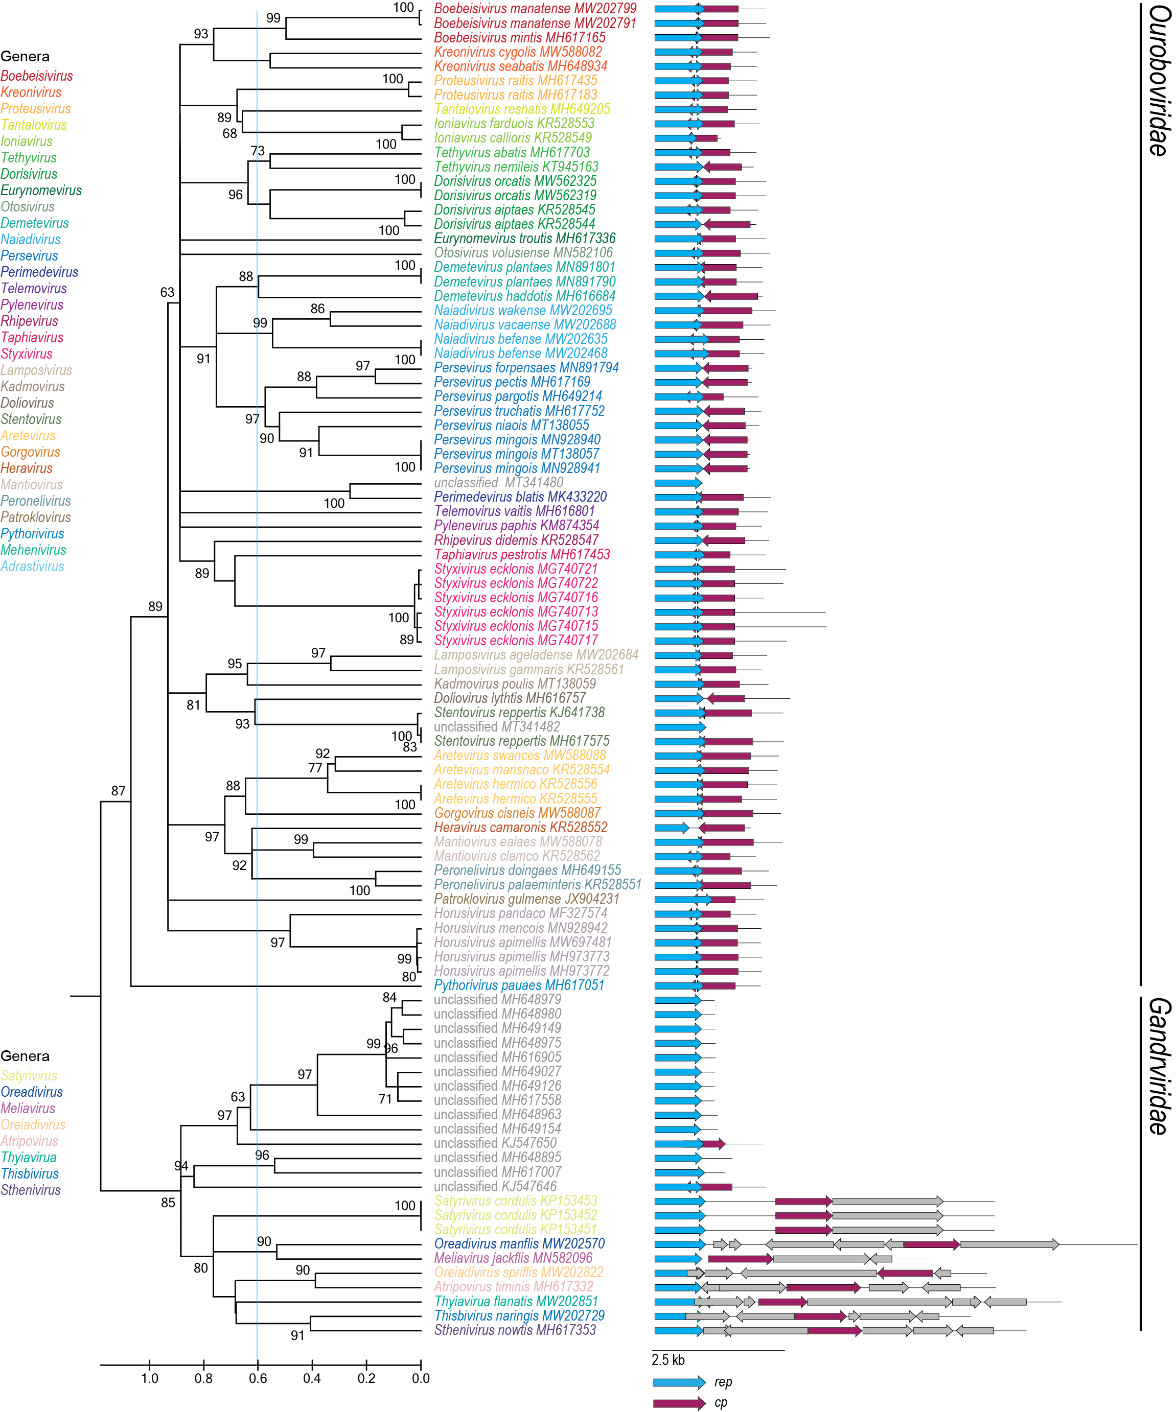

Figure 2: Maximum likelihood phylogenetic tree of the Rep sequences of the members of the Ouroboviridae and Gandrviridae family inferred with PhyML 3.0 [11] with LG+I+G model determined as the best substitution model using ProtTest 3 [12] and rooted with representative sequences of members of the family Smacoviridae. The species belonging to the same genus are indicated with the same color. Numbers at the nodes represent aLRT branch supports. The cyan line shows a proposed demarcation of genera. The genome organization relative to the rep ORF is shown to the right of the phylogeny.

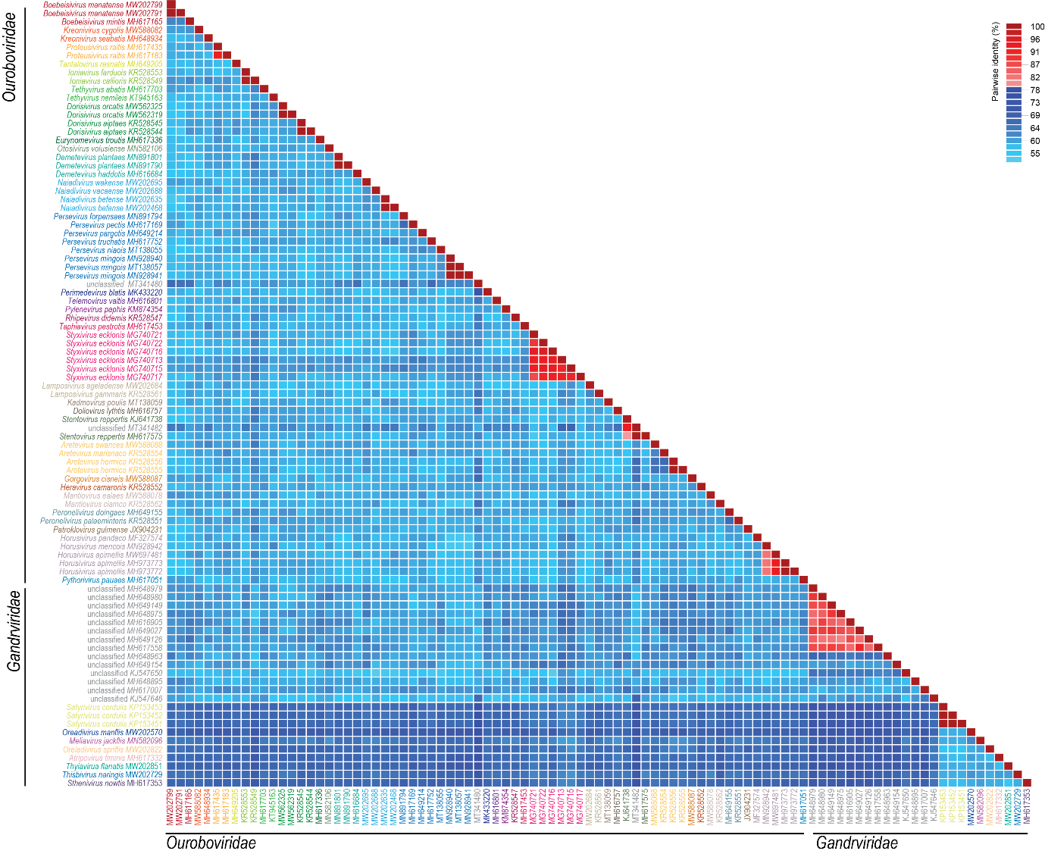

Figure 3: A ‘two color’ pairwise identity matrix of members of the families Ouroboviridae and Gandrviridae with 78% species threshold s inferred using SDT v1.2 [12].

References

- Kazlauskas D, Varsani A, Krupovic M (2018) Pervasive Chimerism in the Replication-Associated Proteins of Uncultured Single-Stranded DNA Viruses. Viruses 10:187. doi:10.3390/v10040187. PMID:29642587
- Kazlauskas D, Varsani A, Koonin EV, Krupovic M (2019) Multiple origins of prokaryotic and eukaryotic single-stranded DNA viruses from bacterial and archaeal plasmids. Nat Commun 10:3425. doi:10.1038/s41467-019-11433-0. PMID:31366885
- Kinsella CM, Deijs M, Becker C, Broekhuizen P, van Gool T, Bart A, Schaefer AS, van der Hoek L. (2022). Host prediction for disease-associated gastrointestinal cressdnaviruses. Virus Evol. 8(2):veac087. doi: 10.1093/ve/veac087. PMID: 36325032; PMCID: PMC9615429.
- Krupovic M, Varsani A, Kazlauskas D, Breitbart M, Delwart E, Rosario K, Yutin N, Wolf YI, Harrach B, Zerbini FM, Dolja VV, Kuhn JH, Koonin EV (2020) Cressdnaviricota: a Virus Phylum Unifying Seven Families of Rep-Encoding Viruses with Single-Stranded, Circular DNA Genomes. J Virol 94:e00582-20. doi:10.1128/JVI.00582-20. PMID:32269128
- Krupovic M, Varsani A, 2022. Naryaviridae, Nenyaviridae, and Vilyaviridae: three new families of single-stranded DNA viruses in the phylum Cressdnaviricota. Arch. Virol. 167, 2907–2921.PMID: 36098801 DOI: 10.1007/s00705-022-05557-w
- Varsani A, Krupovic M (2017) Sequence-based taxonomic framework for the classification of uncultured single-stranded DNA viruses of the family Genomoviridae. Virus Evol 3:vew037. doi:10.1093/ve/vew037. PMID:28458911
- Varsani A, Krupovic M (2018) Smacoviridae: a new family of animal-associated single-stranded DNA viruses. Arch Virol 163:2005-2015. doi:10.1007/s00705-018-3820-z. PMID:29572596
- Capella-Gutierrez S, Silla-Martinez JM, Gabaldon T (2009) trimAl: a tool for automated alignment trimming in large-scale phylogenetic analyses. Bioinformatics 25:1972-3. doi:10.1093/bioinformatics/btp348. PMID:19505945
- Minh BQ, Schmidt HA, Chernomor O, Schrempf D, Woodhams MD, von Haeseler A, Lanfear R (2020) IQ-TREE 2: New Models and Efficient Methods for Phylogenetic Inference in the Genomic Era. Mol Biol Evol 37:1530-1534. doi:10.1093/molbev/msaa015. PMID:32011700
- Guindon S, Dufayard JF, Lefort V, Anisimova M, Hordijk W, Gascuel O (2010) New algorithms and methods to estimate maximum-likelihood phylogenies: assessing the performance of PhyML 3.0. Syst Biol 59:307-321. PMID: 20525638; doi: 10.1093/sysbio/syq010
- Darriba D, Taboada GL, Doallo R, Posada D. (2011).ProtTest 3: fast selection of best-fit models of protein evolution. Bioinformatics. 27(8):1164-5. doi: 10.1093/bioinformatics/btr088. Epub 2011 Feb 17. PMID: 21335321; PMCID: PMC5215816.
- Muhire BM, Varsani A, Martin DP (2014) SDT: A Virus Classification Tool Based on Pairwise Sequence Alignment and Identity Calculation. Plos One 9:e108277. PMID: 25259891; PMCID: PMC4178126.

