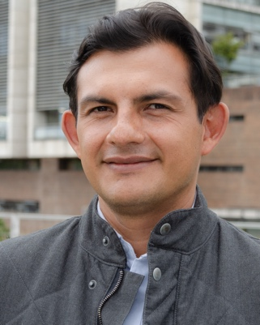

Google Scholar:
http://scholar.google.com/citations?user=hbXF8UEAAAAJ&hl=en

Orcid:
https://orcid.org/0000-0003-2907-3265

Uniandes:
https://cienciasbiologicas.uniandes.edu.co/es/profesores/alejandro-reyes-mu%C3%B1oz

I am a researcher in the field of viral research, with a particular focus on metagenomic analysis of the human gut virome. I hold a Ph.D. in Computational and Systems Biology from Washington University School of Medicine, where I dived into the fascinating world of the human gut virome, investigating its diversity and potential impact on human health. I also hold a Master's degree in Molecular Microbiology from Universidad de los Andes in Bogotá, Colombia, where I conducted research on the gene expression of the White Spot Syndrome virus in Penaeus vannamei. My undergraduate studies in Microbiology were completed at the same university.

Throughout my academic journey, I have been actively involved in various research groups and teaching activities. Currently, I am an Associate Professor at Universidad de los Andes, leading the research group in Microbial Ecology and Computational Biology. I am also the Chair of the undergraduate programs in Biology and Microbiology and have previously held the position of Chair of the M.Sc. Computational Biology program. Additionally, I serve as the Group Leader at the Max Planck Tandem Group in Computational Biology.

My research has resulted in numerous publications in scientific journals. I have been actively involved in organizing and teaching short courses on bioinformatics, metagenomics, and genomics, both nationally and internationally, as well as participating in numerous conferences as an invited speaker.

As a researcher and educator, I am deeply committed to advancing the field of viral research, understanding the complexities of the human virome, and exploring its potential implications for human health. I am eager to continue my work in this exciting and rapidly evolving area of science, contributing to the advancement of knowledge and the development of innovative approaches to combat viral diseases.

