Part 1: TITLE, AUTHORS, APPROVALS, etc

Code assigned: | 2023.001F
Short title: Correction of an error in the ratified binomial names of two species in the family Bacilldnaviridae

Author(s) and email address(es)
Varsani A, Krupovic M | Arvind.varsani@asu.edu; mart.krupovic@pasteur.fr
Author(s) institutional address(es) (optional)

The Biodesign Center for Fundamental and Applied Microbiomics, Center for Evolution and Medicine, School of Life Sciences, Arizona State University, 1001 S. McAllister Ave, Tempe, AZ 85287-5001, USA [AV]
Institut Pasteur, Université Paris Cité, CNRS UMR6047, Archaeal Virology Unit, 25 rue du Dr Roux, 75015 Paris, France [MK]

Corresponding author
Arvind Varsani

List the ICTV Study Group(s) that have seen this proposal

Fungal and Protist Viruses Subcommittee

ICTV Study Group comments and response of proposer

ICTV Study Group votes on proposal

Study Group | Number of members
 | Votes support | Votes against | No vote
Authority to use the name of a living person

Is any taxon name used here derived from that of a living person (Y/N)

Taxon name | Person from whom the name is derived | Permission attached (Y/N)

Submission dates
Date first submitted to SC Chair | 21 May 2023
Date of this revision (if different to above)
ICTV-EC comments and response of the proposer
Part 2: NON-TAXONOMIC PROPOSAL
Text of proposal

Part 3: TAXONOMIC PROPOSAL
Name of accompanying Excel module
2023.001F.N.Bacilladnaviridae_correction_2sp.xlsx
Abstract

An error in the table and accompanying excel module was identified post ratification of the proposal - 2022.002F.N.v1.Bacilladnaviridae_reorg. The two errors stem from a table formatting error which translated to an error in the genus, however, the figure and analysis provide the correct genus assignment. The species Puahadnavirus gataifale should be Seawadnavirus gataifale (OM154949; Avonheates virus SG_154) and
species Seawadnavirus katao should be Kieseladnavirus katao (OM154947; Avonheates virus SG_120)

Text of proposal
An error was identified in the names of two species, Puahadnavirus gataifale and Seawadnavirus katao, in the ratified proposal 2022.002F.N.v1.Bacilladnaviridae_reorg.

These two errors stem from table formatting (genus out by one cell in the row in column 1) and thus the error resulted in a wrong genus being listed. Nonetheless, the analysis summarized in Figure 1 of the original proposal (also provided below) showed the correct assignments, i.e., OM154949 to genus Seawadnavirus and OM154947 to Kieseladnavirus. We request an error correction, namely,

- Puahadnavirus gataifale should be corrected to Seawadnavirus gataifale (OM154949; Avonheates virus SG_154)
- Seawadnavirus katao should be corrected to Kieseladnavirus katao (OM154947; Avonheates virus SG_120)

We would like to thank Peter Simmonds for picking up this error.

Supporting evidence
Table 1 from 2022.002F.N.v1.Bacilladnaviridae_reorg.doc with correction highlighted in bold red font.
“Table 1: Summary of the taxonomy of bacilladnaviruses. New taxa names are provided in blue font.”
New genus | Accession | Virus name | species | Epithet notes
Keisodnavirus | LC379168 | Chaetoceros tenuissimus DNA virus SS12-43V | Keisodnavirus chaetenu | Chaetoceros tenuissimus
Protobacilladnavirus | AB193315 | Chaetoceros salsugineum DNA virus | Protobacilladnavirus chasesal | Chaetoceros salsugineum
 | MH617734 | Bacilladnaviridae sp. isolate ctia23 | Protobacilladnavirus snap | Red snapper
 | AB844272 | Chaetoceros sp. DNA virus 7 | Protobacilladnavirus chaetoc | Chaetoceros sp
 | AB553581 | Chaetoceros lorenzianus DNA virus | Protobacilladnavirus chaelor | Chaetoceros lorenzianus
 | MH616678 | Bacilladnaviridae sp. isolate ctdc18 | Protobacilladnavirus redsnap | Red snapper
 | AB971660 | Chaetoceros tenuissimus DNA virus type-II | Protobacilladnavirus tenuis | Chaetoceros tenuissimus
 | AB971659 | Chaetoceros tenuissimus DNA virus type-II | Protobacilladnavirus tenuis | Chaetoceros tenuissimus
 | AB971658 | Chaetoceros tenuissimus DNA virus type-II | Protobacilladnavirus tenuis | Chaetoceros tenuissimus
 | AB597949 | Chaetoceros tenuissimus DNA virus | Protobacilladnavirus tenuis | Chaetoceros tenuissimus
 | MN229504 | Haslea ostrearia associated bacilladnavirus | Protobacilladnavirus hasleos | Haslea ostrearia
 | KY405007 | Amphibola crenata associated bacilladnavirus 2 | Protobacilladnavirus hasleos | Haslea ostrearia
 | MN229503 | Haslea ostrearia associated bacilladnavirus | Protobacilladnavirus hasleos | Haslea ostrearia
 | KY405006 | Amphibola crenata associated bacilladnavirus 1 | Protobacilladnavirus mudflat | mud-flat snail common name for Amphibola crenata
Puahadnavirus | OM154950 | Avonheates virus SG_479 | Puahadnavirus kaisui | seawater in Japanese
 | OM154944 | Avonheates virus SG_19 | Puahadnavirus aber | estuary in Welsh
 | OM154948 | Avonheates virus SG_146 | Puahadnavirus inbhir | estuary in Scotish
 | OM154945 | Avonheates virus SG_28 | Puahadnavirus takutai | coast in Māori
 | OM154938 | Avonheates virus SG2_28 | Puahadnavirus takutai | coast in Māori
Seawadnavirus | OM154949 | Avonheates virus SG_154 | Seawadnavirus gataifale | estuary / coast in Samoan
 | KF133809 | Bacillariodnavirus LDMD-2013 | Seawadnavirus kuhtahan | seawater in Massaachusett
 | OM154943 | Avonheates virus SG_924 | Seawadnavirus avonheat | Avon-Heathcote estuary
Kieseladnavirus | OM154947 | Avonheates virus SG_120 | Kieseladnavirus katao | water in Māori
 | KY405008 | Avon-Heathcote estuary associated bacilladnavirus | Kieseladnavirus ampcren | Amphibola Crenata
 | OM154942 | Avonheates virus SG_4_10 | Kieseladnavirus titiko | Amphibola crenata in Māori
 | OM154939 | Avonheates virus Gas_102 | Kieseladnavirus titiko | Amphibola crenata in Māori
 | OM154941 | Avonheates virus Gas_1207 | Kieseladnavirus ampcren | Amphibola Crenata
 | OM154940 | Avonheates virus Gas_1078 | Kieseladnavirus karahue | common name for Amphibola crenata in Māori
Aberdnavirus | OM154946 | Avonheates virus SG_61 | Aberdnavirus waitai | Seawater in Māori
Diatodnavirus | AB781089 | Chaetoceros setoense DNA virus | Diatodnavirus chaese | Chaetoceros setoense

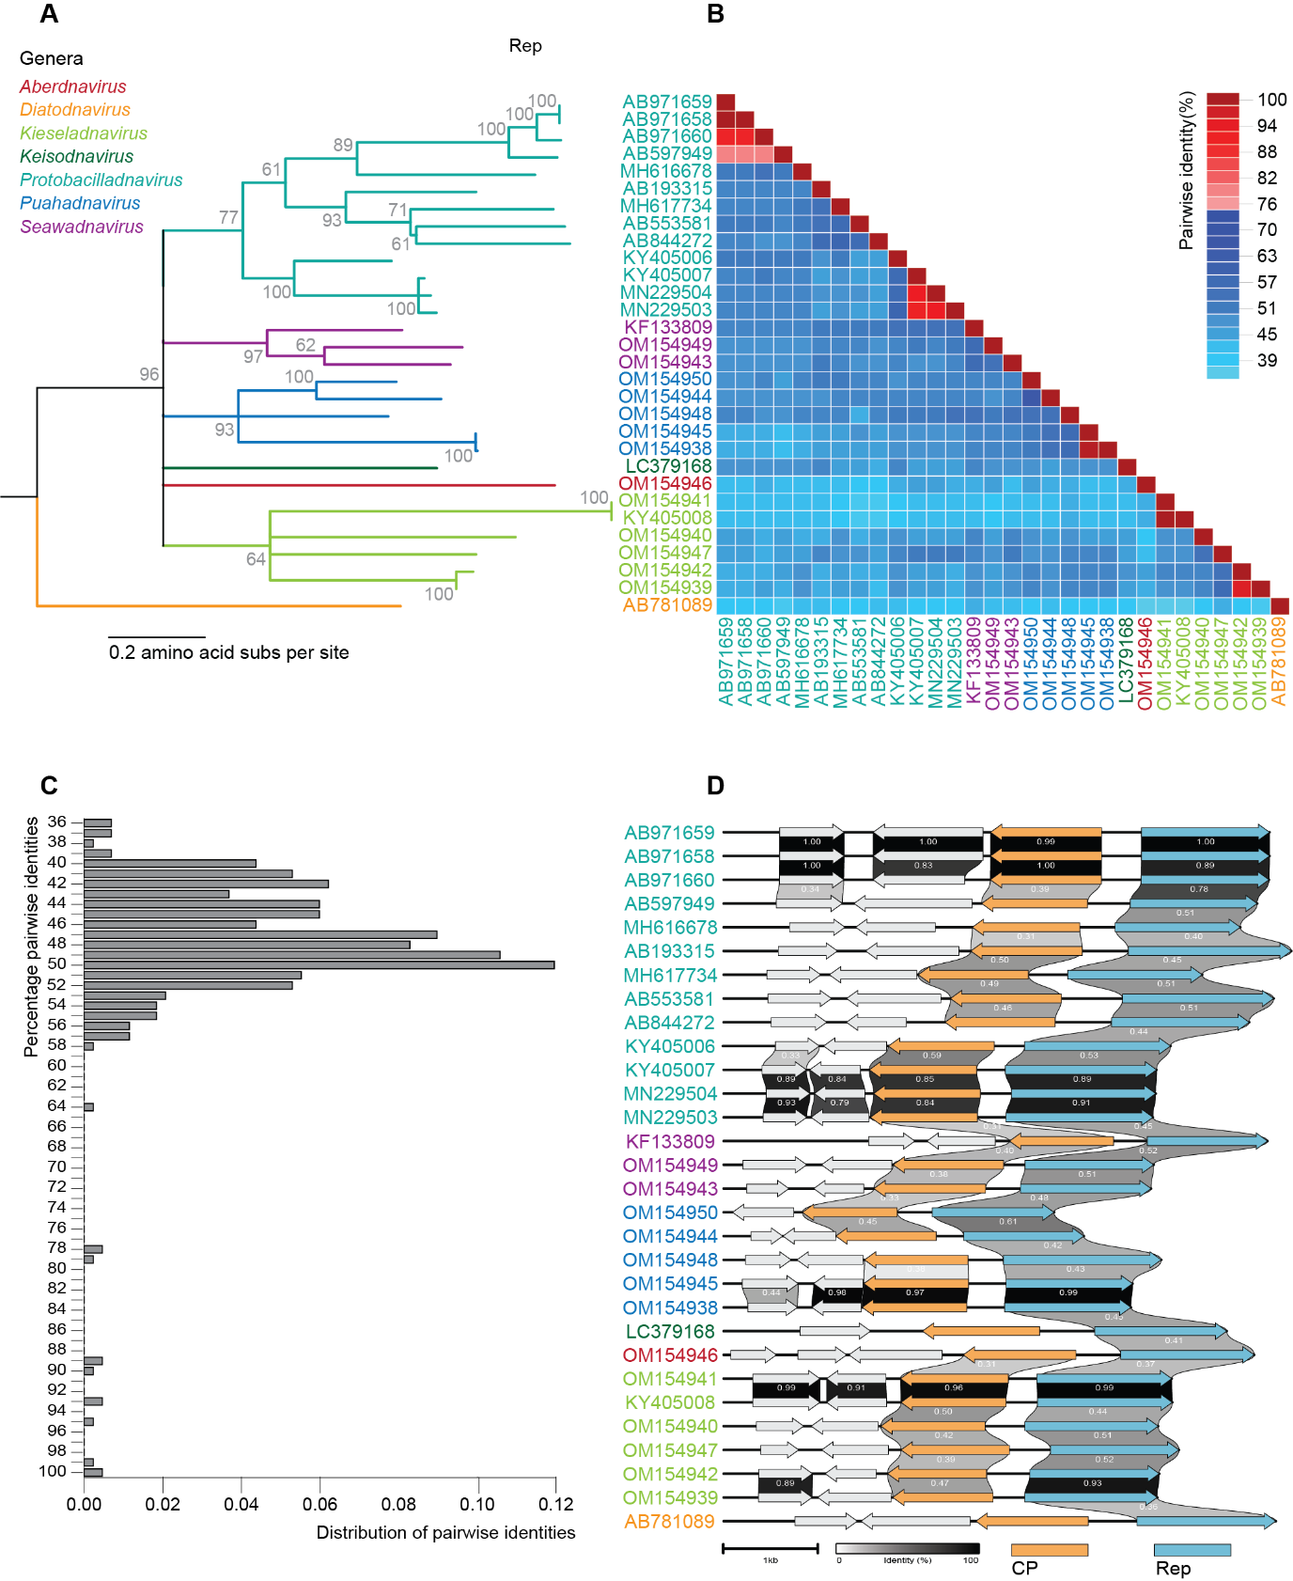
Figure 1: A. Maximum likelihood phylogenetic tree inferred from the aligned (MAFFT v7 [6]) Rep amino acid sequences of bacilladnaviruses using PhyML 3.0 [7] with rtREV+G+I as best substitution model determined using ProtTest [8]. Branches with <60% bootstrap support have been collapsed using TreeGraph2 [9]. B. Pairwise identity matrix of the Rep amino acid sequences of bacilladnaviruses determined using SDT v1.2 [10]. C. Distribution of pairwise identities of the Rep amino acid sequences of bacilladnaviruses determined using SDT v1.2 [10]. D. Genome organization and similarities between encoded proteins of the genomes of bacilladnaviruses determined using Clinker [11].

Figure 1 and the accompanying legend are reproduced in an unaltered form from 2022.002F.N.v1.Bacilladnaviridae_reorg.doc

References

