Part 1: TITLE, AUTHORS, APPROVALS, etc

Code assigned: | 2022.001P
Short title: Create 12 new species (Tymovirales: Betaflexiviridae)
Author(s) and email address(es)
Candresse T, Blouin A, Cao M, Cho WK, Constable F, Mollov D, Nagata T, Sabanadzovic S, Saldarelli P, Tzanetakis I, Villamor DE | thierry.candresse@inrae.fr; arnaud.blouin@agroscope.admin.ch; mengjicao@gmail.com; wonkyong@gmail.com; Fiona.Constable@ecodev.vic.gov.au; dimitre.mollov@usda.gov; tatsuya@unb.br; SSabanadzovic@entomology.msstate.edu; pasquale.saldarelli@ipsp.cnr.it; itzaneta@uark.edu; dvvillam@uark.edu
Author(s) institutional address(es) (optional)
Corresponding author
Candresse T
List the ICTV Study Group(s) that have seen this proposal
ICTV Beta-, Delta- and Gammaflexiviridae Study Group
ICTV Study Group comments and response of proposer

ICTV Study Group votes on proposal
Study Group | Number of members 11
 | Votes support | Votes against | No vote
Beta-, Delta-, Gammaflexiviridae | 11 | 0 | 0
Authority to use the name of a living person
Is any taxon name used here derived from that of a living person (Y/N) | NO

Taxon name | Person from whom the name is derived | Permission attached (Y/N)
Submission dates
Date first submitted to SC Chair | May 16, 2022
Date of this revision (if different to above) | May 26, 2022
ICTV-EC comments and response of the proposer

Part 3: TAXONOMIC PROPOSAL
Name of accompanying Excel module
2022.001P.A.v2.Betaflexiviridae_12ns.xlsx
Abstract
We propose the creation of 12 novel species in extant genera in the family Betaflexiviridae (6 new species in genus Carlavirus, 2 in genus Foveavirus, 1 in genus Capillovirus, 2 in genus Chordovirus, 1 in genus Banmivirus).

Text of proposal
The family Betaflexiviridae currently includes two subfamilies, Trivirinae and Quinvirinae. The Trivirinae contains 10 genera, while the Quinvirinae contains 5 genera. With the exception of Citrivirus, Ravavirus, Banmivirus, Sustrivirus and Wamavirus which are currently monospecific, all other Betaflexiviridae genera already contain multiple species which are differentiated on the basis of multiple criteria, including sequence-based ones. The currently approved species demarcation criteria based on sequence identity for the family are <72% nucleotide identity, or <80% amino acid identity in the replication-associated (REP) or capsid (CP) proteins, of the member viruses.

Here, we propose to expand the family Betaflexiviridae by creation of new species for recently discovered novel viruses [1-10]. In performing its analyses the SG considered only novel recently described viruses for which publications provided solid evidence that the sequence corresponding to the full coding capacity of the genome was at least available.

Application of the current sequence-based criteria results in the expansion of the currently accepted species by a total of 12 species allocated to the following genera: Carlavirus (6), Foveavirus (2), Chordovirus (2), Capillovirus (1), Banmivirus (1).

Etymology
- After extensive debate about possible options for the new binomial nomenclature, the SG voted and decided to adopt “Genus + Acronym” format for species names in the family Betaflexiviridae (Note: the acronym being derived from the virus common name).

Supporting evidence
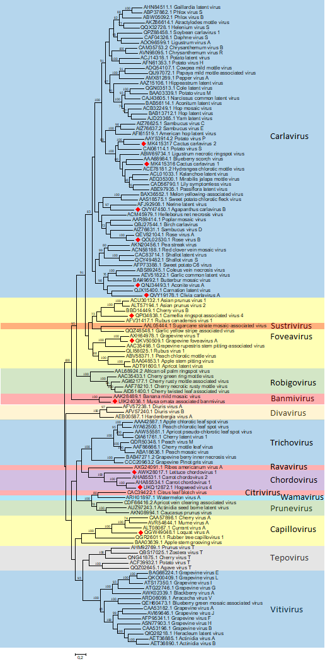
Figure 1. The maximum-likelihood phylogenetic tree was inferred using Mega 11 and a multiple alignment of replication-associated proteins (REP) prepared using Muscle. Bootstrap values >70% are shown. Tree branches are proportional to genetic distances between sequences, and the scale bars at the bottom indicates substitutions per amino acid. Accession numbers are shown next to the respective virus taxon. Novel species proposed in extant genera are indicated by a red diamond.
References
- Diaz‑Lara A, Mollov D, Golino D et al (2021) Detection and characterization of a second carlavirus in Rosa sp. Arch Virol 166:321–323. https://doi.org/10.1007/s00705-020-04864-4
- Fox A, Fowkes A, Vazquez-Iglesias I et al (2022) High throughput sequencing of a 42 year-old isolate of hogweed virus 4 (HV4) reveals that is a member of the genus Chordovirus. J Plant Pathol Online First. https://doi.org/10.1007/s42161-022-01117-y
- Hanafi M, Rong W, Tamisier L et al (2022) Detection of banana mild mosaic virus in Musa in vitro plants: high-throughput sequencing presents higher diagnostic sensitivity than (IC)-RT-PCR and identifies a new Betaflexiviridae species. Plants 11:226. https://doi.org/10.3390/plants11020226
- Liu Q, Yang L, Xuan Z et al (2020) Complete nucleotide sequence of loquat virus A, a member of the family Betaflexiviridae with a novel genome organization. Arch Virol 165:223–226. https://doi.org/10.1007/s00705-019-04444-1
- Peng L, Grinstead S; Kinard G et al (2019) Molecular characterization and detection of two carlaviruses infecting cactus. Arch Virol 164:1873–1876. https://doi.org/10.1007/s00705-019-04279-w
- Read DA, Roberts R, Swanevelder D et al (2021) Novel viruses associated with plants of the family Amaryllidaceae in South Africa. Arch Virol 166:2817–2823. https://doi.org/10.1007/s00705-021-05170-3
- Reynard JS, Brodard J, Remoliff E et al (2020) A novel foveavirus identified in wild grapevine (Vitis vinifera subsp. sylvestris). Arch Virol 165:2999–3002. https://doi.org/10.1007/s00705-020-04817-x
- Svanella‑Dumas L, Τsarmpopoulos I, Marais A et al (2018) Complete genome sequence of lettuce chordovirus 1 isolated from cultivated lettuce in France. Arch Virol 163:2543–2545. https://doi.org/10.1007/s00705-018-3858-y
- Wang R, Chen B, Li Y et al (2021) Complete nucleotide sequence of a new carlavirus infecting Aconitum carmichaelii in China. Arch Virol 166:1513–1515. https://doi.org/10.1007/s00705-021-05028-8
- Zheng L, Chen M, Li R (2020) Camellia ringspot‑associated virus 4, a proposed new foveavirus from Camellia japonica. Arch Virol 165:1707–1710. https://doi.org/10.1007/s00705-020-04655-x

