Part 1: TITLE, AUTHORS, APPROVALS, etc

Code assigned: | 2022.019P
Short title: Create Emaravirus fraxini as a new species in the genus Emaravirus, family Fimoviridae
Author(s) and email address(es)
Gaskin TR, Tischendorf M, Günther I, Rehanek M, Büttner C, von Bargen S | thomas.gaskin@lelf.brandenburg.de;  max.tischendorf@t-online.de;  i_guenther2015@yahoo.com;  marius-rehanek@t-online.de;  carmen.buettner@agrar.hu-berlin.de;  susanne.von.bargen@agrar.hu-berlin.de

Author(s) institutional address(es) (optional)
Brandenburg State Office of Rural Development, Agriculture and Land Consolidation (LELF), Müllroser Chaussee 54, 15236 Frankfurt, Germany
Division Phytomedicine, Thaer-Institute of Agricultural and Horticultural Sciences, Humboldt-Universität Zu Berlin, Lentzeallee 55/57, 14195 Berlin, Germany

Corresponding author
Susanne von Bargen, susanne.von.bargen@agrar.hu-berlin.de

List the ICTV Study Group(s) that have seen this proposal
Fimoviridae Study Group

ICTV study group comments and response of proposer

ICTV Study Group votes on proposal

Study Group | Number of members
 | Votes support | Votes against | No vote
Fimoviridae | 5

Authority to use the name of a living person
Is any taxon name used here derived from that of a living person (Y/N) | N

Taxon name | Person from whom the name is derived | Permission attached (Y/N)

Submission dates
Date first submitted to SC Chair | April 26, 2022
Date of this revision (if different to above) | May 27, 2022
ICTV-EC comments and response of the proposer

Part 3: TAXONOMIC PROPOSAL

Name of accompanying Excel module
2022.019P.N.v1.Emaravirus_1ns.xlsx

Abstract
The creation of the new species Emaravirus fraxini in the genus Emaravirus, family Fimoviridae, is proposed to accommodate ash shoestring-associated virus (ASaV), identified in Switzerland, Germany, Italy and Sweden on European ash (Fraxinus excelsior) and manna ash (F. ornus) trees, as its exemplar virus isolate. The new species consists of five segmented, linear, single-stranded (ss), negative sense RNA genomes, fully sequenced, which show features common to homologous RNAs of other known emaravirus species, but from which it differs significantly in nucleotide and amino acid sequences.

Text of proposal
Ash shoestring-associated virus (ASaV) has been recently identified in European ash (Fraxinus excelsior) and manna ash (F. ornus) trees in Switzerland, Germany, Italy and Sweden and its genome has been completely sequenced (Gaskin et al., 2021). ASaV possesses all molecular and biological features to be considered as a new member of the genus Emaravirus, which currently comprises the following species: Actinidia chlorotic ringspot-associated virus (AcCRaV), Actinidia virus 2 (AcV-2), aspen mosaic-associated virus (AsMaV), blackberry leaf mottle-associated virus (BLMaV), Camellia japonica-associated virus 1 (CjaV-1), Camellia japonica-associated virus 2 (CjaV-2), chrysanthemum mosaic-associated virus (ChMaV), common oak ringspot-associated virus (CORaV), European mountain ash ringspot-associated virus (EMARaV), fig mosaic virus (FMV), High Plains wheat mosaic virus (HPWMoV), jujube yellow mottle-associated virus (JYMaV), lilac chlorotic ringspot-associated virus (LiCRaV), maple mottle-associated virus (MaMaV), palo verde broom virus (PVBV), pear chlorotic leaf spot-associated virus (PCLSaV), perilla mosaic virus (PerMV), pigeonpea sterility mosaic virus 1 (PPSMV-1), pigeonpea sterility mosaic virus 2 (PPSMV-2), Pistacia virus B (PiVB), raspberry leaf blotch virus (RLBV), redbud yellow ringspot-associated virus (RYRSaV), rose rosette virus (RRV), and ti ringspot-associated virus (TiRSaV) (Elbeaino et al. 2018; Mielke and Muehlbach 2007; https://talk.ictvonline.org/ictv-reports/ictv_online_report/negative-sense-rna-viruses/w/fimoviridae/981/genus-emaravirus). The RNA-dependent RNA polymerase (RdRP), glycoprotein precursor (GP), nucleocapsid (NC) and movement protein (MP) show different levels of sequence identity with ortholog proteins of other emaraviruses.

Virus properties
- Genome: resembles that of members of the genus Emaravirus. It is composed of five segments of negative sense ssRNA. RNA-1: 7,031 nt, RNA-2: 2,243 nt, RNA3: 1,483 nt, RNA-4: 1,518 nt, and RNA-5: 1,333 nt (Fig.1) (in order from RNA-1 to RNA-5, accession numbers are: OU466880– OU466884) (Gaskin et al., 2021). Each segment is monocistronic, encoding a single protein translated from the complementary strand (Figure 1). Untranslated regions (UTRs) at the 3’ and 5’ termini of all RNA segments extended from 44 to 103 nt and from 96 to 568 nt, respectively.
- Virus-encoded proteins: RNA-dependent RNA-polymerase (p1): 268 kDa; putative Glycoprotein precursor (p2): 73 kDa; putative Nucleocapsid protein (p3): 35 kDa; putative movement protein (p4): 41 kDa; p5 (function unknown): 26 kDa (Figure 1).
- Phylogenetic relationships: RdRP, GP, NP and MP proteins of ASaV consistently segregated with those of AcV-2 and PPSMaV-2 and formed a cluster with the emaraviruses PPSMV-1, BLMaV, RRV, AcV-2, FMV, PPSMV-2, PiVB (Figure 2). The aa identity between the ASaV proteins and those of other emaraviruses was from 26.2% to 77.9% for p1, from 19.1% to 58.2% for p2, from 13.1% to 73.1% for p3 and from 9.2% to 73.6% for p4.
- Transmission: Aceria fraxinivora is suspected to be a vector of the virus.
- Natural host range: European ash (Fraxinus excelsior) and manna ash (F. ornus).

The detected identities fulfilling the demarcation criteria for species in the genus [aa sequence of relevant gene products of RNA1 (RdRP), RNA2 (GP) and RNA3 (NP) differing by more than 25%], and the genome organization typical of emaraviruses clearly indicate that ASaV represents a new species in the genus Emaravirus. Therefore, the creation of the new viral species Emaravirus fraxini within the genus Emaravirus, which contains ASaV isolate E55270 as the exemplar isolate, is proposed.

Supporting evidence

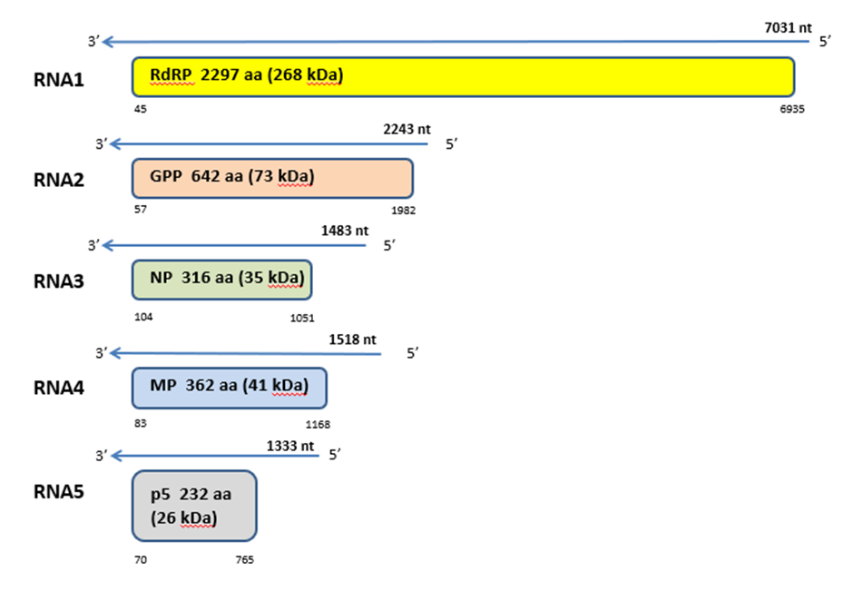

Figure 1. Genome organization of ash shoestring-associated virus (ASaV). Colored boxes represent the protein encoding region (ORF) for each RNA. The length of RNAs, the putative protein product for each ORF, function (if known), and estimated molecular weight are provided. The genomic RNAs are not drawn to scale.

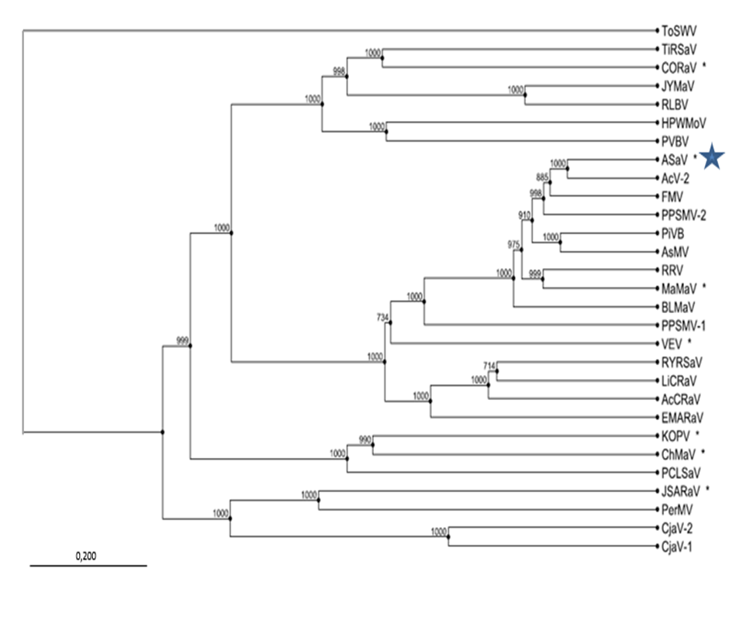
Figure 2. Phylogenetic tree constructed with amino acid sequences encoded by RNA1 (RdRP), of recognized emaraviruses and corresponding tentative species (indicated by a red square). Alignment was obtained using ClustalW, and analyzed by the Neighbor-Joining method, with 1000 bootstrap replicates. The percentage of replicate trees in which the associated taxa clustered together in the bootstrap is shown next to the branches (when >70%). TSWV (tomato spotted wilt virus), a tospovirus of the family Tospoviridae, was used as an outgroup species. Actinidia chlorotic ringspot-associated virus (AcCRaV), Actinidia virus 2 (AcV-2), ash shoestring-associated virus (ASaV), aspen mosaic-associated virus (AsMaV), blackberry leaf mottle associated virus (BLMaV), Camellia japonica-associated virus 1 (CjaV-1), Camellia japonica-associated virus 2 (CjaV-2), chrysanthemum mosaic-associated virus (ChMaV), common oak ringspot-associated virus (CORaV), European mountain ash ringspot-associated virus (EMARaV), fig mosaic virus (FMV), High Plains wheat mosaic virus (HPWMoV), Japanese star anise ringspot-associated virus (JSARaV), jujube yellow mottle-associated virus (JYMaV), karaka Okahu purepure emaravirus (KOPV), lilac chlorotic ringspot-associated virus (LiCRaV), maple mottle-associated virus (MaMaV), palo verde broom virus (PVBV), pear chlorotic leaf spot-associated virus (PCLSaV), perilla mosaic virus (PerMV), pigeonpea sterility mosaic virus 1 (PPSMV-1), pigeonpea sterility mosaic virus 2 (PPSMV-2), Pistacia virus B (PiVB), raspberry leaf blotch virus (RLBV), redbud yellow ringspot-associated virus (RYRSaV), rose rosette virus (RRV), ti ringspot-associated virus (TiRSaV), and Vitis emaravirus (VEV).

References

Elbeaino T, Digiaro M, Mielke-Ehret N, Muehlbach HP, Martelli GP and ICTV Report Consortium (2018) ICTV Virus Taxonomy Profile: Fimoviridae. J Gen Virol 99(11):1478-1479. PMID: 30204080, DOI: 10.1099/jgv.0.001143
Gaskin TR, Tischendorf M, Günther I, Rehanek M, Büttner C, von Bargen S (2021) Characterization of a novel emaravirus affecting ash species (Fraxinus spp.) in Europe. Forests, 12, 1574. doi.org/10.3390/f12111574

Mielke N, Muehlbach HP (2007) A novel, multipartite, negative-strand RNA virus is associated with the ringspot disease of European mountain ash (Sorbus aucuparia L.). J Gen Virol 88:1337–1346. PMID: 17374780. DOI 10.1099/vir.0.82715-0

https://talk.ictvonline.org/ictv-reports/ictv_online_report/negative-sense-rna-viruses/w/fimoviridae/981/genus-emaravirus

