

**Part 1:** **TITLE, AUTHORS, APPROVALS, etc**

|  |  |  |
| --- | --- | --- |
| **Code assigned:** | **2022.022P** |  |
| **Short title:** Create *Emaravirus corynocarpi* as a new species in the genus *Emaravirus,* family *Fimoviridae* | | |
|  | | |

**Author(s) and email address(es)**

|  |  |
| --- | --- |
| Rabbidge LO, Blouin AG, Chooi KM, Higgins CM, MacDiarmid RM | robin.macdiarmid@plantandfood.co.nz |

**Author(s) institutional address(es) (optional)**

|  |
| --- |
| The New Zealand Institute for Plant and Food Research Limited, Private Bag 92169, Auckland 1142, New Zealand [LOR, AGB, KMC, RMM]  The School of Science, Auckland University of Technology, Private Bag 92006, Auckland 1142, New Zealand [LOR, CMH]  Plant Pathology Laboratory, TERRA-Gembloux Agro-Bio Tech, University of Liège, Passage des Déportés, 2, 5030 Gembloux, Belgium AGB]  School of Biological Sciences, The University of Auckland, Private Bag 92019, Auckland 1142, New Zealand [RMM] |

**Corresponding author**

|  |
| --- |
| Robin M. MacDiarmid, [robin.macdiarmid@plantandfood.co.nz](mailto:robin.macdiarmid@plantandfood.co.nz) |

**List the ICTV Study Group(s) that have seen this proposal**

|  |
| --- |
| *Fimoviridae* Study Group |

**ICTV study group comments and response of proposer**

|  |
| --- |
|  |

**ICTV Study Group votes on proposal**

|  |  |  |  |
| --- | --- | --- | --- |
| **Study Group** | **Number of members** | | |
| **Votes support** | **Votes against** | **No vote** |
| Fimoviridae | 5 |  |  |
|  |  |  |  |

**Authority to use the name of a living person**

|  |  |
| --- | --- |
| **Is any taxon name used here derived from that of a living person (Y/N)** | N |

|  |  |  |
| --- | --- | --- |
| **Taxon name** | **Person from whom the name is derived** | **Permission attached (Y/N)** |
|  |  |  |
|  |  |  |
|  |  |  |

**Submission dates**

|  |  |
| --- | --- |
| Date first submitted to SC Chair | April 26, 2022 |
| Date of this revision (if different to above) | May 27, 2022 |

**ICTV-EC comments and response of the proposer**

|  |
| --- |
|  |

**Part 3:** **TAXONOMIC PROPOSAL**

**Name of accompanying Excel module**

|  |
| --- |
| 2022.022P.N.v1.Emaravirus_1ns.xlsx |

**Abstract**

|  |
| --- |
| The creation of the new species *Emaravirus corynocarpi* in the genus *Emaravirus*, family *Fimoviridae,* is proposed to accommodate karaka Okahu purepure virus (KOPV), identified in New Zealand on karaka tree (*Corynocarpus laevigatus*), as its exemplar virus isolate. The new species consists of five segmented, linear, single-stranded (ss), negative sense RNA genomes, fully sequenced, which show features common to homologous RNAs of other known emaravirus species, but from which it differs significantly in nucleotide and amino acid sequences. |

**Text of proposal**

|  |  |  |
| --- | --- | --- |
| |  |  | | --- | --- | | Karaka Okahu purepure virus (KOPV) has been recently identified in karaka tree (*Corynocarpus laevigatus*) in New Zealand and its genome has been completely sequenced (Rabbidge *et al*., 2021). KOPV possesses all molecular and biological features to be considered as a new member of the genus *Emaravirus*, which currently comprises the following species: Actinidia chlorotic ringspot-associated virus (AcCRaV), Actinidia virus 2 (AcV-2), aspen mosaic-associated virus (AsMaV), blackberry leaf mottle-associated virus (BLMaV), Camellia japonica-associated virus 1 (CjaV-1), Camellia japonica-associated virus 2 (CjaV-2), chrysanthemum mosaic-associated virus (ChMaV), common oak ringspot-associated virus (CORaV), European mountain ash ringspot-associated virus (EMARaV), fig mosaic virus (FMV), High Plains wheat mosaic virus (HPWMoV), jujube yellow mottle-associated virus (JYMaV), lilac chlorotic ringspot-associated virus (LiCRaV), maple mottle-associated virus (MaMaV), palo verde broom virus (PVBV), pear chlorotic leaf spot-associated virus (PCLSaV), perilla mosaic virus (PerMV), pigeonpea sterility mosaic virus 1 (PPSMV-1), pigeonpea sterility mosaic virus 2 (PPSMV-2), Pistacia virus B (PiVB), raspberry leaf blotch virus (RLBV), redbud yellow ringspot-associated virus (RYRSaV), rose rosette virus (RRV), and ti ringspot-associated virus (TiRSaV) (Elbeaino et al. 2018; Mielke and Muehlbach 2007; https://talk.ictvonline.org/ictv-reports/ictv_online_report/negative-sense-rna-viruses/w/fimoviridae/981/genus-emaravirus). The RNA-dependent RNA polymerase (RdRP), glycoprotein precursor (GP), nucleocapsid (NC) and movement protein (MP) show different levels of sequence identity with ortholog proteins of other emaraviruses.    **Virus properties**   1. Genome: resembles that of members of the genus *Emaravirus.* It is composed of five segments of negative sense ssRNA. RNA-1: 7,141 nt, RNA-2: 1,943 nt, RNA3: 1,479 nt, RNA-4: 1,518 nt, and RNA-5: 1,576 nt (Fig.1) (in order from RNA-1 to RNA-5, accession numbers are: MZ391827– MZ391831) (Rabbidge et al., 2021). Each segment is monocistronic, encoding a single protein translated from the complementary strand (Figure 1). Untranslated regions (UTRs) at the 3’ and 5’ termini of all RNA segments extended from 41 to 102 nt and from 62 to 680 nt, respectively. 2. Virus-encoded proteins: RNA-dependent RNA-polymerase (p1): 271.1 kDa; putative Glycoprotein precursor (p2): 68.2 kDa; putative Nucleocapsid protein (p3): 34.5 kDa; putative movement protein (p4): 36.2 kDa; p5 (function unknown): 30.3 kDa (Figure 1). 3. Phylogenetic relationships: RdRP, GP, NP and MP proteins of KOPV consistently segregated with those of chrysanthemum mosaic-associated virus and formed a cluster with the emaraviruses pear chlorotic leaf spot-associated virus and chrysanthemum mosaic-associated virus (Figure 2). The highest aa identities of the KOPV proteins were with those of ChMaV, i.e., 46% for p1, 31.9% for p2, and 37.6.1% for p3. 4. Transmission: A role in the transmission of KOPV to karaka plants is suspected for the eriophyde mite *Aculus corynocarpi*. 5. Natural host range: karaka (*Corynocarpus laevigatus*).   The detected identities fulfilling the demarcation criteria for species in the genus [aa sequence of relevant gene products of RNA1 (RdRP), RNA2 (GP) and RNA3 (NP) differing by more than 25%], and the genome organization typical of emaraviruses clearly indicate that KOPV represents a new species in the genus *Emaravirus*. Therefore, the creation of the new viral species *Emaravirus corynocarpi* within the genus *Emaravirus*, which contains KOPV isolate PFR as the exemplar isolate, is proposed. |  | |

**Supporting evidence**

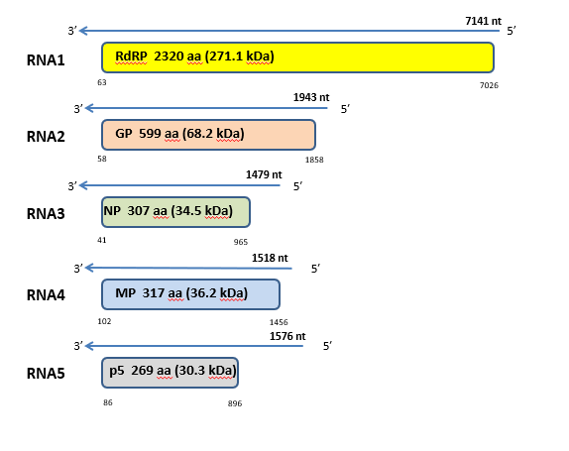

**Figure 1.** Genome organization of karaka Okahu purepure virus (KOPV). Colored boxes represent the protein encoding region (ORF) for each RNA. The length of RNAs, the putative protein product for each ORF, function (if known), and estimated molecular weight are provided. The genomic RNAs are not drawn to scale.

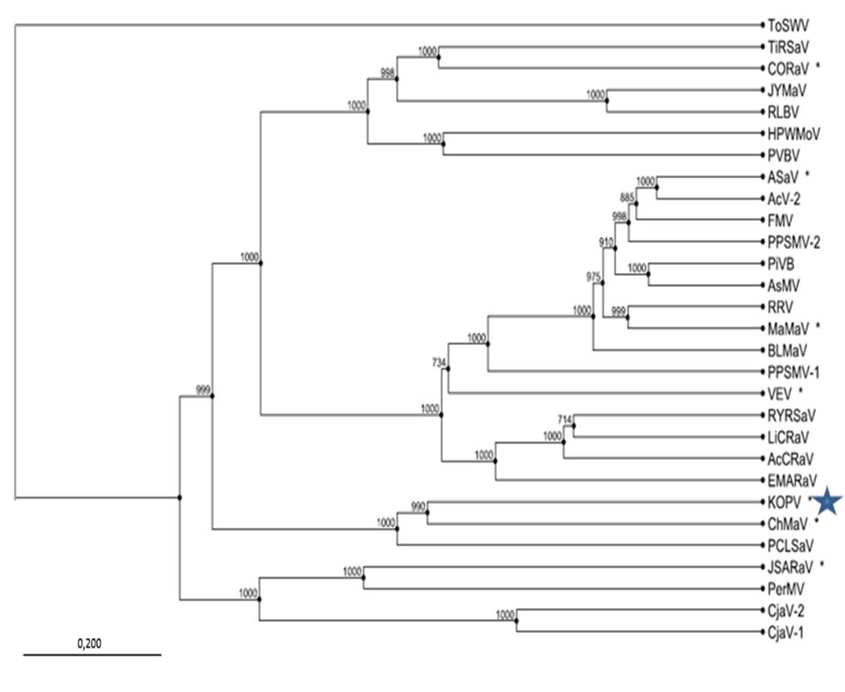

**Figure 2.** Phylogenetic tree constructed with amino acid sequences encoded by RNA1 (RdRP), of recognized emaraviruses and corresponding tentative species (indicated by a red square). Alignment was obtained using ClustalW, and analyzed by the Neighbor-Joining method, with 1000 bootstrap replicates. The percentage of replicate trees in which the associated taxa clustered together in the bootstrap is shown next to the branches (when >70%). TSWV (tomato spotted wilt virus), a tospovirus of the family *Tospoviridae*, was used as an outgroup species. Actinidia chlorotic ringspot-associated virus (AcCRaV), Actinidia virus 2 (AcV-2), ash shoestring-associated virus (ASaV), aspen mosaic-associated virus (AsMaV), blackberry leaf mottle associated virus (BLMaV), Camellia japonica-associated virus 1 (CjaV-1), Camellia japonica-associated virus 2 (CjaV-2), chrysanthemum mosaic-associated virus (ChMaV), common oak ringspot-associated virus (CORaV), European mountain ash ringspot-associated virus (EMARaV), fig mosaic virus (FMV), High Plains wheat mosaic virus (HPWMoV), Japanese star anise ringspot-associated virus (JSARaV), jujube yellow mottle-associated virus (JYMaV), **karaka Okahu purepure emaravirus (KOPV)**, lilac chlorotic ringspot-associated virus (LiCRaV), maple mottle-associated virus (MaMaV), palo verde broom virus (PVBV), pear chlorotic leaf spot-associated virus (PCLSaV), perilla mosaic virus (PerMV), pigeonpea sterility mosaic virus 1 (PPSMV-1), pigeonpea sterility mosaic virus 2 (PPSMV-2), Pistacia virus B (PiVB), raspberry leaf blotch virus (RLBV), redbud yellow ringspot-associated virus (RYRSaV), rose rosette virus (RRV), ti ringspot-associated virus (TiRSaV), and Vitis emaravirus (VEV).

**References**

Elbeaino T, Digiaro M, Mielke-Ehret N, Muehlbach HP, Martelli GP and ICTV Report Consortium (2018) ICTV Virus Taxonomy Profile: Fimoviridae. J GenVirol 99(11):1478-1479. PMID: 30204080, DOI: [10.1099/jgv.0.001143](https://doi.org/10.1099/jgv.0.001143)

Mielke N, Muehlbach HP (2007) A novel, multipartite, negative-strand RNA virus is associated with the ringspot disease of European mountain ash (*Sorbus aucuparia* L.). J GenVirol 88:1337–1346. PMID: 17374780. DOI 10.1099/vir.0.82715-0

Rabbidge LO, Blouin AG, Chooi KM, Higgins CM, MacDiarmid RM (2021) Characterisation and Distribution of Karaka Okahu Purepure Virus—A novel emaravirus likely to be endemic to New Zealand. Viruses, 13:1611. doi.org/10.3390/v13081611

https://talk.ictvonline.org/ictv-reports/ictv_online_report/negative-sense-rna-viruses/w/fimoviridae/981/genus-emaravirus