Part 1: TITLE, AUTHORS, APPROVALS, etc

Code assigned: | 2022.018P
Short title: Create one new species (Emaravirus visci) in the genus Emaravirus, family Fimoviridae
Author(s) and email address(es)
¹Sidharthan VK ²Chaturvedi KK, ³Baranwal VK | vbaranwal2001@yahoo.com

Author(s) institutional address(es) (optional)
¹ Division of Genetics and Tree Improvement, Institute of Forest Biodiversity (ICFRE), Hyderabad, India
² Centre for Agricultural Bioinformatics, ICAR-Indian Agricultural Statistics Research Institute, New Delhi, India
³ Division of Plant Pathology, ICAR-Indian Agricultural Research Institute, New Delhi, India

Corresponding author
Virendra Kumar Baranwal, vbaranwal2001@yahoo.com

List the ICTV Study Group(s) that have seen this proposal
Fimoviridae Study Group

ICTV Study Group comments and response of proposer

ICTV Study Group votes on proposal
Study Group | Number of members
 | Votes support | Votes against | No vote
Fimoviridae | 5

Authority to use the name of a living person
Is any taxon name used here derived from that of a living person (Y/N) | N

Taxon name | Person from whom the name is derived | Permission attached (Y/N)

Submission dates
Date first submitted to SC Chair | April 26, 2022
Date of this revision (if different to above) | May 27, 2022

ICTV-EC comments and response of the proposer

Part 3: TAXONOMIC PROPOSAL

Name of accompanying Excel module
2022.018P.N.v1.Emaravirus_1ns.xlsx

Abstract
The creation of the new species Emaravirus visci in the genus Emaravirus, family Fimoviridae, is proposed to accommodate Arceuthobium sichuanense-associated virus 1 (ASaV-1) identified in China on spruce dwarf mistletoe (Arceuthobium sichuanense), as its exemplar virus isolate. The new species consists of five segmented, linear, single-stranded (ss), negative sense RNA genomes, fully sequenced, which show features common to homologous RNAs of other known emaravirus species, but from which it differs significantly in nucleotide and amino acid sequences.

Text of proposal
Arceuthobium sichuanense-associated virus 1 (ArSaV-1) has been recently identified in spruce dwarf mistletoe (Arceuthobium sichuanense) in China and its genome has been completely sequenced (Sidharthan et al., 2021). ASaV-1 possesses all molecular and biological features to be considered as a new member of the genus Emaravirus, which currently comprises the following species: Actinidia chlorotic ringspot-associated virus (AcCRaV), Actinidia virus 2 (AcV-2), aspen mosaic-associated virus (AsMaV), blackberry leaf mottle-associated virus (BLMaV), Camellia japonica-associated virus 1 (CjaV-1), Camellia japonica-associated virus 2 (CjaV-2), chrysanthemum mosaic-associated virus (ChMaV), common oak ringspot-associated virus (CORaV), European mountain ash ringspot-associated virus (EMARaV), fig mosaic virus (FMV), High Plains wheat mosaic virus (HPWMV), jujube yellow mottle-associated virus (JYMaV), lilac chlorotic ringspot-associated virus (LiCRaV), maple mottle-associated virus (MaMaV), palo verde broom virus (PVBV), pear chlorotic leaf spot-associated virus (PCLSaV), perilla mosaic virus (PerMV), pigeonpea sterility mosaic virus 1 (PPSMV-1), pigeonpea sterility mosaic virus 2 (PPSMV-2), Pistacia virus B (PiVB), raspberry leaf blotch virus (RLBV), redbud yellow ringspot-associated virus (RYRSaV), rose rosette virus (RRV), and ti ringspot-associated virus (TiRSaV) (Elbeaino et al. 2018; Mielke and Muehlbach 2007; https://talk.ictvonline.org/ictv-reports/ictv_online_report/negative-sense-rna-viruses/w/fimoviridae/981/genus-emaravirus). The RNA-dependent RNA polymerase (RdRP), glycoprotein precursor (GP), nucleocapsid (NC) and movement protein (MP) show different levels of sequence identity with ortholog proteins of other emaraviruses.

Virus properties
- Genome: resembles that of members of the genus Emaravirus. It is composed of five segments of negative sense ssRNA. RNA-1: 7,112 nt, RNA-2: 2,177 nt, RNA3: 1,447 nt, RNA-4: 1,739 nt, and RNA-5: 966 nt (Fig.1) (in order from RNA-1 to RNA-5, accession numbers are: BK0592633–BK0592637) (Sidharthan et al., 2021). Each segment is monocistronic, encoding a single protein translated from the complementary strand (Figure 1). Untranslated regions (UTRs) at the 3’ and 5’ termini of all RNA segments extended from 32 to 290 nt and from 61 to 550 nt, respectively.
- Virus-encoded proteins: RNA-dependent RNA-polymerase (p1): 269 kDa; putative Glycoprotein precursor (p2): 73 kDa; putative Nucleocapsid protein (p3): 35 kDa; putative movement protein (p4): 41 kDa; p5 (function unknown): 29 kDa (Figure 1).
- Phylogenetic relationships: RdRP, GP, NP and MP proteins of ArSaV consistently segregated with those of RLBV and JYMaV and formed a cluster with the emaraviruses TiRSaV, CORaV, JYMaV, RLBV, HPWMoV, and PVBV (Figure 2). The aa identity between the ArSaV-1 proteins and those of RLBV was from 40.7 to 68.1% (55–97% query coverage [qcov]).
- Transmission: No observations and specific trials were carried out.
Natural host range: Spruce dwarf mistletoe (Arceuthobium sichuanense) parasitizing Picea crassifolia

The detected identities fulfilling the demarcation criteria for species in the genus [aa sequence of relevant gene products of RNA1 (RdRP), RNA2 (GP) and RNA3 (NP) differing by more than 25%], and the genome organization typical of emaraviruses clearly indicate that ASaV-1 represents a new species in the genus Emaravirus. Therefore, the creation of the new viral species Emaravirus visci within the genus Emaravirus, which contains ASaV-1 isolate China as the exemplar isolate, is proposed.

Supporting evidence
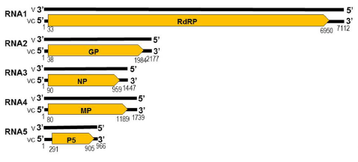
Figure 1. Genome organization of Arceuthobium sichuanense-associated virus (ArSaV-1). Colored boxes represent the protein encoding region (ORF) for each RNA. The length of RNAs, the putative protein product for each ORF, and function (if known), are provided. The genomic RNAs are not drawn to scale.

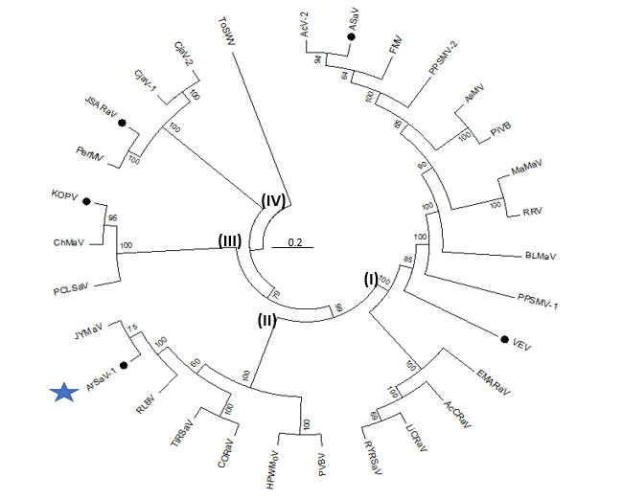

Figure 2. Phylogenetic tree constructed with amino acid sequences encoded by RNA1 (RdRP), of recognized emaraviruses and corresponding tentative species (indicated by a black circle). Alignment was obtained using ClustalW, and analyzed by the Neighbor-Joining method, with 1000 bootstrap replicates. The percentage of replicate trees in which the associated taxa clustered together in the bootstrap is shown next to the branches (when >60%). TSWV (tomato spotted wilt virus), an orthotospovirus of the family Tospoviridae, was used as an outgroup species. Actinidia chlorotic ringspot-associated virus (AcCRaV), Actinidia virus 2 (AcV-2), Arceuthobium sichuanense-associated virus 1 (ArSaV-1), ash shoestring-associated virus (ASaV), aspen mosaic-associated virus (AsMaV), blackberry leaf mottle associated virus (BLMaV), Camellia japonica-associated virus 1 (CjaV-1), Camellia japonica-associated virus 2 (CjaV-2), chrysanthemum mosaic-associated virus (ChMaV), common oak ringspot-associated virus (CORaV), European mountain ash ringspot-associated virus (EMARaV), fig mosaic virus (FMV), High Plains wheat mosaic virus (HPWMoV), Japanese star anise ringspot-associated virus (JSARaV), jujube yellow mottle-associated virus (JYMaV), karaka Okahu purepure emaravirus (KOPV), lilac chlorotic ringspot-associated virus (LiCRaV), maple mottle-associated virus (MaMaV), palo verde broom virus (PVBV), pear chlorotic leaf spot-associated virus (PCLSaV), perilla mosaic virus (PerMV), pigeonpea sterility mosaic virus 1 (PPSMV-1), pigeonpea sterility mosaic virus 2 (PPSMV-2), Pistacia virus B (PiVB), raspberry leaf blotch virus (RLBV), redbud yellow ringspot-associated virus (RYRSaV), rose rosette virus (RRV), ti ringspot-associated virus (TiRSaV), and Vitis emaravirus (VEV).

References
Elbeaino T, Digiaro M, Mielke-Ehret N, Muehlbach HP, Martelli GP and ICTV Report Consortium (2018) ICTV Virus Taxonomy Profile: Fimoviridae. J Gen Virol 99(11):1478-1479. PMID: 30204080, DOI: 10.1099/jgv.0.001143
Mielke N, Muehlbach HP (2007) A novel, multipartite, negative-strand RNA virus is associated with the ringspot disease of European mountain ash (Sorbus aucuparia L.). J Gen Virol 88:1337–1346. PMID: 17374780. DOI 10.1099/vir.0.82715-0
Sidharthan VK · Chaturvedi KK · Virendra Kumar Baranwal VK (2021) Diverse RNA viruses in a parasitic flowering plant (spruce dwarf mistletoe) revealed through RNA‑seq data mining. Journal of General Plant Pathology https://doi.org/10.1007/s10327-021-01049-y
https://talk.ictvonline.org/ictv-reports/ictv_online_report/negative-sense-rna-viruses/w/fimoviridae/981/genus-emaravirus

