Part 1: TITLE, AUTHORS, APPROVALS, etc

Code assigned: | 2022.021P
Short title: Create Emaravirus illicii as a new species in the genus Emaravirus, family Fimoviridae
Author(s) and email address(es)
Shimomoto Y, Okada T, Ikeda K, Tatara A, Hasegawa Y, Yanagisawa H, Takeyama S, Hayashi K, Yano K, Morita Y, Kubota K | yoshifumi_shimomoto@ken2.pref.kochi.lg.jp  kubotak@affrc.go.jp

Author(s) institutional address(es) (optional)

Corresponding author
Yoshifumi Shimomoto, yoshifumi_shimomoto@ken2.pref.kochi.lg.jp

List the ICTV Study Group(s) that have seen this proposal
Fimoviridae study group

ICTV study group comments and response of proposer

ICTV Study Group votes on proposal
Study Group | Number of members
 | Votes support | Votes against | No vote
Fimoviridae | 5

Authority to use the name of a living person
Is any taxon name used here derived from that of a living person (Y/N) | N

Taxon name | Person from whom the name is derived | Permission attached (Y/N)

Submission dates
Date first submitted to SC Chair | April 26, 2022
Date of this revision (if different to above) | May 27, 2022

ICTV-EC comments and response of the proposer

Part 3: TAXONOMIC PROPOSAL

Name of accompanying Excel module
2022.021P.A.v2.Emaravirus_1ns.xlsx

Abstract
The creation of the new species Emaravirus illicii in the genus Emaravirus, family Fimoviridae, is proposed to accommodate Japanese star anise ringspot-associated virus (JSARaV), identified in Japan on Japanese star anise (Illicium anisatum L.), as its exemplar virus isolate. The new species consists of five segmented, linear, single-stranded (ss), negative sense RNA genomes, fully sequenced, which show features common to homologous RNAs of other known emaravirus species, but from which it differs significantly in nucleotide and amino acid sequences.

Text of proposal
Japanese star anise ringspot-associated virus (JSARaV) has been recently identified in Japanese star anise (Illicium anisatum L.) in Japan and its genome has been completely sequenced (Shimomoto et al., 2021). JSARaV possesses all molecular and biological features to be considered as a new member of the genus Emaravirus, which currently comprises the following species: Actinidia chlorotic ringspot-associated virus (AcCRaV), Actinidia virus 2 (AcV-2), aspen mosaic-associated virus (AsMaV), blackberry leaf mottle-associated virus (BLMaV), Camellia japonica-associated virus 1 (CjaV-1), Camellia japonica-associated virus 2 (CjaV-2), chrysanthemum mosaic-associated virus (ChMaV), common oak ringspot-associated virus (CORaV), European mountain ash ringspot-associated virus (EMARaV), fig mosaic virus (FMV), High Plains wheat mosaic virus (HPWMoV), jujube yellow mottle-associated virus (JYMaV), lilac chlorotic ringspot-associated virus (LiCRaV), maple mottle-associated virus (MaMaV), palo verde broom virus (PVBV), pear chlorotic leaf spot-associated virus (PCLSaV), perilla mosaic virus (PerMV), pigeonpea sterility mosaic virus 1 (PPSMV-1), pigeonpea sterility mosaic virus 2 (PPSMV-2), Pistacia virus B (PiVB), raspberry leaf blotch virus (RLBV), redbud yellow ringspot-associated virus (RYRSaV), rose rosette virus (RRV), and ti ringspot-associated virus (TiRSaV) (Elbeaino et al. 2018; Mielke and Muehlbach 2007; https://talk.ictvonline.org/ictv-reports/ictv_online_report/negative-sense-rna-viruses/w/fimoviridae/981/genus-emaravirus). The RNA-dependent RNA polymerase (RdRP), glycoprotein precursor (GP), nucleocapsid (NP) and movement protein (MP) show different levels of sequence identity with ortholog proteins of other emaraviruses.

Virus properties
- Genome: resembles that of members of the genus Emaravirus. It is composed of five segments of negative sense ssRNA RNA-1: 7,163 nt, RNA-2: 2,257 nt, RNA3: 1,686 nt, RNA-4: 1,660 nt, and RNA-5: 1,491 nt (Fig.1) (in order from RNA-1 to RNA-5, accession numbers are: LC597437– LC597441) (Shimomoto et al., 2021). Each segment is monocistronic, encoding a single protein translated from the complementary strand (Figure 1). Untranslated regions (UTRs) at the 3’ and 5’ termini of all RNA segments extended from 70 to 145 nt and from 112 to 777 nt, respectively.
- Virus-encoded proteins: RNA-dependent RNA-polymerase (p1): 273 kDa; putative Glycoprotein precursor (p2): 76.8 kDa; putative Nucleocapsid protein (p3): 31 kDa; putative movement protein (p4): 39 kDa; p5 (function unknown): 31.1 kDa (Figure 1).
- Phylogenetic relationships: RdRP, GP, NP and MP proteins of JSARaV consistently segregated with those of PerMV and formed a cluster with the emaraviruses PerMV, CjaV1 and CjaV2 (Figure 2). The aa identity between the JSARaV proteins and those of other emaraviruses was from 28.9% to 41.9% for p1, from 21.4% to 30.0% for p2, from 15.8% to 30.1% for p3 and from 12.7% to 52.2% for p4.
- Experimental transmission: The virus was experimentally transmitted on healthy JSA plants by eriophyd mites of Diptilomiopus sp.
- Natural host range: Japanese star anise (Illicium anisatum L.).

The detected identities fulfilling the demarcation criteria for species in the genus [aa sequence of relevant gene products of RNA1 (RdRP), RNA2 (GP) and RNA3 (NP) differing by more than 25%], and the genome organization typical of emaraviruses clearly indicate that JSARaV represents a new species in the genus Emaravirus. Therefore, the creation of the new viral species Emaravirus illicii within the genus Emaravirus, which contains JSARaV Igeno_June_2019 isolate as the exemplar isolate, is proposed.

Supporting evidence

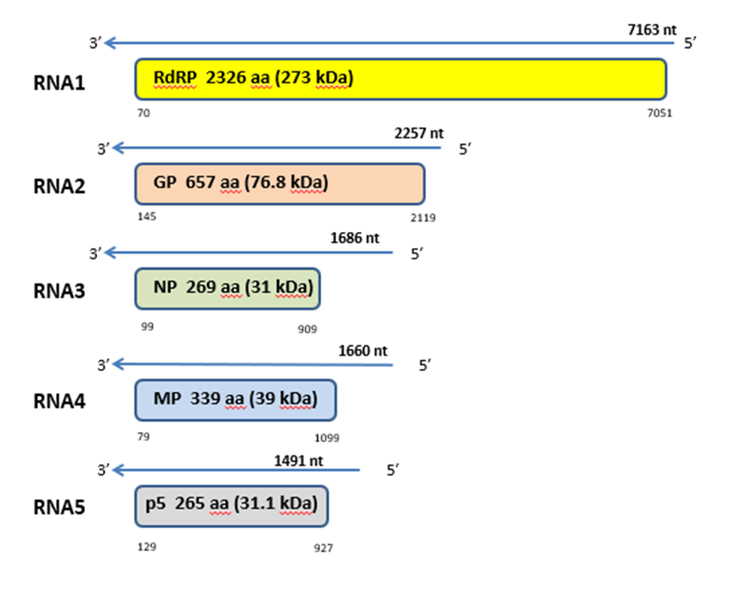

Figure 1. Genome organization of Japanese star anise ringspot-associated virus (JSARaV). Colored boxes represent the protein encoding region (ORF) for each RNA. The length of RNAs, the putative protein product for each ORF, function (if known), and estimated molecular weight are provided. The genomic RNAs are not drawn to scale.

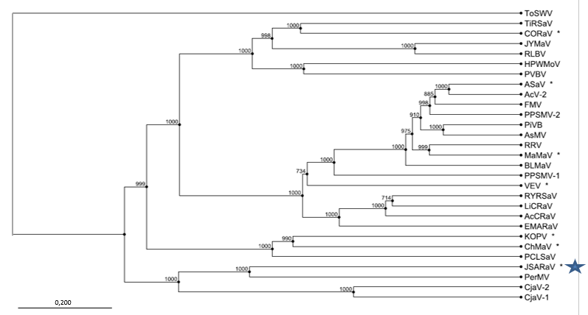

Figure 2. Phylogenetic tree constructed with amino acid sequences encoded by RNA1 (RdRP), of recognized emaraviruses and corresponding tentative species (indicated by a red square). Alignment was obtained using ClustalW, and analyzed by the Neighbor-Joining method, with 1000 bootstrap replicates. The percentage of replicate trees in which the associated taxa clustered together in the bootstrap is shown next to the branches (when >70%). TSWV (tomato spotted wilt virus), a tospovirus of the family Tospoviridae, was used as an outgroup species. Actinidia chlorotic ringspot-associated virus (AcCRaV), Actinidia virus 2 (AcV-2), ash shoestring-associated virus (ASaV), aspen mosaic-associated virus (AsMaV), blackberry leaf mottle associated virus (BLMaV), Camellia japonica-associated virus 1 (CjaV-1), Camellia japonica-associated virus 2 (CjaV-2), chrysanthemum mosaic-associated virus (ChMaV), common oak ringspot-associated virus (CORaV), European mountain ash ringspot-associated virus (EMARaV), fig mosaic virus (FMV), High Plains wheat mosaic virus (HPWMoV), Japanese star anise ringspot-associated virus (JSARaV), jujube yellow mottle-associated virus (JYMaV), karaka Okahu purepure emaravirus (KOPV), lilac chlorotic ringspot-associated virus (LiCRaV), maple mottle-associated virus (MaMaV), palo verde broom virus (PVBV), pear chlorotic leaf spot-associated virus (PCLSaV), perilla mosaic virus (PerMV), pigeonpea sterility mosaic virus 1 (PPSMV-1), pigeonpea sterility mosaic virus 2 (PPSMV-2), Pistacia virus B (PiVB), raspberry leaf blotch virus (RLBV), redbud yellow ringspot-associated virus (RYRSaV), rose rosette virus (RRV), ti ringspot-associated virus (TiRSaV), and Vitis emaravirus (VEV).

References

Elbeaino T, Digiaro M, Mielke-Ehret N, Muehlbach HP, Martelli GP and ICTV Report Consortium (2018) ICTV Virus Taxonomy Profile: Fimoviridae. J Gen Virol 99(11):1478-1479. PMID: 30204080, DOI: 10.1099/jgv.0.001143
Mielke N, Muehlbach HP (2007) A novel, multipartite, negative-strand RNA virus is associated with the ringspot disease of European mountain ash (Sorbus aucuparia L.). J Gen Virol 88:1337–1346. PMID: 17374780. DOI 10.1099/vir.0.82715-0
Shimomoto Y, Okada T, Ikeda K, Tatara A, Hasegawa Y, Yanagisawa H, Takeyama S, Hayashi K, Yano K, Morita Y, Kubota K (2021). Japanese star anise ringspot‑associated virus is a distinct emaravirus transmitted by the eriophyid mite (the family Diptilomiopidae). J Gen Plant Path doi.org/10.1007/s10327-021-01038-1
https://talk.ictvonline.org/ictv-reports/ictv_online_report/negative-sense-rna-viruses/w/fimoviridae/981/genus-emaravirus

