Part 1: TITLE, AUTHORS, APPROVALS, etc

Code assigned: | 2022.020P
Short title: Create Emaravirus vitis as a new species in the genus Emaravirus, family Fimoviridae
Author(s) and email address(es)
Nabeshima T, Abe J | nabeshima@tds1.tr.yamagata-u.ac.jp  abe-junya@jfe-eng.co.jp

Author(s) institutional address(es) (optional)
Department of Agriculture, Yamagata University, Tsuruoka 997-8555, Japan [TN]
Smart Agriculture Division, JFE Engineering Corporation, Yokohama 230-8611, Japan [JA]

Corresponding author
Tomoyuki Nabeshima, nabeshima@tds1.tr.yamagata-u.ac.jp

List the ICTV Study Group(s) that have seen this proposal
Fimoviridae Study Group

ICTV study group comments and response of proposer

ICTV Study Group votes on proposal
Study Group | Number of members
 | Votes support | Votes against | No vote
Fimoviridae | 5

Authority to use the name of a living person
Is any taxon name used here derived from that of a living person (Y/N) | N

Taxon name | Person from whom the name is derived | Permission attached (Y/N)

Submission dates
Date first submitted to SC Chair | April 26, 2022
Date of this revision (if different to above) | May 27, 2022

ICTV-EC comments and response of the proposer

Part 3: TAXONOMIC PROPOSAL

Name of accompanying Excel module
2022.020P.N.v1.Emaravirus_1ns.xlsx

Abstract
The creation of the new species Emaravirus vitis in the genus Emaravirus, family Fimoviridae, is proposed to accommodate Vitis emaravirus (VEV), identified in Japan on Vitis coignetiae, as its exemplar virus isolate. The new species consists of five segmented, linear, single-stranded (ss), negative sense RNA genomes, fully sequenced, which show features common to homologous RNAs of other known emaravirus species, but from which it differs significantly in nucleotide and amino acid sequences.
Text of proposal
Vitis emaravirus (VEV) has been recently identified on Vitis coignetiae in Japan and its genome has been completely sequenced (Nabeshima and Abe, 2021). This virus has high aa sequence identity (from 93.3% to 97.5% in the five RNAs) with another emaravirus identified in grapevine (Vitis vinifera) in China, provisionally named grapevine emaravirus A (Fan et al., 2021). VEV possesses all molecular and biological features to be considered as a new member of the genus Emaravirus, which currently comprises the following species: Actinidia chlorotic ringspot-associated virus (AcCRaV), Actinidia virus 2 (AcV-2), aspen mosaic-associated virus (AsMaV), blackberry leaf mottle-associated virus (BLMaV), Camellia japonica-associated virus 1 (CjaV-1), Camellia japonica-associated virus 2 (CjaV-2), chrysanthemum mosaic-associated virus (ChMaV), common oak ringspot-associated virus (CORaV), European mountain ash ringspot-associated virus (EMARaV), fig mosaic virus (FMV), High Plains wheat mosaic virus (HPWMoV), jujube yellow mottle-associated virus (JYMaV), lilac chlorotic ringspot-associated virus (LiCRaV), maple mottle-associated virus (MaMaV), palo verde broom virus (PVBV), pear chlorotic leaf spot-associated virus (PCLSaV), perilla mosaic virus (PerMV), pigeonpea sterility mosaic virus 1 (PPSMV-1), pigeonpea sterility mosaic virus 2 (PPSMV-2), Pistacia virus B (PiVB), raspberry leaf blotch virus (RLBV), redbud yellow ringspot-associated virus (RYRSaV), rose rosette virus (RRV), and ti ringspot-associated virus (TiRSaV) (TiRSaV) (Elbeaino et al. 2018; Mielke and Muehlbach 2007; https://talk.ictvonline.org/ictv-reports/ictv_online_report/negative-sense-rna-viruses/w/fimoviridae/981/genus-emaravirus). The RNA-dependent RNA polymerase (RdRP), glycoprotein precursor (GP), nucleocapsid (NC) and movement protein (MP) show different levels of sequence identity with ortholog proteins of other emaraviruses.

Virus properties
- Genome: resembles that of members of the genus Emaravirus. It is composed of five segments of negative sense ssRNA. RNA-1: 7,053 nt, RNA-2: 2,091 nt, RNA3: 1,211 nt, RNA-4: 1,628 nt, and RNA-6: 1,324 nt (Fig.1) (in order from RNA-1 to RNA-5, accession numbers are: LC604727– LC604731) (Nabeshima and Abe, 2021). Each segment is monocistronic, encoding a single protein translated from the complementary strand (Figure 1). Untranslated regions (UTRs) at the 3’ and 5’ termini of all RNA segments extended from 55 to 109 nt and from 96 to 465 nt, respectively.
- Virus-encoded proteins: RNA-dependent RNA-polymerase (p1): 269 kDa; putative Glycoprotein precursor (p2): 73 kDa; putative Nucleocapsid protein (p3): 35 kDa; putative movement protein (p4): 41 kDa; p5 (function unknown): 29 kDa (Figure 1).
- Phylogenetic relationships: RdRP, GP, NP and MP proteins of VEV consistently segregated with those of the emaraviruses PPSMV-1, PPSMV-2, FMV, AcEV-2, BLMaV, RRV, AaMaV, PiVB, MaMaV, EMARaV, AcCRaV, RYRSaV, LiCRaV (Figure 2). The aa identity between the VEV proteins and those of other emaraviruses was from 30.2% to 49.3% for p1, from 21.0% to 42.1% for p2, from 18.3% to 40.3% for p3 and from 17.6% to 74.4% for p4.
- Experimental transmission: No experimental transmission onto herbaceous plants were carried out. Grapevine emaravirus A identified in China on V. vinifera, which is a strain of VEV, was experimentally graft-transmitted on grapevine seedlings of cv. Shennong Jinhuanghou and Beta.
- Natural host range: Vitis coignetiae and Vitis vinifera.

The detected identities fulfilling the demarcation criteria for species in the genus [aa sequence of relevant gene products of RNA1 (RdRP), RNA2 (GP) and RNA3 (NP) differing by more than 25%], and the genome organization typical of emaraviruses clearly indicate that VEV represents a new species in the genus Emaravirus. Therefore, the creation of the new viral species Emaravirus vitis within the genus Emaravirus, which contains VEV T1 isolate as the exemplar isolate, is proposed.

Supporting evidence

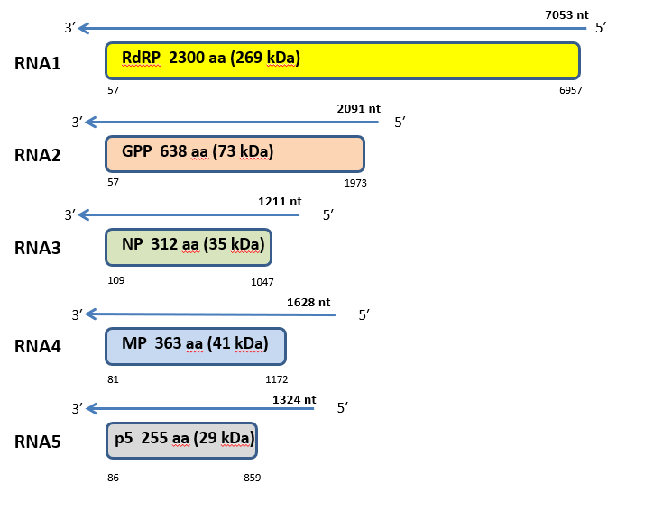

Figure 1. Genome organization of Vitis emaravirus (VEV). Colored boxes represent the protein encoding region (ORF) for each RNA. The length of RNAs, the putative protein product for each ORF, function (if known), and estimated molecular weight are provided. The genomic RNAs are not drawn to scale.

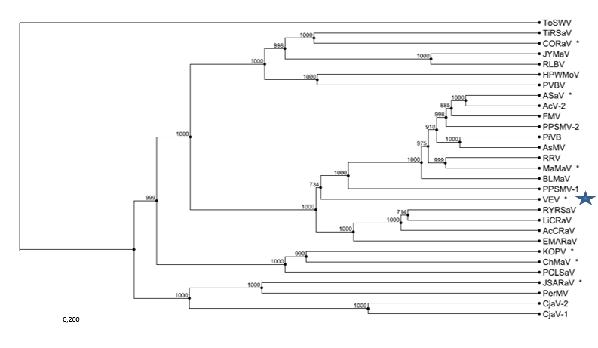

Figure 2. Phylogenetic tree constructed with amino acid sequences encoded by RNA1 (RdRP), of recognized emaraviruses and corresponding tentative species (indicated by a red square). Alignment was obtained using ClustalW, and analyzed by the Neighbor-Joining method, with 1000 bootstrap replicates. The percentage of replicate trees in which the associated taxa clustered together in the bootstrap is shown next to the branches (when >70%). TSWV (tomato spotted wilt virus), a tospovirus of the family Tospoviridae, was used as an outgroup species. Actinidia chlorotic ringspot-associated virus (AcCRaV), Actinidia virus 2 (AcV-2), ash shoestring-associated virus (ASaV), aspen mosaic-associated virus (AsMaV), blackberry leaf mottle associated virus (BLMaV), Camellia japonica-associated virus 1 (CjaV-1), Camellia japonica-associated virus 2 (CjaV-2), chrysanthemum mosaic-associated virus (ChMaV), common oak ringspot-associated virus (CORaV), European mountain ash ringspot-associated virus (EMARaV), fig mosaic virus (FMV), High Plains wheat mosaic virus (HPWMoV), Japanese star anise ringspot-associated virus (JSARaV), jujube yellow mottle-associated virus (JYMaV), karaka Okahu purepure emaravirus (KOPV), lilac chlorotic ringspot-associated virus (LiCRaV), maple mottle-associated virus (MaMaV), palo verde broom virus (PVBV), pear chlorotic leaf spot-associated virus (PCLSaV), perilla mosaic virus (PerMV), pigeonpea sterility mosaic virus 1 (PPSMV-1), pigeonpea sterility mosaic virus 2 (PPSMV-2), Pistacia virus B (PiVB), raspberry leaf blotch virus (RLBV), redbud yellow ringspot-associated virus (RYRSaV), rose rosette virus (RRV), ti ringspot-associated virus (TiRSaV), and Vitis emaravirus (VEV).

References

Elbeaino T, Digiaro M, Mielke-Ehret N, Muehlbach HP, Martelli GP and ICTV Report Consortium (2018) ICTV Virus Taxonomy Profile: Fimoviridae. J Gen Virol 99(11):1478-1479. PMID: 30204080, DOI: 10.1099/jgv.0.001143
Fan X, Li C, Zhang Z, Ren F, Hu G, Shen H, Zhang B, Dong Y (2021). Identification and characterization of a novel emaravirus from grapevine showing chlorotic mottling symptoms. Front Microbiol 12, https://doi.org/10.3389/fmicb.2021.694601
Mielke N, Muehlbach HP (2007) A novel, multipartite, negative-strand RNA virus is associated with the ringspot disease of European mountain ash (Sorbus aucuparia L.). J Gen Virol 88:1337–1346. PMID: 17374780. DOI 10.1099/vir.0.82715-0
Nabeshima T, Abe J (2021). High-throughput sequencing indicates novel Varicosavirus, Emaravirus, and Deltapartitivirus infections in Vitis coignetiae. Viruses 13, 827. doi.org/10.3390/v13050827
https://talk.ictvonline.org/ictv-reports/ictv_online_report/negative-sense-rna-viruses/w/fimoviridae/981/genus-emaravirus

