Part 1: TITLE, AUTHORS, APPROVALS, etc

Code assigned: | 2022.001F
Short title: Create a new family (Alternaviridae) accommodating one new genus (Alternavirus) and five new species
Author(s) and email address(es)
Authors | Email addresses
Kotta-Loizou I, Wu CF, Moriyama H, Coutts RHA | i.kotta-loizou13@imperial.ac.uk; chienfuwu@gmail.com; hmori714@cc.tuat.ac.jp; r.coutts@herts.ac.uk
Author(s) institutional address(es) (optional)
Imperial College London [IKL]
Tokyo University of Agriculture and Technology [CFW, HM]
University of Hertfordshire [RHAC]
Corresponding author
Ioly Kotta-Loizou
List the ICTV Study Group(s) that have seen this proposal

ICTV Study Group comments and response of proposer

ICTV Study Group votes on proposal

Study Group | Number of members
 | Votes support | Votes against | No vote
Authority to use the name of a living person
Is any taxon name used here derived from that of a living person (Y/N) | N

Taxon name | Person from whom the name is derived | Permission attached (Y/N)

Submission dates
Date first submitted to SC Chair | May 21,2022
Date of this revision (if different to above) | September 21, 2022
ICTV-EC comments and response of the proposer
EC Comments:

- Can you please justify use of “homology of dsRNA4” is one of demarcation criteria when there are three-segmented members?

- Can you please explain in the Legend how numerical values in Fig 2 relate to % homology? For example: 0 = no detectable homology 1= identical

Response:

The text concerning demarcation criterion #4 has now been amended to read “presence and homology of dsRNA 4”.
The original figure generated with MEGAX has been replaced with a new one done in SDT v.1.2 software as it directly shows percentages of pairwise identities reported as color code.

Part 3: TAXONOMIC PROPOSAL
Name of accompanying Excel module
2022.001F.N.v1.Alternaviridae_newfam.xlsx
Abstract
Here we propose the establishment of a new family Alternaviridae, a new genus Alternavirus and new five species to accommodate ten recently described mycoviruses.
Text of proposal
The first member of the proposed family Alternaviridae was isolated from the ascomycete Alternaria alternata by Aoki et al. in 2009 and since then a total of ten related viruses have been reported. These recent discoveries have inspired the proposal for creation of novel taxa to classify these viruses (Table 1):

- Creation of the family Alternaviridae (from Alternaria alternata, the name of the original fungal host, which also contains the acronym RNA, the type of nucleic acid comprising the genome of these viruses).
- Creation of the genus Alternavirus within the proposed family Alternaviridae.
- Creation and assignment of five new species to the proposed genus Alternavirus.

Members of the family “Alternaviridae” have isometric virus particles (33 nm in diameter) and genome composed of 3-4 molecules of double stranded (ds) RNA; the overall size of the genome ranges from 8.4 to 10.7 kbp excluding polyA tails. In all currently known alternaviruses, the largest dsRNA encodes the RNA-directed RNA polymerase (RdRP); dsRNA 2 encodes a conserved protein of unknown function; dsRNA 3 encodes the major capsid protein (CP; Wu et al., 2021); and dsRNA 4, when present, encodes a non-conserved protein of unknown function which is often non homologous among alternaviruses. The buoyant density alternavirus virions in CsCl was 1.35–1.40 g/cm³ depending on the size of the packaged dsRNAs (Aoki et al., 2009).

To date, alternaviruses have been found exclusively in ascomycetes. Nevertheless, a study on the virome of sisal using high-throughput sequencing revealed short fragments of sequences with significant similarity to alternaviruses (Quintanilha-Peixoto et al., 2021).
As evidenced by the phylogenetic analysis (Fig. 1), putative members of the proposed family Alternaviridae form a group together. Members of the Chrysoviridae, Megabirnaviridae, Quadriviridae, and Totiviridae – established families within the order Ghabrivirales whose RdRP contains an RDRP_4 domain (PF02123, Pfam database) similar to alternaviruses – were used as the outgroup. The proposed classification is also supported by the pairwise distance matrix (Fig. 2), illustrating that each virus has an evolutionary distance smaller than 1.05 compared to all putative members of the genus.

The genomic organization of Alternaria alternata virus 1 (AaV1), the first member of this group (Aoki et al., 2009), is depicted in Fig. 3. Information on the exemplars and additional isolates within the five proposed species in the genus Alternavirus can be found in Table 2.

The species demarcation criteria within the genus Alternavirus are:
- amino acid sequence data (≤ 70% aa sequence identity in the RdRP)
- host of isolation
- size and number of dsRNA segments
- presence and homology of dsRNA 4

All proposed species are represented by fully sequenced viruses with publicly available accession numbers and with an evolutionary distance larger than 0.3.

Supporting evidence
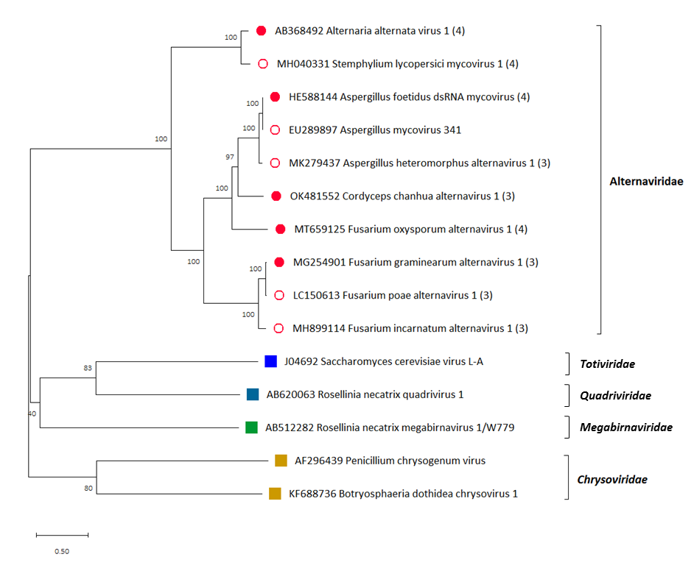
Figure 1: Maximum likelihood phylogenetic tree created based on the RdRP sequences of alternaviruses and related viruses. The sequences were aligned with MUSCLE as implemented by MEGA X (Kumar et al., 2018), all positions with less than 30% site coverage were eliminated and the WAG+G+I+F substitution model was used. The number in brackets after the virus name indicates the number of dsRNA genomic segments. Red circles at the tip of branches indicate members of the proposed family “Alternaviridae”. Full red circles indicate exemplar viruses of the proposed species. Squares indicate members of related, established families: blue for Totiviridae, teal for Quadriviridae, green for Megabirnaviridae and gold for Chrysoviridae.

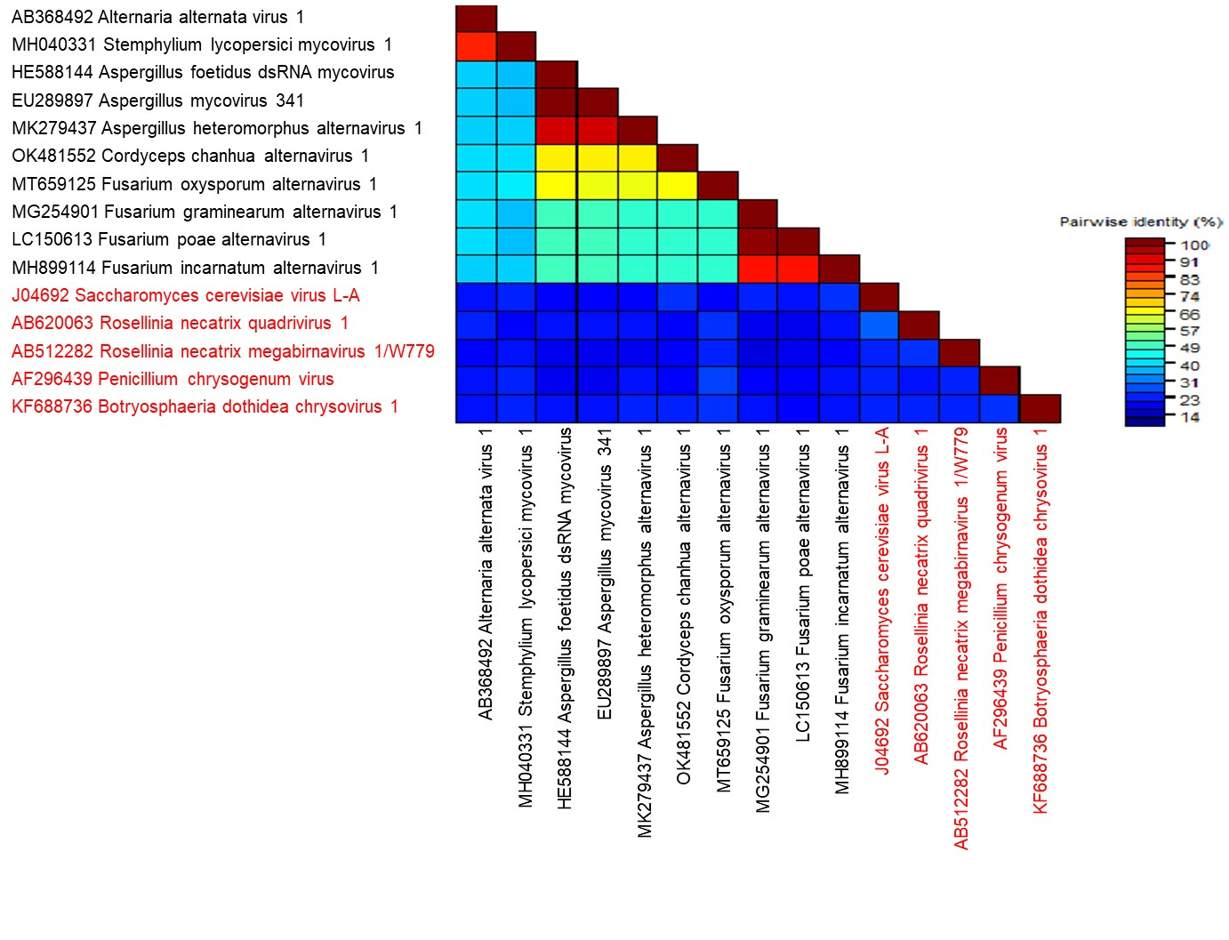
Figure 2: Pairwise distance matrix created based on the RdRP sequences of alternaviruses (black font) and selected related viruses (red font). The sequences were aligned with MUSCLE as implemented by SDT v.1.2 (Kumar et al., 2018). Percentage identity is color-coded.

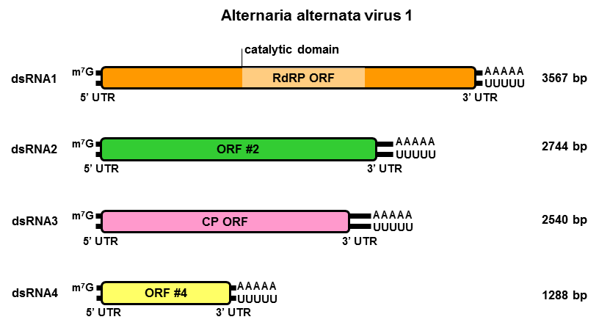
Figure 3: Schematic representation of the genomic organization of Alternaria alternata virus 1, exemplar virus for the proposed species “Alternavirus alternariae”, genus “Alternavirus”, family “Alternaviridae”. The genome consists of four monocistronic dsRNA segments, with a 7-methylguanosine (m⁷G) capping structure and a poly(A) tail at respectively the 5’ and 3’ terminus (Wu et al., 2021). The proteins encoded are represented by rectangular boxes, flanked by 5’- and 3’-UTRs represented by double lines. The light-coloured box in dsRNA 1 represents the RdRP_4 domain (PF02123, Pfam database).

Table 1: Proposed organization of the family Alternaviridae.

FAMILY: Alternaviridae
GENUS: Alternavirus
SPECIES: Alternavirus alternariae
Alternavirus aspergilli
Alternavirus cordycipitae
Alternavirus foxyspori
Alternavirus fusarii

Table 2: Exemplar and additional isolates of the proposed species in genus “Alternavirus”, family “Alternaviridae”.
Virus name & abbreviation | Accession number & size | Reference
Alternaria alternata virus 1  (AaV1) | dsRNA 1: AB368492 (3567 bp) | Aoki et al., 2009
 | dsRNA 2: AB438027 (2744 bp)
 | dsRNA 3: AB438028 (2540 bp)
 | dsRNA 4: AB438029 (1288 bp)
Aspergillus foetidus dsRNA mycovirus  (AfV) | dsRNA 1: HE588144 (3571 bp) | Kozlakidis et al., 2013
 | dsRNA 2: HE588145 (2734 bp)
 | dsRNA 3: HE588146 (2418 bp)
 | dsRNA 4: HE647818 (1961 bp)
Aspergillus heteromorphus alternavirus 1  (AheAV1) | dsRNA 1: MK279437 (3559 bp) | Gilbert et al., 2019
 | dsRNA 2: MK279438 (2734 bp)
 | dsRNA 3: MK279439 (2417 bp)
Aspergillus mycovirus 341  (AsV341) | dsRNA 1: EU289897 (3571 bp) | Hammond et al., 2008
Cordyceps chanhua alternavirus 1 (CcAV1) | dsRNA 1: OK481552 (3488 bp) | Zhang et al., 2022
 | dsRNA 2: OK481553 (2632 bp)
 | dsRNA 3: OK481554 (2369 bp)
Fusarium graminearum alternavirus 1  (FgAV1) | dsRNA 1: MG254901 (3524 bp) | He et al., 2018
 | dsRNA 2: MG254902 (2470 bp)
 | dsRNA 3: MG697236 (2460 bp)
Fusarium incarnatum alternavirus 1  (FiAV1) | dsRNA 1: MH899114 (3525 bp) | Zhang et al., 2019
 | dsRNA 2: MH899115 (2469 bp)
 | dsRNA 3: MH899116 (2451 bp)
Fusarium oxysporum alternavirus 1  (FoAV1) | dsRNA 1: MT659125 (3424 bp) | Wen et al., 2021
 | dsRNA 2: MT659126 (2620 bp)
 | dsRNA 3: MT659127 (2335 bp)
 | dsRNA 4: MT659128 (1815 bp)
Fusarium poae alternavirus 1  (FpAV1) | dsRNA 1: LC150613 (3559 bp) | Osaki et al., 2016
 | dsRNA 2: LC150614 (2473 bp)
 | dsRNA 3: LC150615 (2462 bp)
Stemphylium lycopersici mycovirus 1  (SlMV1) | dsRNA 1: MH040331 (3564 bp) | unpublished
 | dsRNA 2: MH040332 (2750 bp)
 | dsRNA 3: MH040333 (2543 bp)
 | dsRNA 4: MH040334 (1398 bp)

References
Aoki N, Moriyama H, Kodama M, Arie T, Teraoka T, Fukuhara T (2009) A novel mycovirus associated with four double-stranded RNAs affects host fungal growth in Alternaria alternata. Virus Res 140:179-187. doi: 10.1016/j.virusres.2008.12.003.

Gilbert KB, Holcomb EE, Allscheid RL, Carrington JC (2019) Hiding in plain sight: new virus genomes discovered via a systemic analysis of fungal public transcriptomes. PLoS ONE 14:e0219207. doi: 10.1371/journal.pone.0219207.

Hammond TM, Andrewski MD, Roossinck MJ, Keller NP (2008) Aspergillus mycoviruses are targets and suppressors of RNA silencing. Eukaryot Cell 7:350-357. doi: 10.1128/EC.00356-07.

He H, Chen X, Li P, Qiu D, Guo L (2018) Complete genome sequence of a Fusarium graminearum double-stranded RNA virus in a newly proposed family, Alternaviridae. Genome Announc 6:e00064-18. doi: 10.1128/genomeA.00064-18.

Kozlakidis Z, Herrero N, Ozkan S, Kanhayuwa L, Jamal A, Bhatti MF, Coutts RHA (2013) Sequence determination of a quadripartite dsRNA virus isolated from Aspergillus foetidus. Arch Virol 158:267-272. doi: 10.1007/s00705-012-1362-3.

Kumar S, Stecher G, Li M, Knyaz C, Tamura K (2018) MEGA X: molecular evolutionary genetics analysis across computing platforms. Mol Biol Evol 35:1547-1549. doi: 10.1093/molbev/msy096.

Muhire BM, Varsani A, Martin DP (2014) SDT: A virus classification tool based on pairwise sequence alignment and identity calculation. PLoS ONE. 2014;9:e108277. doi: 10.1371/journal.pone.0108277.

Osaki H, Sasaki A, Nomiyama K, Tomioka K (2016) Multiple virus infection in a single strain of Fusarium poae shown by deep sequencing. Virus Genes 52:835-847. doi: 10.1007/s11262-016-1379-x.

Quintanilha-Peixoto G, Fonseca PLC, Raya FT, Marone MP, Bortolini DE, Mieczkowski P, Olmo RP, Carazzolle MF, Voigt CA, Soares ACF, Pereira GAG, Goes-Neto A, Aguiar ERGR (2021) The sisal virome: uncovering the viral diversity of agave varieties reveals new and organ-specific viruses. Microorganisms 9:1704. doi: 10.3390/microorganisms9081704.

Wen C, Wan X, Zhang Y, Du H, Wei C, Zhong R, Zhang H, Shi Y, Xie J, Fu Y, Zhao Y (2021) Molecular characterization of the first alternavirus identified in Fusarium oxysporum. Viruses 13:2026. doi: 10.3390/v13102026.

Wu CF, Aoki N, Takeshita N, Fukuhara T, Chiura XH, Arie T, Kotta-Loizou I, Okada R, Komatsu K, Moriyama H (2021) Unique terminal regions and specific deletions of the segmented double-stranded RNA genome of Alternaria alternata virus 1, in the proposed family Alternaviridae. Front Microbiol 12:773062. doi: 10.3389/fmicb.2021.773062.

Zhang X, Xie Y, Zhang F, Sun H, Zhai Y, Zhang S, Yuan H, Zhou L, Gao F, Li H (2019) Complete genome sequence of an alternavirus from the phytopathogenic fungus Fusarium incarnatum. Arch Virol 164:923-925. doi: 10.1007/s00705-018-04128-2.

