Part 1: TITLE, AUTHORS, APPROVALS, etc

Code assigned: | 2022.004F
Short title: Create 3 new families, 3 subfamilies, 13 genera, and 20 new species within the order Imitervirales (phylum Nucleocytoviricota) and rename two existing species.

Author(s) and email address(es)
Aylward FO, Abrahão J, Brussaard C, Fischer MG, Moniruzzaman M, Ogata H, Suttle CA | faylward@vt.edu; jonatas.abrahao@gmail.com; Corina.Brussaard@nioz.nl; Matthias.Fischer@mpimf-heidelberg.mpg.de; mxm193819@miami.edu; ogata@kuicr.kyoto-u.ac.jp; suttle@science.ubc.ca
Author(s) institutional address(es) (optional)

Corresponding author
Frank O. Aylward, faylward@vt.edu
List the ICTV Study Group(s) that have seen this proposal

Fungal and Protist Viruses SC Chair

ICTV Study Group comments and response of proposer

ICTV Study Group votes on proposal

Study Group | Number of members
 | Votes support | Votes against | No vote
SG Imitervirales | 7 | 0 | 0
Authority to use the name of a living person

Is any taxon name used here derived from that of a living person (Y/N) | N

Taxon name | Person from whom the name is derived | Permission attached (Y/N)

Submission dates
Date first submitted to SC Chair | May 16th, 2022
Date of this revision (if different to above) | September 23rd, 2022
ICTV-EC comments and response of the proposer
ICTV-EC Comments:

- Please change name of the proposed genus “Cronusvirus” (already exist taxon with identical name of prokaryotic viruses in the class Caudoviricetes, as well as another taxon named “Cronosvirus”)
- Please consider proposed minor changes in species names.
- Please adjust irregularities in the Excel file.

Authors response:

All three recommendations/suggestions were addressed in this and accompanying Excel files.

Part 2: NON-TAXONOMIC PROPOSAL
Text of proposal

Part 3: TAXONOMIC PROPOSAL
Name of accompanying Excel module
2022.004F.N.v2.Imitervirales_reorg.xlsx
Abstract
“Giant viruses” within the order Imitervirales have been the subject of intense study over the last decade, but currently only two members of this order are formally classified by ICTV. The creation of several new taxonomic ranks is therefore warranted in order to capture the high level of diversity within this group. We propose the creation of 3 new families, 3 subfamilies, 13 genera, and 20 species within the order Imitervirales. We propose binomial names for all new species and rename two existing species. The new families, subfamilies, genera, and species are all consistently defined within a phylogenetic framework that has recently been proposed [8].

Text of proposal
Large dsDNA viruses belonging to the phylum Nucleocytoviricota, often referred to as “giant viruses”, include the largest viruses that have yet been characterized, both in terms of virion size and genome length [1]. Of particular interest are viruses in the order Imitervirales, which are particularly abundant and widespread in ecosystems around the globe [2–5]. Despite their importance, only two members of the Imitervirales are currently classified: Acanthamoeba polyphaga mimivirus (APMV) and Cafeteria roenbergensis virus (CroV). These viruses belong to two homonymous species, both classified in the family Mimiviridae, but a large number of recently-characterized members of the Imitervirales are only distantly related to either APMV or CroV, and these viruses are sometimes referred to as “extended Mimiviridae” or “extended family Mimiviridae” [6–8]. There is therefore an urgent need to update the taxonomy of the Imitervirales by establishing new species, genera, subfamilies and families to encompass current diversity of these viruses.
To this end we analyzed 43 Imitervirales genomes using both a concatenated phylogenetic approach (Figure 1) and by examining pairwise average nucleotide identity (ANI; Figures 2 and 3)). The concatenated tree is based on 7 marker genes: DNA polymerase family B (PolB), RNA polymerase large subunit (RNAPL), A32-like packaging enzyme (A32), Topoisomerase family II (TopoII), Virus Late Transcription Factor 3 (VLTF3), Transcription Factor IIB (TFIIB), and a superfamily II helicase (SFII). These marker genes have previously been benchmarked and shown to provide high fidelity phylogenetic trees of the Nucleocytoviricota [9]. Families, subfamilies, and genera are demarcated such that they have approximately equivalent phylogenetic depths (i.e., distance from the root).
We only propose classification of viral isolates here, but for our concatenated phylogenetic approach we also included metagenome-derived viral genomes. This was done to improve phylogenetic reconstruction by providing additional evolutionary context and to avoid long branches that arise when only isolates are used. For this purpose a manually-selected set of metagenome-derived genomes were taken from the Giant Virus Database (https://faylward.github.io/GVDB/).
Guidelines used for new names:
Proposed family names have the “-mimiviridae” suffix to denote evolutionary relatedness to the Mimiviridae (Allomimiviridae, Mesomimiviridae, Schizomimiviridae). Proposed subfamily names are either based on names commonly used in the literature (Megamimivirinae, Klosneuvirinae) or use a simple Latin prefix (Aliimimivirinae; alii- Latin for “other”). Subfamilies are proposed for the family Mimiviridae only because the most viral isolates are available for this family. For species we adopted Latinized binomial names. Genus names refer to the names of Titans in Greek mythology (Biavirus, Kratosvirus, Heliosvirus, Oceanusvirus, Rheavirus, Tethysvirus, and Theiavirus) unless another genus name was already in common usage in the literature (Megavirus, Moumouvirus, Fadolivirus, Yasminevirus, Cotonvirus, and Tupanvirus). The species epithet in the binomial name refers to features or geography where viruses were sampled or isolated (i.e., sinusmexicanus denoting isolation from the Gulf of Mexico). For consistent use of binomial names, we also propose renaming species for classifying APMV and CroV to Mimivirus bradfordmassiliense and Rheavirus sinusmexicani, respectively. A full list of all proposed binomial names can be found in Table 1.
Proposed Families:
Family Allomimiviridae
“Allo-“ from Greek allos "other, different". This family contains two monospecific genera to classify species Heliosvirus raunefjordenense and Oceanusvirus keneoense. Members of both species are marine viruses that infect green algae (Pyramimonas orientalis and Tetraselmis sp. respectively). The name denotes broad phylogenetic affinity of this family for the Mimiviridae.
Family Schizomimiviridae
“Schizo-” from Greek schizo, “split”. This family contains Biavirus raunefjordenensis and Kratosvirus quantuckense classified in two new genera. Member viruses are found in marine environment infecting haptophyte or heterokont hosts, respectively. The name refers to the common description of these viruses as “extended Mimiviridae”.
Family Mesomimiviridae
“Meso-“ from Greek mesos, “middle”. This family contains the three species Tethysvirus hollandense, T. ontarioense, and T. raunefjordenense, represented by aquatic viruses that infect haptophytes. These viruses form a highly-supported monophyletic clade in our concatenated phylogeny, and we therefore propose that they should be classified in the same genus. The name refers to the previous description of these viruses as “extended Mimiviridae”. This lineage was previously suggested to be a subfamily within the Mimiviridae with the name Mesomimivirinae [6], but analysis of the concatenated phylogeny demonstrates that this group can be clearly distinguished from the Mimiviridae and that a new family-level rank is therefore appropriate (Figure 1).
Proposed Subfamilies
We also propose reorganization within the Mimiviridae by addition of three subfamilies, which form highly-supported clades of approximately the same phylogenetic depth. The literature often refers to subfamilies “Megamimivirinae” and “Klosneuvirinae”, and we therefore feel it is appropriate to formalize these names and also introduce the Aliimimivirinae such that consistent reference can be made to all sub-clades within this family.
Subfamily Megamimivirinae:
This subfamily includes all members of the genera Tupanvirus, Cotonvirus, Mimivirus, Megavirus, and Moumouvirus, all of which infect amoeba. The name is already used frequently in the literature (e.g. [6]).
Subfamily Klosneuvirinae:
This subfamily contains three species Fadolivirus algeriomassiliense, Yasminevirus saudimassiliense, and Theiavirus salishense represented by fadolivirus, yasminevirus and Bodo saltans virus. The first two of these infect amoebal hosts, while the third infects a kinetoplastid phagotrophic protozoon (Bodo saltans). The name of the subfamily is already used frequently in the literature (e.g. [10]).
Subfamily Aliimimivirinae:
“Alii-”, Latin for “other”. This subfamily contains species Rheavirus sinusmexicani to classify Cafeteria roenbergensis virus (CroV) which infects a bicosoecid phagotrophic protozoon (Cafeteria roenbergensis).

Demarcation Criteria
Members of the same species have pairwise ANI > 95% for >75% of the predicted genes in each genome. Accordingly, the species Mimivirus bradfordmassiliense, Moumouvirus moumou, Megavirus chilense, and Tethysvirus hollandense contain multiple viral isolates that fit these criteria (Table 1, Figures 2 and 3).
Families and genera are defined as monophyletic clades in the concatenated tree that have high bootstrap support (>80%) and approximately equivalent phylogenetic depth (Figure 1). Our family-level demarcations are consistent with a phylogenomic framework that has recently been proposed [9].
The phylogenetic methodology should be adequate for adding new taxonomic levels in the future. Although it relies on 7 marker genes (PolB, A32, SFII, VLTF3, RNAPS, TopoII, and TFIIB), genomes can be included even if they encode only a subset of these genes. For example, prasinoviruses that lack RNA polymerase subunits were still included in these phylogenetic approaches, and they had robust phylogenetic placement [8]. Therefore, novel viral lineages discovered in the future could still be included using these methods even if their genomic composition differed from the viruses examined here.

Supporting evidence

Table 1. Proposed taxonomy
Family | Subfamily | Genus | Species | Virus Isolate | NCBI Access.
Allomimiviridae | - | Heliosvirus | Heliosvirus raunefjordenense | Pyramimonas orientalis virus 01B | MT663534:  MT663543
 | - | Oceanusvirus | Oceanusvirus kaneohense | Tetraselmis virus 1 | KY322437
Mesomimiviridae | - | Tethysvirus | Tethysvirus hollandense | Phaeocystis globosa virus PgV-16T | KC662249
 |  |  |  | Phaeocystis globosa virus PgV-12T | HQ634147
 |  |  |  | Phaeocystis globosa virus PgV-14T | HQ634144
 |  |  | Tethysvirus ontarioense | Chrysochromulina parva virus BQ2 | MH918795
 |  |  | Tethysvirus raunefjordenense | Chrysochromulina ericina virus CeV-01B | KT820662
Mimiviridae | Aliimimivirinae | Rheavirus | Rheavirus sinusmexicani | Cafeteria roenbergensis virus BV-PW1 | GU244497
 | Klosneuvirinae | Fadolivirus | Fadolivirus algeromassiliense | Fadolivirus FV1/VV64 | MT418680
 |  | Theiavirus | Theiavirus salishense | Bodo saltans virus strain NG1 | MF782455
 |  | Yasminevirus | Yasminevirus saudimassiliense | Yasminevirus sp. GU-2018 | UPSH01000001
 | Megamimivirinae | Cotonvirus | Cotonvirus japonicum | Cotonvirus japonicus | AP024483
 |  | Megavirus | Megavirus boshanense | Megavirus baoshan strain SH | MH046811
 |  |  | Megavirus chilense | Megavirus chilensis | JN258408
 |  |  |  | Megavirus lba isolate LBA111 | JX885207
 |  |  |  | Megavirus terra1 genome | KF527229
 |  |  |  | Megavirus courdo11 | JX975216
 |  |  |  | Acanthamoeba polyphaga mimivirus ASM381511v1 | MG602508
 |  |  |  | Acanthamoeba polyphaga mimivirus ASM381513v1 | MG602507
 |  |  |  | Megavirus vitis isolate vigne | MG807319
 |  |  | Megavirus powaiense | Powai lake megavirus isolate 1 | KU877344
 |  | Mimivirus | Mimivirus bradfordmassiliense | Acanthamoeba polyphaga mimivirus ViralProj60053 | HQ336222
 |  |  |  | Mimivirus terra2 genome | KF527228
 |  |  |  | Acanthamoeba castellanii mamavirus Hal-V | JF801956
 |  |  |  | Acanthamoeba castellanii mimivirus kasaii | AP017644
 |  |  |  | Acanthamoeba castellanii mimivirus shirakomae | AP017645
 |  |  |  | Acanthamoeba polyphaga mimivirus M4 | JN036606
 |  |  |  | Acanthamoeba polyphaga mimivirus Oyster | KM982401
 |  |  |  | Acanthamoeba polyphaga mimivirus | AY653733
 |  |  |  | Hirudovirus strain Sangsue | KF493731
 |  |  |  | Mimivirus Bombay isolate 1 | KU761889
 |  |  |  | Niemeyer virus | KT599914
 |  |  |  | Samba virus | KF959826
 |  |  |  | Acanthamoeba polyphaga mimivirus strain Amazonia | KM982403
 |  |  | Mimivirus lagoaense | Acanthamoeba polyphaga mimivirus Kroon | KM982402
 |  | Moumouvirus | Moumouvirus australiense | Moumouvirus australiensis isolate 10A | MG807320
 |  |  | Moumouvirus goulettemassiliense | Moumouvirus goulette | KC008572
 |  |  | Moumouvirus moumou | Acanthamoeba polyphaga moumouvirus | JX962719
 |  |  |  | Saudi moumouvirus | KY110734
 |  | Tupanvirus | Tupanvirus altamarinense | Tupanvirus deep ocean | MF405918
 |  |  | Tupanvirus salinum | Tupanvirus soda lake | KY523104
Schizomimiviridae | - | Biavirus | Biavirus raunefjordenense | Prymnesium kappa virus RF01 | HG999358
 | - | Kratosvirus | Kratosvirus quantuckense | Aureococcus anophagefferens virus isolate BtV-01 | KJ645900

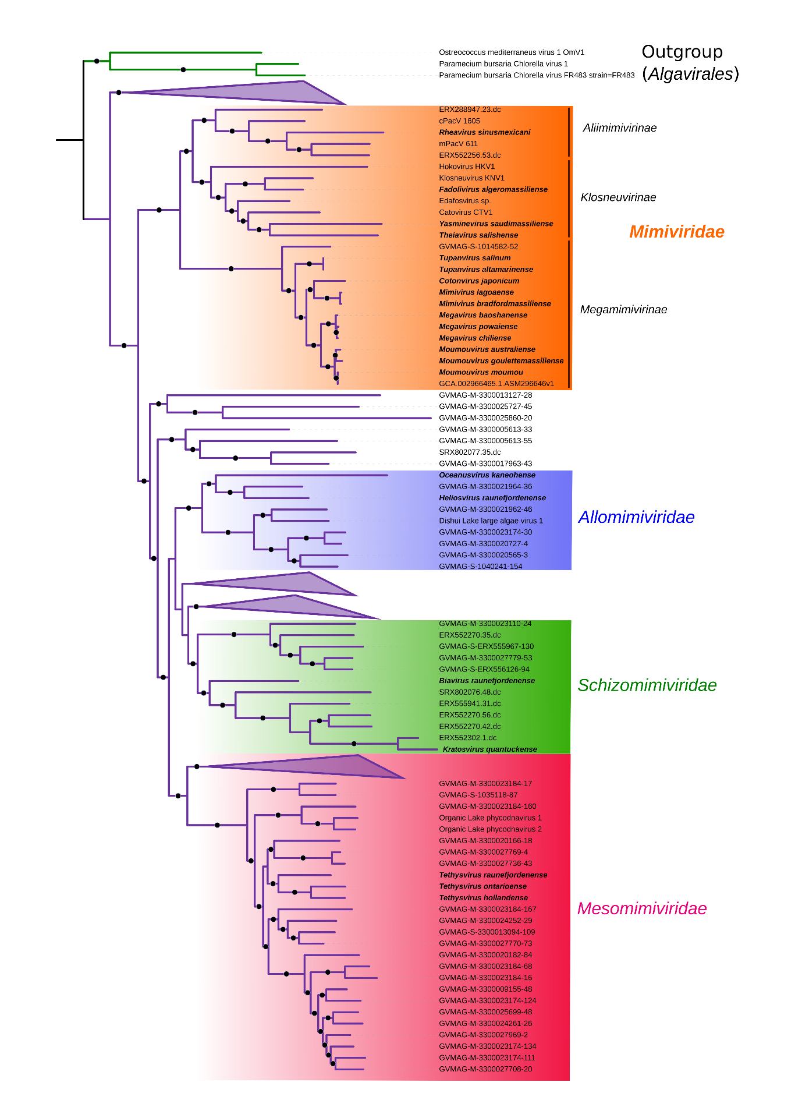
Figure 1. Phylogeny of the order Imitervirales, based on a concatenated alignment of seven marker genes (see main text for details). Species proposed or renamed here are in bold. The Maximum Likelihood based phylogeny was constructed using IQ-TREE 1.6.9. Black circles denote nodes with >80% ultrafast bootstrap support.

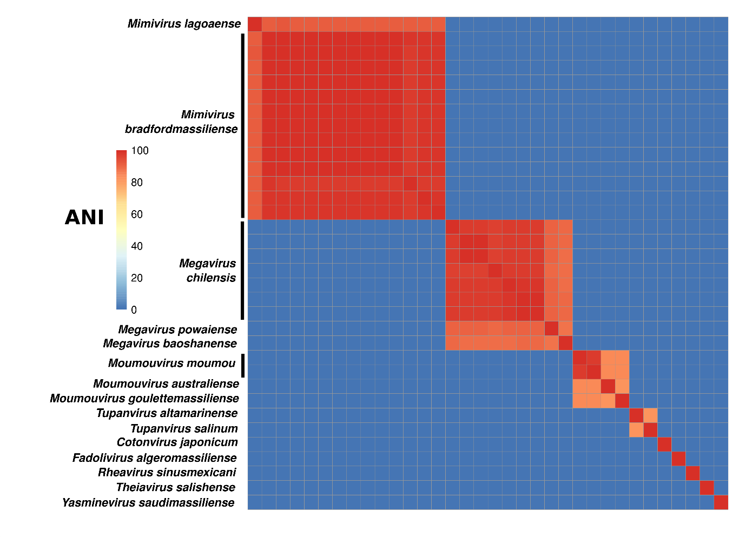
Figure 2. Pairwise Average Nucleotide Identity (ANI) of viral isolates in the family Mimiviridae. ANI was calculated only if the average alignment fraction was >75%; otherwise ANI was set to 0. Nucleotide comparisons were performed with LAST v. 959.

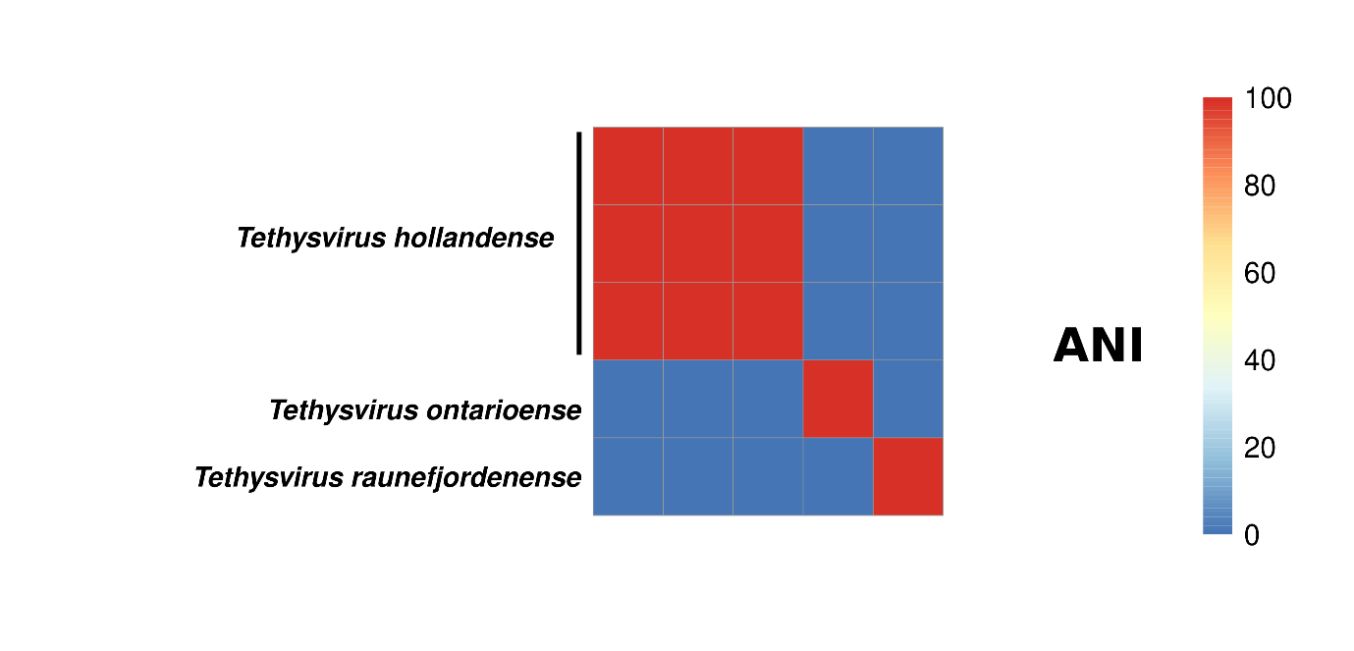
Figure 3. Pairwise Average Nucleotide Identity (ANI) of viral isolates in the proposed genus Tethysvirus. ANI was calculated only if the average alignment fraction was >75%; otherwise ANI was set to 0. Nucleotide comparisons were performed with LAST v. 959.

References
1. Abergel C, Legendre M, Claverie J-M (2015) The rapidly expanding universe of giant viruses: Mimivirus, Pandoravirus, Pithovirus and Mollivirus. FEMS Microbiol Rev 39:779–796. doi: 10.1093/femsre/fuv037
2. Endo H, Blanc-Mathieu R, Li Y, et al (2020) Biogeography of marine giant viruses reveals their interplay with eukaryotes and ecological functions. Nat Ecol Evol 4:1639–1649. doi: 10.1038/s41559-020-01288-w
3. Monier A, Larsen JB, Sandaa R-A, et al (2008) Marine mimivirus relatives are probably large algal viruses. Virol J 5:12. DOI: 10.1186/1743-422X-5-12
4. Moniruzzaman M, Martinez-Gutierrez CA, Weinheimer AR, Aylward FO (2020) Dynamic genome evolution and complex virocell metabolism of globally-distributed giant viruses. Nat Commun 11:1710. doi: 10.1038/s41467-020-15507-2
5. Schulz F, Roux S, Paez-Espino D, et al (2020) Giant virus diversity and host interactions through global metagenomics. Nature 578:432–436. doi: 10.1038/s41586-020-1957-x
6. Gallot-Lavallée L, Blanc G, Claverie J-M (2017) Comparative Genomics of Chrysochromulina Ericina Virus and Other Microalga-Infecting Large DNA Viruses Highlights Their Intricate Evolutionary Relationship with the Established Mimiviridae Family. J Virol 91.: https://doi.org/10.1128/JVI.00230-17.
7. Koonin EV, Yutin N (2018) Multiple evolutionary origins of giant viruses. F1000Res 7.: https://doi.org/10.12688/f1000research.16248.1
8. Yutin N, Colson P, Raoult D, Koonin EV (2013) Mimiviridae: clusters of orthologous genes, reconstruction of gene repertoire evolution and proposed expansion of the giant virus family. Virol J 10:106. doi: 10.1186/1743-422X-10-106
9. Aylward FO, Moniruzzaman M, Ha AD, Koonin EV (2021) A phylogenomic framework for charting the diversity and evolution of giant viruses. PLoS Biol 19:e3001430. doi: 10.1371/journal.pbio.3001430
10. Andreani J, Schulz F, Di Pinto F, et al (2021) Morphological and Genomic Features of the New Klosneuvirinae Isolate Fadolivirus IHUMI-VV54. Front Microbiol 0.: https://doi.org/10.3389/fmicb.2021.719703

