Part 1: TITLE, AUTHORS, APPROVALS, etc

Code assigned: | 2022.003F
Short title: Create 15 new species in the family Botourmiaviridae
Author(s) and email address(es)
Ayllón MA, Turina M, Jiang D, Xie J, Marzano SY, Donaire L, Nerva L, Sabanadzovic S | mariaangeles.ayllon@upm.es; massimo.turina@ipsp.cnr.it; daohongjiang@mail.hzau.edu.cn jiataoxie@mail.hzau.edu.cn; shinyi.marzano@usda.gov ldonaire@cebas.csic.es; luca.nerva@crea.gov.it ssabanadzovic@entomology.msstate.edu
Author(s) institutional address(es) (optional)
Universidad Politécnica de Madrid [MAA]
National Research Council [MT]
Huazhong Agricultural University [DJ, JX]
USDA [SYM]
Spanish National Research Council [LD]
Council for Agricultural Research and Agricultural Economy Analysis [LN]
Mississippi State University [SS]
Corresponding author
María A. Ayllón (mariaangeles.ayllon@upm.es)
List the ICTV Study Group(s) that have seen this proposal

ICTV Fungal and Protist Viruses Subcommittee Chair; ICTV Botourmiaviridae Study Group.

ICTV Study Group comments and response of proposer

ICTV Study Group votes on proposal

Study Group | Number of members
 | Votes support | Votes against | No vote
SG Botourmiaviridae | 7 | 0 | 0
Authority to use the name of a living person

Is any taxon name used here derived from that of a living person (Y/N)

Taxon name | Person from whom the name is derived | Permission attached (Y/N)

Submission dates
Date first submitted to SC Chair | 22/05/2022
Date of this revision (if different to above)
ICTV-EC comments and response of the proposer

Part 3: TAXONOMIC PROPOSAL
Name of accompanying Excel module
2022.003F.N.v1.Botourmiaviridae_15nsp.xlsx
Abstract
The family Botourmiaviridae currently includes twelve genera: Ourmiavirus, Botoulivirus, Betabotoulivirus, Magoulivirus, Scleroulivirus, Betascleroulivirus, Deltascleroulivirus, Gammascleroulivirus, Epsilonscleorulivirus, Rhizoulivirus, Betharhizoulivirus, and Penoulivirus. We searched the NCBI database and found that additional viruses can be classified in the currently recognized genera in the family.
Here we propose the creation of fifteen new species in the following seven genera: Botoulivirus (3 species), Magoulivirus (5), Scleroulivirus (2), Gammascleroulivirus (1), Epsilonscleorulivirus (1), Betharhizoulivirus (1), and Penoulivirus (2).

Text of proposal
The family Botourmiaviridae currently includes twelve genera: Ourmiavirus, Botoulivirus, Betabotoulivirus, Magoulivirus, Scleroulivirus, Betascleroulivirus, Deltascleroulivirus, Gammascleroulivirus, Epsilonscleorulivirus, Rhizoulivirus, Betharhizoulivirus, and Penoulivirus. We searched the NCBI database and found that additional viruses can be classified in the family.
Accordingly, here we propose the creation of fifteen new species in several genera of the family (Table 1). The phylogenetic analysis and alignment of selected viruses are shown in Figures 1 and 2.
Genus Botoulivirus
We propose to create three new species in this genus: Botoulivirus iotabotrytidis, Botoulivirus kappabotrytidis, and Botoulivirus alphapestalotiopsis.
Genus Magoulivirus
We propose to create five new species in this genus: Magoulivirus alphaoryzae, Magoulivirus alphaoxyspori, Magoulivirus alphamellea, Magoulivirus alphaheterobasidion, and Magoulivirus alphaodothidea.
Genus Scleroulivirus
We propose to create two new species in this genus: Scleroulivirus alphapestalotiopsis and Scleroulivirus alphaoryzae.
Genus Gammascleroulivirus
We propose to create a single new species: Gammascleroulivirus alphaoryzae.
Genus Epsilonscleroulivirus
We propose to create a single new species: Epsilonscleroulivirus alphaoryzae.
Genus Penoulivirus
We propose to create two new species in the genus: Penoulivirus alphaoryzae and Penoulivirus alphaerysiphe.
Genus Betarhizoulivirus
We propose to create a single new species: Betarhizoulivirus alphamellea.

The demarcation criteria for species (less than 90% RdRP amino acid identitiy) and genera (less than 30% aa RdRP identity) in the family Botourmiaviridae support the proposed classification in different genera and species (Figure 2).

Supporting evidence

Table 1. Newly proposed species of the family Botourmiaviridae

Genus name | Species name | Virus name/Acronym | Accession number (N/P) | Host | Reference
Botoulivirus | Botoulivirus iotabotrytidis | Botrytis cinerea botoulivirus 18/BcBoV18 | OK634395/UJT32090 | Fungi, Botrytis cinerea | [1]
 | Botoulivirus kappabotrytidis | Botrytis cinerea botoulivirus 19/BcBoV19 | OK634396/UJT32091 | Fungi, Botrytis cinerea | [1]
 | Botoulivirus alphapestalotiopsis | Pestalotiopsis botourmiavirus 3/PBV-3 | MW017457/QTH80197 | Fungi, Botrytis cinerea | [2]
Magoulivirus | Magoulivirus alphaoryzae | Magnaporthe oryzae botourmiavirus 2/MoBV2 | MW117114/QPF16726 | Fungi, Magnaporthe oryzae | [3]
 | Magoulivirus alphaoxyspori | Fusarium oxysporum ourmia-like virus 1/FoOuLV1 | MT551010/QPO14979 | Fungi, Fusarium oxysporum | [4]
 | Magoulivirus alphamellea | Armillaria mellea ourmia-like virus 2/AmOlV2 | MW423803/QUD20356 | Fungi, Armillaria mellea | [5]
 | Magoulivirus alphaheterobasidion | Heterobasidion ourmia-like virus 1/HetOlV1 | MZ502383/UHK02571 | Fungi, Heterobasidion parviporum | [6]
 | Magoulivirus alphaodothidea | Botryosphaeria dothidea Ourmia-like virus 1/BdOLV1 | MK189195/QED22728 | Fungi, Botryosphaeria dothidea | [7]
Scleroulivirus | Scleroulivirus alphapestalotiopsis | Pestalotiopsis botourmiavirus 2/PBV-2 | MW017456/QTH80196 | Fungi, Pestalotiopsis spp. | [2]
 | Scleroulivirus alphaoryzae | Magnaporthe oryzae botourmiavirus 9/MoBV9 | MT995746/UIX55986 | Fungi, Magnaporthe oryzae | [8]
Gammascleroulivirus | Gammascleroulivirus  alphaoryzae | Magnaporthe oryzae botourmiavirus 6/MBOV6 | MN971591/QLJ94430 | Fungi, Magnaporthe oryzae | [3]
Epsilonscleroulivirus | Epsilonscleroulivirus alphaoryzae | Magnaporthe oryzae botourmiavirus 7/MOBV7 | MN971592/QLJ94431 | Fungi, Magnaporthe oryzae | [3]
Penoulivirus | Penoulivirus alphaoryzae | Magnaporthe oryzae botourmiavirus 5/MBOV5 | MN648455/QLJ94076 | Fungi, Magnaporthe oryzae | [3]
 | Penoulivirus alphaerysiph | Erysiphe necator associated ourmia-like virus 21/EnaOLV21 | OL890646/UQG53871 | Fungi, Erysiphe necator | [14]
Betarhizoulivirus | Betarhizoulivirus alphamellea | Armillaria mellea ourmia-like virus 1/AmOlV1 | MW423802/QUD20355 | Fungi, Armillaria mellea | [5]

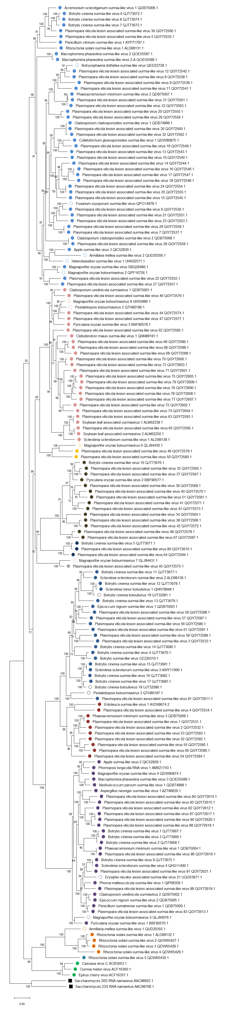
BOTOURMIAVIRIDAE

Magoulivirus

Scleroulivirus

Gammascleroulivirus

Betascleroulivirus

Deltascleroulivirus

Epsilonscleorulivirus

Botoulivirus

Betabotoulivirus

Penoulivirus

Rhizoulivirus

Betarhizoulivirus
Ourmiavirus
NARNAVIRIDAE

Figure 1 Phylogenetic tree of the expanded and reorganized family Botourmiaviridae. A maximum likelihood (ML) phylogenetic tree was constructed based on the multiple amino acid sequence alignment MAFFT (version 7.243) using the E-INS-i settings [9]. All alignments were trimmed with trimAl (v1.3) [10] to remove low-quality regions through heuristic selection under the automatic method (-automated1) based on similarity statistics. The ML phylogenetic trees were constructed using the IQ-TREE (version 1.6.12) [11] with 1,000 replicates ultrafast bootstrap replicates and the best-fit amino acid substitution model (rtREV+F+I+G4) was identified using ModelFinder [12]. Viruses classified in genus Narnavirus were used as outgroups.

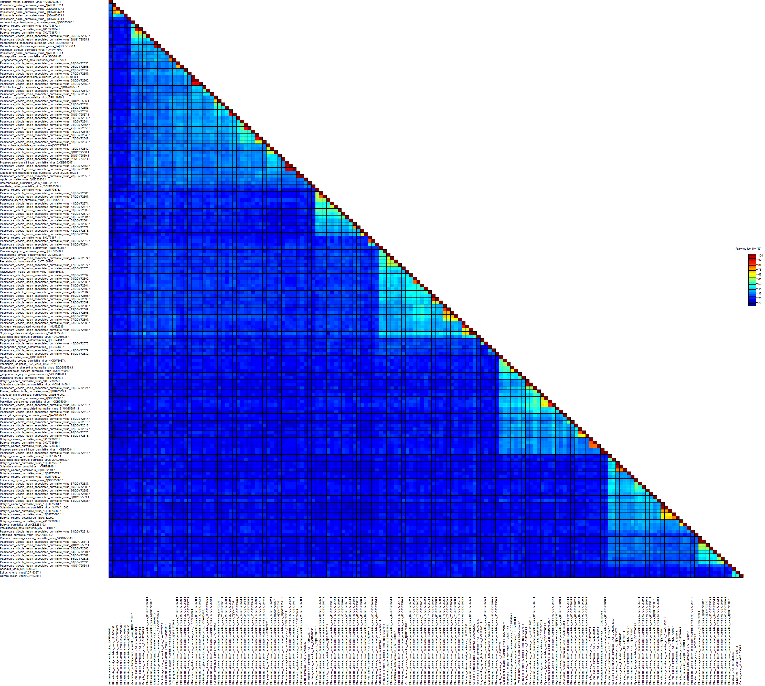
Botoulivirus
Betabotoulivirus
Magoulivirus
Scleroulivirus
Betascleroulivirus
Deltascleroulivirus
Gammascleroulivirus
Epsilonscleorulivirus
Rhizoulivirus
Betharhizoulivirus
Penoulivirus
BOTOURMIAVIRIDAE
Ourmiavirus

Figure 2 Matrix diagrams of amino acid identities of RNA dependent-RNA polymerase (RdRp) proteins among members of the genera in the family Botourmiaviridae. The percent identity matrixes were created via multiple sequence alignment using Muscle. Then, matrix diagrams were color represented using the Sequence Demarcation Tool Version 1.2 [13].

References
1. Wang Q, Zou Q, Dai Z, et al (2022) Four Novel Mycoviruses from the Hypovirulent Botrytis cinerea SZ-2-3y Isolate from Paris polyphylla: Molecular Characterisation and Mitoviral Sequence Transboundary Entry into Plants. Viruses 14:151. https://doi.org/10.3390/v14010151
2. Chen F, Pu Z, Ni H, et al (2021) Multiple mycoviruses identified in Pestalotiopsis spp. from Chinese bayberry. Virol J 18:43. https://doi.org/10.1186/s12985-021-01513-3
3. Liu Y, Zhang L, Esmael A, et al (2020) Four Novel Botourmiaviruses Co-Infecting an Isolate of the Rice Blast Fungus Magnaporthe oryzae. Viruses 12:1383. https://doi.org/10.3390/v12121383
4. Zhao Y, Zhang Y, Wan X, et al (2020) A Novel Ourmia-Like Mycovirus Confers Hypovirulence-Associated Traits on Fusarium oxysporum. Front Microbiol 11:. https://doi.org/10.3389/fmicb.2020.569869
5. Linnakoski R, Sutela S, Coetzee MPA, et al (2021) Armillaria root rot fungi host single-stranded RNA viruses. Sci Rep 11:7336. https://doi.org/10.1038/s41598-021-86343-7
6. Sutela S, Piri T, Vainio EJ (2021) Discovery and Community Dynamics of Novel ssRNA Mycoviruses in the Conifer Pathogen Heterobasidion parviporum. Front Microbiol. https://doi.org/10.3389/fmicb.2021.770787
7. Lian Z, Das S, Luo J, et al (2021) Complete genome sequence of a novel ourmia-like mycovirus infecting the phytopathogenic fungus Botryosphaeria dothidea. Arch Virol 166:3461–3465. https://doi.org/10.1007/s00705-021-05221-9
8. Zhou X, Shuai S, Zheng H, et al (2021) Complete nucleotide sequence of a novel botourmiavirus from the rice blast fungus Magnaporthe oryzae isolate SH05. Arch Virol 166:1783–1787. https://doi.org/10.1007/s00705-021-05044-8
9. Nakamura T, Yamada KD, Tomii K, Katoh K (2018) Parallelization of MAFFT for large-scale multiple sequence alignments. Bioinformatics 34:2490–2492. https://doi.org/10.1093/bioinformatics/bty121
10. Capella-Gutierrez S, Silla-Martinez JM, Gabaldon T (2009) trimAl: a tool for automated alignment trimming in large-scale phylogenetic analyses. Bioinformatics 25:1972–1973. https://doi.org/10.1093/bioinformatics/btp348
11. Nguyen L-T, Schmidt HA, von Haeseler A, Minh BQ (2015) IQ-TREE: a fast and effective stochastic algorithm for estimating maximum-likelihood phylogenies. Mol Biol Evol 32:268–74. https://doi.org/10.1093/molbev/msu300
12. Kalyaanamoorthy S, Minh BQ, Wong TKF, et al (2017) ModelFinder: fast model selection for accurate phylogenetic estimates. Nat Methods 14:587–589. https://doi.org/10.1038/nmeth.4285
13. Muhire BM, Varsani A, Martin DP (2014) SDT: A Virus Classification Tool Based on Pairwise Sequence Alignment and Identity Calculation. PLoS One 9:e108277. https://doi.org/10.1371/journal.pone.0108277
14. Galán-Cubero R, Córdoba L, Rodríguez-Romero J, Chiapello M, Turina M, Ayllón MA. Molecular Data of a Novel Penoulivirus Associated with the Plant-Pathogenic Fungus Erysiphe necator. Phytopathology. 2022 May 4:PHYTO12210536A. doi: 10.1094/PHYTO-12-21-0536-A. Epub ahead of print. PMID: 35509205.

