Part 1: TITLE, AUTHORS, APPROVALS, etc

Code assigned: | 2022.002F
Short title: Establishment of 4 new genera, 13 new species and renaming 9 species in the family Bacilladnaviridae

Author(s) and email address(es)
Varsani A, Krupovic M | Arvind.varsani@asu.edu; mart.krupovic@pasteur.fr
Author(s) institutional address(es) (optional)
The Biodesign Center for Fundamental and Applied Microbiomics, Center for Evolution and Medicine, School of Life Sciences, Arizona State University, 1001 S. McAllister Ave, Tempe, AZ 85287-5001, USA [AV]
Institut Pasteur, Université Paris Cité, CNRS UMR6047, Archaeal Virology Unit, 25 rue du Dr Roux, 75015 Paris, France [MK]
Corresponding author
Arvind Varsani (Arvind.varsani@asu.edu)
List the ICTV Study Group(s) that have seen this proposal

Chair Fungal and Protist Viruses Subcommittee
ICTV Study Group comments and response of proposer

ICTV Study Group votes on proposal

Study Group | Number of members
 | Votes support | Votes against | No vote
Authority to use the name of a living person

Is any taxon name used here derived from that of a living person (Y/N)

Taxon name | Person from whom the name is derived | Permission attached (Y/N)

Submission dates
Date first submitted to SC Chair | 20 May 2022
Date of this revision (if different to above)
ICTV-EC comments and response of the proposer

Part 2: NON-TAXONOMIC PROPOSAL
Text of proposal

Part 3: TAXONOMIC PROPOSAL
Name of accompanying Excel module
2022_Bacilladnaviridae_4neg_13_nsp_9_rensp_final.xlsx
Abstract
Bacilladnaviruses are single-stranded (ss) DNA viruses and infect diatoms and so far, they have primarily been identified from marine environments. In the last 5 years, sixteen new genomes of viruses in the family Bacilladnaviridae have been sequenced. To classify these, we propose creating four new genera and thirteen new species. Also, we rename nine existing species to binomial format with a freeform epithet.
Text of proposal
Bacilladnaviruses are single-stranded DNA viruses in the Phylum Cressdnaviricota (class Arfiviricetes and order Baphyvirales) [1]. The Rep sequences of bacilladnaviruses have conserved motifs distinct from those typical of Reps of other cressdnaviruses, primarily in Motif I and Motif III [2]. The capsid protein of bacilladnaviruses is most closely related to the CP of positive-sense RNA viruses of the Nodaviridae family based on structural homology [2,3].

Currently, the family Bacilladnaviridae comprises three genera, namely, Diatodnavirus (1 species), Kieseladnavirus (1 species) and Protobacilladnavirus (7 species) [4]. The genera were established based on the phylogeny of the HUH superfamily replication initiation protein (Rep), the most conserved protein encoded by bacilladnaviruses, whereas 75% amino acid identity threshold was chosen as a species demarcation criterion. Since the creation of the family Bacilladnaviridae in 2018 [4], the number of viral genomes within this family has doubled.

Based on the maximum likelihood phylogeny to the Rep sequences, we note four well supported clades (>64% bootstrap support) and three singletons (Figure 1A). Thus, we propose to establish four new genera to classify the new viruses and we move one species from Protobacilladnavirus (accession # KF133809) to a new genus, Seawadnavirus.

We propose the following four names for the new genera

- Aberdnavirus: Derived from aber which is an estuary in Welsh
- Keisodnavirus: Derived from Keisō (珪藻) which is diatom in Japanese
- Puahadnavirus: Derived from pūahatanga which is an estuary in Māori
- Seawadnavirus: Derived from seawater

Analysis of the Rep amino acid sequences shows that most members display 36-58% pairwise identities, with only a small fraction showing >78% (Figure 1B, 1C).

The 75% pairwise identity as a species demarcation criterion was proposed for members of the genus Protobacilladnavirus [4] (because other genera were represented by singletons). Based on the distribution of the pairwise identities of all 30 bacilladnavirus Rep amino acid sequences, we propose to extend and apply the same demarcation criterion to all genera with more than one species.

Finally, to comply with the mandated binomial species naming format [5], we have renamed established species using binomial nomenclature with a freeform epithet. All epithets are either derivatives of host species or isolation source using names in local languages of people that inhabit that region or settlers (Table 1).

Supporting evidence
Table 1: Summary of the taxonomy of bacilladnaviruses. New taxa names are provided in blue font.

New genus | Accession | Virus name | species | Epithet notes
Keisodnavirus | LC379168 | Chaetoceros tenuissimus DNA virus SS12-43V | Keisodnavirus chaetenu | Chaetoceros tenuissimus
Protobacilladnavirus | AB193315 | Chaetoceros salsugineum DNA virus | Protobacilladnavirus chasesal | Chaetoceros salsugineum
 | MH617734 | Bacilladnaviridae sp. isolate ctia23 | Protobacilladnavirus snap | Red snapper
 | AB844272 | Chaetoceros sp. DNA virus 7 | Protobacilladnavirus chaetoc | Chaetoceros sp
 | AB553581 | Chaetoceros lorenzianus DNA virus | Protobacilladnavirus chaelor | Chaetoceros lorenzianus
 | MH616678 | Bacilladnaviridae sp. isolate ctdc18 | Protobacilladnavirus redsnap | Red snapper
 | AB971660 | Chaetoceros tenuissimus DNA virus type-II | Protobacilladnavirus tenuis | Chaetoceros tenuissimus
 | AB971659 | Chaetoceros tenuissimus DNA virus type-II | Protobacilladnavirus tenuis | Chaetoceros tenuissimus
 | AB971658 | Chaetoceros tenuissimus DNA virus type-II | Protobacilladnavirus tenuis | Chaetoceros tenuissimus
 | AB597949 | Chaetoceros tenuissimus DNA virus | Protobacilladnavirus tenuis | Chaetoceros tenuissimus
 | MN229504 | Haslea ostrearia associated bacilladnavirus | Protobacilladnavirus hasleos | Haslea ostrearia
 | KY405007 | Amphibola crenata associated bacilladnavirus 2 | Protobacilladnavirus hasleos | Haslea ostrearia
 | MN229503 | Haslea ostrearia associated bacilladnavirus | Protobacilladnavirus hasleos | Haslea ostrearia
 | KY405006 | Amphibola crenata associated bacilladnavirus 1 | Protobacilladnavirus mudflat | mud-flat snail common name for Amphibola crenata
Puahadnavirus | OM154950 | Avonheates virus SG_479 | Puahadnavirus kaisui | seawater in Japanese
 | OM154944 | Avonheates virus SG_19 | Puahadnavirus aber | estuary in Welsh
 | OM154948 | Avonheates virus SG_146 | Puahadnavirus inbhir | estuary in Scotish
 | OM154945 | Avonheates virus SG_28 | Puahadnavirus takutai | coast in Māori
 | OM154938 | Avonheates virus SG2_28 | Puahadnavirus takutai | coast in Māori
 | OM154949 | Avonheates virus SG_154 | Puahadnavirus gataifale | estuary / coast in Samoan
Seawadnavirus | KF133809 | Bacillariodnavirus LDMD-2013 | Seawadnavirus kuhtahan | seawater in Massaachusett
 | OM154943 | Avonheates virus SG_924 | Seawadnavirus avonheat | Avon-Heathcote estuary
 | OM154947 | Avonheates virus SG_120 | Seawadnavirus katao | water in Māori
Kieseladnavirus | KY405008 | Avon-Heathcote estuary associated bacilladnavirus | Kieseladnavirus ampcren | Amphibola Crenata
 | OM154942 | Avonheates virus SG_4_10 | Kieseladnavirus titiko | Amphibola crenata in Māori
 | OM154939 | Avonheates virus Gas_102 | Kieseladnavirus titiko | Amphibola crenata in Māori
 | OM154941 | Avonheates virus Gas_1207 | Kieseladnavirus ampcren | Amphibola Crenata
 | OM154940 | Avonheates virus Gas_1078 | Kieseladnavirus karahue | common name for Amphibola crenata in Māori
Aberdnavirus | OM154946 | Avonheates virus SG_61 | Aberdnavirus waitai | Seawater in Māori
Diatodnavirus | AB781089 | Chaetoceros setoense DNA virus | Diatodnavirus chaese | Chaetoceros setoense

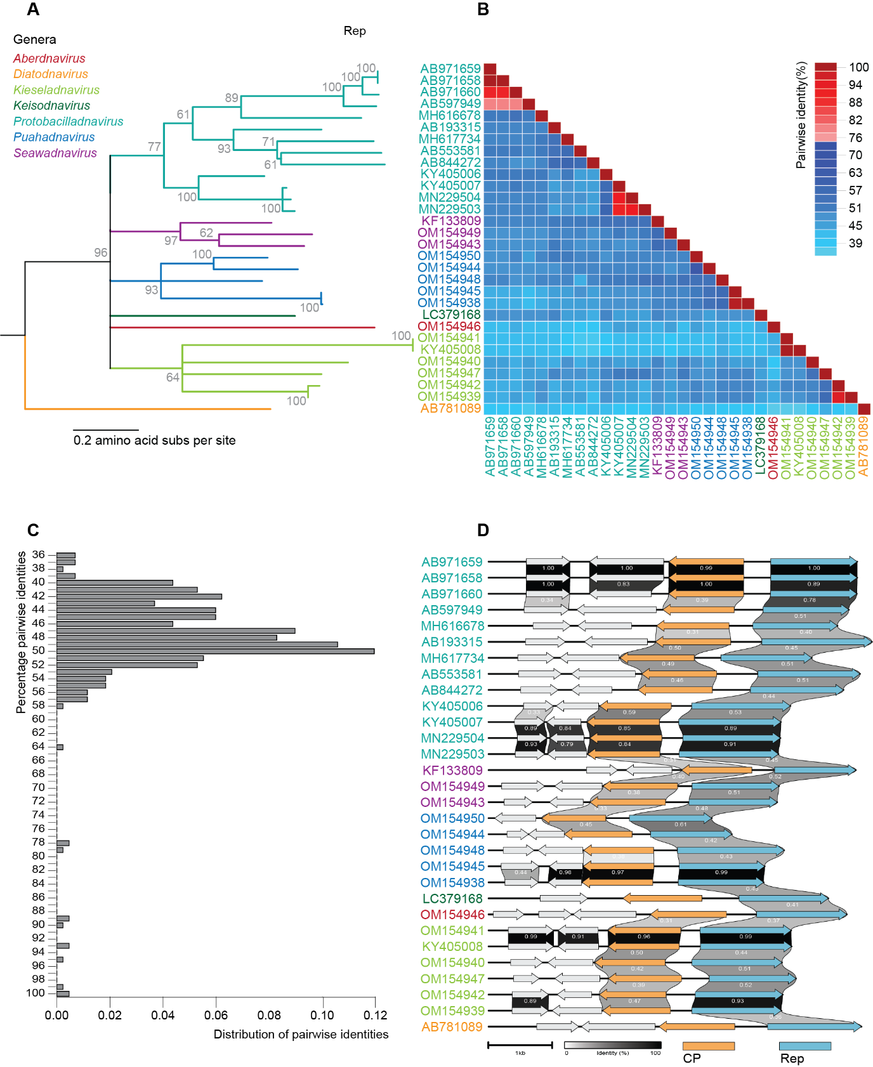

Figure 1: A. Maximum likelihood phylogenetic tree inferred from the aligned (MAFFT v7 [6]) Rep amino acid sequences of bacilladnaviruses using PhyML 3.0 [7] with rtREV+G+I as best substitution model determined using ProtTest [8]. Branches with <60% bootstrap support have been collapsed using TreeGraph2 [9]. B. Pairwise identity matrix of the Rep amino acid sequences of bacilladnaviruses determined using SDT v1.2 [10]. C. Distribution of pairwise identities of the Rep amino acid sequences of bacilladnaviruses determine using SDT v1.2 [10]. D. Genome organization and similarities between encoded proteins of the genomes of bacilladnaviruses determined using Clinker [11].

References
- Krupovic M, Varsani A, Kazlauskas D, Breitbart M, Delwart E, Rosario K, Yutin N, Wolf YI, Harrach B, Zerbini FM, Dolja VV. (2020) Cressdnaviricota: a virus phylum unifying seven families of rep-encoding viruses with single-stranded, circular DNA genomes. Journal of virology. 94(12):e00582-20. PMID: 32269128; doi: 10.1128/JVI.00582-20
- Kazlauskas D, Dayaram A, Kraberger S, Goldstien S, Varsani A, Krupovic M. (2017) Evolutionary history of ssDNA bacilladnaviruses features horizontal acquisition of the capsid gene from ssRNA nodaviruses. Virology. 504:114-21. PMID: 28189969; doi: 10.1016/j.virol.2017.02.001
- Munke A, Kimura K, Tomaru Y, Wang H, Yoshida K, Seiya Mito S, Hongo Y, Okamoto K. (2021) Primordial capsid and spooled ssDNA genome structures penetrate ancestral events of eukaryotic viruses. bioRxiv 2021.03.14.435335; doi: https://doi.org/10.1101/2021.03.14.435335
- King AMQ, Lefkowitz EJ, Mushegian AR, Adams MJ, Dutilh BE, Gorbalenya AE, Harrach B, Harrison RL, Junglen S, Knowles NJ, Kropinski AM, Krupovic M, Kuhn JH, Nibert ML, Rubino L, Sabanadzovic S, Sanfacon H, Siddell SG, Simmonds P, Varsani A, Zerbini FM, Davison AJ. 2018. Changes to taxonomy and the International Code of Virus Classification and Nomenclature ratified by the International Committee on Taxonomy of Viruses (2018). Arch Virol 163:2601–2631. PMID: 29754305; DOI: 10.1007/s00705-018-3847-1
- Siddell SG, Walker PJ, Lefkowitz EJ, Mushegian AR, Dutilh BE, Harrach B, Harrison RL, Junglen S, Knowles NJ, Kropinski AM, Krupovic M, Kuhn JH, Nibert ML, Rubino L, Sabanadzovic S, Simmonds P, Varsani A, Zerbini FM, Davison AJ (2020) Binomial nomenclature for virus species: a consultation. Arch Virol 165:519-525. PMID: 31797129; DOI: 10.1007/s00705-019-04477-6
- Katoh K, Rozewicki J, Yamada KD (2019) MAFFT online service: multiple sequence alignment, interactive sequence choice and visualization. Brief Bioinform 20:1160-1166. PMID: 28968734; DOI: 10.1093/bib/bbx108
- Guindon S, Dufayard JF, Lefort V, Anisimova M, Hordijk W, Gascuel O (2010) New algorithms and methods to estimate maximum-likelihood phylogenies: assessing the performance of PhyML 3.0. Syst Biol 59:307-321. PMID: 20525638; DOI: 10.1093/sysbio/syq010
- Darriba D, Taboada GL, Doallo R, Posada D. (2011) ProtTest 3: fast selection of best-fit models of protein evolution. Bioinformatics. 27(8):1164-5. PMID: 21335321; DOI: 10.1093/bioinformatics/btr088
- Stover BC, Muller KF (2010) TreeGraph 2: combining and visualizing evidence from different phylogenetic analyses. BMC Bioinformatics 11:7. PMID: 20051126; DOI: 10.1186/1471-2105-11-7
- Muhire BM, Varsani A, Martin DP (2014) SDT: A Virus Classification Tool Based on Pairwise Sequence Alignment and Identity Calculation. Plos One 9:e108277. PMID: 25259891; DOI: 10.1371/journal.pone.0108277
- Gilchrist CLM & Chooi Y-H. (2021). Clinker & clustermap.js: Automatic generation of gene cluster comparison figures. Bioinformatics. PMID: 33459763 DOI: 10.1093/bioinformatics/btab007

