

**Part 1:** **TITLE, AUTHORS, APPROVALS, etc**

|  |  |  |
| --- | --- | --- |
| **Code assigned:** | ***2022.001B*** |  |
| **Short title:** Create one new family (*Aliceevansviridae*) with one new genus (*Vansinderenvirus*)and two existing genera (*Moineauvirus* and *Brussowvirus*) (*Caudoviricetes*). | | |
|  | | |

**Author(s) and email address(es)**

|  |  |
| --- | --- |
| Kropinski AM, Turner D, Tolstoy I, Moraru C, Adriaenssens EM, Mahony J | Phage.Canada@gmail.com; Dann2.Turner@uwe.ac.uk; tolstoy@ncbi.nlm.nih.gov liliana.cristina.moraru@uol.de;  evelien.adriaenssens@quadram.ac.uk; j.mahony@ucc.ie |

**Author(s) institutional address(es) (optional)**

|  |
| --- |
| University of Guelph, Canada [AMK]  University of the West of England, Bristol, UK [DT]  National Center for Biotechnology Information, Bethesda, USA [IT]  Carl von Ossietzky Universität Oldenburg, Germany [CM]  Quadram Institute, Norwich UK [EMA]  School of Microbiology & APC Microbiome Ireland, University College Cork, Ireland [JM] |

**Corresponding author**

|  |
| --- |
| Jennifer Mahony |

**List the ICTV Study Group(s) that have seen this proposal**

|  |
| --- |
| Bacterial Viruses Subcommittee, Caudoviricetes Study Group |

**ICTV Study Group comments and response of proposer**

|  |
| --- |
|  |

**ICTV Study Group votes on proposal**

|  |  |  |  |
| --- | --- | --- | --- |
| **Study Group** | **Number of members** | | |
| **Votes support** | **Votes against** | **No vote** |
|  |  |  |  |
|  |  |  |  |

**Authority to use the name of a living person**

|  |  |
| --- | --- |
| **Is any taxon name used here derived from that of a living person (Y/N)** | Y |

|  |  |  |
| --- | --- | --- |
| **Taxon name** | **Person from whom the name is derived** | **Permission attached (Y/N)** |
| Vansinderenvirus | Douwe van Sinderen | Y |
|  |  |  |
|  |  |  |

**Submission dates**

|  |  |
| --- | --- |
| Date first submitted to SC Chair | April 2022 |
| Date of this revision (if different to above) | 15 August 2022 |

**ICTV-EC comments and response of the proposer**

|  |
| --- |
| ICTV-EC: Please provide additional evidence for the monophyly of the proposed new family.  Proposers: We have replaced the separate phylogenetic trees per genus with a unified phylogenetic tree of a subset of members showing the monophyly of the family. An outgroup could not be used because sparse alignment of the sequences. |

**Part 2:** **NON-TAXONOMIC PROPOSAL**

**Text of proposal**

|  |
| --- |
|  |

**Part 3:** **TAXONOMIC PROPOSAL**

**Name of accompanying Excel module**

|  |
| --- |
| 2022.001B.A.v2.Aliceevansviridae_nf.xlsx |

**Abstract**

|  |
| --- |
| The genera *Sfi21dtunalikevirus* (2013.036a-dB) and *Sfi1unalikevirus* (2013.034a-dB) were renamed *Moineauvirus* and *Brussowvirus*, respectively through Taxonomy Proposal 2015.025aB. Since that time numerous representatives of these two genera have been deposited in GenBank. We have created a new genus, *Vansinderenvirus*, for phages which the dairy virology community refer to as the 5093-group of phages. These temperate siphoviruses possess linear ds DNA genomes of, on average, 34.33 kb (38.2 mol%G+C) and encode for 47 proteins. These three genera are combined in the new family, *Aliceevansviridae*. |

**Text of proposal**

|  |  |
| --- | --- |
| |  | | --- | | **Species demarcation criteria:** Two phages are assigned to the same species if their genomes are more than 95% identical over their genome length for isolates.  These values can be calculated by a number of tools, such as BLASTn [1] – usually calculated using intergenomic distance calculator VIRIDIC [2].  **Genus demarcation criteria:** In search for criteria that create cohesive and distinct genera that are reproducible and monophyletic, the Bacterial Viruses Subcommittee has established 70% nucleotide identity of the genome length as the cut-off for genera. Genus-level groupings should always be monophyletic in the signature genes, as tested with a phylogenetic tree. [8]  **Family demarcation criteria:** The family is represented by a cohesive and monophyletic group in the main predicted proteome-based clustering tools (ViPTree, GRAViTy dendrogram, vConTACT2 network). Members of the family share a significant number of orthologous genes (the number will depend on the genome sizes and number of coding sequences of members of the family; usually ca. 10%). [8] | |

**Supporting evidence**

**Proposals:**

1. **To create a new genus, *Vansinderenvirus* with twelve (12) species**
2. **To add twenty-eight (28) new species to *Brussowvirus***
3. **To add seventy-six (76) new species to *Moineauvirus***
4. **To create a new family, *Aliceevansviridae*, for these three genera**

**A. To create a new genus,** ***Vansinderenvirus* with twelve (12) species**

**Origin of the name of this taxon:** This taxon is named in honour of Professor Douwe van Sinderen (PhD, Molecular Genetics (University of Groningen, The Netherlands, 1994) who is the co-author of almost 470 peer-reviewed papers, over 15 book chapters, editor of 2 books, and listed as an (co-)inventor of 6 patents. He is currently a member of the APC Microbiome Ireland and School of Microbiology at University College Cork, Cork, Ireland. His group isolated and sequenced many of these phages.

**Historical aspects:** These lytic phages were isolated in Denmark or Ireland against *Streptococcus thermophilus*. They were originally termed the “5093 group.” [11-13]

**Electron micrograph:**

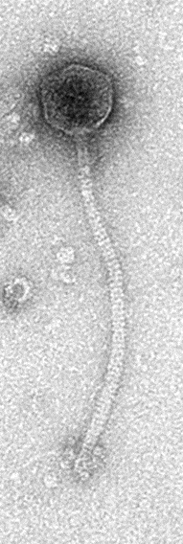

Electron Micrograph of SW27, courtesy of Dr. Horst Neve (retired) Max Rubner-Institut.

**Genome summary:**

|  |  |  |  |  |  |  |  |
| --- | --- | --- | --- | --- | --- | --- | --- |
| Phage name | RefSeq No. | INSDC | Size (Kb) | GC% | Protein | Overall % DNA sequence identity (*) | Overall % homologous proteins (**) |
| Streptococcus phage SW4 |  | MH892355.1 | 34.56 | 38.2 | 47 | 100 | 100 |
| Streptococcus phage SW27 |  | MH892373.1 | 33.95 | 38.2 | 46 | 83.7 | 87.2 |
| Streptococcus phage CHPC1198 |  | MK202159.1 | 33.24 | 38.1 | 47 | 85.9 | 87.2 |
| Streptococcus phage P0093 |  | KY705253.1 | 34.93 | 38.6 | 51 | 80.2 | 83.0 |
| Streptococcus phage SW24 |  | MH973663.1 | 32.09 | 38.3 | 42 | 85.0 | 83.0 |
| Streptococcus phage P0092 |  | KY705252.1 | 34.58 | 38.4 | 50 | 76.7 | 80.8 |
| Streptococcus phage CHPC1151 |  | KX879643.1 | 33.51 | 38.5 | 46 | 77.0 | 85.1 |
| Streptococcus phage 5093 | NC_012753.1 | FJ965538.1 | 37.18 | 38.0 | 48 | 71.8 | 70.2 |
| Streptococcus phage CHPC1282 |  | MK202161.1 | 34.79 | 38.1 | 45 | 77.3 | 76.6 |
| Streptococcus phage CHPC1232 |  | MK202160.1 | 31.97 | 38.3 | 45 | 77.0 | 76.6 |
| Streptococcus phage P0095 |  | KY705255.1 | 35.97 | 38.1 | 54 | 70.4 | 74.5 |
| Streptococcus phage SW19 |  | MH892367.1 | 35.15 | 38.1 | 46 | 72.0 | 70.2 |

**(*) determined using BLASTn [1] or VIRIDIC [2]**

**(**) determined using CoreGenes 3.5 [5]**

**VIRIDIC heat map:** VIRIDIC (Virus Intergenomic Distance Calculator; VIRIDIC (Virus Intergenomic Distance Calculator; [2]; http://rhea.icbm.uni-oldenburg.de/VIRIDIC/) computes pairwise intergenomic distances/similarities amongst phage genomes.



**ViPTree analysis:** ViPTree analysis (https://www.genome.jp/viptree/; [3]) is based upon Rohwer and Edwards (2002) famous Phage Proteomic Tree [4]. The phages of interest are indicated with **red stars**. The blue and black arrowheads indicate reference phages of the genera *Brussowvirus* and *Moineauvirus*, respectively. Lactococcal and enterococcal phage genomes are included as outliers.





**Phylogeny:** The phylogenetic tree was constructed using the TerL proteins from phages belonging to this family with phylogeny.fr in “one click” mode [6]. "The "One Click mode" targets users that do not wish to deal with program and parameter selection. By default, the pipeline is already set up to run and connect programs recognized for their accuracy and speed (MUSCLE for multiple alignment and PhyML for phylogeny) to reconstruct a robust phylogenetic tree from a set of sequences." "The usual bootstrapping procedure is replaced by a new confidence index that is much faster to compute. See: Anisimova M., Gascuel O. Approximate likelihood ratio test for branches: A fast, accurate and powerful alternative [7] for details." The top cluster are members of *Brussowvirus*, the middle *Vansinderenvirus* and the bottom *Moineauvirus*.

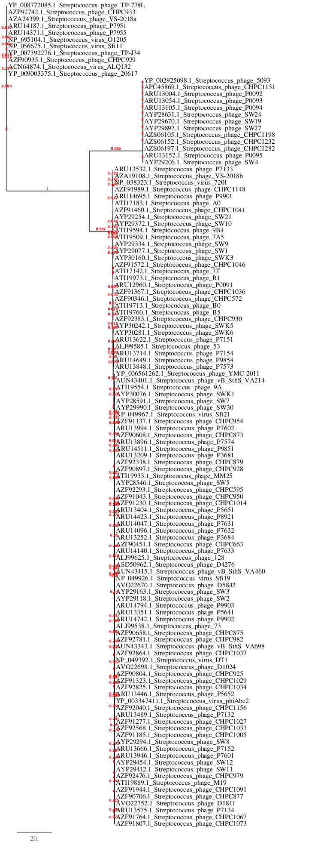

1. **To add twenty-eight (28) new species to *Brussowvirus***

**Origin of the name of this taxon:** N/A

**Historical aspects:** This taxon was originally established through Taxonomy Proposal 2015.006aB (*Sfi11virus*)

**Electron micrograph:** N/A

**Genome summary:** Exemplars for new species. VIRIDIC analyses (attached)

|  |  |
| --- | --- |
| **Phage Name** | **Accession No.** |
| Streptococcus phage 20617 | HG424323.1 |
| Streptococcus phage CHPC1042 | MH937494.1 |
| Streptococcus phage CHPC1109 | MH937505.1 |
| Streptococcus phage CHPC1152 | MH937507.1 |
| Streptococcus phage CHPC1230 | MH937509.1 |
| Streptococcus phage CHPC1246 | MH937510.1 |
| Streptococcus phage CHPC1247 | MH937511.1 |
| Streptococcus phage CHPC1248 | MH937457.1 |
| Streptococcus phage CHPC640 | MH937460.1 |
| Streptococcus phage CHPC869 | MH937464.1 |
| Streptococcus phage CHPC931 | MH937475.1 |
| Streptococcus phage CHPC951 | MH937478.1 |
| Streptococcus phage CHPC952 | MH937479.1 |
| Streptococcus phage P4761 | KY705258.1 |
| Streptococcus phage P7571 | KY705268.1 |
| Streptococcus phage P7951 | KY705277.1 |
| Streptococcus phage P7952 | KY705278.1 |
| Streptococcus phage P7953 | KY705279.1 |
| Streptococcus phage P7954 | KY705280.1 |
| Streptococcus phage P7955 | KY705281.1 |
| Streptococcus phage P9853 | KY705286.1 |
| Streptococcus phage SW1151 | MH892376.1 |
| Streptococcus phage SW13 | MH892362.1 |
| Streptococcus phage SW14 | MH892363.1 |
| Streptococcus phage SW15 | MH892364.1 |
| Streptococcus phage SW18 | MH892366.1 |
| Streptococcus phage TP-778L | HG380752.1 |
| Streptococcus phage TP-J34 | HE861935.1 |
| Streptococcus phage VS-2018a | CP029253.1 |

1. **To add seventy-six (76) new species to *Moineauvirus***

**Origin of the name of this taxon:** N/A

**Historical aspects:** This taxon was originally established through Taxonomy Proposal 2013.036a-dB (*Sfi21dtunalikevirus*)

**Electron micrograph:** N/A

**Genome summary:** Exemplars for new species. VIRIDIC analyses (attached)

|  |  |
| --- | --- |
| **Phage Name** | **Accession No.** |
| Streptococcus phage 128 | KT717085.1 |
| Streptococcus phage 53 | KT717084.1 |
| Streptococcus phage 73 | KT717083.1 |
| Streptococcus phage 7A5 | MF580759.1 |
| Streptococcus phage Abc2 | FJ236310.1 |
| Streptococcus phage B0 | MF580766.1 |
| Streptococcus phage CHPC1005 | MH937483.1 |
| Streptococcus phage CHPC1027 | MH937486.1 |
| Streptococcus phage CHPC1029 | MH937487.1 |
| Streptococcus phage CHPC1033 | MH937488.1 |
| Streptococcus phage CHPC1036 | MH937490.1 |
| Streptococcus phage CHPC1041 | MH937493.1 |
| Streptococcus phage CHPC1045 | MH937495.1 |
| Streptococcus phage CHPC1046 | MH937496.1 |
| Streptococcus phage CHPC1062 | MH937499.1 |
| Streptococcus phage CHPC1067 | MH937500.1 |
| Streptococcus phage CHPC1091 | MH937504.1 |
| Streptococcus phage CHPC1148 | MH937506.1 |
| Streptococcus phage CHPC1156 | MH937508.1 |
| Streptococcus phage CHPC572 | MH937458.1 |
| Streptococcus phage CHPC595 | MH937459.1 |
| Streptococcus phage CHPC642 | MH937461.1 |
| Streptococcus phage CHPC663 | MH937462.1 |
| Streptococcus phage CHPC873 | MH937465.1 |
| Streptococcus phage CHPC875 | MH937466.1 |
| Streptococcus phage CHPC877 | MH937467.1 |
| Streptococcus phage CHPC879 | MH937468.1 |
| Streptococcus phage CHPC919 | MH937469.1 |
| Streptococcus phage CHPC925 | MH937470.1 |
| Streptococcus phage CHPC927 | MH937471.1 |
| Streptococcus phage CHPC928 | MH937472.1 |
| Streptococcus phage CHPC930 | MH937474.1 |
| Streptococcus phage CHPC950 | MH937477.1 |
| Streptococcus phage CHPC979 | MH937481.1 |
| Streptococcus phage D1024 | MH000603.1 |
| Streptococcus phage D1811 | MH000604.1 |
| Streptococcus phage D4276 | MF161328.1 |
| Streptococcus phage L5A1 | MF580769.1 |
| Streptococcus phage M19 | MF580770.1 |
| Streptococcus phage MM25 | MF580771.1 |
| Streptococcus phage P0091 | KY705251.1 |
| Streptococcus phage P3681 | KY705256.1 |
| Streptococcus phage P3684 | KY705257.1 |
| Streptococcus phage P5641 | KY705259.1 |
| Streptococcus phage P5651 | KY705260.1 |
| Streptococcus phage P7132 | KY705262.1 |
| Streptococcus phage P7133 | KY705263.1 |
| Streptococcus phage P7134 | KY705264.1 |
| Streptococcus phage P7151 | KY705265.1 |
| Streptococcus phage P7152 | KY705266.1 |
| Streptococcus phage P7154 | KY705267.1 |
| Streptococcus phage P7573 | KY705270.1 |
| Streptococcus phage P7574 | KY705271.1 |
| Streptococcus phage P7601 | KY705272.1 |
| Streptococcus phage P7602 | KY705273.1 |
| Streptococcus phage P7631 | KY705274.1 |
| Streptococcus phage P7632 | KY705275.1 |
| Streptococcus phage P7633 | KY705276.1 |
| Streptococcus phage P9851 | KY705284.1 |
| Streptococcus phage P9854 | KY705287.1 |
| Streptococcus phage P9901 | KY705288.1 |
| Streptococcus phage P9902 | KY705289.1 |
| Streptococcus phage P9903 | KY705290.1 |
| Streptococcus phage STP1 | MF580773.1 |
| Streptococcus phage SW1 | MH892352.1 |
| Streptococcus phage SW11 | MH892360.1 |
| Streptococcus phage SW12 | MH892361.1 |
| Streptococcus phage SW2 | MH892353.1 |
| Streptococcus phage SW3 | MH892354.1 |
| Streptococcus phage SW5 | MH973661.1 |
| Streptococcus phage SW6 | MH892351.1 |
| Streptococcus phage SW7 | MH973662.1 |
| Streptococcus phage SW8 | MH892357.1 |
| Streptococcus phage SWK3 | MH892379.1 |
| Streptococcus phage SWK6 | MH892382.1 |
| Streptococcus phage vB_SthS_VA214 | MG708274.1 |
| Streptococcus phage vB_SthS_VA460 | MG708275.1 |

1. **To create a new family, *Aliceevansviridae*, for these three genera**

**Origin of the name of this taxon:** This taxon is named in honour of Alice Catherine Evans (b 1881 Neath, PA, USA – d. 1975 Alexandria, VA, USA) was an American microbiologist. She became a researcher at the US Department of Agriculture where she investigated bacteriology of milk and cheese. She later demonstrated that Brucella abortus caused the disease brucellosis (undulant fever or Malta fever) in both cattle and humans. Her findings led to the pasteurization of milk in 1930.

She earned a B.S. in bacteriology from Cornell University in 1909, and was the first woman to receive a bacteriology scholarship from the University of Wisconsin–Madison, where she earned her M.S. the following year. Evans joined the United States Public Health Service in 1918, where she contributed to the field of infectious illness, studying epidemic meningitis and influenza at the department's Hygienic Laboratories.

She is one of the first scientists to isolate phages against Streptococcus (Evans AC. THE PREVALENCE OF STREPTOCOCCUS BACTERIOPHAGE. Science. 1934 Jul 13;80(2063):40-1. doi: 10.1126/science.80.2063.40. PMID: 17818639.)

(References: https://en.wikipedia.org/wiki/Alice_Catherine_Evans; Colwell RR. Alice C. Evans: breaking barriers. Yale J Biol Med. 1999 Sep-Oct;72(5):349-56. PMID: 11049166; PMCID: PMC2579030; Dr. Alice C. Evans Memoir 1963 https://history.nih.gov/display/history/Evans%2C+Alice+C.+1963)

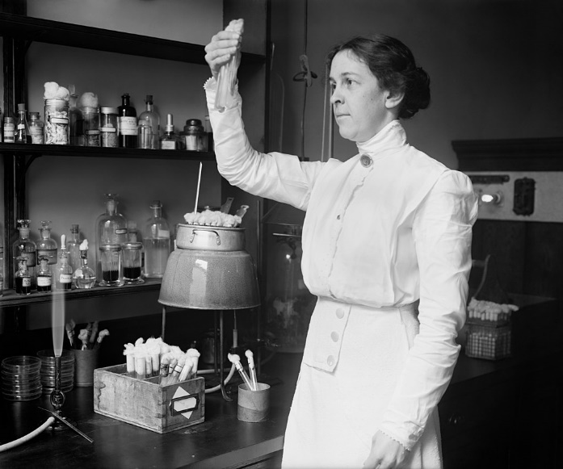

**(National Photo Company portrait, circa 1915)**

**Supporting data:** This huge group of bacteriophages are all temperate siphoviruses and as such are highly recombinogenic butVIRIDIC, ViPTree and phylogenetic analysis of the TerL proteins reveal that members of these three genera are distinct but related. Using CoreGenes 5.0 (https://coregenes.ngrok.io/) Bidirectional Best Hit analysis (below) indicates that only four proteins (lysin, DNA-binding protein and two hypothetical proteins) are conserved – approximately 8.5% of the proteins encoded by these phages. HHpred analyses failed to reveal the function of the two hypothetical proteins. This level of homologous proteins is in keeping with other families created by the Bacterial Viruses Subcommittee of ICTV.



**References**

1. Sayers EW, Beck J, Bolton EE, Bourexis D, Brister JR, Canese K, Comeau DC, Funk K, Kim S, Klimke W, Marchler-Bauer A, Landrum M, Lathrop S, Lu Z, Madden TL, O'Leary N, Phan L, Rangwala SH, Schneider VA, Skripchenko Y, Wang J, Ye J, Trawick BW, Pruitt KD, Sherry ST. Database resources of the National Center for Biotechnology Information. Nucleic Acids Res. 2021 Jan 8;49(D1):D10-D17. doi: 10.1093/nar/gkaa892. PMID: 33095870
2. Moraru C, Varsani A, Kropinski AM. VIRIDIC-A Novel Tool to Calculate the Intergenomic Similarities of Prokaryote-Infecting Viruses. Viruses. 2020 Nov 6;12(11):1268. doi: 10.3390/v12111268. PMID: 33172115; PMCID: PMC7694805. http://kronos.icbm.uni-oldenburg.de/viridic/
3. Nishimura Y, Yoshida T, Kuronishi M, Uehara H, Ogata H, Goto S. ViPTree: the viral proteomic tree server. Bioinformatics. 2017; 33(15):2379-2380. doi:10.1093/bioinformatics/btx157. PubMed PMID: 28379287. https://www.genome.jp/viptree/
4. Rohwer F, Edwards R. The Phage Proteomic Tree: a genome-based taxonomy for phage. J Bacteriol. 2002 Aug;184(16):4529-35. PubMed PMID: 12142423
5. Turner D, Reynolds D, Seto D, Mahadevan P. CoreGenes3.5: a webserver for the determination of core genes from sets of viral and small bacterial genomes. BMC Res Notes. 2013;6:140. doi: 10.1186/1756-0500-6-140. PMID: 23566564.
6. Dereeper A, Guignon V, Blanc G, Audic S, Buffet S, Chevenet F, Dufayard JF, Guindon S, Lefort V, Lescot M, Claverie JM, Gascuel O. Phylogeny.fr: robust phylogenetic analysis for the non-specialist. Nucleic Acids Res. 2008;36(Web Server issue):W465-9. doi: 10.1093/nar/gkn180. Epub 2008 Apr 19. PMID: 18424797.
7. Anisimova M, Gascuel O. Approximate likelihood-ratio test for branches: A fast, accurate, and powerful alternative. Syst Biol. 2006;55(4):539-52. PMID: 16785212. DOI: 10.1080/10635150600755453.
8. Turner D, Kropinski AM, Adriaenssens EM. A Roadmap for Genome-Based Phage Taxonomy. Viruses. 2021 Mar 18;13(3):506. doi: 10.3390/v13030506. PMID: 33803862; PMCID: PMC8003253.
9. O'Leary NA, Wright MW, Brister JR, Ciufo S, Haddad D, McVeigh R, et al. Reference sequence (RefSeq) database at NCBI: current status, taxonomic expansion, and functional annotation. Nucleic Acids Res. 2016;44(D1):D733-45. doi: 10.1093/nar/gkv1189. PMID: 26553804.
10. Olsen NS, Hendriksen NB, Hansen LH and Kot W. A New High-Throughput Screening Method for Phages: Enabling Crude Isolation and Fast Identification of Diverse Phages with Therapeutic Potential. Phage (New Rochelle) 1 (3), 137-148 (2020) https://www.liebertpub.com/doi/10.1089/phage.2020.0016
11. Lavelle K, Martinez I, Neve H, Lugli GA, Franz CMAP, Ventura M, Bello FD, Sinderen DV, Mahony J. Biodiversity of Streptococcus thermophilus Phages in Global Dairy Fermentations. Viruses. 2018 Oct 22;10(10):577. doi: 10.3390/v10100577. PMID: 30360457; PMCID: PMC6213268.
12. McDonnell B, Mahony J, Hanemaaijer L, Neve H, Noben JP, Lugli GA, Ventura M, Kouwen TR, van Sinderen D. Global Survey and Genome Exploration of Bacteriophages Infecting the Lactic Acid Bacterium Streptococcus thermophilus. Front Microbiol. 2017 Sep 12;8:1754. doi: 10.3389/fmicb.2017.01754. PMID: 28955321; PMCID: PMC5601072.
13. Szymczak P, Janzen T, Neves AR, Kot W, Hansen LH, Lametsch R, Neve H, Franz CMAP, Vogensen FK. Novel Variants of Streptococcus thermophilus Bacteriophages Are Indicative of Genetic Recombination among Phages from Different Bacterial Species. Appl Environ Microbiol. 2017 Feb 15;83(5):e02748-16. doi: 10.1128/AEM.02748-16. PMID: 28039135; PMCID: PMC5311409.