Part 1: TITLE, AUTHORS, APPROVALS, etc

Code assigned: | 2022.003A
Short title: Create two new orders, Juravirales and Magrovirales, including two and one new families of marine archaeal viruses, respectively
Author(s) and email address(es)
Zhou Y, Krupovic M, Wang Y | yifan.zhou@pasteur.fr; mart.krupovic@pasteur.fr; yjwang@shou.edu.cn
Author(s) institutional address(es) (optional)
Corresponding author
Krupovic M (mart.krupovic@pasteur.fr), Wang Y (yjwang@shou.edu.cn)
List the ICTV Study Group(s) that have seen this proposal
Archaeal Viruses Subcommittee
ICTV Study Group comments and response of proposer
ICTV Study Group votes on proposal
Study Group | Number of members
 | Votes support | Votes against | No vote
Authority to use the name of a living person
Is any taxon name used here derived from that of a living person (Y/N) | N

Taxon name | Person from whom the name is derived | Permission attached (Y/N)

Submission dates
Date first submitted to SC Chair
Date of this revision (if different to above)
ICTV-EC comments and response of the proposer
Accession numbers were not public at the time of the EC meeting. Now all are public.

Part 3: TAXONOMIC PROPOSAL
Name of accompanying Excel module
2022.003A.N.v1.Caudoviricetes_2no_3nf.xlsx
Abstract
Until recently, only a handful of archaeal tailed viruses have been officially classified. Here we propose creating two new orders. Order ‘Juravirales’ will include two new families of tailed viruses associated with ammonia-oxidizing marine archaea of the class Nitrososphaeria, whereas order ‘Magrovirales’ will include one new family ‘Aoguangviridae’ of viruses associated with marine archaea of the order Poseidoniales.
Text of proposal
Viruses with helical tails and icosahedral capsids (tailed viruses), classified into the class Caudoviricetes, represent the most widespread, abundant and diverse group of viruses on our planet. Members of the Caudoviricetes infect organisms from both prokaryotic domains, Bacteria and Archaea. Until recently, only a handful of archaeal tailed viruses have been officially classified. In 2022, 14 families of archaeal tailed viruses (arTVs) infecting halophilic and methanogenic hosts have been created [1]. However, arTVs infecting other groups of archaea, such as ecologically important ammonia-oxidizers of the class Nitrososphaeria or order Posidoniales, have also been described [2-6].

Metagenomic analysis of surface water samples collected in Yangshan harbor (Shanghai, China) yielded a number of viral contigs clustering with the previously described viruses affiliated to archaeal hosts of the class Nitrososphaeria and order Poseidoniales (previously known as Marine Group II Euryarchaeota) (Fig. 1). All these viruses encode hallmark proteins of the class Caudoviricetes, including the HK97-fold major capsid protein, portal, large subunit of the terminase and various tail proteins (Fig. 2), and hence are genuine members of this virus class. Five of the genomes in the Yangshan harbor dataset, namely, YSH_462411, YSH_174770, YSH_922147, YSH_1032793 and YSH_150918 (Fig. 2), could be assembled as circular contigs, strongly suggesting that they represent complete virus genomes. Four of these viruses, YSH_462411, YSH_174770, YSH_922147 and YSH_1032793, were associated with marine archaea of the class Nitrososphaeria, whereas YSH_150918 displayed considerable similarity to the previously characterized viruses associated with marine archaea of the order Poseidoniales (Fig. 1 and Fig. 2). Notably, none of the Poseidoniales viruses, known as Magroviruses [5], have been officially classified and none of their genomes have been deposited to GenBank, precluding their official classification. Here we propose the classification of viruses from the Yangshan dataset using as the basis the demarcation criteria established previously for classification of arTVs infecting halophilic and methanogenic archaea [1]:

Species demarcation: 95% nucleotide sequence identity.
Genus demarcation: more than 60% of shared proteins.
Family demarcation: members of the same family share 20-50% of homologous proteins, whereas viruses from different families share less than 10% of proteins.

The proportion of orthologous fraction in each archaeal virus genome was estimated using compareM (https://github.com/dparks1134/CompareM) with the E-value of 1e-5 and identity of 30%. The output file was then converted into matrix using tidyr (R package) and set for heatmap construction using pheatmap (R packages). This analysis showed that the four viruses of Nitrososphaeria display high sequence divergence, with few orthologs detected using the used thresholds (Fig. 3). The closest viruses, YSH_462411 and YSH_922147, shared only 21% of proteins. Thus, we propose classifying the four viruses associated with Ntrososphaeria into four species within four separate genera (Table 1). The Poseidoniales virus YSH_150918 showed similarity only to the unclassified magroviruses of group B [5]. Thus, we propose creating a new genus, ‘Aobingvirus’ for classification of YSH_150918.

We next analyzed the relationships between the five viruses in the context of the previously classified arTVs as well as unclassified marine arTVs associated with archaea of the class Nitrososphaeria (mathaviruses) and order Poseidoniales (magroviruses). The proteome-based ViPTree analysis [7] has accurately recovered all established families of haloarchaeal and methanogenic Caudoviricetes viruses [1]. Based on the same genetic distances (branch length of 0.05) observed between the established archaeal virus families, the four Nitrososphaeria viruses can be classified into 2 new families (Fig. 4). Although YSH_174770 shared less than 10% of orthologous proteins with YSH_922147, and in principle, the two viruses could be considered as representatives of separate families, they are connected through YSH_462411, with which they share 14% and 21% of orthologous proteins, respectively (Fig. 3). We expect that with the increased sampling of Nitrososphaeria viruses, this cluster will be further solidified and hence propose classifying YSH_462411, YSH_174770 and YSH_922147 into a single new family ‘Yangangviridae’. YSH_1032793 shared less than 10% of orthologous genes with other archaeal viruses and thus we propose classifying it into a separate family ‘Yanlukaviridae’. The high dissimilarity of this virus from the other Nitrososphaeria viruses is also evident from genome map comparisons (Fig. 2).

Given that viruses from the two proposed families display considerably gene content similarity and form a clade in the ViPTree proteome-based tree (Fig. 4), we propose unifying them within a new order ‘Juravirales’. The low pairwise similarity between these viruses but overall conservation of the gene contents emphasizes a scarce sampling of the Nitrososphaeria viruses.

Poseidoniales viruses (magroviruses) consistently form 3 family level groups in our ViPTree analysis (Fig. 4) as well as in the previously published studies [5]. One of these groups is now represented by YSH_150918 and we propose creating a new family, ‘Aoguangviridae‘, for its classification. Although the two other magrovirus groups currently lack representatives with complete genome sequences in GenBank, we believe that representative genomes will become available in the near future either through metagenomics sequencing efforts or as third party annotations. With this anticipation, we propose creating a monotypic order ‘Magrovirales’, which will include ‘Aoguangviridae‘.

Etymology of the proposed taxon names:
Orders
- Juravirales – from Lithuanian word jūra, which means sea;
- Magrovirales – truncation of Marine Group II Euryarchaeota, historical name of Poseidoniales archaea; besides, name magroviruses has been coined in the first publication [5] describing this group of archaeal viruses.

Families
- Yangangviridae – truncation of Yangshan and gang (harbor in Chinese);
- Yanlukaviridae – truncation of Yangshan and luka (harbor in Croatian);
- Aoguangviridae – after Aoguang, the Dragon King of the East China Sea in ancient Chinese myths and legends.

Genera
- Nohelivirus – truncation of ‘no MCM helicase’ virus;
- Senitvirus – truncation of sea Nitrososphaeria virus;
- Mathaucavirus – truncation of marine thaumarchaeal Caudoviricetes virus;
- Sweetvirus – the name is based on the finding that the sole member of this genus, YSH_1032793, encodes a saccharide transporter of the SWEET superfamily;
- Aobingvirus – after Aobing, son of Aoguang.

Supporting evidence

Table 1. Proposed taxonomy of marine archaeal viruses associated with Nitrososphaeria and Poseidoniales.
Order | Family | Genus | Species | Virus name | Genome length (bp) | Accession number
Juravirales | Yangangviridae | Nohelivirus | Nohelivirus yangshanense | Nitrososphaeria virus YSH_462411 | 36645 | ON649699
 |  | Senitvirus | Senitvirus yangshanense | Nitrososphaeria virus YSH_174770 | 36856 | ON649700
 |  | Mathaucavirus | Mathaucavirus yangshanense | Nitrososphaeria virus YSH_922147 | 38245 | ON649701
 | Yanlukaviridae | Sweetvirus | Sweetvirus yangshanense | Nitrososphaeria virus YSH_1032793 | 35889 | ON649698
Magrovirales | Aoguangviridae | Aobingvirus | Aobingvirus yangshanense | Poseidoniales virus YSH_150918 |  | ON649702

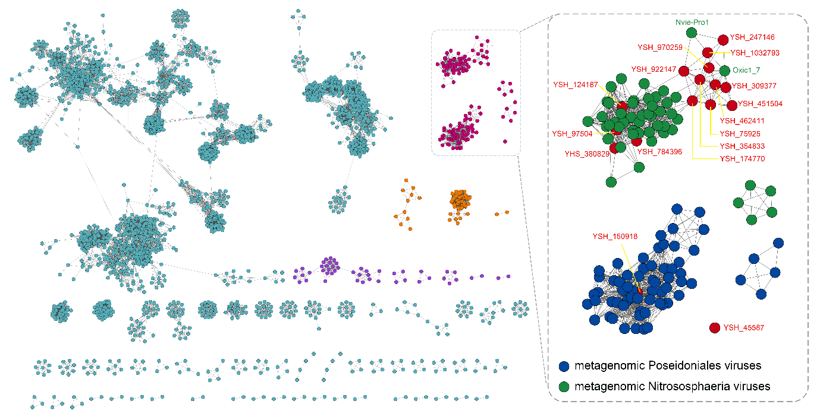

Figure 1. The gene-sharing networks of YSH archaeal viruses and reference prokaryotic DNA viruses constructed by vConTACT2 [8]. Each node represents a viral genome, and the edges between genomes represent the degree of connectivity based on the fraction of shared proteins. Nodes for classified archaeal tailed viruses are colored orange, other classified archaeal viruses are in purple, bacteriophages are in lake blue, whereas unclassified marine archaeal viruses, including those from the Yangshan dataset, are shown in magenta (left panel). More detailed view on the nodes corresponding to the YSH archaeal viruses, metagenomic Poseidoniales viruses and Nitrososphaeria viruses are shown on the right. Yangshan virus genomes are shown in red, whereas uncultured and unclassified viruses of Nitrososphaeria and Poseidoniales are in green and blue, respectively.

Figure 2. Genome maps of marine archaeal viruses from the Yangshan dataset. A. Genome map of Poseidoniales virus YSH_150918 compared to the previously reported genome of a Group B Magrovirus. B. Genome maps of four Nitrososphaeria viruses. Related genes are linked by turquoise shading. Genes sharing significant similarity (BLASTp E-value <10-5, bitscore >50) are linked grey shadings, the intensity of which correspond to sequence identity (see the scale at the bottom of the figure). Abbreviations: MTP, major tail protein; MCP, major capsid protein; Pro, prohead protease; terL, terminase large subunit; MCM helicase, minichromosome maintenance helicase; DEDDy exo, DEDDy 3'-5' exonuclease domain of family-B DNA polymerases; tail TMP, tail tape measure protein; GTase, glycosyltransferase; LamG domain, Laminin G-like domain; MTase, DNA-adenine methyltransferase; TR, transcriptional regulator; RNR_II_monomer, class II ribonucleotide reductase monomeric form; GcrA, cell cycle regulator GcrA; DPSC, DNA polymerase sliding clamp; CL, clamp-loader.

Figure 3. Heatmap of orthologous fraction among archaeal tailed viruses. Values ≥ 0.08 shown in the boxes. The proportion of orthologous contents for family-level demarcation is around 0.1. Viruses for which new taxa are proposed are highlighted with the colored background.

Figure 4. Classification of archaeal Caudoviricetes. The Viral Proteomic Tree (ViPTree) of archaeal tailed viruses. Viruses for which new taxa are proposed are highlighted with the colored background. The tree is constructed using BIONJ based on all-versus-all genomic similarity matrix, and mid-point rooted. Branch lengths are log-scaled. The branch length for family-level demarcation is around 0.05 (red dashed line).

References
1. Liu Y, Demina TA, Roux S, Aiewsakun P, Kazlauskas D, Simmonds P, Prangishvili D, Oksanen HM, Krupovic M (2021) Diversity, taxonomy, and evolution of archaeal viruses of the class Caudoviricetes. PLOS Biology 19:e3001442. PMID: 34752450. doi: 10.1371/journal.pbio.3001442.
2. Chow CE, Winget DM, White RA 3rd, Hallam SJ, Suttle CA (2015) Combining genomic sequencing methods to explore viral diversity and reveal potential virus-host interactions. Front Microbiol 6:265. PMID: 25914678. doi: 10.3389/fmicb.2015.00265.
3. Ahlgren NA, Fuchsman CA, Rocap G, Fuhrman JA (2019) Discovery of several novel, widespread, and ecologically distinct marine Thaumarchaeota viruses that encode amoC nitrification genes. ISME J 13(3):618-631. PMID: 30315316. doi: 10.1038/s41396-018-0289-4.
4. López-Pérez M, Haro-Moreno JM, de la Torre JR, Rodriguez-Valera F (2019) Novel Caudovirales associated with Marine Group I Thaumarchaeota assembled from metagenomes. Environ Microbiol 21(6):1980-1988. PMID: 30370610. doi: 10.1111/1462-2920.14462.
5. Philosof A, Yutin N, Flores-Uribe J, Sharon I, Koonin EV, Béjà O (2017) Novel Abundant Oceanic Viruses of Uncultured Marine Group II Euryarchaeota. Curr Biol 27(9):1362-1368. doi: 10.1016/j.cub.2017.03.052. PMID: 28457865
Environmental Viral Genomes Shed New Light on Virus-Host Interactions in the Ocean.
6. Nishimura Y, Watai H, Honda T, Mihara T, Omae K, Roux S, Blanc-Mathieu R, Yamamoto K, Hingamp P, Sako Y, Sullivan MB, Goto S, Ogata H, Yoshida T (2017) mSphere 2(2):e00359-16. doi: 10.1128/mSphere.00359-16. PMID: 28261669
7. Nishimura Y, Yoshida T, Kuronishi M, Uehara H, Ogata H, Goto S (2017) ViPTree: the viral proteomic tree server. Bioinformatics 33:2379-2380. PMID: 28379287. doi: 10.1093/bioinformatics/btx157.
8. Bin Jang H, Bolduc B, Zablocki O, Kuhn JH, Roux S, Adriaenssens EM, Brister JR, Kropinski AM, Krupovic M, Lavigne R, Turner D, Sullivan MB (2019) Taxonomic assignment of uncultivated prokaryotic virus genomes is enabled by gene-sharing networks. Nature Biotechnology 37:632-639. PMID: 31061483. doi: 10.1038/s41587-019-0100-8.

