Part 1: TITLE, AUTHORS, APPROVALS, etc

Code assigned: | 2022.014M
Short title: Establishment of thirteen new species in genera Auricularimonavirus, Hubranonavirus, Lentimonavirus, Penicilliumonavirus, Plasmopamonavirus and Sclerotimonavirus in family Mymonaviridae (Mononegavirales)
Author(s) and email address(es)
Jiang D, Ayllón MA, Marzano S-Y, Kondo H, Turina M | Daohongjiang@mail.hzau.edu.cn; mariaangeles.ayllon@upm.es; shinyi.marzano@usda.gov;  hkondo@okayama-u.ac.jp; massimo.turina@ipsp.cnr.it
Author(s) institutional address(es) (optional)
Huazhong Agricultural University [DJ]
Universidad Politécnica de Madrid (UPM) [MAA]
United States Department of Agriculture, Agricultural Research Service [SYLM]
Okayama University [HK]
Institute for Sustainable Plant Protection, CNR [MT]
Corresponding author
Jiang D
List the ICTV Study Group(s) that have seen this proposal
ICTV Mymonaviridae Study Group
ICTV Study Group comments and response of proposer
Approved.
ICTV Study Group votes on proposal

Study Group | Number of members
 | Votes support | Votes against | No vote
ICTV Mymonaviridae Study Group | 5 | 0 | 0
Authority to use the name of a living person
Is any taxon name used here derived from that of a living person (Y/N) | N

Taxon name | Person from whom the name is derived | Permission attached (Y/N)

Submission dates
Date first submitted to SC Chair | May 27, 2022
Date of this revision (if different to above)
ICTV-EC comments and response of the proposer

Part 2: NON-TAXONOMIC PROPOSAL
Text of proposal

Part 3: TAXONOMIC PROPOSAL
Name of accompanying Excel module
2022.014M.N.v1.Mymonaviridae_13nsp.xlsx
Abstract
We propose the establishment of one new species in genus Auricularimonavirus, three in genus Hubranonavirus, one in genus Lentimonavirus, four in genus Penicilliumonavirus, one in genus Plasmopamonavirus and thee in genus Sclerotimonavirus, all in mononegaviral family Mymonaviridae.
Text of proposal
The monjiviricete family Mymonaviridae currently includes nine genera. Genera Auricularimonavirus, Hubramonavirus, Lentimonavirus, Penicillimonavirus, Plasmopamonavirus and Sclerotimonavirus include two, two, one, ten, one and fourteen species, respectively. We searched the NCBI database for novel mymonavirids and found that, based upon available coding-complete genome sequences, several novel viruses should be classified into a total of thirteen novel species in genera Auricularimonavirus, Hubramonavirus, Lentimonavirus, Penicillimonavirus, Plasmopamonavirus and Sclerotimonavirus (Table 1). The phylogenetic analysis and alignment of selected viruses are shown in Figures 1 and 2. 32% L protein amino acid sequence identity is proposed as a genus rank demarcation threshold. The demarcation criteria for species (80%) and genus demarcation (32%) in the family Mymonaviridae also are supported by the result of phylogenetic analysis.

Supporting evidence

Table 1 Newly proposed species of the family Mymonaviridae

Genus name | New species name | Newly identified virus | Accession number | Host | Reference
Auricularimonavirus | Auricularimonavirus armillariae | Armillaria mellea negative strand RNA virus 2 | BK014417 | Fungi, Armillaria mellea | 1
Hubramonavirus | Hubramonavirus fusarii | Fusarium oxysporum mymonavirus 1 | OM049502 | Fungi, Fusarium oxysporum | 2
 | Hubramonavirus vitis | Grapevine-associated mononega-like virus 3 | MW648481 | Grapevine associated | 3
 | Hubramonavirus golovinomycesae | Golovinomyces cichoracearum GcM3_contig_4635 | MCBQ01018032 | Golovinomyces cichoracearum | 4
Lentimonavirus | Lentimonavirus armillariae | Armillaria mellea negative strand RNA virus 1 | MW423801 | Fungi, Armillaria mellea | 1
Penicillimonavirus | Penicillimonavirus magnaporthe | Magnaporthe oryzae mononegaambi virus 1 | MW752165 | Fungi, Magnaporthe oryzae | NCBI:txid2838328
 |  | Magnaporthe oryzae mononegaambi virus 1 | MW752172 | Fungi, Magnaporthe oryzae | NCBI:txid2838328
 | Penicillimonavirus alphaerysiphe | Erysiphe necator associated negative-stranded RNA virus 2 | MN617061 | Fungi, Erysiphe necator | NCBI:txid2737064
 | Penicillimonavirus betaerysiphe | Erysiphe necator associated negative-stranded RNA virus 5 | MN617042 | Fungi, Erysiphe necator | NCBI:txid2737072
 | Penicillimonavirus gammaerysiphe | Erysiphe necator associated negative-stranded RNA virus 6 | MN617052 | Fungi, Erysiphe necator | NCBI:txid2737073
Plasmopamonavirus | Plasmopamonavirus erysiphe | Erysiphe necator associated negative-stranded RNA virus 23 | MN617053 | Fungi, Erysiphe necator | NCBI:txid2737068
Sclerotimonavirus | Sclerotimonavirus asiafusarii | Fusarium asiaticum negative-stranded RNA virus 1 | MZ969066 | Fungi, Fusarium asiaticum | NCBI:txid2921215
 | Sclerotimonavirus xinjiangense | Xinjiang mymona-like virus 2 | MW897041 | Soil associated | 5
 | Sclerotimonavirus yunnanense | Yunnan mymona-like virus 1 | MW897022 | Soil associated | 5

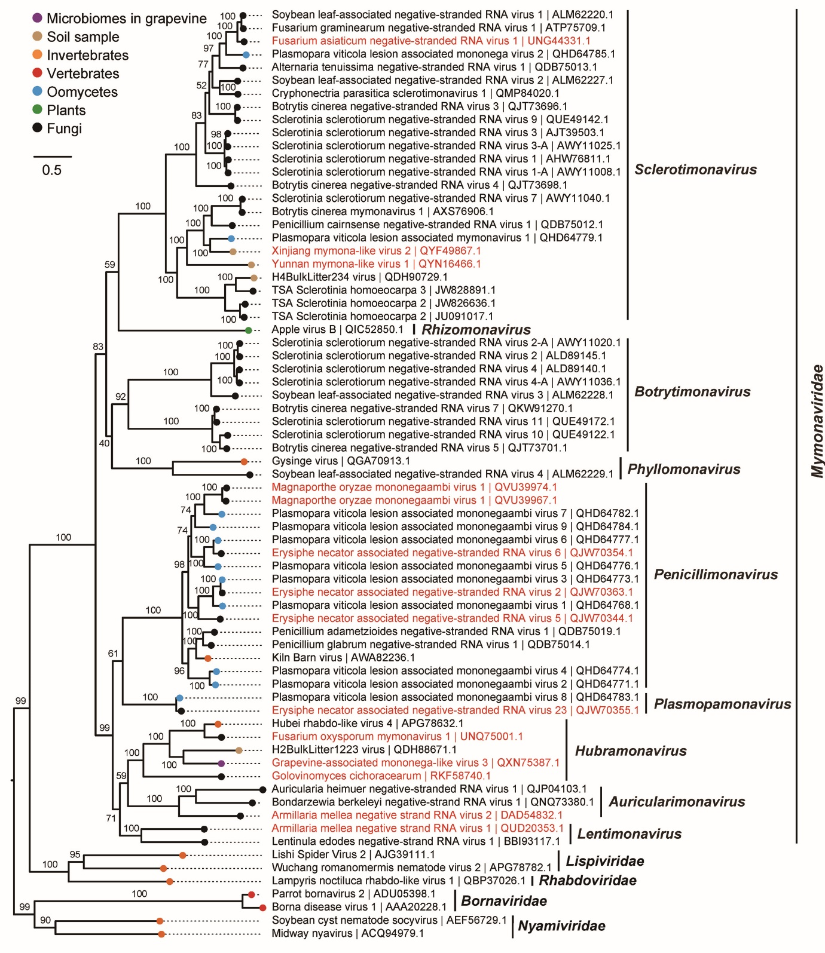
Figure 1 Phylogenetic tree of the expanded and reorganized family Mymonaviridae. A maximum likelihood phylogenetic tree was constructed based on the multiple amino acid sequence alignment of the RNA-directed RNA polymerase (RdRp) using IQ-TREE (version 1.6.11) [1] with the best-fit model “LG+F+R6”. The tree was midpoint-rooted for clarity of presentation and 1,000 bootstrap replicates were performed. Nguyen L-T, Schmidt HA, von Haeseler A, Minh BQ. IQ-TREE: a fast and effective stochastic algorithm for estimating maximum-likelihood phylogenies. Mol Biol Evol. 2015; 32:268-274. Viruses classified in families Lispiviridae, Rhabdoviridae, Nyamiviridae, and Bornaviridae were used as outgroups. Newly identified viruses are written in red.

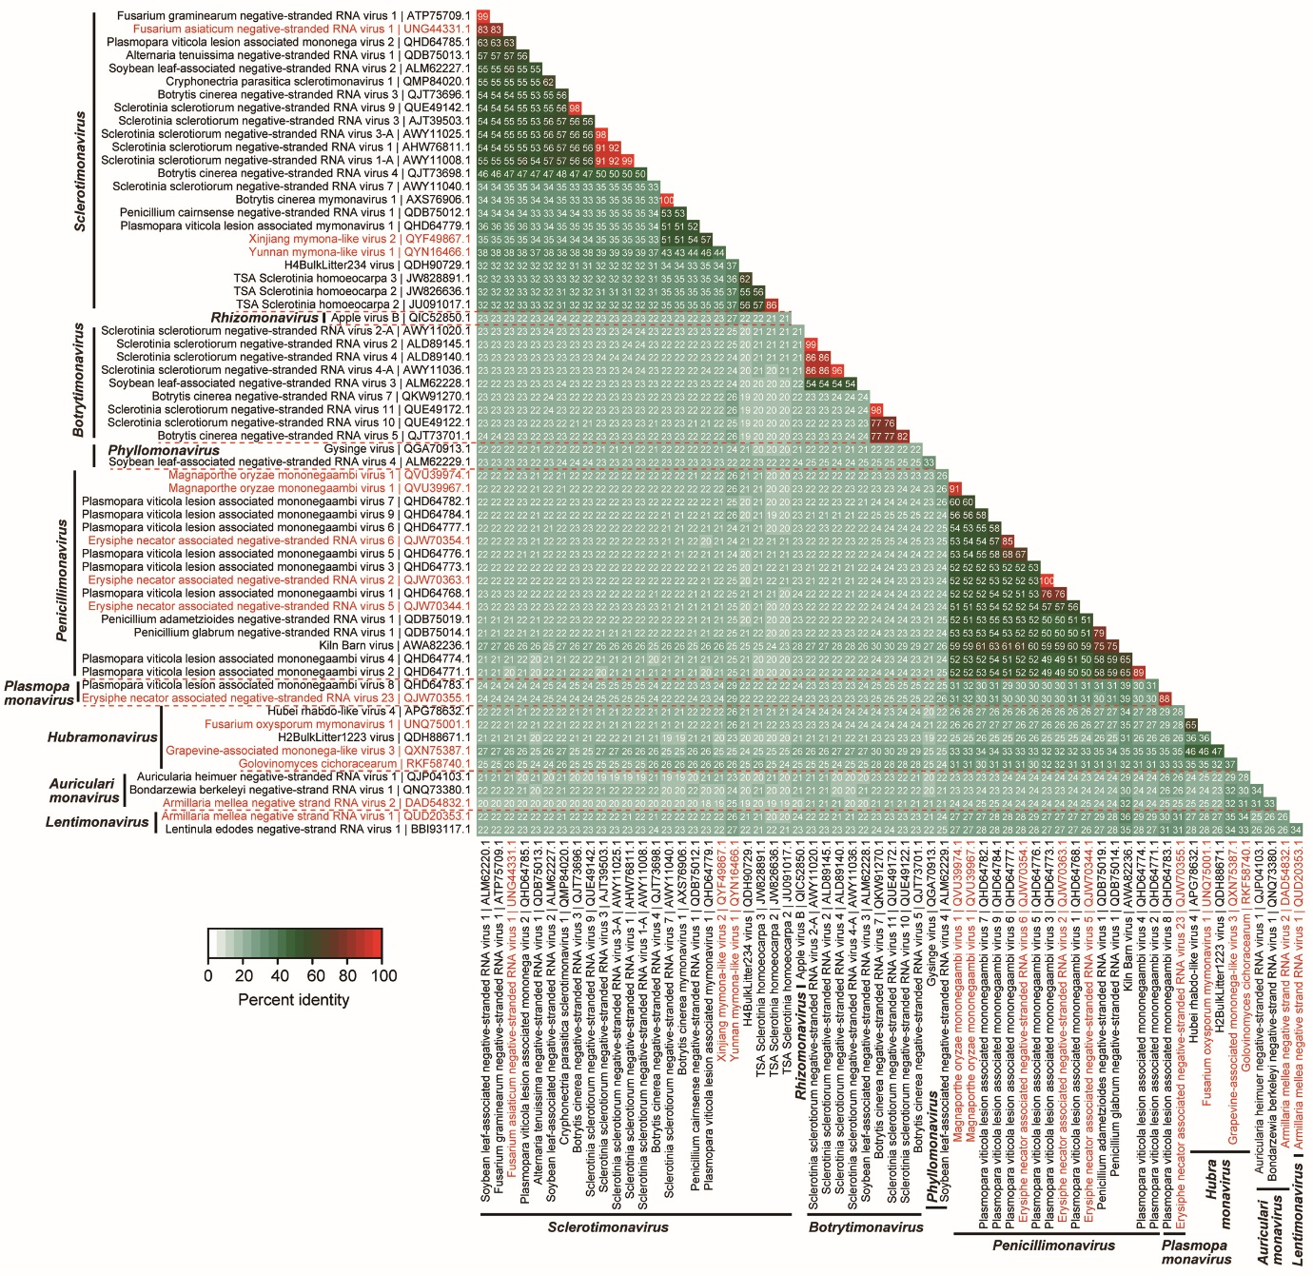

Figure 2 Matrix diagram of amino acid identities of L proteins among members of the expanded and reorganized family Mymonaviridae. The percent identity matrix was created via multiple sequence alignment using Clustal Omega. Percent identity matrices were converted to heat map plots using a custom R script. Newly identified viruses are written in red.

References
- Linnakoski R, Sutela S, Coetzee MPA, Duong TA, Pavlov IN, Litovka YA, Wingfield HJ, Vainio EJ (2021) Armillaria root rot fungi host single-stranded RNA viruses. Scientific Reports 11(1):7336. doi: 10.1038/s41598-021-86343-7.
- Wang J, Li C, Song P, Qiu R, Song R, Li X, Ni Y, Zhao H, Liu H and Li S (2022) Molecular and biological characterization of the first mymonavirus identified in Fusarium oxysporum. Frontier in Microbiology 13:870204. doi.org/10.3389/fmicb.2022.870204
- Nerva L, Garcia JF, Favaretto F, Giudice G, Moffa L, Sandrini M, Cantu D, Zanzotto A, Gardiman M, Velasco R, Gambino G, Chitarra W (2022) The hidden world within plants: metatranscriptomics unveils the complexity of wood microbiomes. Journal of Experimental Botany 73(8):2682-2697. doi: 10.1093/jxb/erac032.
- Wu Y, Ma X, Pan Z, Kale SD, Song Y, King H, Zhang Q, Presley C, Deng X, Wei CI, Xiao S (2018) Comparative genome analyses reveal sequence features reflecting distinct modes of host-adaptation between dicot and monocot powdery mildew. BMC Genomics 19(1):705. doi: 10.1186/s12864-018-5069-z.
- Chen, Yan-Mei and Chen, Yan-Mei and Sadiq, Sabrina and Tian, Jun-Hua and Chen, Xiao and Lin, Xian-Dan and Shen, Jin-Jin and Chen, Hao and Hao, Zong-Yu and Yang, Wei-Di and Zhou, Zhuo-Cheng and Wu, Jun and Li, Feng and Wang, Hong-Wei and Xu, Qi-Yi and Wang, Wen and Gao, Wen-Hua and Holmes, Edward C. and Zhang, Yong-Zhen, RNA Virome Composition Is Shaped by Sampling Ecotype. http://dx.doi.org/10.2139/ssrn.3934022
- Nguyen LT, Schmidt HA, von Haeseler A, Minh BQ (2015) IQ-TREE: a fast and effective stochastic algorithm for estimating maximum-likelihood phylogenies. Mol Biol Evol 32:268-74. doi: 10.1093/molbev/msu300.

