Part 1: TITLE, AUTHORS, APPROVALS, etc

Code assigned: | 2022.021M
Short title: Create nine new species in the genus Varicosavirus, subfamily Betarhabdovirinae (Mononegavirales: Rhabdoviridae)
Author(s) and email address(es)
Bejerman N, Debat H, Dietzgen RG, Kondo H, Ramos-González P, Whitfield AE, Walker PJ, Freitas-Astúa J | bejerman.nicolas@inta.gob.ar;  debat.humberto@inta.gob.ar;  r.dietzgen@uq.edu.au; hkondo@rib.okayama-u.ac.jp;  plrg1970@gmail.com;  awhitfi@ncsu.edu;  peter.walker@uq.edu.au;  juliana.astua@embrapa.br
Author(s) institutional address(es) (optional)
Corresponding author
Bejerman N
List the ICTV Study Group(s) that have seen this proposal

ICTV Rhabdoviridae Study Group
ICTV Study Group comments and response of proposer

Minor corrections
ICTV Study Group votes on proposal

Study Group | Number of members
 | Votes support | Votes against | No vote
ICTV Rhabdoviridae Study Group | 11 | 0 | 3
Authority to use the name of a living person

Is any taxon name used here derived from that of a living person (Y/N) | N

Taxon name | Person from whom the name is derived | Permission attached (Y/N)

Submission dates
Date first submitted to SC Chair | May 23, 2022
Date of this revision (if different to above)
ICTV-EC comments and response of the proposer

Part 2: NON-TAXONOMIC PROPOSAL
Text of proposal
Part 3: TAXONOMIC PROPOSAL
Name of accompanying Excel module
2022.021M.N.v1.Varicosavirus_9nsp.xlsx
Abstract
Viruses classified in the family Rhabdoviridae infect vertebrates, invertebrates, and plants. Nine new plant-infecting rhabdoviruses were discovered recently and their complete or coding-complete genome sequences were determined. This proposal aims to classify taxonomically these viruses in nine new species in the genus Varicosavirus.
Text of proposal
We propose the taxonomic classification of nine novel plant-infecting rhabdoviruses in nine new species in the established genus Varicosavirus in the subfamily Betarhabdovirinae, family Rhabdoviridae:

1) Allium angulosum virus 1 (AAnV1) was identified during an in silico analysis of transcriptome data of mouse garlic (Allium angulosum L.) tissues from Brno, Czech Republic. The AAnV1 genome is bi-segmented with a coding-complete genome (CCG) RNA1 of 6679 nucleotides and RNA2 of 4560 nucleotides (GenBank #BK059208 and BK059209) [1]. RNA1 contains one large ORF for the large protein (L), whereas RNA2 contains three ORFs (Figure 1). The nucleotide sequence of AAnV1 L has the highest sequence identity with that of Brassica rapa virus 1 (BrRV1; 61.61%) (Table 1). Based on ML trees generated from complete L sequences, AAnV1 is placed within a subclade of varicosaviruses with BrRV1 and red clover-associated varicosavirus (Figure 2).

2) Brassica rapa virus 1 (BrRV1) was identified during an in silico analysis of transcriptome data of bok choy (Brassica rapa subsp. chinensis L.) tissues from Guangdong, China. The BrRV1 genome is bi-segmented with a coding-complete genome (CCG) RNA1 of 6397 nucleotides and RNA2 of 4068 nucleotides (GenBank #BK014310 and BK014311) [1]. RNA1 contains one large ORF encoding L, whereas RNA2 contains three ORFs (Figure 1). The nucleotide sequence of BrRV1 L has the highest sequence identity with that of red clover-associated varicosavirus (RCaVV; 63%) (Table 1). Based on ML trees generated from complete L sequences, BrRV1 forms a well-supported clade with the varicosavirus RCaVV (Figure 2).

3) Lolium perenne virus 1 (LoPV1) was identified during an in silico analysis of transcriptome data of perennial ryegrass (Lolium perenne L.) tissues from Store Heddinge, Denmark. The LoPV1 genome is bi-segmented with a coding-complete genome (CCG) RNA1 of 6302 nucleotides and RNA2 of 4167 nucleotides (GenBank #BK014312 and BK014313) [1]. RNA1 contains one large ORF encoding L, whereas RNA2 contains three ORFs (Figure 1). The nucleotide sequence of LoPV1 L has the highest sequence identity with that of Alopecurus myesuroides varicosavirus 1 (AMVV1; 70.07%) (Table 1). Based on ML trees generated from complete L sequences, LoPV1 forms a well-supported clade with the varicosavirus AMVV1 (Figure 2).

4) Melampyrum roseum virus 1 (MelRoV1) was identified during an in silico analysis of transcriptome data of Asian cow-wheat (Melampyrum roseum Maxim) tissues from Kanagawa, Japan. The MelRoV1 genome is bi-segmented with a coding-complete genome (CCG) RNA1 of 6409 nucleotides and RNA2 of 5288 nucleotides (GenBank #BK014314 and BK014315) [1]. RNA1 contains one large ORF encoding L, whereas RNA2 contains four ORFs (Figure 1). The nucleotide sequence of MelRoV1 L has the highest sequence identity with that of Zostera-associated varicosavirus 1(ZaVV1; 62.11%) (Table 1). Based on ML trees generated from complete L sequences, MelRoV1 is placed within a subclade of varicosaviruses with morning glory varicosavirus, Vitis varicosavirus and ZaVV1 (Figure 2).

5) Morning glory varicosavirus (MGVV) was identified in tall morning glory plants (Ipomoea purpurea (L.) Roth) from Henan, China. The MGVV genome is bi-segmented with a complete genome (CG) RNA1 of 6365 nucleotides and RNA2 of 4635 nucleotides (GenBank #MW922438 and MW922439) [2]. RNA1 contains one large ORF encoding L, whereas RNA2 contains four ORFs (Figure 1). The nucleotide sequence of MGVV L has the highest sequence identity with that of Zostera-associated varicosavirus 1(ZaVV1; 62.05%) (Table 1). Based on ML trees generated from complete L sequences, MGVV is placed within a subclade of varicosaviruses with Melampyrum roseum virus 1, Vitis varicosavirus, and ZaVV1 (Figure 2).

6) Pinus flexilis virus 1 (PiFleV1) was identified during an in silico analysis of transcriptome data of limber pine (Pinus flexilis E. James) from Oregon, USA. The coding-complete genome (CCG) sequence of PiFleV1 has 11,740 nucleotides (GenBank #BK014316) [1], and contains five ORFs (Figure 1). The PiFleV1 is unique among the varicosaviruses in terms of genome organization, since its genome is unsegmented, a characteristic that differs from all other known varicosaviruses, which have bi-segmented genomes [1]. The nucleotide sequence of PiFleV1 L protein has the highest sequence identity with that of Lolium perenne virus 1 (59.86%) (Table 1). Based on ML trees generated from complete L sequences, PiFleV1 forms a well-supported clade with other varicosaviruses (Figure 2).

7) Vitis varicosavirus (VVV) was identified in crimson glory vine plants (Vitis coignetiae Pulliat ex Planch) from Hokkaido, Japan. The VVV genome is bi-segmented with a coding-complete genome (CCG) RNA1 of 6450 nucleotides and RNA2 of 5535 nucleotides (GenBank #LC604719 and LC604720) [3]. RNA1 contains one large ORF encoding L, whereas RNA2 contains five ORFs (Figure 1). The nucleotide sequence of VVV has the highest sequence identity with that of Zostera-associated varicosavirus 1 (ZaVV1; 62.57%) (Table 1). Based on ML trees generated from complete sequences, VVV is placed within a subclade of varicosaviruses with Melampyrum roseum virus 1, morning glory varicosavirus, and ZaVV1 (Figure 2).

8) Xinjiang varicosavirus (XVV) was identified from soil samples collected in Xinjiang, China. The XVV genome is bi-segmented with a coding-complete genome (CCG) RNA1 of 6729 nucleotides and RNA2 of 5849 nucleotides (GenBank #MW897032 and MW897033) [4]. RNA1 contains one large ORF encoding L, whereas RNA2 contains five ORFs (Figure 1). The nucleotide sequence of XVV L has the highest sequence identity with that of lettuce big vein-associated virus (LBVaV; 66.45%) (Table 1). Based on ML trees generated from complete L sequences, XVV forms a well-supported clade with the varicosavirus LBVaV (Figure 2).

9) Zostera-associated varicosavirus 1 (ZaVV1) was identified during an in silico analysis of transcriptome data of common eelgrass (Zostera marina L.) tissues from Shandong, China. The ZaVV1 genome is bi-segmented with a coding-complete genome (CCG) RNA1 of 6632 nucleotides and RNA2 of 4304 nucleotides (GenBank #BK014484 and BK014485) [5]. RNA1 contains one large ORF encoding L, whereas RNA2 contains four ORFs (Figure 1). The nucleotide sequence of ZaVV1 L has the highest sequence identity with that of Vitis varicosavirus (VVV; 62.57%) (Table 1). Based on ML trees generated from complete L sequences, ZaVV1 is placed within a subclade of varicosaviruses with Melampyrum roseum virus 1, morning glory varicosavirus and VVV (Figure 2).

Current species demarcation criteria proposed for the genus Varicosavirus by the ICTV Rhabdoviridae Study Group are:
Viruses assigned to different species within the genus Varicosavirus have several of the following characteristics: A) the nucleotide sequence identity of complete genomes is lower than 75%; B) they occupy different ecological niches as evidenced by differences in hosts and/or chytrid vectors; and C) they can be clearly distinguished in serological tests or by nucleic acid hybridisation.

AAnV1, BrRV1, LoPV1, MelRoV1, MGVV, PiFleV1, VVV, XVV, and ZaVV1 meet criteria A and B. Consequently, we propose to classify AAnV1, BrRV1, LoPV1, MelRoV1, MGVV, PiFleV1, VVV, XVV, and ZaVV1 into nine new species

Supporting evidence

Table 1. Varicosavirus L ORF Percent Identity Matrix - created by SDT v1.2

Virus | AAnV1 | AMVV1 | BrRV1 | LBVaV | LoPV1 | MelRoV1 | MGVV | PiFleV1 | RCaVV | VVV | XVV | ZaVV1
AAnV1 | 100
AMVV1 | 59.54 | 100
BrRV1 | 61.61 | 59.09 | 100
LBVaV | 57.51 | 59.05 | 57.94 | 100
LoPV1 | 60.57 | 70.07 | 60.38 | 60.31 | 100
MelRoV1 | 60.53 | 59.80 | 60.96 | 57.58 | 60 | 100
MGVV | 59.75 | 60.27 | 60.53 | 59.71 | 59.17 | 61.84 | 100
PiFleV1 | 58.94 | 59.04 | 58.37 | 58.93 | 59.86 | 57.86 | 57.77 | 100
RCaVV | 60.61 | 60.67 | 63 | 58.81 | 60.64 | 59.57 | 59.88 | 59.84 | 100
VVV | 60.6 | 58.38 | 59.22 | 58.73 | 58.00 | 61.52 | 61.26 | 58.00 | 59.68 | 100
XVV | 58.35 | 58.54 | 58.64 | 66.45 | 59.38 | 59.48 | 60.14 | 59.19 | 58.49 | 59.02 | 100
ZaVV1 | 59.41 | 59.65 | 59.7 | 57.97 | 60.36 | 62.11 | 62.05 | 58.57 | 60.20 | 62.57 | 59.67 | 100

Virus name abbreviations: Allium angulosum virus 1 (AAnV1), Allopecurus myesuroides varicosavirus 1 (AMVV1), Brassica rapa virus 1 (BrRV1), lettuce big vein-associated virus (LBVaV), Lolium perenne virus 1 (LoPV1), Melampyrum roseum virus 1 (MelRoV1), morning glory varicosavirus (MGVV), Pinus flexilis virus 1 (PiFleV1), red clover-associated varicosavirus (RCaVV), Vitis varicosavirus (VVV), Xinjiang varicosavirus (XVV) and Zostera-associated varicosavirus (ZaVV1).

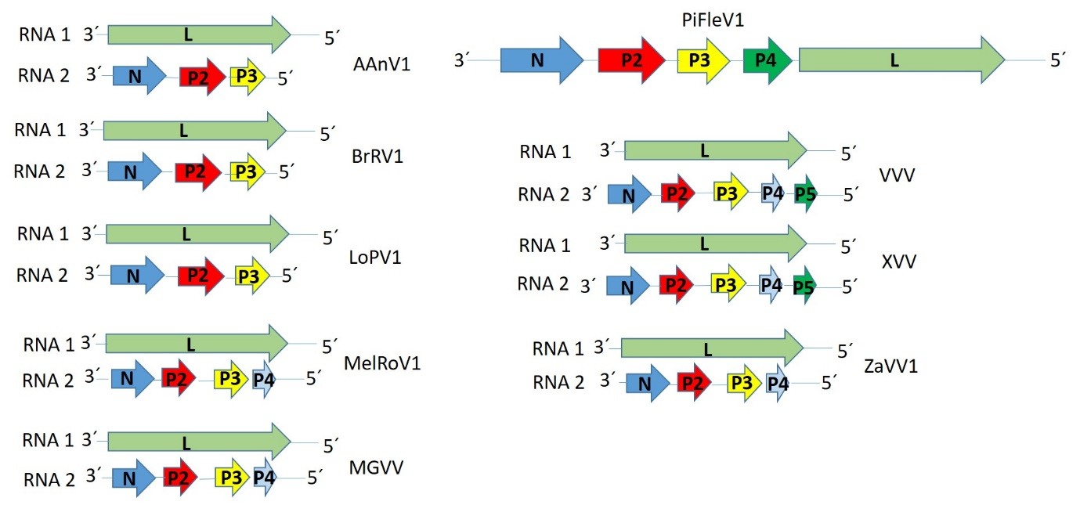

Figure 1. Genome graphs depicting architecture and gene products of viruses proposed to be included in species within genus Varicosavirus. Abbreviations: N: nucleoprotein; P2: protein 2; P3: protein 3; P4: protein 4; P5: protein 5; L: large protein. Virus name abbreviations: Allium angulosum virus 1 (AAnV1), Brassica rapa virus 1 (BrRV1), Lolium perenne virus 1 (LoPV1), Melampyrum roseum virus 1 (MelRoV1), morning glory varicosavirus (MGVV), Pinus flexilis virus 1 (PiFleV1), Vitis varicosavirus (VVV), Xinjiang varicosavirus (XVV) and Zostera-associated varicosavirus (ZaVV1).

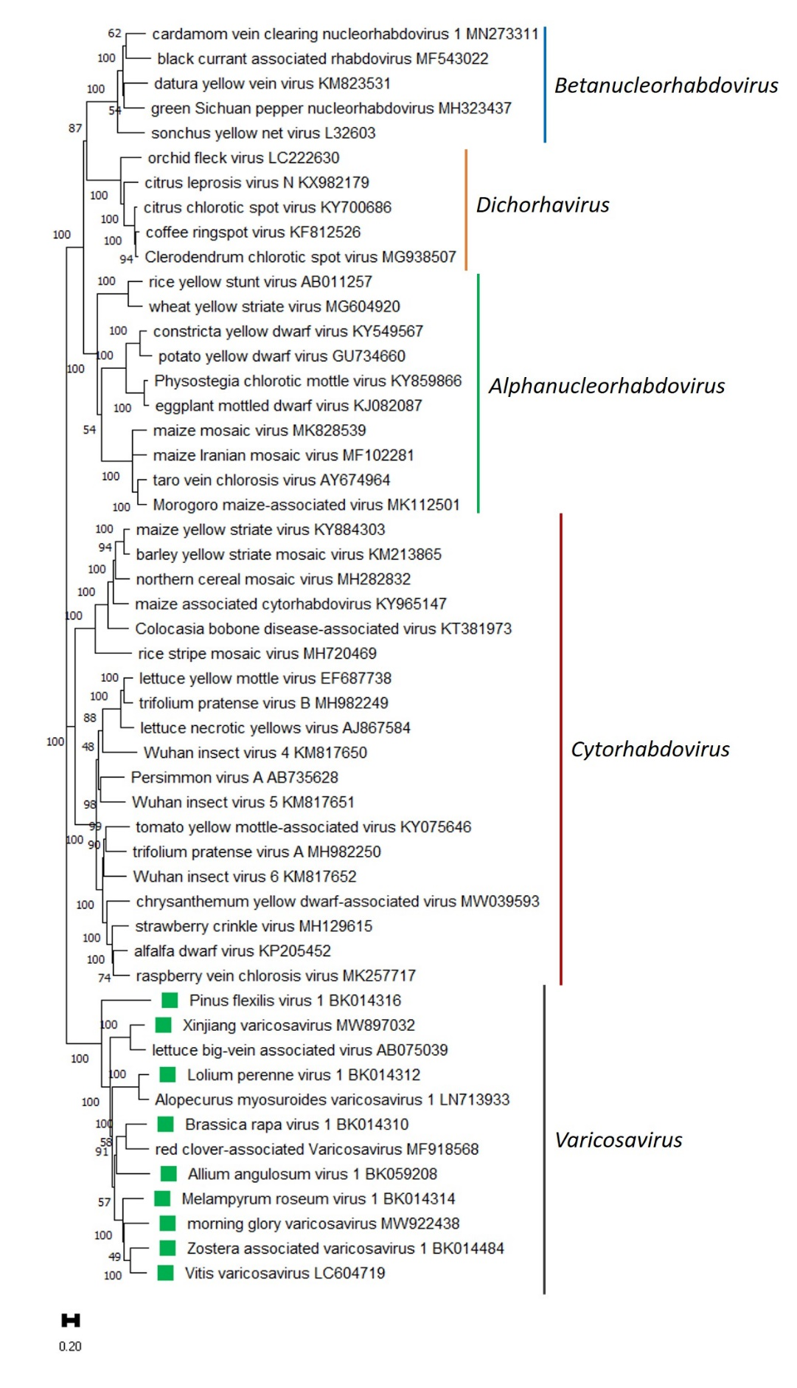

Figure 2. A Maximum Likelihood (ML) phylogenetic tree of plant-infecting rhabdovirus L protein sequences. Amino acid sequences were aligned using MUSCLE. The resulting alignment was used to generate a phylogenetic tree using MegaX with the best-fit model LG + G + I +F. Nine viruses potentially belonging to the new species are indicated with green squares. Numbers at the nodes indicate bootstrap support (1000 replicates).

References
[1] Bejerman N, Dietzgen RG, Debat H (2021). Illuminating the Plant Rhabdovirus Landscape through Metatranscriptomics Data. Viruses 13:1303. PMID: 34372509, doi: 10.3390/v13071304.
[2] Zhao F, Liu H, Qiao Q, Wang Y, Zhang D, Wang S, Tian Y, Zhang Z (2021) Complete genome sequence of a novel varicosavirus infecting tall morning glory (Ipomoea purpurea). Arch Virol 166:3225-3228. PMID: 34519925, doi: 10.1007/s00705-021-05240-6.
[3] Nabeshima T, Abe J (2021). High-Throughput Sequencing Indicates Novel Varicosavirus, Emaravirus, and Deltapartitivirus Infections in Vitis coignetiae. Viruses 13:827. PMID: 34063722. doi: 10.3390/v13050827.
[4] Chen Y, Sadiq S, Tian J, Chen X, Lin X, et al (2021) RNA Virome Composition Is Shaped by Sampling Ecotype. SSRN Electronic Journal. http://dx.doi.org/10.2139/ssrn.3934022.
[5] Shin C, Choi D, Hahn Y (2021) Identification of the genome sequence of Zostera associated varicosavirus 1, a novel negative-sense RNA virus, in the common eelgrass (Zostera marina) transcriptome. Acta Virol 65:373-380. PMID: 34796713. doi: 10.4149/av_2021_404.

