Part 1: TITLE, AUTHORS, APPROVALS, etc

Code assigned: | 2021.015M
Short title: Create ten new species and two new genera in the families Aliusviridae and Chuviridae (Jingchuvirales)
Author(s) and email address(es)
Di Paola N, Dheilly NM, Kuhn JH, Junglen S, Paraskevopoulou S, Postler TS, Shi M | nicholas.dipaola.civ@health.mil; nolwenn.dheilly@anses.fr; kuhnjens@mail.nih.gov; sandra.junglen@charite.de; sofia.paraskevopoulou@charite.de; tp2405@cumc.columbia.edu; shim23@mail.sysu.edu.cn
Author(s) institutional address(es) (optional)
Corresponding author
Di Paola N
List the ICTV Study Group(s) that have seen this proposal
ICTV Jingchuvirales Study Group
ICTV Study Group comments and response of proposer
Approved.
ICTV Study Group votes on proposal
Study Group | Number of members
 | Votes support | Votes against | No vote
ICTV Jingchuvirales Study Group | 6 | 0 | 0
Authority to use the name of a living person
Is any taxon name used here derived from that of a living person (Y/N) | N

Taxon name | Person from whom the name is derived | Permission attached (Y/N)

Submission dates
Date first submitted to SC Chair | May 28, 2021
Date of this revision (if different to above) | July 8, 2022

ICTV-EC comments and response of the proposer
The EC requested to state the Study Group voting results.

Part 2: NON-TAXONOMIC PROPOSAL
Text of proposal
N/A

Part 3: TAXONOMIC PROPOSAL
Name of accompanying Excel module
2021.015M.A.v2.Jingchuvirales_2ngen_10nsp

Abstract
Several new sequencing projects have further increased the known diversity of negative-sense RNA viruses. Here, the ICTV Jingchuvirales Study Group proposes 10 new species and two new genera in order Jingchuvirales. The genomes of the 10 viruses representing the 10 new species have complete polymerase and nucleoprotein gene sequences, but vary substantially in genome organization.

Text of proposal
Several marine- and arthropod-hosted jingchuviral sequences have been reported over the last year (1-5). One study in particular produced sequences representing over 1,000 new viruses in a large variety of samples, including 35 viruses that map to monjiviricete order Jingchuvirales (1). Two viruses are closely related to previously classified viruses first discovered by Käfer et al. (6) with the 1KITE project (BioProject PRJNA183205). Overall, most of the studies that genetically characterized jingchuviral-like viruses did not provide nucleoprotein sequence or did not provide a means to access the sequence publicly.

Species
The 2021, a taxonomical framework for the classification of new jingchuviral species, genera, and families was ratified by the ICTV. A new species should be established if the amino acid identity of two complete RdRp protein sequences of jingchuvirals is <90%. A new jingchuviral species may only be established if a coding-complete RdRp protein sequence is available for the virus to be classified. Additionally, the inclusion or removal of species depends on the presence of a complete nucleoprotein gene (N) sequence. Finally, the genomic organization should be similar to that of monjiviricetes in general and be free of any obvious assembly errors.

From two studies (1, 3), we identified 10 viruses that fulfil these criteria (Figure 1).

Higher taxa
In consideration of jingchuviral percentage of identities and phylogenetic tree (Figure 1), we propose the creation of 2 new genera within the order. New genera are established when amino acid identies of complete RdRp sequences are <31% but >20%. All new genera that include more than one species are clustered together with well-supported nodes.

Etymology: see Excel sheet.

Supporting evidence

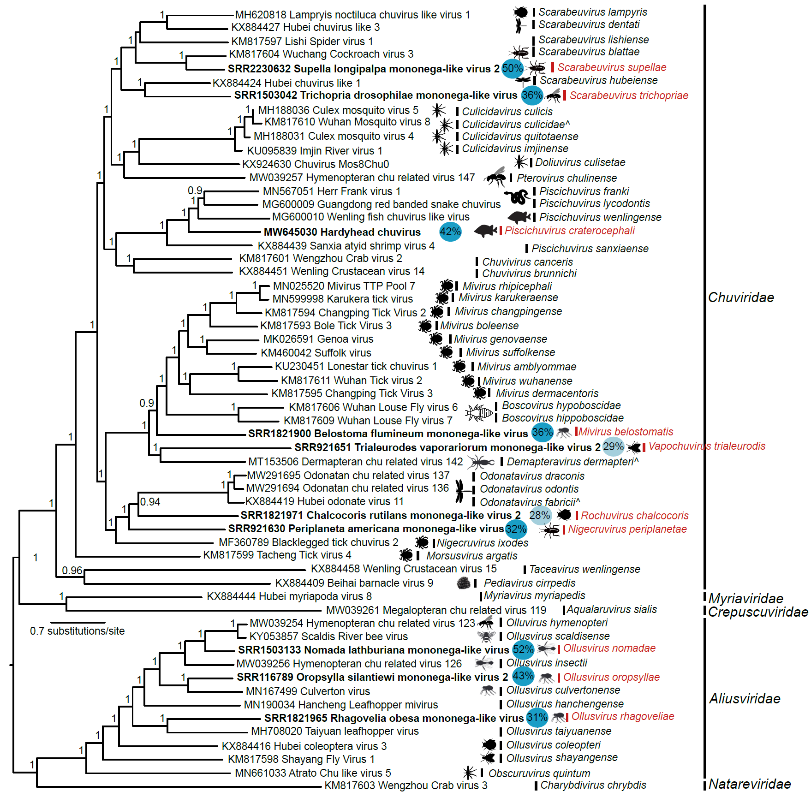

Figure 1. Maximum likelihood phylogenetic tree estimated using 58 complete RNA-directed RNA polymerase protein sequences. Sequences were initially aligned using ClustalW (7), refined using Muscle (8), and manually curated in Geneious R9 (9). Prottest (10) was used to estimate the best amino acid substitution model for the dataset (LG+I+G+F). The tree was estimated using PhyML 3.0 (11), a Subtree Pruning and Regrafting (SPR) topology searching algorithm, and aBayes branches support algorithm. Tree branches are scaled by substitutions per site. Support values are shown as decimal values. Tree tips in bold represent newly proposed jingchuviral species. Each includes a colored circle with a percentage representing the highest pairwise percent identity at the amino acid level, which guides taxonomical demarcations. Additionally, red text shoes newly proposed species and genera.

References

1. Wu H, Pang R, Cheng T, Xue L, Zeng H, Lei T, Chen M, Wu S, Ding Y, Zhang J, Shi M. Abundant and Diverse RNA Viruses in Insects Revealed by RNA-Seq Analysis: Ecological and Evolutionary Implications. Msystems. 2020 Aug 25;5(4).

2. Zhang YY, Chen Y, Wei X, Cui J. Viromes in Marine Ecosystems Reveal Remarkable Invertebrate RNA Virus Diversity. bioRxiv. 2021 Jan 1.

3. Costa VA, Mifsud JC, Gilligan D, Williamson JE, Holmes EC, Geoghegan JL. Metagenomic sequencing reveals a lack of virus exchange between native and invasive freshwater fish across the Murray–Darling Basin, Australia. Virus evolution. 2021 Jan;7(1):veab034.

4. Niu J, Li XL, Wu YL, Sun QZ, Zhang W, Cao M, Wang JJ. RNA virome screening in diverse but ecologically related citrus pests reveals potential virus-host interactions. Journal of invertebrate pathology. 2020 Feb 1;170:107329.

5. Sameroff S, Tokarz R, Jain K, Oleynik A, Carrington CV, Lipkin WI, Oura CA. Novel quaranjavirus and other viral sequences identified from ticks parasitizing hunted wildlife in Trinidad and Tobago. Ticks and Tick-borne Diseases. 2021 Jul 1;12(4):101730.

6. Käfer S, Paraskevopoulou S, Zirkel F, Wieseke N, Donath A, Petersen M, Jones TC, Liu S, Zhou X, Middendorf M, Junglen S. Re-assessing the diversity of negative strand RNA viruses in insects. PLoS pathogens. 2019 Dec 12;15(12):e1008224.

7. Thompson JD, Gibson TJ, Higgins DG. Multiple sequence alignment using ClustalW and ClustalX. Current protocols in bioinformatics. 2003 Jan(1):2-3.

8. Edgar RC. MUSCLE: multiple sequence alignment with high accuracy and high throughput. Nucleic acids research. 2004 Mar 1;32(5):1792-7.

9. Kearse M, Moir R, Wilson A, Stones-Havas S, Cheung M, Sturrock S, Buxton S, Cooper A, Markowitz S, Duran C, Thierer T. Geneious Basic: an integrated and extendable desktop software platform for the organization and analysis of sequence data. Bioinformatics. 2012 Jun 15;28(12):1647-9.

10. Abascal F, Zardoya R, Posada D. ProtTest: selection of best-fit models of protein evolution. Bioinformatics. 2005 May 1;21(9):2104-5.

11. Guindon S, Dufayard JF, Lefort V, Anisimova M, Hordijk W, Gascuel O. New algorithms and methods to estimate maximum-likelihood phylogenies: assessing the performance of PhyML 3.0. Systematic biology. 2010 May 1;59(3):307-21.

