Part 1: TITLE, AUTHORS, APPROVALS, etc

Code assigned: | 2022.001M
Short title: Create two new species in the genus Alphanucleorhabdovirus, and four new species in the genus Betanucleorhabdovirus, subfamily Betarhabdovirinae (Mononegavirales: Rhabdoviridae)
Author(s) and email address(es)
Bejerman N, Debat H, Dietzgen RG, Kondo H, Ramos-González P, Whitfield AE, Walker PJ, Freitas-Astúa J | bejerman.nicolas@inta.gob.ar;  debat.hmberto@inta.gob.ar;  r.dietzgen@uq.edu.au; hkondo@rib.okayama-u.ac.jp;  plrg1970@gmail.com;  awhitfi@ncsu.edu;  peter.walker@uq.edu.au;  juliana.astua@embrapa.br
Author(s) institutional address(es) (optional)
Corresponding author
Bejerman N
List the ICTV Study Group(s) that have seen this proposal
ICTV Rhabdoviridae Study Group
ICTV Study Group comments and response of proposer
Minor corrections
ICTV Study Group votes on proposal

Study Group | Number of members
 | Votes support | Votes against | No vote
ICTV Rhabdoviridae Study Group | 12 | 0 | 2

Authority to use the name of a living person

Is any taxon name used here derived from that of a living person (Y/N) | N

Taxon name | Person from whom the name is derived | Permission attached (Y/N)

Submission dates
Date first submitted to SC Chair | May 23, 2022
Date of this revision (if different to above)
ICTV-EC comments and response of the proposer

Part 2: NON-TAXONOMIC PROPOSAL
Text of proposal

Part 3: TAXONOMIC PROPOSAL
Name of accompanying Excel module
2022.001M.N.v1.Alpha and betanucleorhabdoviruses_6nsp.xlsx
Abstract
Viruses classified in the family Rhabdoviridae infect vertebrates, invertebrates, and plants. Six new plant-infecting rhabdoviruses were discovered recently and their complete or coding-complete genome sequences were determined. This proposal aims to classify taxonomically these six viruses in six new species in the genera Alphanucleorhabdovirus and Betanucleorhabdovirus.
Text of proposal
We propose the taxonomic classification of six novel plant-infecting rhabdoviruses in six new species in two established genera in the subfamily Betarhabdovirinae, family Rhabdoviridae:

Two new species in genus Alphanucleorhabdovirus

1) Agave tequilana virus 1 (ATV1) was identified during an in silico analysis of transcriptome data of blue agave (Agave tequilana Weber var. azul) tissues from Guanajuato, Mexico. The coding-complete genome (CCG) sequence (partial 3’ leader and 5’ trailer) of ATV1 has 13,166 nucleotides (GenBank #BK014297) and contains six ORFs in the order 3’-N-P-P3-M-G-L-5’ [1] representing the five canonical rhabdovirus structural protein genes and the putative cell-to-cell movement protein gene P3 in the conserved location between P and M genes (Figure 1). The CCG nucleotide sequence of ATV1 has the highest sequence identity with that of maize mosaic virus (MMV; 49.3%) [1]. Based on ML trees generated from complete large protein (L) sequences, ATV1 forms a well-supported clade with the monocot-infecting alphanucleorhabdoviruses MMV, maize Iranian mosaic virus, Morogoro maize-associated virus, and taro vein chlorosis virus (Figure 2).

2) Artemisia capillaris nucleorhabdovirus 1 (ArtCaNV1) was identified during an in silico analysis of transcriptome data of capillary wormwood (Artemisia capillaris Thunb) tissues from Kyoto, Japan. The coding-complete genome (CCG) sequence (partial 3’ leader and 5’ trailer) of ArtCaNV1 has 13,939 nucleotides (isolate YK,GenBank #OM372677), and contains six ORFs in the order 3’-N-P-P3-M-G-L-5’ [unpublished] representing the five canonical rhabdovirus structural protein genes and the putative cell-to-cell movement protein gene P3 in the conserved location between P and M genes (Figure 1). The CCG nucleotide sequence of ArtCaNV1 has the highest sequence identity with that of wheat yellow striate virus (WYSV; 51.8%) [unpublished]. Based on ML trees generated from complete L sequences, ArtCaNV1 forms a well-supported clade with the alphanucleorhabdoviruses rice yellow stunt virus and WYSV (Figure 2).

Viruses assigned to different species within the genus Alphanucleorhabdovirus have several of the following characteristics:
- nucleotide sequence identity lower than 75% in the complete genome sequence;
- occupy different ecological niches as evidenced by differences in hosts and/or arthropod vectors; and
- can be clearly distinguished in serological tests or by nucleic acid hybridization.

ATV1 and ArtCaNV1 meet criteria A and B. Consequently, we propose to classify ATV1 and ArtCaNV1 in two new alphanucleorhabdovirus species.

Four new species in the genus Betanucleorhabdovirus

1) Asclepias syriaca virus 2 (AscSyV2) was identified during an in silico analysis of transcriptome data of common milkweed (Asclepias syriaca L.) tissues from Illinois, USA. The coding-complete genome (CCG) sequence (partial 3’ leader and 5’ trailer) of AscSyV2 has 12,940 nucleotides (GenBank #BK014299) and contains six ORFs in the order 3’-N-P-P3-M-G-L-5’ [1] representing the five canonical rhabdovirus structural protein genes and the putative cell-to-cell movement protein gene P3 in the conserved location between P and M genes (Figure 1). The CCG nucleotide sequence of AscSyV2 has the highest sequence identity with that of apple rootstock virus A (ApRVA; 51.3%) [1]. Based on ML trees generated from complete L sequences, AscSyV2 is placed within a subclade of betanucleorhabdoviruses with ApRVA (Figure 2).

2) Cnidium virus 1 (CnV1) was identified in Cnidium officinale plants from Seoul, South Korea. The complete genome (CG) sequence of CnV1 has 14,002 nucleotides (isolate SK, GenBank #MZ983390), and contains six ORFs in the order 3’-N-P-P3-M-G-L-5’ [2] representing the five canonical rhabdovirus structural protein genes and the putative cell-to-cell movement protein gene P3 in the conserved location between P and M genes (Figure 1). CnV1 is most closely related to black currant-associated rhabdovirus (BCaRV) and cardamom vein clearing virus (CdVCV). The CG nucleotide sequence of CnV1 is 54% and 56% identical to that of BCaRV and CdVCV, respectively [2]. Based on ML trees generated from complete L sequences (Figure 2), CnV1 is placed within a subclade of betanucleorhabdoviruses with BCaRV and CdVCV.

3) Plectranthus aromaticus virus 1 (PleArV1) was identified during an in silico analysis of transcriptome data of Cuban oregano (Plectranthus aromaticus Lour.) tissues from Malaysia. The coding-complete genome (CCG) sequence (partial 3’ leader and 5’ trailer) of PleArV1 has 12,994 nucleotides (GenBank #BK014300) and contains six ORFs in the order 3’-N-P-P3-M-G-L-5’ [1] representing the five canonical rhabdovirus structural protein genes and the putative cell-to-cell movement protein gene P3 in the conserved location between P and M genes (Figure 1). The CCG nucleotide sequence of PleArV1 has the highest sequence identity with that of datura yellow vein virus (DYVV; 62.1%) [1]. Based on ML trees generated from complete L sequences, PleArV1 is placed within a subclade of betanucleorhabdoviruses with DYVV and Bacopa monnieri virus 2 (Figure 2).

4) Rhododendron delavayi virus 1 (RhoDeV1) was identified during an in silico analysis of transcriptome data of red rhododendron (Rhododendron delavayi Franch) tissues from Yunnan, China. The coding-complete genome (CCG) sequence (partial 3’ leader and 5’ trailer) of RhoDeV1 has 13,719 nucleotides (GenBank #BK014301) and contains six ORFs in the order 3’-N-P-P3-M-G-L-5’ [1] representing the five canonical rhabdovirus structural protein genes and the putative cell-to-cell movement protein gene P3 in the conserved location between P and M genes (Figure 1). The CCG nucleotide sequence of RhoDeV1 has the highest sequence identity with that of black currant-associated rhabdovirus (BCaRV; 53.1%) [1]. Based on ML trees generated from complete L sequences, RhoDeV1 forms a well-supported clade with other betanucleorhabdoviruses (Figure 2).

Viruses assigned to different species within the genus Betanucleorhabdovirus have several of the following characteristics:
- nucleotide sequence identity lower than 75% in the complete genome sequence;
- occupy different ecological niches as evidenced by differences in hosts and/or arthropod vectors; and
- can be clearly distinguished in serological tests or by nucleic acid hybridization.

AscSyV2, CnV1, PleArV1, and RhoDeV1 meet criteria A and B. Consequently, we propose to classify AscSyV2, CnV1, PleArV1, and RhoDeV1 into four new betanucleorhabdovirus species.

Supporting evidence

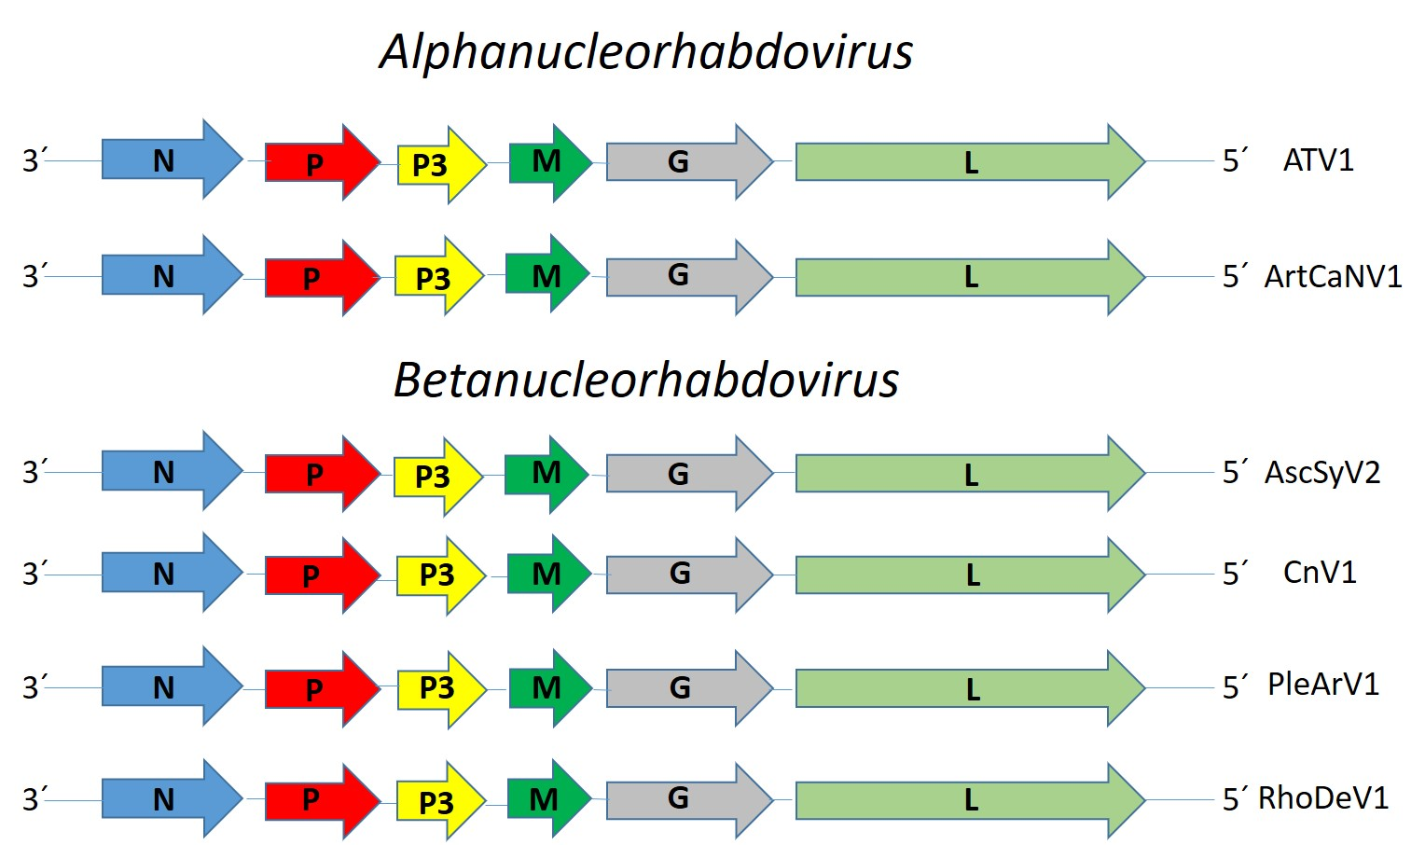

Figure 1. Genome graphs depicting architecture and gene products of proposed viruses to be included in species within genera Alphanucleorhabdovirus and Betanucleorhabdovirus. Abbreviations: N: nucleoprotein; P: phosphoprotein; P3: putative cell-to-cell movement protein; M: matrix protein; G: glycoprotein; L: large protein. Virus name abbreviations: Agave tequilana virus 1 (ATV1), Artemisia capillaris nucleorhabdovirus 1 (ArtCaNV1), Asclepias syriaca virus 2 (AscSyV2), Cnidium virus 1 (CnV1), Plectranthus aromaticus virus 1 (PleARV1), and Rhododendron delavayi virus 1 (RhoDeV1).

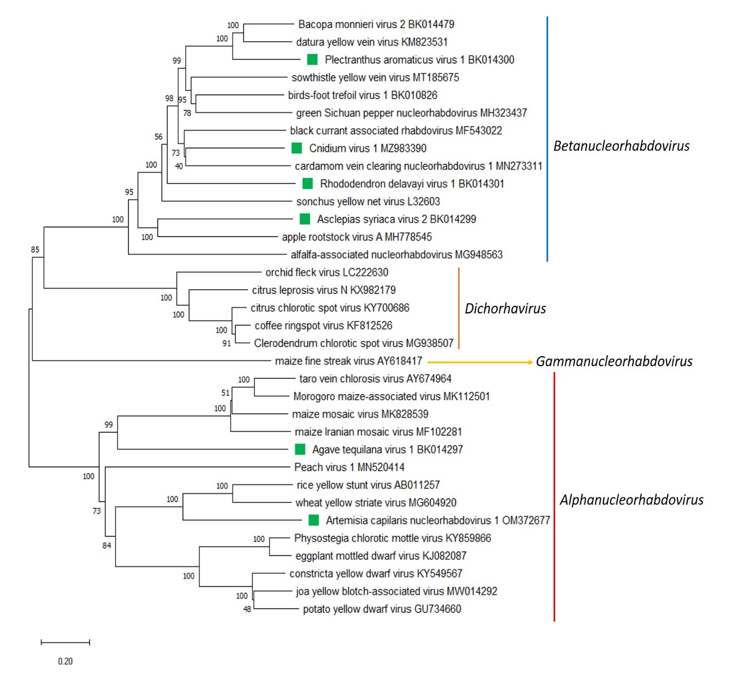

Figure 2. A Maximum Likelihood (ML) phylogenetic tree of plant-infecting rhabdovirus L protein sequences. Amino acid sequences were aligned using MUSCLE. The resulting alignment was used to generate a phylogenetic tree using MegaX with the best-fit model LG + G + I +F. Six viruses potentially belonging to the new species are indicated with green squares. Numbers at the nodes indicate bootstrap support (1000 replicates).

References
[1] Bejerman N, Dietzgen RG, Debat H (2021). Illuminating the Plant Rhabdovirus Landscape through Metatranscriptomics Data. Viruses 13:1303. PMID: 34372509, doi: 10.3390/v13071304.
[2] Belete M, Igori D, Kim S, Lee S, Moon J (2022) Complete genome sequence of cnidium virus 1, a novel betanucleorhabdovirus infecting Cnidium officinale. Arch Virol 167:973-977. PMID: 35112199, doi:10.1007/s00705-021-05348-9.

