Part 1: TITLE, AUTHORS, APPROVALS, etc

Code assigned: | 2022.020M
Short title: Two new genera, 10 new species, and 1 moved and renamed species in family Phenuiviridae (Bunyavirales)
Author(s) and email address(es)
Briese T, Di Serio F, Groschup MH, Jonson GB, Neriya Y, Sasaya T, Song J-W, Tomitaka Y, Kuhn JH, Palacios G | thomas.briese@columbia.edu; francesco.diserio@ipsp.cnr.it; Martin.Groschup@fli.de; g.jonson@irri.org; neriya@a.utsunomiya-u.ac.jp; tsasaya@affrc.go.jp; jwsong@korea.ac.kr; yasut@affrc.go.jp; kuhnjens@mail.nih.gov; gustavo.palacios@mssm.edu
Author(s) institutional address(es) (optional)
Corresponding author
Palacios G
List the ICTV Study Group(s) that have seen this proposal
ICTV Phenuiviridae Study Group
ICTV Study Group comments and response of proposer
Approved.
ICTV Study Group votes on proposal
Study Group | Number of members
 | Votes support | Votes against | No vote
ICTV Phenuiviridae Study Group | 9 | 0 | 0
Authority to use the name of a living person
Is any taxon name used here derived from that of a living person (Y/N) | N

Taxon name | Person from whom the name is derived | Permission attached (Y/N)
Submission dates
Date first submitted to SC Chair | May 27, 2022
Date of this revision (if different to above)
ICTV-EC comments and response of the proposer
Part 2: NON-TAXONOMIC PROPOSAL
Text of proposal

Part 3: TAXONOMIC PROPOSAL
Name of accompanying Excel module
2022.020M.N.v1.Phenuiviridae_3ngen_12nsp_1rensp.xlsx
Abstract
We propose the classification of 10 newly discovered phenuivirids into 1 new species in 1 new monospecific genus and 9 new species in established genera, and the move of one species into a new genus.
Text of proposal
The bunyaviral family Phenuiviridae currently includes 20 genera (Bandavirus, Beidivirus, Coguvirus, Entovirus, Goukovirus, Horwuvirus, Hudivirus, Hudovirus, Ixovirus, Laulavirus, Lentinuvirus, Mobuvirus, Phasivirus, Phlebovirus, Pidchovirus, Rubodvirus, Tanzavirus, Tenuivirus, Uukuvirus, and Wenrivirus). In 2021, the ICTV Phenuiviridae Study Group
established a species demarcation criterion of <95% identity in the amino acid sequence of the phenuivirid RNA-directed RNA polymerase (RdRp) (TaxoProp 2020.029M). A reanalysis of the dataset used in TaxoProp 2020.029M, complemented with newly described phenuivirid sequences, indicated that 10 viruses should be classified into 1 novel monospecific genus and 9 novel species in established genera, and that 1 species ought to be moved into a novel genus (Supplementary Data, Figure 1):

Novel monospecific genera:
- Aphis citricidus bunyavirus (AcBV) was discovered by high-throughput sequencing (HTS) in brown citrus aphids (Aphis citricidus (Kirkaldy, 1907)) sampled from an aphid colony at Southwest University ( 西南大学), Chóngqìng (重庆市), China. Analyses place the virus in Phenuiviridae but not into any established genus [15] (proposed genus Citricivirus); and
- melon chlorotic spot virus (MeCSV) [6], currently classified in phenuivirid genus Tenuivirus, needs to be moved into a new, currently monospecific, genus (proposed genus Mechlorovirus).

Novel phlebovirus species:
Hédǐ virus (HEDV) was isolated from Phlebotomus chinensis Newstead, 1916 sand flies sampled in Hédǐ (河底镇), Shānxī Province (山西省), China [13].

Novel uukuvirus species:
Tōyo virus (TOYOV) was discovered by HTS in in ixodid Haemaphysalis formosensis Neumann, 1913 ticks sampled in Tōyo (東予市), Ehime Prefecture (愛媛県), Japan [4].

[Sunday Canyon virus, isolated from argasid Argas cooleyi Kohls & Hoogstraal, 1960 ticks sampled in Sunday Canyon, Texas, USA [14], was found to be an isolate of the already classified uukuvirus murre virus (MURV)].

Novel bandavirus species:
Zwiesel bat bandavirus (ZbbV) was discovered by HTS in northern bats (Eptesicus nilssonii (Keyserling et Blasius, 1839)) sampled in Zwiesel, Bavaria (Bayern), Germany [5].

[Culex bunyavirus 1 strain CBunV1/Kern, discovered by HTS in culicid Culex sp. mosquitoes sampled in the USA [8], was found to be an isolate of the already classified phasivirus Wǔtái mosquito virus (WtMV)].

Novel horwuvirus species:
Solenopsis invicta virus 14 (SINV-14) was discovered by HTS in red imported fire ants (formicid Solenopsis invicta (Buren, 1972)) collected in Mississippi, USA [12].

Novel goukovirus species:
- Ceraphron bunya-like virus (CerBLV) was discovered in SRA data of ceraphronid Ceraphron sp. [11];
- Aphalara polygoni (ApBLV) bunya-like virus discovered in SRA data of psyllid Aphalara polygoni Foerster, 1848 jumping plant lice [11].

Novel mobuvirus species:
- Browner virus (BRWV) was discovered by HTS in Stephanocircus sp. fleas sampled in New South Wales, Australia [2]; and
- Euproctis pseudoconspersa bunyavirus (EPBV) was discovered by HTS in tea tussock moths (erebid Arna pseudoconspersa Strand, 1914) sampled in Qīngyuǎn (清远市), Guǎngdōng Province (广东省), China [10].

Novel lauravirus species:
Wardell virus (WRDV) was discovered by HTS in Australian paralysis ticks (ixodid Ixodes holocyclus Neumann, 1899) sampled in Wardell, New South Wales, Australia [1].

Novel viruses assignable to established phenuivirid species:
[Leuven phlebovirus, discovered by HTS in castor bean ticks (ixodid Ixodes ricinus (Linnaeus, 1758)) sampled in Belgium [9], was found to be an isolate of the already classified ixovirus Fairhair virus].

Supporting evidence
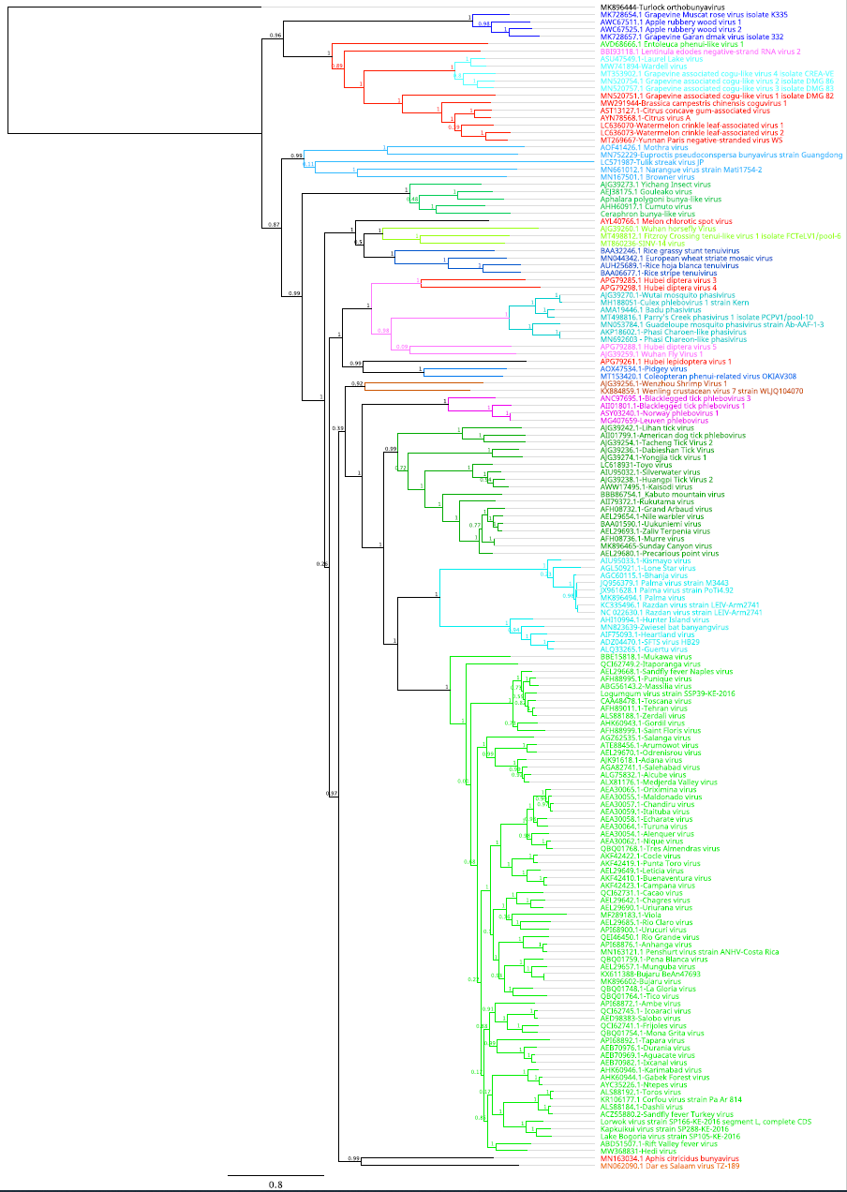

Figure 1. Maximum-likelihood (ML) phylogeny is based on a MAFFT-alignment of the RNA-directed RNA polymerase (RdRp) amino-acid sequences of phenuivirids and phenuivirid-like sequences using E-INS algorithm. The ML phylogenetic tree was inferred using IQ-TREE [7]; the numbers on the nodes represent bootstrap values derived from the ultrafast bootstrap algorithm [3]. Trees were inferred under the LG+G+I substitution model. Tree branches are proportional to genetic distances between sequences and the scale bars at the top indicate substitutions per amino acid. For all taxa shown here, the complete genome or complete coding sequence is available at the GenBank nucleotide sequence database. Accession numbers are shown next to the respective virus taxon.

References
1. Chandra S, Harvey E, Emery D, Holmes EC, Šlapeta J (2021) Unbiased characterization of the microbiome and virome of questing ticks. Front Microbiol 12:627327. PMID: 34054743. PMCID: PMC8153229. doi: 10.3389/fmicb.2021.627327.
2. Harvey E, Rose K, Eden J-S, Lawrence A, Doggett SL, Holmes EC (2019) Identification of diverse arthropod associated viruses in native Australian fleas. Virology 535:189-199. PMID: 31319276. doi: 10.1016/j.virol.2019.07.010.
3. Hoang DT, Chernomor O, von Haeseler A, Minh BQ, Vinh LS (2018) UFBoot2: improving the ultrafast bootstrap approximation. Mol Biol Evol 35:518-522. PMID: 29077904. PMCID: PMC5850222. doi: 10.1093/molbev/msx281.
4. Kobayashi D, Kuwata R, Kimura T, Faizah AN, Higa Y, Hayashi T, Sawabe K, Isawa H (2021) Toyo virus, a novel member of the Kaisodi group in the genus Uukuvirus (family Phenuiviridae) found in Haemaphysalis formosensis ticks in Japan. Arch Virol 166:2751-2762. PMID: 34341873. doi: 10.1007/s00705-021-05193-w.
5. Kohl C, Brinkmann A, Radonić A, Dabrowski PW, Nitsche A, Mühldorfer K, Wibbelt G, Kurth A (2020) Zwiesel bat banyangvirus, a potentially zoonotic Huaiyangshan banyangvirus (Formerly known as SFTS)-like banyangvirus in Northern bats from Germany. Sci Rep 10:1370. PMID: 31992832. PMCID: PMC6987236. doi: 10.1038/s41598-020-58466-w.
6. Lecoq H, Wipf-Scheibel C, Verdin E, Desbiez C (2019) Characterization of the first tenuivirus naturally infecting dicotyledonous plants. Arch Virol 164:297-301. PMID: 30302581. doi: 10.1007/s00705-018-4057-6.
7. Nguyen L-T, Schmidt HA, von Haeseler A, Minh BQ (2015) IQ-TREE: a fast and effective stochastic algorithm for estimating maximum-likelihood phylogenies. Mol Biol Evol 32:268-74. PMID: 25371430. PMCID: PMC4271533. doi: 10.1093/molbev/msu300.
8. Sadeghi M, Altan E, Deng X, Barker CM, Fang Y, Coffey LL, Delwart E (2018) Virome of > 12 thousand Culex mosquitoes from throughout California. Virology 523:74-88. PMID: 30098450. doi: 10.1016/j.virol.2018.07.029.
9. Vanmechelen B, Merino M, Vergote V, Laenen L, Thijssen M, Martí-Carreras J, Claerebout E, Maes P (2021) Exploration of the Ixodes ricinus virosphere unveils an extensive virus diversity including novel coltiviruses and other reoviruses. Virus Evol 7:veab066. PMID: 34532065. PMCID: PMC8438917. doi: 10.1093/ve/veab066.
10. Wang X, Gu Q, Zhang W, Jiang H, Chen S, Smagghe G, Niu J, Wang J-J (2021) Prevalence of a novel bunyavirus in tea tussock moth Euproctis pseudoconspersa (Lepidoptera: Lymantriidae). J Insect Sci 21:1-4. PMID: 34280294. PMCID: PMC8288992. doi: 10.1093/jisesa/ieab045.
11. Wu H, Pang R, Cheng T, Xue L, Zeng H, Lei T, Chen M, Wu S, Ding Y, Zhang J, Shi M, Wu Q (2020) Abundant and diverse RNA viruses in insects revealed by RNA-seq analysis: ecological and evolutionary implications. mSystems 5:e00039-20. PMID: 32636338. PMCID: PMC7343303. doi: 10.1128/mSystems.00039-20.
12. Xavier CAD, Allen ML, Whitfield AE (2021) Ever-increasing viral diversity associated with the red imported fire ant Solenopsis invicta (Formicidae: Hymenoptera). Virol J 18:5. PMID: 33407622. PMCID: PMC7788728. doi: 10.1186/s12985-020-01469-w.
13. Xu Z, Fan N, Hou X, Wang J, Fu S, Song J, Shi M, Liang G (2021) Isolation and identification of a novel phlebovirus, Hedi virus, from sandflies collected in China. Viruses 13:772. PMID: 33925561. PMCID: PMC8145316. doi: 10.3390/v13050772.
14. Yunker CE, Clifford CM, Thomas LA, Keirans JE, Casals J, George JE, Parker JC (1977) Sunday Canyon virus, a new ungrouped agent from the tick Argas (A.) cooleyi in Texas. Acta Virol 21:36-44. PMID: 15436.
15. Zhang W, Wu T, Guo M, Chang T, Yang L, Tan Y, Ye C, Niu J, Wang J-J (2019) Characterization of a new bunyavirus and its derived small RNAs in the brown citrus aphid, Aphis citricidus. Virus Genes 55:557-561. PMID: 31079289. doi: 10.1007/s11262-019-01667-x.

