

**Part 1:** **TITLE, AUTHORS, APPROVALS, etc**

|  |  |  |
| --- | --- | --- |
| **Code assigned:** | ***2022.003M*** |  |
| **Short title:** Create one new genus including one new species in the family *Arenaviridae* | | |
|  | | |

**Author(s) and email address(es)**

|  |  |
| --- | --- |
| Chen Y-M, Sadiq S, Holmes EC, Zhang Y-Z | chenyanmei@shphc.org.cn; sabrina.sadiq@sydney.edu.au; edward.holmes@sydney.edu.au; zhangyongzhen@fudan.edu.cn |

**Author(s) institutional address(es) (optional)**

|  |
| --- |
| Fudan University [CYM, ZYZ];  The University of Sydney [SS, HEC] |

**Corresponding author**

|  |
| --- |
| Zhang Y-Z |

**List the ICTV Study Group(s) that have seen this proposal**

|  |
| --- |
| ICTV *Arenaviridae* Study Group |

**ICTV Study Group comments and response of proposer**

|  |
| --- |
| Approved. |

**ICTV Study Group votes on proposal**

|  |  |  |  |
| --- | --- | --- | --- |
| **Study Group** | **Number of members** | | |
| **Votes support** | **Votes against** | **No vote** |
| ICTV *Arenaviridae* Study Group | 15 | 0 | 0 |

**Authority to use the name of a living person**

|  |  |
| --- | --- |
| **Is any taxon name used here derived from that of a living person (Y/N)** | N |

|  |  |  |
| --- | --- | --- |
| **Taxon name** | **Person from whom the name is derived** | **Permission attached (Y/N)** |
|  |  |  |

**Submission dates**

|  |  |
| --- | --- |
| Date first submitted to SC Chair | May 27, 2022 |
| Date of this revision (if different to above) |  |

**ICTV-EC comments and response of the proposer**

|  |
| --- |
|  |

**Part 2:** **NON-TAXONOMIC PROPOSAL**

**Text of proposal**

|  |
| --- |
|  |

**Part 3:** **TAXONOMIC PROPOSAL**

**Name of accompanying Excel module**

|  |
| --- |
| 2022.003M.N.v1.Arenaviridae_1ngen_1nsp.xlsx |

**Abstract**

|  |
| --- |
| We propose the establishment of a novel genus, *Innmovirus*, including one novel species, *Innmovirus hailarense*, in the family *Arenaviridae*. |

**Text of proposal**

|  |  |
| --- | --- |
| |  | | --- | | Inner Mongolia sediment arena-like virus (IMSV), here renamed Hailar virus (HLRV), was discovered by high-throughput sequencing in river sediment samples collected from Hailar River (海拉尔河; Hǎilā'ěrhé) in Hailar District (海拉尔区; Hǎilā'ěrqū) of Hulunbuir (呼伦贝尔, Hūlúnbèi'ěr), Inner Mongolia Autonomous Region (内蒙古自治区; Nèiménggǔ zìzhìqū), China (1). The coding-complete genomic sequences were subsequently obtained by reverse transcription polymerase chain reaction (RT-PCR). Unlike most currently classified arenavirids, but similar to some fish arenavirids and other bunyavirals, HLRV has a tri-segmented genome with large (L; encoding an RNA-directed RNA polymerase-containing large protein L), medium (M; encoding a glycoprotein precursor GPC), and small (S; encoding a nucleoprotein NP) genomic segments. These sequences have been deposited into GenBank (MW896845–MW896847). Currently, there is no biological isolate of HLRV.  The ICTV *Arenaviridae* Study Group has recommended the use of the Pairwise Sequence Comparison (PASC) tool (<https://www.ncbi.nlm.nih.gov/sutils/pasc/viridty.cgi?textpage=overview>) for the taxonomic assessment of potentially novel arenavirids (2). Cut-off values for classifying arenavirids belonging to the same species using this tool are >80% and >76% nucleotide sequence identity in the S and L segment, respectively. Cut-off values for classifying arenaviruses belonging to the same genus using this tool are >29–40% and >30–35% nucleotide sequence identity in the S and L segment, respectively. Therefore, we performed PASC analyses to compare the HLRV genome to other arenavirids (Figure 1).  The closest PASC hit for the L segment of HLRV is salmon pescarenavirus 1 (SPAV-1; *Arenaviridae*: *Antennavirus*), with a pairwise identity of 23.67% (i.e., <30%).  In addition, due to the tri-segmented genome of HLRV, we compared both S and M segments against the S segments of all known bisegmented arenavirids. Results showed that HLRV had <11% and <23% nucleotide sequence identity in its M and S segments, respectively, when compared to those S segments.  These results justify the creation of a novel genus (*Innmovirus*) including one novel species (*Innmovirus hailaerense*) for HLRV. The name of the new genus (*Innmovirus*) and its proposed species (*Innmovirus hailaerense*) are derived from the location where HLRV was found.  To further confirm the taxonomic position of HLRV, maximum likelihood phylogenetic analyses inferred from alignments of the complete L and NP amino-acid sequences were estimated using IQ-TREE employing a best-fit model of amino acid substitution with 1000 bootstrap replicates and 1000 SH-like approximate likelihood ratio test (SH-aLRT) replicates. The trees were visualized using FigTree v1.4.4 (Figure 2).  In both phylogenies, HLRV (*Innmovirus hailaerense*) formed a distinct evolutionary branch separate from the main arenavirid clades (antennaviruses, hartmaniviruses, reptarenaviruses, and mammarenaviruses), confirming the PASC results. | |

**Supporting evidence**

**Figure 1. PASC analyses for the L, M, and S segments of HLRV.**

(a) L segment: MW896845

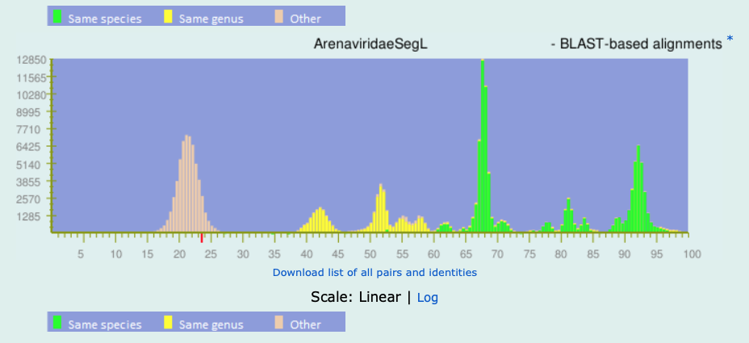

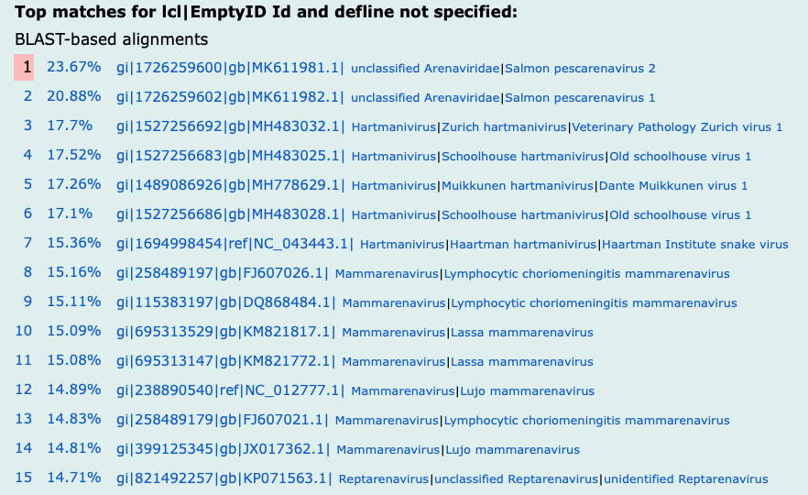

(b) M segment: MW896846

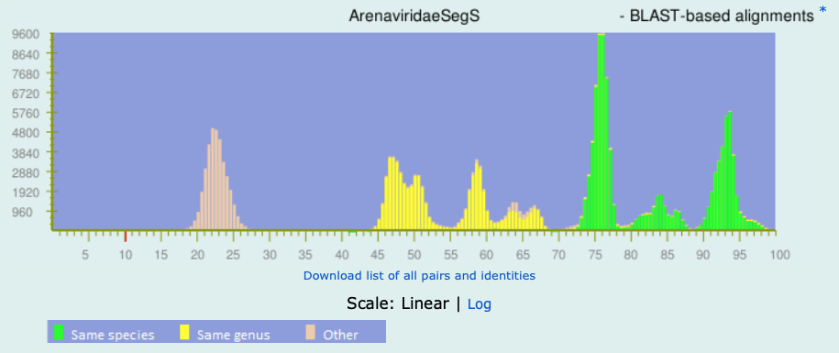

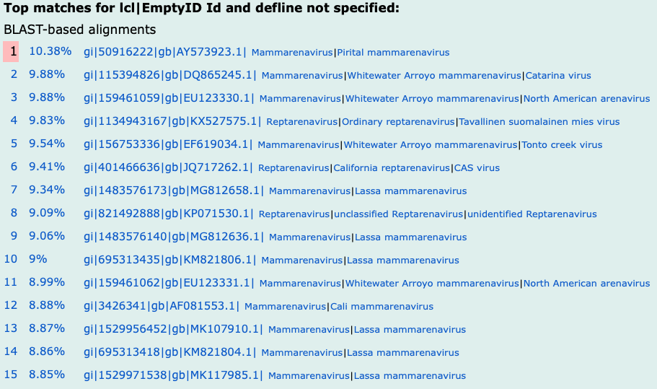

(c) S segment: MW896847

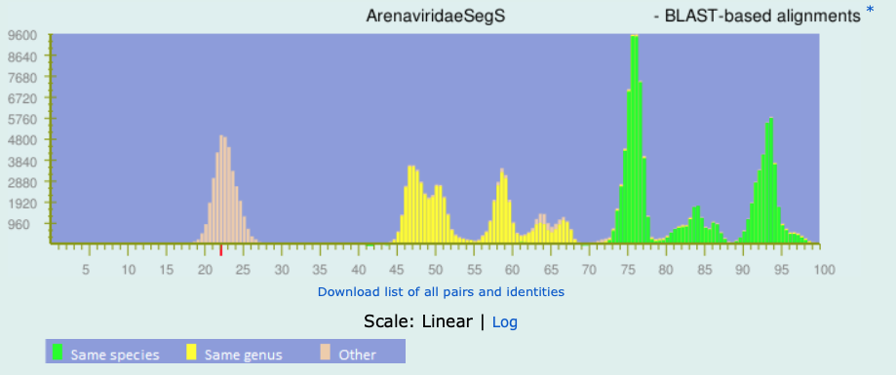

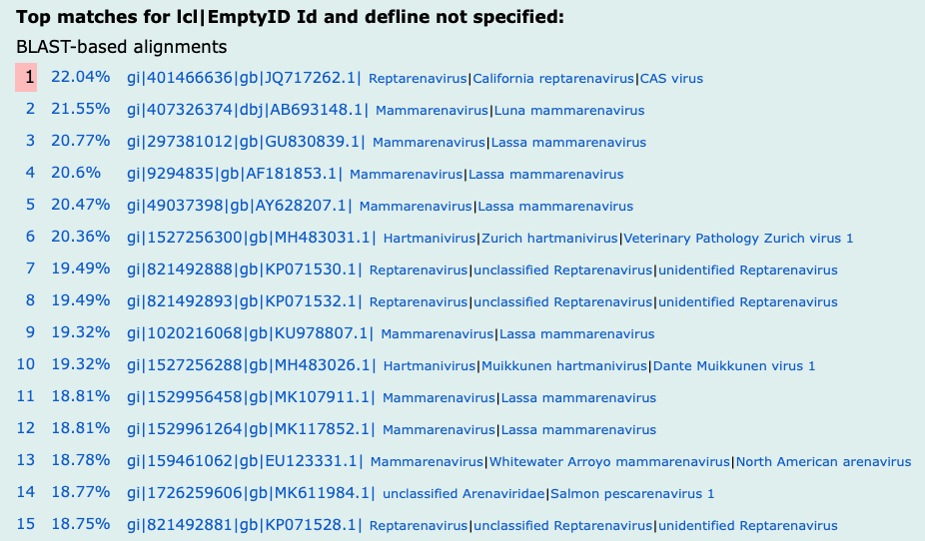

**Figure 2. Maximum likelihood phylogenetic trees based on complete L and NP amino-acid sequences.** The trees were midpoint rooted and only bootstrap values ≥90% are shown.

**(a) L**



**(b) NP**



**References**

1. Chen YM,Sadiq S, Tian JH, Chen X, Lin XD, Shen JJ, Chen H, Hao ZY, Yang WD, Zhou ZC, Wu J, Li F, Wang HW, Xu QY, Wang W, Gao WH, Holmes EC, Zhang YZ. RNA virome composition is shaped by sampling ecotype. SSRN Electronic Journal. 2021. <https://ssrn.com/abstract=3934022>

2. Radoshitzky SR, Bào Y, Buchmeier MJ, Charrel RN, Clawson AN, Clegg CS, DeRisi JL, Emonet S, Gonzalez J-P, Kuhn JH, Lukashevich IS, Peters CJ, Romanowski V, Salvato MS, Stenglein MD, de la Torre JC. Past, present, and future of arenavirus taxonomy. Arch Virol. 2015,160: 1851-1874. PMID: 25935216 DOI: 10.1007/s00705-015-2418-y